Dataset: Voice

library(caTools)

library(glmnet)

library(ROCR)

library(caret)

library(e1071)

library(randomForest)

library (tree)

**Exploratory Data Analysis**

setwd("C:\\Users\\admin\\Downloads")

voiceData<-read.csv("voice.csv", header = TRUE, stringsAsFactors = FALSE)

head(voiceData)

dim(voiceData)

**We have read the dataset**

**#### Check NA values ####**

detectNAs<-function(x){

return(sum(is.na(x)))

}

lapply(voiceData, detectNAs)

**#### Check 0 values ####**

detectZeros<-function(x){

return(sum(x==0))

}

lapply(voiceData, detectZeros)

**###Replace Zero values with mean**

voiceData$dfrange[voiceData$dfrange==0]<-mean(voiceData$dfrange)

voiceData$modindx[voiceData$modindx==0]<-mean(voiceData$modindx)

**###Convert dependent variable into binary terms**

voiceData$label<-ifelse(voiceData$label=="male", 1, 0)

**We have fitted a lasso model in order to identify the significant variables**

**####Fit Lasso Model**

**##### Split Data for Lasso**

x=x=model.matrix(label~.,voiceData)[,-1]

dim(x)

head(x)

y=voiceData$label

grid=10^seq(10,-2,length=100)

train_lasso=sample(1:nrow(x), nrow(x)/2)

test_lasso=(-train_lasso)

lasso.mod=glmnet(x[train_lasso,],y[train_lasso],alpha=1,lambda=grid)

plot(lasso.mod)

set.seed(1)

cv.out=cv.glmnet(x[train_lasso,],y[train_lasso],alpha=1)

plot(cv.out)

bestlam=cv.out$lambda.min

bestlam

out=glmnet(x,y,alpha=1,lambda=grid)

lasso.coef=predict(out,type="coefficients",s=bestlam)[1:20,]

lasso.coef

lasso.coef[lasso.coef!=0]

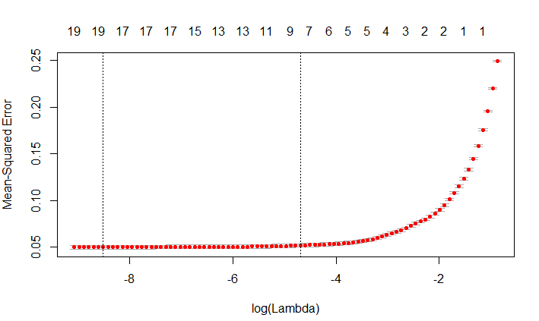

We choose the best lamda here

**The significant variables came out to be**

**Q75 IQR skew sfm mode meanfun minfun maxfun meandom**

###Split Data

split<-sample.split(voiceData$label, SplitRatio=0.8)

voice_train<-subset(voiceData, split==TRUE)

voice_test<-subset(voiceData, split==FALSE)

dim(voice_train)

dim(voice_test)

######Build Model

####Logistics

voice.fit1<-glm(label~(Q75+IQR+skew+sfm+mode+meanfun+minfun+maxfun+meandom), data=voice_train, family = "binomial")

summary(voice.fit1)

predicted_voice<-predict(voice.fit1, newdata = voice_test, type="response")

conf_voice1<-table(predicted=predicted_voice>0.5, actual=voice_test$label)



accuracy_voice1=sum(diag(conf_voice1))/sum(conf_voice1)

accuracy_voice1

0.9700315

test_set_label<-as.factor(ifelse(voice_test$label==1, "male", "female"))

log.pred<-ifelse(predicted_voice>0.5, "male", "female")

confusionMatrix(test_set_label, as.factor(log.pred))

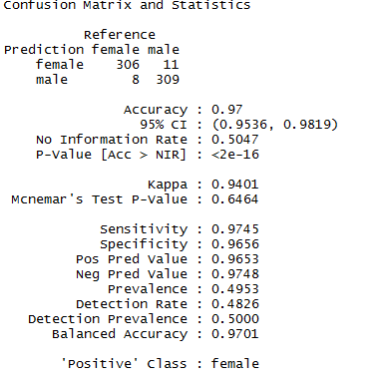

**We have varied the cutoff point in oder to check if accuracy improves.**

**###0.45**

conf_voice1<-table(predicted=predicted_voice>0.45, actual=voice_test$label)

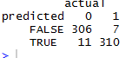

accuracy_voice1=sum(diag(conf_voice1))/sum(conf_voice1)

accuracy_voice1

0.9716088

**###0.35**

conf_voice1<-table(predicted=predicted_voice>0.35, actual=voice_test$label)



accuracy_voice1=sum(diag(conf_voice1))/sum(conf_voice1)

accuracy_voice1

0.966877

**We checked that the accuracy remains nearly same**

**####ROCR**

ROCRpred_log <- prediction(predicted_voice, voice_test$label)

ROCRperf_log <- performance(ROCRpred_log, 'tpr','fpr')

plot(ROCRperf_log, colorize = TRUE, text.adj = c(-0.2,1.7))

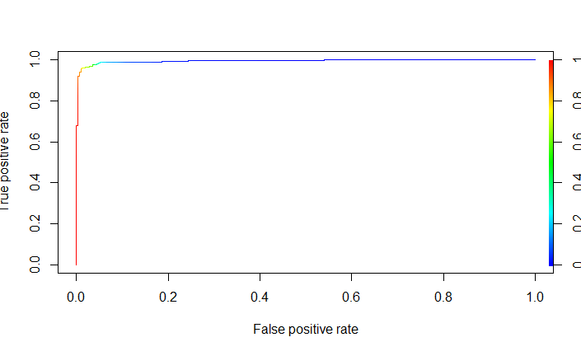

auc.tmp_log <- performance(ROCRpred_log,"auc")

auc_log <- as.numeric(auc.tmp_log@y.values)

auc_log

Area under curve came out to be 0.9946263

giniCoeff_log<-2*auc_log-1

giniCoeff_log

0.9892526

Higher the gini Coeff and auc better is the model

**SVM**

Our next model is a support vector machine, tuned with the best values for cost and gamma. To determine the best fit for an SVM model, the model was initially run with default parameters. A plot of the SVM error rate is then printed, with the darkest shades of blue indicating the best (ie., lowest) error rates. This is the best place to choose a cost and gamma value. You can fine-tune the SVM by narrowing in on the darkest blue range and performing further tuning. This essentially focuses in on the section, yielding a finer value for cost and gamma, and thus, a lower error rate and higher accuracy. The following performance images show how this progresses.

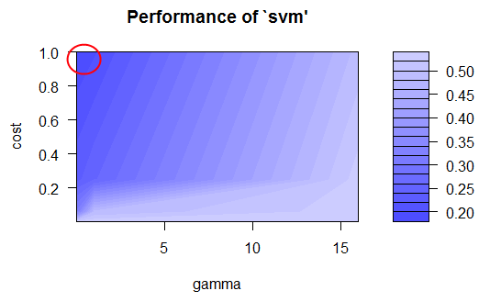

**First pass of tuning the SVM. Our best values are around cost 1 and gamma 0.2**

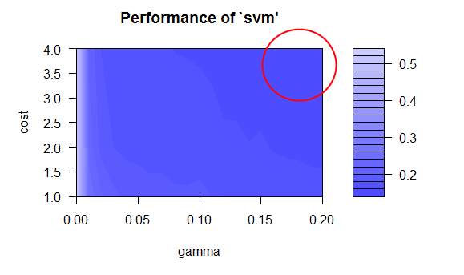

**Further fine-tuning and our best values are around cost 4 and gamma 0.2**

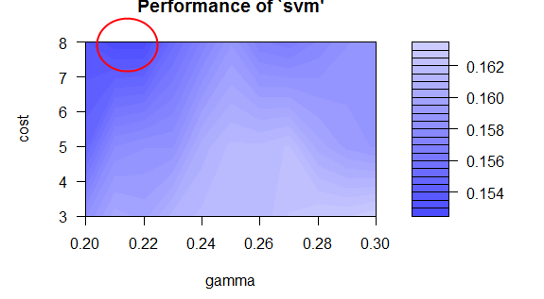

**Zooming in further, our best values are around cost 8 and 0.21 gamma**

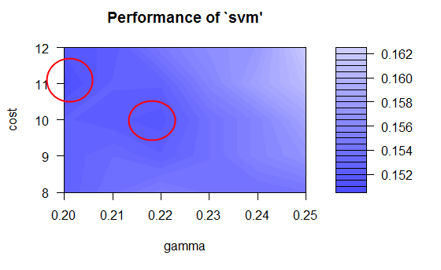

**One more final pass, our best values are around cost 10 and 0.22 gamma**

cat("\014")

voiceData<-read.csv("voice.csv", header = TRUE, stringsAsFactors = FALSE)

voiceData$label<-ifelse(voiceData$label=="male", 1, 0)

**#### Check NA values ####**

detectNAs<-function(x){

return(sum(is.na(x)))

}

lapply(voiceData, detectNAs)

**#### Check 0 values ####**

detectZeros<-function(x){

return(sum(x==0))

}

lapply(voiceData, detectZeros)

**###Replace Zero values with mean**

voiceData$dfrange[voiceData$dfrange==0]<-mean(voiceData$dfrange)

voiceData$modindx[voiceData$modindx==0]<-mean(voiceData$modindx)

split<-sample.split(voiceData$label, SplitRatio=0.8)

voice_train<-subset(voiceData, split==TRUE)

voice_test<-subset(voiceData, split==FALSE)

set.seed(777)

svmTune <- tune.svm(label ~ ., data=voice_train, sampling='fix', gamma = 2^c(-8,-4,0,4), cost = 2^c(-8,-4,-2,0))

**# The darker blue is the best values for a model.**

plot(svmTune)

**# We can re-run the tuning with more specific values for gamma (epsilon) and cost**.

set.seed(777)

svmTune <- tune.svm(label ~ ., data=voice_train, sampling='fix', gamma = seq(0, 0.2, 0.01), cost = c(1, 2, 4))

genderSvm <- svmTune$best.model

plot(svmTune)

**# Accuracy: 0.91**

predictSvm <- predict(genderSvm, voice_train)

table(predictSvm, train$label)

**# Accuracy: 0.83**

predictSvm <- predict(genderSvm, voice_test)

table(predictSvm, test$label)

**# Narrow down one more time**.

set.seed(777)

svmTune <- tune.svm(label ~ ., data=voice_train, sampling='fix', gamma = seq(0.2, 0.3, 0.01), cost = c(3, 5, 8))

genderSvm <- svmTune$best.model

plot(svmTune)

**# Accuracy: 0.96**

predictSvm <- predict(genderSvm, voice_train)

table(predictSvm, train$label)

**# Accuracy: 0.85**

predictSvm <- predict(genderSvm, voice_test)

table(predictSvm, test$label)

**# One final tuning.**

set.seed(777)

svmTune <- tune.svm(label ~ ., data=voice_train, sampling='fix', gamma = seq(0.2, 0.25, 0.01), cost = seq(8, 12, 1))

genderSvm <- svmTune$best.model

plot(svmTune)

**# Accuracy: 0.97**

predictSvm <- predict(genderSvm, voice_train)

table(predictSvm, train$label)

**# Accuracy: 0.85 (one less, so very tiny overfitting)**

predictSvm <- predict(genderSvm, voice_test)

table(predictSvm, test$label)

**By varying different parameters the highest accuracy we obtained is 97%**

**########### ROCR SVM #############**

ROCRpred.svm<-prediction(predictSvm, voice_test$label)

ROCRpref.svm<-performance(ROCRpred.svm, "tpr", "fpr")

plot(ROCRpref.svm, colorize=TRUE)

auc.temp_svm<-performance(ROCRpred.svm, "auc")

auc_svm<-as.numeric(auc.temp_svm@y.values)

auc_svm

area under curve is 0.995711

giniCoeff_svm<-2*auc_svm-1

giniCoeff_svm

0.9914219

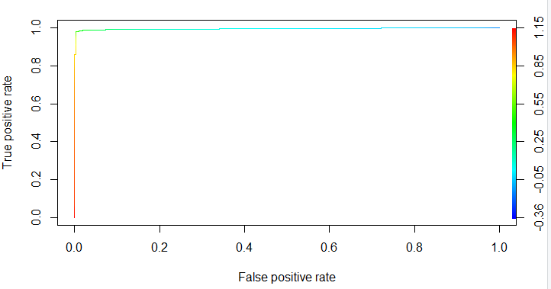

**Therefore we can conclude both logistics and sv model give nearly same prediction accuracy**

**Conclusion**

**We took voice dataset consisting of** 3168 observations and 21 variables.Thee was no na values detected in the data.We only replaced the columns of dfrange and modindx by the mean values as there was some zero values detected.

After that we put Lasso regression in order to identify the most significant variables affecting the model which came out to be **Q75 IQR skew sfm mode meanfun minfun maxfun meandom**

After that we fitted two models Logistics and SVM. Both yielded same level of nearly same level of accuracy, auc and gini coefficient.