Go to

cd /Downloads/big-data-2/vector

**TFIDF**

run

./runLuceneTFIDF.sh <name of the file/directory on which you want to calculate the TFIDF>

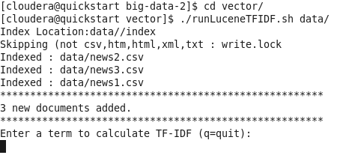

Enter the term fo which you want to calculate the tfidf

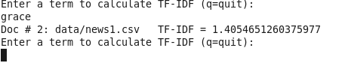

**DOCUMENT FREQUENCY**

run

./runLuceneQuery.sh <name of the file/directory on which you want to calculate the TFIDF>

