TOTAL RAINFALL IN THE MONTH

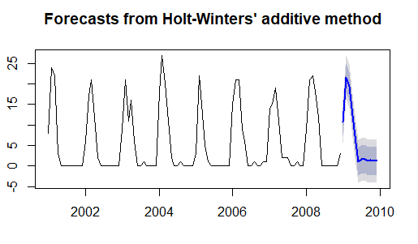

Best Model

cat("\014")

f13<-hw(trainRD,seasonal="additive", h=108)

accuracy(f13, testRD)

### This the best Model

cat("\014")

f12<-hw(testRD, seasonal="additive", h=12)

f12

plot(f12)

MEAN MAXIMUM TEMPERATURE

cat("\014")

f13<-hw(trainTemp,seasonal="additive", h=108)

accuracy(f13, testTemp)

### This the best Model

cat("\014")

f12<-hw(testTemp, seasonal="additive", h=12)

f12

plot(f12)

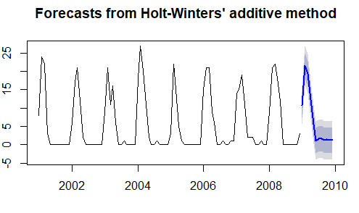

MEAN WIND SPEED

f11<-hw(trainWind,seasonal="additive", damped=TRUE, h=108)

accuracy(f11, testWind)

### This the best Model

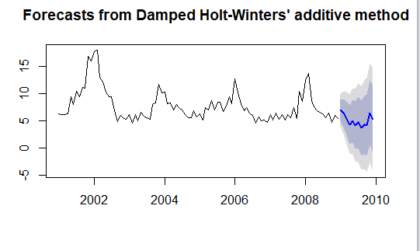

Humidity 3 hour

f11<-hw(trainHumid3,seasonal="additive", damped=TRUE, h=108)

accuracy(f11, testHumid3)

#This is the best Model

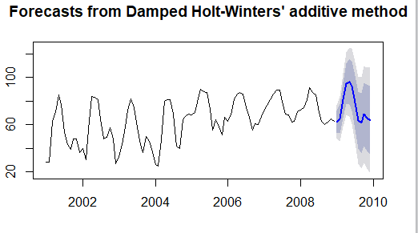

Humidity 12 hour

f12<-hw(trainHumid12,seasonal="multiplicative", exponential =TRUE, h=108)

accuracy(f12, testHumid12)

#This is the best Model

