1:

data <- arima.sim(model = list(ar=c(0.75,-0.25),   
                              ma=c(1,0.5), mean=0.03), n = 100)  
  
adf.test(data)

Therefore in both the cases p <0.05, null hypothesis is rejected

Therefore stationary

Ans2.

library(dplyr)

library(fpp)

library(devtools)

library(forecast)

library(TTR)

library(tseries)

library(ggplot2)

setwd("C:\\F\\NMIMS\\DataScience\\Sem-2\\DS\\TS\\data")

data<-read.csv("UnitRoot.csv", header = TRUE, stringsAsFactors = FALSE)

head(data)

#Detect NAs

detectNA<- function(x){

return(sum(is.na(x)))

}

sapply(unitData, detectNA)

detectNull<- function(x){

return(sum(x=="null"))

}

sapply(unitData, detectNull)

unitSeries1<-ts(data$FX, start=c(1996,1))

plot.ts(unitSeries1)

class(unitSeries1)

unitSeries2<-ts(data$FTSE100, start=c(1996,1))

plot.ts(unitSeries2)

class(unitSeries2)

adf.test(unitSeries1)

adf.test(unitSeries2)

when adf test is applied on unitSeries1 p-value = 0.7424

when adf test is applied on unitSeries1 p-value = 0.7261

Therefore in both the cases p >0.05, null hypothesis is accepted

H0:B=1

Ha:B!=1

Therefore both the series are non stationary and follows random walk and have Beta=1 i.e. unit root.

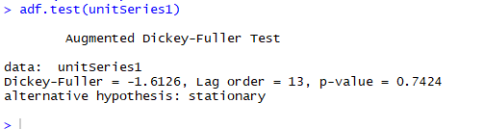

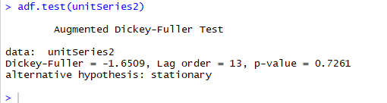

Ans3:

install.packages("AER")

library(AER)

data("UKNonDurables")

dataset1<-UKNonDurables

View(dataset1)

plot.ts(dataset1)

class(dataset1)

adf.test(dataset1)

##Data is non stationary

adf.test(diff(log(dataset1)))

##Model is stationary

acf(diff(log(dataset1)))##Does not follow a sime wave pattern, q=0

pacf(diff(log(dataset1)))##p=1, does not follow any sine wave pattern

arima.fit<-Arima(log(dataset1), order=c(1,0,0), seasonal = c(0,1,1))

summary(arima.fit)

fcast1<-forecast(arima.fit, h=25)

plot(fcast1)

##Validate

Acf(fcast1$residuals)

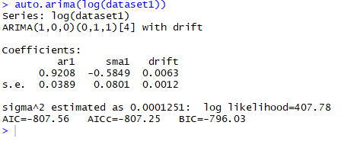

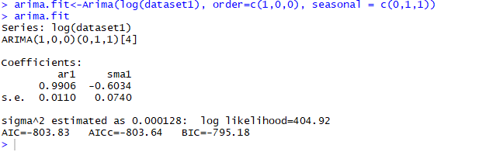

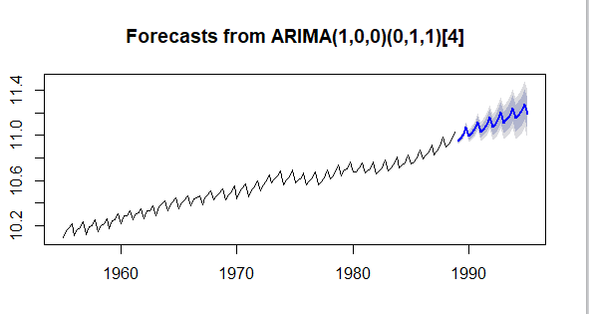

data("PepperPrice")

dataset2<-PepperPrice

dataset2<-as.data.frame(PepperPrice)

dataset3<-ts(dataset2$white)

plot.ts(dataset3)

dataset4<-ts(dataset2$black)

plot.ts(dataset4)

adf.test(dataset3)

adf.test(diff(dataset3, differences = 1))

adf.test(dataset4)

adf.test(diff(dataset4, differences = 1))

acf(diff(dataset3))##Does not follow a sime wave pattern, q=1

pacf(diff(dataset3))#p=0

arima.fit2<-arima(dataset3, order=c(1,1,0))

arima.fit2

arima.fit2<-arima(dataset3, order=c(0,1,1))

arima.fit2

arima.fit2<-arima(dataset3, order=c(0,1,1))##Best Model

arima.fit2

auto.arima(dataset3)

fcast2<-forecast(arima.fit2, h=5)

plot(fcast2)

##Validate

Acf(fcast2$residuals)

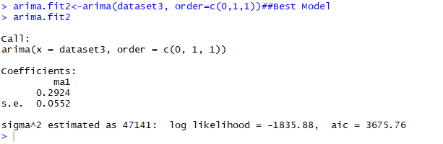

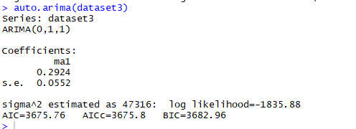

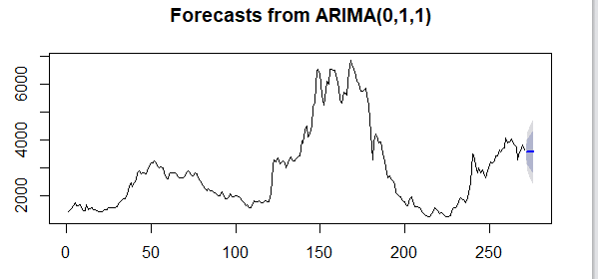

acf(diff(dataset4))##Does not follow a sime wave pattern, q=1

pacf(diff(dataset4))#p=2

arima.fit3<-arima(dataset4, order=c(1,1,0))

arima.fit3

arima.fit3<-arima(dataset4, order=c(1,1,1))

arima.fit3

arima.fit3<-arima(dataset4, order=c(2,1,1))##Best Model

arima.fit3

auto.arima(dataset4)

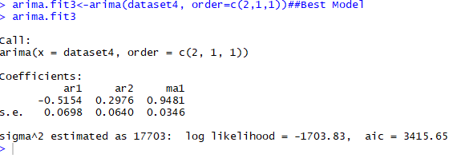

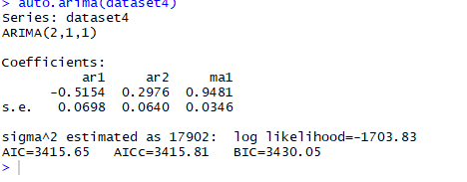

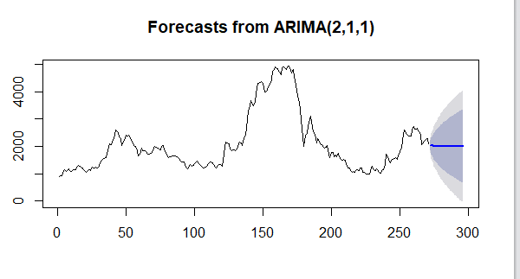

fcast3<-forecast(arima.fit3, h=5)

plot(fcast3)

##Validate

Acf(fcast3$residuals)

4

Mean Max temperature is taken

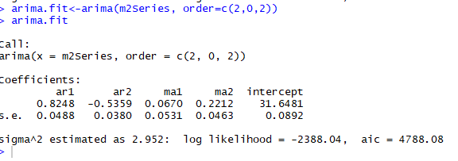

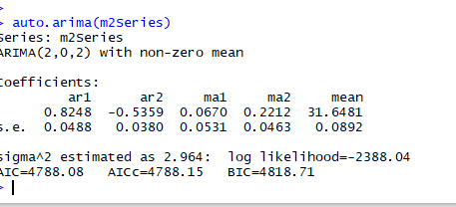

setwd("C:\\F\\NMIMS\\DataScience\\Sem-2\\DS\\TS\\data")

m2Data<-read.csv("temperature.csv", header = TRUE, stringsAsFactors = FALSE)

head(m2Data)

#Detect NAs

detectNA<- function(x){

return(sum(is.na(x)))

}

sapply(m2Data, detectNA)

detectNull<- function(x){

return(sum(x=="null"))

}

sapply(m2Data, detectNull)

detectSpace<- function(x){

return(sum(trimws(x)==""))

}

sapply(m2Data, detectSpace)

m2Data<-na.omit(m2Data)

m2Data$YEAR<-as.Date(m2Data$YEAR)

class(m2Data$YEAR)

class(m2Data$MMAX)

##MEAN MAXIMUM TEMPERATURE (in Deg. C)###############################

m2Series<-ts(m2Data$MMAX, start=c(1984,1), frequency = 1)

class(m2Series)

plot.ts(m2Series)

adf.test(m2Series)

#adf.test(diff(unitSeries))

acf(diff(m2Series))#q=2

pacf(diff(m2Series))#p=2

##Model is(2,0,2)

arima.fit<-arima(m2Series, order=c(1,0,1))

arima.fit

arima.fit<-arima(m2Series, order=c(0,0,1))

arima.fit

arima.fit<-arima(m2Series, order=c(1,0,0))

arima.fit

arima.fit<-arima(m2Series, order=c(2,0,0))

arima.fit

arima.fit<-arima(m2Series, order=c(0,0,2))

arima.fit

arima.fit<-arima(m2Series, order=c(2,0,2))

arima.fit

auto.arima(m2Series)

m2forecast<-forecast(arima.fit, h=1)

plot(m2forecast)

hist(m2forecast$residuals)

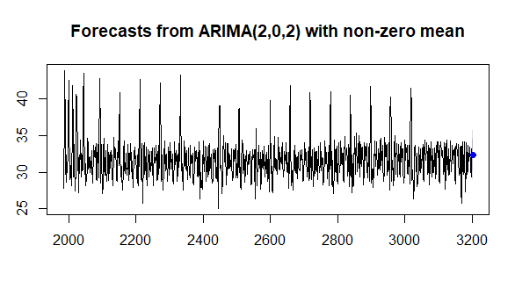

TMRF is considered

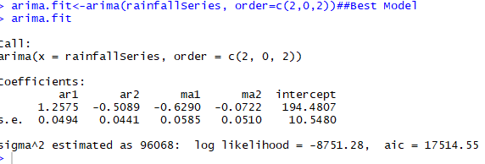

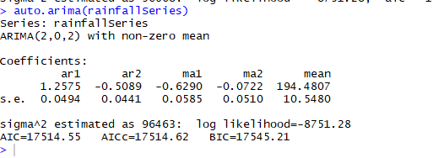

###Rainfall

setwd("C:\\F\\NMIMS\\DataScience\\Sem-2\\DS\\TS\\data")

rainfallData<-read.csv("rainfallData.csv", header = TRUE, stringsAsFactors = FALSE)

head(rainfallData)

detectNA<- function(x){

return(sum(is.na(x)))

}

sapply(rainfallData, detectNA)

rainfallData<-na.omit(rainfallData)

rainfallData$YEAR<-as.Date(rainfallData$YEAR)

class(rainfallData$YEAR)

class(rainfallData$TMRF)

rainfallSeries<-ts(rainfallData$TMRF, start=c(1984,1), frequency = 1)

class(rainfallSeries)

plot.ts(rainfallSeries)

adf.test(rainfallSeries)

#adf.test(diff(unitSeries))

acf(diff(rainfallSeries))#q=2

pacf(diff(rainfallSeries))#p=2

##Model is(2,0,2)

arima.fit<-arima(rainfallSeries, order=c(1,0,1))

arima.fit

arima.fit<-arima(rainfallSeries, order=c(0,0,1))

arima.fit

arima.fit<-arima(rainfallSeries, order=c(1,0,0))

arima.fit

arima.fit<-arima(rainfallSeries, order=c(2,0,0))

arima.fit

arima.fit<-arima(rainfallSeries, order=c(0,0,2))

arima.fit

arima.fit<-arima(rainfallSeries, order=c(2,0,2))##Best Model

arima.fit

auto.arima(rainfallSeries)

rainforecast<-forecast(arima.fit, h=1)

plot(rainforecast)

hist(rainforecast$residuals)

MEAN WIND SPEED

setwd("C:\\F\\NMIMS\\DataScience\\Sem-2\\DS\\TS\\data")

data<-read.csv("mw2.csv", header = TRUE, stringsAsFactors = FALSE)

head(data)

detectNA<- function(x){

return(sum(is.na(x)))

}

sapply(data, detectNA)

data<-na.omit(data)

data$YEAR<-as.Date(data$YEAR)

class(data$YEAR)

class(data$MWS)

dataSeries<-ts(data$MWS, start=c(1984,1), frequency = 1)

class(dataSeries)

plot.ts(dataSeries)

adf.test(dataSeries)

#adf.test(diff(unitSeries))

acf(diff(dataSeries))#q=3

pacf(diff(dataSeries))#p=3

arima.fit<-arima(dataSeries, order=c(1,0,1))

arima.fit

arima.fit<-arima(dataSeries, order=c(0,0,1))

arima.fit

arima.fit<-arima(dataSeries, order=c(1,0,0))

arima.fit

arima.fit<-arima(diff(dataSeries), order=c(0,1,4))

arima.fit

auto.arima(dataSeries)

windforecast<-forecast(arima.fit, h=1)

plot(windforecast)

hist(windforecast$residuals)

###################Relative Humidity

data1<-read.csv("humid.csv", header = TRUE, stringsAsFactors = FALSE)

head(data1)

data1<-na.omit(data1)

dataSeries1<-ts(data1$RH, start=c(1984,1), frequency = 1)

class(dataSeries1)

plot.ts(dataSeries1)

adf.test(dataSeries1)

#adf.test(diff(unitSeries))

acf(diff(dataSeries1))#q=3

pacf(diff(dataSeries1))#p=3

##Model is(2,1,2)

arima.fit<-arima(dataSeries1, order=c(1,0,1))

arima.fit

arima.fit<-arima(dataSeries1, order=c(0,0,1))

arima.fit

arima.fit<-arima(dataSeries1, order=c(1,0,0))

arima.fit

arima.fit<-arima(dataSeries1, order=c(2,0,0))

arima.fit

arima.fit<-arima(dataSeries1, order=c(0,0,2))

arima.fit

arima.fit<-arima(dataSeries1, order=c(2,0,2))

arima.fit

arima.fit<-arima(diff(dataSeries1), order=c(2,1,2))

arima.fit

auto.arima(dataSeries1)

humidforecast<-forecast(arima.fit, h=1)

plot(humidforecast)

hist(humidforecast$residuals)