SMB116 – Rapport de TP n° 2

AUTEUR:

CAUBET
Julien
FOD_Motdepasse1

APK TP2

APK Login

CODE SOURCE DU TP

Question 1:

code java:

private EditText tp2Text;
private ImageButton callBtn;
private ImageButton loginBtn;
private ImageButton internetBtn;
@Override
protected void onCreate(Bundle savedInstanceState) {
super.onCreate(savedInstanceState);
setContentView(R.layout.activity_main);
initializeView();
}
private void initializeView(){
this.tp2Text = findViewById(R.id.tp2Text);
this.callBtn = findViewById(R.id.callBtn);
this.loginBtn = findViewById(R.id.loginBtn);
this.internetBtn = findViewById(R.id.internetBtn);
}
public void onClickCallBtn(View view){
String url = "tel:"+tp2Text.getText().toString();
Intent intent = new Intent(Intent.ACTION_DIAL, Uri.parse(url));
startActivity(intent);
}
public void onClickInternetBtn(View view){
String url = "http://www."+tp2Text.getText().toString()+".com";
Intent intent = new Intent(Intent.ACTION_VIEW, Uri.parse(url));
startActivity(intent);
}

code XML:

<?xml version="1.0" encoding="utf-8"?>
<androidx.constraintlayout.widget.ConstraintLayout xmlns:android="http://schemas.android.com/apk/res/android"
xmlns:app="http://schemas.android.com/apk/res-auto"
xmlns:tools="http://schemas.android.com/tools"
android:layout_width="match_parent"
android:layout_height="match_parent"
tools:context=".MainActivity">
<LinearLayout
android:layout_width="match_parent"
android:layout_height="match_parent"
android:orientation="vertical">
<Space
android:layout_width="match_parent"
android:layout_height="30dp" />
<EditText
android:id="@+id/tp2Text"
android:layout_width="match_parent"
android:layout_height="wrap_content"
android:ems="10"
android:hint="@string/text_hint"
android:inputType="textPersonName" />
<LinearLayout
android:layout_width="match_parent"
android:layout_height="match_parent"
android:orientation="horizontal">
<ImageButton
android:id="@+id/callBtn"
android:layout_width="wrap_content"
android:layout_height="wrap_content"
android:layout_weight="1"
android:contentDescription="@string/phone_hint"
android:onClick="onClickCallBtn"
app:srcCompat="@drawable/ic_baseline_call_24" />
<ImageButton
android:id="@+id/loginBtn"
android:layout_width="wrap_content"
android:layout_height="wrap_content"
android:layout_weight="1"
android:contentDescription="@string/login_hint"
android:onClick="onClickLogin"
app:srcCompat="@drawable/ic_baseline_login_24" />
<ImageButton
android:id="@+id/internetBtn"
android:layout_width="wrap_content"
android:layout_height="wrap_content"
android:layout_weight="1"
android:contentDescription="@string/internet_hint"
android:onClick="onClickInternetBtn"
app:srcCompat="@drawable/ic_baseline_public_24" />
</LinearLayout>
</LinearLayout>
</androidx.constraintlayout.widget.ConstraintLayout>

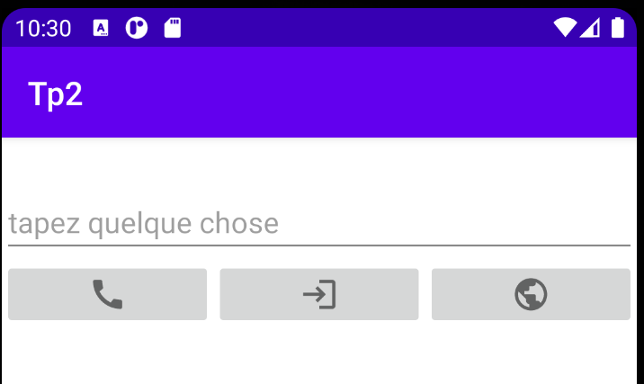

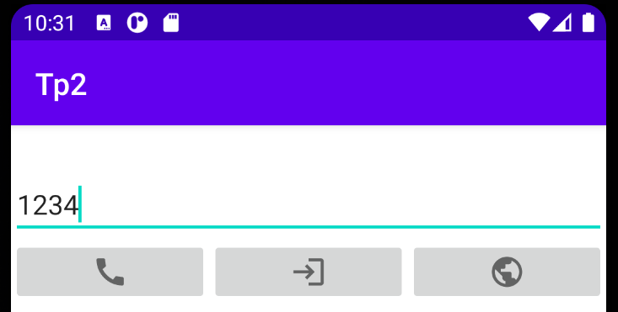

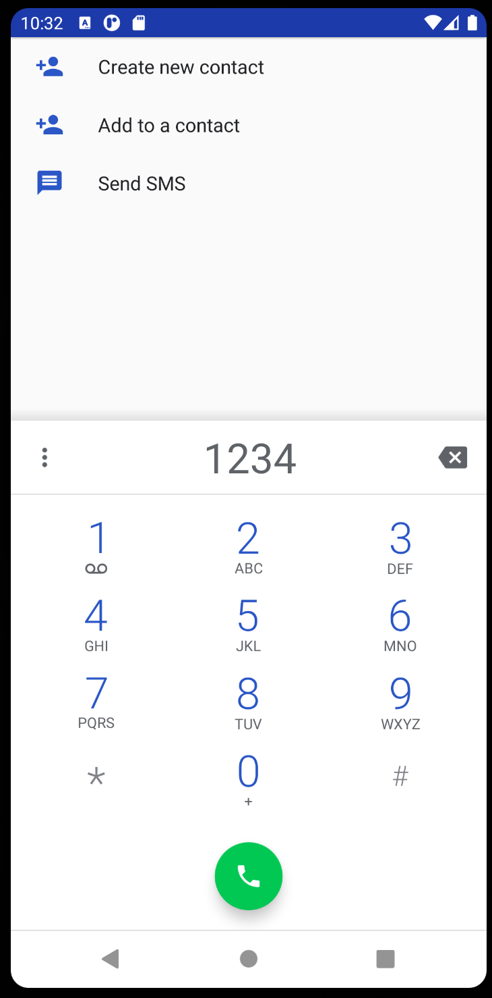

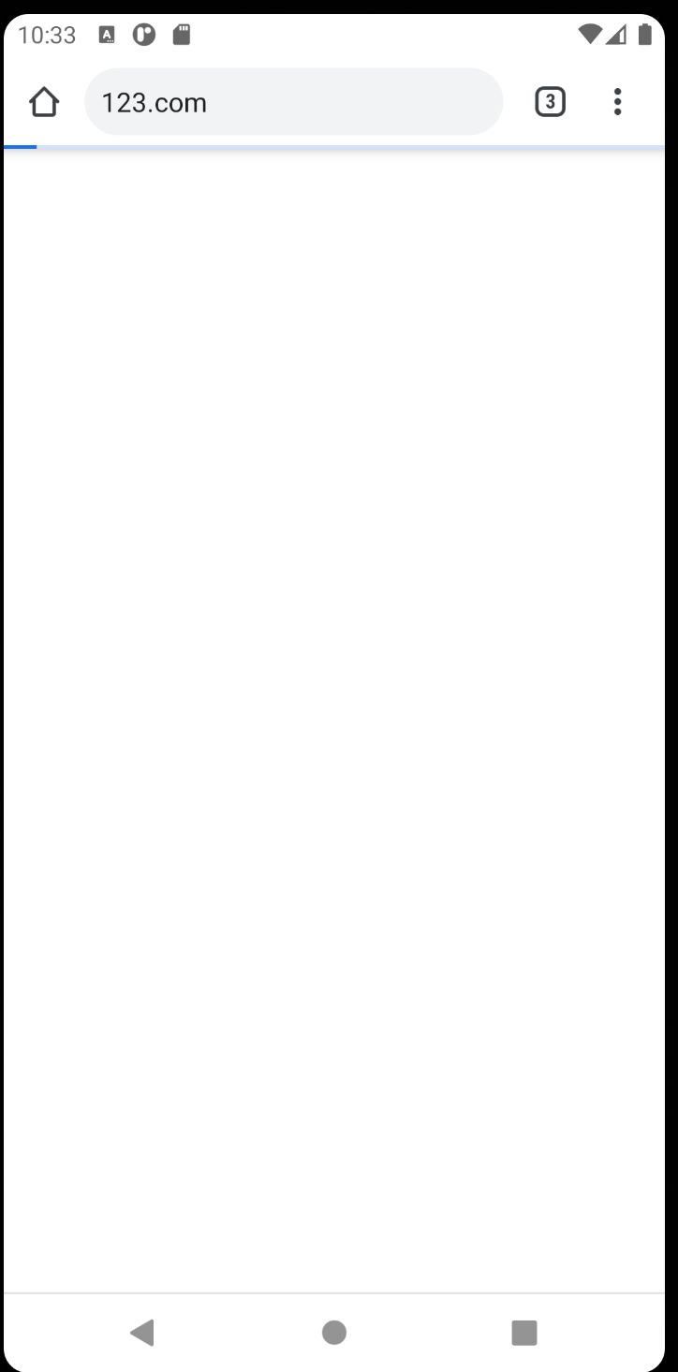

Question 2:

2,1:

code java:

private EditText userName;
private EditText password;
private Button cancel;
private Button login;
private int RESULT_OK = 1;
private int RESULT_CANCELED = -1;
@Override
protected void onCreate(Bundle savedInstanceState) {
super.onCreate(savedInstanceState);
setContentView(R.layout.activity_main);
configureView();
}
private void configureView(){
this.userName = findViewById(R.id.userNameTxt);
this.password = findViewById(R.id.passwordTxt);
this.cancel = findViewById(R.id.cancelBtn);
this.login = findViewById(R.id.loginBtn);
}
public void onClickLogin(View view){
Intent intent = new Intent();
intent.putExtra("reponse", "user: "+userName.getText().toString()+" password: "+password.getText().toString());
setResult(RESULT_OK, intent);
finish();
}
public void onClickCancel(View view){
Intent intent = new Intent();
intent.putExtra("reponse", "canceled opération");
setResult(RESULT_CANCELED, intent);
finish();
}

code XML:

<?xml version="1.0" encoding="utf-8"?>
<androidx.constraintlayout.widget.ConstraintLayout xmlns:android="http://schemas.android.com/apk/res/android"
xmlns:app="http://schemas.android.com/apk/res-auto"
xmlns:tools="http://schemas.android.com/tools"
android:layout_width="match_parent"
android:layout_height="match_parent"
tools:context=".MainActivity">
<LinearLayout
android:layout_width="match_parent"
android:layout_height="match_parent"
android:orientation="vertical"
app:layout_constraintBottom_toBottomOf="parent"
app:layout_constraintEnd_toEndOf="parent"
app:layout_constraintStart_toStartOf="parent"
app:layout_constraintTop_toTopOf="parent">
<LinearLayout
android:layout_width="match_parent"
android:layout_height="wrap_content"
android:orientation="horizontal">
<TextView
android:id="@+id/textView"
android:layout_width="wrap_content"
android:layout_height="wrap_content"
android:layout_marginStart="10dp"
android:layout_marginLeft="10dp"
android:layout_weight="1"
android:text="@string/user_name" />
<EditText
android:id="@+id/userNameTxt"
android:layout_width="wrap_content"
android:layout_height="wrap_content"
android:layout_weight="1"
android:ems="10"
android:hint="@string/user_hint"
android:inputType="textPersonName" />
</LinearLayout>
<LinearLayout
android:layout_width="match_parent"
android:layout_height="wrap_content"
android:orientation="horizontal">
<TextView
android:id="@+id/textView2"
android:layout_width="wrap_content"
android:layout_height="wrap_content"
android:layout_marginStart="10dp"
android:layout_marginLeft="10dp"
android:layout_weight="1"
android:text="@string/password" />
<EditText
android:id="@+id/passwordTxt"
android:layout_width="wrap_content"
android:layout_height="wrap_content"
android:layout_weight="1"
android:ems="10"
android:hint="@string/password_hint"
android:inputType="textPassword" />
</LinearLayout>
<LinearLayout
android:layout_width="match_parent"
android:layout_height="wrap_content"
android:orientation="horizontal">
<Button
android:id="@+id/cancelBtn"
android:layout_width="wrap_content"
android:layout_height="wrap_content"
android:layout_marginStart="10dp"
android:layout_marginLeft="10dp"
android:layout_marginEnd="10dp"
android:layout_marginRight="10dp"
android:layout_weight="1"
android:onClick="onClickCancel"
android:text="@string/cancel" />
<Button
android:id="@+id/loginBtn"
android:layout_width="wrap_content"
android:layout_height="wrap_content"
android:layout_marginStart="10dp"
android:layout_marginLeft="10dp"
android:layout_marginEnd="10dp"
android:layout_marginRight="10dp"
android:layout_weight="3"
android:onClick="onClickLogin"
android:text="@string/login" />
</LinearLayout>
</LinearLayout>
</androidx.constraintlayout.widget.ConstraintLayout>

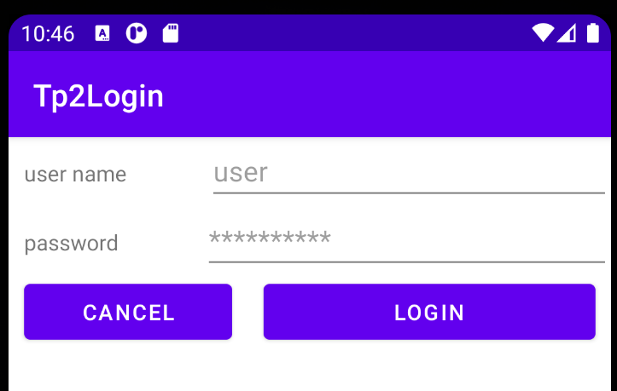

2,2:

<action android:name="android.intent.action.MAIN" />
<category android:name="android.intent.category.LAUNCHER" />
</intent-filter>
<intent-filter>
<action android:name="android.intent.action.VIEW"/>
<category android:name="android.intent.category.DEFAULT"/>
</intent-filter>

Question 3:

<intent-filter>
<action android:name="login.ACTION" />
<category android:name="android.intent.category.DEFAULT" />
</intent-filter>

Question 4:

<category android:name="android.intent.category.DEFAULT" />

Question 5:
5,1:
Code java 1:

public void onClickLogin(View view){
Intent intent = new Intent();
//implicite
// intent.setAction("login.ACTION");
//explicite
String pkg = "com.example.tp2login";
String clazz = pkg + ".MainActivity";
intent.setComponent(new ComponentName(pkg,clazz));
startActivityForResult(intent, 1);
}
@Override
protected void onActivityResult(int requestCode, int resultCode, @Nullable Intent data) {
super.onActivityResult(requestCode, resultCode, data);
if (requestCode == 1 && data != null){
Toast.makeText(getApplicationContext(), data.getStringExtra("reponse"),Toast.LENGTH_LONG).show();
}
if (requestCode == -1 && data != null){
Toast.makeText(getApplicationContext(), data.getStringExtra("reponse"),Toast.LENGTH_LONG).show();
}
}
}

code java login:

public void onClickLogin(View view){
Intent intent = new Intent();
intent.putExtra("reponse", "user: "+userName.getText().toString()+" password: "+password.getText().toString());
setResult(RESULT_OK, intent);
finish();
}
public void onClickCancel(View view){
Intent intent = new Intent();
intent.putExtra("reponse", "canceled opération");
setResult(RESULT_CANCELED, intent);
finish();
}

5,2:

public void onClickLogin(View view){
Intent intent = new Intent();
//implicite
intent.setAction("login.ACTION");
//explicite
// String pkg = "com.example.tp2login";
// String clazz = pkg + ".MainActivity";
// intent.setComponent(new ComponentName(pkg,clazz));
startActivityForResult(intent, 1);
}

Question 6:
6,1:

le composant Login:
<permission android:name="com.example.permission.TP_LOGIN"
android:label="@string/permlab_callPhone"
android:description="@string/permdesc_callPhone"
android:permissionGroup="android.permission-group.CALL_LOG"
android:protectionLevel="dangerous"/>
<application
android:allowBackup="true"
android:icon="@mipmap/ic_launcher"
android:label="@string/app_name"
android:roundIcon="@mipmap/ic_launcher_round"
android:supportsRtl="true"
android:theme="@style/Theme.Tp2Login">
<activity android:name=".MainActivity"
android:permission="com.example.permission.TP_LOGIN"
>
Le client au composant Login:

<uses-permission android:name="com.example.permission.TP_LOGIN" />

6,2:

public void onClickLogin(View view){
Intent intent = new Intent();
if (ContextCompat.checkSelfPermission(this, "com.example.permission.TP_LOGIN") == PackageManager.PERMISSION_GRANTED) {
//Permission already granted!
String pkg = "com.example.tp2login";
String clazz = pkg + ".MainActivity";
intent.setComponent(new ComponentName(pkg,clazz));
startActivityForResult(intent, 1);
// }if (ActivityCompat.shouldShowRequestPermissionRationale(this, "com.example.permission.TP_LOGIN")) {
// //Display a screen saying why you need PERMISSION_X
// Toast.makeText(getApplicationContext(),"The permission is needed to launch the next activity!",Toast.LENGTH_LONG).show();
}
else {
ActivityCompat.requestPermissions(this, new String[]{"com.example.permission.TP_LOGIN"}, 2);
}
//implicite
// intent.setAction("login.ACTION");
//explicite
// String pkg = "com.example.tp2login";
// String clazz = pkg + ".MainActivity";
// intent.setComponent(new ComponentName(pkg,clazz));
//
// startActivityForResult(intent, 1);
}
@Override
protected void onActivityResult(int requestCode, int resultCode, @Nullable Intent data) {
super.onActivityResult(requestCode, resultCode, data);
if (requestCode == 1 && data != null){
Toast.makeText(getApplicationContext(), data.getStringExtra("reponse"),Toast.LENGTH_LONG).show();
}
if (requestCode == -1 && data != null){
Toast.makeText(getApplicationContext(), data.getStringExtra("reponse"),Toast.LENGTH_LONG).show();
}
}
@Override
public void onRequestPermissionsResult(int requestCode, String[] permissions,
int[] grantResults) {
switch (requestCode) {
case 2:
// If request is cancelled, the result arrays are empty.
if (grantResults.length > 0 &&
grantResults[0] == PackageManager.PERMISSION_GRANTED) {
// Permission is granted. Continue the action or workflow
Intent intent = new Intent();
String pkg = "com.example.tp2login";
String clazz = pkg + ".MainActivity";
intent.setComponent(new ComponentName(pkg,clazz));
startActivityForResult(intent, 1);
} else {
Toast.makeText(getApplicationContext(),"The permission is needed to launch the next activity!",Toast.LENGTH_LONG).show();
}
return;
}
}
}

DIFFICULTES:

Certaines questions ne m’ ont pas paru très claire ou ambiguë, difficile à cerner, par exemple :
Question 2-2) Choisissez une ACTION spécifique pour le composant Login,

CONCLUSION:

TP intéressant faisant manipuler des notions d’ interface graphique, communication entre activité et permissions,

CODE SOURCE JAVA DU TP:

TP2:

package com.example.tp2;
import androidx.annotation.Nullable;
import androidx.appcompat.app.AppCompatActivity;
import androidx.core.app.ActivityCompat;
import androidx.core.content.ContextCompat;
import android.Manifest;
import android.content.ComponentName;
import android.content.Intent;
import android.content.pm.PackageManager;
import android.net.Uri;
import android.os.Bundle;
import android.view.View;
import android.widget.Button;
import android.widget.EditText;
import android.widget.ImageButton;
import android.widget.Toast;
public class MainActivity extends AppCompatActivity {
private EditText tp2Text;
private ImageButton callBtn;
private ImageButton loginBtn;
private ImageButton internetBtn;
@Override
protected void onCreate(Bundle savedInstanceState) {
super.onCreate(savedInstanceState);
setContentView(R.layout.activity_main);
initializeView();
}
private void initializeView(){
this.tp2Text = findViewById(R.id.tp2Text);
this.callBtn = findViewById(R.id.callBtn);
this.loginBtn = findViewById(R.id.loginBtn);
this.internetBtn = findViewById(R.id.internetBtn);
}
public void onClickCallBtn(View view){
String url = "tel:"+tp2Text.getText().toString();
Intent intent = new Intent(Intent.ACTION_DIAL, Uri.parse(url));
startActivity(intent);
}
public void onClickInternetBtn(View view){
String url = "http://www."+tp2Text.getText().toString()+".com";
Intent intent = new Intent(Intent.ACTION_VIEW, Uri.parse(url));
startActivity(intent);
}
public void onClickLogin(View view){
Intent intent = new Intent();
if (ContextCompat.checkSelfPermission(this, "com.example.permission.TP_LOGIN") == PackageManager.PERMISSION_GRANTED) {
//Permission already granted!
String pkg = "com.example.tp2login";
String clazz = pkg + ".MainActivity";
intent.setComponent(new ComponentName(pkg,clazz));
startActivityForResult(intent, 1);
// }if (ActivityCompat.shouldShowRequestPermissionRationale(this, "com.example.permission.TP_LOGIN")) {
// //Display a screen saying why you need PERMISSION_X
// Toast.makeText(getApplicationContext(),"The permission is needed to launch the next activity!",Toast.LENGTH_LONG).show();
}
else {
ActivityCompat.requestPermissions(this, new String[]{"com.example.permission.TP_LOGIN"}, 2);
}
//implicite
// intent.setAction("login.ACTION");
//explicite
// String pkg = "com.example.tp2login";
// String clazz = pkg + ".MainActivity";
// intent.setComponent(new ComponentName(pkg,clazz));
//
// startActivityForResult(intent, 1);
}
@Override
protected void onActivityResult(int requestCode, int resultCode, @Nullable Intent data) {
super.onActivityResult(requestCode, resultCode, data);
if (requestCode == 1 && data != null){
Toast.makeText(getApplicationContext(), data.getStringExtra("reponse"),Toast.LENGTH_LONG).show();
}
if (requestCode == -1 && data != null){
Toast.makeText(getApplicationContext(), data.getStringExtra("reponse"),Toast.LENGTH_LONG).show();
}
}
@Override
public void onRequestPermissionsResult(int requestCode, String[] permissions,
int[] grantResults) {
switch (requestCode) {
case 2:
// If request is cancelled, the result arrays are empty.
if (grantResults.length > 0 &&
grantResults[0] == PackageManager.PERMISSION_GRANTED) {
// Permission is granted. Continue the action or workflow
Intent intent = new Intent();
String pkg = "com.example.tp2login";
String clazz = pkg + ".MainActivity";
intent.setComponent(new ComponentName(pkg,clazz));
startActivityForResult(intent, 1);
} else {
Toast.makeText(getApplicationContext(),"The permission is needed to launch the next activity!",Toast.LENGTH_LONG).show();
}
return;
}
}
}

LOGIN:

package com.example.tp2login;
import androidx.appcompat.app.AppCompatActivity;
import android.content.Intent;
import android.os.Bundle;
import android.view.View;
import android.widget.Button;
import android.widget.EditText;
public class MainActivity extends AppCompatActivity {
private EditText userName;
private EditText password;
private Button cancel;
private Button login;
private int RESULT_OK = 1;
private int RESULT_CANCELED = -1;
@Override
protected void onCreate(Bundle savedInstanceState) {
super.onCreate(savedInstanceState);
setContentView(R.layout.activity_main);
configureView();
}
private void configureView(){
this.userName = findViewById(R.id.userNameTxt);
this.password = findViewById(R.id.passwordTxt);
this.cancel = findViewById(R.id.cancelBtn);
this.login = findViewById(R.id.loginBtn);
}
public void onClickLogin(View view){
Intent intent = new Intent();
intent.putExtra("reponse", "user: "+userName.getText().toString()+" password: "+password.getText().toString());
setResult(RESULT_OK, intent);
finish();
}
public void onClickCancel(View view){
Intent intent = new Intent();
intent.putExtra("reponse", "canceled opération");
setResult(RESULT_CANCELED, intent);
finish();
}
}

