**P AINTING** Painting is a hobby that many people love. There are so many things you can do with it; so have a look around and start your painting journey.

**ANYONE CAN BE AN ARTIST** To be an artist, you just have to be creative and think outside of the box. There is not a certain way you have to paint to be accepted in the art world. Coming up with your own style is something that is very important when art is the main focus. You want to make sure you stand out from others around you. While there are basics that you should know when it comes to art and specifically painting, you still have the freedom to express what pops up in your mind. This is a website where you can look at art, buy art and art supplies, and get inspiration from the artist around you.

**John Waterman the paint specialist** He specializes in the paint itself and what kinds of paint should be used for certain projects.

**Peter Johnson the artist** Peter likes to spend his extra time painting and trying to sell his work to those around him and all over the world.

**Julie the art student** She is taking classes to better her painting skills so she can eventually open her own studio to teach painting classes.

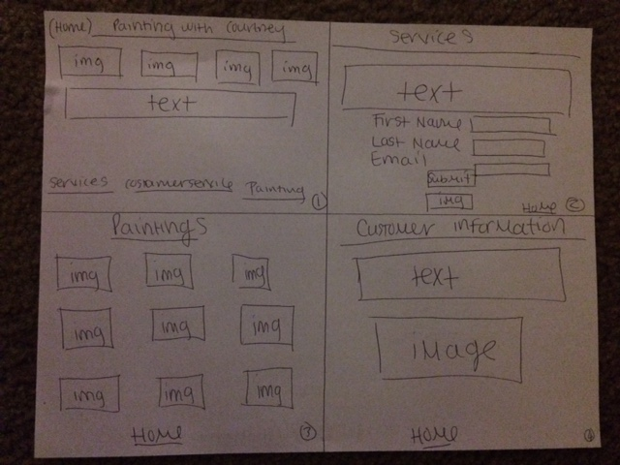**COMP**