

rush of service

Game Design Document Final Draft



courtney adams

Academy of Interactive Entertainment

18/3/19

contents

CORE CONCEPT 3

DAY PHASE 3

END OF DAY PHASE 3

GENRE 3

PLATFORM 3

TARGET AUDIENCE ANALYSIS 4

COMPETITOR ANALYSIS 5

OVERVIEW 7

GAME OBJECTIVES 7

MECHANICS AND SYSTEMS 8

CORE EXPERIENCES 9

GAMEPLAY LOOPS 10

Day Phase 10

End of Day Phase 11

Overall Gameplay 12

ART OVERVIEW 13

AUDIO OVERVIEW 15

NARRATIVE OVERVIEW 15

ECONOMY OVERVIEW 16

REWARD LOOP 18

FEEDBACK LOOP 19

product defintion

# CORE CONCEPT

‘Rush of Service’ is a casual, café management game, where players must serve customers and manage their ingredients and menu to make their café successful!

Players will go through two phases, a day phase and an end-of-day phase;

## 

## DAY PHASE

This phase has the player viewing, cooking and serving customers in a short in-game day. It is a tense yet satisfying gameplay loop.

## END OF DAY PHASE

During this phase, the pace of gameplay slows down, as the player focuses on their ingredients, menu, rating and café customisation.

‘Rush of Service’ offers plenty of options for the player to manage and strategize and is rewarded through a quick, tense and satisfying gameplay style. There are numerous loops of gameplay, rewards and feedback for the player set within a short gameplay experience.

How well the player serves and manages their café, the better their rewards will be. If the player unsuccessfully serves customers, it will negatively impact their café.

# GENRE

Management, simulator, casual and strategy.

# PLATFORM

iOS and Android Devices, Nintendo Switch.

market and target audience

# TARGET AUDIENCE ANALYSIS

‘Rush of Service’ aims to give a fast-paced, rewarding, simple yet challenging management experience to players that prefer games catered towards accessibility and convenience. This drove the decision to focus on platforms that offer portability and touch screen capabilities.

*"More and more people are realizing how fun computer games can be and mobile gaming brings an element of convenience that consoles don’t.”[1]*

Overall, mobile phone production rose from 450 million per year in 2011 to 984 million per year in 2013. More than 50% of the population in many western country’s own mobile phones.

Another study conducted in the United Kingdom showed that smartphones are now the preferred gaming device for 42% of gamers, the rest being 32% for consoles and 26% for PC.

‘Rush of Service’ gameplay flow requires a manual save option through a pause screen, so players can easily pick up where they left off and an automatic save at the end of an in-game day to ensure their progress is constantly being saved. This allows for a casual gameplay experienced and caters towards the target audience.

# COMPETITOR ANALYSIS

Numerous games have been developed surrounding this category, predominately on touch screen devices. These titles include;

## 

## LITTLE DRAGONS CAFÉ

Little Dragons Café was released Nintendo Switch, it received praise for its art style, narrative and interesting twist on owning a pet dragon. However, it was criticized for its lack of management, activities and repetitive gameplay that offered unsatisfactory rewards.

## MY CAFÉ: RECIPES AND STORIES

This game was released on both iOS and Android, becoming one of the highest grossing and most popular café management simulator games. It was praised for giving the player control over numerous gameplay systems. It was criticized for the numerous amounts of relevant currencies and the prices of microtransactions.

## MY CAFÉ STORY

My Café Story was released on both iOS and Android systems. It was praised for its art style and the ability to create your own recipes. It was criticized however, in the long grind to save money and the limited range of recipes that were recognized by the game.

## COFFEE CAFÉ

Coffee Café was released on iOS and Android devices. This game focuses more on the action side of gameplay than it does the management. It was praised for its spikes in difficulty and the quick, yet skilled responses required to successfully play the game. However, in the long term, people criticized it for eventual boring and repetitive gameplay that proved to no longer serve as a challenge.

‘Rush of Service’ offers a combination of two gameplay styles that are approached with this genre of game, all while keeping its design catered towards it target audience. Its rewards and numerous approaches to management options available will keep the player invested and striving for the best possible outcome.

Loss of sale could potentially revolve around a repetitive form of gameplay, that with given time could lose its challenging aspect. Players could also find that the similar games on the market are catered to their play style and are more fun and action based with little to no management required.

gameplay

# OVERVIEW

Initially, players will be presented with the day phase of ‘Rush of Service’. Players will have a basic menu and the appropriate ingredients to help them achieve their first day. After their first in-game day they will be presented with the end of day phase, where they will receive more ingredients and unlock more recipes! Here they can add, swap or remove items from their menu to their liking, as well as customise their café. This loop repeats, with difficulty increased through both the rush of customers and the increased amount of management required.

Players will eventually discover what ingredients are required and what they need to successfully complete their day. They want to serve customers to the best of their ability to receive the best rewards possible.

Players will also be striving for a high café rating, which is dependent on how well they serve customers. The increase in their café rating will result in more customers, which in turn results in more ratings and rewards for their efforts.

# GAME OBJECTIVES

The games objectives can alter between player to player. Whether they want to focus on all recipes, a select few or keep a constantly changing menu to balance their ingredients outtake. Players can also focus on customising their café.

However, players should strive to serve every customer effectively to receive a high rating and raise their café rating to the highest possible and for as consistently as possible, all whilst balancing their resources.

# MECHANICS AND SYSTEMS

## 

## RECEIVING ORDERS

Players will be shown small icons, with graphics of what customers wish to order. Once tapped, players will then receive prompts on cooking equipment to begin cooking their specific order.

## COOKING ORDERS

Cooking orders will require the player to tap on icons that appear over numerous cooking appliances which will correlate to the type of food the customer has ordered. A short amount of time will be required for the food to be cooked. Some recipes will require numerous steps to complete them.

## SERVING CUSTOMERS

Once a meal has been completed, players will tap on the completed dish to serve it to the customer. This dish will be served to the customers who ordered first if an overlay of the same meal presents itself. If a customer is satisfied with the time taken it took to complete their order, players will receive a high rating to their café, if they are unhappy, they will receive a negative rating.

## RECEIVING INGREDIENTS & DISCOVERING RECIPES

Once an in-game day has been completed, players will receive numerous ingredients, or none, depending on how they performed during the day. In early game, once they have received new ingredients, the corresponding recipes will be discovered and now capable of being added to the menu.

## CHANGING MENU

Once players can view their ingredients and what recipes they have available, they will be able to add, remove or swap recipes to keep their resources balanced and capable of completing the next gameplay session to the best possible outcome.

# 

# CORE EXPERIENCES

‘Rush of Service’ focuses on many experiences all within it’s quick gameplay setting, which will keep players invested and interested as they progress through the game.

## RUSH OF SERVICE

Players will experience quick and tense gameplay as they serve, cook and serve orders to customers waiting to try their own menu!

## MANAGEMENT

Players will oversee their ingredients, recipes and their own menu. Players will discover that ingredients are important to the overall success of their café.

## CUSTOMISATION

Players can completely customise their café to a look of their choosing, giving a sense of individuality.

## CASUAL, ON-THE-GO GAMEPLAY

‘Rush of Service’ can be played, when players themselves, are in a rush! A daily commute to work, a long trip or even at home, players can access and experience the game in its entirety in a small gaming session.

## 

# GAMEPLAY LOOPS

### Day Phase

This is the most continuous and repeating loop within ‘Rush of Service’. This will increase in difficulty as the game progresses to keep it interesting to the player.

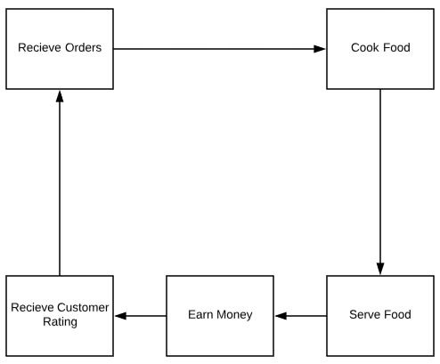

### End of Day Phase

### Overall Gameplay

content

# ART OVERVIEW

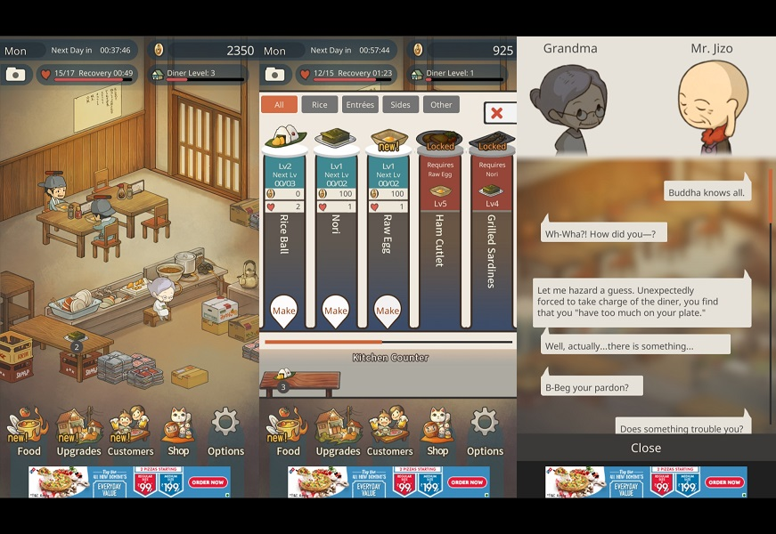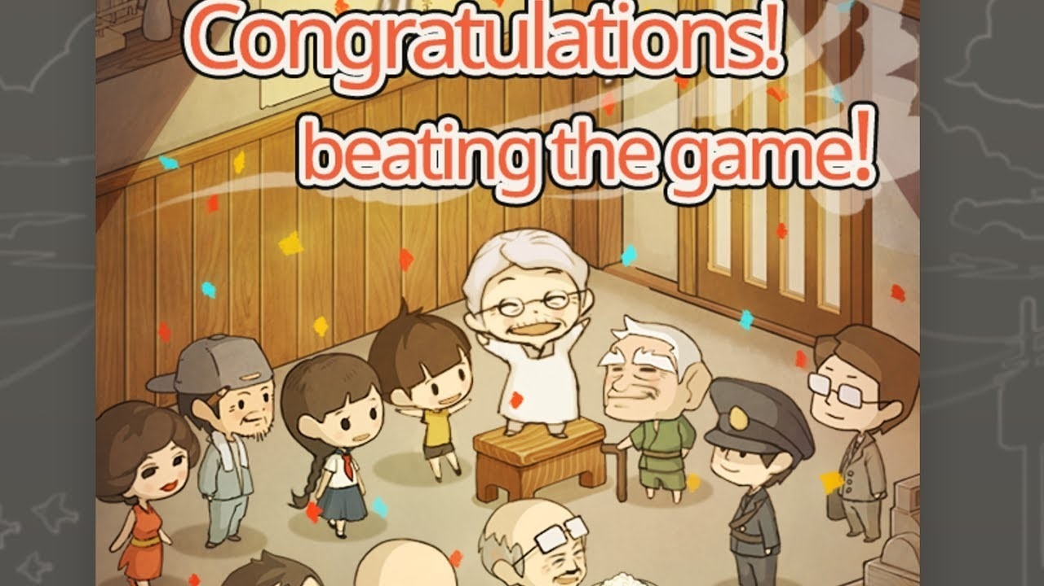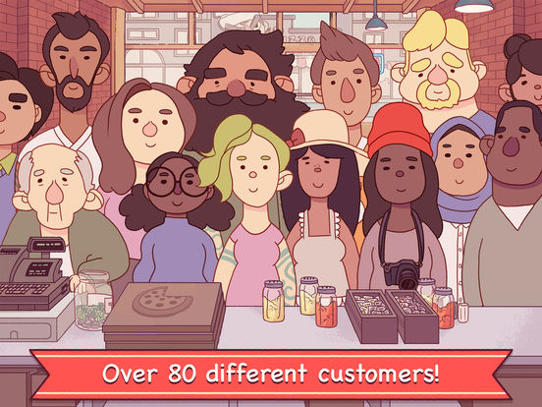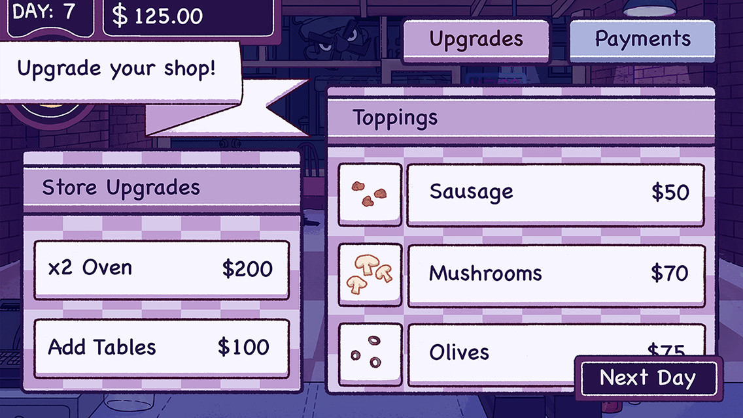

# AUDIO OVERVIEW

In-game music will be appropriate to the different forms of gameplay the player will go through.

The day phase will consist of fast-paced, cheerful music that will add to the tense and adrenaline filled game time of the day phase.

The end of day phase will see a complete difference, having calming, piano based music that will calm the player.

Sound effects will consist of people chattering, clanking of kitchen items, cooking appliance sounds and audio queues to assist the player in keeping track of what is completed.

# NARRATIVE OVERVIEW

The narrative will provide the players with a character, of whom has just taken over his/her mother’s business. The player will be introduced to the rush of the café, and then begin to understand the management side. This loop will continue in quick play sessions and become more complicated yet therefore satisfying to the player.

‘Rush of Service’ will not overly focus on a developed narrative story, instead, players will be able to create their own narrative through their customization choices within the game and the success they bring to their café.

The narrative will focus on the discovery of new recipes, which the player will see impact their café and it’s rating. It will also focus on the interior customization of their café, with more luxurious furniture items being available at higher currency prices, of which the player cannot achieve without spending an enough in-game time playing.

ECONOMY AND REWARDS

# ECONOMY OVERVIEW

‘Rush of Service will focus on four main economies within the game. These include;

* Money
* Ingredients
* Recipes
* Rating

Effectively, earning these “currencies” revolve around serving customers, the more effectively it is completed, the more the player earns. To break down further;

## 

## MONEY

Money will be earnt through serving each individual customer. The faster players can serve the customer, the higher they earn. Money can be spent on different furniture and customization options within their café.

## INGREDIENTS

Ingredients will be earnt at the end of each day, the quantity and variation of which will, again, rely on how effectively customers will be served.

## RECIPES

Recipes will be discovered when the appropriate ingredients are found of which the meals consist of.

## RATINGS

Rating will be separated into two categories; customer and café.

### Customer

When the player completes serving a customer, a simple emoticon with corresponding colours will be presented. There will be four different variations; green (happy), yellow (wanting improvement), red (unhappy) and black (walked out). The quantity of which the player receives throughout the day will be tallied to the café’s rating.

### Café

If the player receives good feedback from their customers, it will positively impact their café’s rating. If the player receives poor feedback, if will negatively impact their customer’s rating. Therefore, the player should be aiming to satisfy every customer to receive the best rewards and improve their café as they continue to play.

# REWARD LOOP

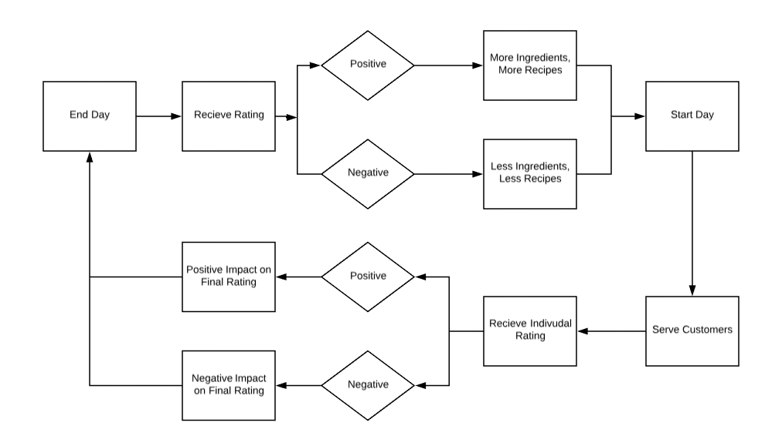Players will gain their rewards at the end of the day, the quantity of those will depend on their performance level during the day phase. To give the player satisfaction during the day phase, basic forms of visual feedback will give the player an incentive to keep playing as they see visually, how well they are performing.

# FEEDBACK LOOP

Players will constantly be receiving feedback during their play time; the main form of feedback players will receive for their efforts is simple, yet colourful emoticons represented their customers happiness with their service.

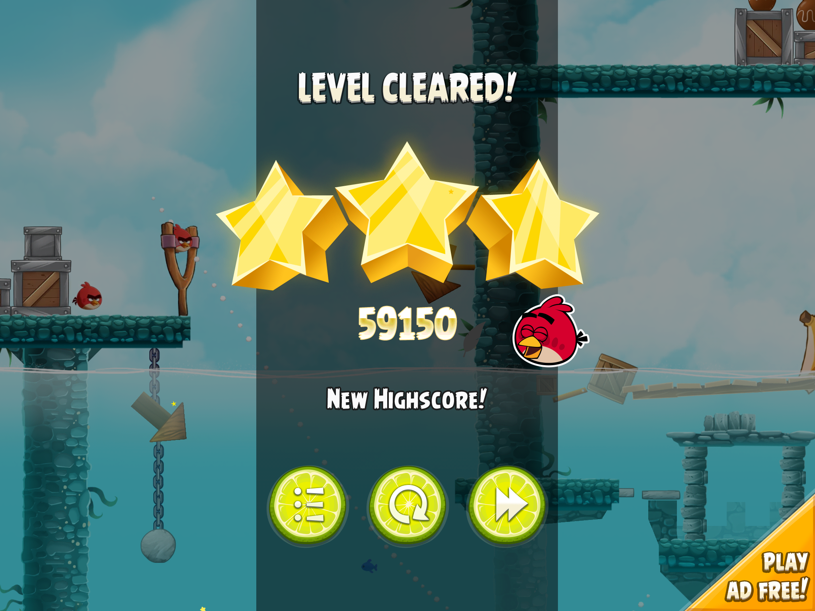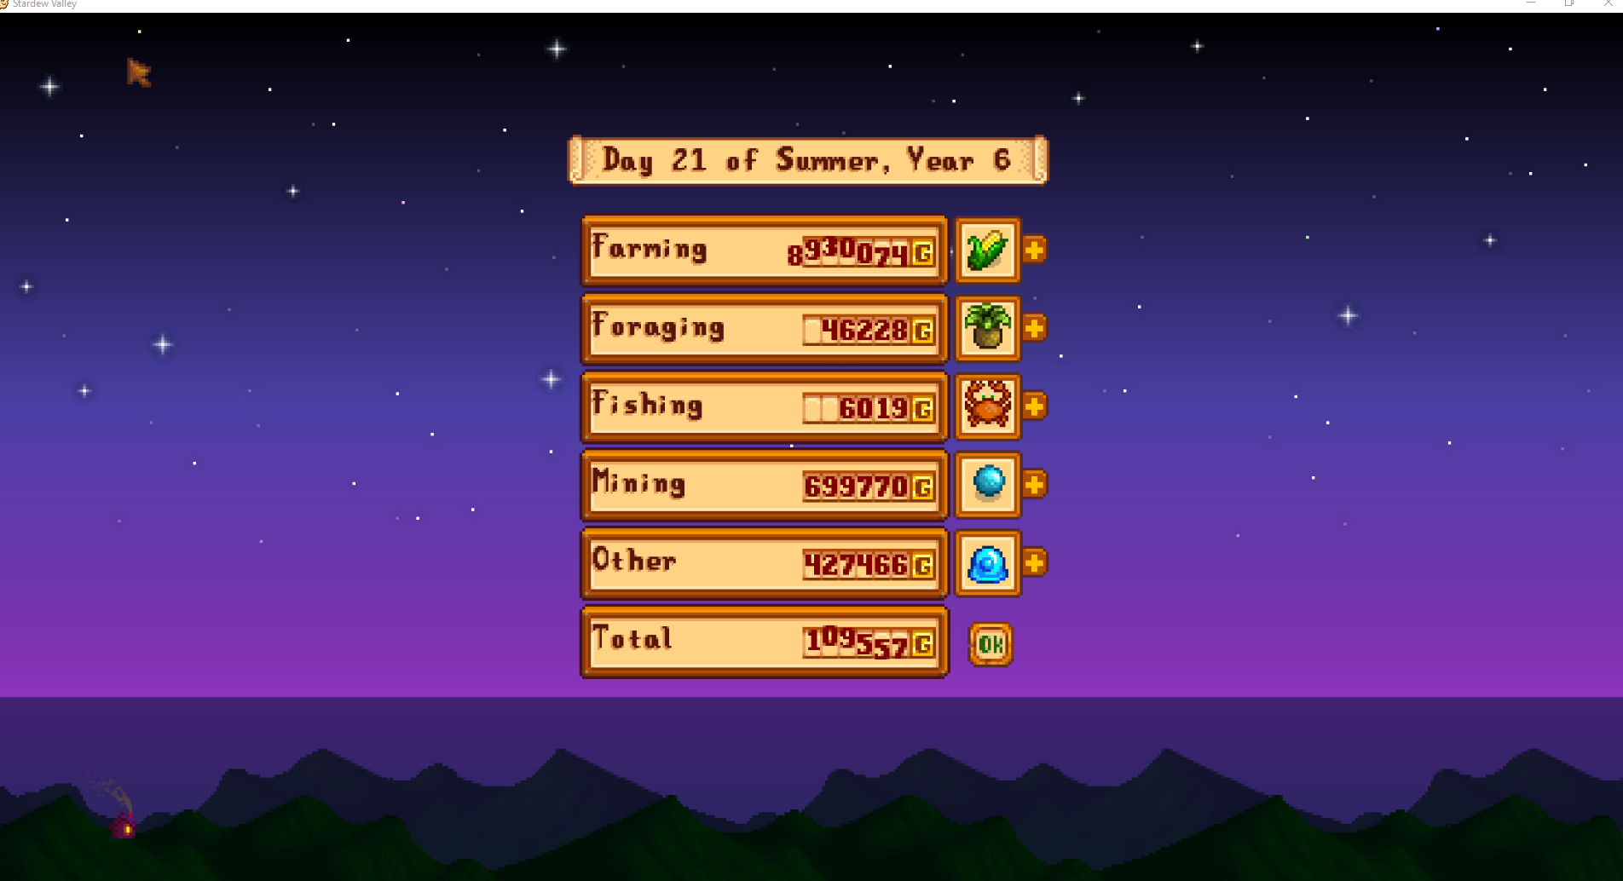

Other forms of feedback will mostly be presented during the end of day phase, where players will overview a menu of their progress. This will include what they have gained, their rating and later their customization options for their café.

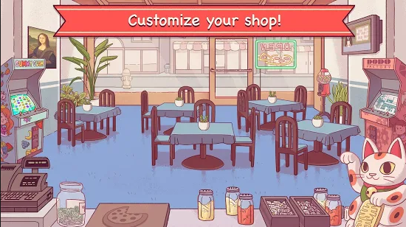

revision history

Minor changes to this final game design document included;

* Updated grammar and sentence structure
* Minor changes to Economic Loop due to testing
* Layout fixes

1. Jason Kingsley OBE, co-founder of independent games developer Rebellion*.*