CollisionAlgorithm is a plugin that can handle collision meshes.

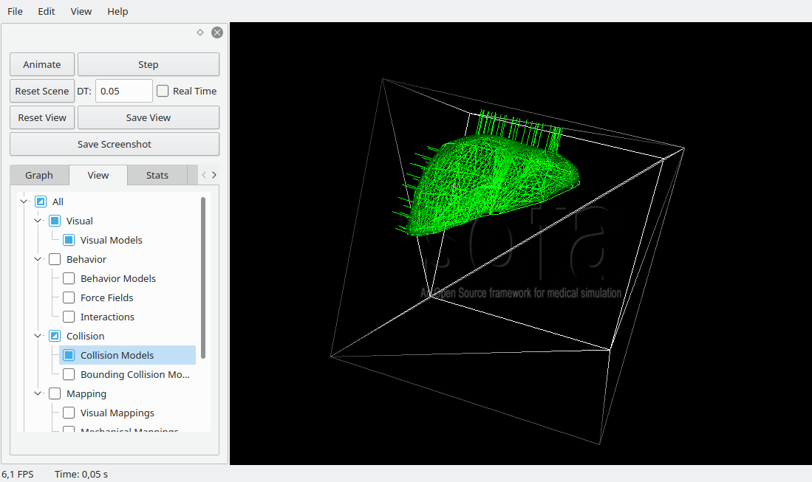
Blablabla

Please cite the following publications if you use the plugin:

