Support for 64-bit Windows 10 Home

**Why Blender?**

Blender is an open source modeling tool used to accurately model the physical satellite using .dae files.

**Installing Blender**

1. Go to [www.blender.org](http://www.blender.org)

**Create a Model**

1. Open Blender

**Edit an Existing Model**

1. Open Blender
2. Go to File $→$ Import $→$ Collada (.dae)

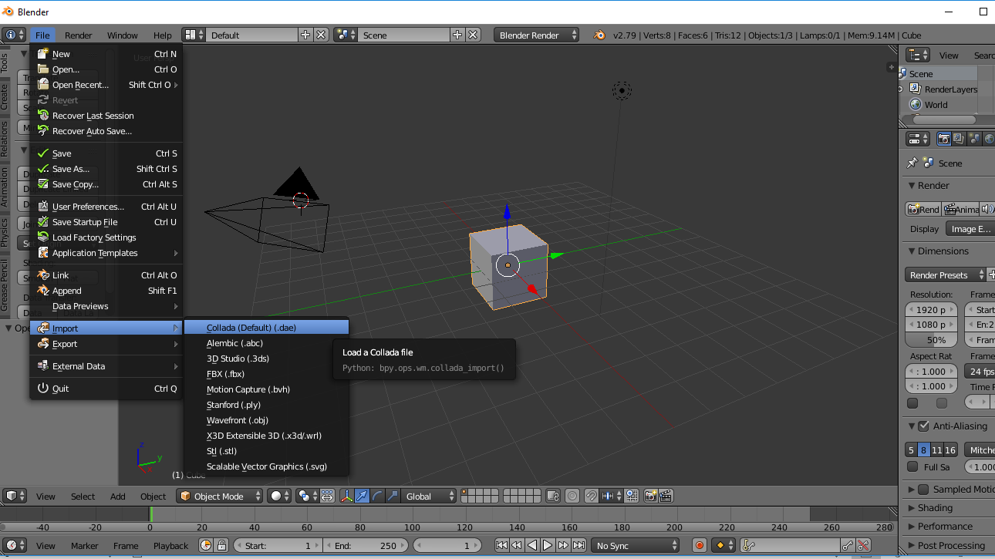

1. Find the .dae file to edit

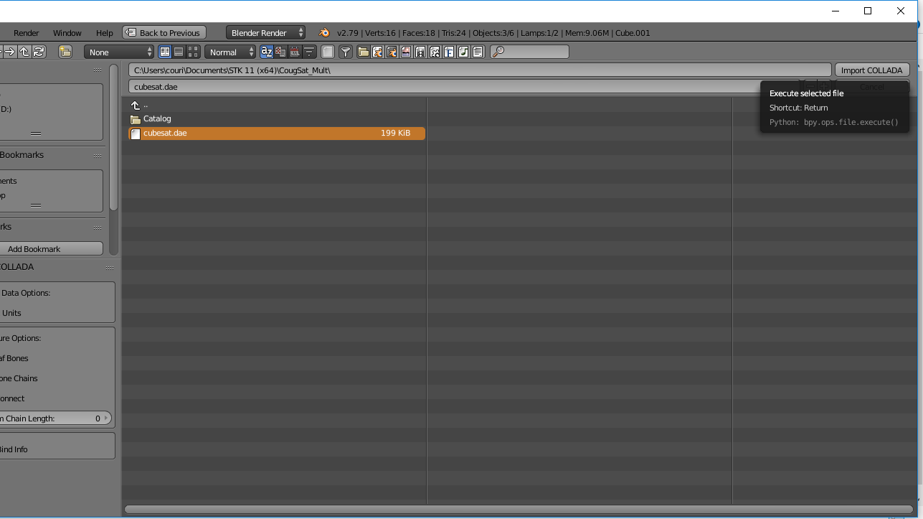

1. Import the existing .dae file by clicking the “Import COLLADA” button