**Support for 64-bit Windows 10 Home**

**Why STK?**

Systems Tool Kit (STK) is a simulated space environment that provides accurate astrophysics and analytic tools to measure communications efficiency, solar power collection, and orbit of CougSat I throughout its lifetime. STK also allows for integration of state machines that represent individual circuit board behavior within the satellite.

**Installing STK**

1. Go to <http://licensing.agi.com/stk/>
2. Click “Download STK”

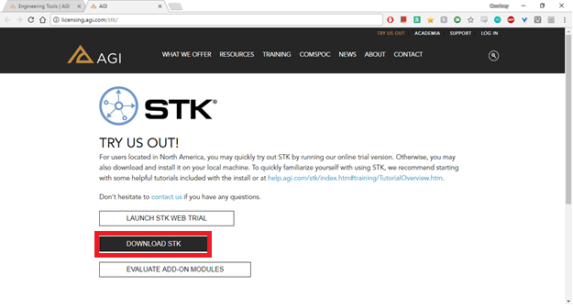

1. Login or Sign Up for an AGI account with your WSU e-mail
2. Download the “STK & Add-Ons” files

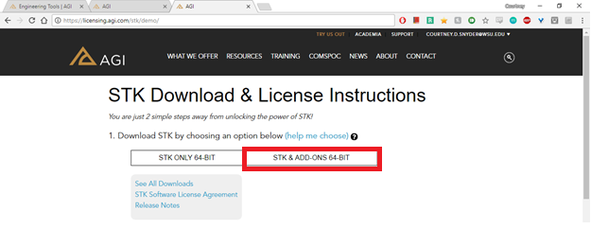

1. Unzip the STKXXXX-64_DVD folder
2. Open the unzipped STKXXXX-64_DVD folder
3. Double click the install.exe application to install STK

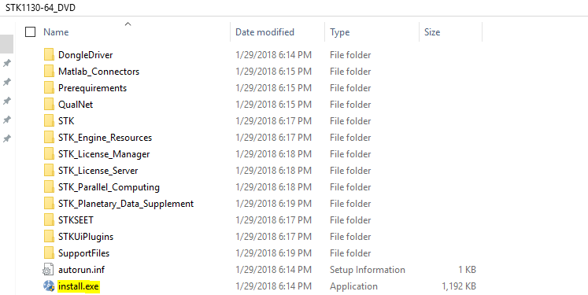

1. Go to the LicenseData folder. By default, STK installs this in the path “C:\ProgramData\AGI\LicenseData”
2. Within the License Data folder, add your license. You may use a free license or an academic license. To get the most accurate possible portrayal of CougSat I, we recommend obtaining an academic license because free licenses do not support Antenna, Transmitter, Receiver, or Solar Panel components, all of which are crucial for CougSat I. Those components are available in Academic licenses, available through the Chief Technology Officer or Crandall.
   1. **Free**:
   2. **Academic**: Create a new text document, paste the academic license contents in the document, and save as “STK_EDUCATION.lic”
3. Go to the Start Menu to access the License Manager. By default, STK creates a folder in the Start menu called STK Support Tools. Within this menu, select the License Manager.

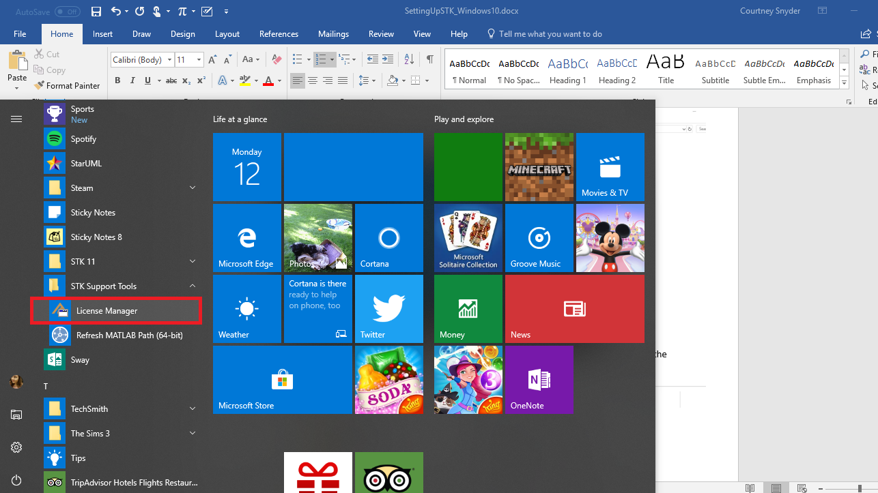

1. The License Manager should open up. If it does not, install the License Manager by going to the STKXXXX-64_DVD folder, STK_License Manager.

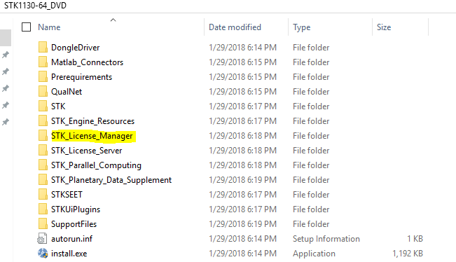

* 1. Select the STK_License Manager.msi application

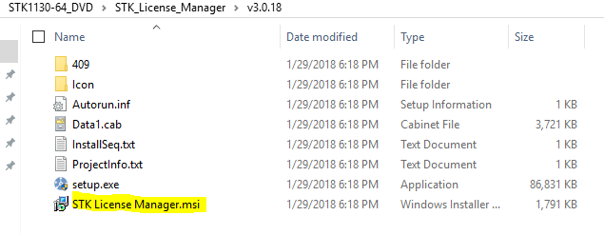

1. Once the License Manager is opened, select the “Manage Licenses” tab. By default, the path to the LicenseData folder will be in License Directories. The STK_EDUCATION.lic file should automatically show up in the “Installed Licenses” section. If it does not, manually add it by clicking the  icon.

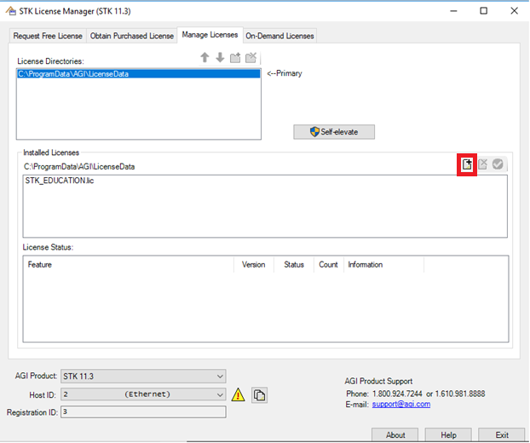

1. Validate the license by clicking the  icon. The following features should have the following statuses for Free and Academic licenses, respectively. The possible statuses are Good and n/a. The highlighted features are mission-critical for accurate portrayal of CougSat I.

|  |  |  |
| --- | --- | --- |
| **Feature** | **Free Status** | **Academic Status** |
| Analysis Workbench | n/a | Good |
| Astrogator | n/a | Good |
| ATT | n/a | n/a |
| Aviator | n/a | Good |
| **Communications** | n/a | **Good** |
| Conjunction Analysis Tool | n/a | Good |
| Coverage | n/a | Good |
| MATLAB Interface MexCon | n/a | Good |
| Model Center Carpet Plot | n/a | Good |
| Model Center Data Visualizer | n/a | Good |
| Model Center Design of Experiments | n/a | Good |
| Model Center Parametric Study | n/a | Good |
| Model Center Run | n/a | Good |
| Model Center Save and Load Capability | n/a | Good |
| Model Center Server Mode | n/a | Good |
| ODMSS | n/a | n/a |
| Radar | n/a | Good |
| Scheduler | n/a | Good |
| **Space Environment and Effects Tool** | n/a | **Good** |
| **STK** | **Good** | **Good** |
| STK Integration | n/a | Good |
| STK Pro Edition | n/a | Good |
| **STK SatPro** | n/a | **Good** |
| Urban Propagation Extension for STK/Communications | n/a | Good |
| Viz2DBar, Viz2DLine, Viz2DScatter, Viz3DScatter, VizCarpet, VizContour, VizParallelCoordinates, VizScatterMatrix | n/a | n/a |

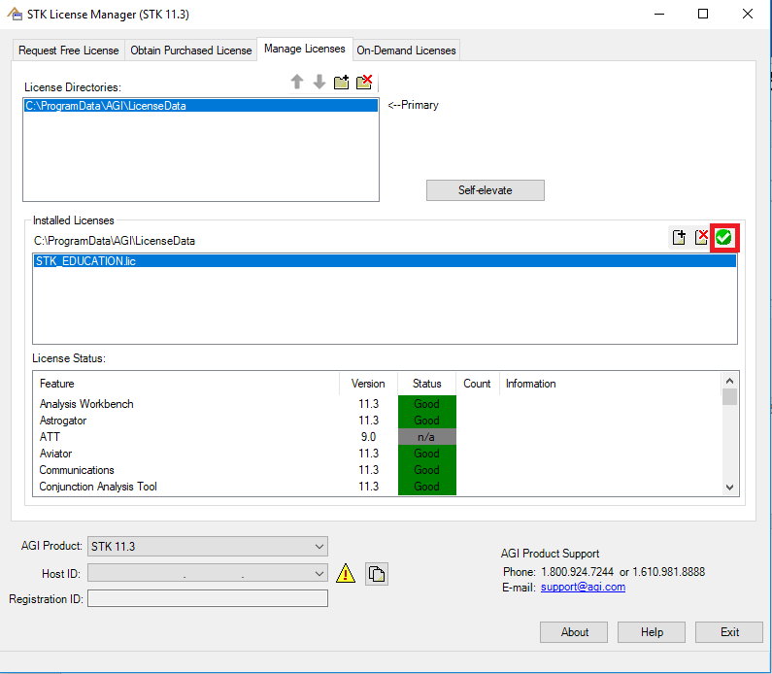

*Image is validating an Academic License*

**Creating a Scenario in STK**

1. Open STK
2. Select “Create Scenario”

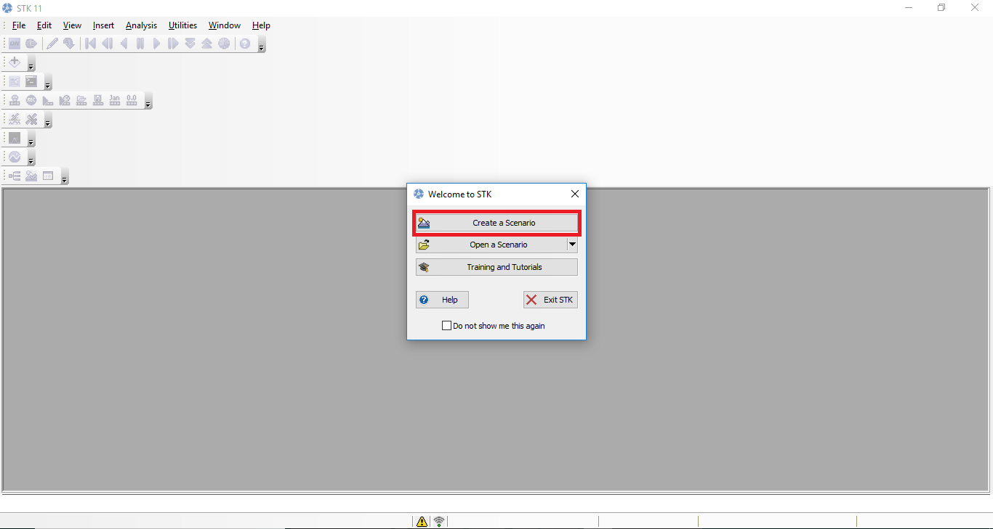

1. Name the scenario something distinct. It will be saved as a folder with that name in your determined scenarios path. By default, STK stores scenario folders in the “C:\Users\USER\Documents\STK 11 (x64)” path.
2. Select the time range for the satellite by clicking the  icon next to the “Start” and “Stop” text box.

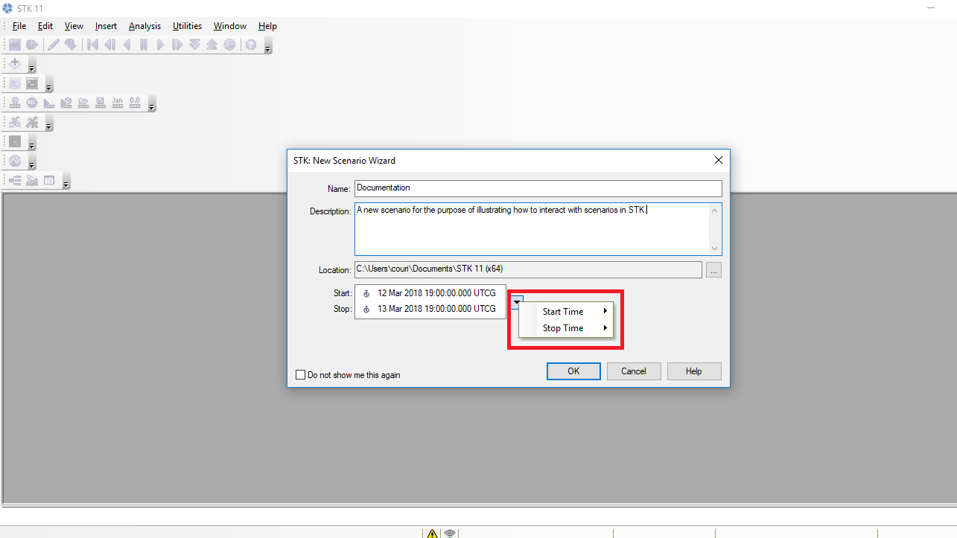

1. f

**Loading a Scenario in STK**

Note: STK stores scenarios in the “C:\Users\USER\Documents\STK 11 (x64)” path by default.

1. Open STK and select “Open Scenario”

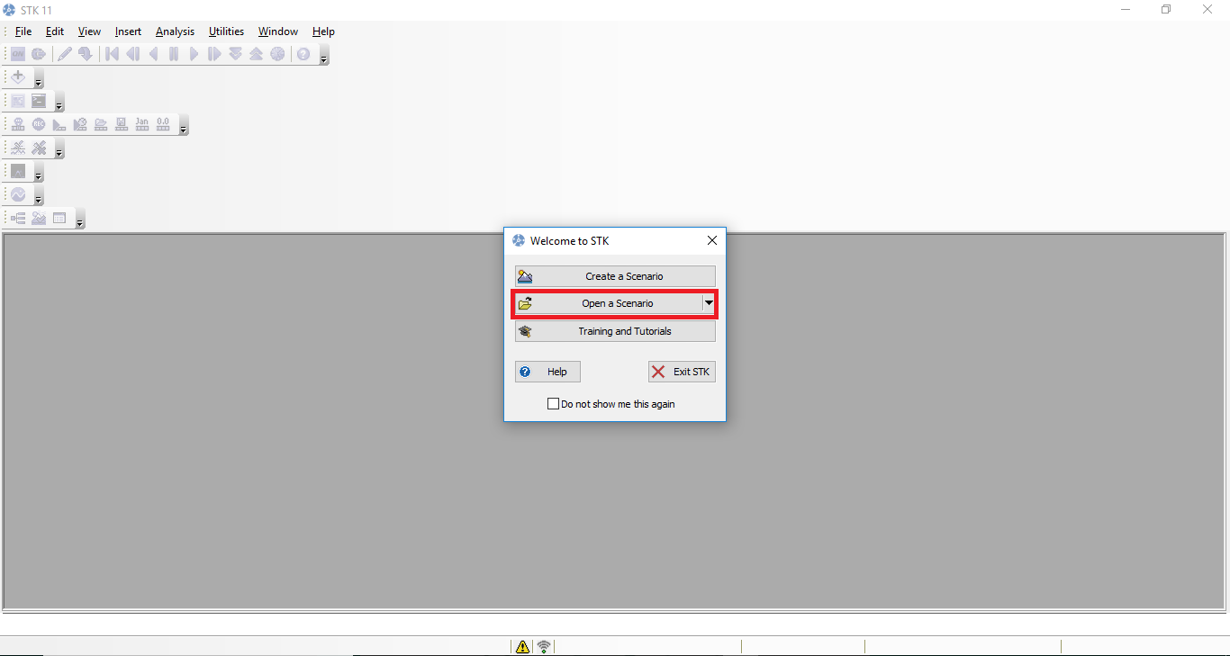

1. Select a scenario folder to open

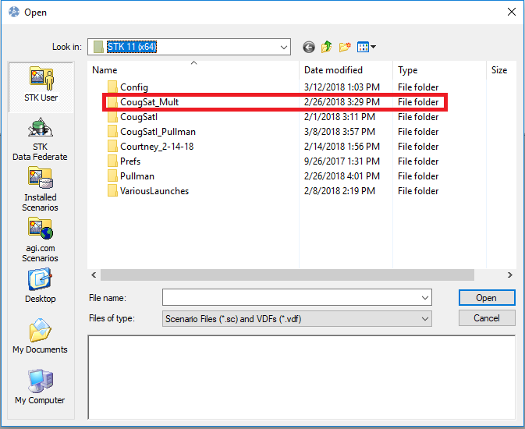

1. Select the .sc file to open within that scenario

