Support for Linux Mint 17 (Sarah)/Ubuntu 14.06 (Xenial)

**Install Blender via Terminal**

1. Open a terminal (shortcut: Ctrl+Alt+T)
2. Enter “sudo add-apt-repository ppa:thomas-schiex/blender” and enter the root password “CougSatI” (without the quotation marks) to continue

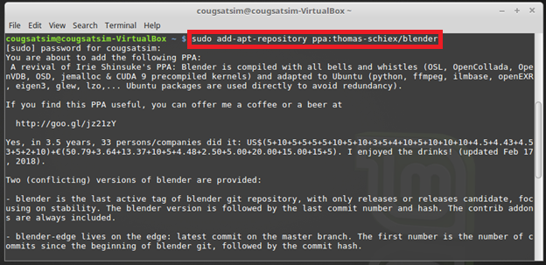

1. Enter “sudo apt-get update”

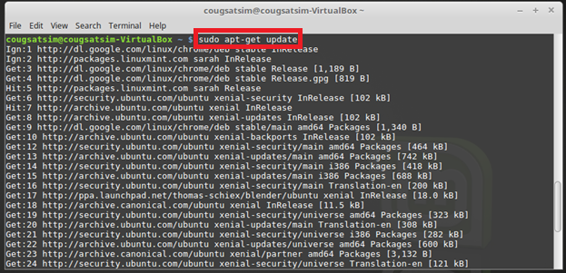

1. Enter “sudo apt-get install blender”

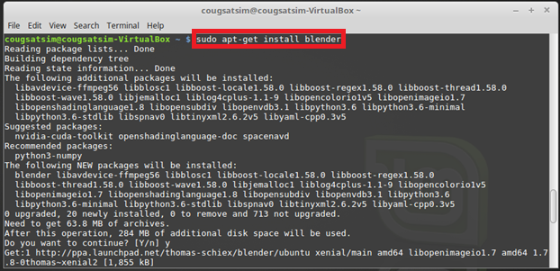

1. f

**Install Blender via Website**

1. Go to [www.blender.org/download](http://www.blender.org/download)
2. The website will automatically direct you to the appropriate download version. Click on “Download Blender”