Support for 64-bit Linux Mint 18 (Sarah)/Ubuntu 16.04 (Xenial)

**Creating a free AGI account**

1. Go to [www.agi.com](http://www.agi.com)
2. Select “Log In”

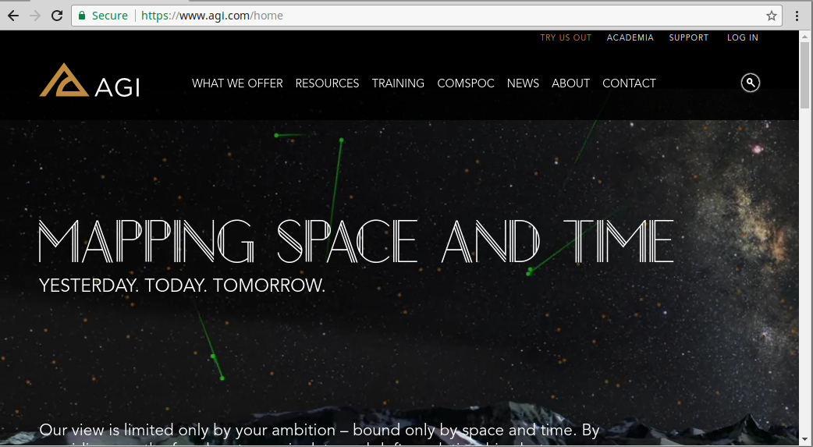

1. Select “Create New Account”

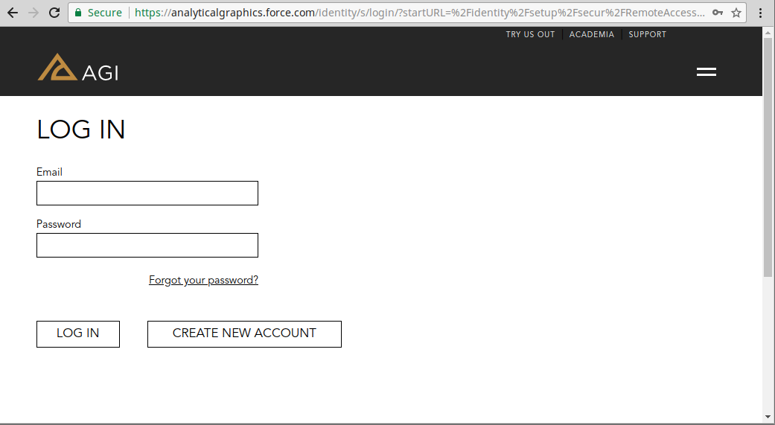

1. Fill out the registration form using these key pieces of information:
   1. Email

[YOURNAME@wsu.edu](mailto:YOURNAME@wsu.edu)

* 1. Organization

Washington State University

* 1. Street

Washington State University EME Building

355 NE Spokane St

Room 107

* 1. City/State/Zip

Pullman, WA 99163

* 1. What best describes your organizational role?

Student/Educator

* 1. Primary Area of Interest

Space Systems

1. You will receive an e-mail in your WSU e-mail prompting you to set your password
2. Done!

**Install STK**

Note: You must have a free AGI account to install STK.

1. Log in to the AGI website and go to [www.support.agi.com/downloads](http://www.support.agi.com/downloads)
2. Select “STK Engine for UNIX”

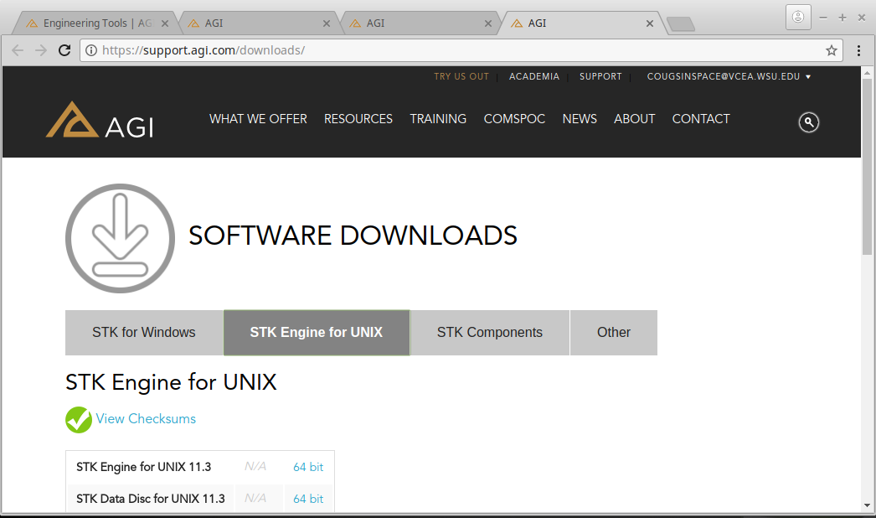

1. Download “STK Engine for UNIX 11.3”. A zip folder will begin to download
2. Select the zip folder once it is done downloading
3. Click on “Extract” to extract the contents of the zip folder. In this case, I extracted the file to the /home/Desktop path.

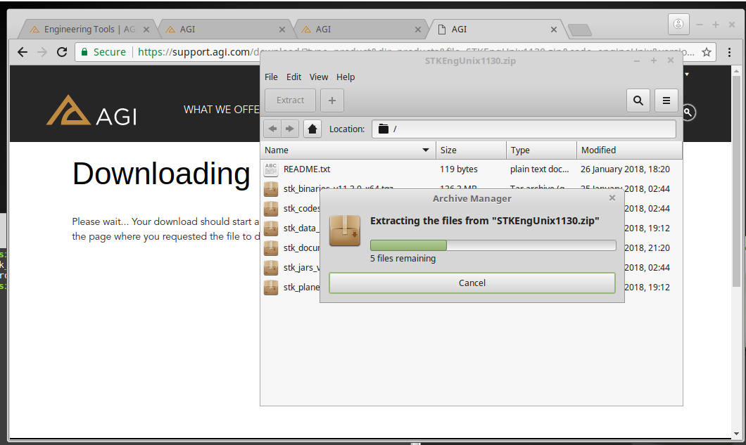

1. Open a terminal and cd into the directory you extracted the zip folder to.

In this case, the command is: “cd Desktop”

1. Enter the command “tar -xvf stk_binaries_v11.3.0_x64tgz” to extract the STK binaries. This will create a new folder called “stk11.3.0” in the directory

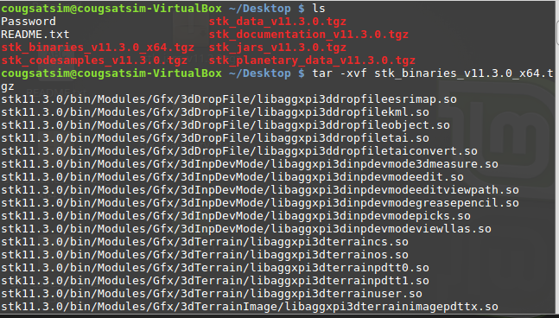

1. Enter the following commands to finish unpacking the engine and documentation. They will automatically go into the stk11.3.0 folder:

For the Engine:

tar -xvf stk_data_v11.3.0.tgz

tar -xvf stk_jars_v11.3.0.tgz

For the Documentation/Code samples:

tar -xvf stk_codesamples_v11.3.0.tgz

tar -xvf stk_documentation_v11.3.0.tgz

Note: Code samples are written in Java and need Eclipse or ant pre-installed to run

them. STK recommends Oracle Java.

1. Set up the path variables using the bin folder and the data folder.
   1. Binaries
      1. Format: export LD_LIBRARY_PATH=<install dir>/bin:$LD_LIBRARY_PATH
      2. Example with the stk11.3.0 folder in the Desktop: export LD_LIBRARY_PATH=/home/cougsatsim/Desktop/stk11.3.0/bin:$LD_LIBRARY_PATH
   2. Data
      1. Format: export STK_INSTALL_DIR=<install dir>
      2. Example: export STK_INSTALL_DIR=/home/cougsatsim/Desktop/stk11.3.0/Data
2. Copy and paste your license file (.lic) into the /bin directory