**Rationale**

Neural accumulation is an accepted framework in perceptual decision making (Purcell et al., 2010), but has not yet been demonstrated in sensorimotor control. Using these ideas, Markkula et al (2017) present a steering model in which the timing of steering corrections appeared to be better explained by accumulation of perceptual evidence (*Accumulator Model*), rather than simply the magnitude of the perceptual error at each point in time (Threshold Model). However, the difference is a subtle one, for many tasks it can be difficult to clearly delineate behaviour determined by noisy accumulation vs. noisy threshold, and the task analysed in Markkula et al (2017) was not specifically designed to differentiate between Accumulator and Threshold accounts. Here we specifically examine scenarios where the two models produce discrepant predictions.

1. **Amplitude**: The Magnitude account predicts that steering corrections will occur when a perceptual error signal ‘PE’ reaches a threshold ‘PT’’. Under the Threhold account the *magnitude of PE* will be constant, irrespective of the rate at which PE increases. The Accumulator Model, however, predicts that the slower the rate of increase of PE, the lower the magnitude of P when the accumulation reaches PT (because the signal has had more time to accumulate). Furthermore, we assume that the amplitude of the steering correction is linked to the magnitude of error (cf. Benderius & Markkula, 2014). It follows that has the rate of increase in P slows – for example, as the radius of bends get larger – then the Accumulation would predict the amplitude of correction to continue to decrease whereas the Threshold model would predict the amplitude to flat-line (Figure 1).
2. **Error Thresholds:** Both models assume that the magnitude of PT would vary dependant on the constraints of the task (e.g. width of road). We predict that changing the width of the road would vary radius which the initial PE is below PT, but it should not change the relationship between timing and amplitude.

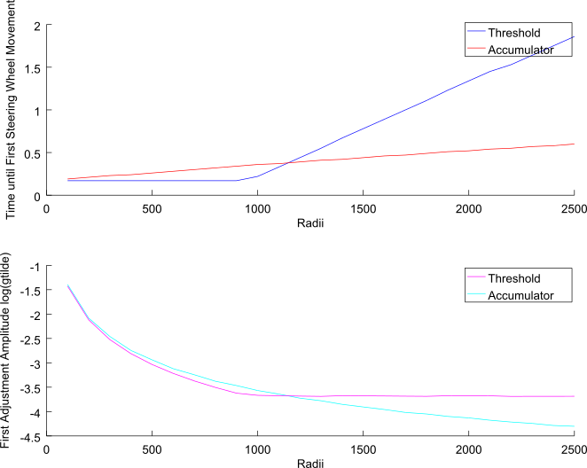

Figure Once the initial perceptual error is below threshold, then the amplitude of

**Methods**

Given the model predictions.

To vary the rate at which PE increases we will change the

OK. As you predicted, we have a concrete testable hypothesis relating the first correction timing to the amplitude, *when initial perceptual error is below threshold.*

Threshold: timing will *increase*with radius, but amplitude will flat-line.

Accumulator: timing will *increase*with radius, but amplitude with *decrease.*

I think we can nicely test this hypothesis with the radii-varying design.

The risk is that the variability may be too high to find results. But one way to mitigate this risk is to pre-register the study, so then we would still be able to publish the findings even if they are ambiguous.