What Makes a Clinical Trial Successful: An Analysis of the Factors Contributing to the Successful Recruitment and Retention of a Clinical Trial Participants

Courtney Roush
Colorado State University Global
MIS581: Capstone – Business Intelligence and Data Analytics
Dr. Goodwin
September 6, 2026

ABSTRACT
Clinical trials play a crucial role in the development of new biopharmaceutical drugs and treatments, yet participant recruitment and retention remain among the most prominent challenges affecting trial success. The purpose of this study was to identify factors associated with the successful recruitment and retention of clinical trial participants through the detailed analysis of historical clinical trial data. Data for this study was obtained from the Aggregate Analysis of ClinicalTrials.gov (AACT) database, which contains information from hundreds of thousands of registered clinical studies. Python was used for the final data preparation, statistical analysis and visualization. Descriptive statistics were generated to examine characteristics of the dataset, and hypothesis testing was conducted using both Chi-square and Analysis of Variance (ANOVA) methods.
Results indicated a statistically significant relationship between clinical trial phase and successful study completion, which ultimately led to the rejection of the null hypothesis related to participant recruitment. Additional analysis of participant withdrawal data identified withdrawal by subject, loss to follow-up, and adverse events as the most commonly observed reasons for participant attrition. ANOVA results demonstrated a statistically significant relationship between clinical trial phase and participant retention rates, which resulted in the rejection of the second null hypothesis pertaining to participant retention. Retention rates were highest among Early Phase 1 studies and lowest among Phase 2 and Phase 3 studies.
These findings suggest that clinical trial characteristics, specifically study phase, are indeed associated with recruitment and retention outcomes. Recommendations include adopting participant-centered trial designs, increasing retention-focused resources for Phase 2 and Phase 3 studies, and implementing strategies aimed at reducing participant burden and loss to follow-up.
What Makes a Clinical Trial Successful: An Analysis of the Factors Contributing to the Successful Recruitment and Retention of a Clinical Trial Participants
INTRODUCTION
Merriam-Webster (2026) defines biopharmaceutics as “the study of the relationships between the physical and chemical properties, dosage, and form of administration of a drug and its activity in the living body.” The biopharmaceutical industry is rapidly evolving due to advancements in various realms of biotechnology as well as drug development. According to Grand View Research (2026) the market size is estimated to be 484.4 billion as of 2025, with more growth expected in 2026. The process of getting a drug from early development to final release to the market is quite complex and involves many key stages, one of which being clinical trials. Clinical trials rely on volunteer participation to test new drugs and gather data pertaining to their actual effects on the end users. In human biopharma these trials rely on people to volunteer, alternatively in the veterinary industry the trials rely on people to volunteer their own pets for the trials. The data from the trials are used to evaluate the safety and effectiveness of new drugs as well as to identify any potential side effects. These trials have a series of defined phases. Phase 0 trials are considered exploratory; they involve small studies where the only intent is to see what the drug does in the body and if it reaches the places it is expected to. Not all Clinical trials involve a phase 0. Phase 1 trials are considered the safety trials. These trials are focused on determining if a drug is safe and how it is best delivered. They involve low doses with detailed monitoring for potential side effects. Phase 2 trials are the efficacy trials; this is where the researcher aims to determine whether or not the treatment of interest actually works. Phase 3 clinical trials involve large-scale testing where the new drug is compared to what is currently available to see if it performs better. For many clinical trials phase 3 is the final phase however sometimes a phase 4 is conducted. Phase 4 is a post marketing surveillance phase which involves monitoring safety over a long period after the drug has been made publicly available. The importance of these trials goes beyond just collecting data for further research, though. The trials are actually apart of the regulatory requirements for registering new drugs. These requirements vary depending upon the regulatory body, but as an example the Food and Drug Administration (FDA) requires submission of results from two separate well designed clinical trials as a part of their approval process for new drugs. Clinical trials are key to advancing research in the pharmaceutical industry and to transferring drugs from research into manufacturing, for this reason this project aims to focus on identifying the factors responsible for making a clinical trial successful.
There are four key areas of challenge faced when it comes to executing clinical trials: participant acquisition and retention, trial design, financial and operational practicality and navigating both ethical and regulatory compliance. Within the scope of this research project the focus will be on participant acquisition and retention. Clinical trials rely on voluntary enrollment. Getting people to volunteer for a trial can already be challenging as is but there is an added level of complication as not just anyone can be a trial participant. The participants for a trial need to meet specific selection criteria which vary depending on the drug being studied. This criterion includes things such as having the condition of interest as well as being at a certain stage in the progression of the condition. There are also exclusion criteria, someone may have the condition at the correct stage but be disqualified due to a separate drug they already take. Ideally trials should also include diverse and representative pools of people to ensure representation of the full population that the drug will one day go to. A trial conducted on just women of a single ethnicity for a drug planned for men and women internationally would not provide an adequate range of data, for example. The second level of the participant challenge is that some trials can require prolonged participation which leads to a problem with retention as some participants inevitably drop out of the study for various reasons. These reasons can range from not having the time to commit to the study, to more extreme cases of facing adverse events that require their withdrawal.
OBJECTIVES
To address these challenges this research project will evaluate what factors lead to successful recruitment of clinical trial participants. The project will also analyze what factors lead to the retention of clinical trial participants. Answering these two questions will provide meaningful insights that can be applied to future clinical trials to boost their success rates.
OVERVIEW OF STUDY
This study is being conducted to identify the factors which contribute to the successful recruitment and retention of clinical trial participants. The biopharmaceutical industry as a whole will benefit greatly from the findings of this study. Clinical trials cannot exist without proper participation therefore making the acquisition and retention of participants the foundation of a successful clinical trial. Organizations can use findings on the factors that lead to participant acquisition to help guide their recruitment efforts for future clinical trials. Additionally, the findings pertaining to participant retention can aid in future clinical trial design to ensure trials are being developed that favor participant retention. Currently, prior to starting, trials usually aim to gather more participants than they actually need in the long run due to assumed dropout rates. If retention rates can be improved this would allow trials to gather less participants initially which could help fast track the trials completion. The faster trials can be completed the faster their data can be evaluated and submitted. This will allow for more potentially life altering drugs to be brought to market.
This study will utilize historic clinical trial data which will be analyzed using a variety of different data analytics tools. Through this analysis, hypothesis testing will be done to answer the research questions that are developed. At the conclusion of this study there will be meaningful insights into ways to design clinical trials to encourage successful recruitment and long-term retention.
RESEARCH QUESTIONS AND HYPOTHESES
This research project will be guided by two key research questions. The first question is, what factors lead to successful recruitment of clinical trial participants? The second question is, what factors lead to successful retention of clinical trial participants?
Clinical trial recruitment and retention are influenced by a variety of study-level characteristics including study design, trial phase, enrollment targets, sponsor type, and study complexity, etc. The statistical analysis of the data will aim to answer the aforementioned research questions by determining whether statistically significant relationships exist between selected study characteristics and successful participant recruitment and retention outcomes. Identifying these relationships will help researchers design more effective clinical trials and reduce delays associated with participant enrollment and attrition. To guide the statistical analysis, I must first identify my hypotheses for the analysis. For my first question pertaining to the recruitment of clinical trial participants, my hypotheses are as follows.
H₀: There is no statistically significant relationship between clinical trial characteristics and successful participant recruitment.
H₁: There is a statistically significant relationship between at least one clinical trial characteristic and successful participant recruitment.
For the second research question, pertaining to participant retention, my hypotheses are as follows.
H₀: There is no statistically significant relationship between clinical trial characteristics and successful participant retention.
H₁: There is a statistically significant relationship between at least one clinical trial characteristic and successful participant retention.
LITERATURE REVIEW
To support the research being conducted on the aforementioned questions, a literary review was conducted, the results of which will be discussed here. Sources for the literary review were acquired by utilizing CSU Global’ s library. All sources are peer-reviewed articles.
As I was reviewing the preexisting literature pertaining to recruitment and retention of clinical trial participants, I came across three key themes: recruitment strategy, trial complexity and trial scheduling. Prior to starting this review, I had planned to focus my analysis of factors solely on the actual elements of clinical trial design; however, my reading revealed the concept of the importance of the recruitment strategy itself. According to Hung et al. (2024), in person recruitment was the most effective method of recruitment when collecting participants for a research team at a local university. Hung et al. (2024) also found that referrals from previous participants were highly valuable in attaining new participants. The importance of recruitment strategy was further emphasized by Perez-Brumer et al. (2025) who found that one of the key motivators for participants to join trials was for the feeling of contributing to “the greater good.” Based on this, Perez-Brumer et al. (2025) recommend including an emphasis on participant impact in the actual strategy for recruiting participants to help motivate their desire to participate.
The other two themes that arose during my review were the importance of trial complexity and trial schedule. Hung et al. (2024) found that scheduling was one of the biggest factors when assessing challenges surrounding clinical trial participation. Based on their study, Hung et al. (2024) concluded that flexibility in scheduling is a key factor to successful participant recruitment. Perez-Brumer et al. (2025) built upon this same finding by emphasizing how the use of remote clinical trials removed some of the challenges frequently faced by clinical trial participants such as travel costs and time dedication. Remote trials provide greater scheduling flexibility for participants which makes it easier to continue to commit to the trial. When evaluating retention challenges Perez-Brumer et al. (2025) found that the number one reason for patients dropping out was for feeling that participation was too burdensome. Often clinical trials require participants who are ill, so creating trials that are as simple as possible will aid in their continued participation. An article by Van Ooik and Hutton (2025) introduced the idea of patient-centric trial design. Van Ooik and Hutton (2025) argue that in order to successfully retain clinical trial participants, clinical trials must be designed with retention in mind. This means designing trials that are simple and flexible for the participants so that the burden on their lives is minimal.
Conducting this literature review offered important insights for me into my research and specifically helped me focus on key variables of interest. Based on my findings from reviewing these articles, I plan to focus on three key variables: recruitment strategy, trial complexity, and trial scheduling. I believe by analyzing these variables I will be able to answer my research questions on which factors influence clinical trial participant recruitment and retention.

RESEARCH DESIGN
Methodology
For the completion of this research project, I will be utilizing the Aggregate Analysis of ClinicalTrials.gov (AACT) database. The dataset is quite large, consisting of a total of 51 tables. For the purposes of my research, I am planning to focus mainly on the designs, drop_withdrawals, milestones, participant_flows, and studies tables. These tables are focused on the study designs as well as the participant recruitment and retention information. The dataset contains various variable types including nominal, ordinal, ratio and binary.
Methods
For the analysis of the data, I plan to utilize three main tools: Python, PowerBI and R studio. Python will be the primary tool I utilize as it is well suited for large volumes of data like that within this dataset. I plan to use libraries such as Pandas and NumPy to both clean and prepare the data for analysis. After using it to prepare the data I then can conduct analysis such as regression, correlation analysis and predictive modeling to help identify which factors influence participant recruitment and retention. I plan to utilize Power BI to create visualizations of the data. Power BI allows for the creation of interactive dashboards which can help translate the analytical findings of python into clear visualizations for those who read my final report. Data visualization is a key element of any good research project as it is much more interpretable to the average person than raw data and coding. The final tool I plan to use is R studio. R studio will be where I conduct the vast majority of my statistical analysis with the main focus being on conducting the hypothesis tests for the identified hypotheses.
I plan to use two main forms of hypothesis testing for my analysis: Chi-square and Analysis of Variance (ANOVA). Chi-square tests are intended to be utilized to assess whether or not there is a statistically significant relationship between two categorical variables. I will utilize this test to assess the categorical variables included within the dataset such as trial phase. On the other hand, ANOVA tests are meant to be used to compare means across multiple groups. I will use this method for numerical variables such as retention rate. Comparing the average retention rate across different study categories such as phases for studies that successfully concluded versus studies that were unable to be finished can help determine if the trial phase is a statistically significant factor in determining participant retention. For all analysis tests, success will be defined based on whether or not the trials were concluded. Trials that reached their conclusion will be considered successful and those that ended prematurely will be considered unsuccessful.
Limitations
While the AACT database provides a large and comprehensive source of clinical trial information, several limitations should be considered when interpreting the findings of this study. First, this project relied entirely on secondary data obtained from a pre-existing database. As a result, the analysis was limited to the variables collected and reported within the AACT dataset. During the literature review, recruitment strategy, scheduling flexibility, and participant burden emerged as important factors influencing clinical trial recruitment and retention. However, these variables were not directly captured in the available data and therefore could not be analyzed quantitatively. Instead, the study focused on variables available within the dataset, including trial phase, enrollment characteristics, study status, and participant withdrawal patterns.
A second limitation relates to the use of study-level rather than participant-level data. The AACT database provides information about individual clinical studies but does not include detailed participant records. Consequently, the analysis could identify associations between study characteristics and recruitment or retention outcomes but could not determine the specific participant-level factors that influenced individual decisions to enroll in or withdraw from a study.
Additionally, the dataset contained several variables with missing or incomplete information. Although key variables used in the analysis contained sufficient data for meaningful statistical testing, missing values may still affect the representativeness of the results. Furthermore, reporting practices within ClinicalTrials.gov have evolved over time. Changes in registration requirements and reporting standards may have introduced inconsistencies across studies conducted during different time periods.
Another limitation involves the interpretation of causality. The statistical methods used in this project identified relationships between variables but cannot establish direct cause-and-effect relationships. For example, while a statistically significant relationship was observed between clinical trial phase and recruitment or retention outcomes, other factors not captured within the dataset may contribute to these relationships. Variables such as study funding, therapeutic area, geographic location, participant demographics, and recruitment methods could influence outcomes and were not directly examined in this analysis.
Finally, several extreme enrollment values were identified within the dataset, resulting in a highly right-skewed distribution. While these observations were retained because they represented legitimate records within the database, they may have influenced measures such as the mean enrollment value. For this reason, median values and additional descriptive measures were considered when interpreting enrollment trends.
Despite these limitations, the large sample size and breadth of information available within the AACT database provide valuable insights into clinical trial recruitment and retention patterns and establish a strong foundation for future research in this area.
Ethical Considerations
When conducting research involving clinical trial data, it is important to consider not only privacy concerns but also the broader ethical responsibilities associated with interpreting and applying findings derived from human research. Although this project utilized the AACT database, a database consisting of publicly available study-level data, ethical considerations still remain relevant throughout the research process.
Because the AACT database contains information at the study-level as opposed to the participant level, risks relating to participant identification and personal privacy are greatly reduced. The dataset does not include any direct participant identifiers, and no interaction with human subjects occurred during the completion of this particular project. This means that this research project relied entirely on de-identified secondary data. However, using secondary data does not eliminate all ethical responsibilities and considerations still need to be made.
One important ethical consideration involves the interpretation of recruitment and retention success. High enrollment numbers or strong retention rates do not necessarily indicate that a clinical trial was equitable or representative of the broader population affected by a certain disease. Different patient populations may face varying barriers to participation, including but not limited to socioeconomic, geographic, logistic, and health related challenges. Therefore, findings from this study should be interpreted as measures of operational success rather than definitive measures of fairness, accessibility, or representativeness.
Another ethical consideration relates to the responsible use of secondary data. The AACT database contains information that was originally acquired for purposes other than this research project. Consequently, conclusions must be limited to what the available data can reasonably support. While statistical analyses can identify relationships between variables, they cannot establish causation or determine the underlying reasons for participant behavior. Therefore, care was taken to avoid drawing conclusions that extend beyond the information contained within the dataset.
Transparency and reproducibility also represent important ethical factors. Throughout the project, data preparation procedures, variable definitions, and analytical methods were documented to promote reproducibility and allow others to understand how conclusions were reached. This includes acknowledging limitations associated with missing data, variations in reporting practices, and the presence of extreme values within certain variables. These acknowledgments need to be made to ensure those who read this report are getting the full picture on how the research was conducted and how the conclusions were ultimately reached.
By considering participant privacy, responsible interpretation, transparency, and the limitations of secondary data analysis, this study sought to maintain ethical research practices while providing meaningful insights into factors associated with clinical trial recruitment and retention.

FINDINGS
As stated in the methodology section of this paper, the original plan for the analysis was to utilize a combination of Python, R studio and Power BI, however once I started actually working on the analysis, I realized that with the structure of the dataset it would be easier to just complete all of my analysis within Python. To achieve this, I used the matplotlib library for visualizations and SciPy for statistical analysis.
Descriptive Statistics
Prior to beginning my hypothesis testing analysis, I conducted some basic descriptive statistics on the data. The enrollment variable exhibited substantial right skewness. While the average enrollment was 5,510 participants, the median enrollment was only 69 participants. This difference indicates the presence of a relatively small number of studies with particularly large enrollment values. The maximum enrollment value exceeded 188 million participants, which contributes to a large standard deviation and suggests the presence of significant outliers within the data. This extreme right skewness can be seen in Figure 1 below.
Figure 1
Enrollment Variable Descriptive Statistics
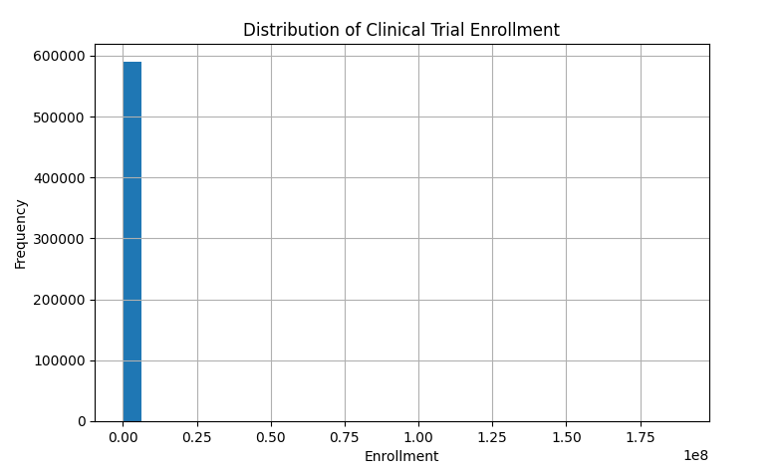
After looking at the enrollment distribution, I looked into the number of arms and completion status variables. The average number of study arms was 2.15, with a median of two. This finding indicates that most clinical trials utilized relatively simple study designs containing only two treatment groups. The majority of the studies in the sample used were classified as completed, however a notable proportion of studies had an unknown recruitment status or were still in the process of recruiting. Figure 2 below shows the full distribution of completion status.
Figure 2
Completion Status Distribution
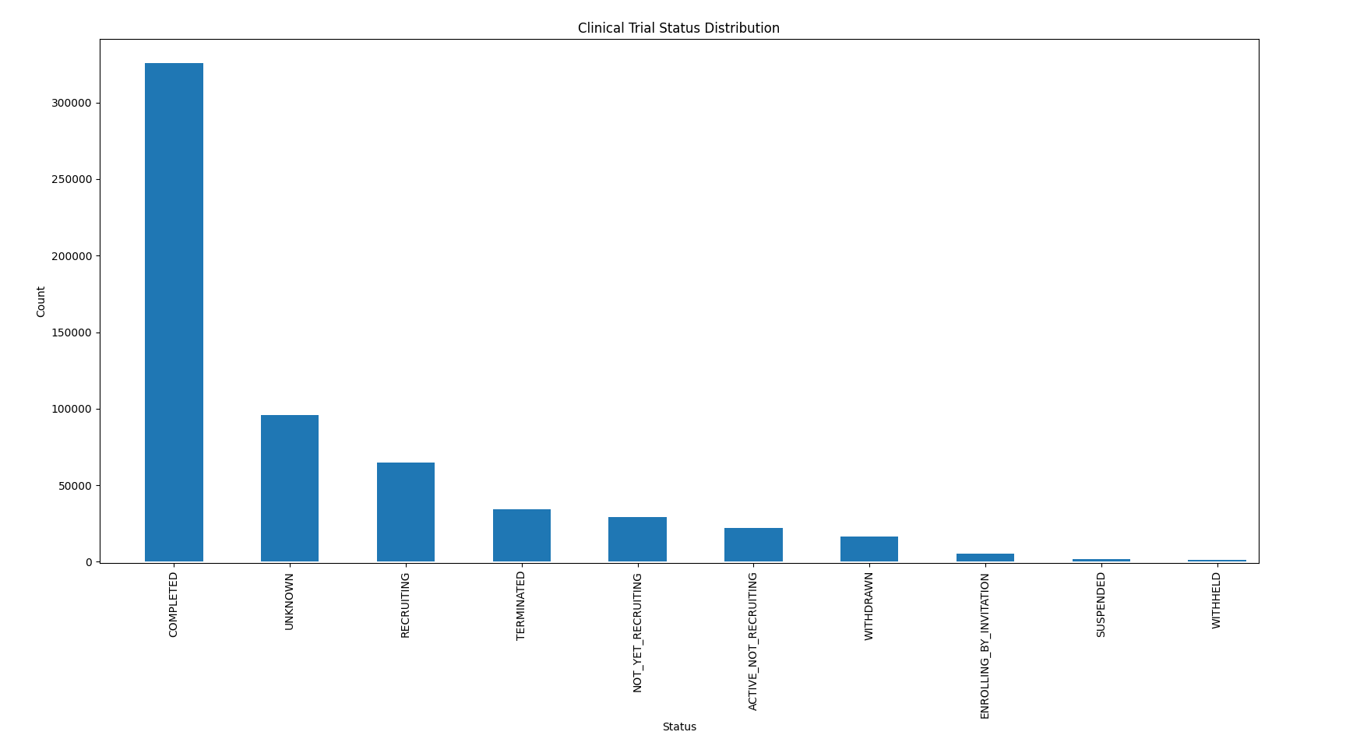
Next, I explored the study type variable. In regard to the study type, interventional studies represented 76.44% of all records and therefore constituted the majority of the data. Approximately a quarter of the dataset was from observational studies. Phase 2 studies made up the largest proportion of trials, followed by phase 1 then phase 3. Figure 3 below shows this distribution.

Figure 3
Trial Phase Distribution
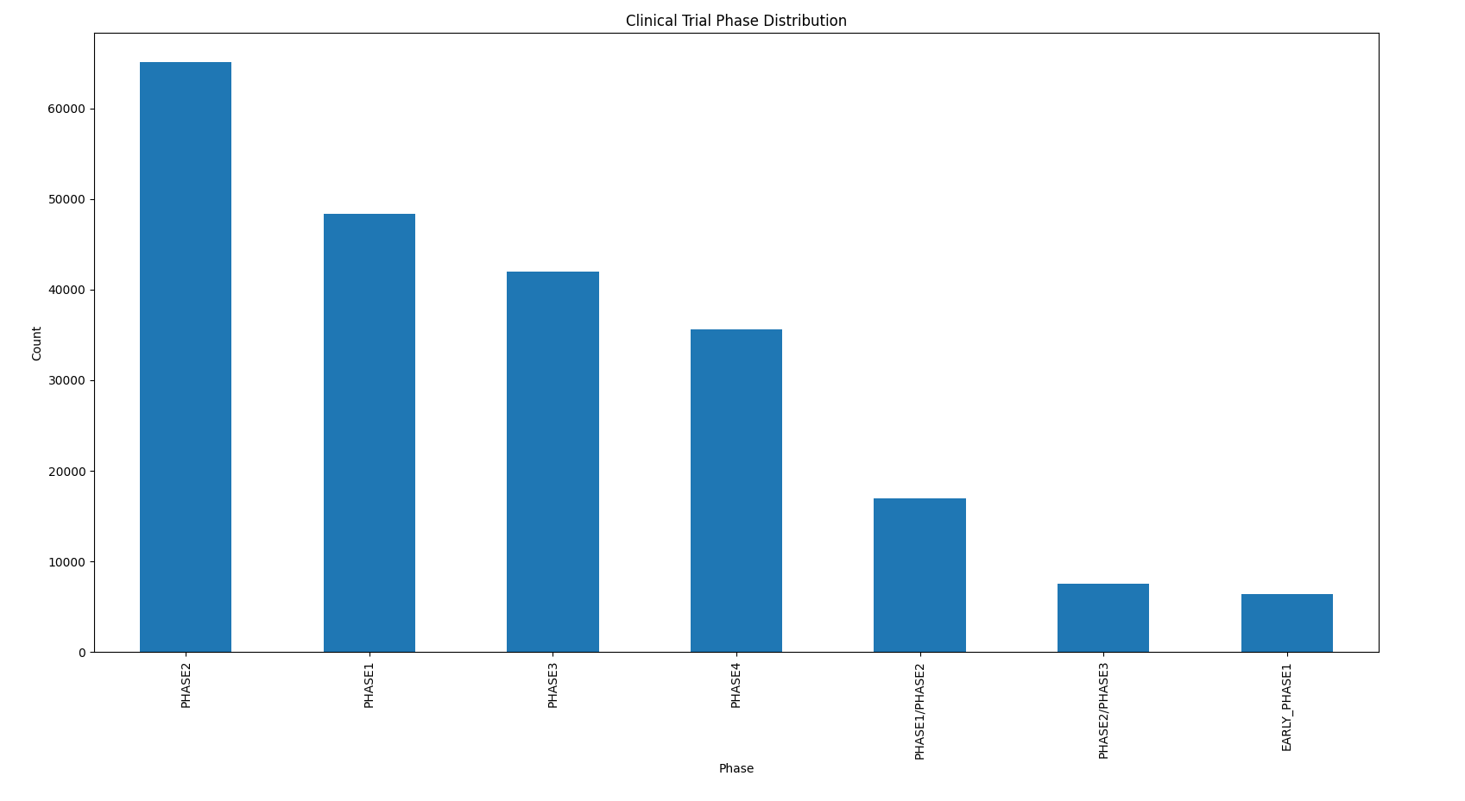
Research Question 1
After completing the preliminary descriptive statistics, I moved on to address the research questions through hypothesis testing. The first research question was, what clinical trial characteristics are associated with successful participant recruitment? The null hypothesis for this question was that there is no statistically significant relationship between clinical trial characteristics and successful participant recruitment. To test this hypothesis a Chi-square test of independence was conducted examining the relationship between clinical trial phase and trial success.
The results of this analysis indicated a statistically significant relationship between the variables. The Chi-square statistic was 5082.23 and the p value was 0. Since the p-value was substantially below the significance threshold of .05, the null hypothesis was rejected. These findings indicate that an association exists between clinical trial phase and successful trial completion. Based on this project’s definition of successful recruitment this means that trial phase may influence participant recruitment outcomes. A summary of this test is in Figure 4 below.
Figure 4
Screenshot of Chi-square results from Python Code
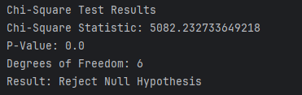
The existence of a statistically significant relationship indicates that there is not uniform distribution of successful recruitment across all clinical trial phases. Certain phases seem to be associated with higher rates of successful trial completion than others. As discussed in the introduction, the different phases of clinical trials serve different purposes and therefore have differing designs. The findings of this hypothesis test suggest that the factors associated with different phases may influence recruitment outcomes.
While the analysis demonstrates a statistically significant relationship, it’s important to note that it does not establish causation. Additional variables such as sponsor type, therapeutic area, geographic location, and eligibility requirements may also influence the recruitment outcomes. Regardless, the results suggest that trial phase should be considered an important factor when planning future recruitment efforts.
Research Question 2
The second research question was, what clinical trial characteristics are associated with successful participant retention? The null hypothesis for this question was that there is no statistically significant relationship between clinical trial characteristics and successful participant retention.
Prior to conducting the hypothesis testing for this question and analysis was completed on the drop_withdrawals table. This analysis revealed several common reasons that participants dropped out of clinical trials. The most frequently observed reason was participant withdrawal by subject followed by loss to follow-up and then adverse events. These findings, which are summarized in Figure 5 below, indicate that participant burden, participant engagement and adverse treatment related outcomes are important considerations when designing clinical trials aiming to maximize retention.
Figure 5
Clinical Trial Drop out Reasons
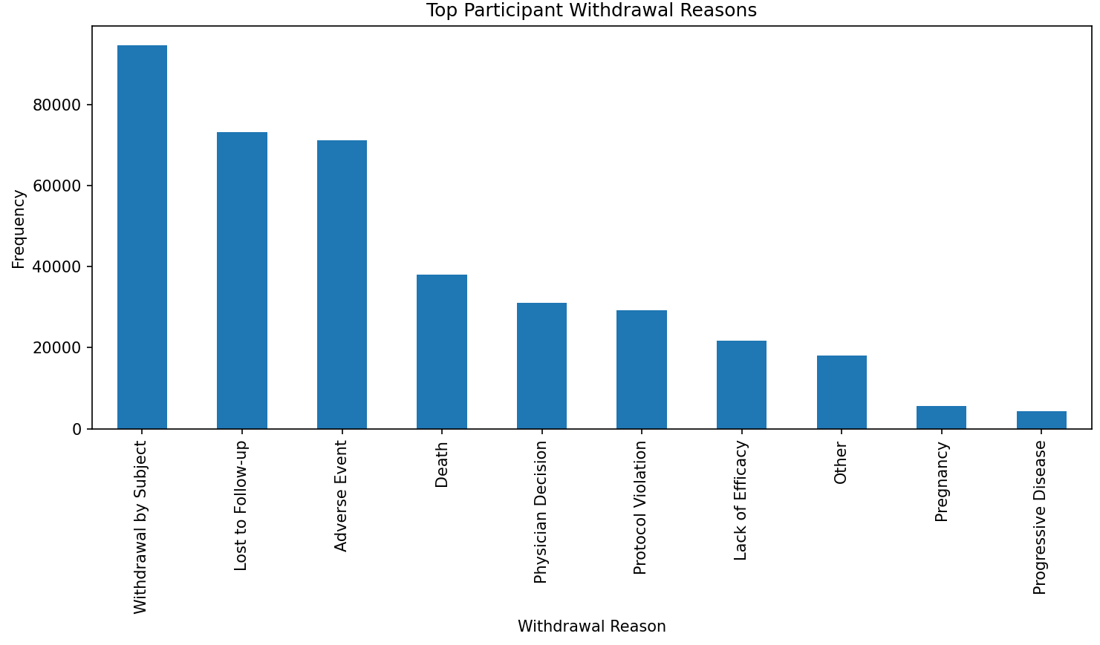
The withdrawal analysis provided valuable insight into why participants fail to complete clinical trials. Withdrawal by subject was the most common reason for attrition, suggesting that participant motivation, convenience, and overall study burden may play key roles in retention. Similaryl, the high frequency of loss to follow-up indicates that maintaining participant engagement throughout a study remains a significant challenge. Adverse events were another major contributor to participant withdrawal, highlighting the importance of participant safety and communication throughout the trial process.
To actually address the research question regarding retention in the form of a hypothesis test, a one-way ANOVA was performed to determine whether or not retention rates differed across clinical trial phases. The analysis resulted in an F-statistic of 695.59 and a p-value of 0. Since the [-value was below the significance threshold of .05, the null hypothesis was rejected. These findings indicate that there are statistically significant differences in retention rates across different clinical trial phases. The summary of the ANOVA results is in figure 6 below.
Figure 6
Screenshot of ANOVA Results from Python Code

Further examination of the retention analysis showed that Early phase 1 and phase 1 studies had the highest retention rates, while phase 2 and phase 3 studies exhibited notably lower retention rates. A summary of these retention rates is in Table 1 below.

Table 1
Retention Rate by Phase Analysis
Phase | Retention Rate
Early Phase 1 | 0.99
Phase 1 | 0.98
Phase 2 | 0.93
Phase 3 | 0.92
Phase 4 | 0.97

A possible explanation for this observation is that later-stage studies often involve larger participant populations, longer study durations, and more demanding participation requirements as these are the studies that are focused more on efficacy of the drug. These factors increase the burden on the participant and create additional opportunities for withdrawal. The findings suggest that trial phase not only is related to recruitment outcomes but also has a measurable relationship with participant retention.
Discussion
Overall, the findings in this study aligns with those found during the literature review. Several authors emphasized the importance of participant burden, scheduling flexibility, and creating patient-centric clinical trial designs in improving recruitment and retention outcomes. The withdrawal reason analysis that was conducted in this study aligns closely with those findings. The number one and number two withdrawal reasons observed were withdrawal by subject and loss to follow-up, respectively. This suggests that participant experience remains a critical factor in successful trial completion.
The literature also revealed the importance of designing studies that minimize disruption to participants’ daily lives. While the AACT database did not directly measure scheduling flexibility or participant burden, the observed withdrawal patterns in the data provide indirect support for these concepts. Participants may be more likely to remain engaged in studies that are convenient and designed with their experience in mind.
Another important finding in this study was the statistically significant relationship between clinical trial Phase and both recruitment and retention. While trial phase alone does not explain why some studies perform better than others, it appears to serve as an indicator of underlying differences in study design and operational complexity. This indicates that organizations should consider tailoring recruitment and retention strategies based on the specific challenges associated with each phase of clinical trial.
Finally, the findings of this study reinforce the concept that successful clinical trials require more than simply enrolling large numbers of participants. Long-term participant engagement is equally important. Organizations that focus both on recruitment and on retention are more likely to generate complete datasets, reduce study delays, and ultimately have success in advancing their therapies.
CONCLUSION
This research project set out to analyze historical clinical trial data in order to determine what factors influence the recruitment and retention of clinical trial participants. This focus was born of the desire to help improve the clinical trial phase of biopharmaceutical research of which participant recruitment and retention are key elements. The project utilized data from the AACT database which is a database consisting of compiled data from clinicaltrials.gov. The data was cleaned and analyzed using Python and all statistical analyses were completed within the same environment.
The results of the study demonstrated statistically significant relationships between clinical trial phase and both recruitment and retention. The Chi-square analysis indicated that recruitment success varies across clinical trial phases, while the ANOVA analysis demonstrated statistically significant differences in participant retention rates among phases. In addition, the withdrawal analysis identified participant withdrawal by subject, loss to follow-up and adverse events as the leading contributors to participant attrition.
Overall, the findings of this study suggest that clinical trial success is influenced by a variety of study-level characteristics and that participant retention deserves as much attention as participant recruitment. Through improving both recruitment and retention practices, organizations can reduce delays, improve data quality, and increase the likelihood of successful completing clinical trials. Ultimately, these improvements may accelerate the development of new drugs and treatments and therefore benefit the biopharmaceutical industry as a whole.
RECOMMENDATIONS
Based on the findings of the hypothesis tests and other analyses, a series of recommendations can be made for the future.
My first recommendation is that clinical trial be designed in a participant-centric manor. Participant withdrawal and loss to follow-up were among the most common reasons for attrition, because of this, future clinical trials should prioritize participant convenience through flexible scheduling, reduced visit requirements and remote study participation where feasible.
My second recommendation is that particular attention should be paid to Phase 2 and Phase 3 studies. Retention rates were lowest among these two phases. Organizations should consider devoting additional resources toward participant engagement and retention strategies for these stages of development. Additionally, it may be worth analyzing key differences between these phases and the phases with better retention rates to maybe identify the source of the difference in retention.
My third recommendation is that organizations should continue to closely monitor adverse event trends in their trials. This was the third leading cause for participant withdrawal. Clinical trial teams should closely monitor participant safety and maintain effective communication regarding treatment-related concerns. If organizations take all of these findings into consideration, I believe that moving forward recruitment and retention can be greatly improved for clinical trial studies. Improving these elements will in turn allow for greater success in the biopharmaceutical industry as a whole.
Future Research
As was mentioned previously this study was not without its limitations, future research should aim to explore additional variables beyond those that were available within the current dataset. To support this, future studies may benefit from analyzing data on a participant-level instead of just on the study level. These analyses could provide a more detailed understanding of the factors influencing enrollment and withdrawal decisions. I also believe a deeper dive should be conducted on the root cause between the difference in recruitment and retention across the different trial phases. Understanding why the differences exist will help the creation of solutions moving forward for the designs of clinical trials.

REFERENCES
AACT Database | Clinical Trials Transformation Initiative. (2016). Ctti-Clinicaltrials.Org. https://aact.ctti-clinicaltrials.org/documentation
Amaya Perez-Brumer, Balasa, R., Doshi, A. S., Bowra, A., Brisson, J., Philbin, M. M., Doan, T., & Oldenburg, C. E. (2025). Qualitative evaluation to improve participant engagement and retention in remote COVID-19 treatment trials. Discover Public Health, 22(1), 572–572. https://doi.org/10.1186/s12982-025-00970-3
Cameron, D., Willoughby, C., Messer, D., Lux, M., Aitken, M., & Getz, K. (2020). Assessing Participation Burden in Clinical Trials: Introducing the Patient Friction Coefficient. Clinical Therapeutics, 42(8), e150–e159. https://doi-org.csuglobal.idm.oclc.org/10.1016/j.clinthera.2020.06.015
FDA. (2022). Development & approval process (drugs). In U.S. Food and Drug Administration. www.fda.gov. https://www.fda.gov/drugs/development-approval-process-drugs
Grand View Research. (2024). Biopharmaceutical market size, share | industry report, 2030. In Grandviewresearch.com. https://www.grandviewresearch.com/industry-analysis/biopharmaceutical-market
Hung, M., Amir Mohajeri, Konstantinia Almpani, Carberry, G., Wisniewski, J. F., Janes, K., Janes, B., Hardy, C., Golnoush Zakeri, Raymond, B., Trinh, H., Bretner, J., Cheever, V. J., Garibyan, R., Bachstein, P., & Licari, F. W. (2024). Successes and Challenges in Clinical Trial Recruitment: The Experience of a New Study Team. Medical Sciences, 12(3), 39–39. https://doi.org/10.3390/medsci12030039
Jager, W. (2023). The importance of clinical trials in advancing medical research. Annals of Clinical Trials and Vaccines Research, 13(3), 93–98. https://www.openaccessjournals.com/articles/the-importance-of-clinical-trials-in-advancing-medical-research-16485.html
Medical definition of biopharmaceutics. (n.d.). In www.merriam-webster.com. Retrieved July 23, 2026, from https://www.merriam-webster.com/medical/biopharmaceutics
Nazar Hembara. (2024, April 21). Phases Of Clinical Trials: Clinical Trial Phases Explained. Allclinicaltrials.Com; AllClinicalTrials. https://www.allclinicaltrials.com/blog/phases-of-clinical-trials
Polonsky, M. J., & Waller, D. S. (2005). Designing and managing a research project : A business student’s guide. Sage Publications.
Science Insights Team. (2025, November 8). The major challenges in conducting clinical trials - ScienceInsights. ScienceInsights. https://scienceinsights.org/the-major-challenges-in-conducting-clinical-trials/
Van Ooik, K., & Hutton, M. (2025). Retention by Design: Operationalizing Patient-Centric Trials Without Increasing Site Burden. Applied Clinical Trials, 34(4), 32–36.
World Health Organization. (n.d.). Clinical trials. In www.who.int. Retrieved July 23, 2026, from https://www.who.int/health-topics/clinical-trials/#tab=tab_1

