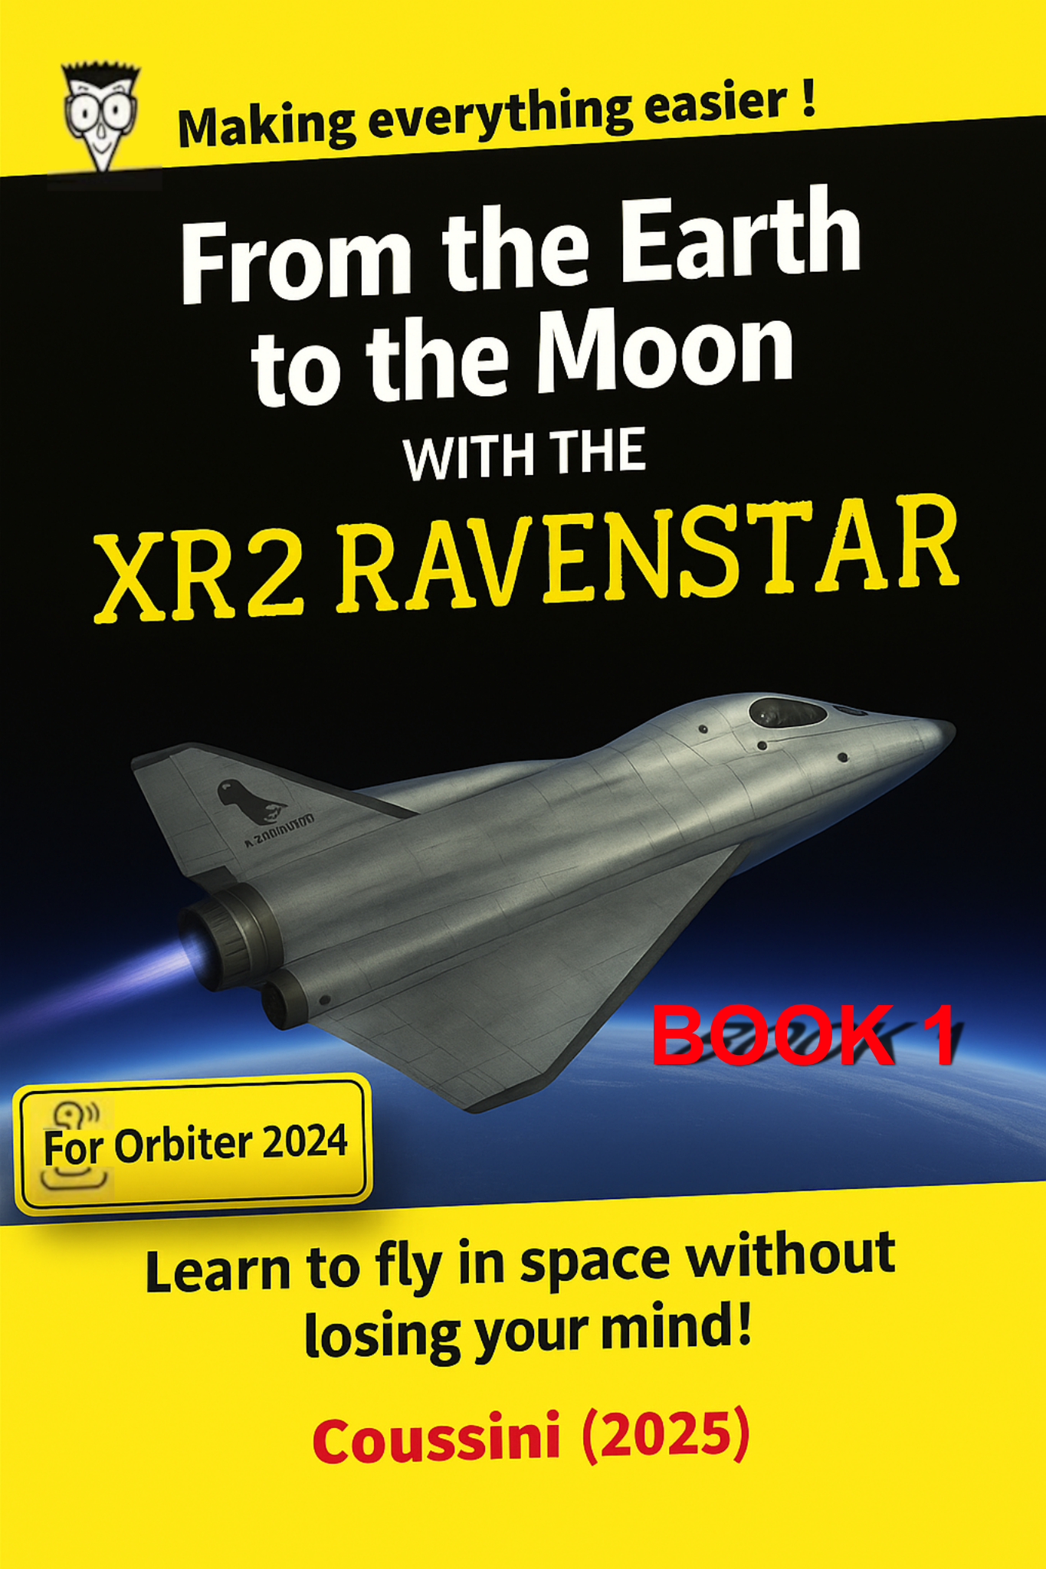
Installation of Orbiter 2024 and elements for this trip

To help you complete this tutorial, my friend ChatGPT helped me optimize the fuel for this beautiful journey with Orbiter 2024.

A) Here is the list of elements necessary to complete this tutorial

Orbiter 2024
https://www.orbiter-forum.com/resources/orbiter-2024.5634/
01 - Your brand new XR2 Ravenstar.
https://www.orbiter-forum.com/resources/xr2-official-for-orbiter-2024.5644/
02 - Lunar Transfer MFD.
https://www.orbiter-forum.com/resources/lunartransfer-mfd-ltmfd.5501/
03 - Burn Time Calc MFD.
https://www.orbiter-forum.com/resources/burntimecalcmfd-btc-3-1-for-orbiter-2016.736/
04 - Base Sync MFD.
https://www.orbiter-forum.com/resources/basesyncmfd-3-3-for-orbiter-2016.2705/
05 - Universal Autopilots.
https://orbiter-forum.com/resources/universal-autopilots-0-3-1.212/
06 - Pursuit MFD.
https://www.orbiter-forum.com/resources/pursuitmfd-2016.3096/
07 - Moon Landing Pad replacement
https://www.orbiter-forum.com/resources/moon-landing-pad-replacement.5683/
08 - XRSound with No ATC.
https://www.orbiter-forum.com/resources/xrsound-with-no-atc.5684/

B) Installing the files for this tutorial

Copy the unzipped content of Orbiter 2024 to a location of your choice. (*)

(*) IMPORTANT:
This tutorial will use C:/Orbiter-2024 as a reference.

01 - Copy the contents of XR2Ravenstar-2.0-x86 to the root of C:/Orbiter-2024.
02 - Copy the contents of LTMFD16 to the root of C:/Orbiter-2024.
03 - Copy the contents of BurnTimeCalcMFD-v.3.2.0-2016 to the root of C:/Orbiter-2024.
04 - Copy the contents of BaseSync 3.3 for Orbiter 2016 to the root of C:/Orbiter-2024.
05 - Copy the contents of uap-0.3.1 to the root of C:/Orbiter-2024.
06 - Copy the contents of PursuitMFD_171119 to the root of C:/Orbiter-2024.
07 - Copy the contents of Moon Landing Pad to the root of C:/Orbiter-2024.
08 - Copy the contents of XRSound with No ATC to the root of C:/Orbiter-2024.
C) Creation of a scenario for this tutorial
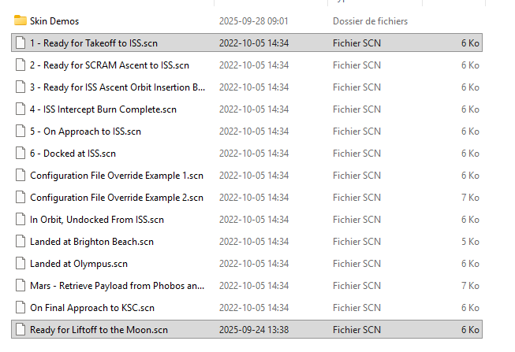
01 - Open your C:/Orbiter-2024 folder, then the Scenarios folder and finally the XR2 Ravenstar folder.

02 - In the XR2 Ravenstar folder, take a copy of the following scenario:
"1 - Ready for Takeoff to ISS.scn".

03 - Rename this copy as "Ready for Liftoff to the Moon.scn".

04 - Open the file “Ready for Liftoff to the Moon.scn” using a text editor.

05 - Replace the 6th line “Date MJD 51984.6053168878” with “Date MJD 51918.06”.

06 - Save this file.

D) First window

01 - Open your C:/Orbiter-2024 folder, then double-click on Orbiter_ng.exe.

Here's what you'll get.
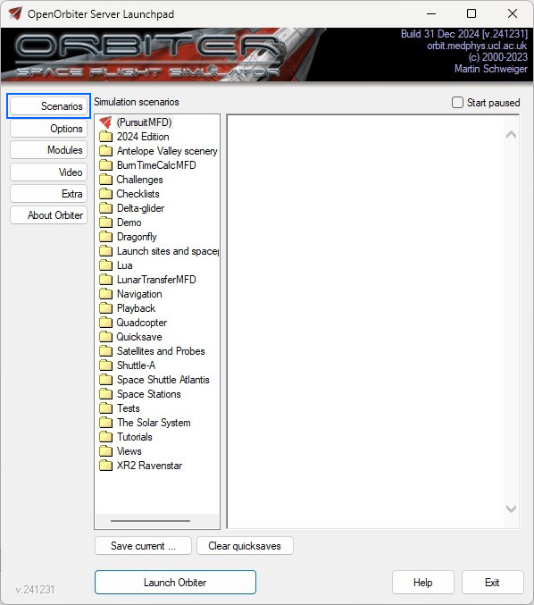

E) Instruments & panels tab (Options)

01 - Click the Options button (left), then choose Instruments & panels.
02 - Adjust the value like the ones below.

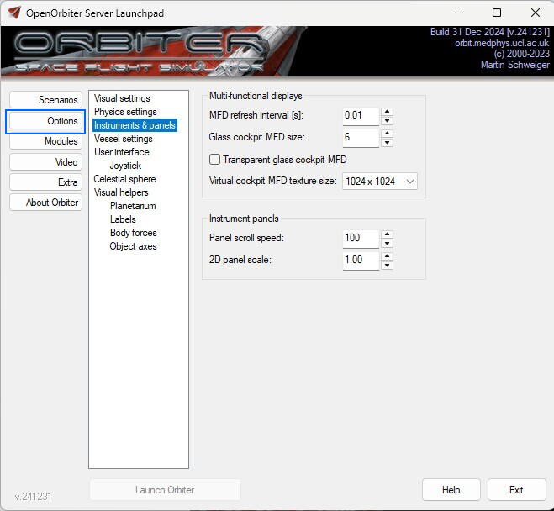

F) Joystick tab (Options)

01 - Still regarding the Options button (on the left), choose Joystick.
02 - In the drop-down list under Joystick device select your joystick.

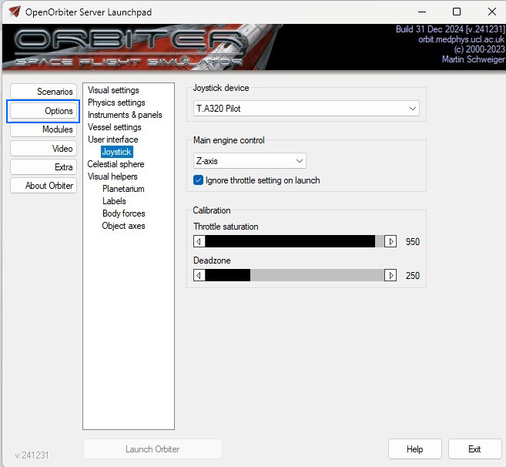

G) Video button

01 - Click on the Video button (left).
02 - Adjust the values like the ones below.
03 - Under 3D device, choose your graphics card.

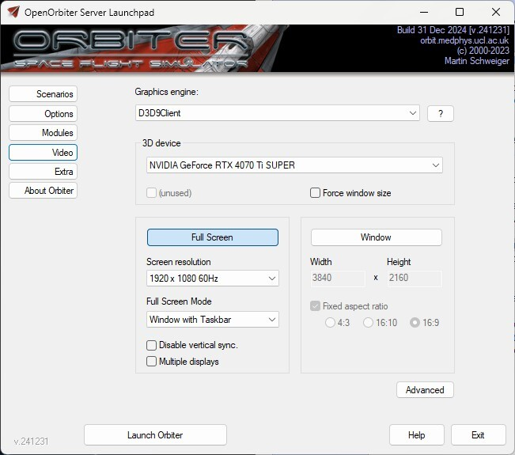

H) Modules button

01 - Click on the Modules button.
02 - Choose modules such as the following.
03 - Click on the Exit button to close this window.
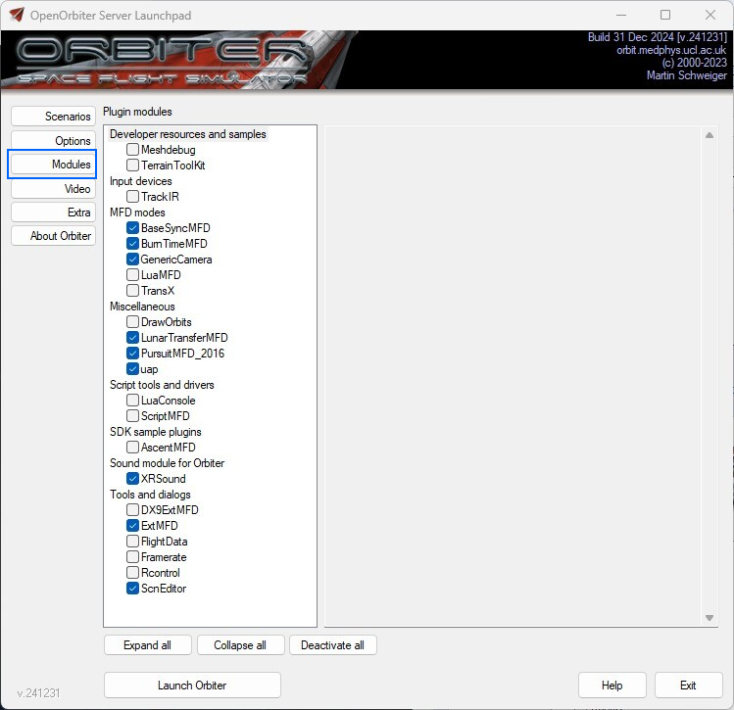
We are ready to start a new session with Orbiter 2024.

I) Start your scenario for this trip
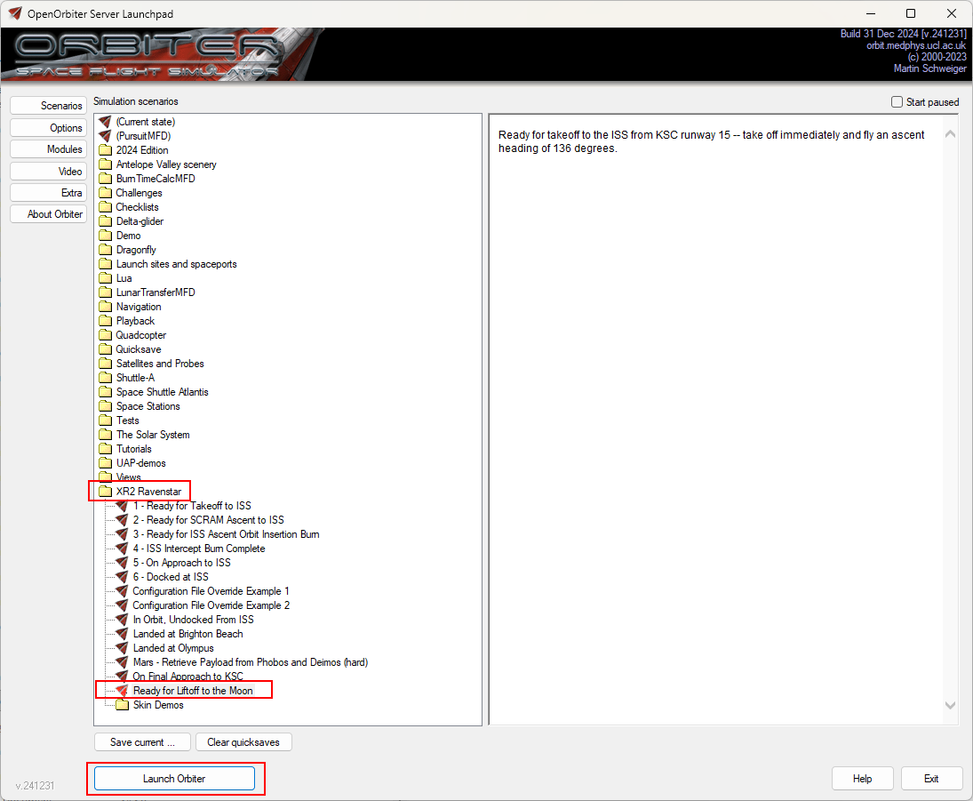
01 - Open your C:/Orbiter-2024 folder then double-click on Orbiter_ng.exe.

02 - Double-click on “Ready for Liftoff to the Moon.scn” as you see in the following image. It's in the XR2 Ravenstar folder.

J) Menu bar
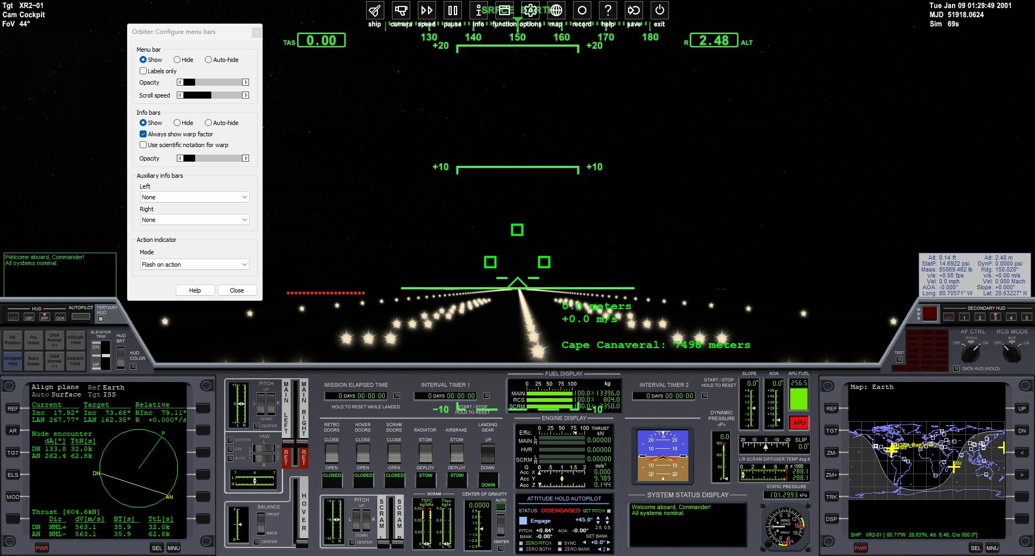
Click on the image to enlarge it

01 - Move your mouse to the center and top of the screen.
02 - A context menu appears.
03 - Right-click on this context menu.
04 - In the Menu bar option, choose Show.
05 - Press the Close button to close this window.

K) We will configure the Lunar Transfer MFD on the left
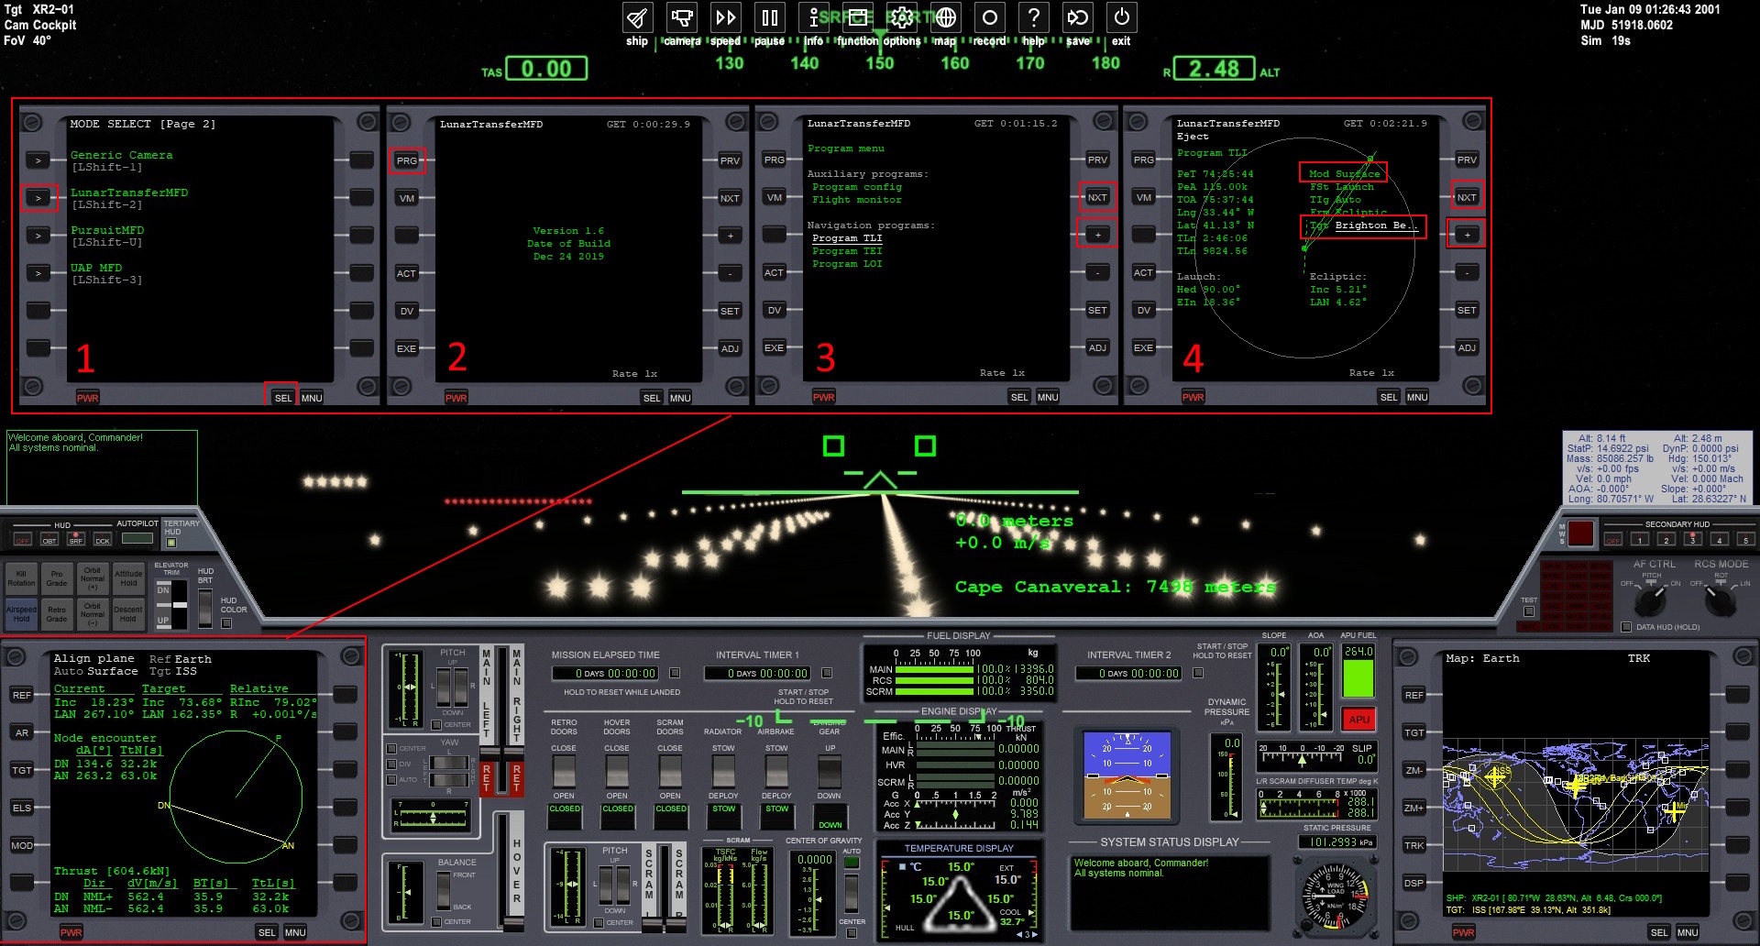
Click on the image to enlarge it

In the previous image we have 4 steps to configure the MFD on the left

Step 1
01 - Click on the SEL button, as many times as necessary, in order to see LunarTransferMFD in this menu.
02 - Click on the button to the left of the word LunarTransferMFD to select it.

Step 2
01 - Click on the PRG button on the left to see the list of programs.

Step 3
01 - Click on the NXT button to select Program TLI.
02 - Click the [+] button to enter parameters for Program TLI.

Step 4
01 - You are already on the Mod field.
02 - Click on the [+] button to choose Mod Surface.
03 - Click on the NXT button to select the Tgt field.
04 - Click on the [+] button to choose Tgt Brighton Be..

L) We will configure the ATTITUDE HOLD AUTOPILOT in the center
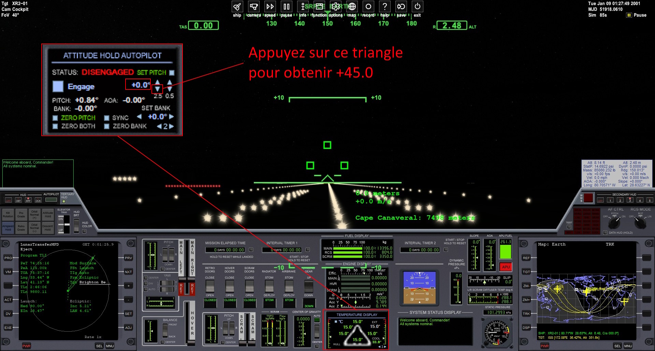
Click on the image to enlarge it

01 - Click on 2 key on your keyboard (not the numeric keypad) to see ATTITUDE HOLD AUTOPILOT.

02 - Adjust the PITCH value using the small blue triangle as shown, to obtain +45.0.

M) We will configure the Universal Autopilots control MFD on the right
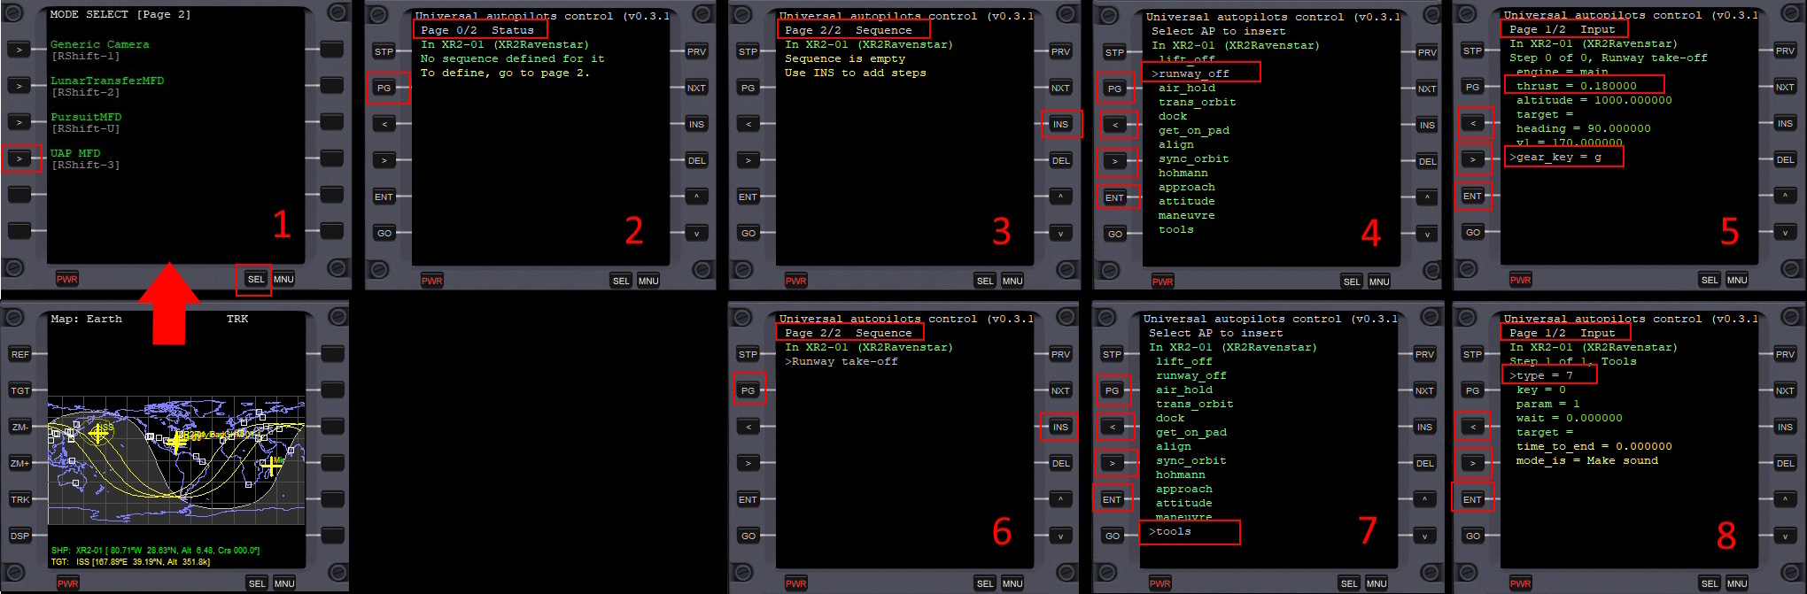
Click on the image to enlarge it

In the previous image we have 8 steps to configure the MFD on the right

On the right in the XR2 Ravenstar screen we have the MAP MFD (represents earth).

We will replace it with Universal Autopilots control MFD

Step 1
01 - Click on the SEL button, as many times as necessary, in order to see UAP MFD in this menu.
02 - Click on the button to the left of the word UAP MFD to select this MFD.

Step 2
01 - Display the Sequence page with the PG button.

Step 3
01 - Press the INS key to add a new sequence.

Step 4
01 - Use the [>] button to highlight runway_off.
02 - Press the ENT key to accept this new sequence.
03 - Display the Input page with the PG button.

Step 5
01 - Use the [>] button to highlight the thrust field.
02 - Press the ENT key to bring up an input window.
03 - Type the value ‘0.18’ and press the ENTER key on your keyboard.
04 - Use the [>] button to highlight gear_key.
05 - Press the ENT key to bring up an input window.
06 - Type the value ‘g’ and press the ENTER key on your keyboard.

Click on the image to enlarge it

Step 6
01 - Display the Sequence page with the PG button.
02 - Press the INS key to add a new sequence.

Step 7
01 - Use the [>] button to highlight tools.
02 - Press the ENT key to accept this new sequence.
03 - Display the Input page with the PG button.

Step 8
01 - Use the [>] button to highlight the type field.
02 - Press the ENT key to bring up an input window.
03 - Type the value ‘7’ and press the ENTER key on your keyboard.

N) Saving the scenario for this trip

01 - In the context menu, at the very top of the screen, click exit.
02 - You will see the Orbiter 2024 Simulation scenarios menu.

N.B: The “(Current state)” scenario is the scenario that you have just created.

03 - Click on the Save current… button (at the bottom of the screen) to save your scenario.
04 - In the Scenario name field enter "XR2 is going into Earth orbit".
05 - Click the OK button to accept this name.

06 - Click at the bottom and right of the screen, on the Exit button to leave Orbiter 2024.

