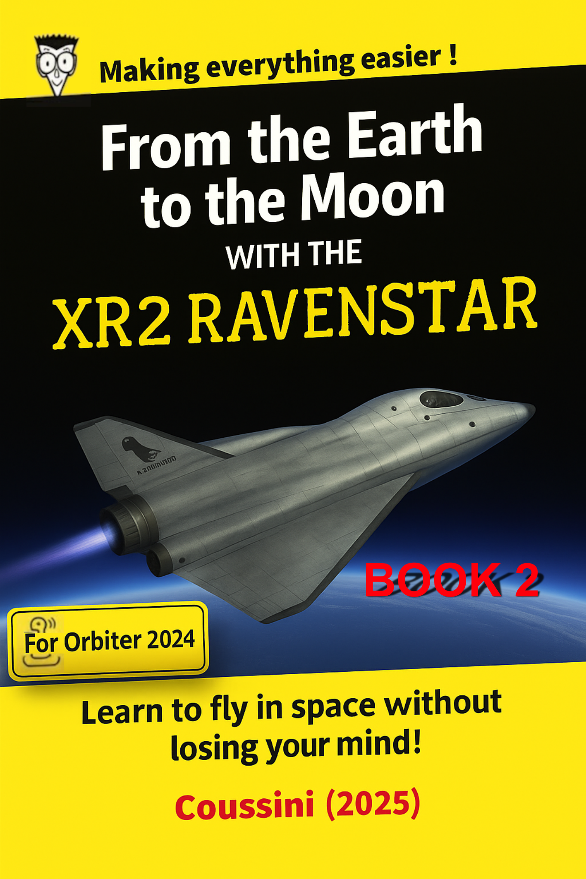
Orbiter 2024 keys for this tutorial

Here I will explain the most important keys or buttons for this tutorial.

The most important keys to memorize are in red.

KEYS or BUTTONS | UTILISATION
XR2 RAVENSTAR DASHBOARD DISPLAY
CTRL + up arrow (↑ or ▲) | Go to the dashboard above
CTRL + low arrow (↓ or ▼) | Go to the dashboard below
SIMULATION (VERY IMPORTANT KEYS)
CTRL + P | Pausing the simulation
T (*) | Accelerate simulation from 0x, 10x... to 100000x
R (*) | Decelerate the simulation from 100000x... to 0x and 0.1x
PROPULSION (NUMERIC KEYPAD)
“*” on the numeric keypad | Turn off the main thrusters
“+” on the numeric keypad | Ignition of the main thrusters
“6” on the numeric keypad | Ignition of the attitude thrusters (forward)
“9” on the numeric keypad | Ignition of the attitude thrusters (towards the rear)
“5” on the numeric keypad | Stop the ship from rotating
VIEW FROM ORBITER 2024
F1 | Show external view versus internal view
F8 | Display the different internal views (2D, 3D, generic)
H | Show 3 different HUDs (SRFCE, DOCK, ORBIT)
ATTITUDE BUTTONS
LIN | Translation
ROT | Rotation (not used in the tutorial)
PRO GRADE or PRO GRD | Prograde
RETRO GRADE or RETR GRD | Retrograde
ORBIT NORMAL + ou NML + | Normal +
ORBIT NORMAL - ou NML - | Normal -

(*) Do not exceed 10000x in this tutorial.
Let's prepare ourselves to better understand (open a scenario)

I invite you here, in the Let's prepare... section, to familiarize yourself with some of the buttons or keys explained before.

01 - Open your C:/Orbiter-2024 folder then double-click on Orbiter_ng.exe.

02 - Double-click on “In Orbit, Undocked From ISS” as you see in the following image. It's in the XR2 Ravenstar folder.
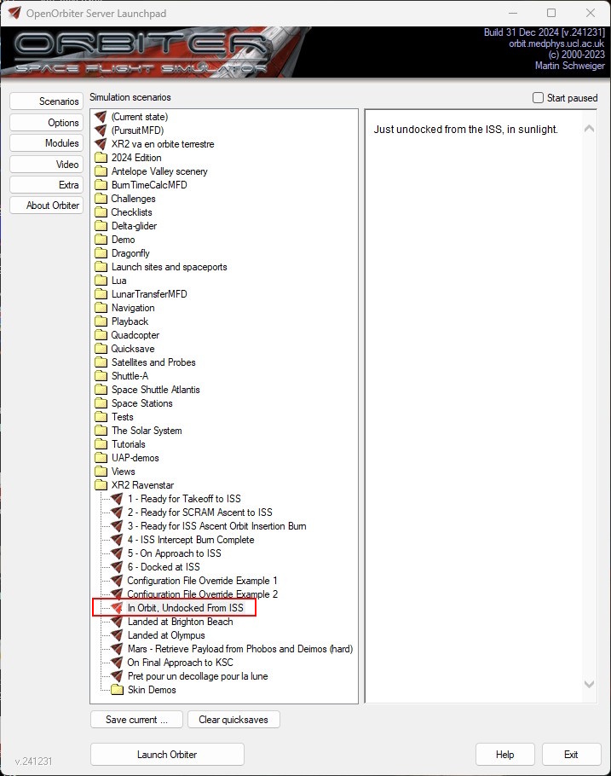

Let's prepare ourselves to better understand (views from Orbiter 2024)

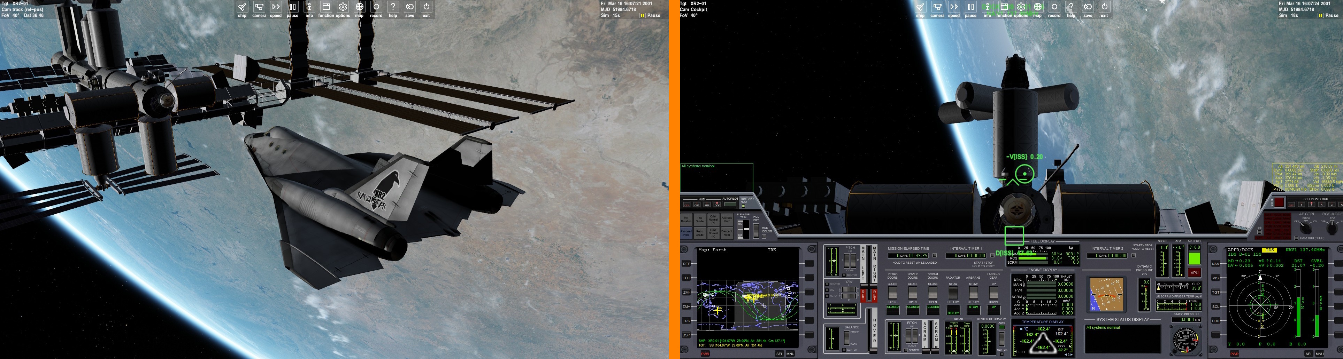
Click on the image to enlarge

The first view you see when you start the scenario is the one on the left.

To switch between the external and internal view of the ship, press F1.

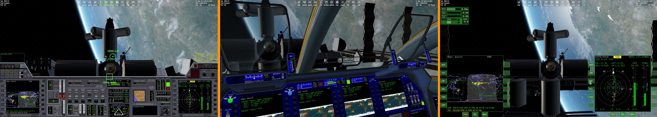
Click on the image to enlarge

To switch between different internal views of the ship, press F8. From the left we have the 2D view, then the 3D view and finally the generic view.

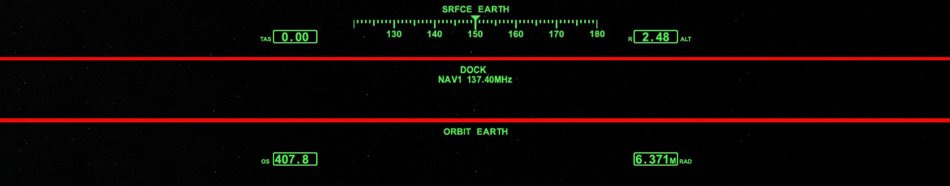
Click on the image to enlarge

To switch between the different Orbiter 2024 HUDs, press H.

From the top we have the SRFCE HUD (surface), then the DOCK HUD, and finally the ORBIT HUD.

Each of these HUDs offers benefits. We will only use the SRFCE and ORBIT HUD.
Let's prepare ourselves to better understand (basic instruments)

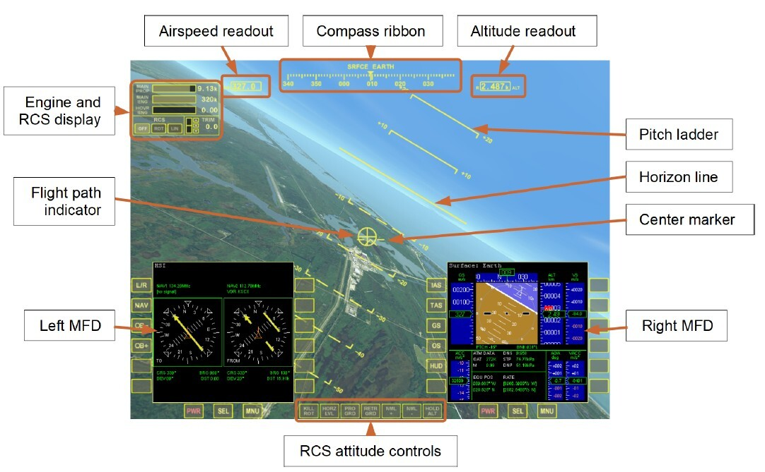
Click on the image to enlarge

The Orbiter 2024 simulation screen allows us to obtain a wealth of useful information for navigation.

MFD = Multifunction display.

Note that the 2D view is similar to the generic view as shown previously.

However, the attitude buttons, MFDs and fuel quantities are arranged differently in the 2D view.
Let's prepare ourselves to better understand (2D dashboards)

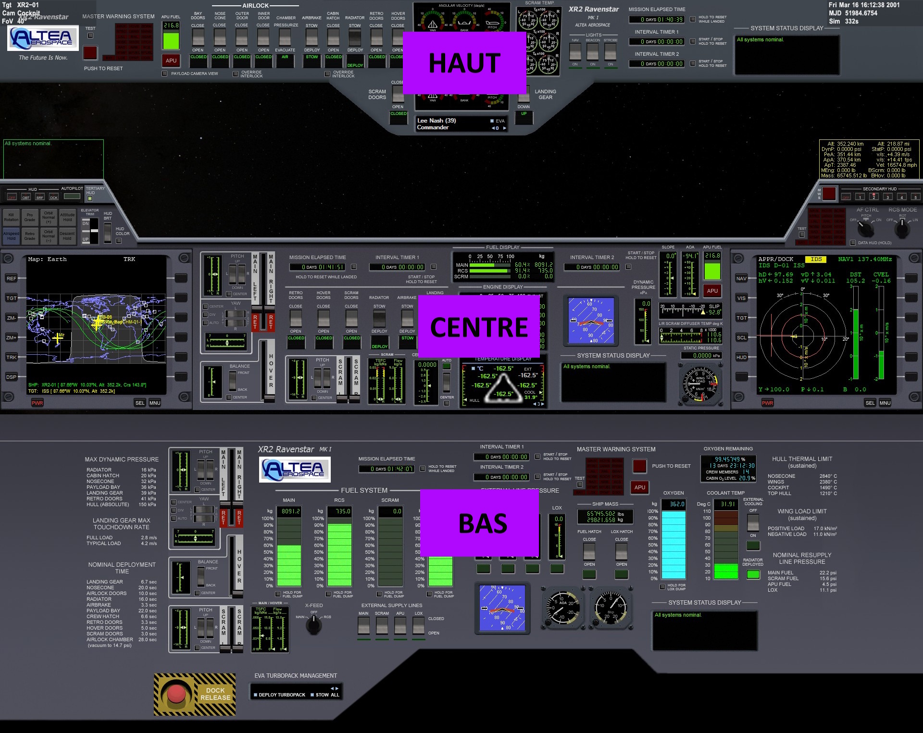
Click on the image to enlarge

The dashboards of the XR2 Ravenstar are haut (OVERHEAD), centre (CENTER) and bas (BOTTOM). To navigate between the different dashboards, use the following keys.

Touches
CTRL + up arrow (↑ or ▲) to go to the table above.
CTRL + down arrow (↓ or ▼) to go to the table below.

Let's prepare ourselves to better understand (explanation of simulation speed)

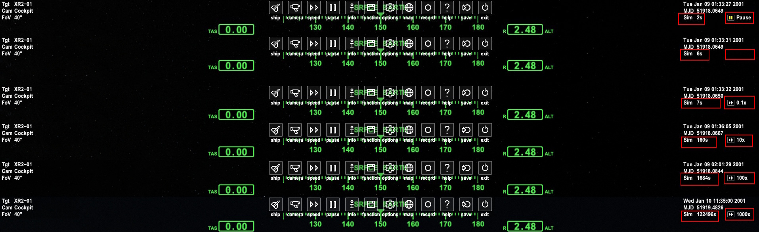
Click on the image to enlarge

I stacked various display headers taken during a simulation.

The first, at the top, explains that we are on PAUSE. This is a good time to think or consult a tutorial (CTRL+P).

Orbiter 2024 also offers a simulation acceleration function to accelerate phases where nothing is really happening or to move to a specific step.

I have circled the simulation speed with a red square. The empty red square represents normal simulation speed (no acceleration). Look at the Sim variable to the left of this empty red square and you will see that the seconds are ticking normally.

The red square with 0.1X represents a speed 10 times lower than normal.
The red square with 10X represents a speed 10 times faster than normal.
The red square with 100X represents a speed 100 times faster than normal... ETC.

IMPORTANT
- Never go 100,000X regarding this tutorial.
- It is very practical to accelerate the simulation to obtain a target value.
- After an acceleration, return the simulation speed to normal.

Touches
CTRL + P to pause the simulation
T to speed up the simulation
R to decelerate the simulation

Too high simulation speeds can affect the accuracy and stability of the simulation.

Let's prepare ourselves to better understand (play with simulation speed)

01 - In the context menu, at the very top of the screen, click exit.

02 - Double-click “In Orbit, Undocked From ISS”. It's in the XR2 Ravenstar folder.

We will practice with the simulation speed.

03 - Press F1 to display the 2D view.

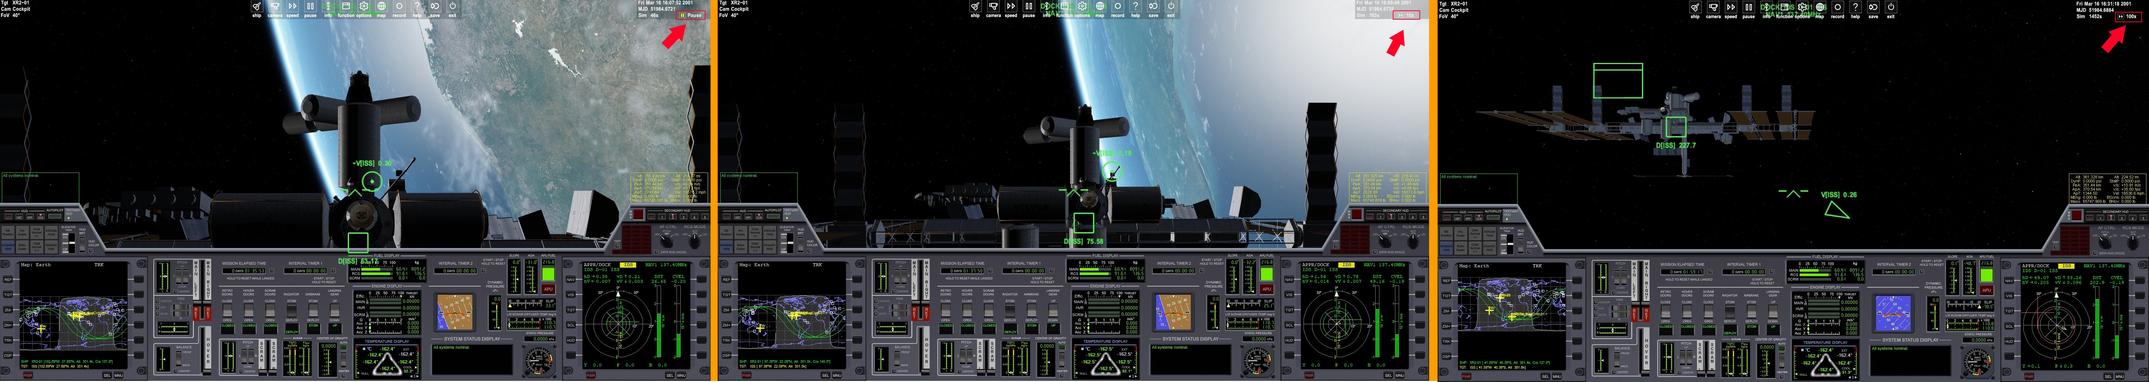
Click on the image to enlarge

The scenario you just loaded indicates that the XR2 Ravenstar is leaving the international station after undocking.

The first image on the left tells us that we are paused (CTRL-P)

As soon as we apply a speed of 10X (with the T key), the international station seems further away.

As soon as you apply a speed of 100X (with the T key), the international station moves quickly.

As soon as we return to a normal simulation speed (with the R key), the station moves slowly.

Always observe the upper right corner of the screen and the Sim variable during the simulation shift maneuver.

04 - In the context menu, at the very top of the screen, click exit.

Events to enter Earth orbit

EVENTS) | ACTION / TOUCHES
A) Preparations before the simulation | “XR2 Ravenstar (standby mode)”
B) TLn ± 500 | T or R then “XR2 Ravenstar (start mode)”
C) TLn = 300 (takeoff) | GO “Universal autopilot control MFD”
D) Shrill noise | MAIN 100% + ATTITUDE HOLD (ON)
E) ± 15.00 k | 8 + ▲ (PITCH 7) “Attitude hold autopilot MFD”
F) ± 24.00 k | (PITCH 7)
G) Mach 3 | SCRAM DOORS (OPEN) + SCRAM 100% + MAIN 0%
H) ± 30.00 k | ▲ (PITCH 5) “Attitude hold autopilot MFD”
I) ± 40.00 k | ▲ (PITCH 4) “Attitude hold autopilot MFD”
J) ± 50.00 k | ▲ (PITCH 3) “Attitude hold autopilot MFD”
K) SCRAM temp ± 7700°K | SCRAM DOORS (CLOSE) + MAIN 100%
L) Apa ± 200.00 k | MAIN 0%
M) ± 90.00 k | RADIATOR (DEPLOY) + APU (OFF) + PRO GRADE
N) EOI | Earth circularization “Burn time MFD (Apoapsis)”

To give you an idea of ​​the time it takes to carry out the different events mentioned above, I will show you the simulation times.

Simulation time
- From takeoff to 15 kilometers = 2 minutes and 29 seconds.
- From takeoff to 50 kilometers = 7 minutes and 29 seconds.
- From takeoff to 90 kilometers = 12 minutes and 05 seconds.

“As you see, 12 minutes and we are in space. Everything is happening quickly.”

Here's how we'll approach our tutorial and previous events

I will first offer you a summary, before developing each point in depth. Orbiter 2024 navigation Top Gun will be able to skip straight to the Procedures while beginners will be treated to the Procedures Explanations section. From then on, I will go through each part of this tutorial (from point A to point N (previous table))

01 - Start the scenario “XR2 is going into Earth orbit” by double-clicking on it. This scenario is just above the 2024 Edition folder in the “Simulation scenarios”.

IMPORTANT: “Pause using the CTRL+P keys between each page.”

A) Preparations before the simulation

A.1) Procedures
01 - On the “Overhead” dashboard, CABIN HATCH will be on OPEN.
02 - On the “Bottom” dashboard, EXTERNAL COOLING will be ON.
03 - APU sur OFF.
04 - Add a floating ORBIT MFD.

A.2) Explanations of procedures
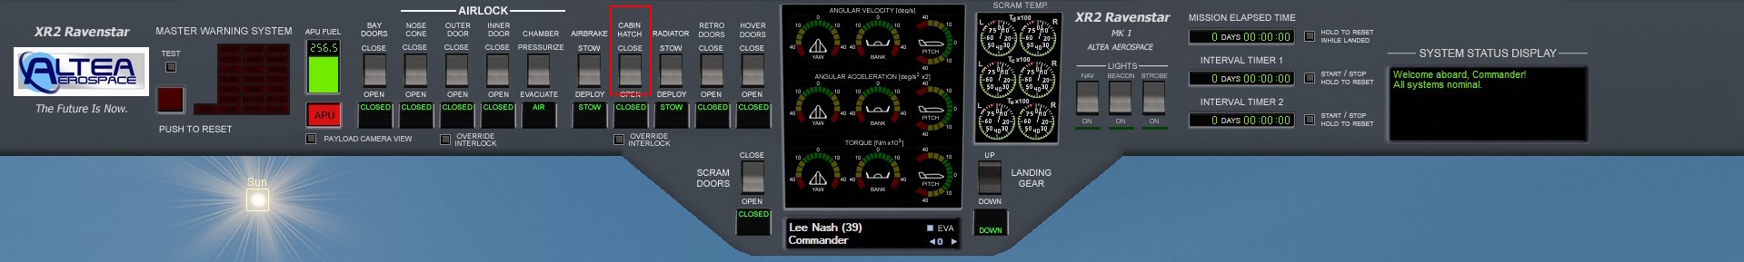
Click on the image to enlarge

01 - Show the “Overhead” dashboard of the XR2 Ravenstar.
02 - Press the button framed in red to open the CABIN HATCH.

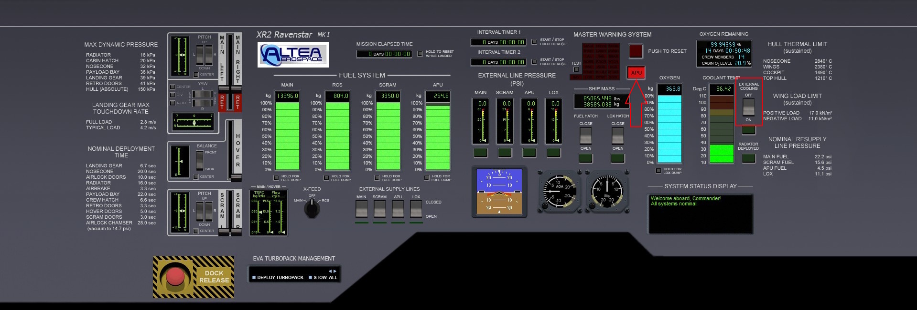
Click on the image to enlarge

03 - Show the “Bottom” dashboard of the XR2 Ravenstar.
04 - Press the button framed in red to activate EXTERNAL COOLING.

When you no longer hear the sound of the CABIN HATCH opening
01 - Press the red APU button, pointed by the red arrow.

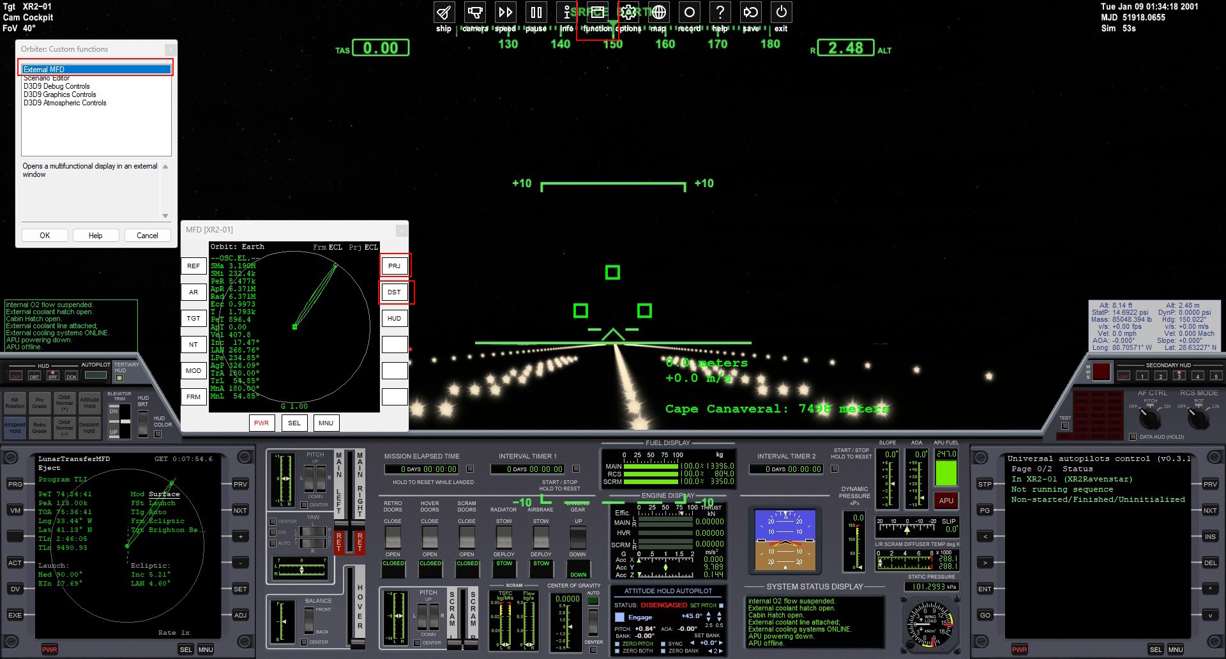
Click on the image to enlarge

02 - Display the “center” dashboard of the XR2 Ravenstar.
03 - Move your mouse to the center and top of the screen.
04 - Click on the function button.
05 - In the functions window, choose External MFD then press OK.
06 - Move the new window with the mouse, and place it as the previous image.
07 - In this window, click on the PRJ and DST buttons.

B) TLn ± 500

B.1) Procedures
01 - Accelerate the simulation up to Tln ± 500.
02 - On the “Overhead” dashboard, APU will be ON.
03 - On the “Overhead” dashboard, CABIN HATCH will be on CLOSE.
04 - On the “Bottom” dashboard, EXTERNAL COOLING will be OFF.

B.2) Explanations of procedures
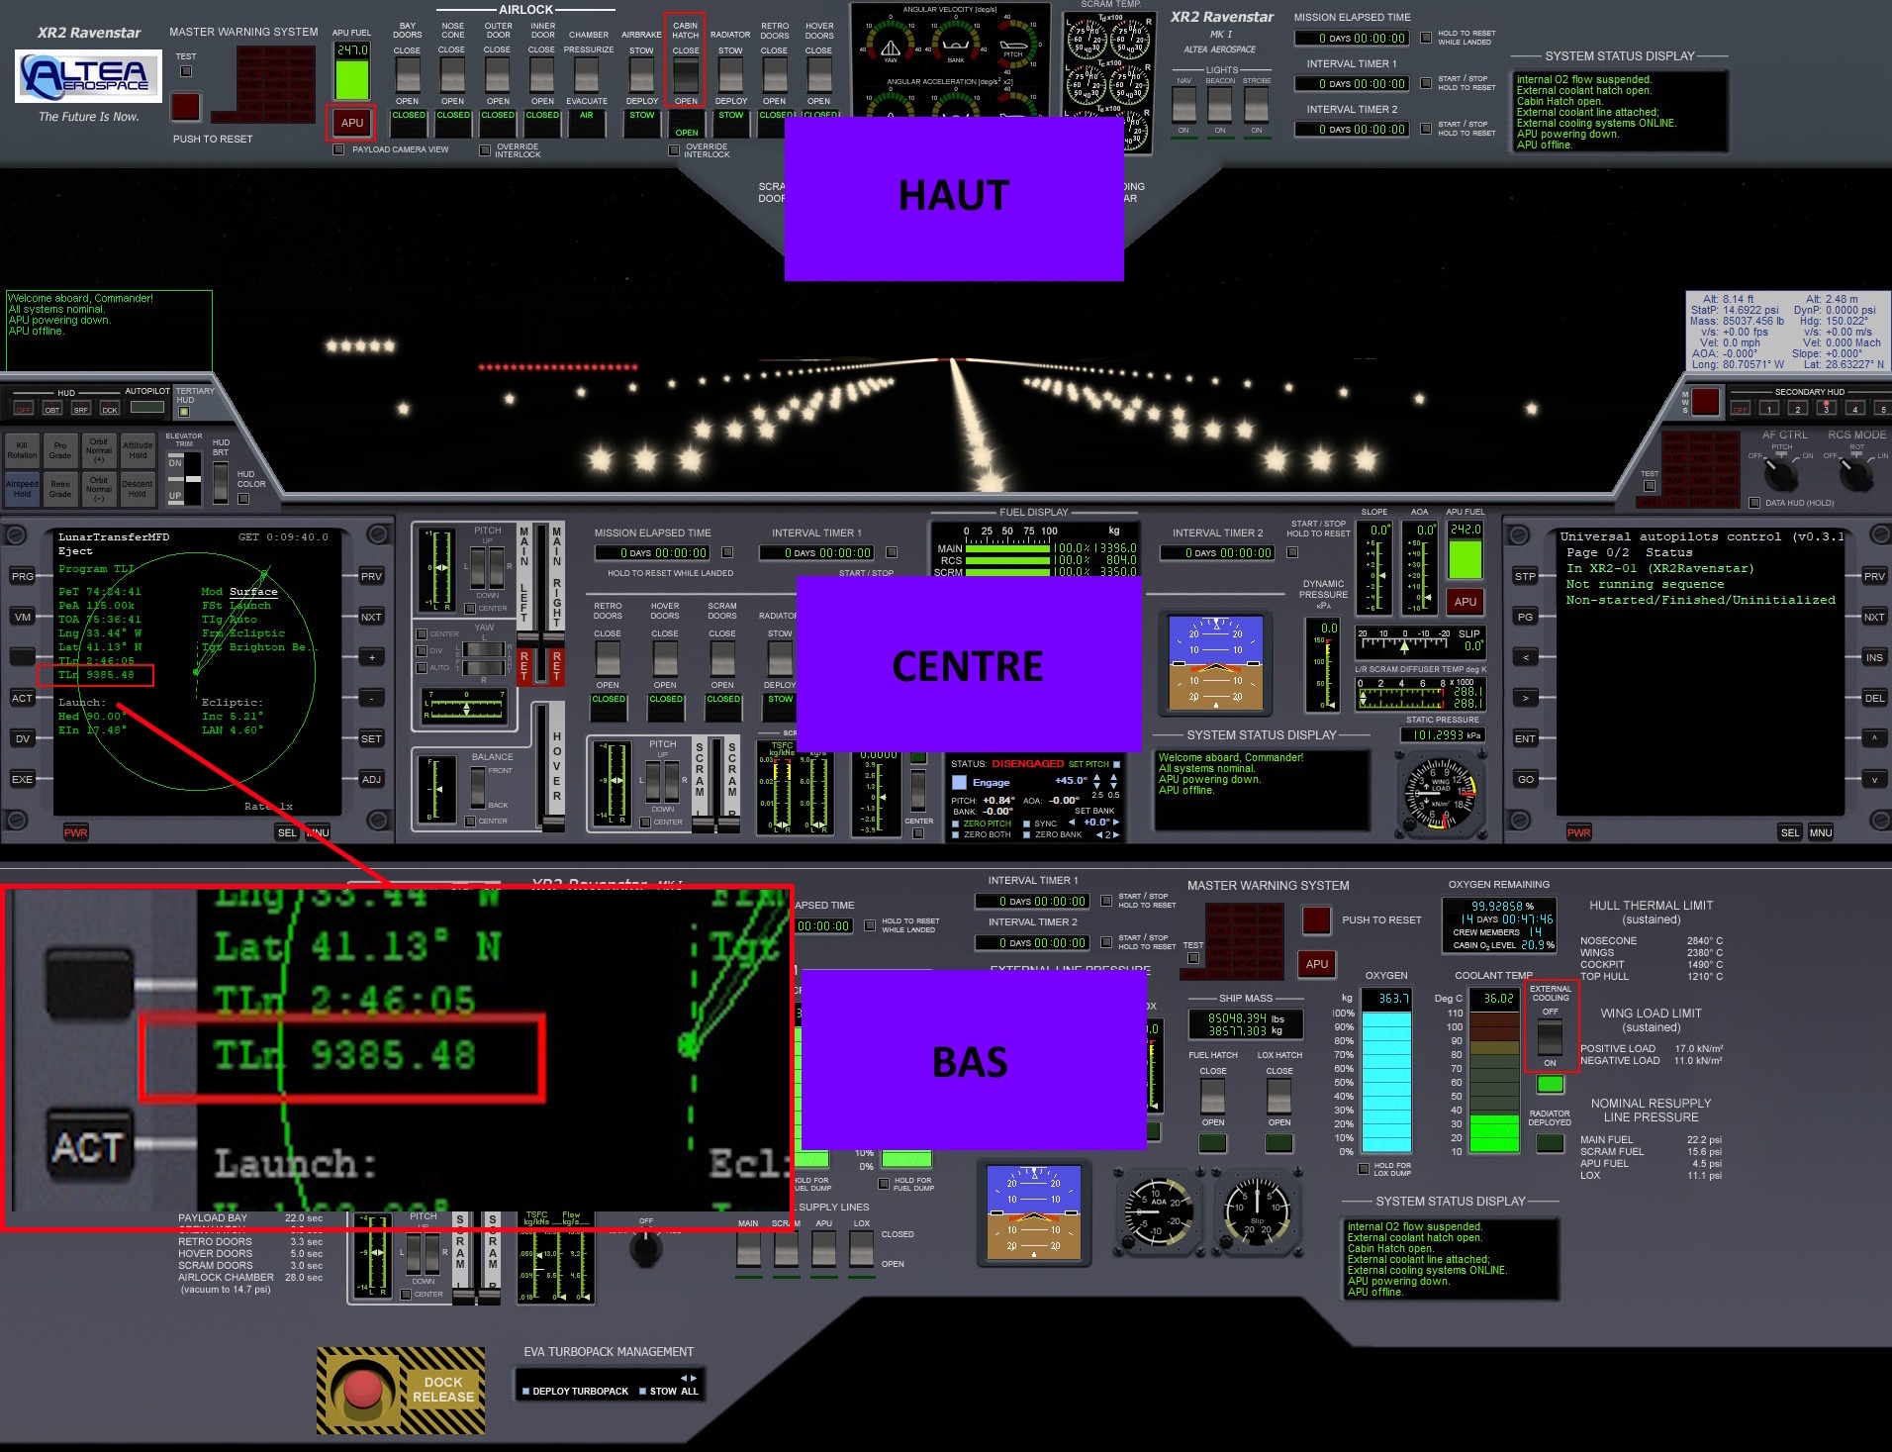

Click on the image to enlarge

01 - Observe the value of the TLn field on the left.
02 - For this procedure, this value must be within ± 500 (this figure is expressed in seconds).
03 - Accelerate then decelerate the simulation, carefully, to obtain the value TLn ± 500.
04 - Show the “Overhead” dashboard of the XR2 Ravenstar.
05 - Press the red APU button to activate the APU.
06 - Wait until the red APU button stops flashing.
07 - Press the CABIN HATCH button to close it.
08 - Show the “Bottom” dashboard of the XR2 Ravenstar.
09 - Press the EXTERNAL COOLING button to close it.
10 - Display the “center” dashboard of the XR2 Ravenstar.

C) TLn = 300

C.1) Procedures “must be carried out quickly, read before”

TLn is exactly = 300
01 - Press the GO button.
02 - Set AF CTRL to ON.

C.2) Explanations of procedures “must be carried out quickly, read before”
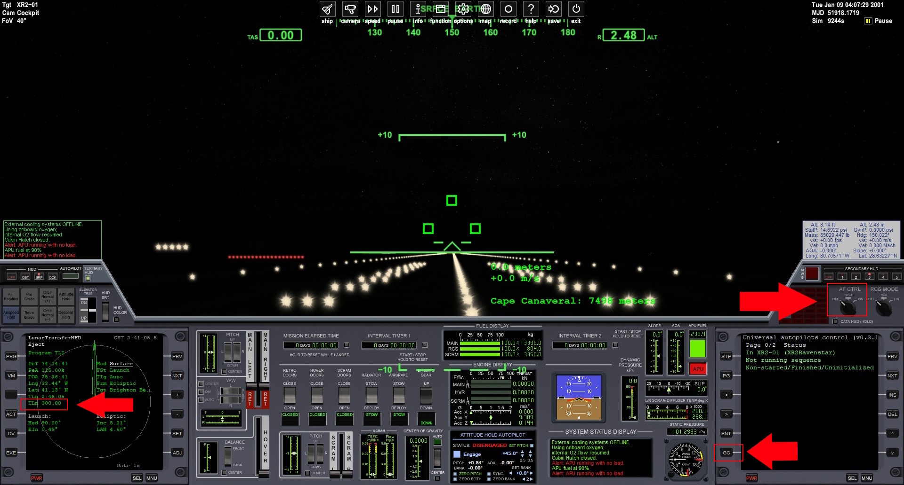
Click on the image to enlarge

TLn = 300.00
01 - When TLn reaches 300.00, press the GO button on the right MFD.
02 - Quickly right-click the AF CTRL area to turn it ON.
03 - Relax, because Universal autopilot control works for you.

D) Shrill noise

D.1) Procedures

You hear a very shrill noise
01 - MAIN 100%
02 - Activate ATTITUDE HOLD.

D.2) Explanations of procedures
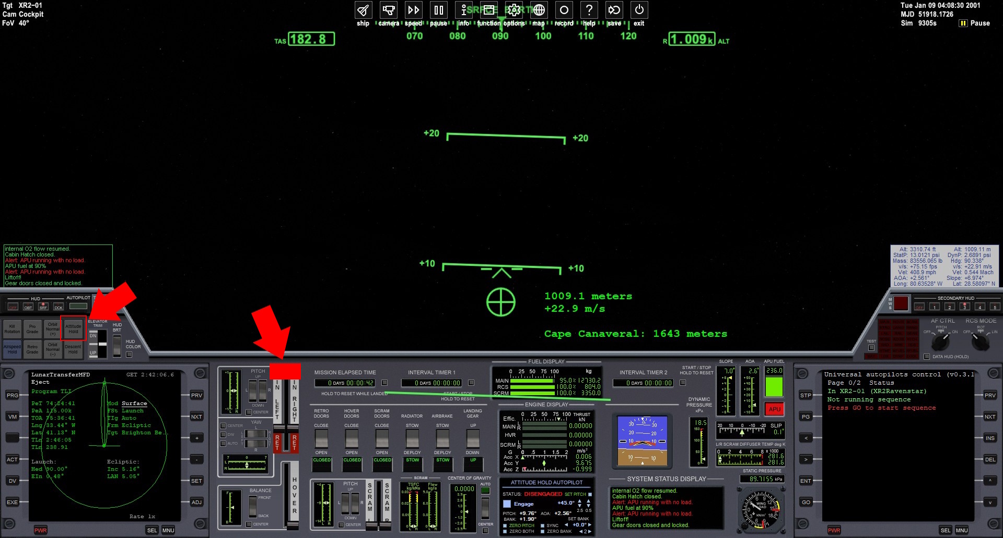
Click on the image to enlarge

You hear a VERY SHRILL NOISE (around 1,000 kilometers)
01 - Click at the top, in the red MAIN area.
02 - Click on the ATTITUDE HOLD button.
03 - Relax, because ATTITUDE HOLD AUTOPILOT works for you.

E) ±15.00 k (altitude)

E.1) Procedures
01 - Decrease the PITCH to 7.0

E.2) Explanations of procedures
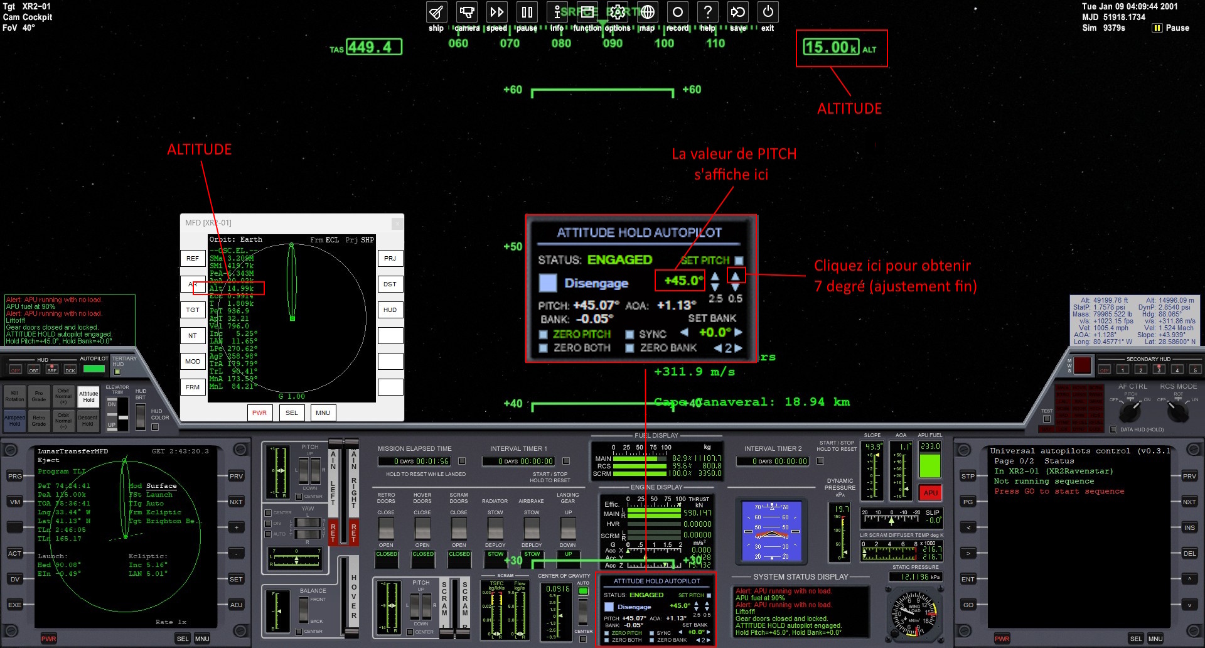
Click on the image to enlarge

We are at ±15.00k on the altimeter

Explanations before proceeding
* The PITCH value is displayed in the ATTITUDE HOLD AUTOPILOT.
* For a 5 degree adjustment, use the 8 key on the numeric keypad.
*For a 0.5 degree adjustment, use the mouse over the blue triangles on the right as shown.

01 - Slowly click the 8 key on the numeric keypad until the PITCH is at 7.5.
02 - Use the mouse on the blue triangle on the right to obtain the PITCH value at 7.0.
03 - Relax, because ATTITUDE HOLD AUTOPILOT always works for you.

F) ±24.00 k (altitude)

F.1) Procedures
01 - The PITCH should already be at 7.0.

F.2) Explanations of procedures

We are at ±24.00k on the altimeter
01 - The PITCH should already be at 7.0.

G) Mach 3

G.1) Procedures
01 - Open the SCRAM DOORS.
02 - Scram to 100%.
03 - MAIN at 0%.

G.2) Explanations of procedures
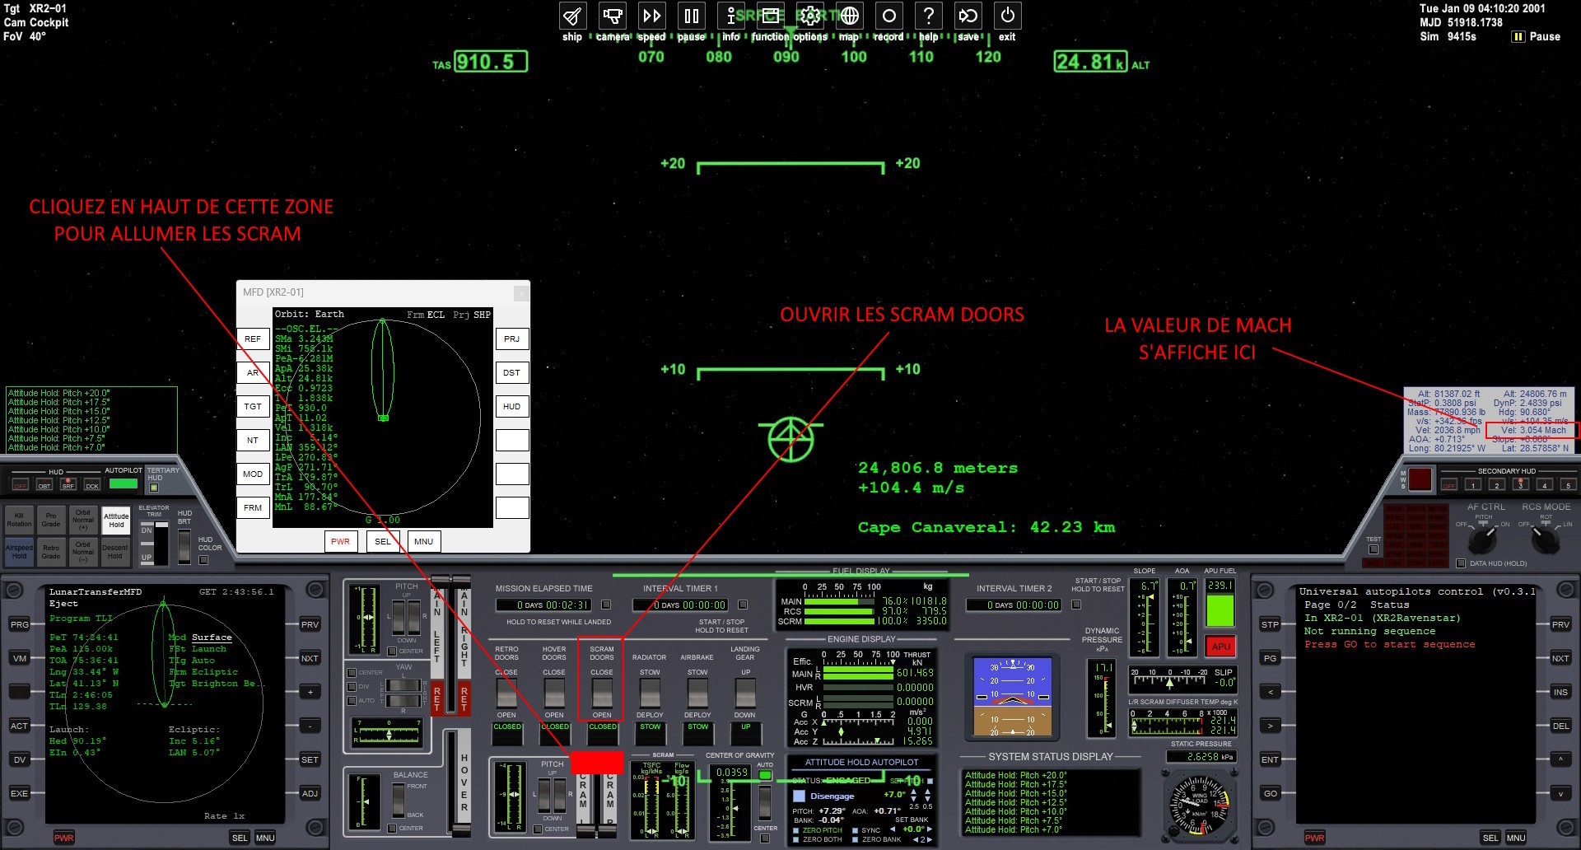
Click on the image to enlarge

You hear the word “MACH 3”
01 - Press the SCRAM DOORS button.

When you no longer hear the opening sound of SCRAM DOORS
02 - Click at the top of the red SCRAM area.
03 - Click the “*” key on the numeric keypad to turn off the main thrusters (MAIN).

H) ±30.00 k (altitude)

H.1) Procedures
01 - Decrease the PITCH to 5.0.
02 - Decrease the EIn.

H.2) Explanations of procedures
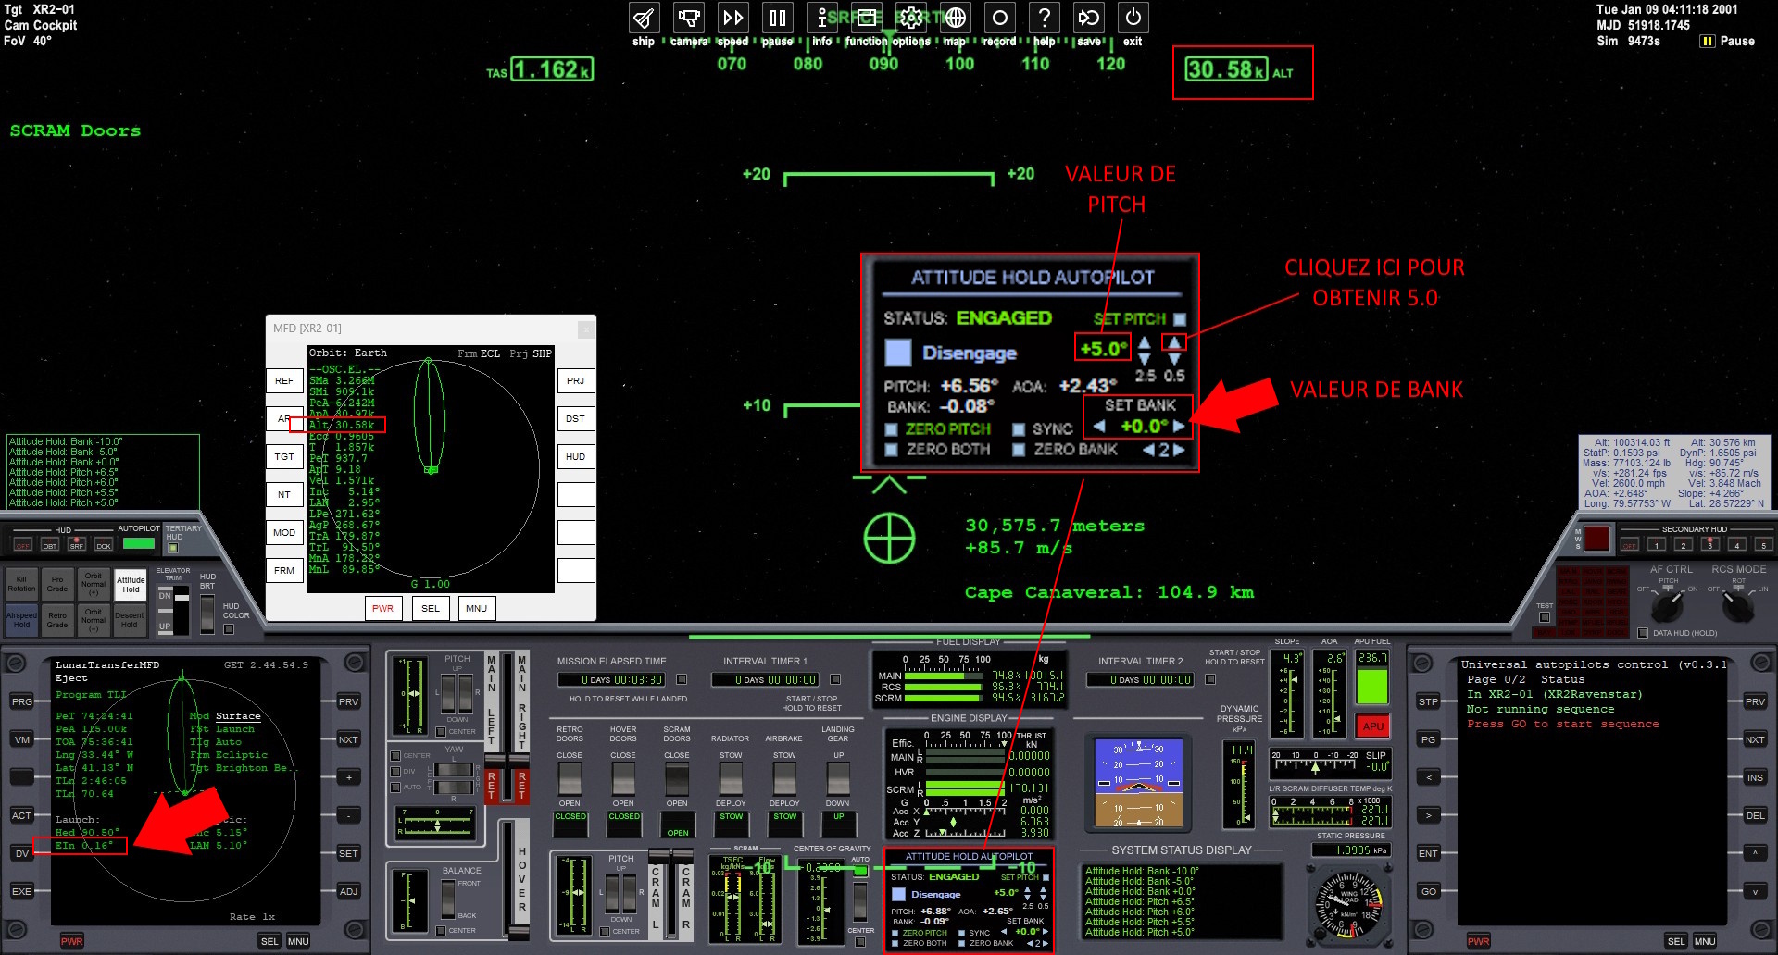
Click on the image to enlarge

We are at ±30.00k on the altimeter

Explanations before proceeding
* The value of the EIn is displayed in the LunarTransferMFD.
* The BANK value is displayed in the ATTITUDE HOLD AUTOPILOT.
* The ideal value of EIn should be +/-0.00.
* If the EIn is > +0.00, press 4 key to decrease it and 6 key to stabilize the BANK at 0.0.
* If the EIn is < -0.00, press 6 key to decrease it and 4 key to stabilize the BANK at 0.0.

01 - Decrease the PITCH to 5.0.
02 - Decrease the Ein as explained previously without looking away from the altitude.

I) ± 40.00 k (altitude)

I.1) Procedures
01 - Decrease the PITCH to 4.0.
02 - Decrease the EIn.

I.2) Explanations of procedures
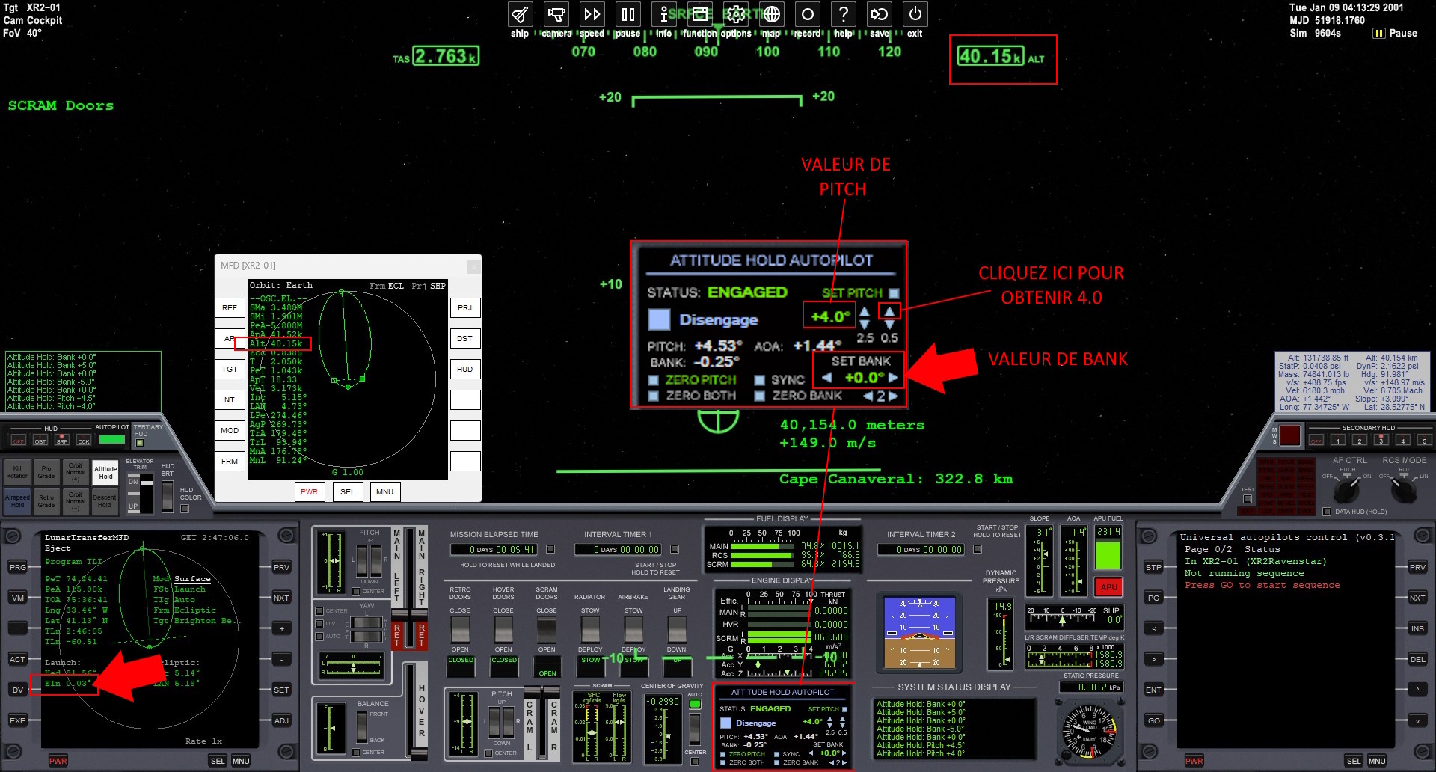
Click on the image to enlarge

We are at ±40.00k on the altimeter

01 - Decrease the PITCH to 4.0 at 40 kilometers altitude.
02 - Decrease the EIn as on the previous page, without looking away from the altitude.

J) ± 50.00 k (altitude)

J.1) Procedures
01 - Decrease the PITCH to 3.0.
02 - Decrease the EIn.

J.2) Explanations of procedures
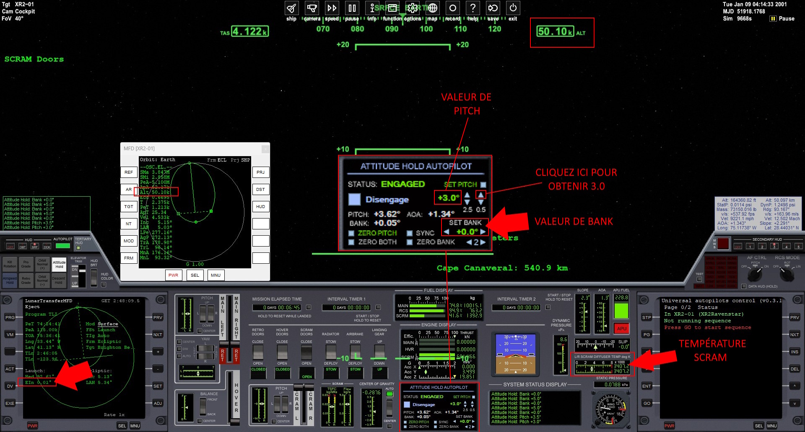
Click on the image to enlarge

We are at ±50.00k on the altimeter

01 - Decrease the PITCH to 3.0.
02 - Decrease the EIn without looking away from the SCRAM temperature on the right.

K) SCRAM temp ± 7700°K

K.1) Procedures
01 - Close the SCRAM DOORS.
02 – MAIN at 100%.

K.2) Explanations of procedures
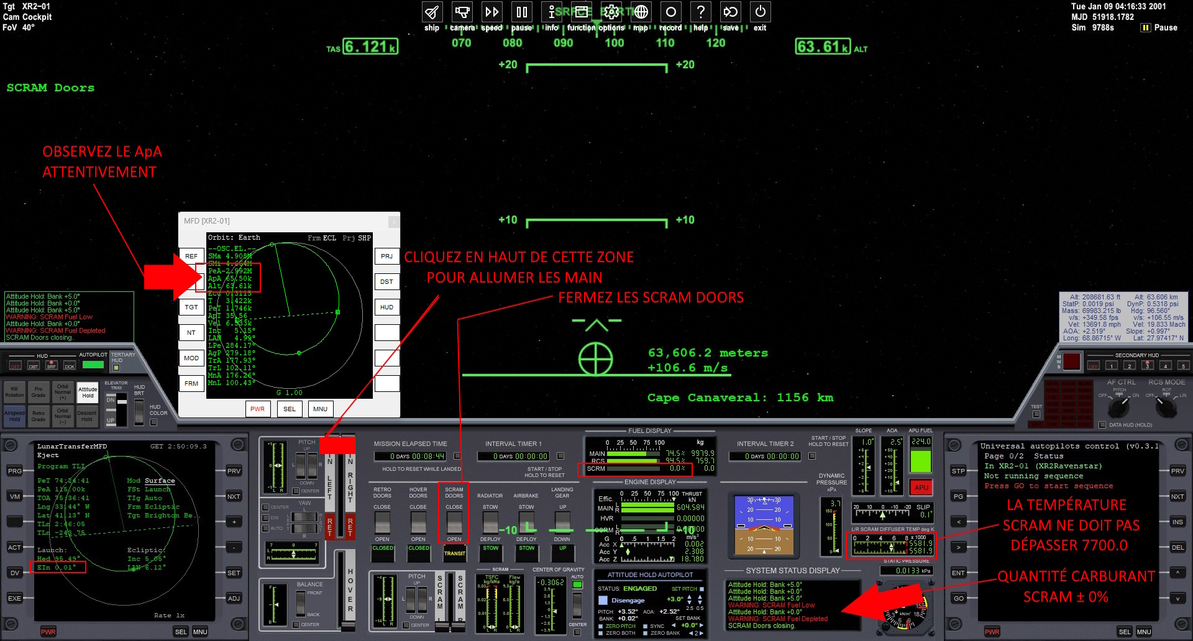
Click on the image to enlarge

The SCRAM temperature reaches 7700°K or you hear SCRAM fuel low
01 - Press the SCRAM DOORS button to close the SCRAMs.
02 - Press the red MAIN area to turn on the main thrusters.

Quickly move to the next page.

IMPORTANT: Place your finger on the “*” key on the numeric keypad before the procedure.

L) ApA ± 200.00 k

L.1) Procedures
01 - MAIN at 0%.

L.2) Explanations of procedures
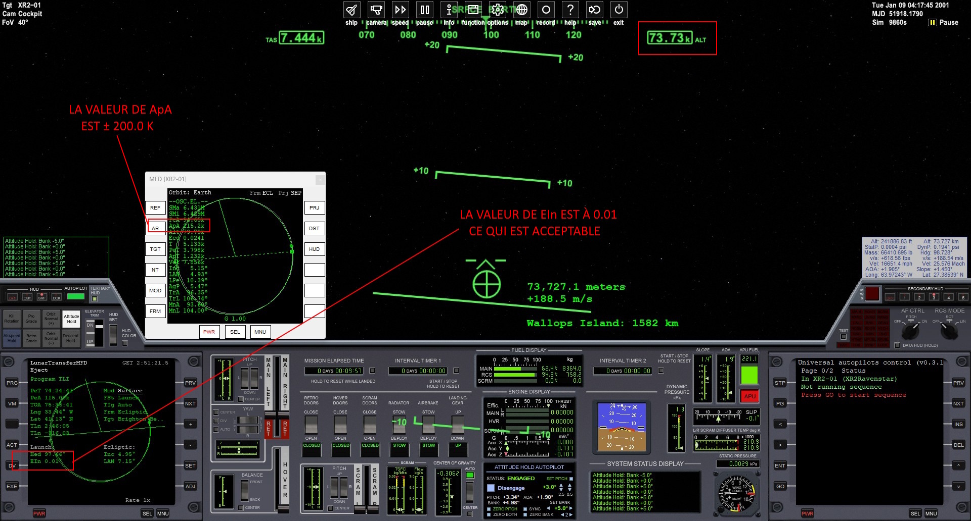
Click on the image to enlarge

ApA value reaches ±200k
01 - Quickly press “*” on the numeric keypad to turn off the thrusters (MAIN).
02 - Relax.

We reached 73.73 kilometers above sea level.

The following procedures will be more relaxed.

M) ± 90.00 k (altitude)

M.1) Procedures
01 - Open the RADIATORS.
02 - Activate PRO GRADE.
03 - Close the APU.

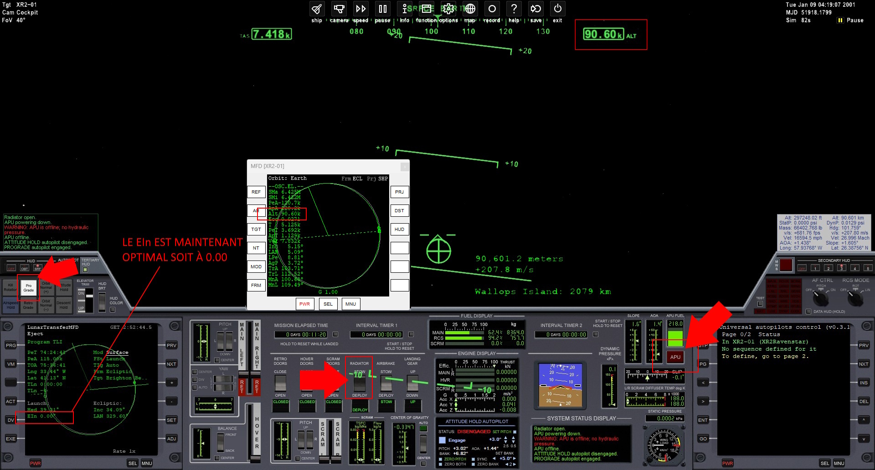
M.2) Explanations of procedures
Click on the image to enlarge

We are at ±90.00k on the altimeter
01 - Click on the RADIATOR (DEPLOY) button.

When you no longer hear the sound of the RADIATOR opening
02 - Click the APU button to turn it off.
03 - Click on the PRO GRADE button.

We reached 90.60 kilometers of altitude.
N) EOI

N.1) Procedures
01 - Open the BurnTimeMFD on the right MFD.
02 - Choose the MOD “Time to Apoapsis”.
03 - Press CIR.

N.2) Explanations of procedures
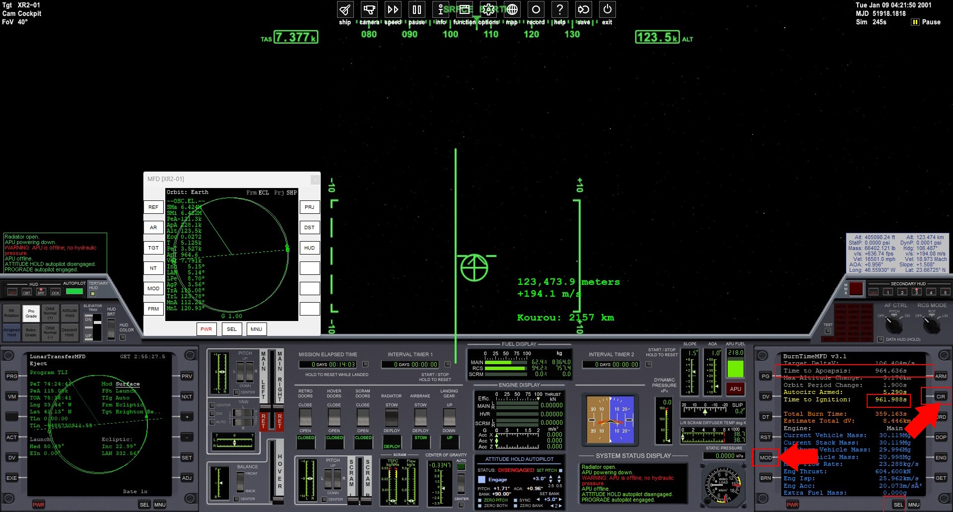
Click on the image to enlarge

Perform these procedures as soon as possible
01 - Click on the SEL button, as many times as necessary, in order to see BurnTimeMFD in this menu.
02 - Click on the button to the right of the word BurnTimeMFD to select it.
03 - Click the MOD button to select Time to Apoapsis (see red box).
04 - Click on the CIR button to execute this MFD.
05 - You will see in yellow Time to ignition: 961.988s.
06 - Accelerate then decelerate the simulation, carefully, to obtain the value ± 200.00s.
07 - At 0.00s, thruster (MAIN) will turn on.

Relax! You will see a beautiful sunrise.

Congratulations !
You have successfully completed the first part of your mission.

Save your flight for next tutorial

01 - In the context menu, at the very top of the screen, click exit.
02 - Click on the Save current… button (at the bottom of the screen) to save your scenario.
03 - In the Scenario name field enter "XR2 is going to the moon".
04 - Click the OK button to accept this name.

