
Orbiter 2024 keys for this tutorial

The most important keys to memorize are in red.

KEYS or BUTTONS | UTILISATION
XR2 RAVENSTAR DASHBOARD DISPLAY
CTRL + up arrow (↑ or ▲) | Go to the dashboard above
CTRL + low arrow (↓ or ▼) | Go to the dashboard below
SIMULATION (VERY IMPORTANT KEYS)
CTRL + P | Pausing the simulation
T (*) | Accelerate simulation from 0x, 10x... to 100000x
R (*) | Decelerate the simulation from 100000x... to 0x and 0.1x
PROPULSION (NUMERIC KEYPAD)
“*” on the numeric keypad | Turn off the main thrusters
“+” on the numeric keypad | Ignition of the main thrusters
“6” on the numeric keypad | Ignition of the attitude thrusters (forward)
“9” on the numeric keypad | Ignition of the attitude thrusters (towards the rear)
“5” on the numeric keypad | Stop the ship from rotating
VIEW FROM ORBITER 2024
F1 | Show external view versus internal view
F8 | Display the different internal views (2D, 3D, generic)
H | Show 3 different HUDs (SRFCE, DOCK, ORBIT)
ATTITUDE BUTTONS
LIN | Translation
ROT | Rotation (not used in the tutorial)
PRO GRADE or PRO GRD | Prograde
RETRO GRADE or RETR GRD | Retrograde
ORBIT NORMAL + ou NML + | Normal +
ORBIT NORMAL - ou NML - | Normal -

(*) Do not exceed 10000x in this tutorial.

Events to leave Earth orbit and land7

EVENTS) | ACTION / TOUCHES
A) TLI | Trans lunar injection “Lunar Transfer MFD (TLI)”
B) TLCC | Mid-course correction “Lunar Transfer MFD (TLCC)”
C) Summary alignment with the base | Using Normal + and “MAP MFD”
D) LOI 1 | Lunar Circularization 1 “Lunar Transfer MFD (LOI)”
E) LOI 2 | Lunar Circularization 2 “Lunar Transfer MFD (LOI)”
F) Complete alignment with the base | Base Alignment “Base sync MFD (Dist ± 20.00 m)”
G) Lower the orbit towards lunar base | Orbit to base “Base sync MFD (PeA ± 10.00 k)”
H) Moon landing | Moon landing with “Pursuit land MFD”
I) You are clear to land | LAND GEAR (DOWN)

This is how we will approach our tutorial

I will first offer you a summary, before developing each point in depth. Orbiter 2024 navigation Top Gun will be able to skip straight to the Procedures while beginners will be treated to the
Procedures Explanations section.

Therefore, I will go through each part of this tutorial (from point A to point I).

01 - Start the scenario “XR2 is going to the moon” by double-clicking on it.

IMPORTANT: “Pause using the CTRL+P keys between each page.”

A) TLI

A.1) Procedures
01 - Open the LunarTranserMFD (Flight monitor program), on the right MFD.
02 - In the left MFD, select the Mod field and choose the Heading value.
03 - Select the FSt field and choose the TLI value.
04 - Execute an AutoBurn and then go into PROGRADE.

A.2) Explanations of procedures
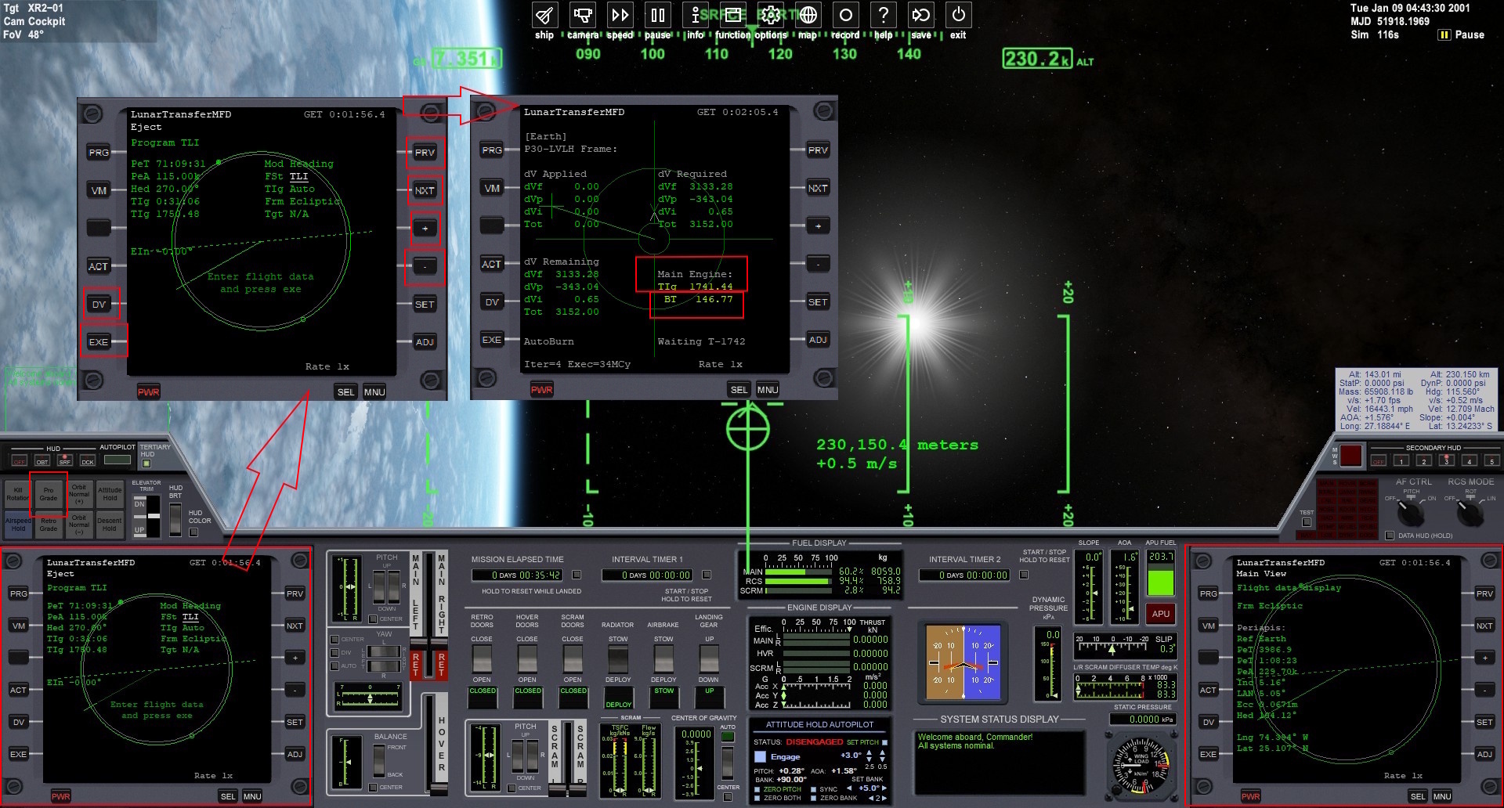

Click on the image to enlarge

On the right MFD
01 - Click on the SEL button, as many times, in order to see LunarTranserMFD in this menu.
02 - Click on the button to the left of the word LunarTranserMFD to select it.
03 - Click the PRG button to see the LunarTranserMFD menu.
04 - Click on the NXT button to select the Flight monitor field.
05 - Click on the [+] button to display the information.

On the left MFD
01 - Click on the NXT button to select the Mod field.
02 - Click on the [+] button to display the Heading value.
03 - Click on the NXT button to select the FSt field.
04 - Click on the [+] button to display the TLI value.
05 - Click on the EXE button, on the DV button then again on the EXE button.
06 - The TIg 1741.44 value represents the number of seconds remaining before ignition.
07 - The value BT 146.77 represents the combustion duration.
08 - Accelerate then decelerate the simulation, carefully, in order to have the TIg value ±200.00.
09 - Combustion will begin at TIg 0.00.
10 - Once combustion is complete, press the PRO GRADE button on the left and top.

B) TLCC

B.1) Procedures
01 - Accelerate then decelerate the simulation in order to have the PeT value ±100.00k.
02 - In the left MFD, select the FSt field and choose the TLCC value.
03 - Run an AutoBurn.

B.2) Explanations of procedures
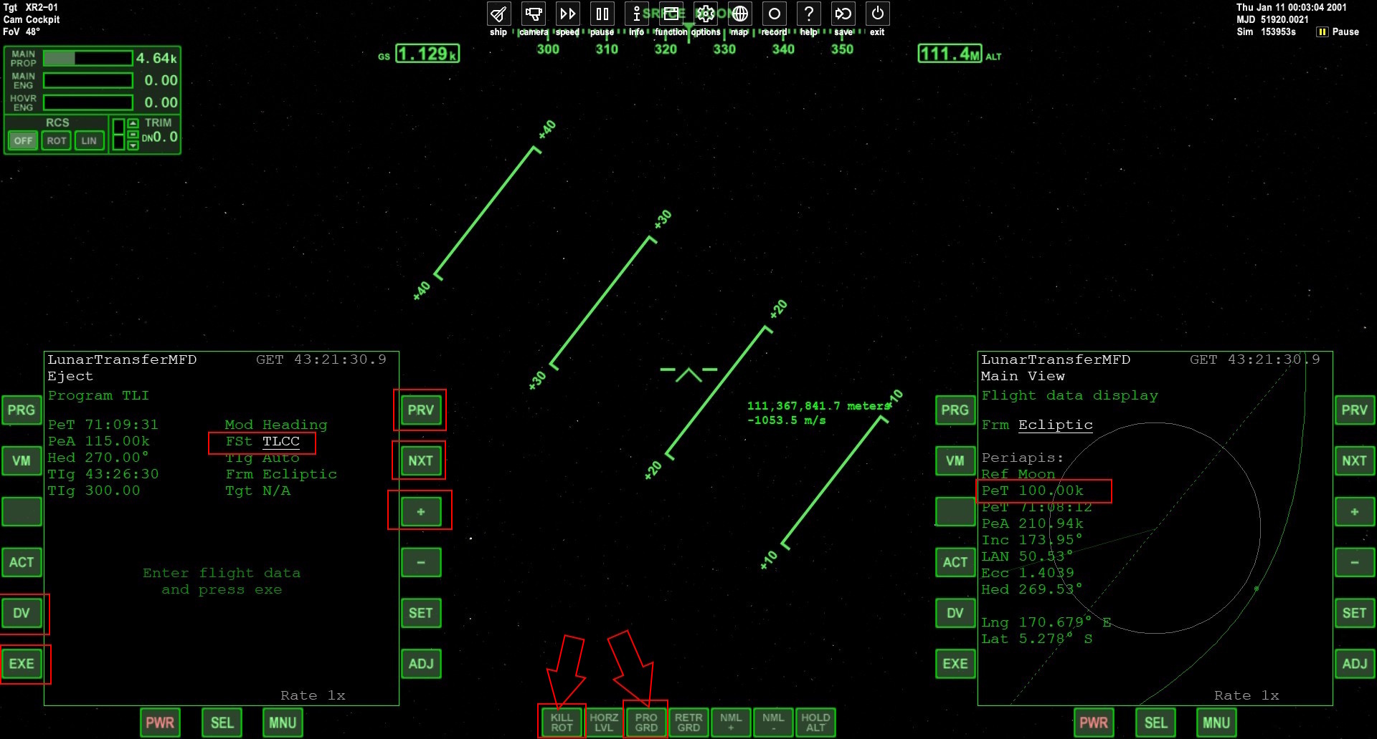

Click on the image to enlarge

Press F8 to display the generic screen as above.

Note the PeT variable on the right MFD.

01 - At the bottom of the screen, click on KILL ROT. The PRO GRD button (PRO GRADE) will be disabled.
02 - Accelerate then decelerate the simulation, carefully, in order to have a PeT ±100.00k then return the simulation speed to normal.

On the left MFD
01 - Click the DV button to see the settings page.
02 - Click on the NXT button to select the FSt field.
03 - Click on the [+] button to display the TLCC value.
04 - Click on the EXE button, on the DV button then again on the EXE button.
05 - Accelerate then decelerate the simulation, carefully, in order to have a TIg ±200.00.
06 - Combustion will begin at TIg 0.00.
07 - Once combustion is complete, press the KILL ROT button at the bottom.

C) Summary alignment with the base

C.1) Procedures
01 - Accelerate then decelerate the simulation in order to have the PeT value ±20.00k.
02 - In the right MFD, choose the MAP MFD with Brighton Beach as target.

If your trajectory (in green) is below the Brighton Beach target
01 - Run a burn in NORMAL + mode to align the trajectory with the base.

If your trajectory (in green) is at the top of the Brighton Beach target
01 - Run a burn in NORMAL - mode to align the trajectory with the base.

C.2) Explanations of procedures
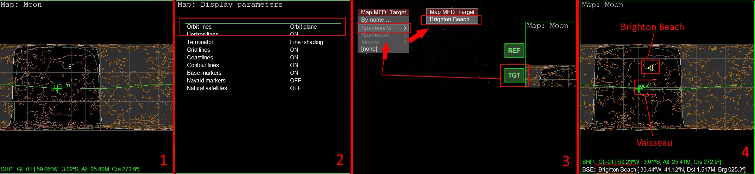
Click on the image to enlarge

Note the PeT variable on the right MFD.

01 - Accelerate then decelerate the simulation, carefully, in order to have a PeT ±20.00k then return the simulation speed to normal.

On the right MFD
01 - Click on the SEL button, as many times, in order to see this Map menu.
02 - Click on the button to the left of the word Map to select it (1).
03 - Click the DSP button to display the options.
04 - Click the MOD button to change the current option to “Orbit lines = Orbit plane” (2).
05 - Click the OK button to return to the map.
06 - Click on the TGT button.

Don't move your mouse anymore.

07 - Use ↓ or ▼ on your keyboard to choose “Spaceports”.
08 - Use → or ►on your keyboard to display the choice “Brighton Beach”, then ENTER (2).
09 - You will have the map as displayed in point (4).

On the right MFD
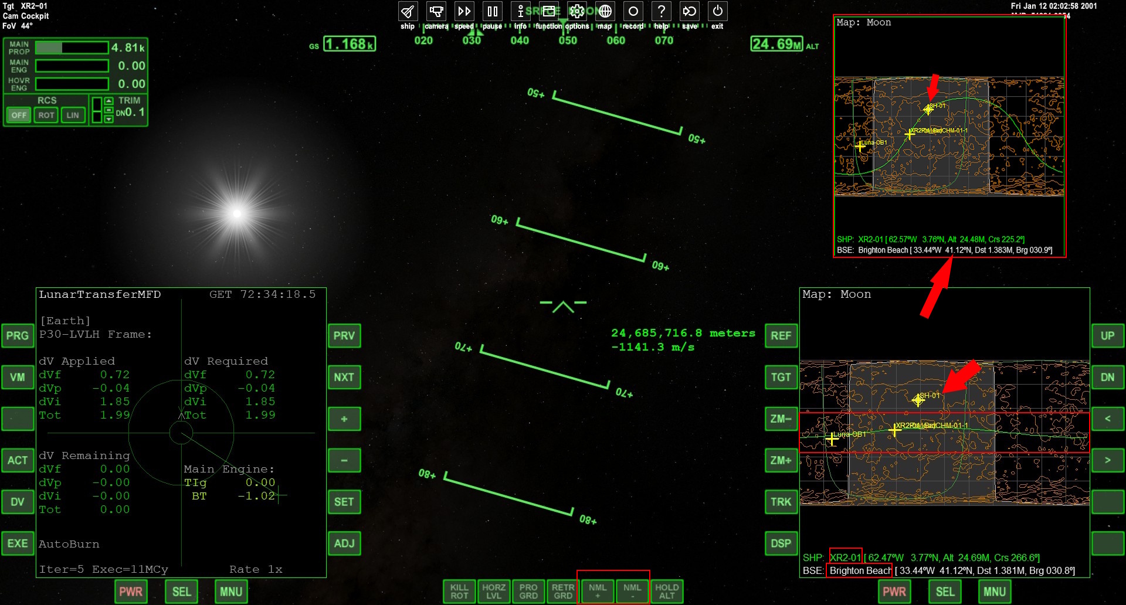
Click on the image to enlarge

Notice on the MFD Map (bottom right) that your ship is on a green line.
This green line (your orbit) is at the bottom of your target which is SH-01 (Brighton Beach).

If the ship's trajectory (in green) is below the target
01 - Press the “NML +” button like at the bottom of the image (means NORMAL +).
02 - Wait for “NML +” to finish executing (the ship will no longer move).

03 - Using the “+” key on the number pad, perform a burn and pay attention until the green line overlaps the target.

04 - Once combustion is complete, press the KILL ROT button at the bottom.

If the ship's trajectory (in green) is at the top of the target
01 - Press the “NML -” button like at the bottom of the image (means NORMAL -).
02 - Wait for “NML -” to finish executing (the ship will no longer move).

03 - Using the “+” key on the number pad, perform a burn and pay attention until the green line overlaps the target.

04 - Once combustion is complete, press the KILL ROT button at the bottom.

Your result should be similar to the image at the top right.

D) LOI 1

D.1) Procedures
01 - In the left MFD, select the LOI program.
02 - As the value of the Pri field, choose ApALT.
The orbit will not yet be circular (as Apollo 11 achieved).
03 - As the value of the ApA field, enter 100.00k.
04 - Execute an AutoBurn and then go into PROGRADE.

D.2) Explanations of procedures
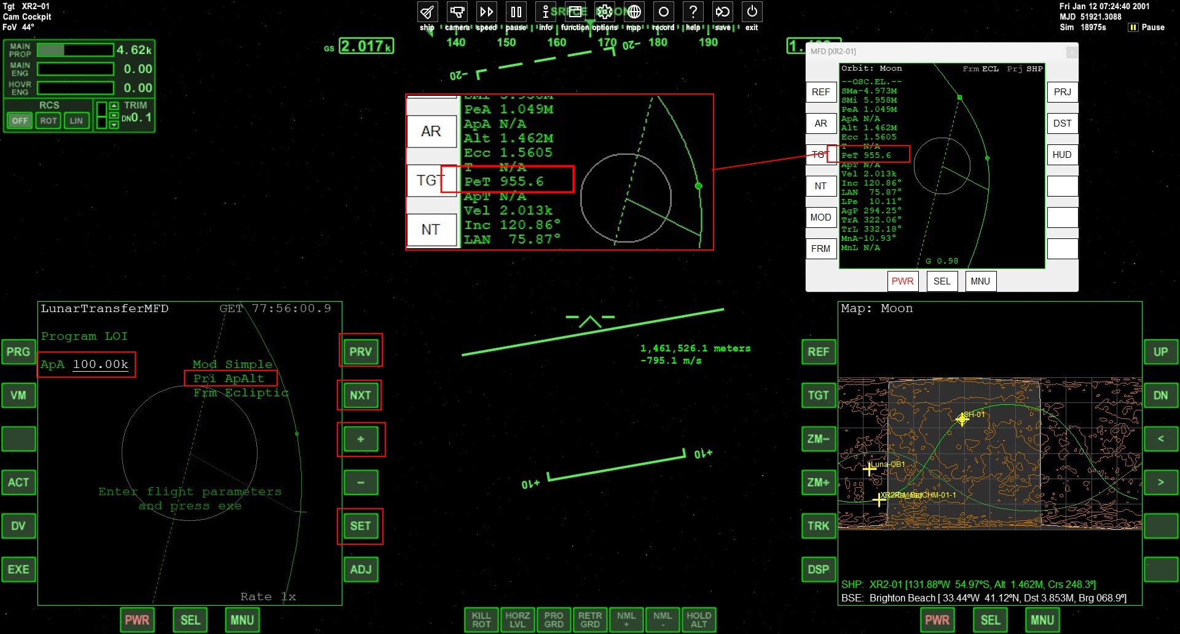
Click on the image to enlarge

On the left MFD
01 - Click on the PRG button to see the programs page.
02 - Click on the NXT button to select the program LOI field.
03 - Click on the [+] button to bring up the LOI program page.
04 - Click on the NXT button to select the Pri field.
05 - Click on the [+] button to display the Pri ApAlt value.
06 - Click on the NXT button to select the ApA field.
07 - Click the SET button, a window will appear, then enter “100.00k” then press the ENTER key.

Open a floating Orbit MFD
01 - Move your mouse to the center and top of the screen.
02 - Click on the function button.
03 - In the functions window, choose External MFD then press OK.
04 - Move the new window with the mouse, and place it as in the example in the previous image.
05 - In this window, click on the PRJ and DST buttons.
06 - At the bottom of this window, click the MNU button.
07 - In this window, click the button to the left of Auto reference.
08 - At the bottom of this window, click the MNU button.

On the left MFD
01 - Click on the EXE button, on the DV button then again on the EXE button.

02 - Accelerate then decelerate the simulation, carefully, in order to have a TIg ±200.00 then return the simulation speed to normal.

03 - Combustion will begin at TIg 0.00.
04 - Once combustion is complete, press the KILL ROT button at the bottom.

This should produce a first lunar orbit, as Apollo 11 achieved.
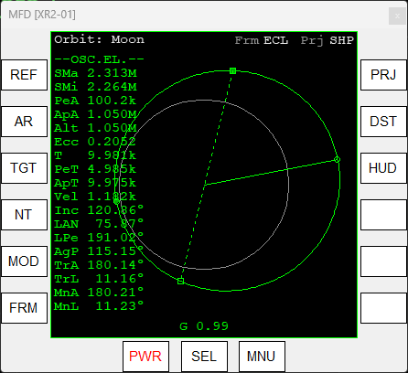

E) LOI 2

E.1) Procedures
01 - Accelerate then decelerate the simulation in order to have the PeT value ±900.
02 - In the left MFD, select the Pri field and the “Ecc” value.
03 - Execute an AutoBurn and then go into PROGRADE.

E.2) Explanations of procedures
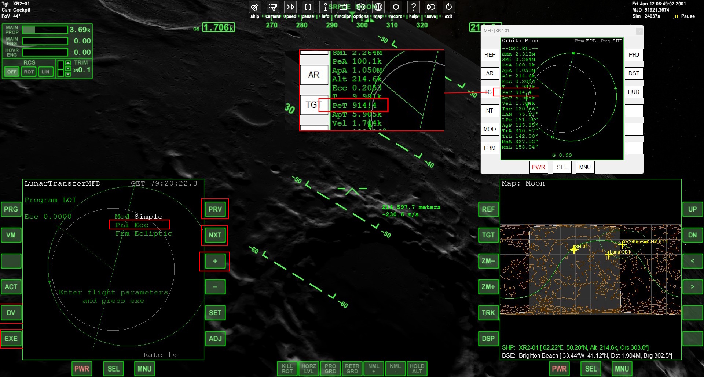
Click on the image to enlarge

Note the PeT variable on the floating MFD.

01 - At the bottom of the screen, click on KILL ROT.
02 - Accelerate then decelerate the simulation, carefully, in order to have a PeT ±900 then return the simulation speed to normal.

On the left MFD
01 - Click the DV button to see the settings page.
02 - Click on the NXT button to select the Pri field.
03 - Click on the [+] button to display the Pri Ecc value.
04 - Click on the EXE button, on the DV button then again on the EXE button.
05 - Accelerate then decelerate the simulation, carefully, in order to have a TIg ±200.00 then return the simulation speed to normal.

06 - Combustion will begin at TIg 0.00.
07 - Once combustion is complete, press the KILL ROT button at the bottom.

Exterior view
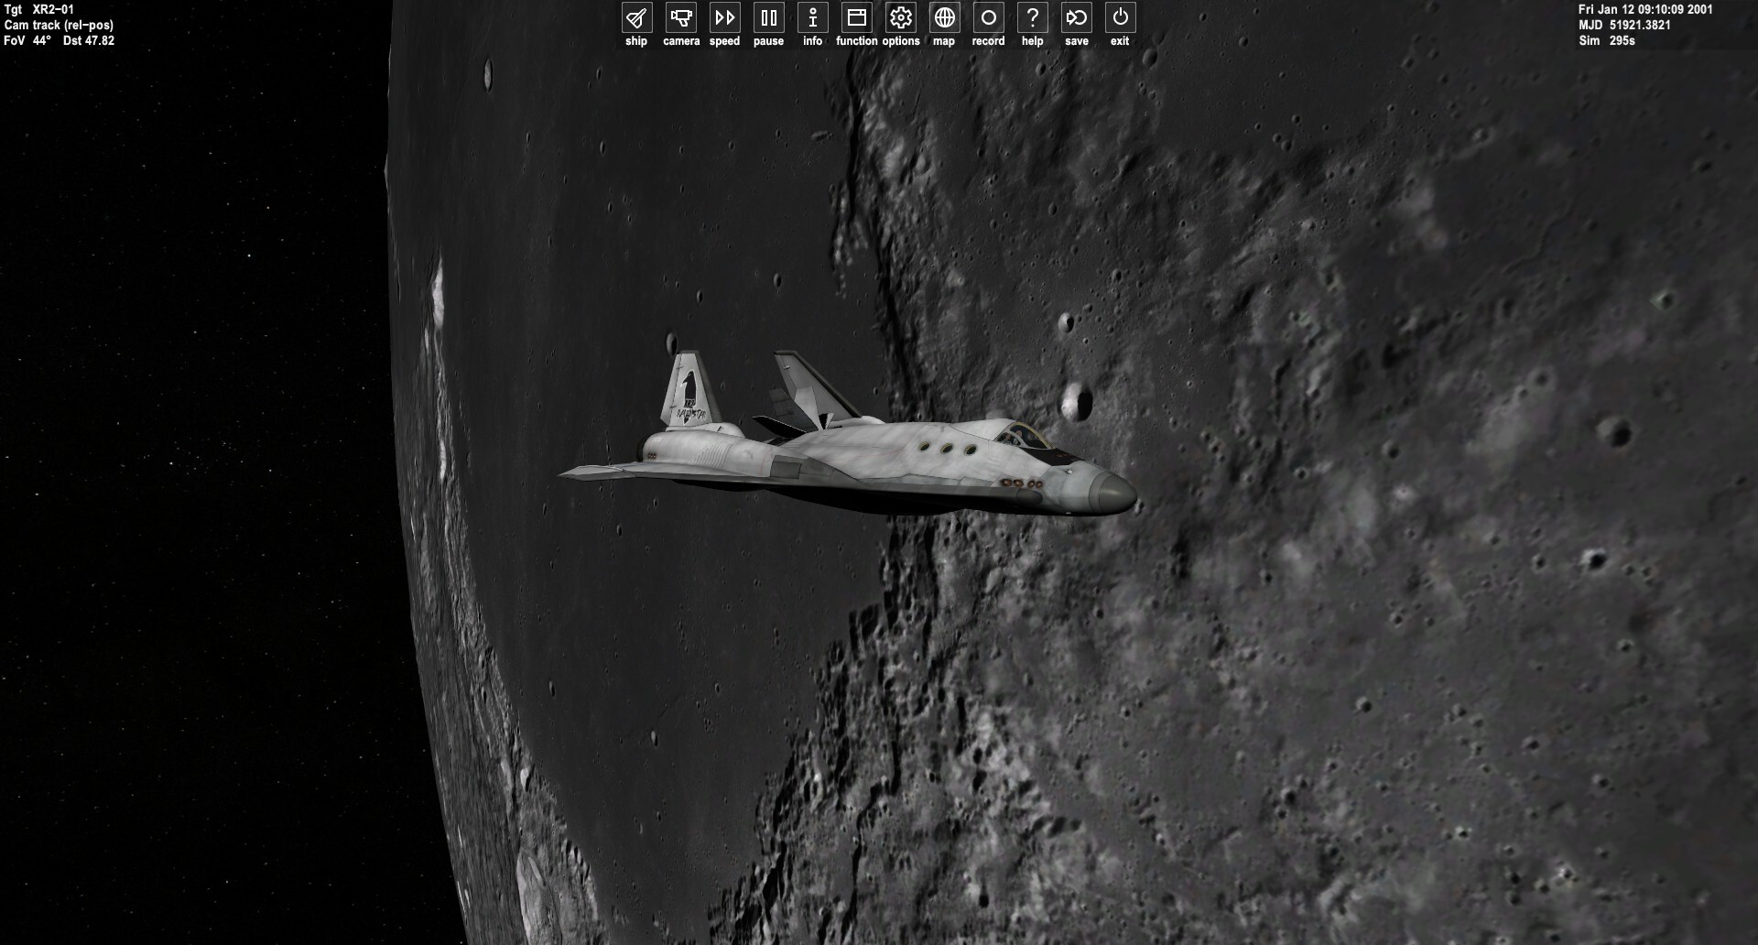
Click on the image to enlarge

01 - Press the F1 key.
02 - Using the right mouse button, you can change perspective such as the previous image.
03 - Using the central mouse wheel, you can zoom in on your ship.
04 - If you zoom out completely, you will see an entire moon.
05 - Using the central mouse wheel, zoom your ship back to normal.
06 - Press the F1 key to have the generic view.

F) Complete alignment with the base

F.1) Procedures
01 - In the left MFD, choose the BaseSync MFD with Brighton Beach as the target.

If the green line approaches an EMPTY NODE
01 - Run a burn in NORMAL - mode to align the trajectory with the base.

If the green line approaches a FULL NODE
01 - Run a burn in NORMAL + mode to align the trajectory with the base.

F.2) Explanations of procedures
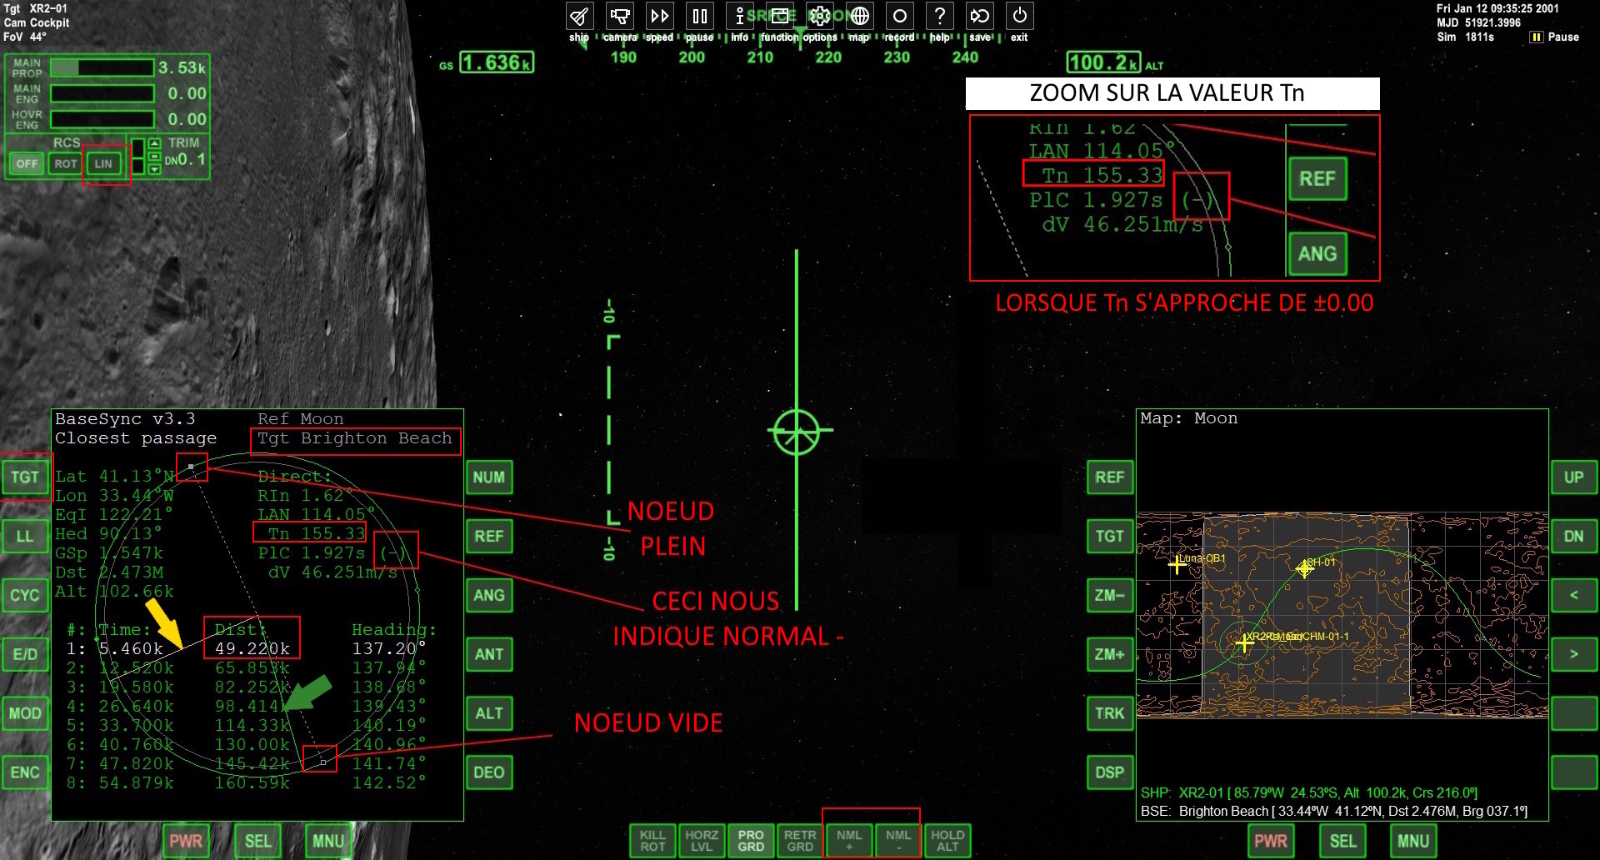
Click on the image to enlarge

On the left MFD
01 - Click on the SEL button, as many times, in order to see BaseSyncMFD in this menu.
02 - Click on the button to the right of the word BaseSyncMFD to select it.
03 - Press the TGT button to bring up a window
04 - Enter (carefully regarding the syntax) Brighton Beach then press ENTER.

Notice the value of Dist with its value 49.220k (as shown).
We are 49 kilometers lateral to our target Brighton Beach.
We will therefore carry out a complete alignment with the base.

On the left MFD
Click on the image to enlarge

Notice the yellow line pointed by the yellow arrow. This represents the target.
Notice the green line pointed by the green arrow. This represents our ship in orbit.

Do a short acceleration of the simulation and you will see that the green line is moving.

If the green line approaches an EMPTY NODE (see image)
01 - Press the NML – button at the bottom of the screen.
02 - Press the LIN button at the top left of the screen (see image).
03 - Watch the ZOOM ON THE Tn VALUE. When it is close to ±0.00, do the next step.
04 - Using the “+” key on the numeric keypad, carefully execute small pulses until the Dist value approaches ±1,000k.
05 - Using the “6” key on the numeric keypad, carefully execute small pulses until the Dist value approaches ±50.

If the green line approaches a FULL NODE (see image)
01 - Press the NML + button at the bottom of the screen.
02 - Press the LIN button at the top left of the screen.
03 - Watch the ZOOM ON THE Tn VALUE. When it is close to ±0.00, do the next step.
04 - Using the “+” key on the numeric keypad, carefully execute small pulses until the Dist value approaches ±1,000k.
05 - Using the “6” key on the numeric keypad, execute small pulses (be careful) until the Dist value approaches ±50.

This should produce an approach like the following
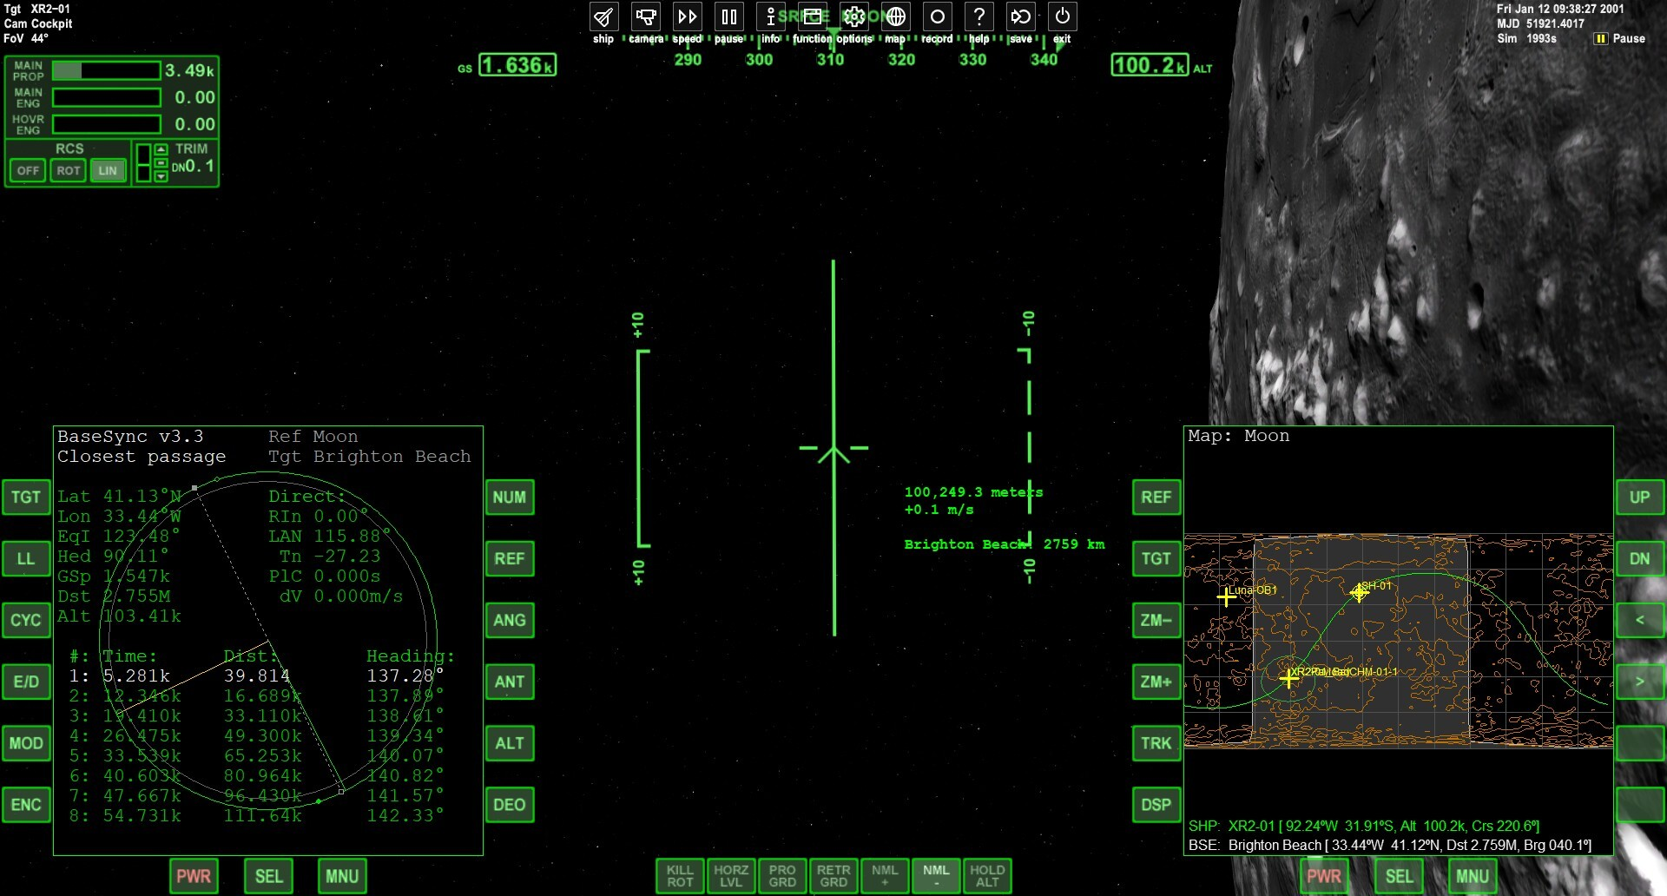
Click on the image to enlarge

Notice the value of Dist with its value 39.814 (as shown).

We are 39 meters lateral to our target Brighton Beach.

Our alignment is optimal for the rest of the trip.

01 - Press the KILL ROT button at the bottom.
G) Lower the orbit towards the lunar base

G.1) Procedures
01 - Wait until your ship is opposite the target on BaseSync MFD.
02 - Do a retrograde burn to lower your orbit by ±10.00k near your target.

G.2) Explanations of procedures
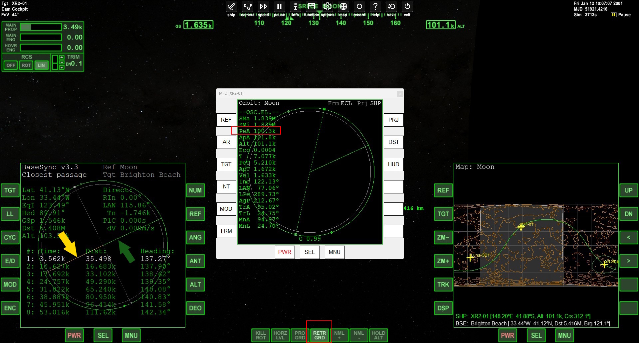
Click on the image to enlarge

Explanations before proceeding
When the yellow and green lines are aligned, then our ship will be opposite our target (Brighton Beach). This is the perfect time to perform a small burn to lower our orbit by ±10.00k towards the target.

In Apollo parlance, this is a DOI (descent orbit insertion).

On the left MFD
01 - Press the RETR GRD button at the bottom of your screen (as above).
02 - Accelerate then decelerate the simulation to 10X, carefully, in order to have perpendicular green and yellow lines.

On the floating ORBIT MFD (center of image)
01 - Using key “6” on the numeric keypad, carefully execute small pulses until the PeA value approaches ±10.00k.
02 - Press the PRO GRD button at the bottom of your screen.
H) Moon landing

H.1) Procedures
01 - Follow the Explanations of procedure.

H.2) Explanations of procedures
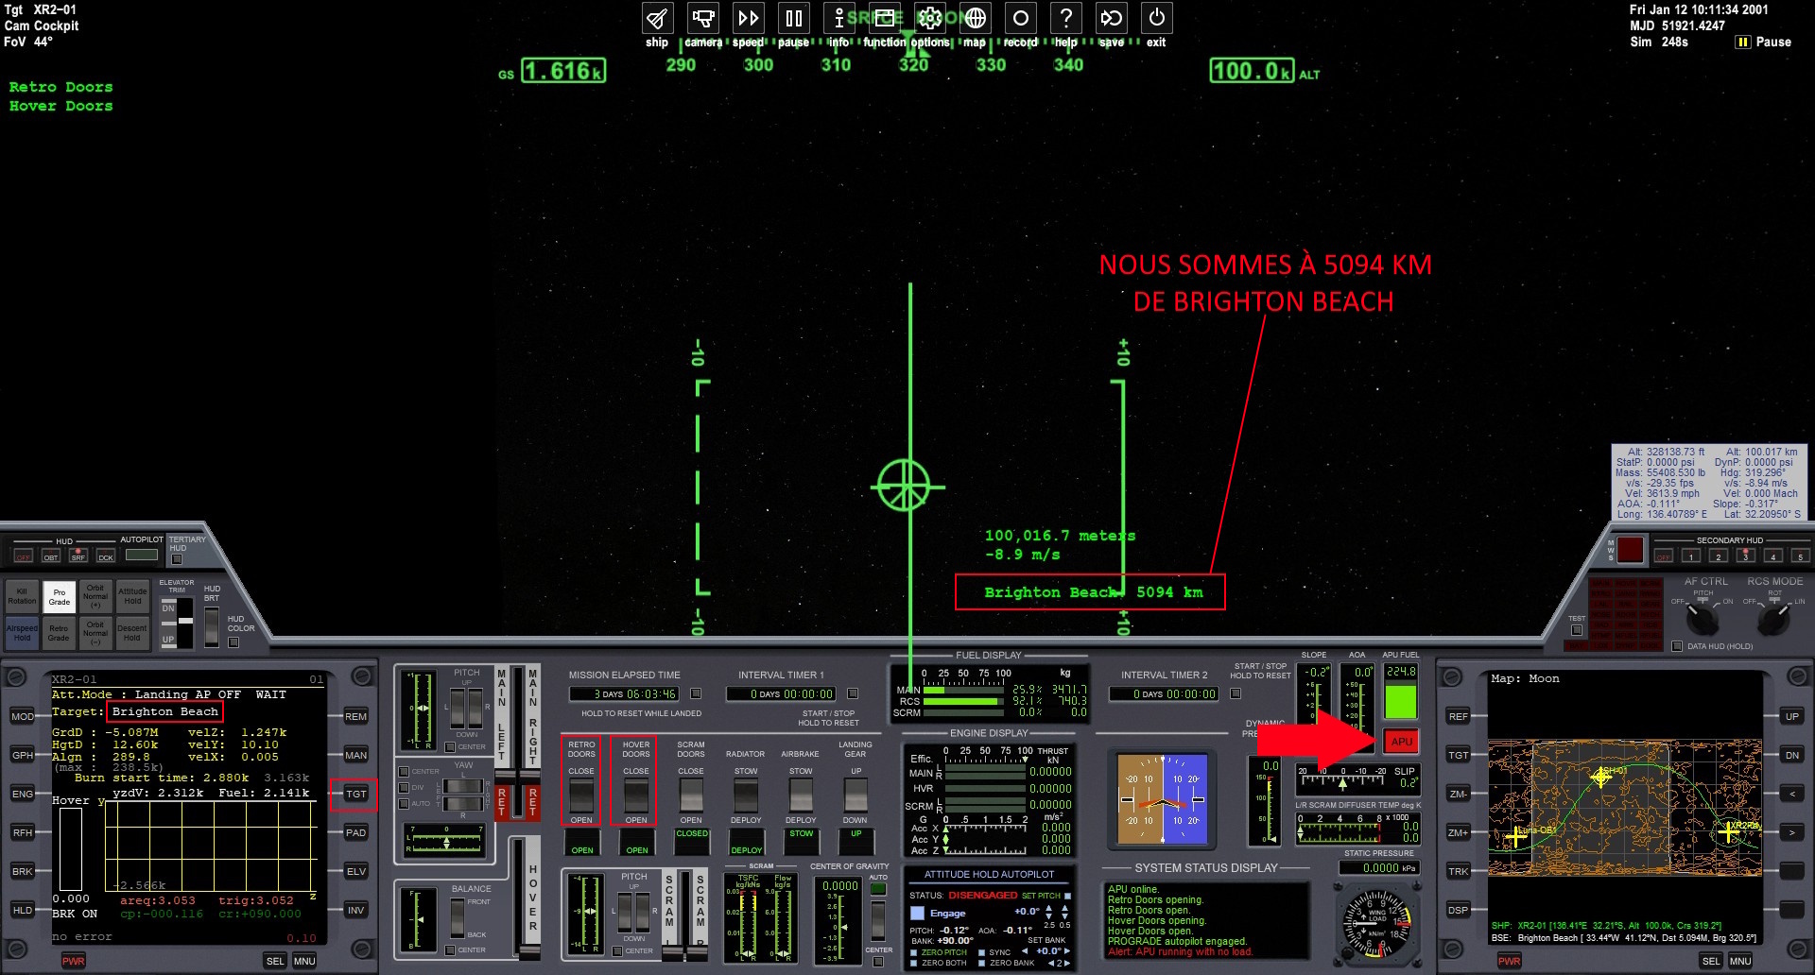
Click on the image to enlarge

Press F8 to display the 2D view of the ship as above.

On the left MFD
01 - Click on the SEL button, as many times, in order to see PursuitMFD in this menu.
02 - Click on the button to the left of the word PursuitMFD to select it.
03 - Press the LAN button (means landing).

04 - Default Target should be Brighton Beach.
Otherwise, you must press the TGT button to bring up a window, then enter Brighton Beach (be careful about the syntax of the word), then on the keyboard type ENTER.

05 - Press the red APU button to activate the APU.
06 - Wait until the red APU button stops flashing.
07 - Press the RETRO DOORS button to open them.
08 - Press the HOVER DOORS button and wait for the opening noise to stop.
09 - Press the red APU button to deactivate the APU.

We will determine which Landing Pad to use.
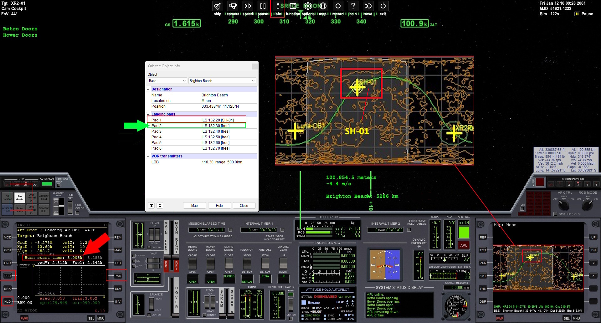
Click on the image to enlarge

Note that on the Map MFD on the right and bottom we see the word SH-01, which explains that there is already a ship at the Brighton Beach base. Let's look at an information window to find out where this ship is located at the Brighton Beach base.

01 - Click at the very top, on the menu bar, on the info button.
02 - In this new window, at the very top, click on Focus vessel and change to Base.
03 - Click on Alcantara and change to Brighton Beach (use the mouse wheel to reach this choice then click with the left mouse button).
04 - Note that landing pads 1 is occupied by the SH-01 vessel: “Pad 1 ILS 132.20 (SH-01)”.
05 - Note that Pad2 is free
06 - Close the floating window on the Brighton Beach base information.

We will choose a free PAD and register it on the left MFD
01 - Press the PAD button to bring up a window, then enter 2 then ENTER.

Let's prepare the XR2 Ravenstar for this moon landing
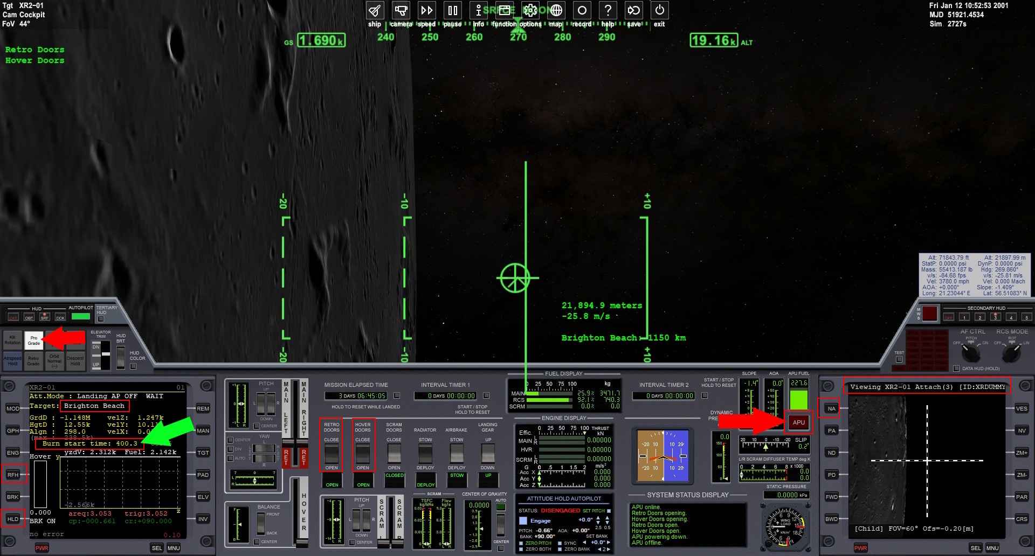
Click on the image to enlarge

On the left MFD
When Burn start time will be ±400.0 (see green arrow)
01 - Press the Pro Grade button (this will deactivate prograde).
02 - Press the RFH button (necessary for the rest).
03 - Press the HLD button (you start the moon landing).

On the right MFD
01 - Click on the SEL button, as many times, in order to see Generic Camera in this menu.
02 - Click on the left button of the word Generic Camera to select it.
03 - Press the NA button (until you see the lunar ground moving).

Do not speed up the simulation so as not to harm the work of PursuitMFD

Moon landing sequences with PursuitMFD
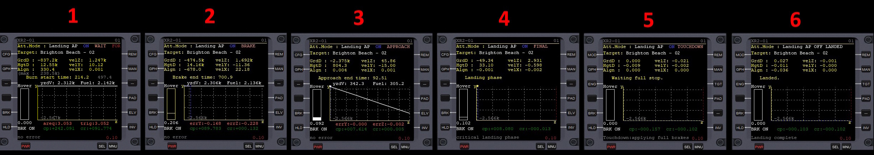
Click on the image to enlarge

01 - Sequence 1 indicates that PursuitMFD is in WAIT mode.
02 - When Burn start time reaches 180.0, the program will modify the attitude of the ship.
03 - Sequence 2 indicates that PursuitMFD is in BRAKE mode.

In sequence 2 you can accelerate the simulation to 10X, carefully, in order to have a
Brake end time = ±300.0 then return the simulation speed to normal.

From there, do not speed up the simulation any more so as not to harm the work of PursuitMFD

04 - Sequence 3 indicates that PursuitMFD is in APPROACH mode.
- You need to press the APU button (wait until it stops flashing)
- Click on LANDING GEAR (next image).

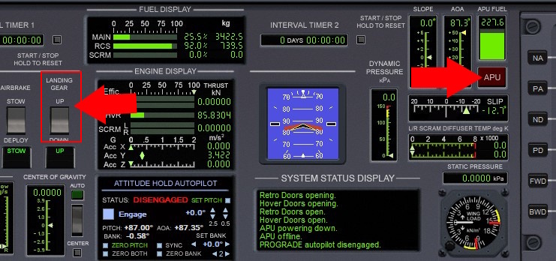
05 - Sequence 4 indicates that PursuitMFD is in FINAL mode.
06 - Sequence 5 indicates that PursuitMFD is in TOUCHDOWN mode.
07 - Sequence 6 indicates that PursuitMFD is in LANDED mode.

Brighton Beach and its two vessels
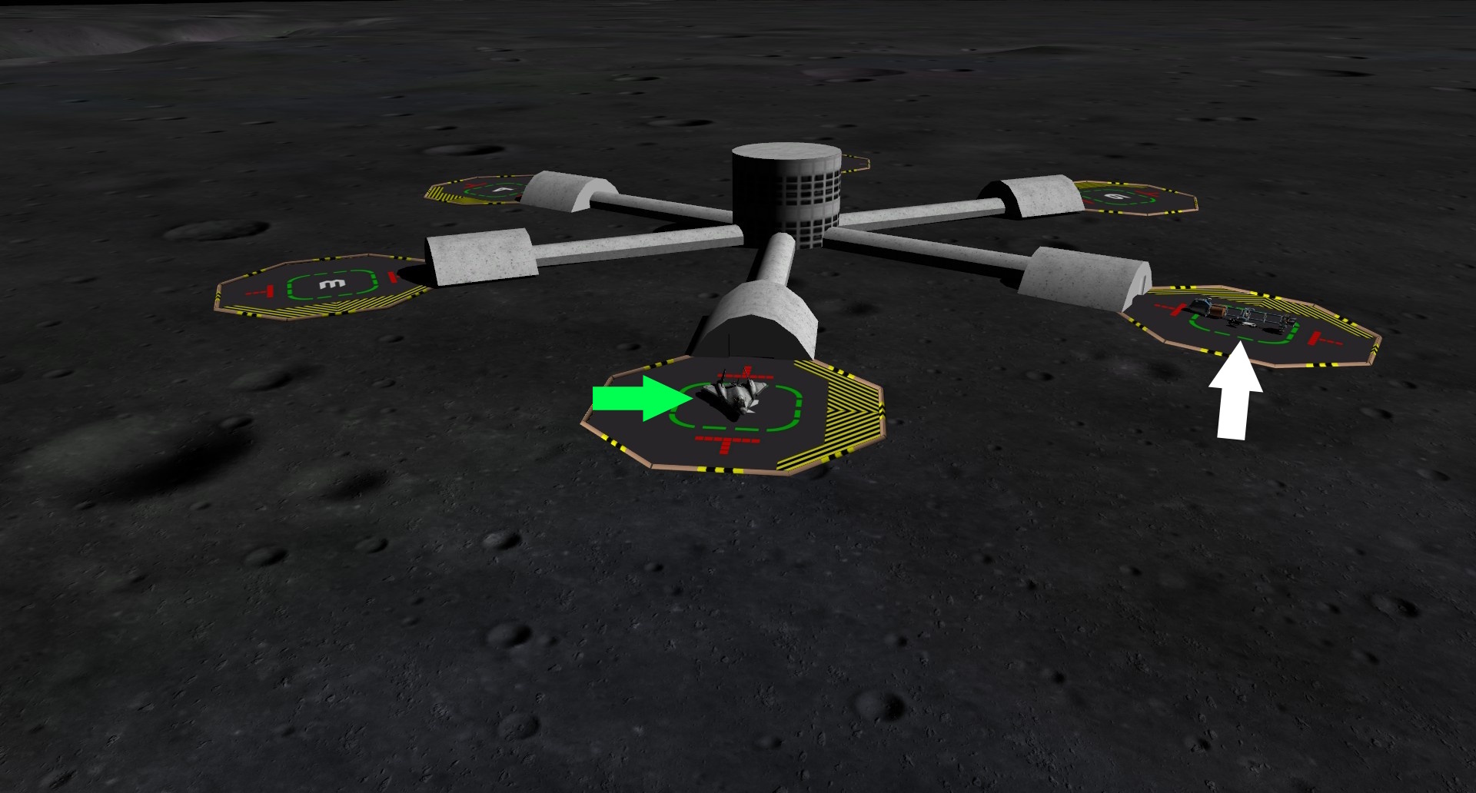
Click on the image to enlarge

We discussed on page 16 that there was already a ship at the Brighton Beach base.

This ship is pointed by a white arrow. The XR2-01 is pointed to by a green arrow.
The XR2-01 is our XR2 Ravenstar.

Congratulations !
You have succeeded in your mission with flying colors.
You are on the Moon.

Thank you for choosing Orbiter 2024.

It is an excellent space simulator that can allow us to visit Mars and many other planets.

Read the official Orbiter 2024 documentation
Orbiter-2024/Doc/Orbiter User Manual.pdf.

Browse the discussion forums for more details
http://orbiter.dansteph.com/?language=french
https://www.orbiter-forum.com/

This tutorial is dedicated to my good friend Papyref (Pierre Refoubelet).
Coussini 2025 (Louis Cyr)

