Definition

This eyeglass repair kit is useful for projects in which a small screw must be tightened, loosened, installed, or removed, such as repairing glasses or working with small-scale electronics.

Description

The eyeglass repair kit consists of two tools: a magnifying glass and a screwdriver.
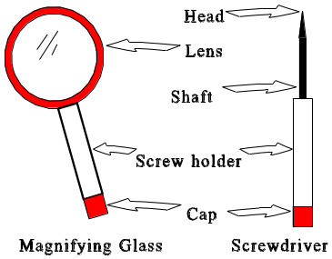

The magnifying glass is useful for magnifying the working area to get a better view. It is built out of plastic, and is therefore lightweight and crack-resistant. However, because the lens is plastic, it scratches easily, and should be handled accordingly.

The screwdriver is a small flat-headed screwdriver, useful for working with screws for which an ordinary-sized screwdriver might not be appropriate. Particularly, it is designed for eyeglass repair, but can be used in other projects as well. It too is built out of plastic, though the head and shaft are made out of metal.

Both tools come with holders for screws; this keeps the user from losing small screws. The cap is rubber; this provides a tight fit so the screws will not fall out.

Instructions

To remove or loosen an eyeglass screw

- Place the glasses on a table or other surface.
- Use the magnifying glass to get a good view of the screw.
- Place the head of the screwdriver to the head of the screw (see diagram), so that the screwdriver’s head fits the slot on the screw. You may need to let go of the magnifying glass to hold the eyeglasses in place.
- Assuming a standard (right-handed) screw, rotate the screwdriver counter-clockwise. To remove the screw, continue until the screw comes out of the screw hole. If the screw is a left-handed screw, you will need to rotate the screwdriver clockwise.
To insert or tighten an eyeglass screw

- Place the glasses on a table or other surface.
- Use the magnifying glass to get a good view of the screw.
- Place the head of the screwdriver to the head of the screw (see diagram), so that the screwdriver’s head fits the slot on the screw. You may need to let go of the magnifying glass to hold the eyeglasses in place.
- Assuming a standard (right-handed) screw, rotate the screwdriver clockwise. If the screw is a left-handed screw, you will need to rotate the screwdriver counter-clockwise. Continue until the screw is tight and will not easily rotate.

To hold a screw for later use

- Remove the cap from either the magnifying glass or the screwdriver
- Place the screw into the screw holder.
- Replace the cap.

