

Brushing teeth can be an important part of taking care of your body in the 21st century. Doing so well help to ensure a healthy smile, great gums, and shiny white teeth. While most children learn the process even before kindergarten, you may be interested to know that dental technology has advanced far beyond the sassafras root. This may also be a little bit overwhelming.

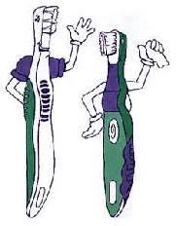
Before you brush your teeth for the first time, you will need a few items: a toothbrush, a container of toothpaste, and a supply of water. There are a wide selection of products available in this area, and they do range in quality.

The toothbrush you select will be an important factor in determining how easy it is to
reach all of your teeth’s many surfaces. All toothbrushes are made from the same basic design: a handle with bristles at the end. Newer toothbrushes arrange the bristles differently to aid your brushing, but they can be costly. There are even some electric brushes, though a good technique will work just as well. Almost any toothbrush will do, but most dentists will recommend a soft-bristled toothbrush with a medium head; the other features are just frills.

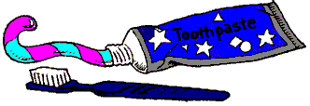
Toothpaste selection is also important, though most toothpastes have almost identical ingredients. Most name brands will have approval of the American Dental Association, the most important mark to look for in a good toothpaste. Other features to look for are whitening (which can be harsh, sometimes), sensitivity formula (if regular toothpaste hurts your teeth), and baking soda (which you may be used to). All toothpastes should have fluoride, to fight tooth decay, and an antibacterial agent, to rid your teeth of disease.

  1. The first step in brushing your teeth is opening the tube of toothpaste. The tube should indicate what type of container it is, i.e. flip-top or screw-cap. |   2. The next step involves applying toothpaste to the toothbrush. The toothpaste, which is inside the tube, must be applied to the head of the toothbrush (the bristled end). Wet the toothbrush, and then squeeze the tube of toothpaste and place just enough toothpaste to the bristles to cover them. Close the toothpaste container and set it aside. | 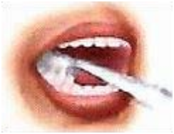  3. Gently press the bristles of the toothbrush against your teeth at a 45 degree angle.  While continuing to press the toothbrush to the teeth, move the toothbrush in short strokes against the teeth to remove any food and loose particles.
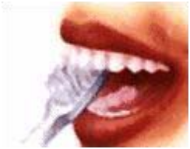  5. After brushing the outer surfaces of your teeth, brush the inner surfaces. At this point, you may want to spit out any saliva that has built up into the sink. Do not swallow the toothpaste. | 6. Brush the flat chewing surfaces of your back teeth by using horizontal movements. | 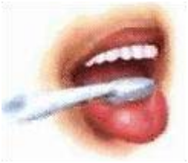  7. Every so often, it’s also a good idea to brush your tongue.

All clip art comes from the public domain dental clip art page, “Flossie’s dental, smile, and tooth fairy art” at http://mir.spaceports.com/~flossies/

