Paul Brannan
November 15, 2000
Individual assignment 1
Revision 3

Definition

This eyeglass repair kit is useful for tightening and replacing screws on a pair of eyeglasses, though it is also useful in projects in which a small screw must be tightened, loosened, installed, or removed, such as repairing glasses or working with small-scale electronics. The kit consists of a magnifying glass and a screwdriver.

Description
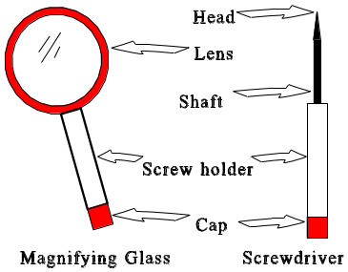
The eyeglass repair kit consists of two tools: a magnifying glass and a screwdriver.

The magnifying glass is useful for magnifying the working area to get a better view. It is built out of plastic, and is therefore lightweight and crack-resistant. However, because the lens is plastic, it scratches easily and should be handled accordingly.

The screwdriver is a small flat-headed screwdriver, useful for working with screws for which an ordinary-sized screwdriver might not be appropriate. Particularly, it is designed for eyeglass repair, but can be used in other projects as well. It too is built out of plastic, though the head and shaft are made out of metal.

Both tools come with holders for screws; these are clear plastic tubes that can keep the user from losing small screws. The cap is rubber; this provides a tight fit so the screws will not fall out.

Instructions

To tighten a loose screw
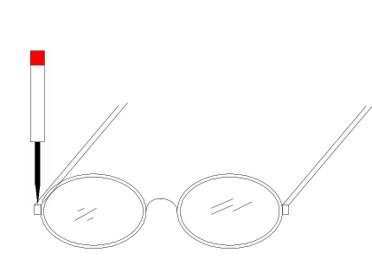
- Place the glasses on a table or other surface.
- Use the magnifying glass to get a good view of the screw.
- Place the head of the screwdriver to the head of the screw (see diagram), so that the screwdriver’s head fits the slot on the screw. You may need to let go of the magnifying glass to hold the eyeglasses in place.
- Assuming a standard (right-handed) screw, rotate the screwdriver clockwise. If the screw is a left-handed screw, you will need to rotate the screwdriver counter-clockwise. Continue until the screw is tight and will not easily rotate.

To replace a screw

To complete this task, you will need a replacement screw handy. You can obtain one of these at any eyeglass shop.

- Place the glasses on a table or other surface.
- Use the magnifying glass to get a good view of the screw.
- Place the head of the screwdriver to the head of the screw (see diagram), so that the screwdriver’s head fits the slot on the screw. You may need to let go of the magnifying glass to hold the eyeglasses in place.
- Assuming a standard (right-handed) screw, rotate the screwdriver counter-clockwise. Continue until the screw comes out of the screw hole. If the screw is a left-handed screw, you will need to rotate the screwdriver clockwise.
- If you wish to keep the old screw for later use, remove the cap on the magnifying glass or screwdriver, and place the screw into the screw holder. Replace the cap.
- Place the new screw into the screw hole, using the magnifying glass if necessary. Rotate the screw clockwise to get it into position. Continue, using the above instructions for tightening the screw.

Troubleshooting

A screw that needs to be tightened periodically may be a symptom of a stripped screw hole. Take the glasses into an eyeglass shop for repair.

When replacing a screw, the old screw may be broken or stripped, and may not come out easily. In this case, use a pair of needle-nose pliers to grab hold of the screw and remove it by rotating it, taking care not to strip the screw hole. Do not pull the screw out without rotating it, or the screw hole may become stripped. If the screw will not come out using pliers, take your glasses in to an eyeglass shop for repair.

When replacing a screw, if the new screw will not fit, you may have the wrong size or thread screw. Use a different screw or take the glasses into an eyeglass shop for repair.

If the rubber cap on the screw holders becomes worn, it may not stay in position well. Replace the cap with a size ¹/₄" cork.

