To: Dr. Bausser

From: Group 5.3  Jim Matthews, Paul Brannan, Suzanne Morton, John Palastro
Subject: Strode Tower Evacuation Proposal Transmittal
Date: 10/6/00

Our group from Safety Consultants, Inc. has completed a proposal for a new evacuation plan for Strode Tower. Included with the proposal is a plan to create awareness of the new evacuation procedures, the instructions for exiting the building, and a set of evacuation considerations that must be taken in account when implementing the new procedures. We hope that you will find the proposal useful and beneficial to the occupants of Strode Tower.

Table of Contents
Overview 3
Creating Awareness 4
Proposed Plan for Evacuation 5
Getting out of a Room 5
Getting to the Stairs 5
Getting down the stairs 5
Getting out of an elevator 6
Evacuation Considerations 7

Overview

The evacuation plan contained herein is divided into three parts: creating awareness, a proposed plan, and special considerations that must be made to ensure everyone’s safety. Each of these parts is necessary, and it is imperative that each part be carried out for the plan to run smoothly.

Perhaps the most important part of the plan is creating awareness about the evacuation procedure. There is little sense in having a procedure to follow if none of the building’s occupants knows there is a procedure to follow.

Secondly, included in the evacuation plan is a procedure that, if properly followed, will help everyone to get out of the building safely and smoothly. The procedure outlines proper techniques for exiting a room in case of fire, for getting to and down the stairs, and for exiting the building. Modern elevators, such as those in Strode Tower are designed to stop at the nearest floor during an emergency, but elevator escape procedures have also been included in case of elevator malfunction.

Lastly, the evacuation plan examines special considerations not covered in the evacuation plan itself. Because the evacuation procedure is geared toward the average person and is meant to be easy to read and understand in an emergency, it is not efficient to include these considerations in the procedure itself. It is, however, of utmost importance that those directly involved with these issues understand these considerations; those ensuring awareness of the evacuation procedures should therefore address these considerations.

Creating Awareness about the Evacuation Procedure

Before discussing our plan for awareness, we must recognize that the teachers and students who benefit from a safety procedure of this type often ignore the procedure altogether in the event of an emergency; these individuals will be the main focus of our awareness plan. For this reason, our awareness plan will assume that the beneficiaries of the evacuation procedure will need both strong motivation and constant reminders of the evacuation procedure. Through reiteration, we hope our evacuation procedure will become a reflex action, not just a mere formality.

The first step is to introduce the evacuation procedure to all faculty, staff, and students who enter Strode tower on a daily basis. This can be accomplished by organizing a mandatory meeting at which the evacuation process and the reasons behind it can be described in detail. This meeting can also give the attendees an opportunity to voice their opinions about the new procedure.

After the evacuation procedure has been introduced, an email should be sent out about once every two months reminding these individuals about the proper procedures for evacuating Strode tower. To ensure the e-mails are not ignored, a reply email should be mandatory. By sending the email once every two months, the individuals involved will become familiarized with the procedure and begin to recognize its importance.

Although the meeting and subsequent e-mails will familiarize individuals with the procedure, the key to an effective execution is practice. We therefore propose a mandatory evacuation drill once every two months. Individuals who work in Strode tower should be informed of the drill before its occurrence. Once these individuals show proficiency in the announced drills, the drills should proceed to occur unannounced, so that the drill will be more like a real life situation. These drills will help make the evacuation procedure second nature, which will in turn expedite evacuation in an actual emergency.

We also propose that easy-to-read diagrams and quick reference instructions be placed at each exit and stairwell in Strode. When those evacuating the building begin to panic, they can refer to the instructions. These instructions will be a constant in the hallways, which the faculty, staff, and students in Strode tower will always see as they enter or leave the building. Arrows pointing to exits and stairwells will also be placed in the hallways, helping those individuals unfamiliar with Strode tower to evacuate.

It may be unreasonable to expect all individuals to become familiarized with the evacuation procedure, but reiteration will ingrain the procedure into at least some individuals. It is these individuals who will assume responsibility in the case of an emergency, and it is these individuals who will save lives. With the full support of all those involved, we can prevent unnecessary death and injury in emergency situations.

Proposed Plan for Evacuation

The most important part of the evacuation plan is the procedure that accompanies it. This procedure or a variation thereof should be posted visibly throughout the building so that the occupants of the building will be aware of the procedure in the event of an emergency. There are many cases in which those evacuating the building may not be able to follow these procedures to the letter; please see the section titled “Evacuation Considerations” for more information on what to do in these cases.

Getting out of a Room

- First, check the door handle for excessive heat. Use the back of your hand, since it is more resistant to scalding.
- Also check for smoke under the door. Since smoke rises, smoke coming from under the door indicates the hallway is full of smoke. If this is the case, tie a shirt around your nose and mouth before opening the door.
- If the door handle is safe to touch, then carefully open the door and enter the hallway.
- If the door handle is too hot to touch, then place a shirt or towel at the base of the door to prevent smoke from entering the room. Open a window and motion for help. Remain where you are and stay calm.

Getting to the Stairs

          - Most importantly, stay calm. Be aware of those around you, and proceed with caution.
- If there is a lot of smoke, stay low to the ground and use a shirt to cover your nose and mouth.
- Follow the arrows on the attached diagram to reach the nearest stairwell. From there you will exit the building.
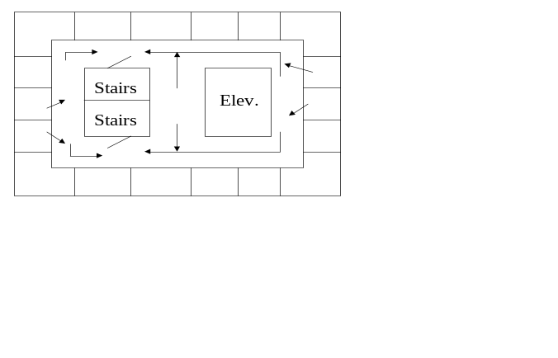
Getting down the stairs

1. Upon entering the stairwell merge towards the inside railing away from the doors on each level so that others will be able to smoothly enter the stairwell from lower floors.
- If stairwell passageway is blocked near the lower floors, exit at either the 4th, 3rd, or 2nd floors and proceed right outside of the building and across the walkway to Daniel Hall.
- Otherwise, after reaching the first floor those on the side of the exit door should exit and take a right out of the building. Those on the inside of the stairwell should continue to the bottom floor, through the exit door and immediately left until safely out of the building.
- Once outside of the building on the first floor take a right and gather in the parking lot to the side of the building. From the bottom floor, continue walking straight and gather in the parking lot a safe distance from the building.

Getting out of an elevator

- In case of fire or emergency DO NOT use an elevator.

- In the case of an emergency the alarm will be activated and the elevator will return to the ground floor and remain there. Exit the elevator and take a left outside the exit doors and across to the parking lot.

- If the elevator should lock between floors, remain calm, sound the alarm, use the emergency telephone, and wait for assistance. Do not attempt to open the doors and escape. Trained professionals will help you get to safety.
Evacuation Considerations

As members of Safety Consultants Inc, it is our project teams responsibility to ensure the safest evacuation procedures for buildings on campus. Problems can arise when people faced with danger must exit a building as quickly as possible. Our top priority is to ensure that everyone can get out safely. However, some special consideration must be made for people who may not completely understand evacuation procedures, or who may have a condition that may hinder their performance in an evacuation. People who may fall into this category include children, the elderly, and the handicapped. We must accommodate any needs they may have to ensure they can evacuate the building safely and effectively in an emergency.

Children are extremely vulnerable when faced with an emergency. Their reactions are sometimes unpredictable, as many hide, or leave the building unnoticed. Parents should be held accountable for their children. Parents should know where they are at all times and leave with them. A parent with missing children may panic and slow down the evacuation as they distract individuals trying to evacuate. One way to resolve this issue is to inform parents of the evacuation procedures of Strode through employee meetings. Encouraging them to educate their children about evacuation will also serve to reduce problems. Diagrams placed on the walls should be clear enough so that a child who cannot yet read can follow them. Also, no child should be allowed to roam the halls without a parent or guardian present.

The elderly may also need special attention during an evacuation. Depending on the mental and physical health of a person, an elderly person may not be able to evacuate Strode effectively or at all. We must take extra measures to ensure a higher success rate for them. Meetings will help them to remember procedures, but repeated meetings will make the process become second nature. Also, easy to read diagrams with simple directive words will increase the success rate of evacuation. Large or bold writing will help those with poor eyesight. Loud sirens with flashing lights will alert even those with severe loss of eyesight or hearing.

Handicapped individuals often become victims in emergency situations because they physically cannot get out of the building fast enough. Many have canes, walkers, or wheelchairs that hinder them from exiting safely. They may get trampled by others, or ignored when needing assistance. Those in wheelchairs must use an elevator to go downstairs, but cannot do so in the event of fire. One possible plan for those individuals who cannot descend stairs is to wait at the top of the stairs until help arrives. We also suggest that these individuals arrange with someone in the building to help them when an emergency occurs. Another possible plan would be for those people to get to the closest window, and call for help from the ground.

