EcoInfo paper category re-organization

Jessica Couture

4/23/2016

#### This script re-organizes the 400+ datasets we have for the EVOSTC project into more sensible groups showing a bit of the process for feedback:

## **Original mess:**

##### We started with the following category structure which intially was based on a system and got more and more random as I came across projects that didn't fit within my original categories:

* modeling
* habitat
* fish
* dataMgmt
* monitoring
* terrestrial
* inverts
* oceanography
* marineBirds
* mammals
* anthropogenic
* oil
* plankton
* mapping
* freshWater
* meta
* misc projects
* unk

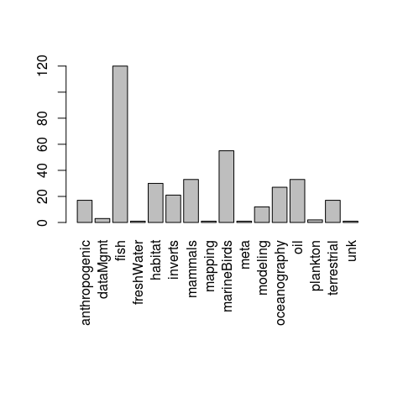

...Kinda all over the place.

## **First re-organization:**

##### When Rachael, Colette and I got together to make new groups, we came up with the following:

|  |  |
| --- | --- |
| DataType | Sub-category |
| Biological | fish |
| Biological | benthicInverts |
| Biological | mammals |
| Biological | plankton |
| Physical | NA |
| Chemical | NA |
| Other (default) | NA |

##### This still leaves us with a lot of "other" since everything doesn't fit nicely into these clean groups:

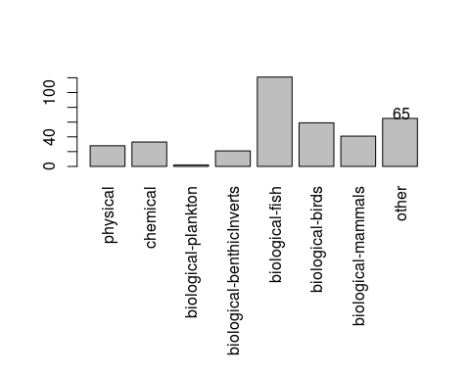

## **Adding an "ecosystem/habitat" group:**

##### Rachael and I briefly discussed the many modeling, mapping and habitat projects that were lumped into the "other" category we decided that pulling these out into an "ecosystem/habitat" category might be a little vague but would work for these groups. Here's what this does to the distribution of datasets:

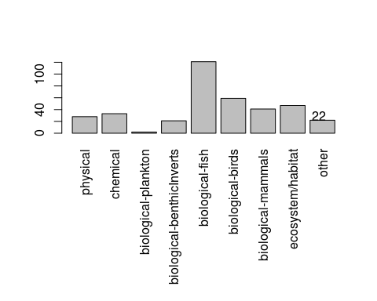

##### This brings the other group down to 22 datastes, which can be loosely described by the following terms:

(each row is a dataset with 1-2 descriptive terms)

|  |  |
| --- | --- |
| subCat | subCat2 |
| projMgmt | habitat |
| projMgmt | ecosystem |
| economics | recreation |
| projMgmt | habitat |
| economics | subsistence |
| subsistence | film |
| communityMgmt | waste |
| social | subsistence |
| environmentalImpacts | infrastructure |
| samplingImpacts | metaAnalysis |
| projMgmt | NA |
| meeting | 10yrSymposium |
| economics | resarchPrograms |
| economics | subsistence |
| economics | fisheries |
| economics | resources |
| economics | resources |
| economics | fisheries |
| subsistence | resources |
| dataMgmt | NA |
| dataMgmt | NA |
| communityMgmt | waste |

###### **Note:** I haven't sorted these into "terrestrial", "nearshore" and "pelagic" yet. That will take a bit more work.