Project 3

A Simple Interactive 3D Game

Mitchell Couturier | CIS 367 | April 18, 2017

# Purpose

The purpose of this program is to develop a simple 3D interactive game that features interactive computer graphics. The game I chose to develop was an “asteroids shooter”-style game, with a 3rd person perspective from the spaceship.

# Architecture

This program and the graphics generated by it are created using the Three.js library. Three.js is a Javascript library used to create and draw computer graphics. In this program, the main.js file runs the program by an *init()* command, which initializes all of the game objects, and an *animate()* command, which draws the scene. The main.js file uses the classes **Asteroid**, **SpaceFighter**, **Lazer**, **LazerSights**, **ExplosionPlane**, and **SpaceBackground**, which represent all of the objects/visuals of the game. The text elements of the game, such as the score or remaining time, are inserted by adding text through the HTML DOM. The img folder contains texture images that are used by the **Asteroid**, **ExplosionPlane**, and **SpaceBackground** objects.

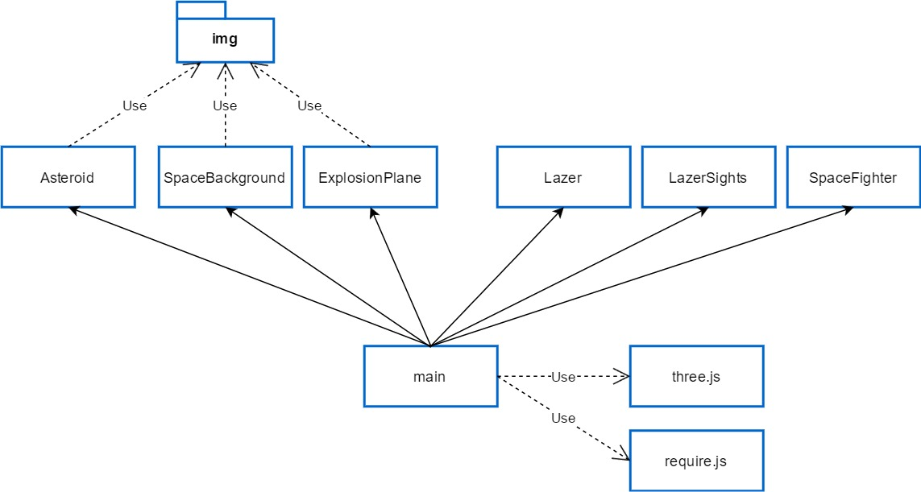

# Building the scene

The scene is made up of many parts, from game objects to background images to explosion animations. First, we will discuss the game objects. The first game object is the space fighter (based off of the Star Wars X-Wing). This object is made up of many different geometric shapes. The middle sections of the body are cylinders, while the ends of the body are half-spheres, to create a rounded effect. The cockpit glass cover of the ship is made up of a cube with bevels. It is angled inside the ship in such a fashion that the protruding end looks like a glass cover. The wings are then made up of 4 trapezoids with bevels, with added cylinders on the ends as poles. Lastly, the engines are made up with multiple cylinders, 8 total, and a red ring at the end to simulate the hot engine.

The next objects in the scene are the asteroids. These are simply made up of randomly sized spheres, with a random asteroid texture attached to them. Whenever an asteroid is shot, it is replaced by an explosion object, or **ExplosionPlane**, which consists of a square plane with an explosion texture attached to it.

The next object is the lazer. The lazer sights are created by a 2D ring and a circle in the middle. The actual lazer object is a red cylinder, which is shot towards the sights whenever a shot is fired.

The last object is the space background. This is created by adding a sphere of a very large size and placing the camera within the sphere. A space texture is then added to the inside of the sphere to create the illusion of a background.

# Gameplay

The game itself is simply a 3-dimensional asteroid shooter. The object of the game is to quickly shoot as many asteroids as possible before the timer runs out. The spaceship moves around in the x and y direction, and a lazer-sight/cursor is aimed in also the x and y direction. Asteroids appear in random locations on the screen and in random sizes. If the cursor is placed over an asteroid and the lazer is shot, then the asteroid explodes and it is counted as a hit. In this case the player earns points. If the cursor is not over an asteroid and the lazer is shot, then it is counted as a miss, and the player loses points. A timer appears at the top of the screen and counts down. If the timer reaches zero, the game is over and the score is final. If a player clears all of the asteroids from the screen, the player advances to the next level and a few seconds are added on to the timer.

# Screenshots

