JobExecRequestWebUI manual

V. 1.0

Breogan COSTA

https://www.linkedin.com/in/breocosta/
https://github.com/covelus

Contents
1. Idea, what this small application does: 3
2. Folder structure: 4
3. Run: 5
3.1 Opening the WebApp: 5
4. Graphical explanation of the WebApp: 6
4.1 Initial page 6
4.2 Running a script 7
4.3 Uploading a file 7
4.4 Checking STDERR and STDOUT 10
4.5 Checking the generated Key Performance Indicators (KPIs) 12

Idea, what this small application does:

Imaging you have some scripts deployed in a datacenter machine, inside a trusted environment. You already have the mechanism to upload them (i.e: a software repository), but you want to give users the chance to manually run the scripts and recover the execution status output (STDOUT, STDERR).
Also, this application would take some statistics and KPI’s (Key Performance Indicators).

Folder structure:
Inside the application’s directory, they could be found some s src_scripts subdirectory and files:

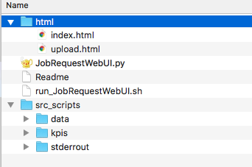

- html/
  - auxiliary HTML pages that will be used by the WebApp’s
- JobExecRequestWebUI.py
  - WebApp Python 3 script
- Readme
  - Something you must read
- run_JobExecRequestWebUI.sh
  - shell script to launch the Web server and WebApp
- src_scripts/
  - data used by the script and captured stdout/stderr and KPIs
  - Scripts are also deployed here. It is not responsibility of this application.
  - src_scripts/data/
    - uploaded data files by the user, that will be used by the deployed scripts (developer responsibility)
  - src_scripts/kpis/
    - data gathered to generate the KPIs
  - src_scripts/stderrout/
    - captured stdout and stderr

An example of how this structure could be populated after some operations:
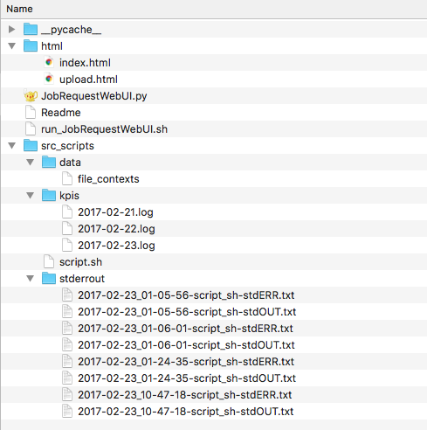

Run:

This application requires a embedded server (and micro-framework), flask.
It was automated through an script located in the application’s directory.
In the shell in that folder, we just run the script “run_JobExecRequestWebUI .sh”:

$ ./run_JobExecRequestWebUI.sh

Opening the WebApp:

It can be found in http://[server-url]:5000/, for example,
http://localhost:5000/

Graphical explanation of the WebApp:

This WebApp is very intuitive, but some screenshots could be helpful.

Initial page

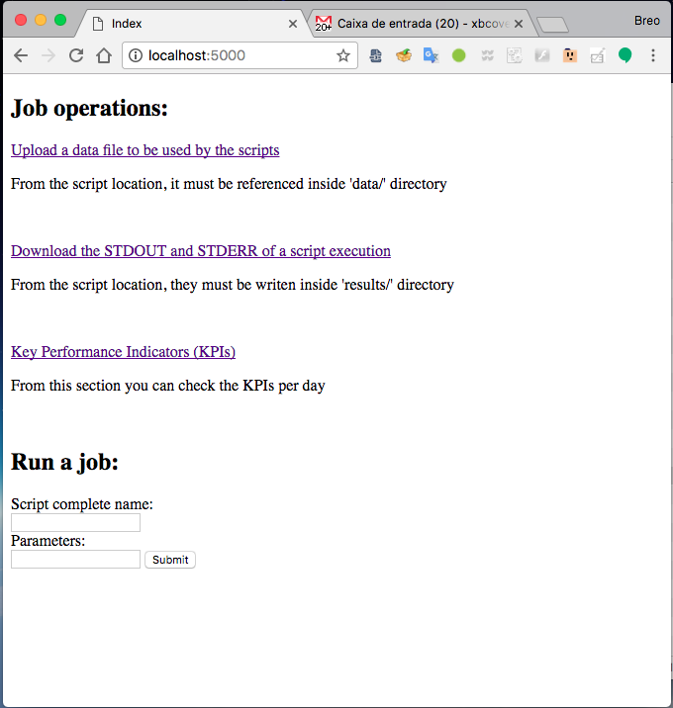

Running a script
You can do this in the bottom of the page, typing the name of the script and the parameters. For example:
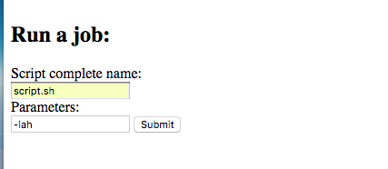

Uploading a file

This option is presented in the top of the page.
It is simple, but an example of the whole process is shown below:
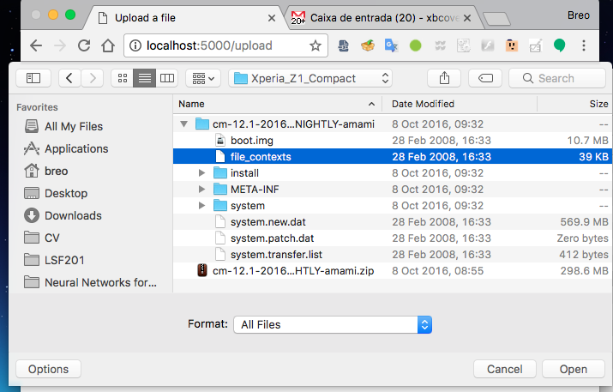

After, you must press upload:
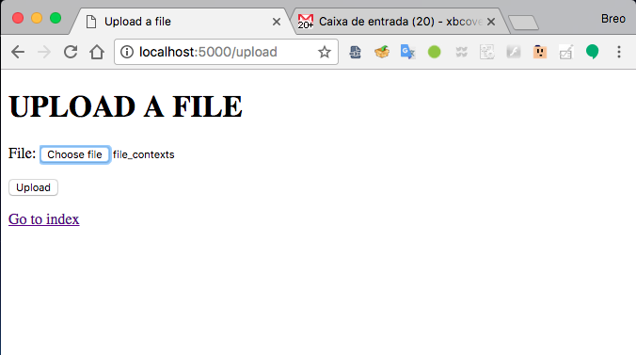

And the result of the upload will be presented:
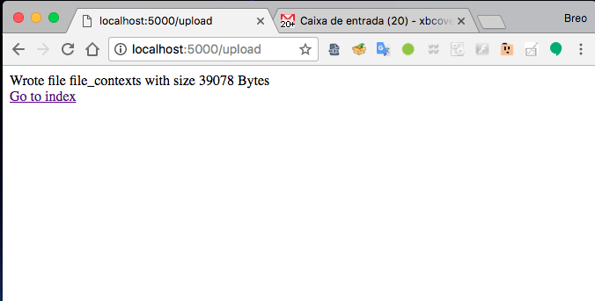

Also, having read rights in the server, it can be seen the file in the src_scripts/data/ directory:

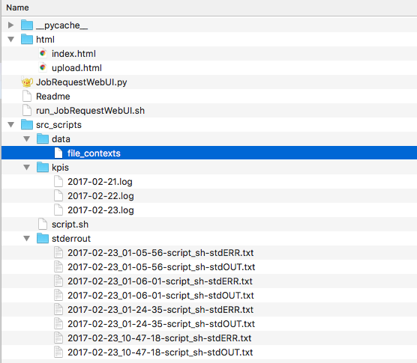

Checking STDERR and STDOUT
This is presented in the second option of the WebApp index page.
Once there, all captured stdout and stderr files are listed and can be opened.
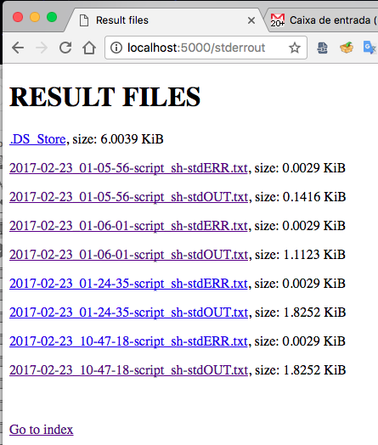

Opening the last file (result of the script execution example shown in a previous section) would show:
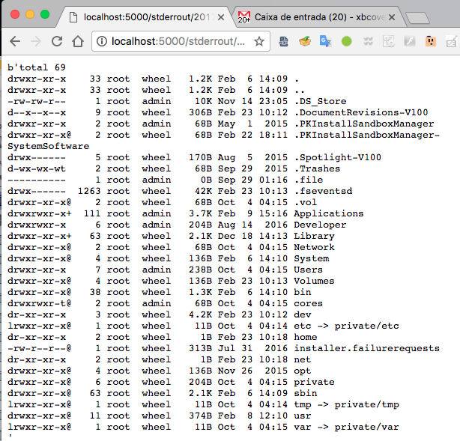

Checking the generated Key Performance Indicators (KPIs)
Some Key Performance Indicators were manually generated using Python pandas package and HTML code.
There are some KPI package projects for Python (Ax_Metrics), but they were not adapted to Python 3 yet, so, it is possible that they are not maintained.
Some results could be seen with matplotlib and mpld3, but they were not included in this solution, due to they require a further research regarding to the Web integration with flask.
In the WebApp, the option is presented in 3rd position, and it will bring a list of links to KPIs by date, that can be pressed.

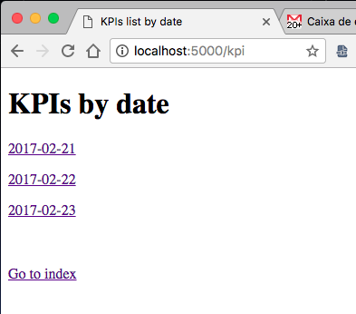

Once opened, they will show the number of executed tasks in that day, the free space after each script run, and the runs log ordered by timestamp:
