Setup Office 365 for Federated Search.

# Introduction

This document will describe what needs to be done to let Coveo execute a Federated search against your Office 365 data.

Using a Federated search approach Coveo is then able to display the results from Office 365 (Email, and Files from Sharepoint, Teams and OneDrive) inside the same Search Interface.

Coveo will use the Graph API (Microsoft) to authenticate and to perform searches.

Remark: THIS WILL NOT REQUIRE TO INDEX THE CONTENT, only a search is being executed to fetch the data.

Remark: The data which is retrieved is only from the current logged in user.

# Permissions

To access the Graph API, Microsoft requires to create a Registered Application. This Registered Application will contain the allowed URL’s to access the App, and the required/needed permissions to access the data.

## Permissions needed

The following (Delegated, only content for the current user is being accessed) permissions are required for the registered application:

Mail.Read (To read the emails of the current logged in user)

Mail.Read.Shared (To read the emails of the current logged in user)

User.Read (To Sigin in for the current logged in user)

Files.Read.All (To read all the files from OneDrive, Teams, SharePoint)

Sites.Read.All (To read all the sites from Sharepoint and Teams)

## Protocol used

Coveo will use the openid/OAuth2 protocol to connect to the Graph API. Reference: <https://docs.microsoft.com/en-us/azure/active-directory/develop/v2-protocols-oidc>

Remark: All calls Coveo will execute are READONLY calls. No data is being altered.

# Flow

The first thing what Coveo will do is authenticate against the Graph API (<https://login.microsoftonline.com/common/oauth2/v2.0/authorize>) , for that we need the ApplicationID from the registered app. After the user is authenticated, we will receive an access token (<https://docs.microsoft.com/en-us/azure/active-directory/develop/access-tokens>).

The access token is then used to call the following api’s:

Get latest emails:

/me/mailfolders/inbox/messages

Search emails:

/me/messages?$search

Get Files from SharePoint, Teams, OneDrive:

/beta/search/query

# Setup

To setup the application, you need a user who is an Office 365 Administrator.

* Using this account, you navigate to: <https://portal.azure.com/>
* Goto ‘App Registrations’ 
* Hit ‘New Registration’ 
* In the following screen:  
  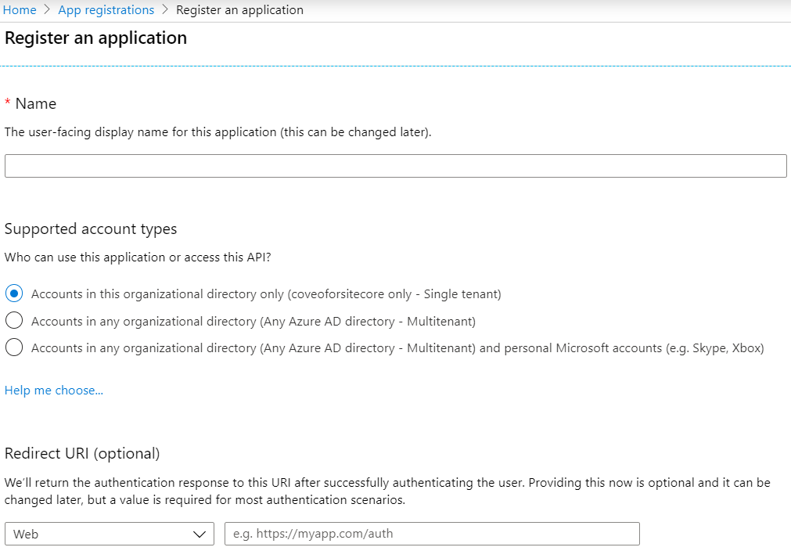
* Enter Name: **CoveoFederatedSearch**
* Leave everything else as above.
* Hit **Register**
* Next, navigate to (left panel) 
* Add a platform:  
  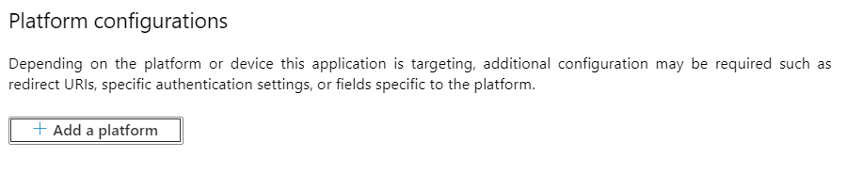
* Choose **‘Web’**
* 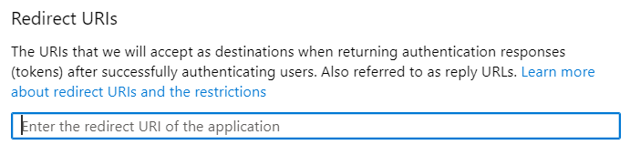
* In the ‘**Redirect URIs**’ enter the following URL’s:
  + INSTRUCTED BY THE COVEO TEAM
  + *The Redirect URI’s are the URL’s which can access the application. Normally this would be https://search.company.com/index*
* In the ‘**Implicit grant**’ section:
  + Activate Access Tokens
  + Activate ID Tokens
  + 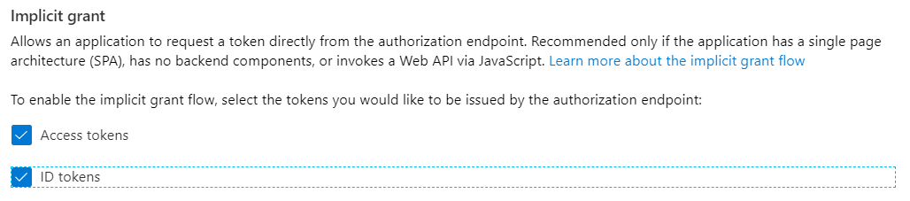
* Hit ‘**Save’** (top screen)
* Setup the Permissions. Navigate to (left panel) 
* Make sure the following permissions are set:  
  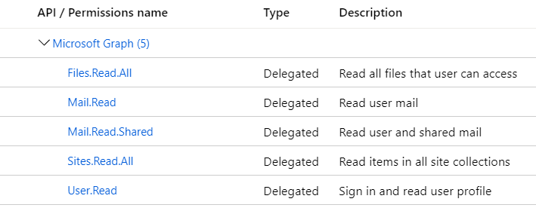
* Now click on the ‘Grant Admin’:  
  
* Done
* Continue to ‘**What Coveo Needs**’ (below)

# What Coveo needs

The only thing the Coveo team needs is the Application (client) ID from the above registered application.

* Using an admin account, you navigate to: <https://portal.azure.com/>
* Goto ‘App Registrations’ 
* In the list of Registrations, click on ‘**CoveoFederatedSearch’**
* 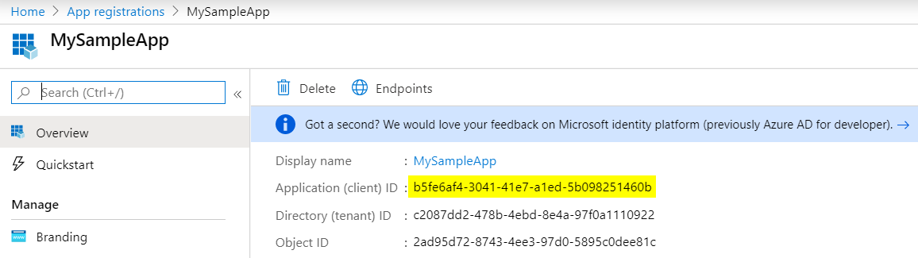
* In the next screen you will see the ‘**Application (client) ID**’. Sent that to the Coveo Team.
* Goto ‘Azure Active Directory’: 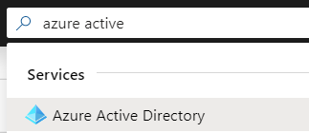
* In the ‘Overview’, you will directly see your Tenant Id:  
  
* Copy that, and sent it to the Coveo Team