生成一个指定长度的验证码，验证码由英文字大小写和数字组成。

生成长度为6的验证码，前3个为英文，后3个为数字

import random  
zm=["a","s","d","f","g","h","j","k","l","z","x","c","v","b","n","m","q","w","e","r","t","y","u","i","o","p","Q","W","E","R","T","Y","U","I","O","A","S","D","F","G","H","J","K","L","Z","X","C","V","B","N","M"]

c=0  
d=6  
while True:  
 a = random.randrange(len(zm))  
 b=random.randint(0,9)  
 if d>3:  
 d-=1  
 print(zm[a],end="")  
 c+=1  
 continue  
 if c<6:  
 c+=1  
 print(b,end="")  
 continue  
 else:  
 break

双色球选号：

1. 双色球由7个两位数组成 前六个范围是1-33，第七个是1-15
   1. 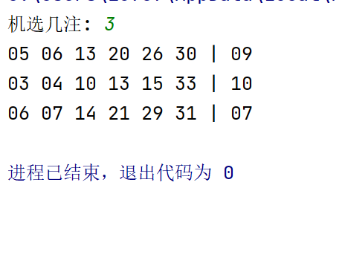
   2. 后一个比第一个数字大，第七个数字随机
2. 键盘输入一个数字，就打印几个几组号码

import random  
b=6  
c=1  
x=[]  
v=[]  
g=[]  
l=6  
Max=0  
z=int(input("请输入您想机选的注数："))  
for i in range(z):  
 j=b  
 m=c  
 x=[]  
 while True:  
 a=random.randint(1, 33)  
 d=random.randint(1,15)  
 x.append(a)  
 if j>0:  
 j-=1  
 continue  
 else:  
 print(x)  
 break  
 for h in range(len(x)):  
 for j in range(len(x)-1):  
 if x[h]<x[j]:  
 x[h],x[j]=x[j],x[h]  
 print(x)  
 for i in range(len(x)):  
 if x[i]<10:  
 print(end="0")  
 print(x[i],end=" ")  
 else:  
 print(x[i],end=" ")  
 if d<10:  
 print("| 0", end="")  
 print(d)  
 else:  
 print("|",d)

打印杨辉三角形

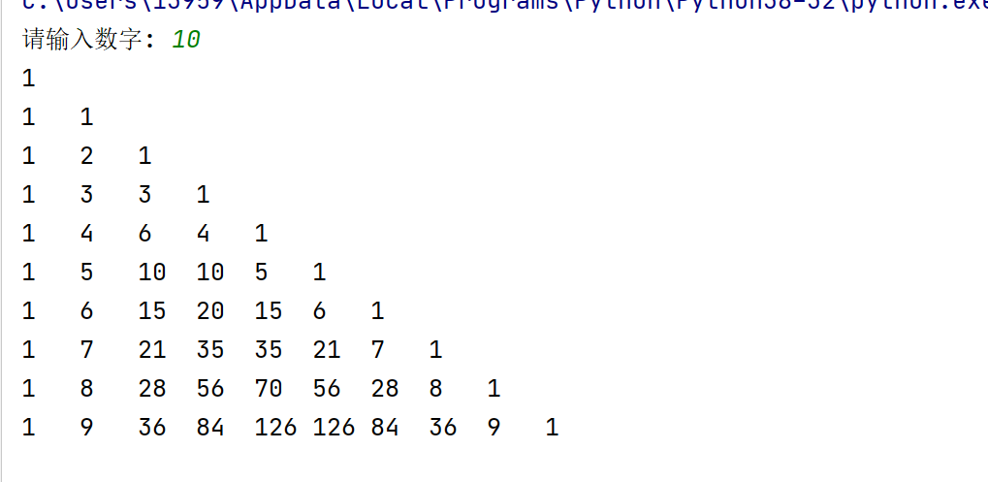

x=int(input("请输入需要的杨辉三角的层数："))  
triangle=[[1],[1, 1]] n=3 while True:  
 if x>0:  
 while n<=x:  
 for i in range(0, n-1):  
 if i == 0:triangle.append([1, 1])  
 else:triangle[n-1].insert(i, triangle[n - 2][i] + triangle[n - 2][i - 1])  
 n += 1for i in range(x):  
 print((triangle[i])) x-=1  
 print("是否继续？是输入T，输入其他退出：")  
 c=input("")  
 elif c=="T":  
 x = int(input("请输入需要的杨辉三角的层数："))  
 continue  
 else:  
 break