

**COVIDWIPER 2021**

**Abstract**

CovidWiper is a BEP20-based token established in the Binance Smart Chain network in the 4th Quarter of 2020. CovidWiper is a token developed in the field of Blockchain with its expert team. The aim of CovidWiper is to provide safe money exchange to people and to collect everything related to Blockchain in a mobile application and make them ready for people to use.

**WHAT IS OUR PROJECT?**

CovidWiper is a Smart Contract created on the BSC network.

The purpose of this token is to encourage people for vaccines used in the treatment of the ongoing COVID-19 epidemic in the world.

As much as the daily dose of vaccine completed in the world, tokens will be burned every day.

**TOKEN ECONOMICS**

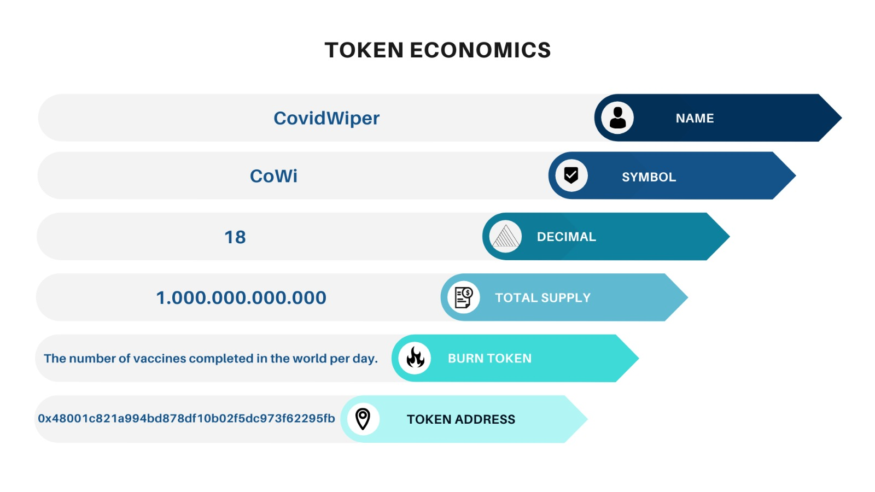

**ROADMAP**

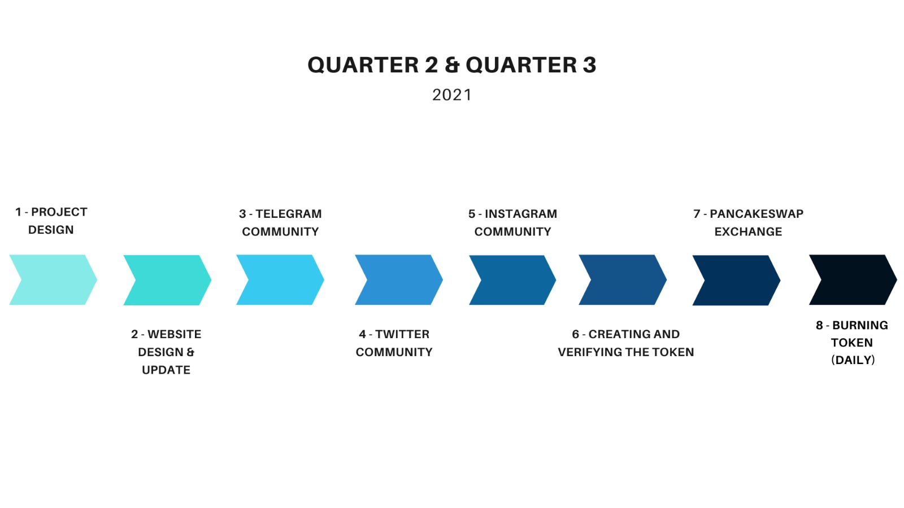

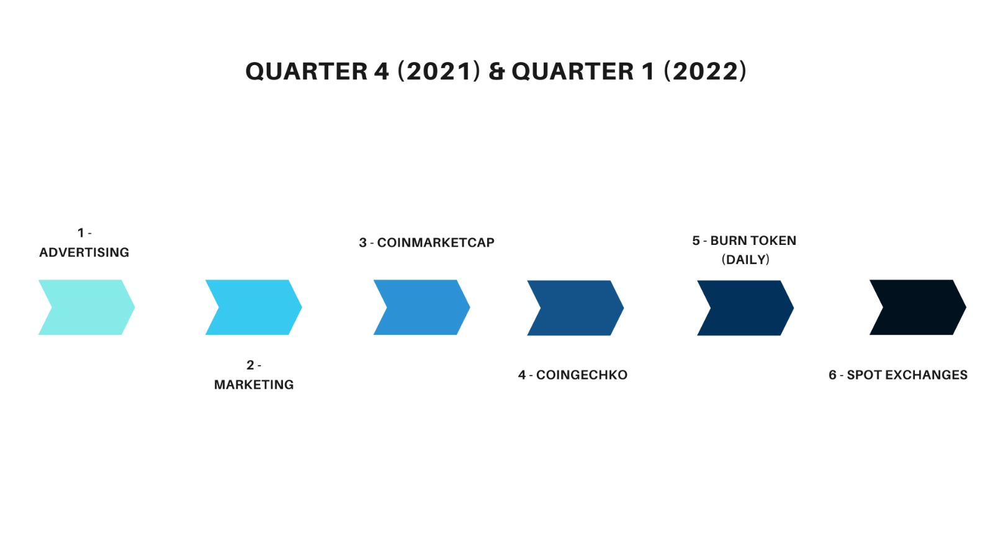

**OUR SOCIAL MEDIAS**

**BscScan Profile:** <https://bscscan.com/token/0x48001c821a994bd878df10b02f5dc973f62295fb>

**Telegram Channel:** <https://t.me/CovidWiper20212021>

**Telegram Group:** <https://t.me/CovidWiper2021>

**Twitter Account:** <https://twitter.com/CovidWiper?s=08>

**Instagram Account:** <https://www.instagram.com/covidwiper/?utm_medium=copy_link>