111064503 吳紹齊 https://github.com/cowboy35927/exam1-p1

1. (**p2 20pt**) Implementation of a decimation filter module with FIFO channels.
   * Please use SystemC FIFO channels to implement the communication interface of the decimation filter
   * Main.cpp

定義FIFO channel

* + 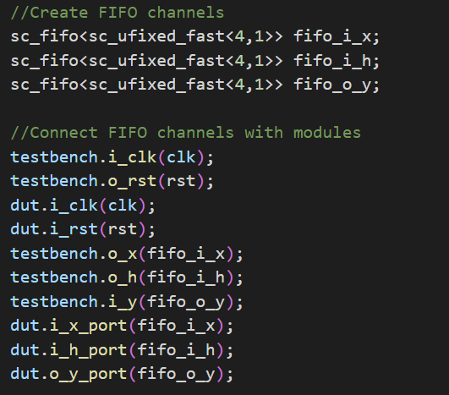
  + Adder.h
  + 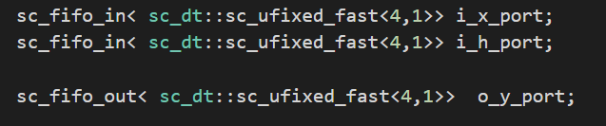
  + 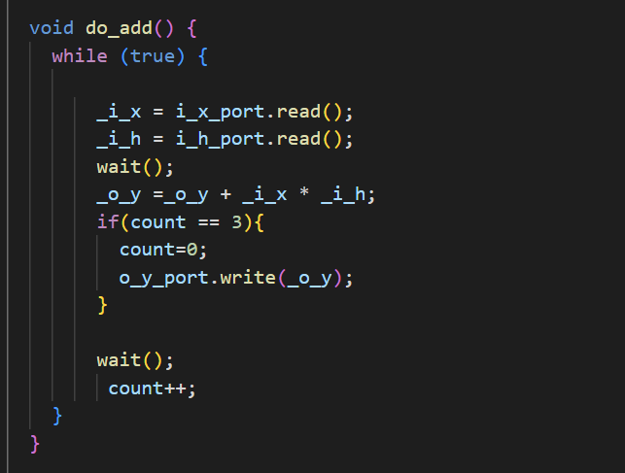

decimation filter累加

* + Stim.h
  + 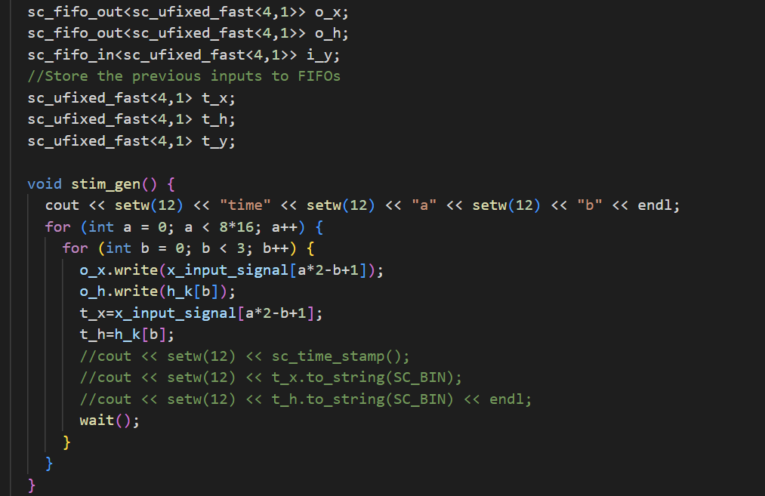

decimation filter的設計

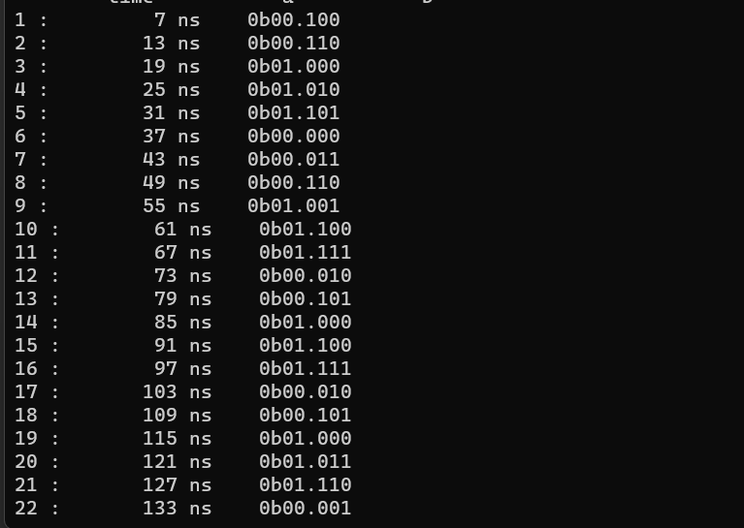

result

1. (**p3 30pt**) Implementation of a decimation filter module with TLM2 interface.
   * (**20pt**) Please use TLM2 blocking transport to implement the communication interface of the decimation filter

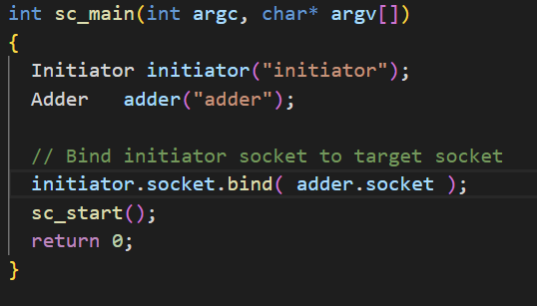

decimation filter的設計

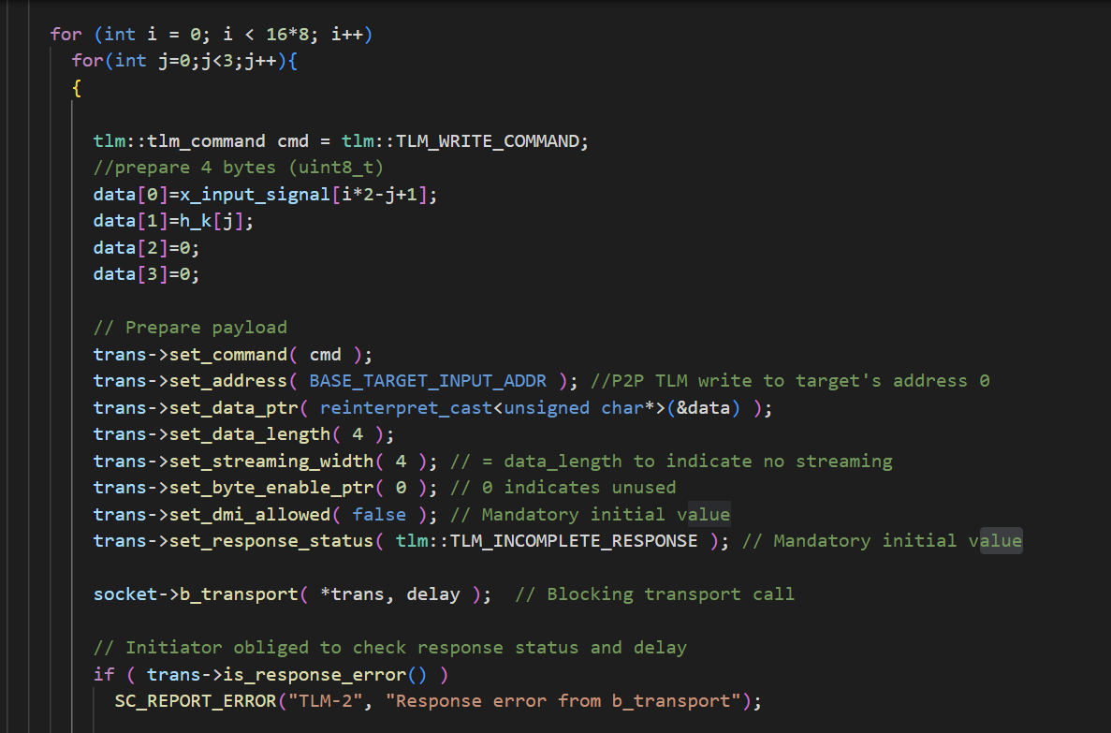

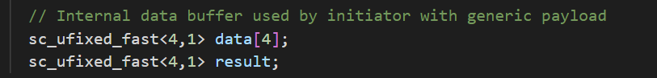

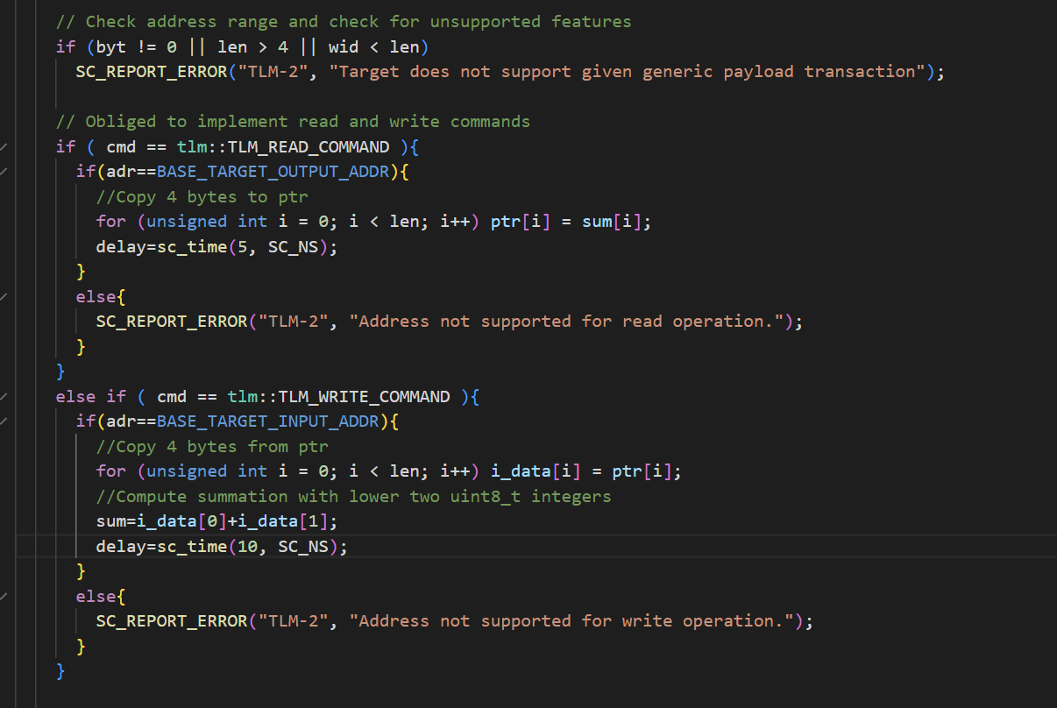



Target.h的設計

* + (**10pt**) Please use quantum keeper for timing annotation. The timing parameters of the filter should be derived from the FIFO channel version above.
  + 
  + 加上這include
  + 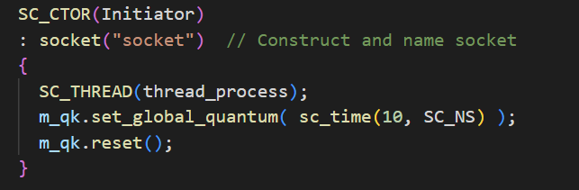
  + 初始化m_qk
  + 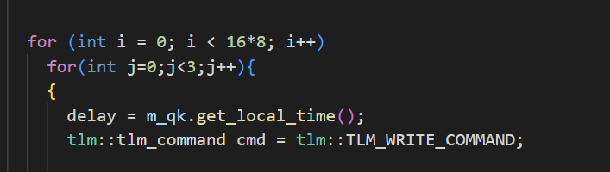
  + 得到local time
  + 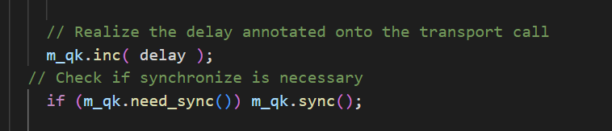
  + 將wait改成上述兩式，其意義是累加local time若超過設置的quantum time就進行同步。
  + 其他地方都和TLM一樣。