Chapter 5 Linkage, Recombination, and the Mapping of Genes on Chromosomes

Synopsis:
This chapter is devoted to a very important topic: linkage of genes. The concept of linkage is the basis for genetic mapping. Genes on the same chromosome are physically connected or linked. Gene pairs that are close together on the same chromosome are genetically linked because the alleles on the same homolog are transmitted together (parental types) into gametes more often than not during meiosis (Figures 5.2 and 5.3).
Gene pairs that assort independently exhibit a recombination frequency of 50% because the number of parental types = the number of recombinants (Table 5.2). Genes may assort independently either because they are on different chromosomes or because they are far apart on the same chromosome. The recombination frequencies of pairs of genes indicate how often 2 genes are transmitted together. For linked genes, the frequency is less than 50%. The greater the distance between linked genes, the higher the recombination frequency (rf). Recombination frequencies become more inaccurate as the distance between genes increases.
The relationship between relative recombination frequency and distance is used to create genetic maps. The greater the density of genes on the map, and the smaller the distances between the genes, the more accurate the map.
Statistical analysis can help determine whether or not 2 genes assort independently. The Chi square test can also be used to determine how well the outcomes of crosses fit other genetic hypotheses (Figure 5.5).
Tetrad analysis is done in certain species of yeast in which the meiotic products are kept together in a sac (ascus) so the results of a single meiosis are displayed in each tetrad. This array of 4 spores reveals the relation between genetic recombination and the segregation of chromosomes during the 2 meiotic divisions. Solving tetrad analysis problems will increase your understanding of chromosome segregation during meiosis.
In diploid organisms heterozygous for 2 alleles of a gene rare mitotic recombination between the gene and its centromere can produce genetic mosaics in which some cells are homozygous for one allele or the other (Figure 5.24 and Problem 5-43).

Significant Elements:
After reading the chapter and thinking about the concepts you should be able to:
- Determine if genes are linked or not based on the frequency of different types of gametes or progeny.
- Determine whether observed results are statistically consistent with expected results using the chi square test.
- When given the genotypes of parents and information on linkage of genes, list the gametes that can be produced with and without recombination.
- Beginning with 3 genes, map the genes. Determine the order of the genes and the distance between linked genes based on the percentage of recombination that occurred during meiosis.
- Determine if there is crossover interference in a three point cross.
- Identify different types of tetrads [parental ditype (PD), non-parental ditype (NPD), tetratype (T)] and understand what events during meiosis gives rise to these different types of asci.
- Determine linkage between genes given either random spore results or numbers of different types of asci.
- Identify centromere linked genes and determine distance from gene to centromere in Neurospora tetrads.

Problem Solving Tips:
This chapter discusses the analysis of linked genes. One way to analyze recombination frequency (rf) between linked genes is using 2 point crosses, as is done in Tetrad Analysis. A more accurate map of linked genes can be derived from analyzing the data from 3 linked genes (3 point crosses). Both of these types of analysis of linked genes lead to maps, but each type of analysis has its own peculiarities.
- The minimum requirement for detecting recombination is heterozygosity for 2 genes. The recombination events that can be detected are the ones that occur between the 2 genes, giving recombinant gametes instead of parental gametes.
- It is easiest to detect the parental vs recombinant gametes if you do a test cross.
- In a test cross of aa+ bb+ x aa bb the expected phenotypic frequencies and classes of progeny are 1 a+- b+- : 1 aa bb : 1 a+- bb : 1aa b+- if the genes are assorting independently. The genes are genetically linked if you see more parental than recombinant progeny.
- Recombination frequency = # recombinant progeny / total # progeny = rf x 100 = mu or cM. Depending on the vagaries of the particular system or problem we may derive some basic variations of this formula.
- When discussing recombination, you must write the genotypes in a way that represents linkage. Remember that there is one allele per homolog, so aa becomes a / a. When discussing more than one gene on a chromosome you must initially assume an order. While solving a problem, always write the genes in the same arbitrary, assumed order. Thus, a+ b+ c / a b c+ is more accurately written as:
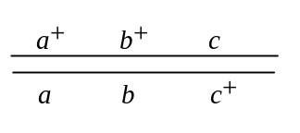
Genes on the X chromosome can be mapped without a test cross. Just use the hemizygous male progeny as in Problem 5-8.
- The Chi Square calculation is (o - e)2/e.

Problem Solving - How to Begin:
THREE ESSENTIAL QUESTIONS (3EQ):
1. How many genes are involved in the cross?
2. For each gene involved in the cross: what are the phenotypes associated with the gene? Which phenotype is the dominant one and why? Which phenotype is the recessive one and why?
3. For each gene involved in the cross: is it X-linked or autosomal?
The 3EQ are still useful, as you often have to diagram the cross and assign genotypes! For a more thorough list of Hints, review Solving Problems - How to Begin in Chapter 4 of this Study Guide.

THREE POINT CROSSES:
- In a three point cross first rewrite the classes of progeny (data) assigning genotypes to each trait. These genotypes are based on your answers to the 3EQ!
- The offspring are generated by a heterozygous individual. Therefore, all classes (parental, etc.) will occur as reciprocal pairs of progeny. These reciprocal pairs will be both genetic reciprocals and numerically equivalent.
- Designate the different gametes or offspring as noncrossover (parental), single crossover or double crossover. The noncrossover classes are those classes of progeny who have one of the intact, non-recombinant homologs from the parent. The noncrossover classes will be represented by the greatest numbers of offspring. The double crossover classes will be represented by the smallest numbers of offspring (Figure 5.10). Sometimes one or both double crossover classes are missing because they are rare.
- By examining the pattern of data seen in a problem, you can often start solving the problem with a basic understanding of the linkage relationships of the genes. Some of the more common patterns of data are:
- 3 linked genes give 8 classes of data that occur as 4 reciprocal pairs genetically and numerically;
- 3 unlinked genes gives 8 classes of data that occur as 4 genetically reciprocal pairs, but all classes are seen in a 1:1:1:1:1:1:1:1 ratio;
- 4 linked genes give 16 classes of progeny that occur in 8 reciprocal pairs;
- 4 unlinked genes give 16 classes of progeny in a 1:1:1:1:1:1:1:1:1:1:1:1:1:1:1:1 ratio;
- 3 linked genes and 1 gene assorting independently gives 16 classes of data occurring as 8 reciprocal pairs genetically and 4 groups of 4 numerically.
- Begin the process of mapping the genes by ordering the genes. To figure out which gene is in the middle of a group of three genes, choose one of the double crossover classes. Compare it to the most similar parental class of progeny where two of the three genes will have the same combination of alleles. The gene that differs is the gene in the middle. See problem 5-24c for further explanation.
- The last step is to determine the distance between the genes on each end and the gene in the middle. Use the formula rf = # recombinants between the 2 genes / total # of progeny.
- See problem 5-24 for an example of using the data to make a map.
- See problem 5-29 for an example of how to generate the data when you start with the map.
- See problem 5-27 for some hints on how to solve more complicated arrangements of genes.

TETRAD ANALYSIS:
- Some of the things that can be done here when analyzing recombination frequency (rf) are based on the biology of the organisms. Thus you must understand some of the basic biology of Neurospora and yeast (Figure 5.14). There is no three point cross analysis in tetrads. Instead you map two genes at a time. Study Figure 5.15 (two genes on different chromosomes) and Figure 5.17 (two linked genes) to understand the derivation of the Three Easy Rules for Tetrad Analysis.
- Rule #1 - If the number of PD tetrads is about equal to the number of NPD tetrads then the genes are unlinked. If the # PD tetrads >>> # NPD tetrads, the genes are linked.
- Independent assortment dictates that these two classes of asci will be about equal when genes are unlinked, see Figure 5.15.
- Rule #2 - Distance between linked genes is determined by calculating recombination frequency using the equation: rf = (NPD + 1)/2T/ total # tetrads × 100.
- Rule #3 - Crossovers between a gene and the centromere mean that the two alleles are separated at the second meiotic division (second division segregation) instead of during the first meiotic division. Centromere distance can be measured in yeasts with ordered asci, such as Neurospora and Ascobolus.
- These rules are based on the effects of meiosis on two unlinked genes (Figure 5.15) versus the effects on two linked genes (Figure 5.17). Further intricacies of single and double crossovers are discussed in problem 5-38.

Solutions to Problems:

Vocabulary
5-1. a. 8; b. 4; c. 1; d. 11; e. 2; f. 5; g. 6; h. 3; i. 10; j. 12; k. 9; l. 7.

Section 5.1 – Gene Linkage and recombination
5-2.
a. Diagram the cross.
scabrous ♂ (scsc j+j+) x javelin ♀ (sc+sc+ jj) → F1 WT ♀ (scsc+ j+j) x scabrous javelin ♂ (scsc jj) → 1/4 scabrous (P) : 1/4 javelin (P) : 1/4 WT (R) : 1/4 scabrous javelin (R).
This F1 female will make four different types of gametes in equal frequency – 1/4 sc+ j : 1/4 sc j+ : 1/4 sc+ j+ : 1/4 sc j. Because this is a test cross the male parent will always give the recessive alleles of the genes. Thus the phenotypes of the progeny will be determined by the gamete they receive from the heterozygous F1 female.
Of course these genes may be linked. In this case the cross would be diagrammed as follows:
scabrous ♂ (sc j+ / sc j+) x javelin ♀ (sc+ j / sc+ j) → F1 WT ♀ (sc j+ / sc+ j) x scabrous javelin ♂ (sc j / sc j) → scabrous (sc j+) (P) : javelin (s+ j) (P) : WT (sc+ j+) (R) : scabrous javelin (sc j) (R). Again, this F1 female will make 4 different types of gametes. There will be the two Parental (P) types and two Recombinant (R) types - s+ j (P) : sc j+ (P) : sc+ j+ (R) : sc j (R). The two Parental types must be equal frequency and the two Recombinant types must be equal to each other. The relative proportion of Parental to Recombinant will depend on the genetic distance (recombination frequency = rf) between the genes on the chromosome. The recombination frequency could be anything from 0 mu (the genes are very closely linked) to 50 mu (the genes are far apart on the same chromosome. In the latter case P = R and the proportions of the four types of gametes will also be 1 : 1 : 1 : 1.
b. In these results the parental (77 scabrous + 74 javelin) are equal frequency to the recombinants (76 wild type + 73 scabrous javelin). Thus the genes assort independently (are 50 mu apart).
c. F1 WT ♀ (scsc+ j+j) x wild type ♂ (sc+sc+ j+j+) → all wild type progeny. The F1 female will still make four types of gametes in equal frequency. However the male parent in this cross can only contribute sc+ j+ gametes so all the progeny will be phenotypically wild type. Thus you could not determine the frequency of parental and recombinant gametes from the F1 female.
d. Diagram the cross.
javelin ♀ (sc+sc+ jj) x scabrous javelin ♂ (scsc jj) → F1 javelin ♀ (scsc+ jj). This F1 female will make sc+ j and sc j) parental gametes. Her recombinant gametes will be the same genotypes as her parental gametes thus making it impossible to detect crossing over. In order to detect crossing over (or independent assortment) the parent must be heterozygous for two genes or markers. The cross overs detected will occur between the two genes.

5-3.
a. Diagram this cross.
B1B2 D1D4 ♂ x B3B3 D2D3 ♀ → B1B3 D1D3 ♂ (John). Thus John received a B1 D1 gamete from his father and a B3 D3 gamete from his mother. John will produce parental gametes of these types - B1 D1 and B3 D3.
b. The recombinant gametes produced by John will be B1 D3 and B3 D1.
c. All 100 sperm have the parental genotypes. There are no recombinant sperm. Therefore the B and D DNA loci are linked. Based on this data they are 0 mu apart.

Section 5.2 – Chi-Square Test
5-4. The null hypothesis is that there is independent assortment of 2 genes yielding a dihybrid phenotypic ratio of 9/16 R-Y- : 3/16 R- yy : 3/16 rr Y- : 1/16 rr yy. Use the Chi square (Χ2) test to compare Mendel's observed data with the 9:3:3:1 ratio expected for 2 genes that assort independently.
Genotypes | Observed # | Expected # | Χ2 square equation | Sum of Χ2
R-Y- | 315 | 9/16 (556) = 313 | (315 − 313)2/313 | 0.01
R- yy | 108 | 3/16 (556) = 104 | (108 − 104)2/104 | 0.15
rr Y- | 101 | 3/16 (556) = 104 | (101 − 104)2/104 | 0.09
rr yy | 32 | 1/16 (556) = 35 | (32 − 35)2/35 | 0.26
 |  |  |  | 0.51

The number of classes is 4, so the degrees of freedom is 4−1 or 3. Using Table 5-1 in the text, the probability of having obtained this level of deviation by chance alone is between 0.9 and 0.99 (90 - 99%). Thus we can NOT reject the null hypothesis. In other words, the data are consistent with independent assortment and we therefore conclude that Mendel's data could indeed result from the independent assortment of the 2 genes.

5-5.
a. Diagram the cross.
orange (O- bb) x black (oo B-) → F1 brown (O- B-) → 100 brown (O- B-) : 25 orange (O- bb) : 22 black (oo B-) : 13 albino (oo bb)
Because the F1 snakes were all brown, we know that the orange snake could not have contributed an o allele, or there would have been some black snakes. The orange snake must be OO bb. The black snake could not have contributed a b allele or there would have been some orange snakes, so the black parent must be oo BB. Therefore the F1 snakes must be Oo Bb.
b. The F1 snakes are heterozygous for both genes (Oo Bb). If the two loci assort independently, we expect the F2 snakes to show a 9 brown : 3 orange : 3 black : 1 albino ratio. The total number of F2 progeny is 160. We expect 90 (160 x 9/16) of these progeny to be brown, 30 (160 x 3/16) to be orange, 30 to be black and 10 (160 x 1/16) to be albino.
c.
Genotypes | Expected # | Observed # | Χ2 square equation | Sum of Χ2
O- B- | 90 | 100 | (100−90)2/90 | 1.11
O- bb | 30 | 25 | (25−30)2/30 | 0.83
oo B- | 30 | 22 | (22−30)2/30 | 2.13
oo bb | 10 | 13 | (13−10)2/10 | 0.9
 |  |  |  | 4.97

There are three degrees of freedom (4 classes − 1) and the p value is between 0.5 and 0.1. The observed values do not differ significantly from the expected.
d. There is a 10% - 50% probability that these results would have been obtained by chance if the null hypothesis were true; this is simply another way of writing the meaning of the p value.

5-6.
a. The cross is:
normal (DD) x dancer (dd) → F1 normal (Dd) F2 3/4 D- (normal) : 1/4 dd (dancer)
1/4 of the F2 mice will be dancers if the trait is determined by a single gene with complete dominance.
b. Diagram the cross:
normal (AA BB) x dancer (aa bb) → F1 normal (Aa Bb) F2 15/16 normal (A- B- + A- bb + aa B-) : 1/16 dancer (aa bb)
1/16 of the mice would be expected to be dancers given the second hypothesis that dancing mice must be homozygous for the recessive alleles of two genes.
c. Calculate the chi square values for each situation. Null hypothesis #1: Dancing is caused by the homozygous recessive allele of one gene, so 1/4 of the F2 mice should be dancers. Calculating the expected numbers, 1/4 × 50 mice or 13 should have been dancers, 37 should have been nondancers.
Genotypes | Observed # | Expected # | Χ2 square equation | Sum of Χ2
nondancers | 42 | (3/4) x 50 = 37 | (42−37)2/37 | 0.68
dancers | 8 | (1/4) x 50 = 13 | (8−13)2/13 | 1.92
 |  |  |  | 2.60

With one degree of freedom the p value is between 0.5 and 0.1 and we cannot reject the null hypothesis. The hypothesis that dancing is caused by the homozygous recessive allele of one gene is therefore a good fit with the data. Null hypothesis #2: Dancing is caused by being homozygous for the recessive alleles of two genes (aa bb), so 1/16 of the F2 mice should be dancers.
Genotypes | Observed # | Expected # | Χ2 square equation | Sum of Χ2
nondancers | 42 | 47 | (42−47)2/47 | 0.53
dancers | 8 | 3 | (8−3)2/3 | 8.33
 |  |  |  | 8.86

With one degree of freedom, the p value is < 0.005, so the null hypothesis that two genes control the dancer phenotype is not a good fit; in fact, the hypothesis can be rejected by the criteria employed by most geneticists. The one gene hypothesis is a better fit with the data.

5-7. This question asks you to weigh the advantages and disadvantages of using Chi square analysis to test for linkage between two genes using two different assumptions.
a. In assumption #1, as seen in Figure 5.5, the expectation of independent assortment is that the frequency of parentals is the same as the frequency of recombinants. In assumption #2, the expectation of independent assortment is the parental and recombinant progeny should be present in a ratio of 1:1:1:1. Notice that the null hypothesis is the same in both cases: that the genes are assorting independently.
b. Assumption #1, 50 progeny:
Genotypes | Observed # | Expected # | Χ2 square equation | Sum of Χ2
parental | 31 | 25 | (31 - 25)2/25 | 1.44
recombinant | 19 | 25 | (9 - 25)2/25 | 1.44
 |  |  |  | 2.88

1 dof (degree of freedom), 0.05 < p < 0.1 and the null hypothesis cannot be rejected - the data is compatible with the hypothesis that the genes are assorting independently.
Assumption #2, 50 progeny:
Genotypes | Observed # | Expected # | Χ2 square equation | Sum of Χ2
AB | 17 | 12.5 | (17 - 12.5)2/12.5 | 1.62
ab | 14 | 12.5 | (14 - 12.5)2/12.5 | 0.18
Ab | 8 | 12.5 | (8 - 12.5)/12.5 | 1.62
aB | 11 | 12.5 | (11 - 12.5)2/12.5 | 0.18
 |  |  |  | 3.6

3 dof, 0.10 < p < 0.5 and the null hypothesis cannot be rejected - the data is compatible with the hypothesis that the genes are assorting independently.
Assumption #1, 100 progeny:
Genotypes | Observed # | Expected # | Χ2 square equation | Sum of Χ2
parental | 62 | 50 | (62 - 50)2/50 | 2.88
recombinant | 38 | 50 | (38 - 50)2/50 | 2.88
 |  |  |  | 5.76

1 dof, 0.01 < p < 0.05 and the null hypothesis is rejected - the genes are not assorting independently, so they must be linked.
Assumption #2, 100 progeny:
Genotypes | Observed # | Expected # | Χ2 square equation | Sum of Χ2
AB | 34 | 25 | (34 - 25)2/25 | 3.24
ab | 28 | 25 | (28 - 25)2/25 | 0.36
Ab | 16 | 25 | (16 - 25)2/25 | 3.24
aB | 22 | 25 | (22 - 25)2/25 | 0.36
 |  |  |  | 7.2

3 dof, 0.05 < p < 0.1 and the null hypothesis cannot be rejected - the data is compatible with the hypothesis that the genes are assorting independently.
In the first experiment with only 50 progeny, p < 0.05 using both the 2 class and 4 class assumptions, so neither assumption supports the idea that the genes are linked (although the test with 2 classes is closer to significance). When more progeny are scored, the null hypothesis (that the genes are assorting independently) is rejected when you look at the data as 2 classes but not as 4 classes. This suggests that using 2 classes is a more sensitive test for linkage than using 4 classes.
c. There is actually a subtle difference in the null hypotheses: in the 2 class situation the null hypothesis is linkage; in the 4 class situation it is 1:1:1:1, which not only means linkage but also equal viability of the 4 classes. You could imagine a situation in which certain classes are sub-viable, for example any class with the a allele. In such a case, you might see linkage with the 2 class test, but you would miss the even more important point that one allele causes reduced viability. This ability to see the relative viability of the alleles is an advantage to the 4 class method.

Section 5.3 – Recombination Results from Crossing-Over During Meiosis
5-8. The parents are from true breeding stocks. Diagram the cross:
raspberry eye color ♂ x sable body color ♀ → F1 wild type eye and body color ♀ x sable body color ♂ (if no mention is made of the eye color, then it is assumed to be wild type) → F2 216 wild type ♀ : 223 sable ♀ : 191 sable ♂ : 188 raspberry ♂ : 23 wild type ♂ : 27 raspberry sable ♂
3EQ #1 - the phenotypes seem to be controlled by 2 genes, one for eye color and the other for body color. 3EQ #2 - the F1 female progeny show that the wild type allele is dominant for body color (s+ > s) and the wild type allele is also dominant for eye color (r+ > r). Question #3 - sable body color is seen in the F1 males but not the F1 females, so the s gene is X-linked. In the F2 generation the raspberry eye color is seen in the males but not in the females, so r is also an X-linked gene. We can now assign genotypes to the true-breeding parents in this cross:
r s+ / Y (raspberry ♂ ) x r+ s / r+ s ♀ → F1 r s+ / r+ s ♀ (wild type) x r+ s / Y (sable ♂) → [the heterozygous F1 female can make the following gametes: (parentals) r s+, r+ s and (recombinants) r s, r+ s+; the F1 male can make Y and r+ s gametes] → F2 will be r s+ / r+ s (wild type females), r+ s / r+ s (sable females), r s / r+ s (sable females), r+ s+ / r+ s (wild type females), r+ s / Y (sable males), r s+ / Y (raspberry males), r s / Y (raspberry sable males), r+ s+ / Y (wild type males)
The F1 female is heterozygous for both genes and will therefore make parental and recombinant gametes. The F1 male is not a true test cross parent, because he does not carry the recessive alleles for both of the X-linked genes. However, this sort of cross can be used for mapping, because F2 sons receive only the Y chromosome from the F1 male and are hemizygous for the X chromosome from the F1 female. Thus the phenotypes in the F2 males represent the array of parental and recombinant gametes generated by the F1 female as well as the frequencies of these gametes. Using the F2 males, the rf between sable and raspberry = 23 (wild type males) + 27 (raspberry sable males) / 429 (total males) = 0.117 x 100 = 11.7 cM.

5-9.
a. The parental females are heterozygous for the X-linked dominant Greasy fur (Gs) and Broadhead (Bhd) genes. They are crossed to homozygous recessive males. The male progeny of this cross will show four phenotypes, which will fall into two genetic reciprocal pairs. One pair will be Gs Bhd and wild type (Gs Bhd and Gs+ Bhd+) while the other pair will be Gs and Bhd (Gs Bhd+ and Gs+ Bhd). If the genes are far apart on the X chromosome then they will assort independently and all four classes will show equal frequency. If the genes are more closely linked then there will be a more frequent reciprocal pair (the parental pair) and a less frequent pair (the recombinant pair). There are 51 Gs Bhd+ and 48 Gs+ Bhd male progeny. Thus, this is the parental pair and the genotype of the female is Gs Bhd+ / Gs+ Bhd. The cross can be diagrammed:
Gs Bhd+ / Gs+ Bhd ♀ x Gs+ Bhd+ / Y ♂ → 51 Gs Bhd+ ♂ : 48 Gs+ Bhd ♂ : 2 Gs Bhd ♂ : 1 Gs+ Bhd+ ♂.
The distance between these two genes: rf = 2 + 1 / 100 = 0.03 = 3mu.
b. The daughters in this cross must inherit the Gs+ Bhd+ X chromosome from their fathers. This chromosome carries the recessive alleles of both genes, so this is a true test cross. Thus the genotypes, phenotypes and frequencies of the female progeny would be the same as their brothers.

5-10.
a. Diagram the cross:
CC DD x cc dd → F1 C D / c d x cc dd → 903 Cc Dd, 897 cc dd, 98 Cc dd, 102 cc Dd. Because the gamete from the homozygous recessive parent is always c d, we can ignore one c and one d allele (the c d homolog) in each class of the F2 progeny. The remaining homolog in each class of F2 is the one contributed by the doubly heterozygous F1, the parent of interest when considering recombination. In the F2 the two classes of individuals with the greatest numbers represent parental gametes (C D or c d from the heterozygous F1 parent combining with the c d gamete from the homozygous recessive parent). The other two types of progeny result from a recombinant gametes (C d or c D combining with the c d gamete from the homozygous recessive parent). The number of recombinants divided by the total number of offspring x 100 gives the map distance: (98 + 102)/(903 + 897+ 98 + 102) = 200/2000 = 0.01 x 100 = 10% rf or 10 map units (mu) or 10 cM.
b. CC dd x cc DD → F1 C d / c D x c d / c d → as determined in part a, c and d are 10 cM apart. Thus the gametes produced by the heterozygous F1 will be 45% C d, 45% c D, 5% C D, 5% c d. After fertilization with c d gametes, there would be 45% Cc dd, 45% cc Dd, 5% Cc Dd, 5% cc dd. Because this is a test cross, the gametes from the doubly heterozygous F1 parent determine the phenotypes of the progeny.

5-11. To determine the probability that a child will have a particular genotype, look at the gametes that can be produced by the parents. In this example, A and B are 20 mu apart, so in a doubly heterozygous individual 20% of the gametes will be recombinant and the remaining 80% will be parental. The aa bb homozygous man can only produce a b gametes. The doubly heterozygous woman, with a genotype of A B / a b, can produce 40% A B, 40% a b, 10% A b and 10% a B gametes. (Total of recombinant classes = 20%.) The probability that a child receives the A b gamete from the female (and is therefore A b / a b) = 10%.

5-12.
a. Designate the alleles: H = Huntington allele, h = normal allele; B = brachydactyly, b = normal fingers. John's father is bb Hh; his mother is Bb hh. The Roman numerals are missing from the pedigree diagram below.
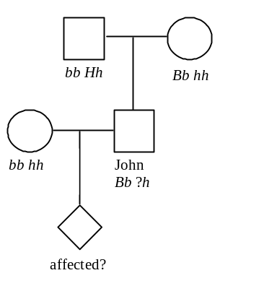
b. We know the John is Bb because he has brachydactyly. His complete genotype could be Bb Hh or Bb hh. The probability that John's genotype is Hh = 1/2 (chance that he inherited the H allele from his father) x 1/3 (probability of >50 years of age for onset of symptoms) = 1/6.
c. The probability that the child will have and express brachydactyly = 1/2 (probability of inheriting B from John) x 9/10 (probability of expressing the phenotype) = 0.45. The probability that the child will express Huntington's disease by age 50 = 1/6 (probability that John is Hh) x 1/2 (probability that the child will inherit the H allele) x 2/3 (probability the child will show symptoms of Huntington's by age 50) = 0.056. If brachydactyly and Huntington's assort independently the probability that the child will express both phenotypes by age 50 = 0.45 (probability of expressing brachydactyly) x 0.056 (probability of expressing Huntington's by age 50) = 0.025.
d. If the two loci are linked, the alleles on each of John's homologs will be either B h / b H or B h / b h. If it is the former (and John has Huntington's), the B H gamete could only be produced by recombination. The probability of that specific recombinant gamete = 10% (b h constitutes the other 10% of the recombinant gametes). As shown in part a, the probability that John's genotype is B h / b H = 1/6. The probability that John's child will inherit both the Huntington and brachydactyly alleles = 1/6 (probability that John is B h / b H) x 1/10 (probability of child inheriting B H recombinant gamete from John) x 9/10 (probability of expressing brachydactyly) x 2/3 (probability of expressing Huntington's by age 50) = 0.01.

5-13. Designate the alleles of the genes: A = normal pigmentation and a = albino allele; HbßA = normal globin and HbßS = sickle allele.
a. Because both traits are rare in the population, we assume that the parents are homozygous for the wild type allele of the gene dictating their normal traits (that is, they are not carriers). Diagram the cross: a HbßA / a HbßA (father) x A HbßS / A HbßS (mother) → a HbßA / A HbßS (son). Given that the genes are separated by 1 map unit, parental gametes = 99% and recombinant gametes = 1% of the gametes. The son's gametes will consist of: 49.5% a HbßA, 49.5% A HbßS, 0.5% a HbßS and 0.5% A HbßA.
b. In this family, the cross is A HbßA / A HbßA (father) x a HbßS / a HbßS (mother) → a HbßS / A HbßA (daughter). The daughter's gametes will be: 49.5% a HbßS, 49.5% A HbßA, 0.5% a HbßA and 0.5% A HbßS.
c. The cross is: a HbßA / A HbßS (son) x a HbßS / A HbßA (daughter). The probability of an a HbßS / a HbßS child (sickle cell and anemic) = 0.005 (probability of a HbßS from son) x 0.495 (probability of a HbßS from daughter) = 0.0025.

5-14. Diagram the cross:
blue smooth x yellow wrinkled → 1447 blue smooth, 169 blue wrinkled, 186 yellow smooth, 1510 yellow wrinkled.
a. To determine if genes are linked, first predict the results of the cross if the genes are unlinked. In this case, a plant with blue, smooth kernels (A- W-) is crossed to a plant with yellow, wrinkled kernels (aa ww). Since there are four classes of progeny, the parent with blue, smooth kernels must be heterozygous for both genes (Aa Ww). From this cross, we would predict equal numbers of all four phenotypes in the progeny if the genes were unlinked. Since the numbers are very skewed, with the smaller classes representing recombinant offspring, the genes are linked. rf = (169 + 186) / (1447 + 169 + 186 + 1510) = 355/3312 = 10.7% = 10.7 cM.
b. The genotype of the blue smooth parent was Aa Ww. The arrangement of alleles in the parent is determined by looking at the phenotypes of the largest classes of progeny (the parental reciprocal pair). Since blue, smooth and yellow wrinkled are found in the highest proportion, A W must be on one homolog and a w on the other = A W / a w.
c. The genotype of the blue, wrinkled progeny is A w /a w. This genotype can produce A w or a w gametes in equal proportions. Recombination can NOT be detected here, as this genotype is only heterozygous for one gene. Notice that recombination between these homologs yields the same two combinations of alleles (A w and a w) as the parental, so each type of gamete is expected 50% of the time. The yellow smooth progeny plant has a genotype of a W / a w. Again since recombination cannot be detected, the frequency of each type is 50%. Thus the cross is A w / a w (blue wrinkled) x a W / a w (yellow smooth). Four types of offspring are expected in equal proportions: 1/4 A w / a W (blue smooth) : 1/4 A w / a w (blue wrinkled) : 1/4 a w / a W (yellow smooth) : 1/4 a w / a w (yellow wrinkled).

5-15. Diagram the cross: CC bb (brown rabbits) x cc BB (albinos) → F1 Cc Bb x cc bb → 34 black : 66 brown : 100 albino.
a. If the genes are unlinked, the F1 will produce C B, c b, C b and c B gametes in equal proportions. A mating to animals that produce only c b gametes will produce four genotypic classes of offspring: 1/4 Cc Bb (black) : 1/4 cc Bb (albino) : 1/4 Cc bb (brown) : 1/4 cc BB (albino). The ratio would be 1/4 black : 1/2 albino : 1/4 brown.
b. If c and b are linked, then the genotype of the F1 class is C b / c B and you would expect the parental type C b and c B gametes to predominate; c b and C B are the recombinant gametes and are therefore present at lower levels. The parental gametes are represented in the F2 by the Cc bb (brown) and cc Bb (albino) classes. Since we cannot distinguish between the albinos resulting from fertilization of recombinant gametes (c b), and those resulting from parental gametes (c B), we have to use the proportion of the C B recombinant class and assume that the other class of recombinants (c b) is present in equal frequency. Since the crossing-over is a reciprocal exchange, this assumption is reasonable. There were 34 black progeny; assuming that 34 of the 100 albino progeny were the result of recombinant gametes, the genes are (34 + 34) recombinant / 200 total progeny = 34% rf = 34 cM apart.

5-16. Notice that you are asked for the number of different kinds of phenotypes, not the number of individuals with each of the different phenotypes.
a. 2 (A- and aa);
b. 3 (AA, Aa and aa);
c. 3 (AA, Aa and aa);
d. 4 (A- B-, A- bb, aa B-, aa bb);
e. 4 (A- B-, A- bb, aa B-, aa bb; because the genes are linked, the frequency of the four classes will be different than that seen in part d);
f. Nine phenotypes in total. There are three phenotypes possible for each gene. The total number of combinations of phenotypes is (3)2 = 9 ((AA, Aa and aa) x (BB, Bb and bb)).
g. Normally there are four phenotypic classes, as in parts d and e (A-B-, A-bb, aaB- and aabb). In this case, one of the genes is epistatic so two of the classes have the same phenotype, giving 3 phenotypic classes.
h. Two genes means four phenotypic classes (A- B-, aa B-, A- bb and aa bb). Because gene function is duplicated the first three classes are all phenotypically equivalent in that they have function, and only the aa bb class will have a different phenotype, being without function. Thus there are only 2 phenotypic classes.
i. There is 100% linkage between the two genes. The number of phenotypic classes will depend on the arrangement of alleles in the parents. If the parents are A B / a b x A B / a b, the progeny will be 3/4 A- B- : 1/4 aa bb and there will be two phenotypic classes. If the parents are A b / a B x A b / a B, the progeny will be 1/4 A- b : 1/2 A- B- : 1/4 a B- and there will be three phenotypic classes in the offspring.

5-17.
a. AA BB x aa bb → F1 A B / a b (A B on one homolog and a b on the other homolog). The F1 progeny will produce gametes of the parental types A B and a b; and of the recombinant types A b and a B. Because the genes are 40 cM apart, the recombinants will make up 40% of the gametes (20% Ab and 20% aB). The parental gametes make up the remaining 60% of the gametes, 30% A B and 30% a b. Set up a Punnett square to calculate the frequency of the 4
phenotypes in the F2 progeny. In the Punnett square the phenotypes are shown in parentheses (A- bb). The F2 phenotypic ratio is: 0.59 A- B- : 0.16 A- bb : 0.16 aa B- : 0.09 aa bb.
 | 0.3 A B | 0.3 a b | 0.2 A b | 0.2 a B
0.3 A B | A B / A B  (0.09 A- B-) | A B / a b  (0.09 A- B-) | A B / A b  (0.06 A- B-) | A B / a B  (0.06 A- B-)
0.3 a b | a b / A B  (0.09 A- B-) | a b / a b  (0.09 aa bb) | a b / A b  (0.06 A- bb) | a b / a B  (0.06 aa B-)
0.2 A b | A b / A B  (0.06 A- B-) | A b / a b  (0.06 A- bb) | A b / A b  (0.04 A- bb) | A b / a B  (0.04 A- B-)
0.2 a B | a B / A B  (0.06 A- B-) | a B / a b  (0.06 aa B-) | a B / A b  (0.04 A- B-) | a B / a B  (0.04 aa B-)

b. If the original cross was AA bb x aa BB, the allele combinations in the F1 would be A b / a B. Parental gametes in this case are 30% A b and 30% a B and the recombinant gametes are 20% A B and 20% a b. Set up a Punnett square, as in part a. The F2 phenotypic ratio is: 0.54 A- B- : 0.21 A- bb : 0.21 aa B- : 0.04 aa bb.

5-18. v1, v2, and v3 are codominant alleles of the DNA variant marker locus, while D and d are alleles of the disease gene. The marker and the disease locus are linked. Diagram the cross:
v1 D / v2 d (father) x v3 d / v3 d (mother) → v2 ? / v3 d.
The fetus must get a v3 d homolog from the mother. The fetus also received the v2 allele of the marker. The father could have given a v2 d (non-recombinant) or a v2 D (recombinant) gamete.
a. If the D locus and the v1 allele of the marker are 0 mu apart (there is no recombination between them; they appear to be the same gene), the probability that the child, who received the v2 allele of the marker, has the D allele = 0.
b. If the distance between the disease locus and marker is 1 mu, 1% of the father's gametes are recombinant between D and the marker locus. Half of the recombinant gametes (0.5%) will be v2 D; the other half will be v1 d. Because we are only considering cases where the child has the v2 marker, the probability that the child inherited D = 0.05 (probability of inheriting v2 D / 0.5 (probability of inheriting v2) = 0.01 = 1%.
c. 5%.
d. 10%.
e. 50%.

Section 5.4 – Mapping: Locating Genes Along a Chromosome
5-19.
a. There are four equally frequent phenotypic classes in the progeny must include a reciprocal pair of parentals and a reciprocal pair of recombinants. The parental reciprocal pair could either be wild type wings, wild type eyes and dumpy wings, brown eyes or wild type wings, brown eyes and dumpy wings, wild type eyes. The first possibility means the genotype of the heterozygous female was dp+ bw+ / dp bw while the second pair means the genotype of the female was dp bw+ / dp+ bw. In either case the recombination frequency is 50% (178 + 181 / 716 or 185 + 172 / 716) so the two genes are assorting independently.
b. In this cross the heterozygous parent is the male and there is no recombination in Drosophila males! If dumpy and brown were on separate chromosomes then they must assort independently and there would be four classes of progeny as in part a. If the two genes are on the same chromosome then the lack of recombination in the male parent means that only the two parental classes of progeny are seen. Also, the genotype of the heterozygous male must have been dp+ bw+ / dp bw.
c. If the genes are far enough apart on the same chromosome they will assort independently in the first cross. This is because (1) recombination occurs at the four strand stage of meiosis, and (2) so many crossovers occur between genes when they are far apart on the same chromosome that the linkage between alleles of these genes will be randomized. Independent assortment does not occur in the second cross because there is no recombination in Drosophila males. In Drosophila, therefore, it is a simple matter to decide if genes are syntenic (linked to the same chromosome). A cross between a male heterozygous for the two genes of interest and a recessive female will clearly distinguish between genes on separate chromosomes and syntenic genes. In the case of genes on separate chromosomes there will be four equally frequent classes of progeny. In the case of genes on the same chromosome (even genes that are very far apart on the same chromosome) there will only be two classes of progeny – the parental classes.
d. This distance can not be measured in any two-point cross. The measured recombination frequency can be no higher than 50% when looking at data involving a single pair of genes. Large genetic distances can be measured accurately only by summing up the values obtained for smaller distances separating other genes in between those at the ends.

5-20. Diagram the cross:
wild type ♀ x reduced cinnabar ♂ → F1 ♀ x F1 ♂ → 292 wild type, 9 cinnabar, 7 reduced, 92 reduced cinnabar.
Two genes are involved in this cross, but the frequencies of the phenotypes in the second generation offspring do not look like frequencies expected for a cross between double heterozygotes for two independently assorting genes (9:3:3:1). The genes must be linked. Designate the alleles: cn+ = wild type, cn = cinnabar; rd+ = wild type, rd = reduced. The cross is:
cn+ rd+ / cn+ rd+ ♀ x cn rd / cn rd ♂ → F1 cn+ rd+ / cn rd.
Recombination occurs in Drosophila females but not in males. Thus males can only produce the
parental cn+ rd+ or cn rd gametes. The females produce both the parental gametes and the recombinant gametes cn+ rd and cn rd+.
female gametes | male gamete  cn⁺ rd⁺ | male gamete  cn rd
cn⁺ rd⁺  (parental) | cn⁺ rd⁺ / cn⁺ rd⁺  (wild type) | cn⁺ rd⁺ / cn rd  (wild type)
cn rd  (parental) | cn rd / cn⁺ rd⁺  (wild type) | cn rd / cn rd  (cinnabar reduced)
cn⁺ rd  (recombinant) | cn⁺ rd / cn⁺ rd⁺  (wild type) | cn⁺ rd / cn rd  (reduced)
cn rd⁺  (recombinant) | cn rd⁺ / cn⁺ rd⁺  (wild type) | cn rd⁺ / cn rd  (cinnabar)

The reduced flies and the cinnabar flies are recombinant classes. However, there should be an equal number of recombinant types that have a wild-type phenotype because they got a cn+ rd+ gamete from the male parent. If we assume that these recombinants are present in the same proportions, then rf = 2 x (7+9)/400 = 8% recombination. The genes are separated by 8 cM.

5-21.
The shortest distances are the most accurate. Therefore begin assembling a map using the genes that are closest together. MAT-LEU2 are 16 cM apart and MAT-THR4 are 16 cM apart. This gives two possible maps: MAT - (16 cM) - LEU2/THR4 or LEU2 - (16 cM) - MAT - (16 cM) - THR4. Because THR4 is 35 cM from LEU2 the second map must be the correct one. Note that the two smaller distances to not sum to the longer distance because these recombination frequencies are based on two point crosses. The HIS4 gene is 23 cM from LEU2. This initially leads to two possible maps: HIS4 - (23 cM) - LEU2 - MAT - THR4 or LEU2 - (23 cM) - HIS4/MAT - THR4. The first map is the most likely because HIS4 is 37 cM from MAT instead of being very close to MAT. So the order of the genes is HIS4 - LEU2 - MAT - THR4 (or the inverse).

5-22.
a. A test cross is the best way to find the map distance between two genes. One parent must the heterozygous for both genes and the other parent must the homozygous recessive. Thus the cross would be Bb Cc x bb cc. Because these genes are syntenic the heterozygous parent may be either B C / b c or B c / b C.
b. There are two possible orders for these genes:
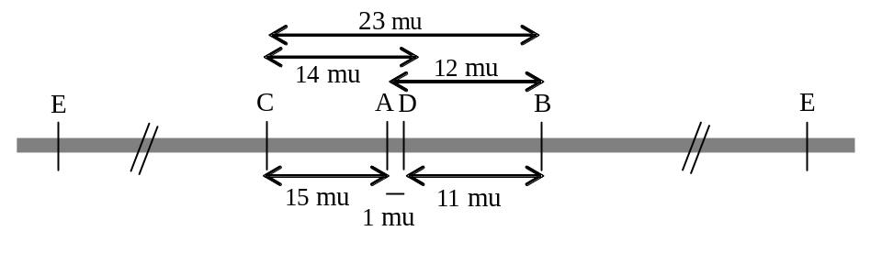
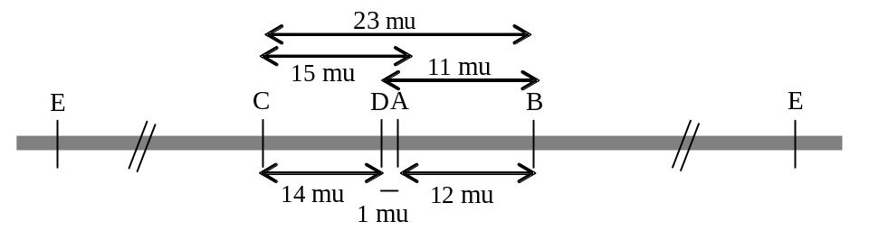
c. Because the map positions of A and D are so close, the relative order of A and D is not clear. Another uncertainty is the location of gene E. This gene must be on this chromosome because we are told all of these genes are syntenic. However the E gene is genetically unlinked to any of the other genes (A, B, C and D).
d. To figure out the actual order of the genes you must do a three point cross with either B A D or A D C and order the genes by finding the double cross over class, comparing this to the Parental class and ascertaining the order of the genes. This is described in the 'How to Begin - Three Point Crosses' section at the beginning of this chapter (page 67). Also see problem 5-24c for a further explanation of this method of determining the gene order.
The location of the E gene can be determined by finding new genes that are genetically linked to the left of C and to the right of B in the maps seen in part b. This extension of the linkage group will eventually allow the placement of gene E when shows genetic linkage to one of these new genes.

5-23.
Although this problem considers three different genes each cross only considers two at a time. You are thus asked to construct a map of the three genes based on 3 two point crosses. Note the unusual usage of a comma to separate the genes in the genotypes written for the parents of each cross. This is meant to show that we don't know if any of the genes are on the same chromosome. If the two genes in each cross are assorting independently then the four phenotypic classes in the test cross progeny must occur in equal frequencies (see problem 5-17). This is clearly not the case in any of the three crosses. Therefore the mb, e and k genes are all linked. The genotypes of the parents in the first cross may be correctly written as mb+ e+ / mb+ e+ x mb e / mb e.
In the first cross, the mb+ e+ and mb e classes are the parentals. This is based both on the known genotypes of the true breeding parental generation and on the fact that this reciprocal pair is the most frequent. The recombinants are the mb+ e and the mb e+ flies, so the rf = 11 + 15 / 250 = 0.104 = 10.4mu. In the second cross the recombinant reciprocal pair is k+ e+ and k e so the recombination frequency is 11 + 7 / 312 = 0.058 = 5.8mu. The k mb+ and k+ mb classes are the recombinant reciprocal pair for the third cross. In this case the rf = 11 + 15 / 422 = 0.062 = 6.2mu. The mb and e genes in the first cross are the furthest apart, so the k gene must be in between them. Thus the map of this data is:
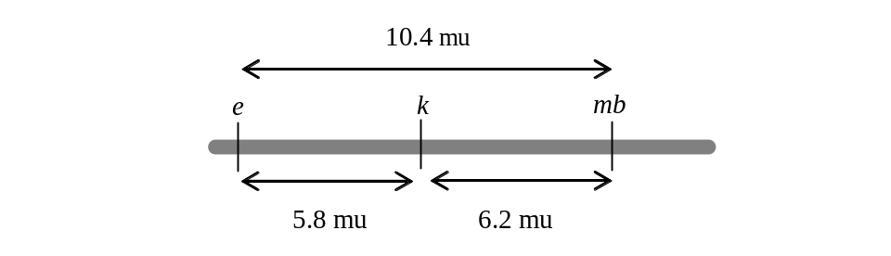
Note that the distance calculated between e and mb in cross one (10.4mu) does NOT equal the sum of the two shorter distances (12.0mu). The distance calculated from cross one is less accurate because it is based on single crossovers between e and mb and does not include any of the double crossovers that occurred in the e – k and k – mb regions simultaneously. Thus, the best map of these genes is:
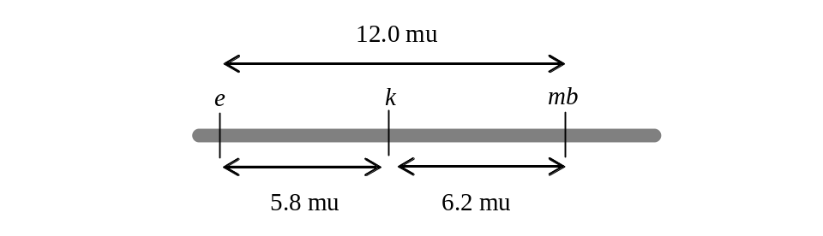

5-24. In foxgloves wild type flower color is red and the mutant color is white; the mutation peloria causes the flowers at the apex of the stem to be very large; normal foxgloves are very tall, and dwarf affects the plant height. When you describe the phenotype of an individual you usually only refer to the non-wild type traits. The cross is:
white flowered x dwarf peloria → F1 white flowered x dwarf peloria → 172 dwarf peloria, 162 white, 56 dwarf peloria white, 48 wild type, 51 dwarf white, 43 peloria, 6 dwarf, 5 peloria white.
a. Because there is only 1 phenotype of F1 plant, the parents must have been homozygous for all three genes. The phenotype of the F1 heterozygote indicates the dominant alleles: white flowers , tall stems, and normal-sized flowers ( 3EQ #2).
b. Designate the alleles for the 3 genes: W = white, w = red; P = normal-sized flowers, p = peloria; T = tall, t = dwarf. The cross is: WW PP TT (white flowered) x ww dd pp (dwarf peloria).
c. Note that all 3 of these genes are genetically linked. There are only 2 classes of parental progeny as defined both phenotypically and numerically. In order to draw a map of these genes, organize the test cross data, figure out which of the 3 genes is in the middle and calculate the recombination frequencies in regions 1 and 2. By definition, the parentals are the class with the same phenotype as the original parents of the cross, and the DCO class is the least frequent reciprocal pair of progeny. At this point, arbitrarily one of the remaining 2 reciprocal pairs of progeny is SCO 1 and the last remaining pair is SCO 2.
Classes of gametes | Genotype | Numbers
Parental (P) | W P T  w p t | 162  172
SCO 1 | W p t  w P T | 56  48
SCO 2 | W P t  w p T | 51  43
DCO | w P t  W p T | 6  5
Compare the DCO class with the parental class. Remember that a DCO comes from a meiosis with a simultaneous crossover in regions 1 and 2. As a result, the allele of the gene in the middle switches with respect to the alleles of the genes on the ends. In this data set, take one of the DCO classes (for example W p T) and compare it to the most similar parental gamete (W P T). Two alleles out of three are in common; the one that differs (p in this case) is the gene in the middle. Thus, the order is W P T (or T P W).
Once you know the order of the 3 genes, you must calculate the 2 shortest distances - from the end to the center (W to P) and from the center to the other end (P to T). The total number of progeny in this test cross = 543. rf W-P = (56 + 48 + 6 + 5)/543 = 115/543 = 21.2 cM; rf P-T = (51 + 43 + 6 + 5)/543 = 19.3 cM.
The map is:
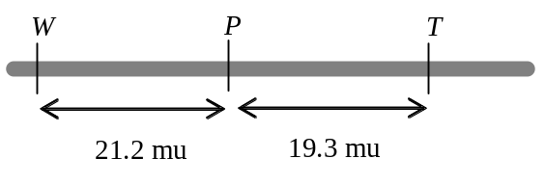
d. Interference (I) = 1 - coefficient of coincidence (coc)
coc = frequency of observed DCO / frequency of expected DCO
As discussed in problem 5-25, the expected percentage of double crossovers is the product of the frequency of recombination in each interval: (0.193) x (0.212) = 0.0409. The observed DCO frequency = 11/543 = 0.0203; coc = 0.0203/0.0409 = 0.496; I = 1 - 0.496 = 0.504.

5-25.
a. See problem 5-29 for a detailed explanation of the methodology. Diagram the cross:
a+ b+ c+ / a b c ♀ x a b c / a b c ♂ → ??. Recombination occurs in Drosophila females, so the female parent will make the following classes of gametes. Because this is a test cross, these gametes will determine the phenotypes in the progeny.
Classes of gametes | Genotype | Frequency of reciprocal pair | Numbers | Frequency of each class | # of progeny freq x 1,000
Parental (P) | a+ b+ c+  a b c | 1 - all else | 1 - (0.18 + 0.08 + 0.02) = 0.72 | 0.36  0.36 | 360  360
SCO 1 | a+ b c  a b+ c+ | rf in region 1 = SCO 1 + DCO | SCO 1 = 0.2 - 0.02 = 0.18 | 0.09  0.09 | 90  90
SCO 2 | a+ b+ c  a b c+ | rf in region 2 = SCO 2 + DCO | SCO 2 = 0.1 - 0.02 = 0.08 | 0.04  0.04 | 40  40
DCO | a+ b c+  a b+ c | (rf in region 1)  x (rf in region 2) | (0.2) x (0.1) = 0.02 | 0.01  0.01 | 10  10

b. Diagram the cross: a+ b+ c+ / a b c ♂ x a b c / a b c ♀ → ??. Here, the heterozygous parent is the male. Recombination DOES NOT OCCUR in male Drosophila. Thus, the heterozygous parent will only give 2 types of gametes, the parental types. If you score 1,000 progeny of this cross, you will find 500 a+ b+ c+ and 500 a b c progeny.

5-26. Diagram the cross:
pink petals, black anthers, long stems x pink petals, black anthers, long stems →
a. The cross is pink x pink → (78 + 6 + 44 + 15) red : (39 + 13 + 204 + 68) pink : (2 + 2 + 117 + 39) white = 143 red : 324 pink : 160 white. The appearance of two new phenotypes (red and white) suggest that flower color shows incomplete dominance. This is confirmed by the 1:2:1 monohybrid ratio seen in the self-cross progeny. The pink flowered plants are Pp, red are PP and white are pp.
b. The expected ratio of red: pink : white would be 1:2:1. Calculating for the 650 plants, this equals 162.5 red, 325 pink, and 162.5 white.
c. The monohybrid ratio of the black and with tan anthers =. (78+26+39+13+5+2) tan : (44 + 15 + 204 + 68 + 117 + 39) black = 163 tan : 487 black = ~ 1 tan : 3 black. Therefore black (B) is dominant to tan (b). The monohybrid ratio for the stem length = 487 long stems : 163 short stems. = ~ 3 long :1 short, so long (L) is dominant to short (s).
d. Designate the alleles: P = red, Pp = pink, p = white; B =black, b =tan, L =long, l =short. Because all 3 monohybrid phenotypic ratios are characteristic of heterozygous crosses, the genotype of the original plant is Pp Bb Ll.
e. If the stem length and anther color genes assort independently, the 9:3:3:1 phenotypic ratio should be seen in the progeny. Totaling all the progeny in each of the classes: 365 long black : 122 short black : 122 long tan : 41 short tan. The observed dihybrid ratio is close to a 9:3:3:1 ratio, so the genes for anther color (B) and stem length (L) are unlinked.
The expected monohybrid ratio for flower color is 1 red : 2 pink :1 white, while that for stem length is 3 long :1 short. If the two genes are unlinked, the expected dihybrid ratio can be calculated using the product rule to give 3/8 long pink : 3/16 long red : 3/16 long white : 1/8 short pink : 1/16 short red : 1/16 short white, or a 6 L- Pp :3 L- PP :3 L- pp :2 ll Pp :1 ll PP :1 ll pp ratio. The observed numbers are: 243 long pink : 122 long red : 122 long white : 81 short pink : 41 short red : 41 short white. This observed ratio is close to the predicted ratio, so the genes for petal color (P) and stem length (L) are unlinked.
The same analysis is done for flower color and anther color. The expected dihybrid ratio here is also 6:3:3:2:2:1. The observed numbers are: 272 black pink : 59 black red : 156 black white : 52 tan pink : 104 tan red : 7 tan white. Because these numbers do not fit a 6:3:3:2:1:1 ratio, we can conclude that flower color (P) and anther color (B) are linked genes.
f. It is clear that the original snapdragon was heterozygous for Pp and Bb. However the genotype of this heterozygous plant could have been either P B / p b or P b / p B. If it is the former and the genes are closely linked, then the pp bb phenotype will be very frequent (almost 1/4 of the progeny because it is non-recombinant). Instead the pp bb class is very infrequent, accounting for only about 1% (7/650) of the progeny. Thus, the parental genotype must have been P b / p B. In this case, the infrequent pp bb class received a p b recombinant gamete from both parents (see problem 5-30 parts a & b). The frequency of the pp bb genotype = (probability of the p b recombinant gamete)2. The recombination frequency (rf) between the P gene and the B gene = frequency of P B + p b gametes = 2(√(#pp bb/# total progeny)) = 2(√(7/650)) = ~20 map units.

5-27.
a. wild type ♀ x scute echinus crossveinless black ♂ → 16 classes of data! Among the 16 classes there are wild type and sc, ec, cv and bl. This tells you that the parental female was heterozygous for all 4 traits. The fact the parental female is wild type also tells you that the wild-type alleles of all 4 genes are dominant. Remember that if you do a test cross with a female that is heterozygous for 3 linked genes, the data shows a very specific pattern. Because each type of meiosis (no recombination, DCO, etc.) gives a pair of gametes, you will see 8 classes of data that will occur in 4 pairs, both genetically and numerically. Thus, if you begin a cross with a female that is heterozygous for 4 linked genes, you should see 16 classes of progeny in a pattern of 8 genetic and numeric pairs. Although we have 16 classes of data, they do NOT occur in numeric pairs - instead we see numeric groups of 4. If one (or more) of the genes instead assorts independently of the others, then in a test cross you must see numeric groups of 4. For example, the most frequent classes will be parental, and there will be a 1:1:1:1 ratio of the 4 parental types.
Which gene is assorting independently relative to the other 3 genes? To answer this question, list the genotypes of the gametes that came from the heterozygous parent in the largest group of 4. This group should include the parental classes for the 3 linked genes; there are 4 genotypes here to account for the independent assortment of the unlinked gene. Then choose one of the 4 genes, and remove the allele of that gene from all 4 groups. When you do this with the gene that is assorting independently of the rest, you will find there are only 2 reciprocal classes of data left, which are the parental classes for the linked genes. If you choose one of the linked genes to remove, you will still have 4 different phenotypic classes left. Try removing the b gene first. You see that when the b allele is removed there are only 2 classes left, s e c and + + +; when this analysis is repeated removing the allele of the s gene there are still 4 different phenotypes left.

Genotype | Numbers | remove b | remove s
b s e c | 653 | s e c | b e c
+ s e c | 670 | s e c | + e c
+ + + + | 675 | + + + | + + +
b + + + | 655 | + + + | b + +

The b gene is therefore assorting independently of the other 3 genes. When the b gene is removed from all 16 classes of data, you can see that the data reduces to 8 classes that form 4 genetic and numeric reciprocal pairs, just as in any three-point cross (see answer to part b below). Thus, the genotype of the parental female is:
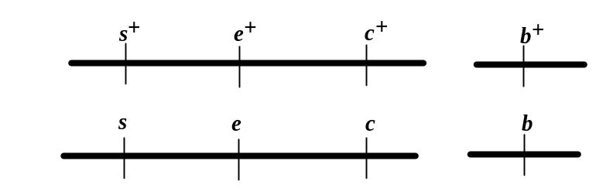
b. Write the classes out as reciprocal pairs.
Classes of gametes | Genotype | Numbers
Parental (P) | + + +  s e c | 1323  1330
SCO 1 | s + +  + e c | 144  147
SCO 2 | s  e +  + + c | 171  169
DCO | s + c  + e + | 2  2

Compare the DCO s + c to the parental s e c; this shows that e is in the middle. Calculate rf s - e = (144 + 147 + 2 + 2)/3288 = 9.0 cM; rf e - c = (171 + 169 + 2 + 2)/3288 = 10.5 cM.
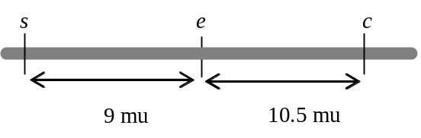
c. Interference = 1 - coefficient of coincidence
coc = observed DCO frequency / expected DCO frequency = (4/3288) / (0.09 x 0.105) = 0.001 / 0.009 = 0.11
I = 1− 0.11 = 0.89; yes, there is interference.

5-28.
First re-write the data as genotypes grouping the genetic reciprocal pairs.
Classes of gametes | Genotype | Numbers
Parental (P) | th h st  + + + | 432  429
recombinant | th h +  + + st | 37  33
recombinant | th + st  + h + | 35  34
The th h st and wild type classes are defined as parental because they are the most frequent reciprocal pair.
a. Each class of the parental reciprocal pair corresponds to one homolog of the heterozygous Drosophila female that was test crossed to the homozygous recessive male. Thus the genotype of this female is th h st / th+ h+ st+.
b. This is a test cross with three linked genes, but there are only 6 classes of data (3 reciprocal pairs) instead of 8 classes. The missing reciprocal pair is th + + and + h st. This pair must be the least frequent DCO class. Comparing the th + + DCO class to the + + + parental class (the most similar) shows that th is the gene that differs so th must be the gene in the middle. The h to th distance is 35 + 34 / 1000 = 0.069 = 6.9mu. The th to st distance is 37 + 33 / 1000 = 0.07 = 7mu. The best map is:
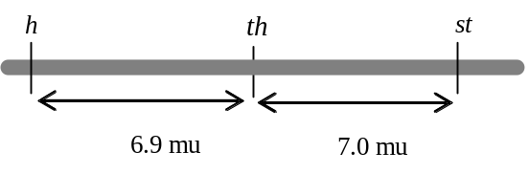
c. I = 1 – coefficient of coincidence; coefficient of coincidence = observed DCO / expected DCO. Thus coefficient of coincidence = 0 / (0.069)(0.07) = 0 and I = 1 – 0 = 1. The interference is complete.

5-29. Diagram the cross:
M C S / M C S (Virginia strain) x m c s / m c s (Carolina strain) → F1 M C S / m c s x m c s / m c s → ?
Assume no interference, and remember the map of these 3 genes:

You are being asked to calculate the proportion of the test cross progeny that will have the Virginia parental phenotype. In Chapter 3 we could answer this question by calculating the monohybrid ratios each pair of alleles: M : m, C : c and S : s in the heterozygous parent. The test cross parent can only provide the recessive alleles for each gene, so the probabilities of the various phenotypes can be determined by applying the product rule. Unfortunately, this method of arriving at the probability of the progeny phenotypes only works when the genes under discussion are assorting independently! When the 3 genes are linked, as in this problem, to calculate the frequency of a parental class we must calculate first calculate the frequencies of ALL of the phenotypes expected in the test cross progeny!
A parent that is heterozygous for 3 genes will give 8 classes of gametes. In a test cross, the gamete from the heterozygous parent determines the phenotype of the progeny. When the 3 genes are genetically linked, these 8 classes will be found as 4 reciprocal pairs. In other words, each meiotic event in the heterozygous parent must give 2 reciprocal products that occur in equal frequency. For instance, a meiosis with no recombination will produce the parental gametes, M C S and m c s in equal frequency. This particular reciprocal pair will also be the most likely event and so the most frequent pair of products. The least probable meiotic event is a double crossover which is a recombination event in the region between M and C (region 1) and simultaneously in the region between C and S (region 2). The remaining gametes are produced by a single crossover in region 1 (the reciprocal pair known as single crossovers in region 1) and a single crossover in region 2 (the reciprocal pair known as single crossovers in region 2).
The numbers shown on the map of this region of the chromosome represent the recombination frequencies in the gene-gene intervals. There are 6 mu between the M and C genes, so 6% (rf = 0.06) of the progeny of this cross will have had a recombination event in region 1. This recombination frequency includes all detectable recombination events between these 2 genes - both SCO in region 1 AND DCO. Likewise, 17% of all the progeny will be the result of a recombination event in region 2. The DCO class is the result of a simultaneous crossover in region 1 and region 2. Recombination in two separate regions of the chromosome should be independent of each other, so we can apply the product rule to calculate the expected frequency of DCOs. Thus frequency of DCO = (0.06) x (0.17) = 0.01. Remember that the recombination frequency between M and C (region 1) includes both SCO 1 and DCO. Thus, 0.06 = SCO 1 + 0.01; solve for SCO 1 = 0.06 - 0.01 = 0.05. The same calculation for region 2 shows that SCO 2 = 0.16. The parental class = 1 - (SCO 1 + SCO 2 + DCO). Also remember that each class of gametes (parental, etc.) is made up of a reciprocal pair. If the frequency of the DCO class is 0.01, then the frequency of the M c S gamete is half of that = 0.005. This is summarized in the table below.

Classes of gametes | Genotype | Frequency of reciprocal pair | Numbers | Frequency of each class
Parental (P) | M C S  m c s | 1 - all else | 1 - (0.05 + 0.16 + 0.01) = 0.78 | 0.39  0.39
SCO 1 | M c s  m C S | rf in region 1 = SCO 1 + DCO | SCO 1 = 0.06 - 0.01 = 0.05 | 0.025  0.025
SCO 2 | M C s  m c S | rf in region 2 = SCO 2 + DCO | SCO 2 = 0.17 - 0.01 = 0.16 | 0.08  0.08
DCO | M c S  m C s | (rf in region 1)  x (rf in region 2) | (0.06) x (0.17) = 0.01 | 0.005  0.005

a. The proportion of backcross progeny resembling Virginia (parental, M C S) = 0.39.
b. Progeny resembling m c s (P) = 0.39.
c. Progeny with M c S (DCO) = 0.005.
d. Progeny with M C s (SCO 2) = 0.8.

5-30.
a. Recombination does NOT occur in male Drosophila. Therefore, in the cross A b / a B ♀ x A b / a B ♂ → F1 the females will make 4 types of gametes (parental A b and a B; recombinant A B and a b). The frequencies of the 2 parental gametes will be equal to each other, and the frequency of the A B recombinant will be equal to the frequency of its reciprocal recombinant, a b.
female gametes | male gamete  A b | male gamete  a B
A b  [parental] | A b / A b  (A- bb) | A b / a B  (A- B-)
a B  [parental] | a B / A b  (A- B-) | a B / a B  (aa B-)
A B  [recombinant] | A B / A b  (A- B-) | A B / a B  (A- B-)
a b  [recombinant] | a b / A b  (A- bb) | a b / a B  (aa B-)

There is a ratio of 1/4 A- bb : 1/2 A- B- : 1/4 aa B- for the progeny receiving the parental gametes AND the same ratio among the progeny receiving the recombinant gametes. Thus, the overall phenotypic dihybrid ratio will always be 1/4 A- bb : 1/2 A- B- : 1/4 aa B-, independent of the recombination frequency between the A and B genes.
This will not be true of the cross A B / a b ♀ x A B / a b ♂. The male will make the parental gametes, A B and a b, while the female will make 4 types of gametes: parental A B and a b; recombinant A b and a B. In this case, as in problem 5-17, half of the progeny will look A- B- because they received the A B gamete from the male parent irrespective of the gamete from the female parent. When the male parent donates the a b gamete, then it is the gamete from the female parent that determines the phenotype of the offspring. The progeny that are A- bb and aa B- have received a recombinant gamete from the female parent (and the a b gamete from the male). These classes of progeny can then be used to estimate the recombination frequency between the A and B genes: rf = 2(# of A- bb + # of aa B-)/total progeny.
b. In mice, recombination occurs in both females and males. Therefore, in the cross A b / a B ♀ x A b / a B ♂ both sexes will make the same array of gametes (parental A b and a B; recombinant A B and a b). In this case, the only phenotype of progeny with a singular genotype will be aa bb. In the cross under consideration here, the aa bb phenotype can only arise if both parents donate the a b recombinant gamete. Of course, the other recombinant gamete, A B, occurs with equal frequency. The probability of the aa bb genotype = (probability of an a b recombinant gamete)2. If you know the frequency of the aa bb phenotypic class in the progeny, recombination frequency (frequency of recombinant products) between the A and B genes = 2(√#aa bb/# total progeny).
In the case of the A B / a b ♀ x A B / a b ♂ cross in mice, both sexes are making the same parental gametes (A B and a b) and recombinant gametes (A b and a B) gametes. Again, the only phenotype of progeny with a singular genotype will be aa bb. In this example, this phenotype is the result of the fusion of the a b parental gamete from each parent. The frequency of the aa bb phenotype = (the frequency of the a b gamete) x (the frequency of the a b gamete). If you know the frequency of the aa bb phenotypic class in the progeny, the frequency of non-recombinant products between the A and B genes = 2(√#aa bb)/# total progeny. Recombination frequency = 1 - frequency of non-recombinant products between the A and B genes.

5-31. In cross #1 the criss-cross inheritance of the recessive alleles for dwarp and rumpled from mother to son tells you that all these genes are X-linked. In cross #2, you see the same pattern of inheritance for pallid and raven, so these genes are X-linked as well. The fact that the F1 females in both crosses were wild type tells you that the wild type allele of all 4 genes is dominant to the mutant allele. Designate alleles: dwp+ and dwp for the dwarp gene, rmp+ and rmp for the rumpled gene, pld+ and pld for the pallid gene, and rv+ and rv for the raven gene. Assign the genes an arbitrary order to write the genotypes. If you keep the order the same throughout the problem, it is sufficient to represent the wild type allele of a gene with +.
Cross 1: dwp rmp + + / dwp rmp + + x + + pld rv / Y → dwp rmp + + / + + pld rv (wild-type females) and dwp rmp + + / Y (dwarp rumpled males).
Cross 2: + + pld rv /+ + pld rv x dwp rmp + + / Y → + + pld rv / dwp rmp + + (wild-type females) and + + pld rv / Y (pallid raven males).
dwp rmp + + / + + pld rv (cross 1 F1 females) x dwp rmp pld rv / Y → 428 + + pa ra, 427 dw ru + +, 48 + ru pa ra, 47 dw + + +, 23 + ru pa +, 22 dw + + ra, 3 + + pa +, 2 dw ru + ra.
All 4 genes must be linked, as they are all on the X chromosome. You expect 16 classes of progeny (2 x 2 x 2 x 2) in 8 genetic and numeric pairs. Notice that there are only 8 classes of progeny. The data that is seen shows exactly the pattern you expect for a female that is heterozygous for 3 linked genes! If 2 of the 4 genes NEVER recombine then you would expect the pattern of data that is seen. If 2 genes never recombine, they will always show the parental configuration of alleles. Thus, examine the various pairs of genes for the presence or absence of recombinants. Note that you never see recombinants between pallid and dwarp: all the progeny are either pallid or dwarp, but never pallid and dwarp nor wild type for both traits. This suggests that the two genes are so close together that there is essentially no recombination between the loci. If a much larger number of progeny were examined, you might observe recombinants. Treat dwp and pld as 2 genes at the same location, so one of them (dwp, for instance) can be ignored, and this problem becomes a three-point cross between pld, rv and rmp.
Classes of gametes | Genotype | Numbers
Parental (P) | dwp rmp + +  + + pld rv | 427  428
SCO 1 | + rmp pld rv  dwp + + + | 48  47
SCO 2 | dwp + + rv  + rmp pld + | 22  23
DCO | + + pld +  dwp rmp + rv | 3  2
When the rmp + rv DCO class is compared to the rmp + + parental class, you can see that rv is in the middle. The rmp - rv rf = (48 + 47 + 3 + 2)/1000 = 10 cM; the pld - rv rf = (22 + 23 + 3 + 2)/1000 = 5 cM. I = 1 - coc; coc = observed frequency of DCO/expected frequency of DCO. So coc = (5/1000)/(0.05)(0.1) = 0.005/0.005 = 1; I = 1 - 1 = 0, so there is no interference.
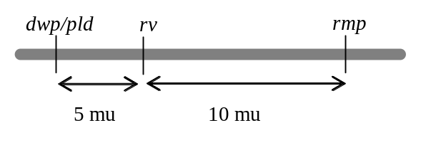

Section 5.5 – Tetrad Analysis
5-32.
a. This data is presented as phenotypes of individual spores. Because there is data for 3 genes, this may be analyzed as a 3 point cross. Organize the data into reciprocal pairs of spores.
Classes of gametes | Genotype | Numbers
Parental (P) | α + +  a f g | 31  29
SCO 1 | a + g  α f + | 6  6
SCO 2 | α + g  a f + | 13  14
DCO | a + +  α f g | 1  1
The α f g DCO spore type is most similar to the a f g parental spore type. Thus, the mating type (a/α) is the gene in the middle. The distances are: f - a/α = (6 + 6 + 1 + 1)/101 = 13.9 cM and a/α to g = (13 + 14 + 1 + 1)/101 = 28.7 cM.
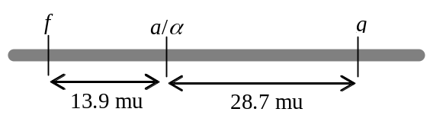
b. This problem says you have an ascus with an α f g spore. This spore is the result of a double crossover (see part a). The reciprocal product would be the a + + spore, but this is not seen in the ascus. Remember that there are 3 different types of double crossovers - 2 strand DCOs, 3 strand DCOs and 4 strand DCOs. Each of these types of DCOs gives a different array of spores in the resulting ascus (Figure 5.17). Draw a meiotic figure of this chromosome and try some different types of DCOs. A 3 strand DCO gives the desired result.
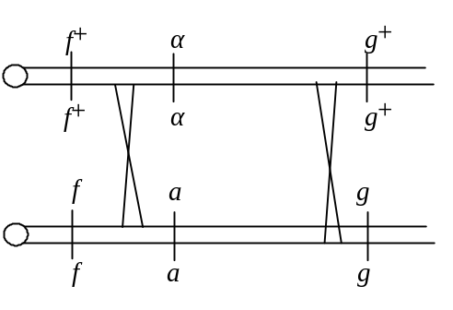

5-33.
a. The number of meioses represented here is the total of the number of asci = 334. Each ascus contains the 4 products of one meiosis.
b. Diagram the cross: a + c x + b +
To map these genes, use the Three Easy Rules for Tetrad Analysis. First designate the type of asci represented. This has to be done for each pair of loci as PD (P), NPD (N) and T refer exclusively to the relationship between two genes. In the table below, the top row shows the designations for all three pairs: the a-b comparison is at the lower left, the b-c comparison is at the lower right and the a-c comparison is at the top of the pyramid.
P  P P | P  N N | T  T P | T  T N | N  N P | P  T T
a + c | a b c | + + c | + b c | a b + | a + c
a + c | a b c | a + c | a b c | a b + | a b c
+ b + | + + + | + b + | + + + | + + c | + + +
+ b + | + + + | a b + | a + + | + + c | + b +
137 | 141 | 26 | 25 | 2 | 3
I I I | I I I | II I I | II I I | I I I | I II I

Rule #1: For genes a and b PD = NPD, so these two genes are not linked. For genes b and c PD = NPD, so genes b and c are not linked. For genes a and c, PD>>NPD, so the genes are linked. Calculate rf between a and c = 2 + 1/2(26 + 25)/334 = 8.2 cM (Rule #2).
Gene-centromere distances can be calculated in Neurospora (Rule #3), so analyze the data for MI and MII segregation patterns for the alleles of each gene in each ascus type. This analysis is done separately for each gene, unlike the gene - gene analysis done above. The designation for each gene is presented under that gene at the bottom row of the table (I - MI, II = MII). Rule #2 shows that the distance between a and its centromere = 1/2(26 + 25)/334 = 7.6 mu; the distance between b and its centromere = 1/2(3)/334 = 0.4 mu; the distance between c and its centromere = 1/2(0)/334 = 0.
Now compile all of these pieces of data into one map. Rule #1 shows that gene b is 0.4 mu from its centromere and is on a different chromosome from genes a and c. Genes a and c are on the same chromosome, so the a-centromere distance and the c-centromere distance refer to the same centromere. Gene c is 0 mu from the centromere. As you can see from the map, there are 2 slightly different distances for the gene a to gene c region - the gene-gene distance is 8.2 mu and the a-centromere distance is 7.6 mu. In this case the longer gene-gene distance is more accurate
as it includes the SCOs between a and c as well as some of the DCOs between a and c (the 4 strand DCO, Figure 5.17).
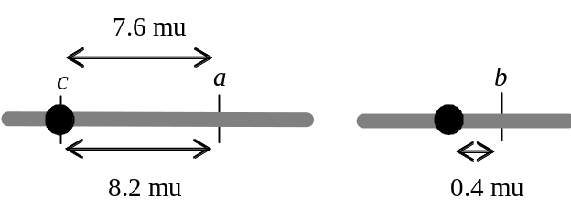
c. Carefully consider the information you have for the different chromosomes in the ascus type chosen (the group with 3 members). The a and c genes show PD segregation, which can mean either no crossing over between them or a 2 strand DCO. Both genes show MI segregation, which means there haven't been any single crossovers between either gene and the centromere. Gene b shows MII segregation, which means there has been an SCO between the gene and its centromere. This crossover also means the a-b and c-b comparisons in this class will show the tetratype pattern (T are due to crossovers between either gene and its centromere when the genes are on separate chromosomes).
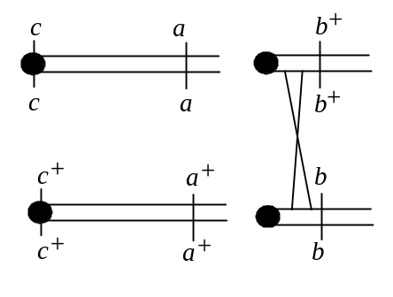

5-34. Use the Three Easy Rules for Tetrad Analysis to help you solve this problem.
a. In cross 1, the number of PD (parental ditypes) = NPD (nonparental ditypes) so the ad gene and the mating type locus assort independently. In cross 2 the number of PD >> NPD so we can conclude the p gene and the mating locus are linked; rf p - mating type = (NPD + 1/2T)/ total tetrads = (3) + (1/2)(27)/54 =16.5/54= .31 × 100 = 31 cM between the two genes.
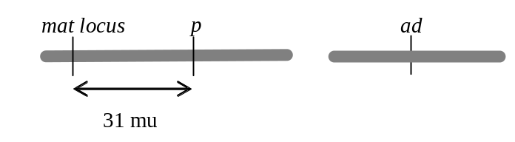
b. To calculate gene-centromere distances you need information on the order of ascospores in each ascus type. Only with this information can you calculate gene - centromere distances based on 1/2(# of asci showing MII segregation for the gene)/total asci.

5-35. Diagram the cross and summarize the data: met- lys- x met+ lys+
P | T
met+ lys+ | met+ lys+
met+ lys+ | met- lys+
met- lys- | met+ lys-
met- lys- | met- lys-
89 | 11

a. The two types of cells in the first group of 89 asci are met+ lys+ (could grow on all four types of media) and met- lys- (require the addition of met and lys to minimal medium). These asci are parental ditypes (PD). The four types of cells in the second group of 11 asci are met+ lys+; met+ lys- (grew on min + lys and on min + lys + met); met- lys+(grew on min + met and on min + lys + met); and met - lys-. These are tetratype (T) asci.
b. Because the number of PD>>> NPD, the genes are linked. The distance between them is:
(NPD + 1/2(T)) / total tetrads = (0 + 1/2(11))/100 × 100 = 5.5 m.u.
c. NPD should be seen eventually and would result from four strand double crossovers. There would be two types of spores: met- lys+ (could grow on min + met and on min + met + lys) and met+ lys- (could grow on min + lys and on min + met + lys).

5-36. Genes a, b, and c are all on different chromosomes. Thus, all crosses between these genes are expected to give an equal number of PD and NPD asci. The fact that the cross involving genes a and b yields no T indicates that genes a and b are both very close to their respective centromeres. If two genes are on separate chromosomes, tetratypes arise when a crossover occurs between one of the genes and its centromere or between the other gene and its centromere. In the crosses involving genes a and c or genes b and c, many T asci are seen. Because genes a and b are tightly centromere-linked, gene c must be very far from its centromere in order to generate these T asci.

5-37.
a. The genotype of a true breeding wild type diploid strain of Saccharomyces can be written + / +. If this diploid undergoes meiosis, all (100%) of the asci will have 4 viable spores.
b. The genotype of this strain is + / n, where n = a null activity allele of an essential gene. The diploid cells will be viable, because they have functional enzyme for this essential gene from the + allele. If this diploid undergoes meiosis, then all (100%) of the tetrads will have 2 + : 2 n spores (that is, only 2 spores in each tetrad will be viable).
c. Gene a and gene b are different essential genes; a and b represent temperature-sensitive alleles of these genes. When you diagram a cross you must write complete genotypes for both haploid parents: a b+ (strain a) x a+ b (strain b) → aa+ bb+. Each haploid parent strain will die when grown under restrictive conditions because they cannot produce a required product, while the diploid cells are viable because they have a wild type allele for both genes.
If these genes are unlinked, then after meiosis PD asci = NPD asci ('3 Easy Rules for Tetrad Analysis' rule #1). When the genes are unlinked, also remember that T tetrads (asci) arise from SCOs between either gene and its centromere. Because both of these genes are 0 mu from their centromeres, you will not see T asci. Thus, after meiosis, you will have 50% PD (2 a b+ spores : 2 a+ b spores) : 50% NPD (2 a+ b+ : 2 a b). None of the spores in the PD tetrads are viable under restrictive conditions, while 2 of the 4 spores in the NPD asci are viable (a+ b+). Thus, 50% of the asci will have 0 viable spores (PD) and 50% of the asci will have 2 viable spores (NPD).
d. Again genes a and b are unlinked essential genes, but now gene a-centromere = 0 mu and gene b-centromere = 10 mu. A SCO between gene b and its centromere will happen in 20% of the asci (because only half of the ascospores of an SCO are recombinant) and will give T asci. A T ascus will have a spore ratio of 1 a+ b+ : 1 a b : 1 a b+ : 1 a+ b. There is 1 viable spore (a+ b+) in a T ascus. The remaining 80% of the asci will be equally divided between PD and NPD because the genes are unlinked. Thus, 40% of the asci will have 0 viable spores (PD), 40% of the asci will have 2 viable spores (NPD) and 20% of the asci will have 1 viable spore (T).
e. Because both genes are on the same chromosome, you can diagram this cross: a b+ (strain a) x a+ b (strain b) → a b+ / a+ b. When the genes are linked, SCO and 3 strand DCO between the genes give T asci and 4 strand DCO between the genes gives NPD asci. The remainder of the asci are PD (no crossover and 2 strand DCO). If the recombination frequency between gene a and gene b = 0 mu, then the only possible result will be PD asci (2 a b+ : 2 a+ b) in which none of the spores are viable. Thus, 100% of the asci will have 0 viable spores.
f. Now the genes are 10 mu apart and there are no DCO events. This means that 20% of the asci produced will be T (see part d) and the remaining 80% will be PD. Therefore, 80% of the asci will have 0 viable spores (PD) and 20% of the asci will have 1 viable spore (T).
g. A 4 strand DCO gives an NPD ascus. The genotypes of the spores will be 2 a+ b+ : 2 a b. Thus, 2 of the 4 spores will be viable.

5-38. Genes c and d are a total of 22 mu apart.
a. If interference = 1, then there are no double crossovers (DCO). Therefore, all the recombinants between the 2 genes are due to single crossovers (SCO). If two genes are linked, then SCOs between the genes give tetratype asci (T). Remember that the rf between C and D is 0.22, DCO between C and D is 0 (so there can be no NPD tetrads), and the formula for recombination frequency between 2 genes = NPD + 1/2(T)/total asci. Solve for T: 0.22 = 0 + 1/2(T) so T = 2(0.22) = 0.44. Therefore, 44% of the asci will be tetratypes and the remaining 56% will be parental ditypes.
b. Interference = 0, so DCOs will occur in the expected frequency (see problems 5-29 and 5-25). The expected frequency of DCO = (recombination frequency in the C-D region) x (recombination frequency in the C-D region) = (0.22) x (0.22) = 0.0484. The rf between C-D = SCO + DCO; so 0.22 = SCO + 0.0484; SCO = 0.22 - 0.0484 = 0.1716. If SCO frequency between C and D = 0.1716 then T due to SCO = 0.3432 (see part a of this problem).
Remember that when analyzing tetrads the three different types of DCOs can be distinguished: 2 strand DCOs, which give PD asci; 3 strand DCOs, which give T asci; and 4 strand DCOs, which give NPD asci (Figure 5.17b-f). These DCOs occur in the ratio of 1/4 (2 strand DCOs) : 1/2 (3 strand DCOs) : 1/4 (4 strand DCOs). If the total DCO frequency = 0.0484 then 1/4 (0.0484) = 0.0121 is the frequency of 4 strand DCOs (NPD), 1/2 (0.0484) = 0.0242 is the frequency of 3 strand DCOs (T) and the remaining 1/4 of the DCOs (0.0121) are 2 strand DCOs, which will be PD tetrads.
In total, NPD = 0.0121, T = 0.0242 (due to DCO) + 0.3674 (due to SCO) = 0.3795 and the remainder are PD = 0.6205.
c. In Neurospora the recombination events that underlie the formation of PD, NPD and T are the same as in yeast. The difference is that the ordered tetrads allow you to distinguish whether a SCO event occurs between C and the centromere or between D and the centromere. If the SCO occurs between C and the centromere then you will see MII segregation for the alleles of the C gene and MI segregation for the alleles of the D gene. If the SCO occurs between D and the centromere then you will see the reverse - MI segregation for C and MII segregation for D.
Here, I = 1, so there are no DCOs. Therefore, as in part a, T = 0.44 and PD = 0.56. However 7/22 of the SCO events occur between gene C and the centromere, while the remaining 15/22 of
the SCOs occur between D and the centromere. The expected results are summarized in the table below.
crossover type and location: | no crossover | SCO C-cent. | SCO D-cent
ascus type: | PD | T | T
MI or MII gene C: | MI | MII | MI
MI or MII gene D: | MI | MI | MII
frequency: | 0.56 | 7/22 x 0.44 = 0.14 | 15/22 x 0.44 = 0.30
d. Here, I = 0, so DCO events are occurring at the expected frequencies. The frequencies of each of the DCO events is as in part b. A DCO represents a single meiosis in which a crossover in the first region (C to centromere) happens simultaneously with a crossover in the second region (centromere to D). Thus any of the DCO events will show MII segregation for both genes. The expected results are summarized in the table below.
crossover type  and location: | no crossover | SCO  C-cent. | SCO  D-cent | DCO  2 strand | DCO  3 strand | DCO  4 strand
ascus type: | PD | T | T | PD | T | NPD
MI or MII gene C: | MI | MII | MI | MII | MII | MII
MI or MII gene D: | MI | MI | MII | MII | MII | MII
frequency: | 0.528 | 7/22 x 0.419  = 0.14 | 15/22 x 0.419  = 0.30 | 1/4 x 0.0105  = 0.003 | 1/2 x 0.0105  = 0.005 | 1/4 x 0.0105  = 0.003

5-39. Diagram the yeast cross: his- trp+ x his+ trp- → his-his+ trp+trp- → 233 PD, 11 NPD, 156 T.
a. The PD asci must have 2 his- trp+ : 2 his+ trp- spores, the NPD asci have 2 his+ trp+ : 2 his- trp- spores and the T asci have 1 his- trp+ : 1 his+ trp- : 1 his+ trp+ : 1 his- trp- spores.
b. PD>>NPD so the genes are linked; rf between 2 genes = 11 + 1/2(156)/400 = 22.3 mu.
c. Because the genes are linked, you know that NPD asci are the result of 4 strand DCOs. This sort of DCO is 1/4 of all the DCO events. The 3 strand DCOs (1/2 of all DCOs) give T while 2 strand DCOs (1/4 of all DCOs) give PD. In the data you see 11 NPD tetrads, or 11 meioses that underwent 4 strand DCOs. There are another 22 tetrads that are the result of 3 strand DCOs (and are Ts), and another 11 asci that underwent 2 strand DCOs (and are PDs), for a total of (11 + 22 + 11 =) 44 asci that underwent 2 crossovers. The remaining (156 - 22 =) 142 T asci underwent a SCO, or 1 crossover, and the remaining (233 - 11=) 222 PD asci underwent 0 recombination events.
d. There are 44 asci that underwent DCOs for a total of 88 crossover events. There were another 142 asci that underwent SCOs. Thus, there were 142 + 88 = 230 crossover events / 400 meioses = 0.575 crossovers/meiosis.
e. The equation for recombination frequency between 2 genes used in the textbook and in part b above only includes 4 strand DCO (NPD). This formula ignores 3 strand and 2 strand DCOs. This calculation for recombination frequency assumes that all T asci are due to SCOs. Though this is true for the majority of T asci, a small proportion of T asci are due to 3 strand DCO events. Also, it is an oversimplification to assume that all PD asci are non-recombinant, because a very few of them are due to 2 strand DCOs. Remember that the 3 types of DCO events occur in a ratio of 1/4 2 strand DCO : 1/2 3 strand DCO : 1/4 4 strand DCO. With this information we can derive a more accurate formula for recombination frequency between 2 genes = SCO + DCO/total asci: rf = 1/2(T – 2NPD) + 4(NPD)/total asci = 1/2(T) + 3(NPD)/total asci. Many yeast geneticists use this more accurate formula in preference to the one in your textbook.
f. rf = 1/2(156 – 22) + 4(11)/400 = 1/2(134) + 44/400 = 111/400 = 0.278 = 27.8 mu. As you can see, this is somewhat larger than the distance calculated in part b.

5-40.
a. Refer to the three strains as trp1, trp2 and trp3. Remember that in Neurospora the 4 meiotic products undergo a subsequent mitosis to give 8 spores in the ascus. However, the first 2 spores are identical to each other (they are mitotic products of the same initial spore), the 3d and 4th spores are the same as each other, and so on. For the purposes of discussing the results, assume that the ascus is made up of the 4 original spores prior to this extra mitosis. You cross trp1- x wild type → diploid → 2 wild type : 2 trp1-. You are seeing a monohybrid ratio of 1:1, which means there is only one gene controlling the trp- phenotype in strain trp1. Each of the strains gives the same result, so in each haploid strain a single mutant gene is responsible for the trp- phenotype.
b. First consider the cross between trp3 and wild type. The diploid is trp3- / trp3+. After meiosis the first 2 spores were either both trp3+ (could grow on minimal media) or they were both trp3- (could not grow on minimal media). Thus, all the asci were 2 trp3- : 2 trp3+, and the order of the alleles was either - - + + or + + - -. In other words, all the asci showed MI segregation for the trp3 gene! In the case of the crosses with trp1- x wild type and trp2- x wild type, the resultant diploids gave some asci that gave a different result - only one spore of the top 2 was trp+ while the other one was trp-. In other words, these asci showed MII segregation for the trp gene in question. In summary, the trp3 gene is very closely linked to its centromere (no T = no crossovers between the gene and the centromere), while the trp1 and trp2 mutations are further from their centromere(s).
c. If 2 strains have mutations in the same gene, then the resulting diploid would be unable to grow on minimal media trpx- / trpx- and would give asci where all 4 spores were trpx- (0 spores viable on minimial media). This result is never seen, so each mutant strain must have a mutation in a different gene, for a total of 3 different trp- genes in the 3 strains. Diagram the cross between trp1 and trp2: trp1- trp2+ x trp1+ trp2- → trp1- trp1+ trp2+ trp2-. When this diploid is allowed to undergo meiosis you see 78 asci with 0 viable spores (2 trp1- trp2+ : 2 trp1+ trp2- = PD - see problem 5-33f) and 22 asci with 2/8 or 1/4 viable spores (1 trp1+trp2+ : 1 trp1-trp2- : 1 trp1- trp2+ : 1 trp1+ trp2- = T). In the trp1 x trp3 cross you see a new class of asci, those with 2 viable spores (2 trp1+trp3+ : 2 trp1-trp2- = NPD). In this cross there are 46 PD, 48 NPD, and 6 T asci. In the last cross, trp2 x trp3, there are 42 PD, 42 NPD and 16 T asci.
d. In trp1 x trp2 PD>>NPD (= 0) so the genes are linked. The T asci are caused by SCOs between the 2 genes. The recombination frequency between trp1 and trp2 = (0 + 1/2(22))/100 = 0.11 = 11 mu. In trp1 x trp3 there are 46 PD = 48 NPD so the genes are unlinked; the 6 T asci arise from SCOs between trp1 and its centromere. None of these T asci can arise from crossovers between trp3 and its centromere because you found in part b that they were very tightly linked. Thus, trp1 is 3 mu from its centromere. In the cross between trp2 x trp3, PD = NPD so the genes are unlinked. There are 16 T asci, so gene 2 must be 8 mu from its centromere. The map is shown below.
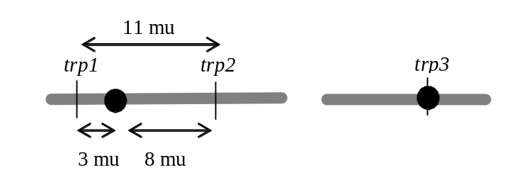
e. Ordered octads show the segregation pattern for each gene separately. In this example, both mutant genes give the same phenotype (trp-). Thus, it is impossible to determine if a trp- spore is + - or -- or - +. If you cannot distinguish these different types of spores, then you cannot determine the segregation pattern (MI vs MII) for the individual genes.
f. You can calculate gene-centromere distances because you discovered that one of the genes (trp3) is tightly linked to its own centromere. Therefore, when trp3- is crossed with either of the other mutants, any T asci must be due to SCO between the other gene and its centromere, and these T asci can then be used to calculate a distance between the other gene and its centromere. This same sort of analysis can also be used in yeast to map gene-centromere distances if a strain is available with a mutation known to be right at a centromere.

Section 5.6 – Mitotic Recombination and Genetics Mosaics
5-41.
a. Red sectors arise when one cell in the growing colony becomes ade2- / ade2-. As all the cells continue to grow, the colony continues to expand and the ade2⁻ / ade2⁻ cells form a red sector within the white colony (Figure 5.25). Red cells of the ade2- / ade2- genotype could arise by mitotic recombination (Figure 5.24), by loss of the entire chromosome containing the ade2+ allele, by a deletion of the portion of the chromosome containing the ade2+ allele, or by spontaneous mutation of the ade2+ allele to an ade2- allele.
b. The size of the red sectors depends on when in the formation of the colony the event occurred to form the initial ade2- / ade2- cell. If the event occurred early in the formation of the colony there will be a larger red sector than if the event occurred near the end of colony formation. All of the events mentioned in part a are rare, so in general they will occur later in colony formation when there are more cells in which they could occur. As a result, most of the red sectors will be small.

5-42. After replication in the heterozygous diploid, each chromosome would be composed of a pair of sister chromatids, as shown below. The centromeres on sister chromatids split and segregate from each other during mitosis (Figure 5.24). The centromeres are numbered in the figure below so you can follow them more easily. For example, cen1 and cen2 segregate from each other, so chromatids 1 or 2 and 3 or 4 will end up in a daughter cell. In a normal mitosis, this gives daughter cells that are genotypically a b c leth d e / a+ b+ c+ leth+ d+ e+ and are phenotypically wild type, like the original cell. Mitotic recombination can rarely occur between non-sister chromatids, for example between chromatid 2 and 3. Several possible locations for such recombination events are indicated by X-I - X-V in the figure. Assume that no crossovers occur between gene a and the cen because they are so closely linked.
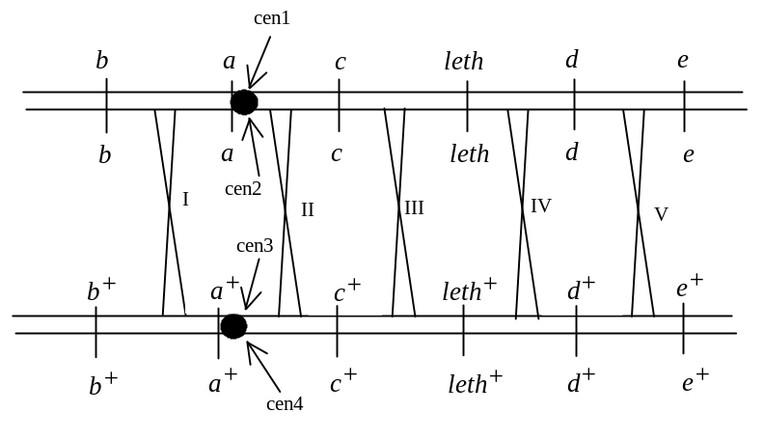
Consider the results of the X-I crossover. In one possible segregation, chromatids 2 and 4 segregate into one daughter cell; this cell will be homozygous for the b+ allele and heterozygous for the rest of the genes on the chromosome. Thus, this cell will be phenotypically wild type and indistinguishable from the non-recombinant cells surrounding it. The reciprocal product will be the daughter cell with chromatids 1 and 3 whose genotype will be homozygous mutant for gene b and heterozygous wild type for everything else. This cell will continue to divide mitotically and give you a patch of b mutant tissue in a sea of wild type tissue. In effect, the genes that are further away from the centromere than the site of mitotic recombination become homozygous. One segregant (the 2 and 4 chromatids in this example) will be homozygous wild type, and thus indistinguishable from the non-recombinant cells; the other segregant (the 1 and 3 chromatids here) becomes homozygous for the mutant allele of the gene(s) that are further from the centromere than the crossover while those genes that are closer to the centromere than the recombination event (or on the other side of the centromere, i.e. those genes unaffected by the mitotic recombination event) remain heterozygous. Next consider crossover X-II. In this case the same segregations will give you a wild type cell (chromatids 2 and 4) while the reciprocal daughter cell will be b+ a+ c leth d e (lethal, chromatids 1 and 3). Crossover X-III will also give a lethal recombinant product. Crossover X-IV will give a d e patch of mutant tissue, and crossover X-V will give a patch of e mutant tissue. Thus, the only phenotypes that will be found in sectors as a result of mitotic recombination will be b, e, and d e (#2, 5, and 9).

5-43. The genotype of the female fly is y+ sn+ / y sn:
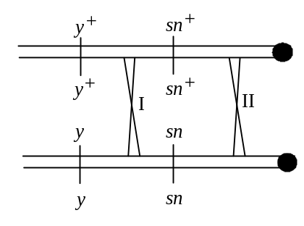
a. The larger patch of yellow tissue arises from a mitotic crossover in region I. This mitotic recombination will generate a cell of the genotype y sn+ / y sn (problem 5-42). The smaller patch of tissue must have arisen from a second mitotic recombination between the centromere and sn, in region II. This would produce cells that are y sn / y sn. Because the yellow patch is larger, the recombination in region I occurred earlier in development. The yellow, singed cells are a small patch within a larger patch of yellow cells, so the mitotic crossover in region II happened after (later in development than) the crossover in region I, and this second crossover happened in a recombinant daughter cell of the first recombination event. No wonder these patches within patches are rare!
b. If the genotype of the female was y+ sn / y sn+, then a recombination event in the region I would give you a detectably recombinant cell with the genotype y sn / y sn+. A subsequent second mitotic crossover in region II in one of these originally recombinant y sn / y sn+ cells will give you a patch of y sn tissue inside a patch of yellow tissue, as in part a.
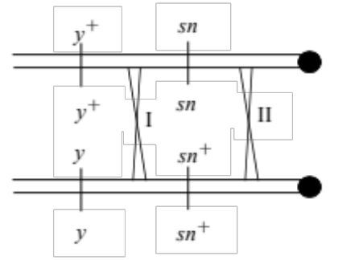
There is one mitotic recombination event which will give a different result in a y+ sn+ / y sn female (part a) than a y+ sn / y sn+ female (part b). After a recombination event in region II the female from part a will show a y sn patch of tissue. The other recombinant product will be homozygous y+ sn+, and thus indistinguishable from non-recombinant cells. The same sort of recombination event in region II in the female from part b will give one daughter cell of genotype y+ sn / y+ sn which will give a patch of sn tissue. The other product of the mitotic recombination will be y sn+ / y sn+ and will give an adjacent patch of yellow tissue. This phenomenon is called twin spots.

5-44. List the phenotypes seen in the normal tissue and the 20 tumors and their frequency of occurrence:
- normal tissue = AFAS BFBS CFCS DFDS
- tumor type 1 = AF BFBS CFCS DF = 12 tumors
- tumor type 2 = AF BFBS CFCS DFDS = 6 tumors
- tumor type 3 = AF BS CFCS DF = 2 tumors
Remember that all of the tumor tissues were also homozygous for NF1- while the normal tissue is heterozygous NF1-NF1+.
a. Mitotic recombination could have caused all 3 types of tumors.
b. Remember that mitotic recombination causes genes further from the centromere to become homozygous, while genes between the recombination event and the centromere, or those on the other side of the centromere, remain heterozygous (review problem 5-42). Notice that all 3 types of tumor cells are homozygous for NF1-, so by definition all 20 mitotic recombination events that gave rise to the 20 tumors occurred between the centromere and the NF1 gene. Notice also that all 20 tumors are homozygous for gene A, specifically the AF allele. Because gene A is affected by all of the mitotic recombination events, it must be further from the centromere than the NF1 gene. Because these tumors become homozygous for the AF allele, that allele must be on the same homolog with the NF1- allele. There are 6 tumors that are homozygous for these 2 genes (tumor type 2). As you work your way along the chromosome from NF1 toward the centromere the next gene to also become homozygous is the D gene (tumor type 1), specifically the DF allele, then the B gene (tumor type 3), the BS allele. Gene C never becomes homozygous, yet we are told it is on this chromosome as well. Thus it could either be on the other side of the centromere from NF1, A, D and B or it could be on the same side of the centromere as the rest of the genes but very closely linked to the centromere (like the a gene in problem 5-42). The order of the genes and coupling of the alleles is shown below:
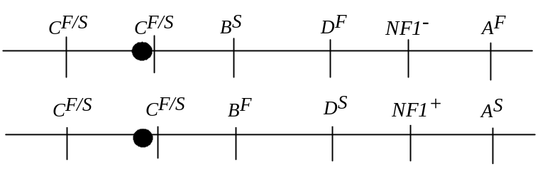
It is possible to use the mitotic recombination frequencies with which the various genotypes of tumors arose as a rough, relative approximation of the distances between the genes. These numbers are NOT to be confused with the meiotic recombination frequency we have been calculating in the other problems in this and other chapters! In tumor type 2 the mitotic recombination event happened between gene NF1 and gene D (NF1- is homozygous, and so further from the centromere than the recombination event while gene D is still heterozygous), and this occurred in 6/20 tumors = 0.3, so the relative recombination frequency between NF1 gene D is 0.3. In tumor type 1 the mitotic recombination event happened between gene B and gene D (B is still heterozygous in these tumors while D is homozygous DF), and this happened in 12/20 tumors = 0.6, so the relative recombination frequency between genes B and D is 0.6. In tumor type 3 the mitotic recombination event happened between the centromere and gene B (or between gene C and gene B if you place gene C on the same side of the centromere as the NF1 gene). This event happened in 2/10 tumors = 0.1 so the relative recombination frequency between the centromere and gene B is 0.1.
c. In this mechanism an entire homolog of one chromosome is lost. If the lost homolog was the one with the NF1+ allele, then the resulting cell would be hemizygous for the NF1- allele, and would develop into a tumor. This did NOT occur here, because ALL 3 genotypes of tumors are still heterozygous for at least the C gene.
d. Yes, deletions of portions of the NF1+ homolog which cause loss of the NF1+ allele could cause tumors to develop in the resulting NF1- cells. If these deletions extended to the neighboring genes A, D, or B, the tumor cells could show the same protein variants as in the problem. Likewise, point mutations which inactivate the NF1+ allele could cause tumors to develop in the resulting NF1- cells.

