Part 1
> Do your measured values of the frequency agree with the value displayed on
the function generator? Take a photo of the waveform on the oscilloscope screen and include
it your write-up.
Our measured values agree with eachother, According to https://www.gwinstek.com/en-global/products/downloadSeriesSpec/528, there is a 2 percent uncertainty in the frequency of a triangle wave at all frequencies. That puts our range uncertainty to ~9.8 – 10.22 kHz. Our oscilloscope measures a rate of 10.04 kHz, which is within that range.
See image below. Pk-Pk set to 10. The oscillator reports 10.04 kHz and the radio transmitter reports 10.029 kHz
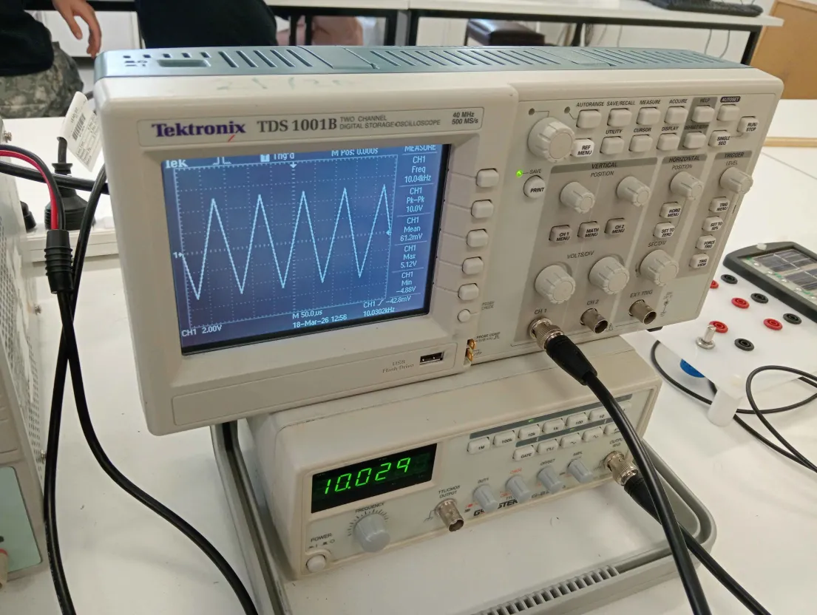

> Measure the rise time of the signal (defined as the time taken to increase
from 10% to 90% of the final voltage)
Measured on our oscilloscope are the max, min and pk-pk of the square wave
min was -5.36V, max was 5.44V, pk-pk was 10.5 (with some unmeasured uncertainty)
The 10% amplitude = min + 0.1 * pk-pk = -5.36 + 10.5 * 0.1 = -4.31
The 90% amplitude = max - 0.1 * pk-pk = 5.44 - 10.5 * 0.1 = 4.39
Our measurement for time was 50ns. Or 5E-9 seconds

See image below. The Hz is set to 10023 on the radio transmitter, and depicted on the oscilloscope is the saw wave zoomed in, as well as the cursor on the two different areas of 90% and 10% amplitude
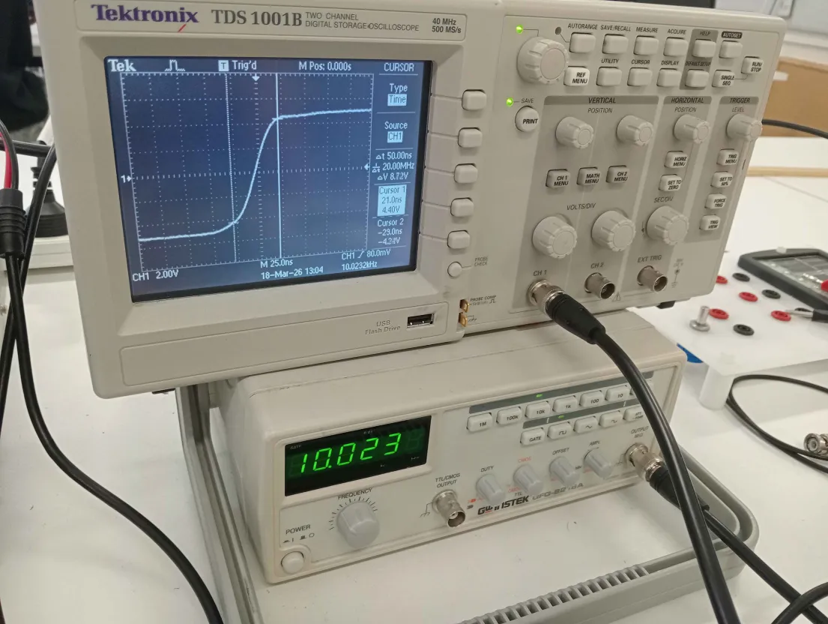

Part 2
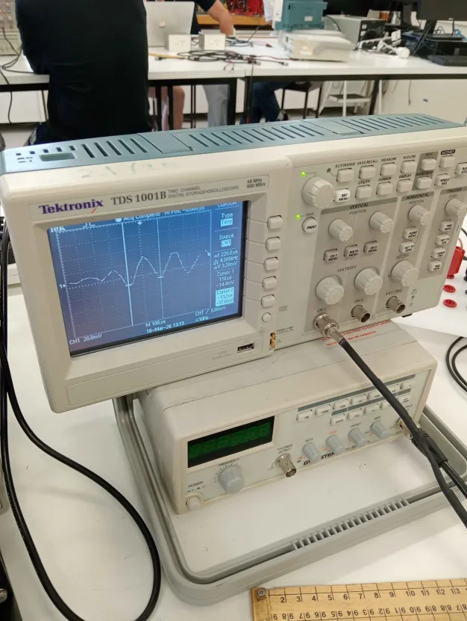
We measured the peaks/troughs of 5 different places in our clap
We had the measurements (in kHz): 4.4, 4.9, 4.5, 4.3, 5.1. Which averages to 4.64 kHz, which is in the realm of expectation for what a clap should be like

> Determine the speed at which the fan
rotates (in revolutions per second).
Oscilloscope measured a frequency of about 252hz, the fan had 5 blades, so divide the frequency by 5, and we get around 50.4. Using cursor the distance between each trough was around 3.9ms, which means each blade took ~ 19.5 ms to spin, which 1/19.5ms = ~ 51hz. So its in the realm of 50hz. Checking the sample rate, which is about 500 million times per second, the error is super negligible. But another source of error is air, air density and the direction at any time may affect the rate at which the dc motor fan can spin.
(no photos this time)
> Examine the light output from fluorescent lights. Is the light intensity (voltage) constant? If not, what is its frequency and can you explain the measured frequency?
Just plugging it in, all in all the frequency is measured ot be almost exactly 100hz. The voltage remains quite constant as well. If I put my hand over the cell, the voltage fluctuates, but the frequency harldy does the same.
The frequency being 100 is likely due to the fact that the light being absorbed are the building lights, which have an ac voltage flowing through them, which fluctuates at ~ 50hz. Since the lights reach zero twice, per cycle, and zero to zero is the size of our wavelength on the photovoltaic cell, it makes sense that our frequency is twice as big.
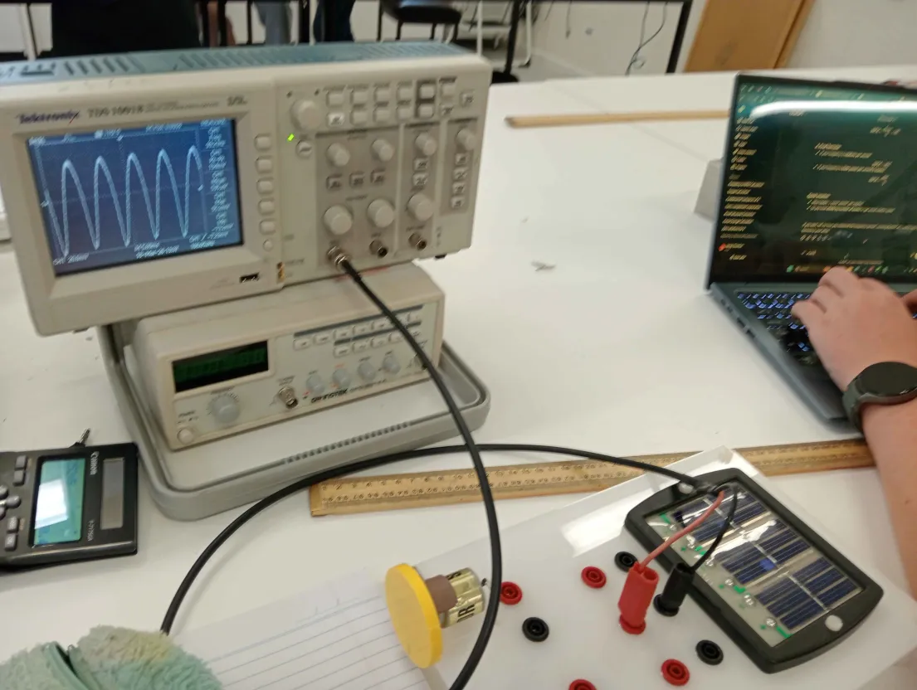
Image of photovoltaic cell being plugged into to oscilloscope.
> Does your measured value agree with the accepted value (343 m/s)?
Our experiment consisted of two microphones, each placed ~ 1 meter away from eachother, one of us clapped on one side of the microphone, and the microphone would receive that instantly, whilst the other microphone would receive it some time later. We would measure around the time difference between the start of the claps between each microphone. This time was the amount of time it takes for the sound to pass one meter. So the measured speed of sound would be 1/deltaT. The oscillator already has a built in measurement for 1/deltaT on cursor, which is around 335hz, which means that the measured speed of sound ~ 335 ms-1
In fact our measurement could even be more accurate than the actual speed of sound value of 343, since it fluctuates everywhere, maybe the speed of sound is 335 in our area. Although not likely, and a great deal of uncertainty has to be taken into consideration.

Extension

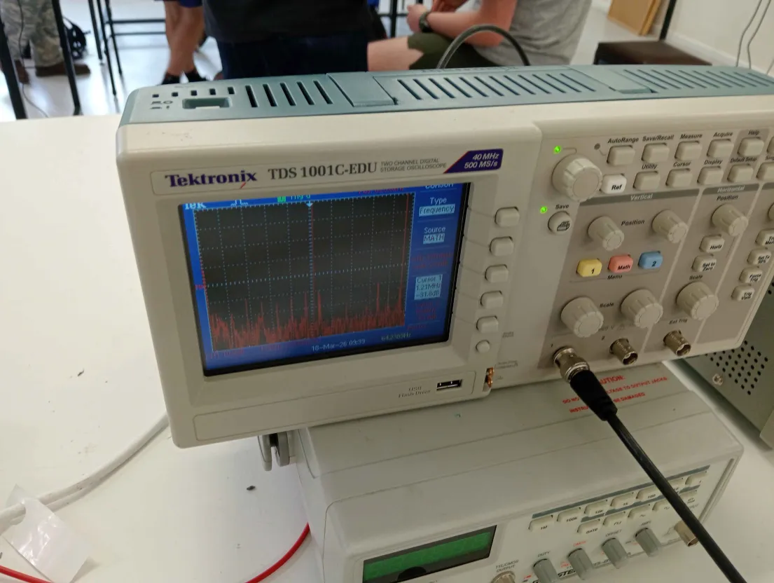
Depicted is a photo of all the steps done on an oscilloscope.
Measured Peaks (kHz) | 670 | 845 | 1050 | 1130 | 1210
These closely enough align with the australian radio am radio frequencies, of course taken manually with the cursor, they are not very accurate at all.

