Top-Down camera video recording procedures ROOM 312A.

# Preliminaries

* Make sure cameras and Intan system are plugged in and that there is a headstage plugged into the Intan system.

# INTAN PC:

1. Start Intan, load the correct settings, start acquisition (NOT RECORDING), and view the digital in input. This will allow you to verify that the proper TTL signals from the cameras and feeder are being registered by the INTAN system.

# Top Cam PC:

1. On CAM PC: Start StreamPix 8 Lite and choose the AVT Vimba config. This is paid for software so there has to be a license on the computer you are using (e.g., if you use this on another computer, it will not work). IT’s not too bad – around $450. There may be something out there for free, but I have not found anything better.
2. Read the manual and experiment. Get to know this software and the code. When you start up, you should see something like this…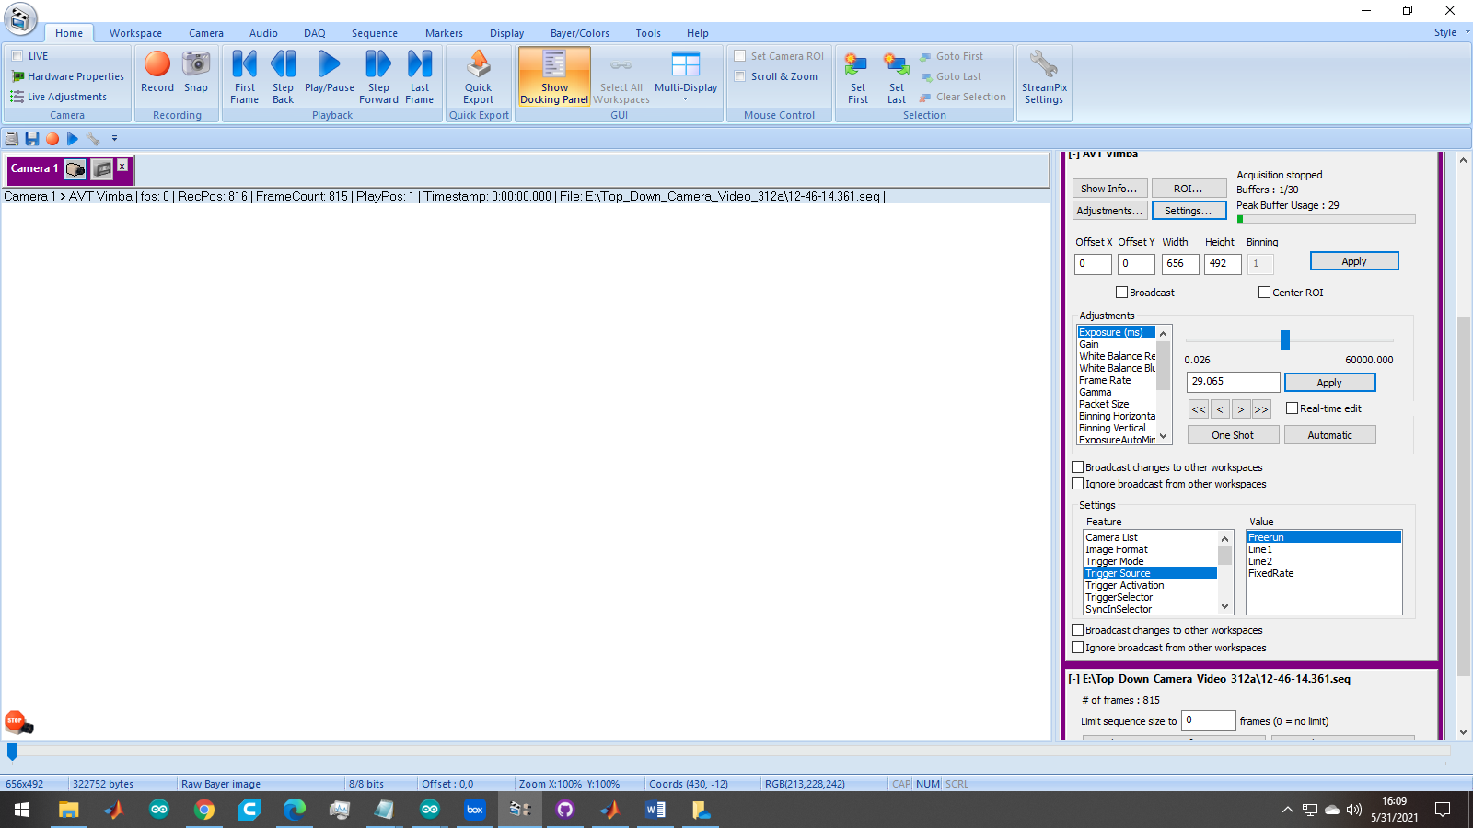  
   If the camera is connected, and you hit, Live (upper left) then you should see the video.  
   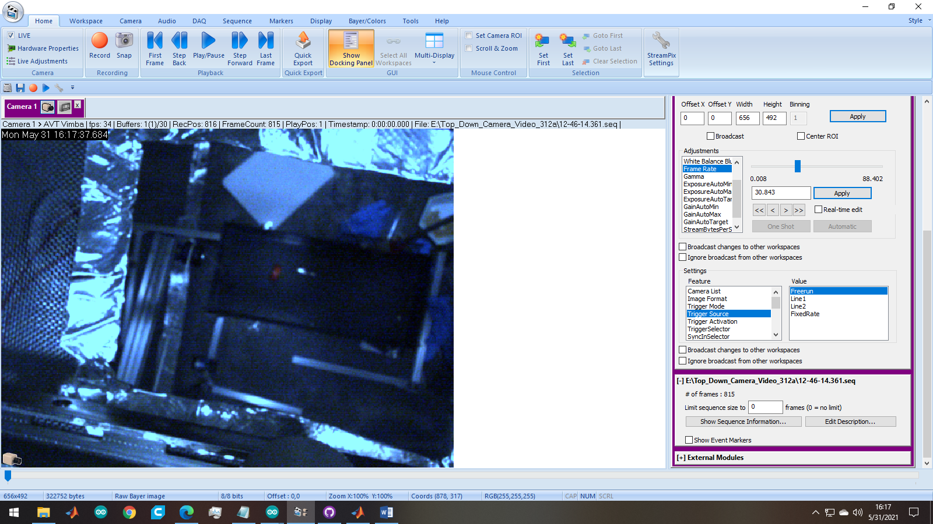
3. Ensure the save directory is correct. This is convoluted. You need to go to the little icon in the upper right (StreamPix settings) and then to workspace.
   1. Make sure the working folder is correct (see below)
   2. Make sure the AVI is set to NorPix h264 encoder (or no compression).  
      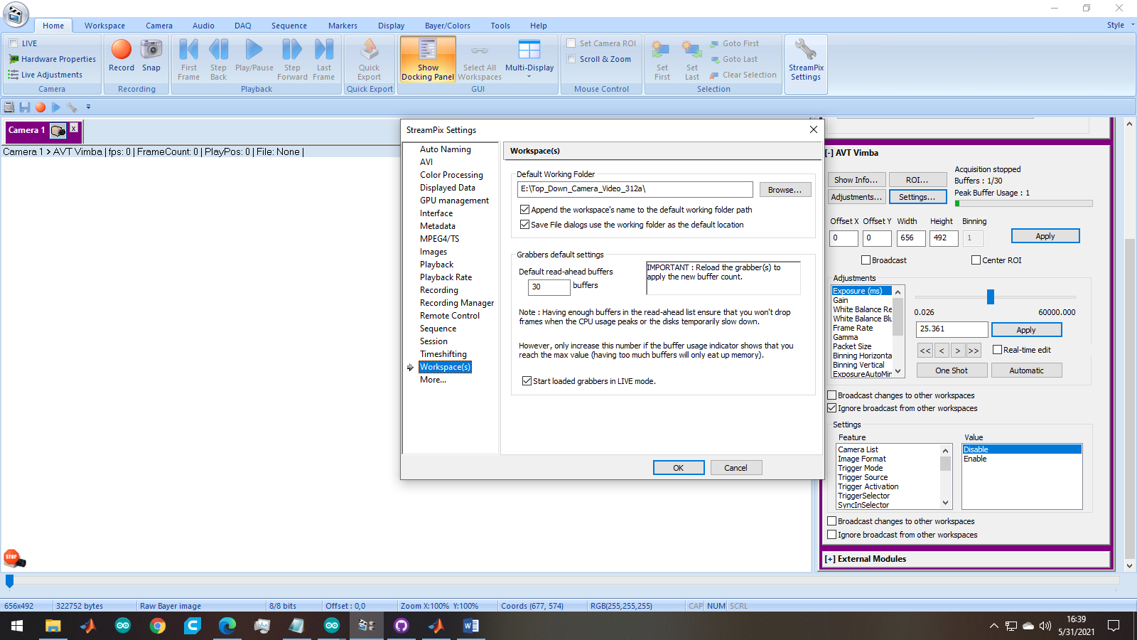
4. Ensure adjustments and settings (on right panel – there is a separate pane for adjustments and settings) are correct (these need to be fine tuned):
   1. Adjustments
      1. Exposure: 29.065
      2. Gain: 27.000
      3. ROI: 0 0 656 492
   2. Settings
      1. Trigger Mode: On
      2. Trigger Source: Free Run
      3. Image Format: BayerRG8
      4. Sync Out Source: Exposing
5. Check the frame rate. It needs to be >= 30 fps. If not, something should be adjusted.
6. DO NOT HIT RECORD FOR ANY OF THIS – ONLY ONCE INTAN IS RECORDING.
7. Check to be sure the color of the red LED or red mark is very clear.
8. Look back at the INTAN system. Look at Dig In for input 10. You should see TTLs coming in. If you adjust the frame rate on the camera computer, then these TTL should change accordingly. Feel free to test this. For TTLs to come in, you need to have LIVE clicked in NorPix. If you unclick, the TTLs will go away.
9. Once you are all satisfied that things are set up correctly, UNCLICK LIVE AND GO BACK TO INTAN.
10. When everything on the Intan system and other devices (e.g., the front camera) are ready to go, then start recoding on the intan system.
11. Go back to the top down camera system.
12. Hit Record. (nothing should appear on the screen or on the Intan).
13. Hit Live (now the pulses should appear and the video should appear on the screen.
14. WHEN DONE AND BEFORE YOU STOP RECORDING ON THE INTAN SYSTEM: Stop record on the video acquisition system. Check the file – make sure it was saved.
15. Back up data and put in same folder as INTAN data.