DATE: 5/27/2022
Abhi, Nathan, Andrea

These are my (cowen) post-hoc notes based on scanning the files.

DANA LV experiment using different LV values. Neuropixels in ventral striatum with tip at -7mmDV
Stimulation electrode in the MFB
FSCV in ventral striatum (coordinates?)

A csv file in this folder should have the depth and channels.

Digital input into analog input of Neuropixels:
channel 0: 1 sec sync pulse
channel 3: FSCV scan pulse.
Channel 4: scan trial start (when the FSCV is actually recorded on WCCV)
channel 5: the MFB stimulation times.

BAD CHANNELS: 285 – should be zeroed out.

Artifact from FSCV very clear on all single-unit channels. Will need to make sure this gets blanked out on the pre-processing stage. It’s about .2mv biphasic on the .ap.bin file.

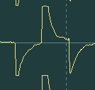
The MFB stim artifact is about +/- 1mv and it’s pretty much on all channels. This will have to be blanked out as well to avoid contamination of spike sorting. It’s about 6ms in duration at peak but clearly lasts longer as seen on right.

Good news is that the digital sync pulse seems to be working. In theory, all ditital in might work – this would save some space and post processing time and free up some more analog input channels.

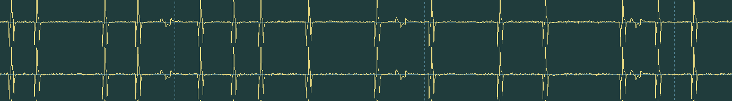
The smaller blips above are the FSCV scan artifact.

NOTE: from now on, we should save the runit.bat file for CatGT in the data directory for archiving purposes.- but sadly, the code won’t run in this folder as it expects to be run in the folder with CatGT.exe.

