**UML Use Case Model**

Use Case Diagram

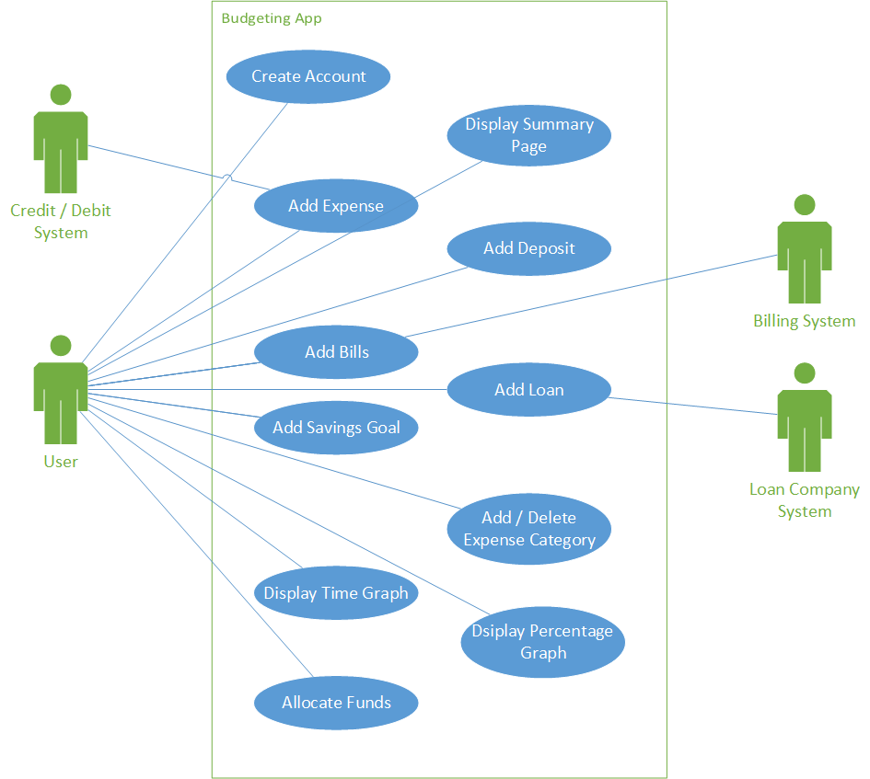

Use Case 1: Create Account

**Scope:** Budgeting Application

**Level:** user goal

**Primary Actor:** User

**Stakeholders and Interests:**

* User: Wants to create an account for initial use of the application.

**Preconditions:** User has opened the application or gone to the web URL.

**Success Guarantee:** User account is saved and user may begin utilizing other features of the software.

**Basic Flow:**

1. User presses “Create Account” button.
2. On the following page, user fills out the form with name, email, and desired password.
3. System checks to see if email has not already been used.
4. Account has been created and saved, and user is taken to Summary Page.

**Alternative Flow:**

1. User presses “Create Account” button.
2. On the following page, user fills out the form with name, email, and desired password.
3. System finds that the given email has already been used.
4. User is notified that the email entered is already in use, and to enter a different one.
5. User enters a new email.
6. System checks and verifies it has not been used.
7. Account has been created and saved, and user is taken to Summary Page.

**Frequency of Occurrence:** Once per user

Use Case 2: Add Expense

**Scope:** Budgeting Application

**Level:** user goal

**Primary Actor:** User

**Stakeholders and Interests:**

* User: wants to accurately and conveniently record any expense made.

**Preconditions:** User is logged in to the application.

**Success Guarantee:** Expense has been recorded and accurately deducted from account total and category total, and these values are updated to reflect the change.

**Basic Flow:**

1. User presses “Add Expense” button from the Summary Page.
2. User enters price and chooses category from a drop-down list.
3. Once user hits “OK,” they are taken back to the summary page with totals updated.

**Frequency of Occurrence:** Varies.

Use Case 3: Add Deposit

**Scope:** Budgeting Application

**Level:** user goal

**Primary Actor:** User

**Stakeholders and Interests:**

* User: wants to accurately and conveniently record any deposit made.

**Preconditions:** User is logged in to the application.

**Success Guarantee:** Deposit has been recorded and totals have been updated accurately.

**Basic Flow:**

1. User presses “Add Deposit” button from the Summary Page.
2. User enters total value of the deposit and hits “OK.”
3. Summary Page is loaded with updated totals.

**Frequency of Occurrence:** Varies, typically once a week or less often.

**Display Summary Page:** This is the “home page” for the application. It shows most relevant information such as account total and due dates for any payments entered. It also displays options for actions the user can take, such as adding expenses, deposits, loans, bills, etc.

**Add Bills:**  Here the user can input an expense that occurs every month, such as cable, cell phone, and electricity bills. The user can also link to an online account with any of these billing companies to more accurately display the cost of the upcoming bill(s).

**Add Loan:** The user enters a loan amount and the interest rate. If the user already knows how much to pay per month, they can enter the amount in as well. If it is not a fixed amount, the user can enter the number of months/ years in which they would like to complete the loan, and the system will calculate the monthly payment automatically. The user may also link their account to an external system to add the loan information for them.

**Add Savings Goal:** Similar to Add Loan, the user can input the amount they wish to save, and either the amount of time to reach that goal, or an amount (fixed or percentage) of future deposits that they wish to place into the savings goal.

**Add / Delete Expense Category:** This is where the user can edit names, add, or delete categories from which to deduct expenses or allocate funds.

**Allocate Funds:** Here, the user can choose to allocate part of a deposit, whether it be a flat amount or a percentage, to some or all of the expense categories. The user can also add/subtract funds already allocated to specific categories.

**Display Time Graph:** Graphical representation of the increase / decrease in funds over time. The user can choose the time span and organize by category, month, etc.

**Display Percentage Graph:** Graphical representation of the percentage of expenses from each category. This can also be edited to reflect different time periods.