Intra-network Multiplayer Scrabble® Application

User Manual For Application Usage

Ian Boyer

David Carr

Samuel Costa

Maximus Latkovski

Jy’el Mason

## 

## 1. Description

Scrabble® is a tiled board game in which at least two players compete to score the highest point total with lettered tiles on a 15x15 square board;these tiles are placed on the board to create English words outlined in the Scrabble® dictionary. Players draw seven tiles from a pool at the start and replenish their supply after each turn. The application will host up to four online players and simulate a game of Scrabble®, adapting the traditional rules to a virtual setting where possible. Users can customize game settings before starting, providing a more tailored experience.

If you are new to Scrabble®, please see Hasbro’s [Scrabble Guide](https://www.hasbro.com/common/instruct/Scrabble_(2003).pdf). Note that some rules may differ from this application’s implementation.

## 2. Game: How to Play. Rules Being Used

| **Game Terms** | |
| --- | --- |
| **Term** | **Definition** |
| Board | A 15 by 15 cell interface upon which Scrabble® tiles are placed |
| Tile | A square containing both letter and letter value |
| Tile Bag | The data structure that holds the letters that the players will play during the game |
| Rack | The tiles a player may use to make plays on their given turn. These tiles are drawn from the tile bag and will number 7 in total in a traditional Scrabble® game. |
| Cell | A spot on the playable board |
| Modifier Cells | Specific squares on the board that increase points made when words are placed on them |
| DL/Double Letter Cell | A light blue-colored cell which doubles the value of any tile placed on it |
| TL/Triple Letter | A navy blue-colored cell which triples the value of any tile placed on it |
| DW/Double Word | A pink-colored cell that doubles the value of any word on the first turn and has a tile placed on it |
| TW/Triple Word | A red-colored cell that doubles the value of any word on the first turn and has a tile placed on it |
| Letter | The character centered on the tile |
| Turn | A turn is a set period during which a player may pass, exchange either one of or all their tiles, or play tiles on the board |
| Letter Value | The numeric value on the bottom right corner of a tile |
| Word Value | The total value of a word. The individual tile scores calculate this score (see 4.5.2.5 for more details), with any modifier cells triggered on a turn. |
| Bingo | When a player uses all tiles on their rack |
| Turn Score | The total amount of points a player scores in each turn. This score consists of all word values, plus a 50-point bonus if a bingo is earned |
| Player Score | A player’s score is the cumulative points earned throughout their turns |
| Blitz Mode | A game of Scrabble® which has a lower timer countdown preset |

## 3. System Requirements

The Scrabble Application will run on Windows and is built on and requires Java SE 16, the game will require an internet connection with a minimum speed of 30 kbps.

(Java 16, headless exception can't be thrown).

## 4. How to Start a Game.

The Main Menu consists of 3 buttons: Host, Join, and 2 check buttons for the audio. The 2 aforementioned audio check buttons control the in-house game music and audio cues. The host button will direct a player to the host screen where the host will set the rules for the game, while the join button will direct you to the join screen where you will connect to the host and lastly the exit button simply exits and terminates the application.

## 

### 4.1 How to Host a Game

After you press the host button, you will be redirected to the host screen. Here you will be able to see your IP address and port, a list of the players that joined your session and are waiting for the game to start, customization options for the match, and the host button. Your IP address and port are essential if you want other people to join your game, make sure you share it with your friends that want to join your game!

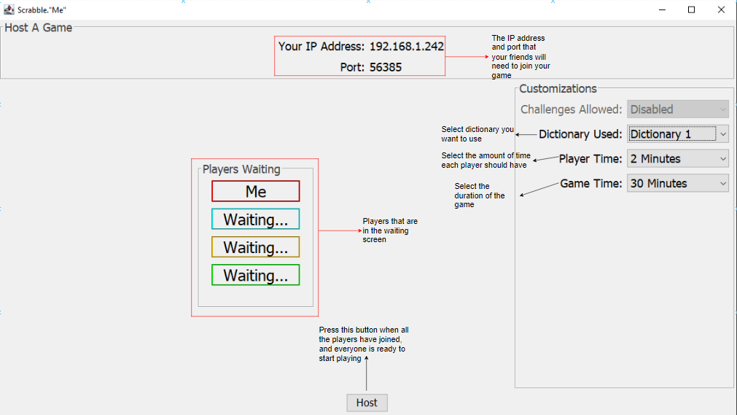

### 4.2 How to Connect to a Host

If you want to join a game hosted by one of your friends, press the “Join” button on the main menu. That will redirect you to the join screen. Here you will enter your name and the host IP and port number. The player hosting the game will have the IP and port on his screen. After you enter all the information needed, press the join button. That will redirect you to the waiting screen where you can wait for the game to start. The game begins when the host presses the host button.

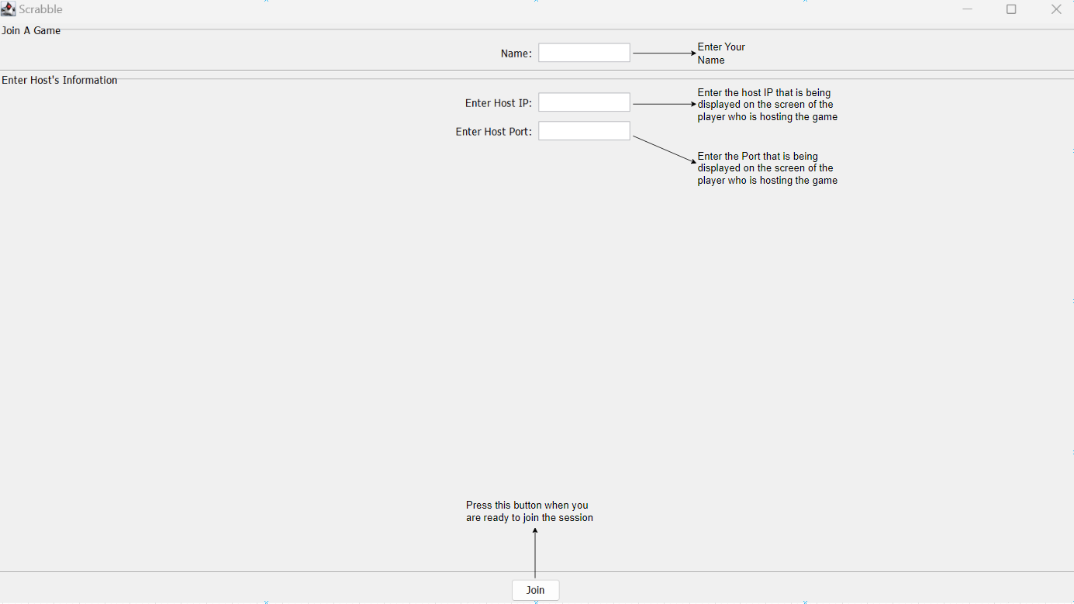

## 5. How to Play

When starting a game a player is first introduced to the rules set by the host and if any additional modes have been selected. Furthermore, a link at the bottom will direct a user to this manual. Rules, with sound settings, can be accessed via the game button in the top left of the application. Once the game starts, there can be up to four corners containing player information while the bottom area contains the rack of the user with buttons containing different actions a player can make. The first button displayed is the submit button which is used to submit a word if the word does not exist in the dictionary the letters will be placed back in their original spots on the rack, and the exchange tiles button will allow a player to exchange either one or all tiles on their rack, while pass turn will allow a player to skip their turn.

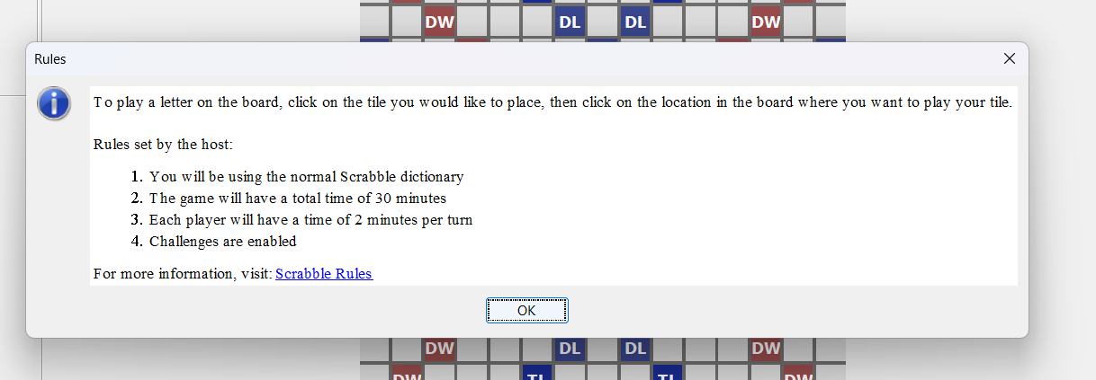

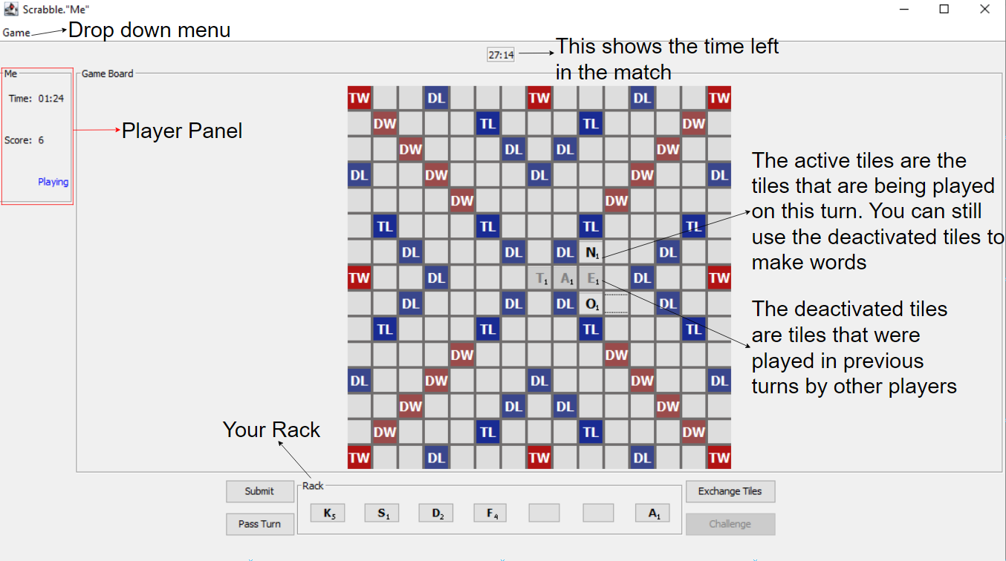

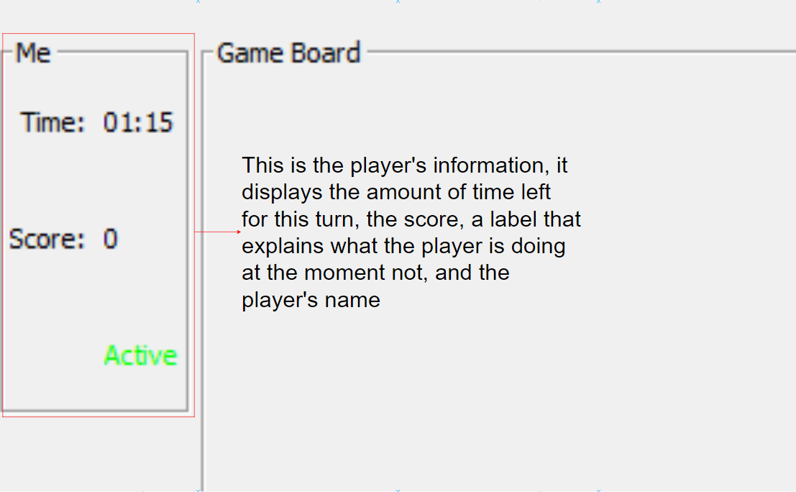 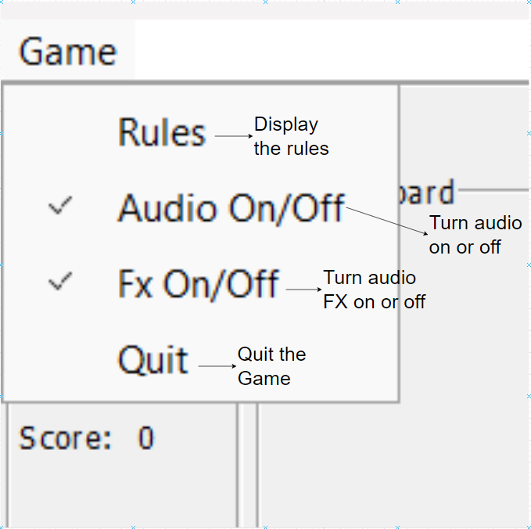

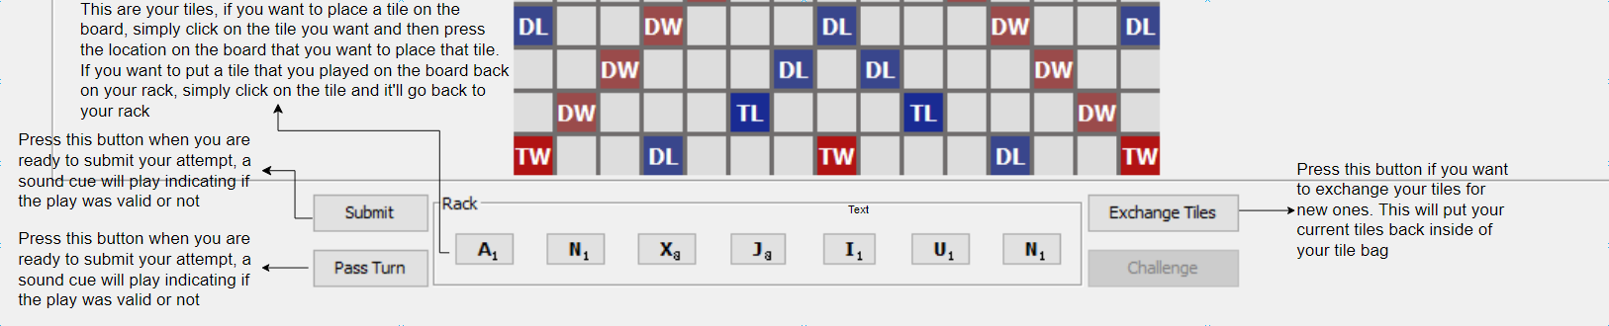

### 

### 6. Ending the Game

There are three ways to end the game: the first is by exhausting both the tile bag and a player's rack, the second is if all players pass their turn once(?), and lastly, if the game timer hits zero. This will then redirect players to the leaderboard screen displaying the players in descending order of score.

### Addendum: Unimplemented Planned Features

Challenge Mode - Enabling this feature will allow players to make word plays, which other players must then challenge to remove from the game board.

Dictionaries - Options to switch between dictionaries given by the official Scrabble® dictionaries (i.e. OSW). It only uses the Fourth edition of the Official Scrabble® Players Dictionary (OSPD).

Screen Transitions - Including Fade-in and Fade-out transitions between screens for a smoother user experience.

### Alpha and Beta Testing

For alpha testing, as we developed the program, we ran the project with various logging outputs to check its internal logic.

For beta testing, we had our family and friends try out an early version of the application and fill out Google forms and we used the feedback to improve our program.