**EEL 4930/5934**

**Introduction to Biomedical Image Analysis**

**Assignment – 12**

**Due: 04/23/2024, Noon**

**Image analysis use-case: Analyzing results of fluorescent microscopy experiment**

For this assignment, you’ll be given a set of glomerulus images from mice stained with a specific marker for podocytes, a terminally-differentiated glomerular cell that plays a crucial role in facilitating the filtration of blood. One group of mice are Tg26 transgenic, which mimics HIV-associated nephropathy, while the other group is a control.

**Part I.** **Podocyte Segmentation:**

Use any of the image analysis methods you have learned in this course to isolate the dark-brown stained podocytes in each image (see below). Include 3 examples below (separate figures is fine) **(5 pts)**

* Hint: Use the *dir()* command on the folder of glomerulus images to get a list of file names to iterate over. Then you can either create a function for segmenting podocytes from a given image or write out all the steps within a for-loop.

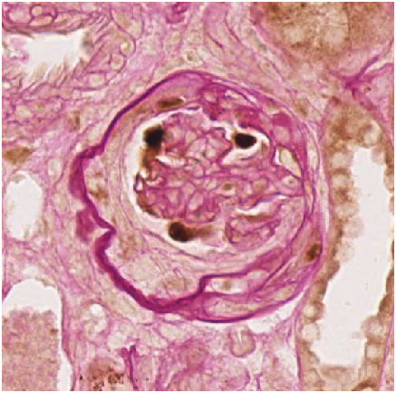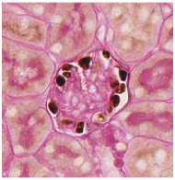

Podocytes

**Part II. Simple Feature Extraction:**

After extracting binary masks for podocytes, we now want to calculate some quantitative values in order to compare glomeruli from each group.

1. Use the *regionprops()* command to calculate the following features for each podocyte in each image. **(3 pts.)**
   1. Area, Circularity, Solidity, and Perimeter
2. Generate a table with median, minimum, and maximum values for each feature for each glomerulus along with number of podocytes in each image. Make sure to keep track of the name of each glomerulus. **(2 pts.)**
   1. Hint: You’ll want to first initialize an empty table with column names (‘*VariableNames*’) set to your final aggregated feature names. Then, iterate through your list of glomerular image file names and generate podocyte segmentations. Then extract features for all podocytes, you can use the following syntax to output quantitative features in a table format: *regionprops(‘table’, podocyte_mask, ‘Area’, ‘Circularity’, ‘Solidity’, ‘Perimeter’).* Then, get the number of podocytes used to calculate those features (‘*height()’*) and summary statistics of that table (*‘summary()’*). Then add those values to a row and concatenate that with your initial table (*‘total_feature_table = [total_feature_table; new_table];’)*.

**Part III. Visualization and Conclusions:**

The last part of this assignment will consist of using these extracted features to generate figures and answer questions about your dataset. Of course, this dataset is very limited in the total number of glomeruli and number of features but it’s good practice for a real-world problem.

1. Use the provided labels (‘Glomeruli_Labels.csv’) to assign a label of either ‘Control’ or ‘Tg26’ to each row of your feature matrix. **(2 pts.)**
   1. Hint: You can use *readtable(‘path/to/Glomeruli_Labels.csv’, ‘Delimiter’, ’,’)* to read the labels file and then *innerjoin()* to combine the two tables.
2. Generate boxplots for each extracted feature (*boxplot(total_feature_table.Feature, Label))* **(2 pts.)**
3. Which feature seems to present the biggest difference between the two provided groups? Any guesses as to why that is? **(1 pts.)**