**EEL 4930/5934**

**Introduction to Biomedical Image Analysis**

**Assignment – 2**

**Due: 01/30/2024, Noon**

1. a.) Identify the binary image(s) from the images below (1 pt.).

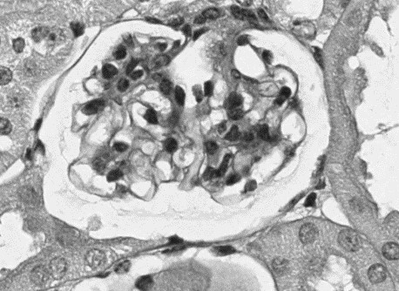 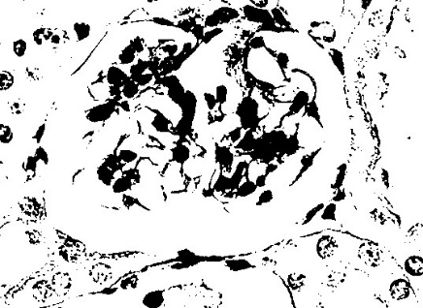

1. Use the built-in MATLAB commands *im2bw()* and *imbinarize()* on the non-binarized image and include their outputs. Choose a value between 0 and 1 as a threshold for *im2bw()*

(1 pt.).

1. How are these binarization methods impacted by changes in starting image intensity? Test out both commands on the darker (“Dimmer.png”) and lighter (“Brighter.png”) images below and include their outputs. (2 pts.)

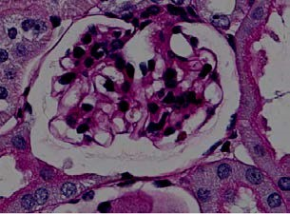 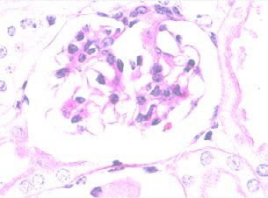

1. Describe a scenario where each command is preferred to the other. (1 pt.)

# Total: 5 points

2. a.) For the following intensity images, derive the corresponding binary images using threshold 128. Replace the ‘#’.

Image 1:

|  |  |  |  |  |  |
| --- | --- | --- | --- | --- | --- |
| $$\left[\begin{matrix}255 & 127 & 0 \\ 120 & 200 & 234 \\ 40 & 160 & 134\end{matrix}\right]→ \left[\begin{matrix}1 & 0 & 0 \\ 0 & 1 & 1 \\ 0 & 1 & 1\end{matrix}\right]$$ Image 2: |  |  |  |  |  |
|  |  |  |  |  |  |

$$\left[\begin{matrix}155 & 17 & 0 \\ 125 & 20 & 34 \\ 140 & 11 & 160\end{matrix}\right]→ \left[\begin{matrix}\# & \# & \# \\ \# & \# & \# \\ \# & \# & \#\end{matrix}\right]$$

b.) Given Image 3 below, if Image 1 corresponds to R, Image 2 corresponds to G, and Image 3 corresponds to B, use the following formula and derive the matrix representation of the RGB image composed of Images 1, 2 and 3. Use MATLAB and provide code.

|  |  |  |
| --- | --- | --- |
| Image 3: |  | RGB Formula: |
| $\left[\begin{matrix}175 & 17 & 0 \\ 130 & 5 & 34 \\ 140 & 11 & 200\end{matrix}\right]$ Final RGB Image: |  | $RGB=\frac{R+G+B}{3}$ $$RGB= \left[\begin{matrix}\# & \# & \# \\ \# & \# & \# \\ \# & \# & \#\end{matrix}\right]$$ |

# Total: 5 points

3. a.) For the following image A, use MATLAB to: (i) read the image (“K6T.jpg”), (ii) form a grayscale intensity image, (iii) binarize the image by selecting a threshold using grayscale intensity data, and (iv) form a binary image with nuclei in the foreground (white) and all other structures in the background (black). How many nuclei are in your final image?

**Image A**

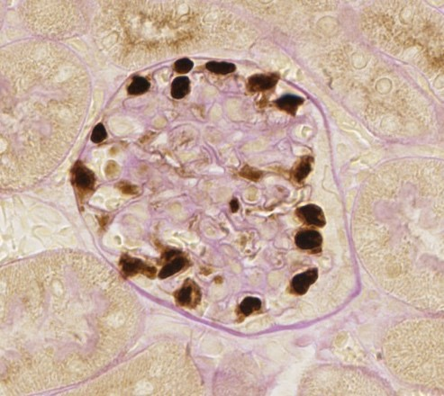

b.) Given the sequence of images below, identify the image artifacts in image D and propose how you would remove them to achieve image E.

# Total : 15 points Image A Image B

**Image C**

**Image D**

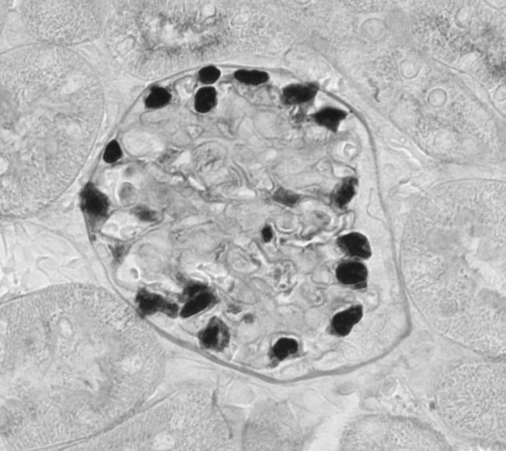

# Image E Image F

