**EEL 4930/5934**

**Introduction to Biomedical Image Analysis**

**Assignment – 8**

**Due: 04/02/2024, Noon**

**Segmentation Performance Quantification**

In last week’s lecture, we talked about different metrics used to quantify segmentation performance compared to ground-truth annotations. For this assignment, you will try to segment the cells from two different imaging modalities, DIC (Differential Interference Contrast) and fluorescence.

**DIC Fluorescence**

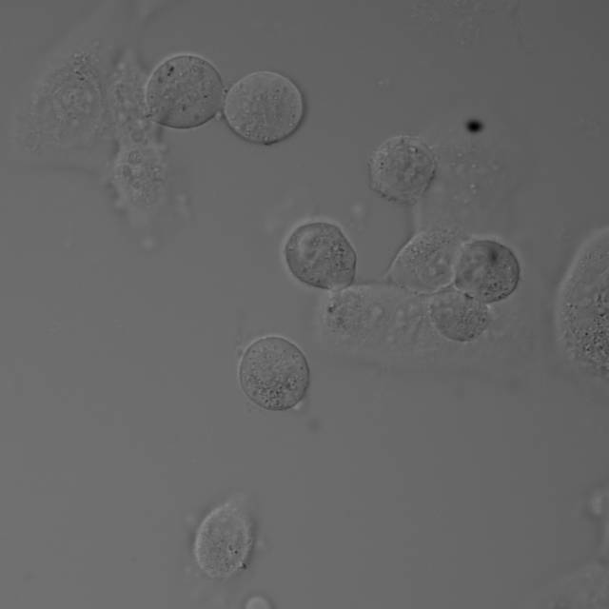 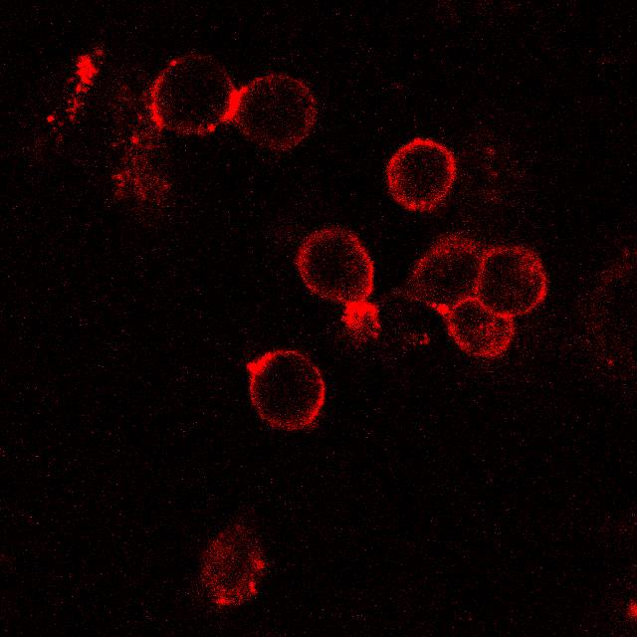

1. Segment cells from both of these images. Output should be two binary masks (one for each imaging modality). **(10 pts X 2 = 20 pts)**
2. Now we will compare the segmentations to the provided ground truth (*SS-ANT_GT.jpg*). For each of the two binary masks generated in question 1, generate the F1 score, precision, recall, and specificity. **(2 pts X 2 images X 4 metrics = 16 pts)**
$F1 score= \frac{True Positives}{True Positives+\frac{1}{2}(False Positives+False Negatives)}$

$Precision= \frac{True Positives}{True Positives+False Positives}$

$Recall= \frac{True Positives}{True Positives+False Negatives}$

$Specificity= \frac{True Negatives}{True Negatives+False Positives}$

3. Describe the segmentation performance for each one of these images. What do the metrics generated in question 2 tell you about your segmentation quality? Which imaging modality resulted in a better/easier segmentation? **(4 pts)**