**EEL 4930/5934**

**Introduction to Biomedical Image Analysis**

**Exam 1**

**Joseph Cox**

**Instructions:**  This exam will consist of two parts. The first part will consist of theoretical questions based on material covered in lecture while the second part will test how you can apply techniques learned in lab. The last question in the exam will be a difficult segmentation task with 10 possible bonus points. Total points available = 30pts Theoretical Questions + 30 pts Segmentation Challenges + 10 Bonus points = 60 pts + 10 pts Bonus.

**Theoretical Question 1:**

Name two possible sources of noise and/ or aberration in microscopy: (2.5 pts each) (5 pts Total)

1. Photon Shot Noise – noise from the fluctuation/randomness of discrete photon particles hitting the detector. This has much more of an effect on weaker optical signals where this randomness will account for a more substantial part of the signal.
2. Lens imperfection – small imperfections in the lenses in a microscope, their allignment, or crystal defects can cause differences in the refracitve index or focal distance that differ from the theoretical values, causing aberration.

**Theoretical Question 2:**

Given a filter kernel containing all 1’s, what is the influence of increasing the size of the filter from 3x3 to 10x10? Support your answer with images and/or equations. (Hint: For a generic image, type: I = imread(‘peppers.png’); in Matlab). (10 pts)

A filter of all 1’s can be thought of as a scaled version of an average filter. That is, a 3x3 average filter is comprised of all 1/9’s and a 10x10 average filter is comprised of all 1/100’s. Increasing the size of the average filter will result in a much greater image smoothing effect across the image and more blurring. The larger filter may lose some of the finer details present in the image, and if no padding is used, the larger filter will produce a smaller resulting image.

The example image below of my cat Ms. Burger shows the effects of both filters, which were normalized by dividing by the number of elements in each filter to make them an average filter. Without this normalization, the images’ pixels become scaled too high and they become mostly white.

**Theoretical Question 3:**

Binarize the following image matrices using a threshold value of 70. (5 pts each) (15 pts Total)

(A)

For each of the tasks below, (i) complete the image segmentation challenge within the limits defined by the task, (ii) produce a well-annotated, original MATLAB script (.m file) to be turned in along with your midterm, (iii) save the segmentation result and paste your result into the “Results” box. Exams without an original MATLAB script will receive a score of **zero**.

**Segmentation Challenge 1:**

Below is an image of an embryonic Zebrafish eye captured via confocal micrscopy. DNA editing technology CRISPR/Cas9 was used to insert a reporter gene (red fluorescence) to study the the lens of the eye as well as cells called neuromasts (red dots/speckles).

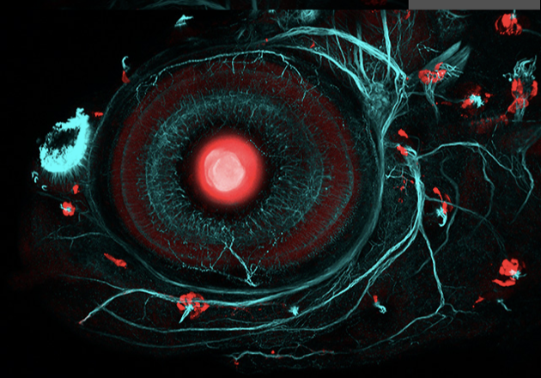

**Task:** Segment the lens (red, central dot)

**Max points:** 10

**Segmentation Challenge 2:**

Below is an image of Fluorescent bacteria (*Bacillus subtilis*) under confocal microscopy.

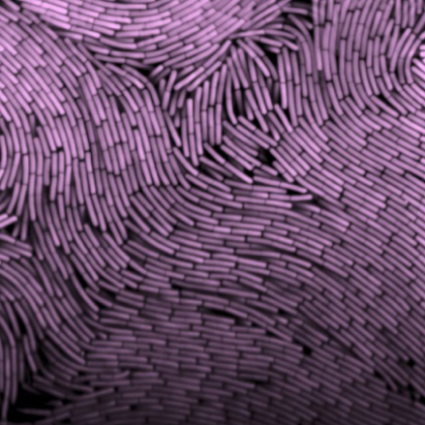

**Task:** Derive accurate boundaries for each cell individually.

**Hint(s):** Correcting this image’s non-uniform contrast will increase ease of segmentation.

**Max points:** 20

**Bonus Segmentation Challenge:**

Below is a super-resolution image of human respiratory epithelium captured via electron microscopy.

**Task:** Segment the nuclei from the respiratory epithelial cells. Example nuclei marked by “C” and “Cl.”

**Max points:** 10 Bonus Points