SWE 573 Software Development Practice, Fall 2012
Instructor: M. Ufuk Çağlayan

Project 2
RWPA-Phase 2
Reader-Writer Process Application
Phase 2
Design Specifications Document

Revision 2.0
19.11.2012

By: Mustafa Göksu GÜRKAŞ
Student Id: 2011719225

Revision History

Revision | Date | Explanation
1.0 | 15.10.2012 | Initial high level design
1.1 | 05.11.2012 | Sections 2.2, 3.1.1, 3.1.2, 3.2.1.1, 3.2.2.1 and 3.3.1.1 have been updated as suggested by the client.  Section 3.3.2 and 3.3.3 have been added.
2.0 | 19.11.2012 | Section 3 – Detailed Design has been updated as suggested by the client.

Table of Contents

Revision History 2
Table of Contents 3
Table of Figures 4
1. Introduction 5
2. System Design 5
2.1. Software Architecture 5
2.2. Software System Components 5
2.3. Environment 6
3. Detailed Design 7
3.1. Main Module/Class 7
3.1.1. Program Class 7
3.1.2. Activity Diagram 7
3.2. Other Modules/Classes 8
3.2.1. ReaderProcess Class 8
3.2.1.1. Activity Diagram 10
3.2.2. WriterProcess Class 11
3.2.2.1. Activity Diagram 12
3.3. Common Infrastructure Modules/Classes 13
3.3.1. Logger Class 13
3.3.1.1. Activity Diagram 13
3.3.2. LogRecord Class 14
3.3.3. ConfigurationRecord Class 14
3.3.4. DataRecord Class 15
3.3.5. Data File and Record Format 16
4. Testing Design 16
5. References 16

Table of Figures

Figure 1. Overall Package and Classes 5
Figure 2. Class Diagram 6
Figure 3. Program Class 7
Figure 4. Activity Diagram for Program Object 8
Figure 5. ReaderProcess Class 8
Figure 6. Activity Diagram for ReaderProcess Object 10
Figure 7. WriterProcess Class 11
Figure 8. Activity Diagram for WriterProcess Object 12
Figure 9. Logger Class 13
Figure 10. Activity Diagram for Logger Object 13
Figure 11. LogRecord Class 14
Figure 12. ConfigurationRecord Class 14
Figure 13: DataRecord Class 15
Figure 14: Record Format 16

1. Introduction

The purpose of this software project is to design and develop a console application by using C# as the programming language and Windows operating system as the environment, to accomplish the following main tasks.

- The user should be able to execute a program that shall be able to create a file filled with records which shall be used by some reader and writer processes as input and output respectively,
- The main program shall be able to create a defined number of reader and writer processes to process the data file it created,
- The reader processes shall be able to pick a random record from the data file and decrypt the plain text message which exists as encrypted in the record by using the encrypted token and the key provided by a writer process,
- The writer processes shall be able to pick a random record from the data file, generate a random plain text message and generate an encryption key. Those processes shall be responsible to encypt the text message with the generated key and record that encrypted message with its encryption key to the data file in order to allow the reader processes to decrypt the message,
- The actions taken by all processes shall be traceable through a log file.

The design is based on RWPA-APP Requirements Specification Document, Revision 2.0, in file Gurkas-P2-RWPA-Ph2-RSD-2012-11-12-Rev-2.0.doc [1]. The design process used produce the design conforms to organizational specifications given in [2]. The notation used in this document to describe the design of RWPA Console Application is mainly UML and conforms to organizational specifications given in [3]. The ISO and TSE standards in [4], [5] and [6] are extensively used during the design.

The software architecture and overall high-level structure and components in terms of classes of RWPA Console Application are given in Section 2 and design details of all application functions and the user interface in terms of are methods of all classes are given in Section 3 of this document.

2. System Design

2.1. Software Architecture

The software to be developed shall have a multithreaded classical objects architecture model. Instead of creating new processes to handle reading and writing operations, threads will be preferred to accomplish those tasks considering the performance of the system.
Both processes and threads refer to a type of multitasking. Processes are an architectural construct where a thread is a coding construct. The main distinction is that processes have their own context (usually meaning data space), while threads have a shared context. The advantage of threads is that the CPU can switch from thread to thread without having to also change all the address context state, resulting far less usage of system resources than processes.

2.2. Software System Components

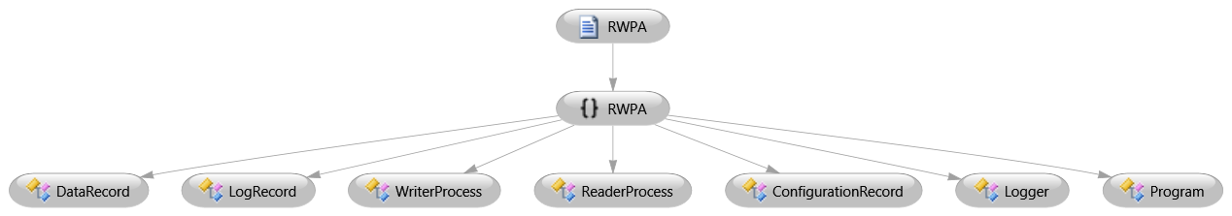

Figure 1. Overall Package and Classes

As depicted in figure 1, the system shall have only one package which is called RWPA. This package shall be composed of seven classes which are;
- Program class that contains the main program,
- ReaderProcess class which shall be responsible for reading records from data file,
- WriterProcess class which shall be responsible for writing records to data file,
- Logger class which shall undertake the logging operations of the system,
- LogRecord class which encapsulates a log record object to be written to log file,
- ConfigurationRecord class which encapsulates the parameters provided through the configuration file,
- DataRecord class which encapsulates the structure of a single record many of which reside within the data file.

The Program object shall load the configuration parameters to the application and creates a data file with initially nulled records. After that, it shall initiate a number of ReaderProcess and WriterProcess objects. All of those three objects shall use Logger class in order to keep the record of their own operations through a log file. The ReaderProcess and the WriterProcess objects shall use DataRecord object which represents a single record to be processed by processor objects. The data file shall be composed of several DataRecord objects which are initially set to null by the Program object. A representation of the interactions between the classes of the system is shown below.

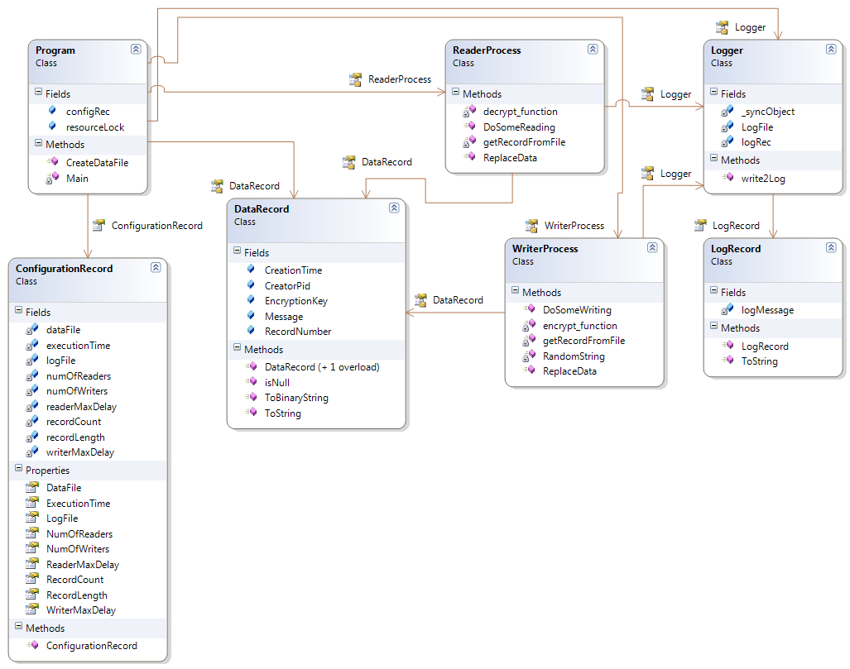
Figure 2. Class Diagram

2.3. Environment

The application shall be designed to execute on a 64-bit Windows 7 operating system with a Intel processor. The application shall be developed and tested by using Microsoft Visual Studio 2010 Ultimate (Version: 10.0.40219.1 SP1Rel). Programming language to implement the system shall be C#.

3. Detailed Design

3.1. Main Module/Class

3.1.1. Program Class

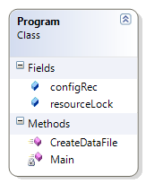
Figure 3. Program Class

Class Name: Program
Fields:
- Name: resourceLock
Type: ReaderWriterLock
Description: Static global lock object which is acquired and released by the reader/writer processes during their operations. ReaderWriterLock is used to synchronize access to a resource. At any given time, it allows either concurrent read access for multiple threads, or write access for a single thread.
- Name: configRec
Type: ConfigurationRecord
Description: A static object which encapsulates the parameters passed through configuration file.

Methods:
- Name: Main
Signature: static void Main(string[] args)
Description: Main entry point of the application. This method shall be responsible for directing the flow of loading configuration file, creation of data file with initial records and build up a number of reader/writer processes.
- Name: CreateDataFile
Signature: public static void CreateDataFile()
Description: This method creates a data file as named in the configuration file. This created file is then filled with records number of which is given through the configuration file. Initial records is composed of binary zeros length of which is decided upon the configuration file.

3.1.2. Activity Diagram

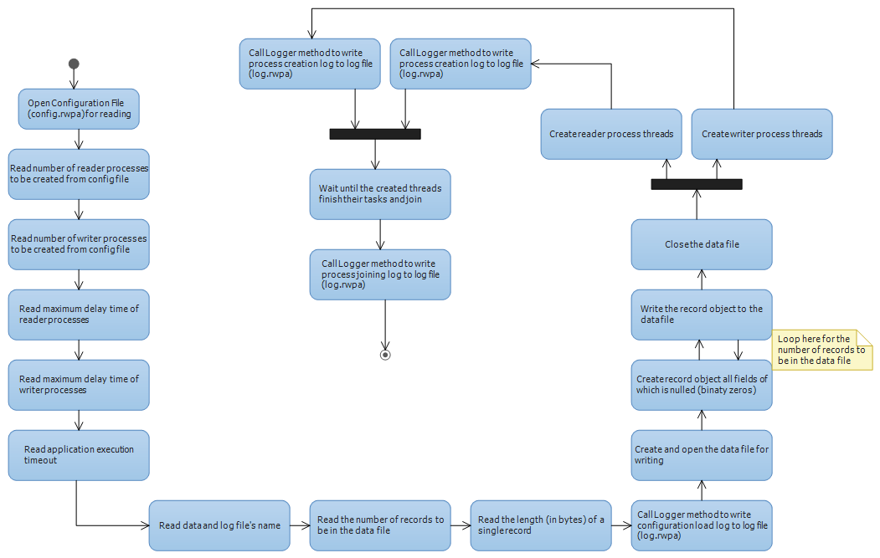
Figure 4. Activity Diagram for Program Object

3.2. Other Modules/Classes

3.2.1. ReaderProcess Class

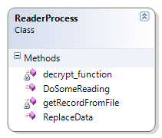

Figure 5. ReaderProcess Class

Class Name: ReaderProcess
Fields: None.
Methods:
- Name: DoSomeReading
Signature: public void DoSomeReading()
Description: This method controls the execution time of the thread by gathering system time on each of its loop. If execution time exceeds the one told in the configuration file, it makes thread join to the main process. On the other hand, on each loop, it suspends for a random delay, scans the records in the data file until it finds a non-null record. If a non-null record is found, the method decrypts the encrypted message that lies in the record, writes that value to the log file and nullifies the record are in the data file.

- Name: decrypt_function
Signature: private string decrypt_function(byte[] Cipher_Text, byte[] Key)
Description: This method decrypts the encrypted message (which is encrypted by using the key that is presented as the byte array Key) passed to it by byte array Cipher_Text. The plain text (string) obtained from this operation is returned as the decrypted message to the caller.
- Name: getRecordFromFile
Signature: private DataRecord getRecordFromFile(int recordNumber)
Description: This method seeks on the data file in order to position the file reader pointer to the beginning of the data record, number of which is given to the method through parameter recordNumber. It allocates a byte array that has the same size as a record do, reads the content of record from the data file into that array and returns it as a DataRecord object to the caller.
- Name: ReplaceData
Signature: public void ReplaceData(int position, DataRecord data)
Description: This method seeks on the data file in order to position the file writer pointer to the beginning of the data record, position of which is given to the method through parameter position. It then writes the DataRecord object data to data file, overwriting the old one.

3.2.1.1. Activity Diagram

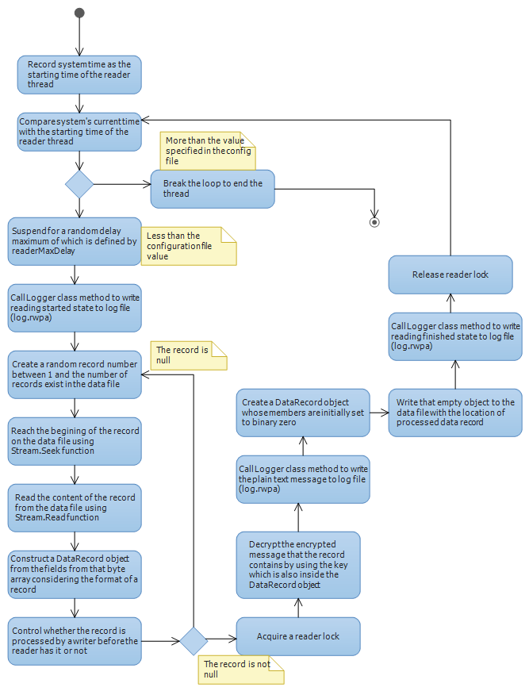

Figure 6. Activity Diagram for ReaderProcess Object

3.2.2. WriterProcess Class

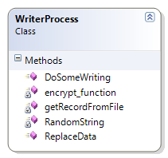

Figure 7. WriterProcess Class

Class Name: WriterProcess
Fields: None.
Methods:
- Name: DoSomeWriting
Signature: public void DoSomeWriting(object maxDelay)
Description: This method controls the execution time of the thread by gathering system time on each of its loop. If execution time exceeds the one told in the configuration file, it makes thread join to the main process. On the other hand, on each loop, it creates a random record number between 1 and the records number that exist in the data file. It also generates a 128 bit random key and a random character string. It then encrypts the random character string with the generated key and builds up a DataRecord object contianing those values. After all, it is expected from this function to seek to the position of the record (randomly selected above) on the data file and write the new DataRecord object instead of the old one.
- Name: encrypt_function
Signature: private byte[] encrypt_function(string Plain_Text, byte[] Key)
Description: This method encrypts the message Plain_Text by using the key that is presented as the byte array Key. The byte array specifying the encrypted message is returned to the caller.
- Name: getRecordFromFile
Signature: private DataRecord getRecordFromFile(int recordNumber)
Description: This method seeks on the data file in order to position the file reader pointer to the beginning of the data record, number of which is given to the method through parameter recordNumber. It allocates a byte array that has the same size as a record do, reads the content of record from the data file into that array and returns it as a DataRecord object to the caller.
- Name: ReplaceData
Signature: public void ReplaceData(int position, DataRecord data)
Description: This method seeks on the data file in order to position the file writer pointer to the beginning of the data record, position of which is given to the method through parameter position. It then writes the DataRecord object data to data file, overwriting the old one.
- Name: RandomString
Signature: private string RandomString(int size)
Description: This method creates a random string that is composed of characters A-Z and 0-9 length of which is specified by the parameter size.

3.2.2.1. Activity Diagram
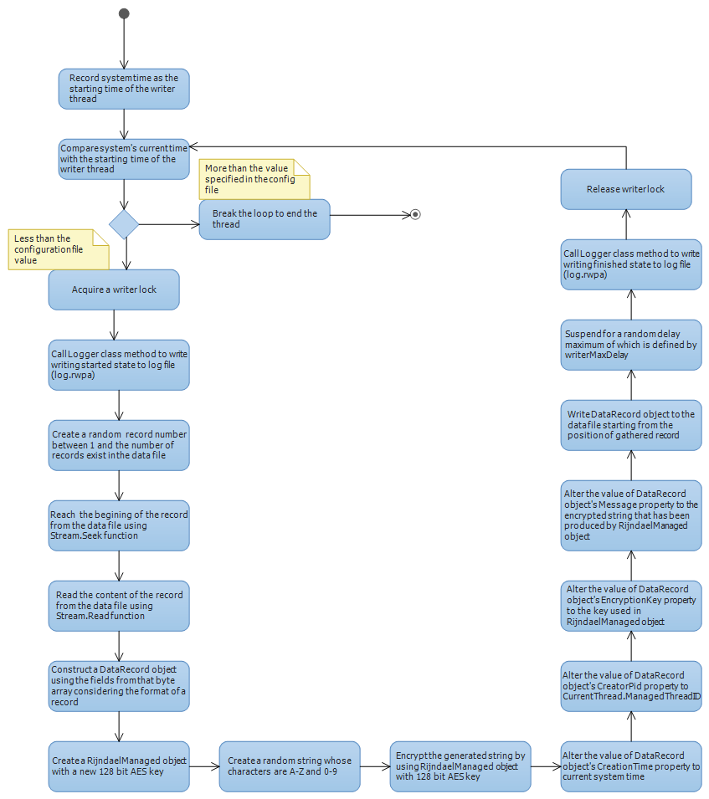

Figure 8. Activity Diagram for WriterProcess Object

3.3. Common Infrastructure Modules/Classes

3.3.1. Logger Class

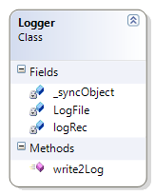
Figure 9. Logger Class
Class Name: Logger
Fields:
- Name: _syncObject
Type: object
Description: A static readonly object used to create a synchronized code area, where multiple threads will be trying to write to a shared log file.
- Name: LogFile
Type: string
Description: The name of the shared log file that threads will write their own logs.
- Name: logRec
Type: LogRecord
Description: An object which constructs and stores the formatted message to be passed to log file.

Methods:
- Name: write2Log
Signature: public static void write2Log(int threadID, string message)
Description: A static method which is used by the threads to write their actions to the shared log file. The threadId parameter is passed through the method in order to record the log demanding thread’s id into the log file. Parameter message is the plain text message of the thread to be written to log.

3.3.1.1. Activity Diagram

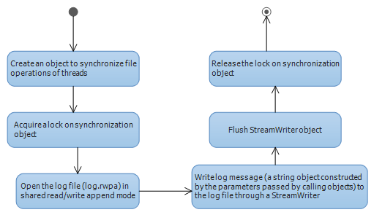

Figure 10. Activity Diagram for Logger Object

3.3.2. LogRecord Class

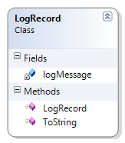
Figure 11. LogRecord Class

Class Name: LogRecord
Fields:
- Name: logMessage
Type: string
Description: A string object used to identify the message to be written in the log file.
Methods:
- Name: LogRecord
Signature: public LogRecord(int ID, string msg)
Description: Constructor method of the class which composes a formatted string to be written as log.
- Name: ToString
Signature: public override string ToString()
Description: Returns the formatted log message to the caller object.

3.3.3. ConfigurationRecord Class

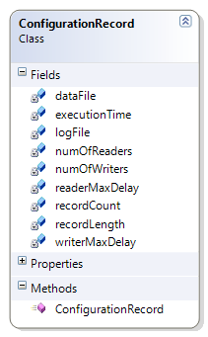

Figure 12. ConfigurationRecord Class

Class Name: ConfigurationRecord
Fields:
- Name: dataFile
Type: string
Description: The name of the data file which is composed of binary records.
- Name: executionTime
Type: int
Description: The maximum execution time of the application in secods.
- Name: logFile
Type: string
Description: The name of the log file used by the objects to write their actions.
- Name: numOfReaders
Type: int
Description: The number of reader processes as defined in the configuration file.
- Name: numOfWriters
Type: int
Description: The number of writer processes as defined in the configuration file.
- Name: readerMaxDelay
Type: int
Description: The maximum time interval that a reader process will suspend to simulate reading operation, which shall be defined in the configuration file.
- Name: writerMaxDelay
Type: int
Description: The maximum time interval that a writer process will suspend to simulate writing operation, which shall be defined in the configuration file.
- Name: recordCount
Type: int
Description: The number of records that will be in the data file.
- Name: recordLength
Type: int
Description: The length of a record (in bytes) in the data file. Notice that recordLength must have a value of at least 200.

Methods:
None.

3.3.4. DataRecord Class

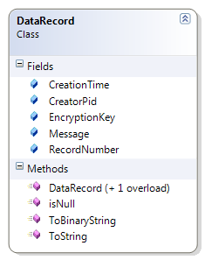
Figure 13: DataRecord Class

Class Name: DataRecord
Fields:
- Name: CreationTime
Type: byte []
Description: A 17-byte representation of DateTime object which specifies the creation time of the record.
- Name: CreatorPid
Type: byte []
Description: A 4-byte array identifying the identification number of the process creating the DataRecord.
- Name: EncryptionKey
Type: byte []
Description: A 16-byte array holding the 128 bit AES encryption key used to encrypt the Message field.
- Name: Message
Type: byte []
Description: A byte array containing the plain text or encrypted message of DataRecord object.
- Name: RecordNumber
Type: byte []
Description: A 2-byte array containing the number of DataRecord object.

Methods:
- Name: DataRecord
Signature: public DataRecord()
Description: Default constructor method of the class which composes a formatted data record with null fields.
- Name: DataRecord
Signature: public DataRecord(byte[] record)
Description: Constructor method of the class which composes a formatted data record with splitting the bytes given as parameter into member fields.
- Name: ToBinaryString
Signature: public byte[] ToBinaryString()
Description: Returns the byte array representation of a DataRecord object.
- Name: isNull
Signature: public bool isNull()
Description: Controls whether the DataRecord object is null or not.
- Name: ToString
Signature: public override string ToString()
Description: Returns a string representation of a DataRecord object.

3.3.5. Data File and Record Format

The data file shall be composed of n records (which is specified in the configuration file). Each record shall have m bytes (which is also specified in the configuration file and must be at least 200). The structure of a record will be as follows:

Record Number  (2 bytes) | Record Creation Time  (17 bytes)  Format: yyyyMMddHHmmssfff | Identification Number of Creator Process  (4 bytes) | AES 128 Encryption Key  (16 bytes) | Payload/Message  Encrypted/Decrypted  (m-39) bytes

Figure 14: Record Format

4. Testing Design

Testing and demo of the application will be completed within the time set by the user. Starvation prevention and how it is achieved will be demonstrated by testing.

5. References

- RWPA-APP Requirements Specification Document, Rev.2.0.
- Reference to organizational design process procedure document(s), or a generic design process procedure document(s)
- Reference to organizational design product specification document(s), or a generic design product specification document(s)
- Other references to additional documents, like other internal organizational documents, software project management documents, software design tool documents, etc
- References to additional bibliographic sources, like professional books, textbooks, handbooks, patents, standards, technical reports, journal/conference papers, etc.

