SWE 573 Software Development Practice, Fall 2012
Instructor: M. Ufuk Çağlayan

Project 3
WB-SFTS
Web Based Short Film Trade System
Design Specifications Document

Revision 1.0
24.12.2012

By: Mustafa Göksu GÜRKAŞ
Student Id: 2011719225

Revision History

Revision | Date | Explanation
1.0 | 24.12.2012 | Initial high level design

Table of Contents

Revision History 2
Table of Contents 3
Table of Figures 4
1. Introduction 5
2. System Design 5
2.1. Software Architecture 5
2.2. Software System Components 6
2.3. Environment 6
3. Detailed Design 7
3.1. Main Module/Class 7
3.2. Other Modules/Classes 7
3.2.1. OrdinaryUser Class 7
3.2.2. FilmProducer Class 8
3.2.3. Administrator Class 10
3.2.4. ShortFilm Class 11
3.2.5. Video Class 12
3.2.6. Photograph Class 12
3.2.7. FilmEvaluationForm Class 13
3.2.8. Invoice Class 13
3.3. Common Infrastructure Modules/Classes 14
4. Testing Design 14
5. References 14

Table of Figures

Figure 1. Overall Package and Classes 6
Figure 2. Class Diagram 6
Figure 3. OrdinaryUser Class 7
Figure 4. FilmProducer Class 8
Figure 5. Administrator Class 10
Figure 6. ShortFilm Class 11
Figure 7. Video Class 12
Figure 8. Photograph Class 12
Figure 9. FilmEvaluationForm Class 13
Figure 10. Invoice Class 13

1. Introduction

The purpose of this software project is to design and develop a new web based short film trade system application on Windows platform by using an object oriented programming language, specifically C# and a database system, MSSQL in order to accomplish the following tasks by using the system.

- Ordinary users of the application shall be able to browse the web site, display a list of short films available on the system, search for a specific short film by providing some criteria to the system, display the detailed information about the short film they select, watch the trailer of the selected short film and download the full version of the selected film after paying the fee set for that short film. Ordinary users shall also be able to search and display the information about short film producers.
- Ordinary users of the application shall be able to register to the short film trade system by providing their personal information to the system and become registered user of the system.
- Registered ordinary users shall be able to perform the same operations for the ordinary users described in the 1st item. Besides those operations, registered ordinary users shall be able to update their registration information, evaluate a selected short film and post their comments on the selected short film.
- Short film producers shall be able to perform the same operations for the ordinary users described in the 1st item. After the registration, they shall have the rights to upload their short films to the system with a specific information about their film, update their registration information, evaluate a selected short film and post their comments on the selected short film. They should also be able to alter/delete their short film information and prepare sales reports for all their films regarding to a specific month and year.
- Administrators of the system shall be able to create, update and delete all information about the users (registered ordinary users or registered short film producers).
- Administrators of the system shall be able to get some statistical information or evaluation results about the films they select.
- Administrators shall also be able to send e-mail to a selected group of WB-SFTS users.
- Administrators of the system shall be able to prepare a monthly sales report for short film producers and ordinary users.

The design is based on WB-SFTS Requirements Specification Document, Revision 2.0, in file Gurkas-P3-WB-SFTS-RSD-2012-12-17-Rev-2.0.pdf [1]. The design process used produce the design conforms to organizational specifications given in [2]. The notation used in this document to describe the design of WB-SFTS is mainly UML 2.0 and conforms to organizational specifications given in [3]. The ISO and TSE standards in [4], [5] and [6] are extensively used during the design.

The software architecture and overall high-level structure and components in terms of classes of WB-SFTS Application are given in Section 2 and design details of all application functions and the user interface in terms of are methods of all classes are given in Section 3 of this document.

2. System Design

2.1. Software Architecture

The software to be developed shall have a classical client/server architecture model.
The server side file system, the application sever, database, and external systems (banking applications) -- are essentially the same as found in traditional client/server systems. The client side components for the application such as, the browser, the web server, and again the file system (in this case, a distributed one) -- are elements unique to the Web space.
As the communication from the browser to the web server involving the request for, and then the delivery of a web page is generally stateless, the user's session state has to be preserved. Cookies shall be used in this application to preserve user sessions. Application’s business logic shall be kept on the server which leads to a thin client architecture that offers simplicity of security and distribution.

2.2. Software System Components

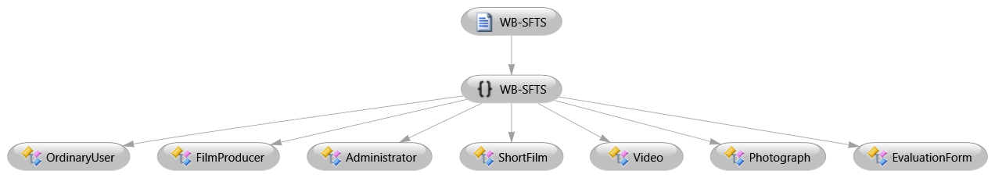
Figure 1. Overall Package and Classes

As depicted in figure 1, the system shall have only one package which is called WB-SFTS. This package shall be composed of eight classes which are;
- OrdinaryUser class that encapsulates the ordinary user data,
- FilmProducer class which respresents the filme producer user data,
- Administrator class which encapsulates the administrator user data,
- Short Film class which contains the short film data,
- Video class which is composed of the trailer and full version video information about a short film,
- Photograph class which encapsultaes the information about the uploaded photographs of a short film,
- EvaluationForm which represents the evaluation forms filled by the users to evaluate the films,
- Invoice class which includes the necessary information about the purchase of a short film by a user.

A representation of the interactions between the classes of the system is shown below.

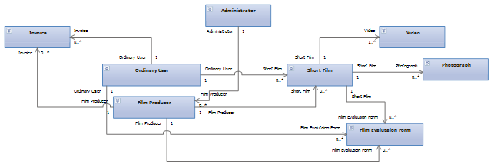
Figure 2. Class Diagram

2.3. Environment

The application shall be designed to execute on a 64-bit Windows 7 operating system with a Intel processor. The application shall be developed and tested by using Microsoft Visual Studio 2010 Ultimate (Version: 10.0.40219.1 SP1Rel). Programming language to implement the system shall be C#.

3. Detailed Design

3.1. Main Module/Class

None.

3.2. Other Modules/Classes

3.2.1. OrdinaryUser Class

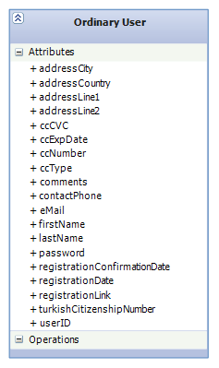
Figure 3. OrdinaryUser Class

Class Name: OrdinaryUser
Fields:
- Name: addressCity
Type: string
Description: The city of residence of the user.
- Name: addressCountry
Type: string
Description: The country of residence of the user.
- Name: addressLine1
Type: string
Description: The first part of the user’s address line.
- Name: addressLine2
Type: string
Description: The second part of the user’s address line.
- Name: ccCVC
Type: string
Description: CVC number of the user’s credit card.
- Name: ccExpDate
Type: string
Description: Expiration date of the user’s credit card.
- Name: ccNumber
Type: string
Description: Number of the user’s credit card.
- Name: ccType
Type: string
Description: Type of the user’s credit card.
- Name: comments
Type: string
Description: Further comments of the user’s information.
- Name: contactPhone
Type: string
Description: Phone Number of the user.
- Name: eMail
Type: string
Description: Email address of the user.
- Name: firstName
Type: string
Description: First name of the user.
- Name: lastName
Type: string
Description: Last name of the user.
- Name: password
Type: string
Description: System password of the user.
- Name: registrationConfirmationDate
Type: DateTime
Description: The date of confirmation performed by the administrator once the proper documents received.
- Name: registrationDate
Type: DateTime
Description: The date of registration performend by the user through WB-SFTS.
- Name: registrationLink
Type: string
Description: The web link that is generated when the user submits his registration. This link shall be emailed to the user as a confirmation link.
- Name: turkishCitizenshipNumber
Type: string
Description: Turkish citizenship number of the user.
- Name: userID
Type: string
Description: ID number that is generated by the WB-SFTS once the user completes his registration.

3.2.2. FilmProducer Class

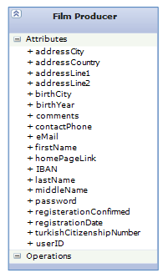
Figure 4. FilmProducer Class

Class Name: FilmProducer
Fields:
- Name: addressCity
Type: string
Description: The city of residence of the producer.
- Name: addressCountry
Type: string
Description: The country of residence of the producer.
- Name: addressLine1
Type: string
Description: The first part of the producer’s address line.
- Name: addressLine2
Type: string
Description: The second part of the producer’s address line.
- Name: birthCity
Type: string
Description: The city of birth of the producer.
- Name: birthYear
Type: string
Description: The year of birth of the producer.
- Name: comments
Type: string
Description: Further comments of the producer’s information.
- Name: contactPhone
Type: string
Description: Phone Number of the producer.
- Name: eMail
Type: string
Description: Email address of the producer.
- Name: firstName
Type: string
Description: First name of the producer.
- Name: homePageLink
Type: string
Description: The home page link of the producer within WB-SFTS.
- Name: IBAN
Type: string
Description: Bank account number of the producer.
- Name: lastName
Type: string
Description: Last name of the producer.
- Name: middleName
Type: string
Description: Middle name of the producer.
- Name: password
Type: string
Description: System password of the producer.
- Name: registrationConfirmed
Type: boolean
Description: The indicator whether the producer has been confirmed by an administrator or not.
- Name: registrationDate
Type: DateTime
Description: The date of registration performend by the producer through WB-SFTS.
- Name: turkishCitizenshipNumber
Type: string
Description: Turkish citizenship number of the producer.
- Name: userID
Type: string
Description: ID number that is generated by the WB-SFTS once the producer completes his registration.

3.2.3. Administrator Class

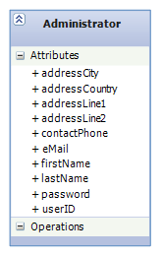
Figure 5. Administrator Class

Class Name: Administrator
Fields:
- Name: addressCity
Type: string
Description: The city of residence of the administrator.
- Name: addressCountry
Type: string
Description: The country of residence of the administrator.
- Name: addressLine1
Type: string
Description: The first part of the administrator’s address line.
- Name: addressLine2
Type: string
Description: The second part of the administrator’s address line.
- Name: contactPhone
Type: string
Description: Phone Number of the administrator.
- Name: eMail
Type: string
Description: Email address of the administrator.
- Name: firstName
Type: string
Description: First name of the administrator.
- Name: lastName
Type: string
Description: Last name of the administrator.
- Name: password
Type: string
Description: System password of the administrator.
- Name: userID
Type: string
Description: ID number of the administrator.

3.2.4. ShortFilm Class

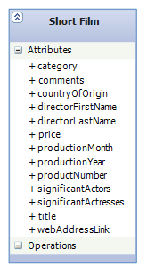
Figure 6. ShortFilm Class

Class Name: ShortFilm
Fields:
- Name: category
Type: string
Description: The category of short film (i.e. Horror, Thriller vs).
- Name: comments
Type: string
Description: A free area for the comments on the film made by its producer.
- Name: countryOfOrigin
Type: string
Description: The origin country of the short film.
- Name: directorFirstName
Type: string
Description: Name of the director of the short film.
- Name: directorLastName
Type: string
Description: Last name of the director of the short film.
- Name: price
Type: double
Description: Price of the short film determined by its producer.
- Name: productionMonth
Type: int
Description: The month of production of the short film.
- Name: productionYear
Type: int
Description: The year of production of the short film.
- Name: productNumber
Type: string
Description: A special 8-digit number assigned by the WB-SFTS to the short film after its upload.
- Name: significantActors
Type: string
Description: Names of the significant actors, seperated by a comma, took role in the short film.
- Name: significantActresses
Type: string
Description: Names of the significant actresses, seperated by a comma, took role in the short film.
- Name: title
Type: string
Description: Title of the short film.
- Name: webAddressLink
Type: string
Description: The web address of the short film.

3.2.5. Video Class

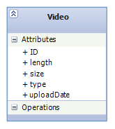
Figure 7. Video Class

Class Name: Video
Fields:
- Name: ID
Type: string
Description: ID of the video file assigned by the WB-SFTS.
- Name: length
Type: int
Description: Length of the video file in seconds.
- Name: size
Type: double
Description: The size of the video file on the file system.
- Name: type
Type: int
Description: The type of the video file, a trailer/preview or full version.
- Name: updloadDate
Type: DateTime
Description: The date of upload for the video file.

3.2.6. Photograph Class

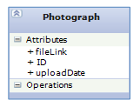
Figure 8. Photograph Class

Class Name: Photograph
Fields:
- Name: fileLink
Type: string
Description: The path of the photograph file on the file system.
- Name: ID
Type: string
Description: ID number that is assigned by the WB-SFTS to the photograph file.
- Name: updloadDate
Type: DateTime
Description: The date of upload for the photograph file.

3.2.7. FilmEvaluationForm Class

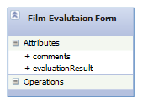
Figure 9. FilmEvaluationForm Class

Class Name: FilmEvaluationForm
Fields:
- Name: comments
Type: string
Description: User comments that on the short film.
- Name: evaluationResult
Type: string
Description: Evaluation criteria given by the user who watches the short film.

3.2.8. Invoice Class

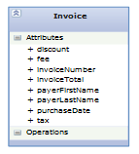
Figure 10. Invoice Class

Class Name: Invoice
Fields:
- Name: discount
Type: double
Description: The discount made during the purchase of the short film.
- Name: fee
Type: double
Description: The amount taken from the customer as the price of the short film.
- Name: invoiceNumber
Type: int
Description: A unique generated number by WB-SFTS to each invoice.
- Name: invoiceTotal
Type: double
Description: Grand total of the invoice.
- Name: payerFirstName
Type: string
Description: The name of the person who pays for the short film.
- Name: payerLastName
Type: string
Description: The last name of the person who pays for the short film.
- Name: purchaseDate
Type: DateTime
Description: Date of purchase of the short film.
- Name: tax
Type: double
Description: Tax amount taken from the sales transaction of the short film.

3.3. Common Infrastructure Modules/Classes

None.

4. Testing Design

Testing and demo of the application for both the web server and the client shall be performed on the same machine.

5. References

- RWPA-APP Requirements Specification Document, Rev.1.1.
- Reference to organizational design process procedure document(s), or a generic design process procedure document(s)
- Reference to organizational design product specification document(s), or a generic design product specification document(s)
- Other references to additional documents, like other internal organizational documents, software project management documents, software design tool documents, etc
- References to additional bibliographic sources, like professional books, textbooks, handbooks, patents, standards, technical reports, journal/conference papers, etc.

