SWE 530 Software Design Process, Spring 2013
Instructor: M. Ufuk Çağlayan

Project 5
GEW-Generic E-Commerce Web Application
Design Specifications Document

Revision 2.0
05.06.2013

By: Mustafa Göksu GÜRKAŞ
Student Id: 2011719225

Revision History

Revision | Date | Explanation
1.0 | 22.05.2013 | Initial high level design
2.0 | 05.06.2013 | Detailed Design Product has been released.

Table of Contents

Revision History 2
Table of Contents 3
Table of Figures 4
1. Introduction 5
2. System Design 5
2.1. Software Architecture 5
2.2. Software System Components 6
2.3. Environment 7
3. Detailed Design: 8
3.1. Main Module/Class 8
3.2. Other Modules/Classes 8
3.2.1. User Class 8
3.2.2. Administrator Class 9
3.2.3. Email Class 9
3.2.4. Producer Class 11
3.2.5. Consumer Class 13
3.2.6. OrdinaryUser Class 15
3.2.7. OrderCart Class 15
3.2.8. Order Class 16
3.2.9. Product Class 17
3.2.10. ShippingInfo Class 18
3.2.11. OrderDetail Class 19
3.3. Common Infrastructure Modules/Classes 19
3.3.1. Logger Class 19
3. Testing Design 20
4. References 20

Table of Figures

Figure 1: Structure of the system (3-tier / Client and Server Architecture) 5
Figure 2: MVC Pattern applied 6
Figure 3: Package Diagram 6
Figure 4: Class Diagram 7
Figure 5: Deployment Diagram 8
Figure 6: User Class 8
Figure 7: Administrator Class 9
Figure 8: Email Class 9
Figure 9: Producer Class 11
Figure 10: Consumer Class 13
Figure 11: OrdinaryUser Class 15
Figure 12: OrderCart Class 15
Figure 13: Order Class 16
Figure 14: Product Class 17
Figure 15: ShippingInfo Class 18
Figure 16: OrderDetail Class 19
Figure 17: Logger Class 19

1. Introduction

The purpose of the software project is to develop a web application in an object oriented programming language, as JAVA is selected in this case and on Linux Platform by using MySQL as the relational database management system. As the web server application of the system, Apache Tomcat is selected. The system is aimed to do mainly the following:

- Large number of Producers shall advertise and sell their products through a common e-commerce web site.
- Large number of Consumers shall browse, inspect and buy products through the same common e-commerce web site.
- Producers and Consumers shall be able to register as users of e-commerce web site and update their registration information.
- E-commerce web site Administrators should be able to retrieve information about individual Producers and Consumers, update their information, enter additional information and display/list information about Producers and Consumers in various forms.

The design is based on Generic E-Commerce Web Application (GEW) Requirements Specification Document, Revision 2.0, in file SWE-530-P5-GEW-RSD-2013-05-08-Rev-2.0 [1]. The design process used to produce the design conforms to organizational specifications given in Kuka Yazılım Geliştirme A.Ş. Design Process Specification Document, Revision 1.0, in file Gurkas-SWE-530-P4-Kuka-DPSD-2013-05-01-Rev-1.0 [2]. The notation used in this document to describe the design of GEW Application is mainly UML and conforms to organizational specifications given in [3].

The software architecture and overall high-level structure and components in terms of classes of GEW Application are given in Section 2 and design details of all application functions, the user interface and the methods of all classes are given in Section 3 of this document.

2. System Design

2.1. Software Architecture

The suggested solution for this problem is to build a distributed web application. The overall architecture of the system is selected as Client and Server (Data Centered Repository) architecture. The system will be implemented as a three-tier distributed web application with EJB’s as an integral part of server-side component architecture.
The system shall be divided into three tiers, client layer (upper layer), presentation and business layer (middle layer) and data layer which is also called as the lower layer. Figure 1 illustrates the structure of the system that corresponds to the selected architecture, Client and Server.
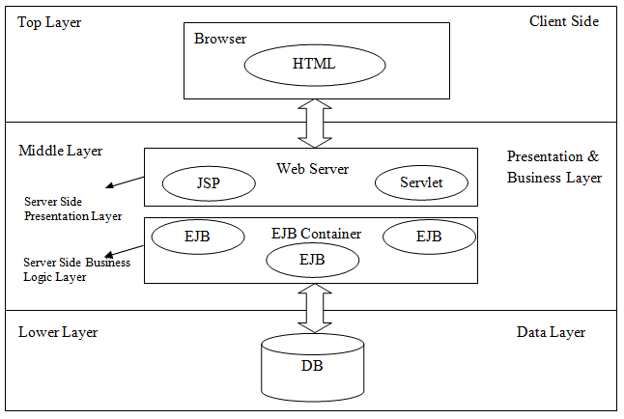
Figure 1: Structure of the system (3-tier / Client and Server Architecture)
The Client Layer shall be responsible for presentation of data via user interface. Static HTML and JSP pages shall be used as solution for this layer. The Presentation Layer shall be the layer that is responsible for the client interface. The Presentation Layer can be resided only on the client in a client/server model or it can be split between the client and the server. Servlets and JSP pages shall be used as the solution developed for this layer and they shall be deployed on Apache Tomcat Web Server. Web browsers like Mozilla Firefox and Google Chrome are used to access those components. The Business Logic Layer shall be split between client and server but the major functionality shall be provided on the Web Server via EJBs. EJB stands for “Enterprise Java Beans” which are distributed network aware components for developing secure, scalable, transactional and multiuser components in a J2EE environment. As the last point, MySQL Relational Database Management System shall be used as the data layer to store the data.
MVC (Model-View-Controller) pattern shall be applied to the model of this project. Servlets shall be used as controllers and JSP/HTML pages shall be used as viewing objects. A simple representation of the application of MVC to this project is shown below:

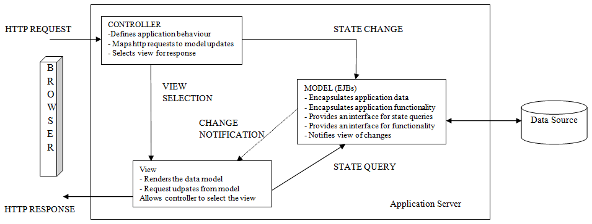
Figure 2: MVC Pattern applied

2.2. Software System Components

The following figure depicts the overall package structure of the system.
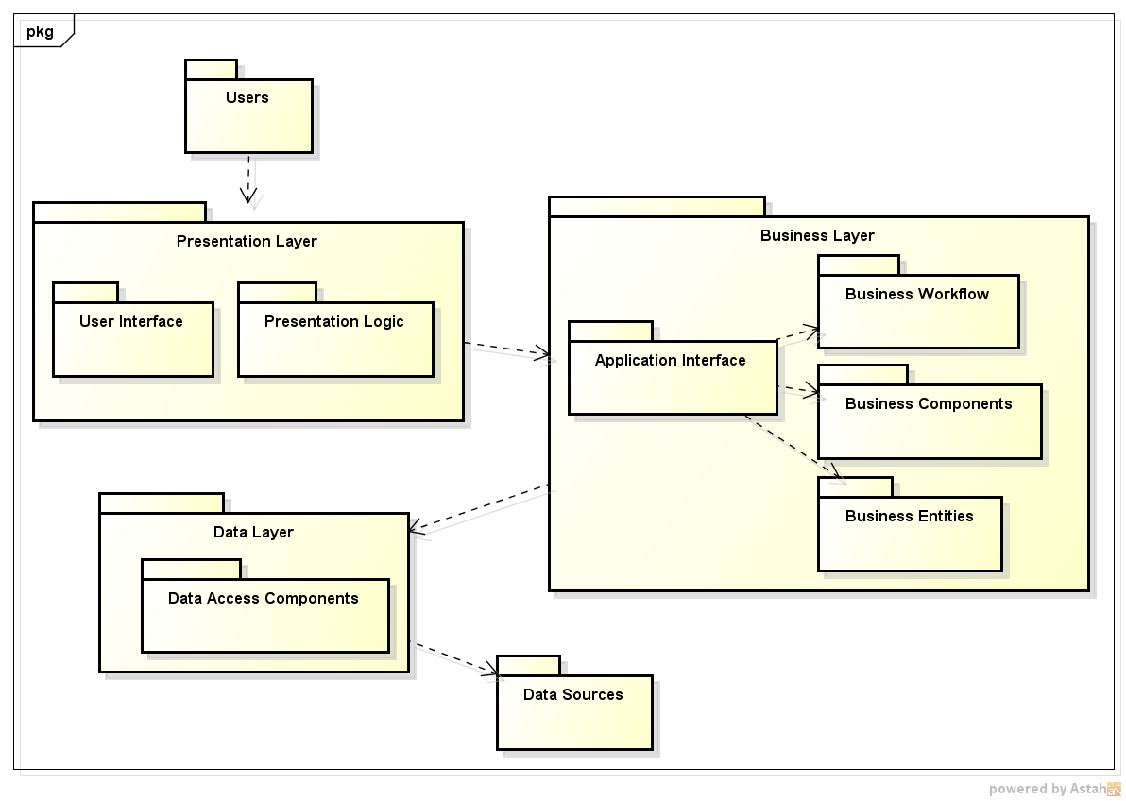
Figure 3: Package Diagram
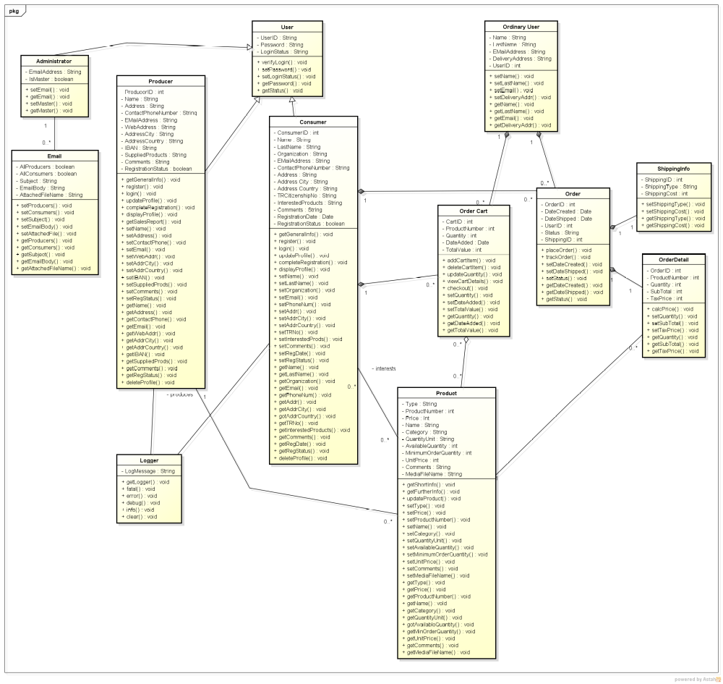

Figure 4: Class Diagram

2.3. Environment

In this project, the following toolchain shall be used for development:
- Linux (Kernel Version: 3.10-rc1) for x86 platform as the operating system,
- Eclipse Java EE IDE for Web Developers (Build id: 20130320-2352) as the development environment,
- Java(TM) SE Runtime Environment (build 1.6.0_15-b03) as the runtime environment,
- Apache Tomcat 7.0 (Core) or newer as the web server,
- Mozilla Firefox/Google Chrome as the browser,
- Oracle MySQL 5.6.11, as the relational database management system.

The following figure represents the overall deployment diagram of GEW components.

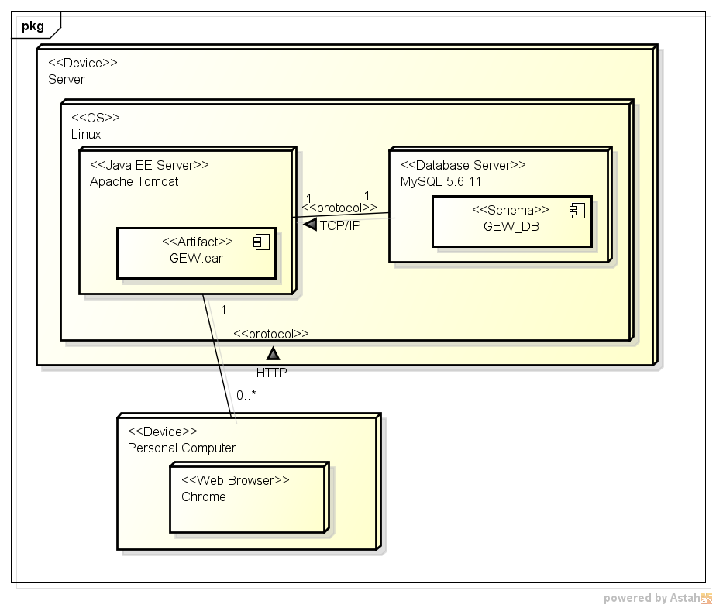
Figure 5: Deployment Diagram

3. Detailed Design:

3.1. Main Module/Class

N/A.

3.2. Other Modules/Classes

3.2.1. User Class

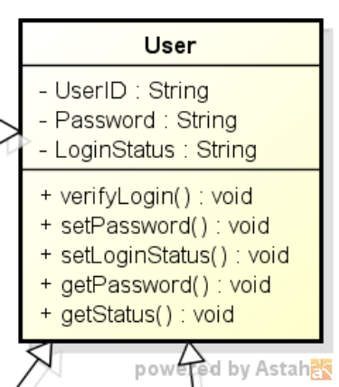
Figure 6: User Class

Class Name: User
Fields:
1. Name: UserID
Type: String
Description: Identification Number of the User.
2. Name: Password
Type: String
Description: System password of the user.
3. Name: LoginStatus
Type: String
Description: Login status of the user to the system.

Methods:
1. Name: verifyLogin
Description: Verifies the credentials that are provided by the user of the system.
2. The rest of the methods are classical OOP getter and setter methods that are used to get and set the values of attributes of the class.

3.2.2. Administrator Class
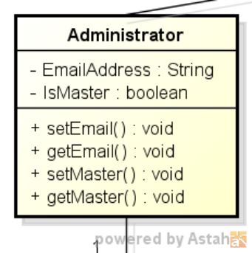

Figure 7: Administrator Class

Class Name: Administrator
Fields:
1. Name: EmailAddress
Type: String
Description: Email address of the user that is granted with an Administrator role.
2. Name: isMaster
Type: boolean
Description: An indicator that is used to determine whether that administrator is the master of others or not.

Methods:
1. All of the methods are classical OOP getter and setter methods that are used to get and set the values of attributes of the class.

3.2.3. Email Class
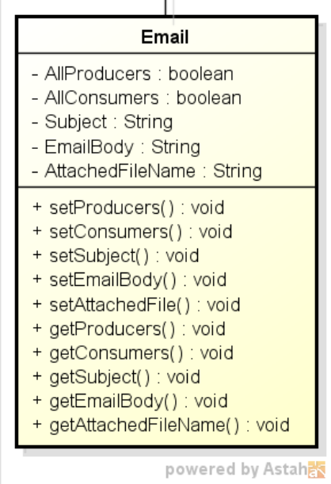

Figure 8: Email Class

Class Name: Email
Fields:
1. Name: AllProducers
Type: boolean
Description: An indicator to show if that mail is to be sent to all producers or not.
2. Name: AllConsumers
Type: boolean
Description: An indicator to show if that mail is to be sent to all consumers or not.
3. Name: Subject
Type: String
Description: Subject part of the email message.
4. Name: EmailBody
Type: String
Description: Body part (plain text) of the email message.
5. Name: AttachedFileName
Type: String
Description: Path of the file that is to be sent to all recipents as the attachment of message.
Methods:
1. All of the methods are classical OOP getter and setter methods that are used to get and set the values of attributes of the class.

3.2.4. Producer Class
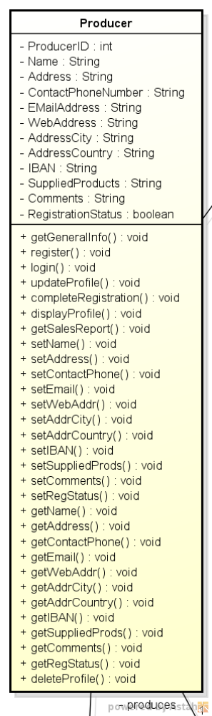

Figure 9: Producer Class

Class Name: Producer
Fields:
1. Name: Name
Type: String
Description: Name of the user that is granted with the role of Producer.
2. Name: Address
Type: String
Description: Address information of the producer.
3. Name: ContactPhoneNumber
Type: String
Description: Phone number that is used to contact with that producer.
4. Name: EMailAddress
Type: String
Description: Email address information of the producer.
5. Name: WebAddress
Type: String
Description: Web address of the producer.
6. Name: AddressCity
Type: String
Description: City part of the producer’s address.
7. Name: AddressCountry
Type: String
Description: Country part of the producer’s address.
8. Name: IBAN
Type: String
Description: Bank account number of the producer.
9. Name: SuppliedProducts
Type: String
Description: Categories of products being supplied.
10. Name: Comments
Type: String
Description: Further comments about the producer.
11. Name: RegistrationStatus
Type: boolean
Description: The actual registration of the producer will be completed by a system administrator only after the proper documents are received and verified by the organization which administers the e-commerce web site.
Methods:
1. Name: getGeneralInfo
Description: Such items as producer name, address, telephone number, email address, web address, type of products being produced shall be returned.
2. Name: register
Description: Performs the registration operations of the producer.
3. Name: login
Description: Performs the login operations of the user.
4. Name: updateProfile
Description: Updates the information that is intended to be changed by the user of the system.
5. Name: completeRegistration
Description: Performs the finalization of the registration process of the producer once the documents are received by the administrator.
6. Name: displayProfile
Description: Returns the information of the producer.
7. Name: getSalesReport
Description: Produces sales report that is desired with some date parameters by the user.
8. Name: deleteProfile
Description: Performs the deletion of the producer from the system.
9. The rest of the methods are classical OOP getter and setter methods that are used to get and set the values of attributes of the class.

3.2.5. Consumer Class
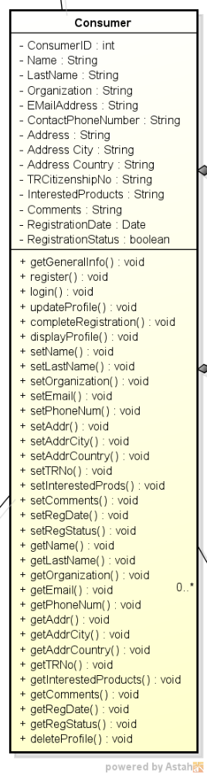

Figure 10: Consumer Class

Class Name: Consumer
Fields:
1. Name: Name
Type: String
Description: Name of the user that is granted with the role of Consumer.
2. Name: LastName
Type: String
Description: Last name of the consumer.
3. Name: Organiztion
Type: String
Description: Organization that the consumer belongs to.
4. Name: Address
Type: String
Description: Address information of the consumer.
5. Name: ContactPhoneNumber
Type: String
Description: Phone number that is used to contact with that consumer.
6. Name: EMailAddress
Type: String
Description: Email address information of the consumer.
7. Name: AddressCity
Type: String
Description: City part of the consumer’s address.
8. Name: AddressCountry
Type: String
Description: Country part of the consumer’s address.
9. Name: TRCitizenshipNo
Type: String
Description: TR Citizenship Number of the consumer.
10. Name: InterestedProducts
Type: String
Description: Categories of products that the consumer is interested in.
11. Name: Comments
Type: String
Description: Further comments about the consumer.
12. Name: RegistrationStatus
Type: boolean
Description: Following the confirmation of the consumer who hit the web link within at most 24 hours, the entered data must be stored in the system database.
13. Name: RegistrationDate
Type: Date
Description: Date of the registration of the consumer to the system.
Methods:
1. Name: getGeneralInfo
Description: Such items as consumer name, address, telephone number, email address, shall be returned.
2. Name: register
Description: Performs the registration operations of the consumer.
3. Name: login
Description: Performs the login operations of the user.
4. Name: updateProfile
Description: Updates the information that is intended to be changed by the user of the system.
5. Name: completeRegistration
Description: Performs the finalization of the registration process of the consumer once he hits the link that is provided by email.
6. Name: displayProfile
Description: Returns the information of the consumer.
7. Name: deleteProfile
Description: Performs the deletion of the consumer from the system.
8. The rest of the methods are classical OOP getter and setter methods that are used to get and set the values of attributes of the class.

3.2.6. OrdinaryUser Class
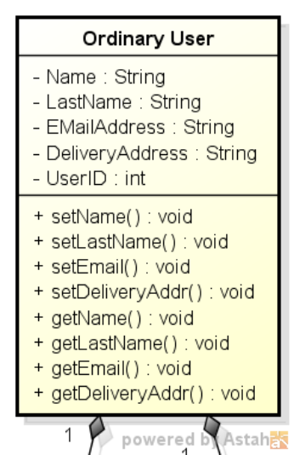

Figure 11: OrdinaryUser Class

Class Name: OrdinaryUser
Fields:
1. Name: Name
Type: String
Description: Name of the ordinary user that is giving an order.
2. Name: LastName
Type: String
Description: Last name of the ordinary user.
3. Name: DeliveryAddress
Type: String
Description: Address information of the user.
4. Name: EMailAddress
Type: String
Description: Email address information of the user.
Methods:
1. All of the methods are classical OOP getter and setter methods that are used to get and set the values of attributes of the class.

3.2.7. OrderCart Class
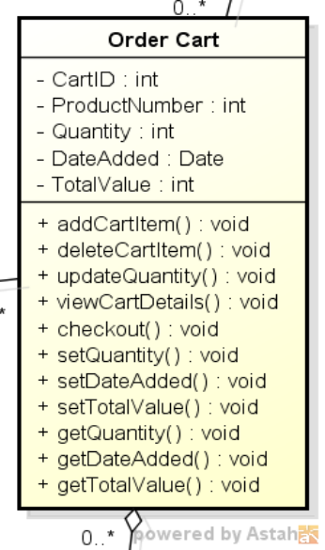

Figure 12: OrderCart Class

Class Name: OrderCart
Fields:
1. Name: ProductNumber
Type: int
Description: The number of the product that is added to the cart.
2. Name: Quantity
Type: int
Description: Quantity of the items that are present on the cart.
3. Name: DateAdded
Type: Date
Description: Cart’s creation date.
4. Name: TotalValue
Type: int
Description: Total value of the items that are present on the cart.
Methods:
1. Name: addCartItem
Description: Adds the selected item to the cart.
2. Name: deleteCartItem
Description: Removes the selected item from the cart.
3. Name: updateQuantity
Description: Changes the quantity of the items that are on the cart.
4. Name: viewCartDetails
Description: Returns the items that are on the cart.
5. Name: checkout
Description: Converts the cart to an order of the system.
6. The rest of the methods are classical OOP getter and setter methods that are used to get and set the values of attributes of the class.

3.2.8. Order Class
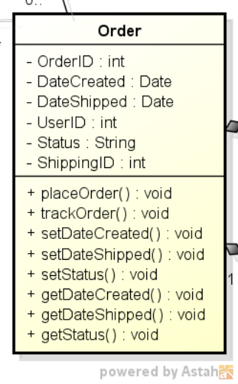

Figure 13: Order Class

Class Name: Order
Fields:
1. Name: DateCreated
Type: Date
Description: Creation date of the order.
2. Name: DateShipped
Type: Date
Description: Shipment date of the order.
3. Name: Status
Type: String
Description: The shipment status of the order.
Methods:
1. Name: placeOrder
Description: Places the order on the system and stores it on database.
2. Name: trackOrder
Description: Returns the tracking information of the order.
4. The rest of the methods are classical OOP getter and setter methods that are used to get and set the values of attributes of the class.

3.2.9. Product Class
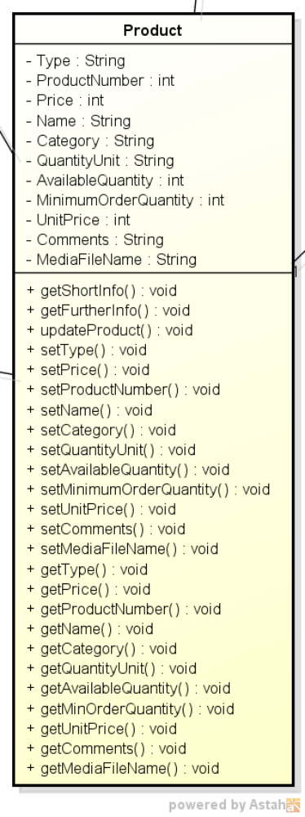

Figure 14: Product Class

Class Name: Product
Fields:
1. Name: Type
Type: String
Description: Type of the product.
2. Name: ProductNumber
Type: int
Description: Unique number that is provided by the user.
3. Name: Price
Type: int
Description: Price of the product per unit.
4. Name: Name
Type: String
Description: Name of the product
5. Name: Category
Type: String
Description: Category of the product.
6. Name: QuantityUnit
Type: String
Description: Unit of the quantity of the product (i.e. kgs.).
7. Name: AvailableQuantity
Type: int
Description: Quantity of the product that is available to sell.
8. Name: MinimumOrderQauntity
Type: int
Description: Minimum quantity of the product to sell.
9. Name: UnitPrice
Type: int
Description: Price per unit.
10. Name: Comments
Type: String
Description: Further comments on the product.
11. Name: MediaFileName
Type: String
Description: Files that may contain some photographs and/or some multimedia files, for example music or film clips in any media format.
Methods:
1. Name: getShortInfo
Description: Returns some brief information about the product.
2. Name: getFurtherInfo
Description: Returns detailed information about the product.
3. Name: updateProduct
Description: Changes the information provided by the user.
4. The rest of the methods are classical OOP getter and setter methods that are used to get and set the values of attributes of the class.

3.2.10. ShippingInfo Class
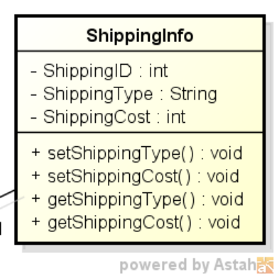

Figure 15: ShippingInfo Class

Class Name: ShippingInfo
Fields:
1. Name: ShippingType
Type: String
Description: Type of shipment (air cargo, standard, fast track).
2. Name: ShippingCost
Type: int
Description: The cost of shipment.
Methods:
1. All of the methods are classical OOP getter and setter methods that are used to get and set the values of attributes of the class.

3.2.11. OrderDetail Class
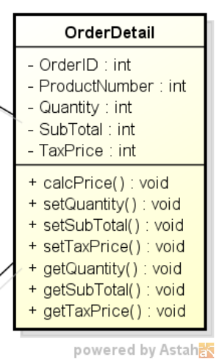

Figure 16: OrderDetail Class

Class Name: OrderDetail
Fields:
1. Name: Quantity
Type: int
Description: Quantity of the items that are present on the order.
2. Name: SubTotal
Type: int
Description: Total price of the order excluding tax.
3. Name: TaxPrice
Type: int
Description: The price of the tax for the items on the order.
Methods:
1. Name: calcPrice
Description: Calculates the grand total of the items that are on the order including tax.
2. The rest of the methods are classical OOP getter and setter methods that are used to get and set the values of attributes of the class.

3.3. Common Infrastructure Modules/Classes

3.3.1. Logger Class
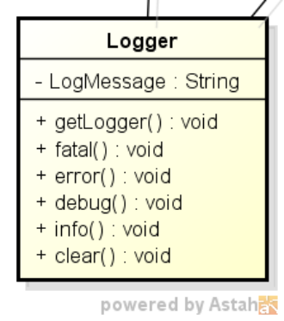

Figure 17: Logger Class

Class Name: Logger
Fields:
1. Name: LogMessage
Type: String
Description: Message to be written on the specified log file.
Methods:
1. Name: getLogger
Description: Returns the logger class instance.
2. Name: fatal
Description: Writes the log message on fatal system errors.
3. Name: error
Description: Writes the log message on system errors.
4. Name: debug
Description: Writes the log message on debug purposes.
5. Name: info
Description: Writes the log message on information purposes.
6. Name: clear
Description: Clears the log file.

3. Testing Design

The test document must cover the details of testing the correct operation and boundary conditions of each requirement in Section 2.

4. References

- SWE-530-P5-GEW-RSD-2013-05-08-Rev-2.0
- Gurkas-SWE-530-P4-Kuka-DPSD-2013-05-01-Rev-1.0
- Gurkas-SWE-530-P4-Kuka-UMLStandards-2013-04-01-Rev-1.0

