SWE 530 Software Design Process, Spring 2013
Instructor: M. Ufuk Çağlayan

Project 5
GEW-Generic E-Commerce Web Application
Design Specifications Document

Revision 2.0
05.06.2013

By: Mustafa Göksu GÜRKAŞ
Student Id: 2011719225

Revision History

Revision | Date | Explanation
1.0 | 22.05.2013 | Initial high level design
2.0 | 05.06.2013 | Detailed Design Product has been released.  High level design has been refined.  Activity diagrams have been added.  Design decisions are refined and detailed.  Class Diagrams and class methods have been refined and detailed.

Table of Contents

Revision History 2
Table of Contents 3
Table of Figures 5
1. Introduction 6
2. Stakeholder and Scenario Analysis 6
2.1. System Integrator and Solutions Provider 6
2.2. End Users 6
2.3. Maintenance Crew 7
3. Methodology 7
3.1. Software Architecture Design Fundamentals 7
3.1.1. Requirements & Architecture 7
3.2. Software Architecture Design Process 7
3.2.1. Architecture Definition Activities 7
4. System Design 7
4.1. Scope 7
4.2. Software Architecture 7
4.3. Software System Components 9
4.3.1. Client (Presentation Layer) 10
4.3.1.1. Browser 10
4.3.2. Server (Business Layer) 10
4.3.2.1. Application Server 10
4.3.2.2. Business Logic 11
4.3.2.2.1. Model 11
4.3.2.2.2. View 11
4.3.2.2.3. Controller 11
4.3.2.3. Database (Data Layer) 11
4.3.3. System Classes 11
4.4. Environment 13
5. Detailed Design: 13
5.1. Main Module/Class 13
5.2. Other Modules/Classes 14
5.2.1. User Class 14
5.2.1.1. Activity Diagrams 14
5.2.2. Administrator Class 15
5.2.3. Email Class 16
5.2.3.1. Activity Diagrams 16
5.2.4. Producer Class 17
5.2.4.1. Activity Diagrams 19
5.2.5. Consumer Class 22
5.2.5.1. Activity Diagrams 24
5.2.6. OrdinaryUser Class 26
5.2.7. OrderCart Class 26
5.2.7.1. Activity Diagrams 27
5.2.8. Order Class 27
5.2.8.1. Activity Diagrams 28
5.2.9. Product Class 29
5.2.10. ShippingInfo Class 30
5.2.11. OrderDetail Class 31
5.3. Common Infrastructure Modules/Classes 31
5.3.1. Logger Class 31
6. Testing Design 32
7. References 32

Table of Figures

Figure 1: Structure of the system (3-tier / Client and Server Architecture) 8
Figure 2: Data Flow of the System 8
Figure 3: MVC Pattern applied 9
Figure 4: Package Diagram 10
Figure 5: Class Diagram 12
Figure 6: Deployment Diagram 13
Figure 7: User Class 14
Figure 8: verifyLogin Activity Diagram 15
Figure 9: Administrator Class 15
Figure 10: Email Class 16
Figure 11: sendEmail Activity Diagram 17
Figure 12: Producer Class 17
Figure 13: register Activity Diagram 19
Figure 14: updateProfile Activity Diagram 20
Figure 15: completeRegistration Activity Diagram 20
Figure 16: getGeneralInfo Activity Diagram 21
Figure 17: getSalesReport Activity Diagram 21
Figure 18: Consumer Class 22
Figure 19: updateProfile Activity Diagram 24
Figure 20: completeRegistration Activity Diagram 24
Figure 21: getGeneralInfo Activity Diagram 25
Figure 22: register Activity Diagram 25
Figure 23: OrdinaryUser Class 26
Figure 24: OrderCart Class 26
Figure 25: Order Class 27
Figure 26: placeOrder Activity Diagram 28
Figure 27: Product Class 29
Figure 28: ShippingInfo Class 30
Figure 29: OrderDetail Class 31
Figure 30: Logger Class 31

1. Introduction

The purpose of the software project is to develop a web application in an object oriented programming language, as JAVA is selected in this case and on Linux Platform by using MySQL as the relational database management system. As the web server application of the system, Apache Tomcat is selected. The system is aimed to do mainly the following:

- Large number of Producers shall advertise and sell their products through a common e-commerce web site.
- Large number of Consumers shall browse, inspect and buy products through the same common e-commerce web site.
- Producers and Consumers shall be able to register as users of e-commerce web site and update their registration information.
- E-commerce web site Administrators should be able to retrieve information about individual Producers and Consumers, update their information, enter additional information and display/list information about Producers and Consumers in various forms.

The Generic E-Commerce web application project is an online project for people who want to do e-commerce.
In general producers are able to advertise and sell their products and consumers are able to browse and buy products
after registration through this web application. Administrator actor is able to retrieve and update consumers and
producers account information. The goal is to let the people easily sell and buy what they want.

The design is based on Generic E-Commerce Web Application (GEW) Requirements Specification Document, Revision 2.0, in file SWE-530-P5-GEW-RSD-2013-05-08-Rev-2.0 [1]. The design process used to produce the design conforms to organizational specifications given in Kuka Yazılım Geliştirme A.Ş. Design Process Specification Document, Revision 1.0, in file Gurkas-SWE-530-P4-Kuka-DPSD-2013-05-01-Rev-1.0 [2]. The notation used in this document to describe the design of GEW Application is mainly UML and conforms to organizational specifications given in [3].

Stakeholder and Scenario Analysis and Methodolgy used to produce this design is given in Section 2 and 3 respectively. The software architecture and overall high-level structure and components in terms of classes of GEW Application are given in Section 4 and design details of all application functions, the user interface and the methods of all classes are given in Section 5 of this document.

2. Stakeholder and Scenario Analysis

Here we present the stakeholders and an analysis for a simple scenario. For the definition of requirements traditionally
the user was taken as a reference. One could argue what exactly the term user includes but it is obvious that not only the
requirements of the user have to be analyzed. The software has to be developed, run, administered, maintained and
monitored according to the certain standards or regulations. Each of these aspects is of interest to different people which
not necessarily are using the system at all. We refer to these groups of people stakeholders. We use the following
definition (taken from IEEE 1471) [4]:

Stakeholder: An individual, team, or organization (or classes thereof) with interests in, or concerns relative to, a system. We have identified seven types of stakeholders in our analysis of the Building Automation scenario. Each stakeholder has interests and concerns, which influence the requirements and also architecture design. We will continuously check if the architectural design choices reflect also the interests and concerns.

2.1. System Integrator and Solutions Provider

The system integrators responsibilities are to develop a technically sound application for integration and interoperability
of the E-Commerce back-end and available devices and services as well as the availability of the system. The developers of the system integrator will use the J2EE modules intensively. He needs to perform continuous upgrade and extension services and ensure compliance with traditional standards and regulations in Java development. His goal is to deliver the implementation of the application to contract cost and time effectively. The provider wants to ensure business continuity by way of risk litigation.

2.2. End Users

The responsibilities of the tenants are to use the system effectively and read the user manual before using the system.
The user’s goal is to find the tour they desire in the least time spent and they want the most possible user-friendly interface.

2.3. Maintenance Crew

The maintenance crew has to monitor the subsystem states and react responsibly to provide maintenance according to
the SLA. They are also responsible to deliver diagnostic and logging information to the user data repository. Their goal
is to fulfill the SLA’s contractual obligations and ensure cost effectiveness in monitoring and maintenance.

3. Methodology

3.1. Software Architecture Design Fundamentals

We have based our process on the standard IEEE 1471 "Recommended Practice for Architectural Description of
Software-Intensive Systems"[4] which defines core elements like viewpoint and view. It also describes that
stakeholders need to be involved and how to apply stakeholders needs to the architecture.

3.1.1. Requirements & Architecture

We have established a process to gather requirements in a structured way. For this we have conducted discussion rounds
with focus groups of expert developers, which possibly will be responsible for the development of Generic E-Commerce Web Application project. The requirements were then prioritized and a fit criterion selected which allows
measuring if a requirement is met or not. We have not only deduced requirements from the focus group discussions but
also from other sources e.g. standards, best practices, each partner´s experience and so on. In this way we made sure
that we collect a broad range of requirements to reflect the wide range of stakeholders. Requirements and architecture
influence one another. Requirements are an input for the architectural design process in that they frame the architectural
problem and explicitly represent the stakeholders’ needs and desires. On the other hand, during the architecture design
one has to take into considerations what is possible and look at the requirements from a risk/cost perspective.

3.2. Software Architecture Design Process

3.2.1. Architecture Definition Activities

We have to consider a broad set of principles if the architectural design should be of good quality. We need to engage stakeholders to collect their concerns so the requirements can be balanced if there are conflicting or incompatible ones. The architectural design must allow for effective communication between all stakeholders and it must be structured to ensure continuous progress. Given the complexity of the project the design and also the process have to be flexible so we can react quickly to changing requirements and environments.

4. System Design

4.1. Scope

The scope of this software project is a generic E-Commerce web application. The list of features cover:
- Consumer and Producer registration,
- Updates of registrations, consumers and producers by administrator,
- Listing products, consumer, and producers,
- Browsing and Ordering products and creating sale reports, and
- Logging.

4.2. Software Architecture

The suggested solution for this problem is to build a distributed web application. The overall architecture of the system is selected as Client and Server (Data Centered Repository) architecture. The system will be implemented as a three-tier distributed web application with EJB’s as an integral part of server-side component architecture.
The system shall be divided into three tiers, client layer (upper layer), presentation and business layer (middle layer) and data layer which is also called as the lower layer. Figure 1 illustrates the structure of the system that corresponds to the selected architecture, Client and Server.
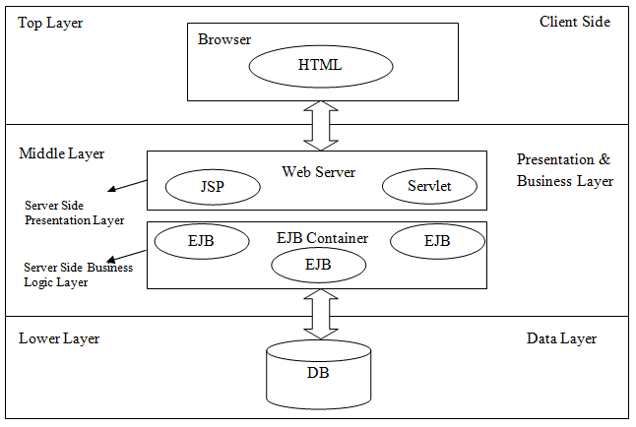
Figure 1: Structure of the system (3-tier / Client and Server Architecture)

Here, the client, server and the database are the components of the system. The client uses its browser to request a page
from the server via HTTPS secure protocol and the server uses (if necessary) its database to retrieve the information the
client asks for, and returns it to the client in the same protocol it was requested. The Client Layer shall be responsible for presentation of data via user interface. Static HTML and JSP pages shall be used as solution for this layer. The Presentation Layer shall be the layer that is responsible for the client interface. The Presentation Layer can be resided only on the client in a client/server model or it can be split between the client and the server. Servlets and JSP pages shall be used as the solution developed for this layer and they shall be deployed on Apache Tomcat Web Server. Web browsers like Mozilla Firefox and Google Chrome are used to access those components. The Business Logic Layer shall be split between client and server but the major functionality shall be provided on the Web Server via EJBs. EJB stands for “Enterprise Java Beans” which are distributed network aware components for developing secure, scalable, transactional and multiuser components in a J2EE environment. As the last point, MySQL Relational Database Management System shall be used as the data layer to store the data.

Basic flow of data is as follows:

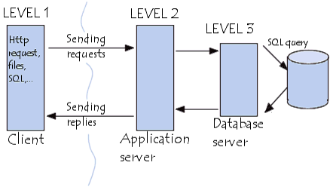
Figure 2: Data Flow of the System

MVC (Model-View-Controller) pattern shall be applied to the model of this project. Servlets shall be used as controllers and JSP/HTML pages shall be used as viewing objects. A simple representation of the application of MVC to this project is shown below:

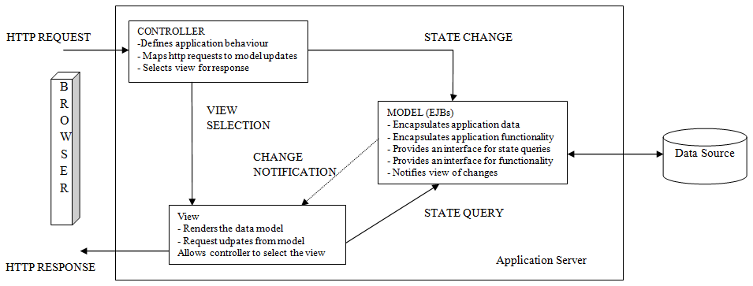
Figure 3: MVC Pattern applied

The layers of the architectural design can be broken into 3 levels with each level being dependent on the one directly
below itself. The lowest of these levels is the data structure level. This level of the application involves building data
structures, at startup, to be filled during program execution. Without these data structures, the next highest level, the
processing level, would crash.
The processing level will interact back and forth with the preceding level as it fills and manipulates the data structures
generated at program startup. Manipulation of these structures is done in the form of adding or removing units from the
team arrays as well as manipulating the health values of the unit structures. All other values are read-only. The
processing level also handles polling for user input and performing the necessary actions on relevant data, depending on
in which state the program is.
The final level, the display level, interacts with the lower levels on a strictly read-only basis. At this level, 3d and 2d
objects are drawn to the screen. The data structures detailed above each contain data on their type, which is read by the
display functions and used to determine what is to be displayed to the screen.

4.3. Software System Components

The client/server characteristic describes the relationship of cooperating programs in an application. The server
component provides a function or service to one or many clients, which initiate requests for such services.

The client/server model is a computing model that acts as distributed application which partitions tasks or workloads
between the providers of a resource or service, called servers, and service requesters, called clients. Often clients and
servers communicate over a computer network on separate hardware, but both client and server may reside in the same
system.

The following figure depicts the overall package structure of the system.
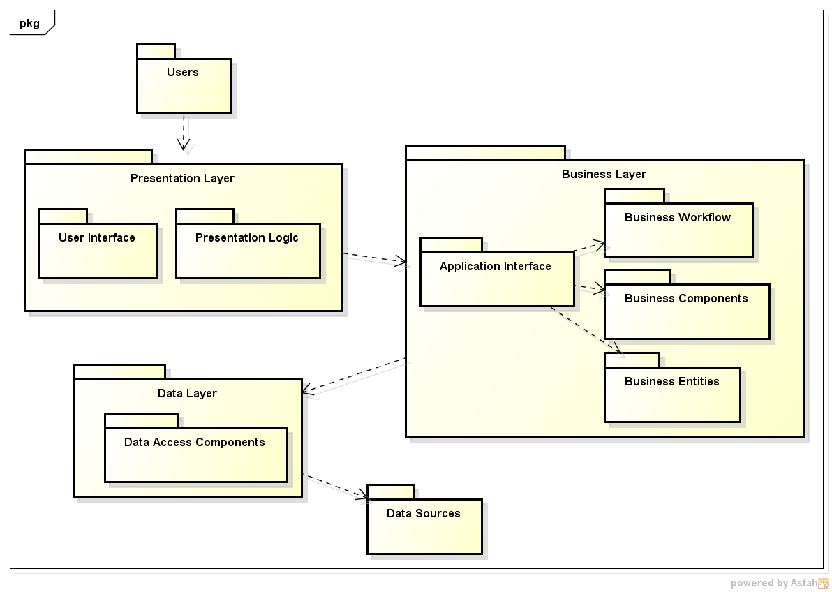
Figure 4: Package Diagram

4.3.1. Client (Presentation Layer)

In the current system, the client can be any device which has a capability of HTTPS calls to a remote machine. It
doesn’t even have to have a browser in it to get the response from the server. But of course, to display the response in
HTML format, it should have a browser in it.

A client does not share any of its resources, but requests a server's content or service function. Clients therefore initiate
communication sessions with servers which await incoming requests.

4.3.1.1. Browser

The current list of the browsers which can display the project as it was meant to be can be mentioned as Internet
Explorer, Opera, Google Chrome, Mozilla etc.

4.3.2. Server (Business Layer)

The server is the host machine which has the web application running on it. It has the capability of receiving requests in
a specific port of the machine and redirecting the request to the application server of the application, Apache Tomcat in
this case.

A server machine is a host that is running one or more server programs, which share their resources with clients.
Servers commonly contain data files and applications that can be accessed across the network, by workstations or
employee computers. An employee who wants to access company-wide data files, for instance, would use his or her
client computer to access the data files on the server. Other employees may use a common-access application by
accessing the server through their client computers.

In our project, the server will be in a remote location and hosted by any hosting firms with receiving the credentials to
manage it from a remote location.

4.3.2.1. Application Server

An application server is a server, which provides software applications with services such as security, data services,
transaction support, load balancing, and management of large distributed systems. The term is often used for web
servers, which support the Java Platform, Enterprise Edition; however its use isn't restricted to Java.
Application servers take full advantage of the client-server architecture by using the server as a storage device for
applications and requiring the clients to log in to the server in order to use those applications. Examples of this kind of
application are numerous; among the most popular are word processors, spreadsheets, and graphic design programs. In
each case, the use of the applications illustrates the client-server architecture.

This project will be having Apache Tomcat for its application server for J2EE enterprise application. This is a design
decision, which is made by taking community support, open source and stability factors into consideration.

4.3.2.2. Business Logic

The business logic of the application is the code flow in the project after receiving the request until returning the
response. The pattern we stick to in this project is Model–View–Controller (MVC), which will be covered in detail in
the latter sections. According to this pattern, we separate the application into layers and handle each operation in its own
section.

4.3.2.2.1. Model

In the model section, we have our plain old Java objects (POJOs), which has our data objects, used in the system. In
addition, in this layer we also have database access objects (DAOs), which have the responsibility of access to database
and to operations on it.

4.3.2.2.2. View

In the view section, we have our HTML codes and the necessary code to connect this layer to the model and controller
layer.

4.3.2.2.3. Controller

This layer has the business logic in itself. It takes the input parameters from the view layer, uses model layer artifacts to
construct a result and returns it to the view layer again. So it plays a role of connection the layers and carrying out the
controlling and data flowing functions of the application.

4.3.2.3. Database (Data Layer)

A database is an organized collection of data, today typically in digital form. The data are typically organized to model
relevant aspects of reality (for example, the availability of rooms in hotels), in a way that supports processes requiring
this information (for example, finding a hotel with vacancies).

This application has the MySQL Relational Database Management System as its database. This is a design decision
made with considering the community support, open source, easy-to-use and stability factors into consideration.

4.3.3. System Classes

The class diagram of Generic E-Commerce web application is given as follows:

Figure 5: Class Diagram

4.4. Environment

In this project, the following toolchain shall be used for development:
- Linux (Kernel Version: 3.10-rc1) for x86 platform as the operating system,
- Eclipse Java EE IDE for Web Developers (Build id: 20130320-2352) as the development environment,
- Java(TM) SE Runtime Environment (build 1.6.0_15-b03) as the runtime environment,
- Apache Tomcat 7.0 (Core) or newer as the web server,
- Mozilla Firefox/Google Chrome as the browser,
- Oracle MySQL 5.6.11, as the relational database management system.

The following figure represents the overall deployment diagram of GEW components.

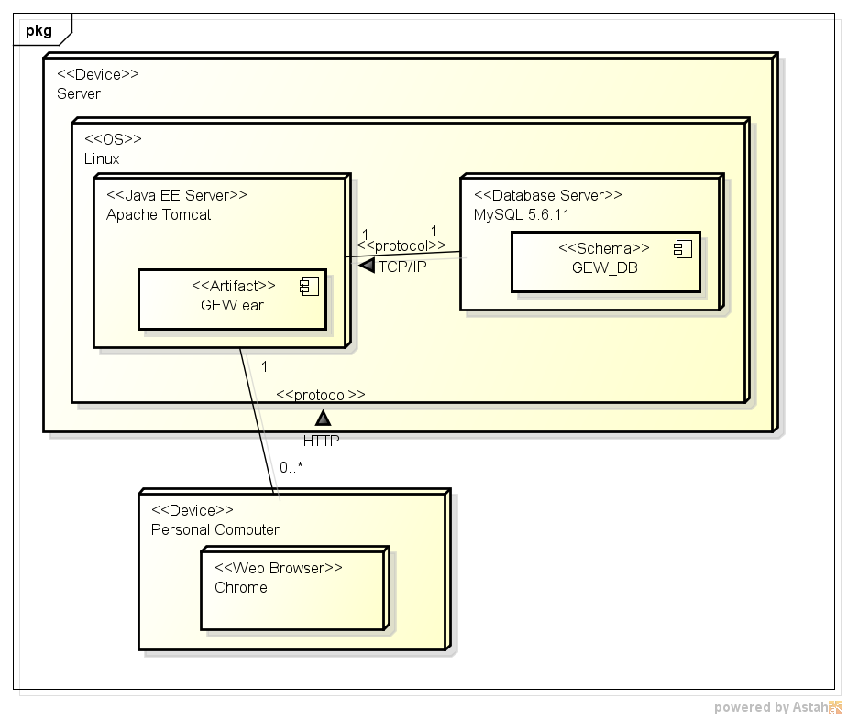
Figure 6: Deployment Diagram

5. Detailed Design:

5.1. Main Module/Class

N/A.

5.2. Other Modules/Classes

5.2.1. User Class

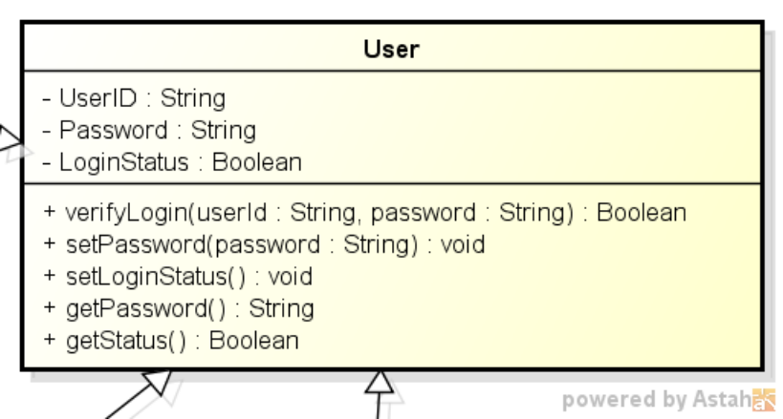
Figure 7: User Class

Class Name: User
Fields:
1. Name: UserID
Type: String
Description: Identification Number of the User.
2. Name: Password
Type: String
Description: System password of the user.
3. Name: LoginStatus
Type: String
Description: Login status of the user to the system.
Methods:
1. Name: verifyLogin
Description: Verifies the credentials that are provided by the user of the system.
2. The rest of the methods are classical OOP getter and setter methods that are used to get and set the values of attributes of the class.

5.2.1.1. Activity Diagrams

Activity Diagram for verifyLogin method has been given as follows. The remaining methods are classical setter/getter methods so activity diagrams for such methods have been omitted throughout the document.

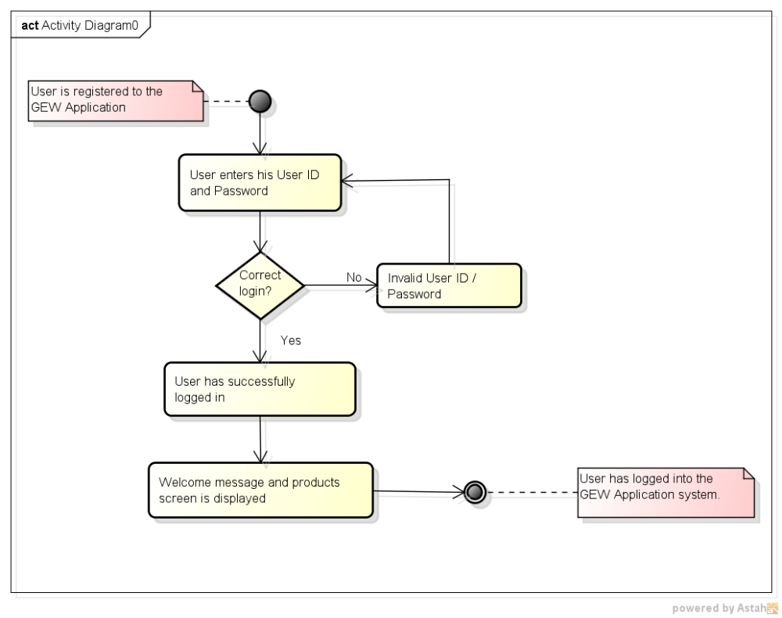
Figure 8: verifyLogin Activity Diagram

5.2.2. Administrator Class
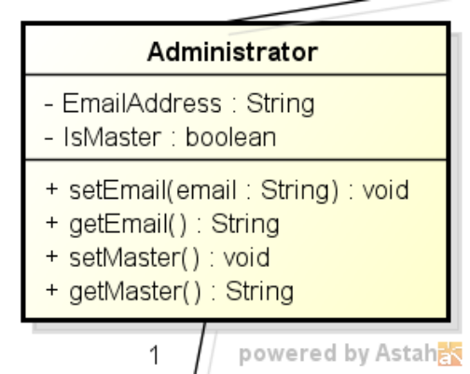

Figure 9: Administrator Class

Class Name: Administrator
Fields:
1. Name: EmailAddress
Type: String
Description: Email address of the user that is granted with an Administrator role.
2. Name: isMaster
Type: boolean
Description: An indicator that is used to determine whether that administrator is the master of others or not.
Methods:
1. All of the methods are classical OOP getter and setter methods that are used to get and set the values of attributes of the class.

5.2.3. Email Class
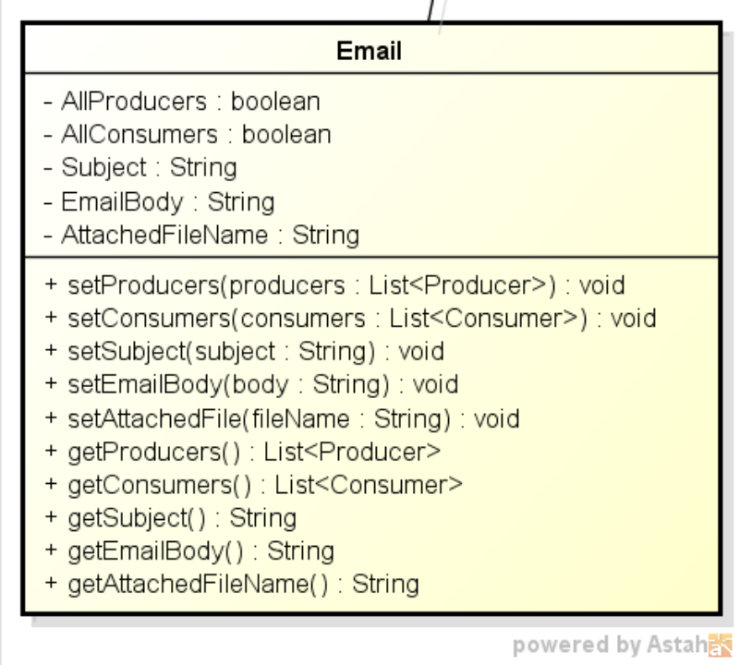

Figure 10: Email Class

Class Name: Email
Fields:
1. Name: AllProducers
Type: boolean
Description: An indicator to show if that mail is to be sent to all producers or not.
2. Name: AllConsumers
Type: boolean
Description: An indicator to show if that mail is to be sent to all consumers or not.
3. Name: Subject
Type: String
Description: Subject part of the email message.
4. Name: EmailBody
Type: String
Description: Body part (plain text) of the email message.
5. Name: AttachedFileName
Type: String
Description: Path of the file that is to be sent to all recipents as the attachment of message.
Methods:
1. All of the methods are classical OOP getter and setter methods that are used to get and set the values of attributes of the class.

5.2.3.1. Activity Diagrams

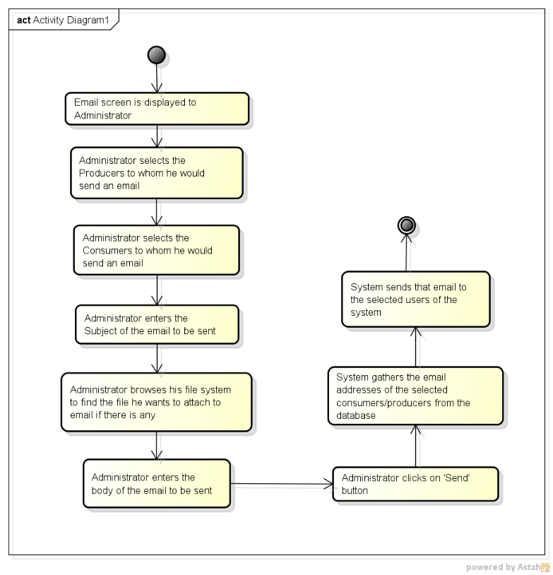
Figure 11: sendEmail Activity Diagram

5.2.4. Producer Class
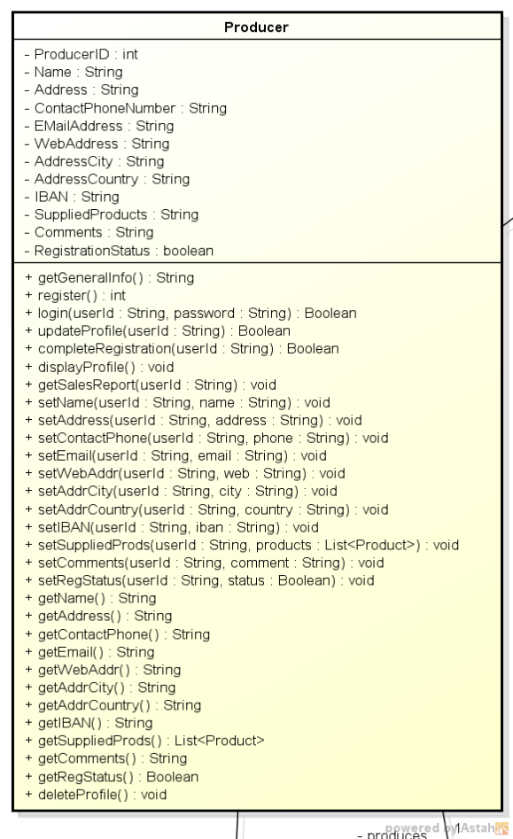

Figure 12: Producer Class
Class Name: Producer
Fields:
1. Name: Name
Type: String
Description: Name of the user that is granted with the role of Producer.
2. Name: Address
Type: String
Description: Address information of the producer.
3. Name: ContactPhoneNumber
Type: String
Description: Phone number that is used to contact with that producer.
4. Name: EMailAddress
Type: String
Description: Email address information of the producer.
5. Name: WebAddress
Type: String
Description: Web address of the producer.
6. Name: AddressCity
Type: String
Description: City part of the producer’s address.
7. Name: AddressCountry
Type: String
Description: Country part of the producer’s address.
8. Name: IBAN
Type: String
Description: Bank account number of the producer.
9. Name: SuppliedProducts
Type: String
Description: Categories of products being supplied.
10. Name: Comments
Type: String
Description: Further comments about the producer.
11. Name: RegistrationStatus
Type: boolean
Description: The actual registration of the producer will be completed by a system administrator only after the proper documents are received and verified by the organization which administers the e-commerce web site.
Methods:
1. Name: getGeneralInfo
Description: Such items as producer name, address, telephone number, email address, web address, type of products being produced shall be returned.
2. Name: register
Description: Performs the registration operations of the producer.
3. Name: login
Description: Performs the login operations of the user.
4. Name: updateProfile
Description: Updates the information that is intended to be changed by the user of the system.
5. Name: completeRegistration
Description: Performs the finalization of the registration process of the producer once the documents are received by the administrator.
6. Name: displayProfile
Description: Returns the information of the producer.
7. Name: getSalesReport
Description: Produces sales report that is desired with some date parameters by the user.
8. Name: deleteProfile
Description: Performs the deletion of the producer from the system.
9. The rest of the methods are classical OOP getter and setter methods that are used to get and set the values of attributes of the class.

5.2.4.1. Activity Diagrams

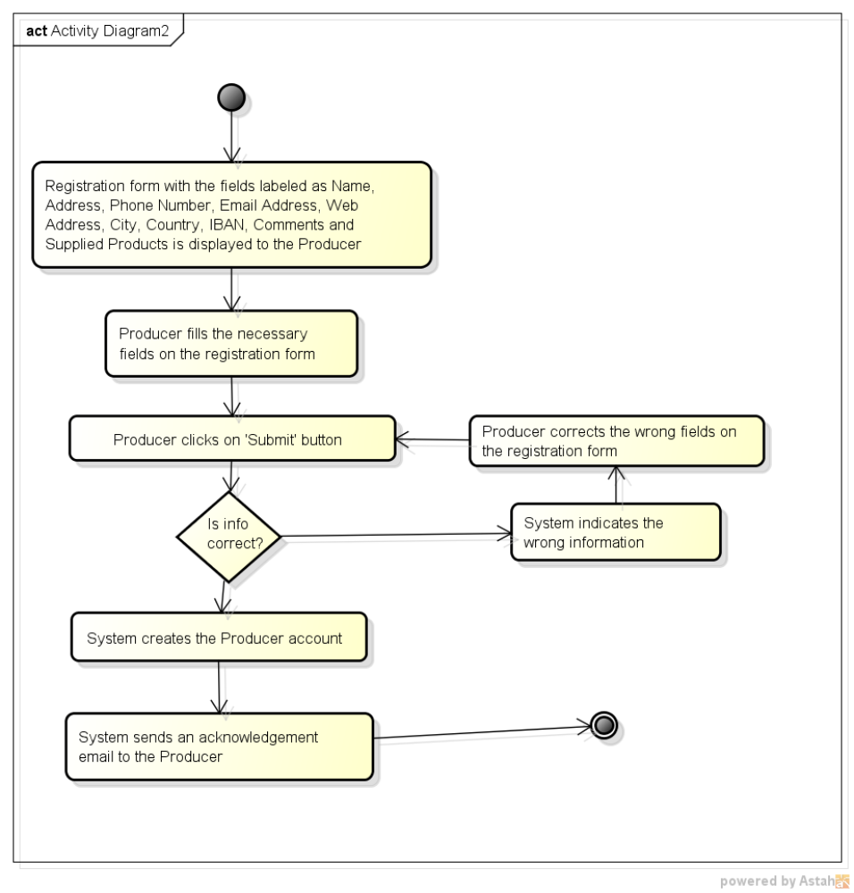
Figure 13: register Activity Diagram

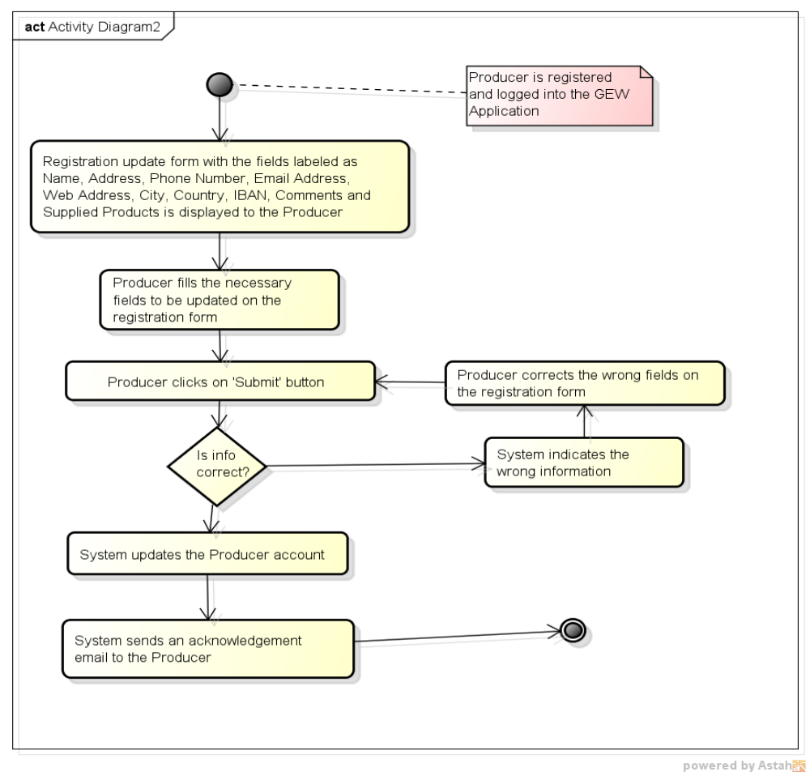
Figure 14: updateProfile Activity Diagram
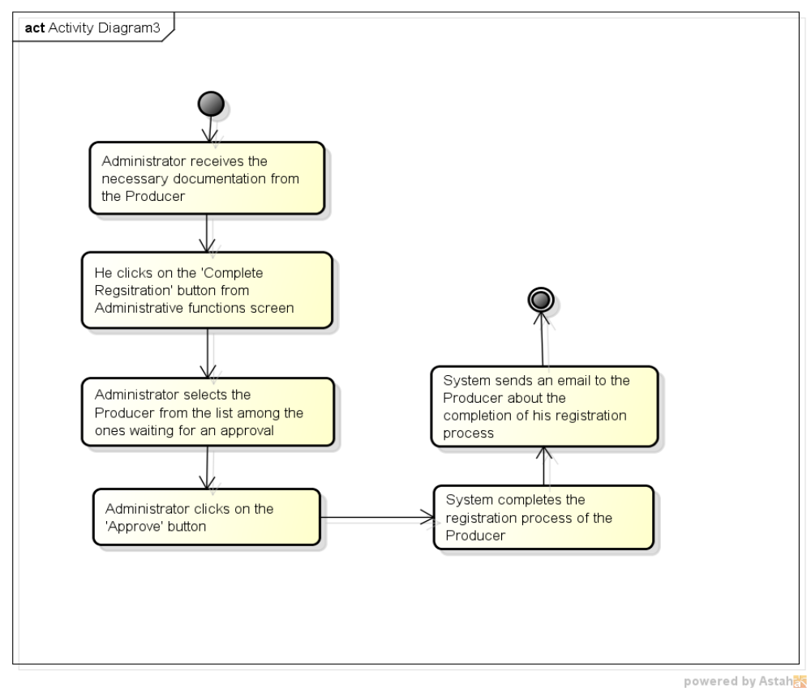
Figure 15: completeRegistration Activity Diagram
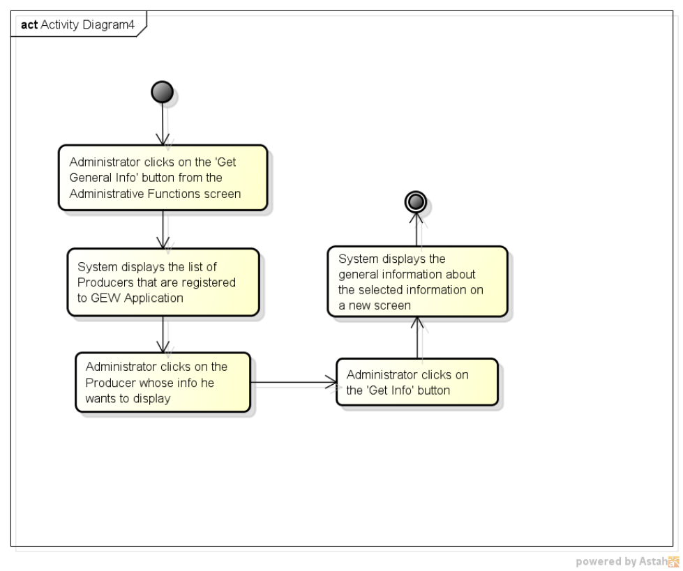
Figure 16: getGeneralInfo Activity Diagram

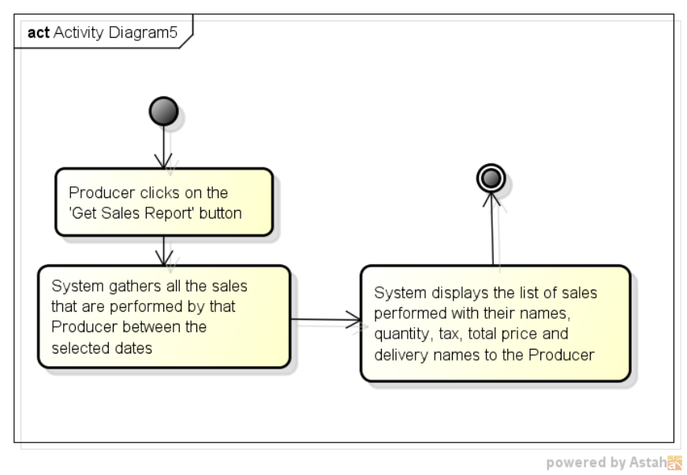
Figure 17: getSalesReport Activity Diagram

5.2.5. Consumer Class
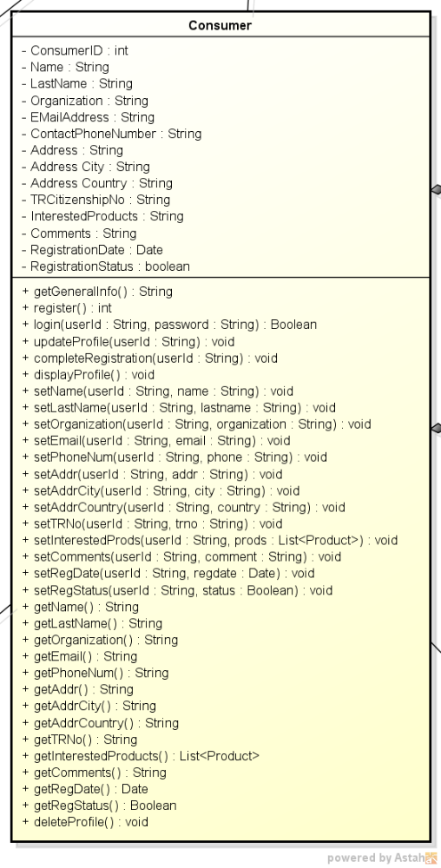
Figure 18: Consumer Class

Class Name: Consumer
Fields:
1. Name: Name
Type: String
Description: Name of the user that is granted with the role of Consumer.
2. Name: LastName
Type: String
Description: Last name of the consumer.
3. Name: Organiztion
Type: String
Description: Organization that the consumer belongs to.
4. Name: Address
Type: String
Description: Address information of the consumer.
5. Name: ContactPhoneNumber
Type: String
Description: Phone number that is used to contact with that consumer.
6. Name: EMailAddress
Type: String
Description: Email address information of the consumer.
7. Name: AddressCity
Type: String
Description: City part of the consumer’s address.
8. Name: AddressCountry
Type: String
Description: Country part of the consumer’s address.
9. Name: TRCitizenshipNo
Type: String
Description: TR Citizenship Number of the consumer.
10. Name: InterestedProducts
Type: String
Description: Categories of products that the consumer is interested in.
11. Name: Comments
Type: String
Description: Further comments about the consumer.
12. Name: RegistrationStatus
Type: boolean
Description: Following the confirmation of the consumer who hit the web link within at most 24 hours, the entered data must be stored in the system database.
13. Name: RegistrationDate
Type: Date
Description: Date of the registration of the consumer to the system.
Methods:
1. Name: getGeneralInfo
Description: Such items as consumer name, address, telephone number, email address, shall be returned.
2. Name: register
Description: Performs the registration operations of the consumer.
3. Name: login
Description: Performs the login operations of the user.
4. Name: updateProfile
Description: Updates the information that is intended to be changed by the user of the system.
5. Name: completeRegistration
Description: Performs the finalization of the registration process of the consumer once he hits the link that is provided by email.
6. Name: displayProfile
Description: Returns the information of the consumer.
7. Name: deleteProfile
Description: Performs the deletion of the consumer from the system.
8. The rest of the methods are classical OOP getter and setter methods that are used to get and set the values of attributes of the class.

5.2.5.1. Activity Diagrams

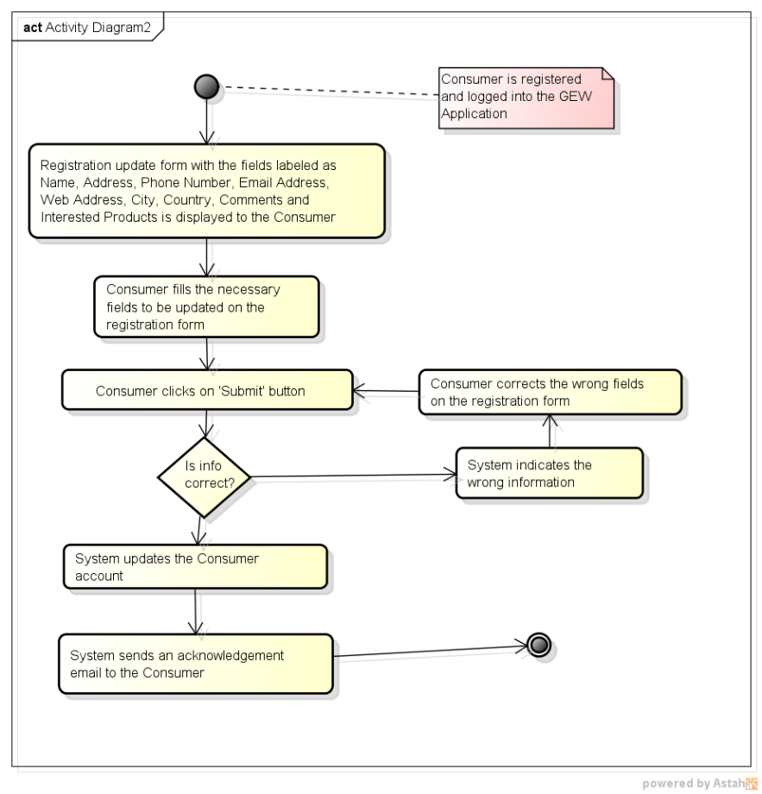
Figure 19: updateProfile Activity Diagram

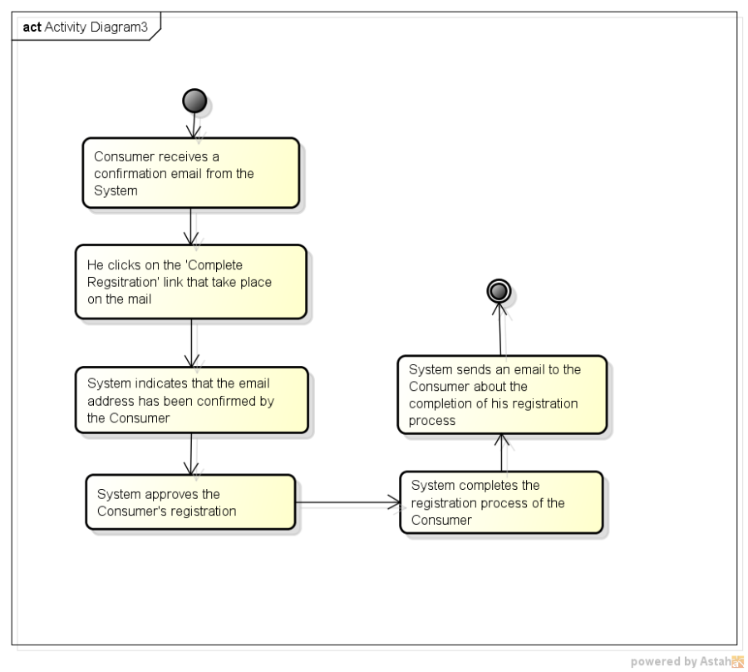
Figure 20: completeRegistration Activity Diagram

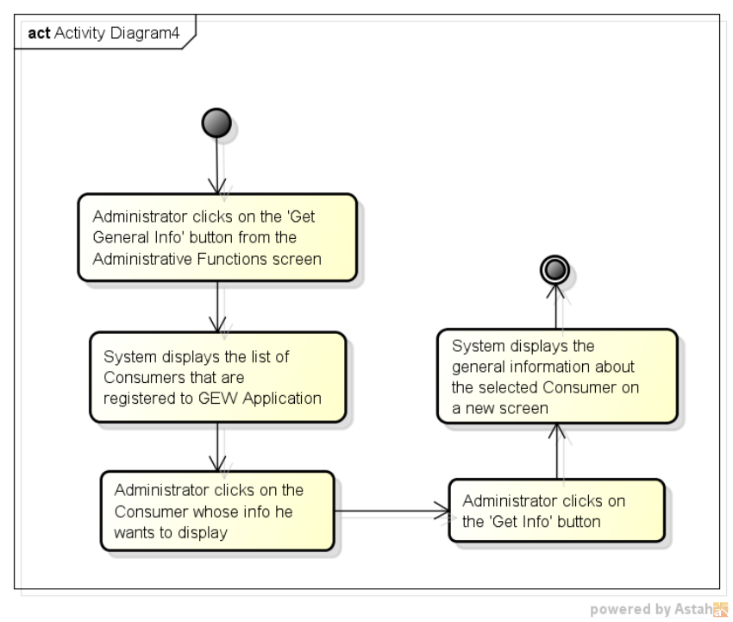
Figure 21: getGeneralInfo Activity Diagram

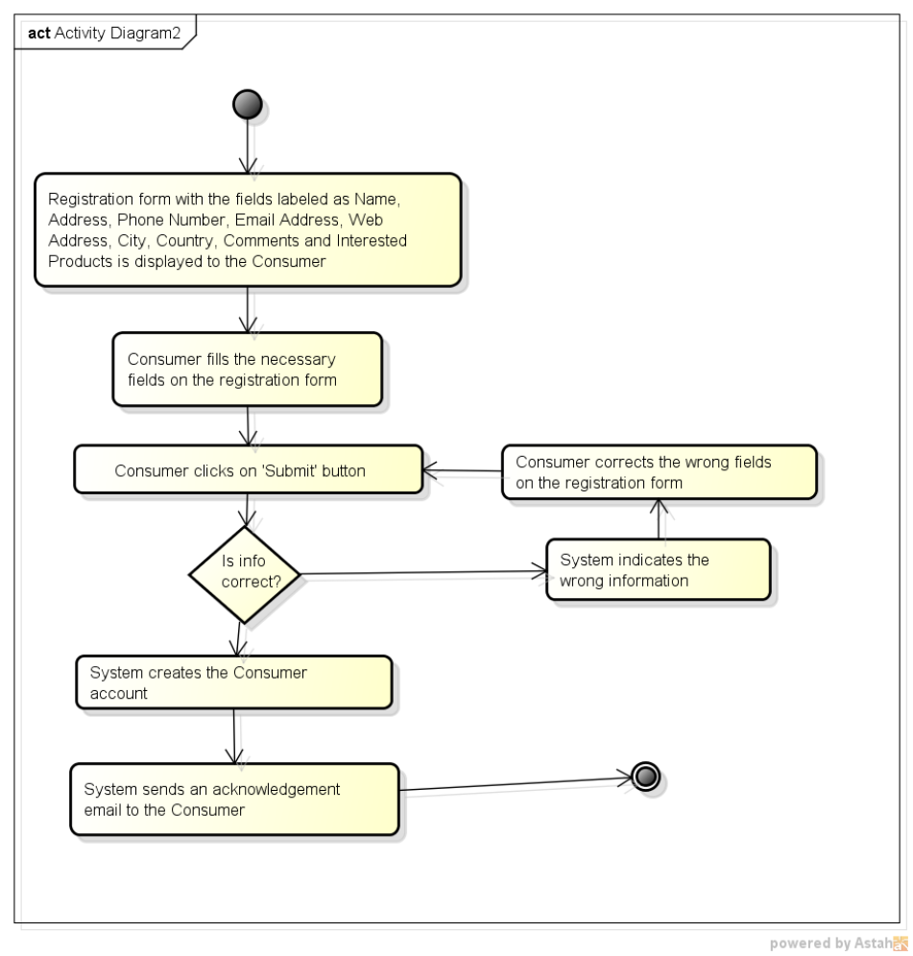
Figure 22: register Activity Diagram

5.2.6. OrdinaryUser Class
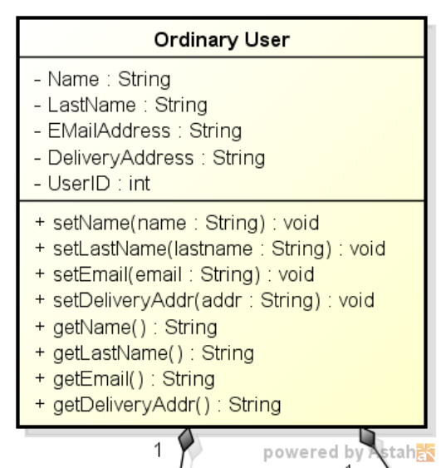

Figure 23: OrdinaryUser Class

Class Name: OrdinaryUser
Fields:
1. Name: Name
Type: String
Description: Name of the ordinary user that is giving an order.
2. Name: LastName
Type: String
Description: Last name of the ordinary user.
3. Name: DeliveryAddress
Type: String
Description: Address information of the user.
4. Name: EMailAddress
Type: String
Description: Email address information of the user.
Methods:
1. All of the methods are classical OOP getter and setter methods that are used to get and set the values of attributes of the class.

5.2.7. OrderCart Class
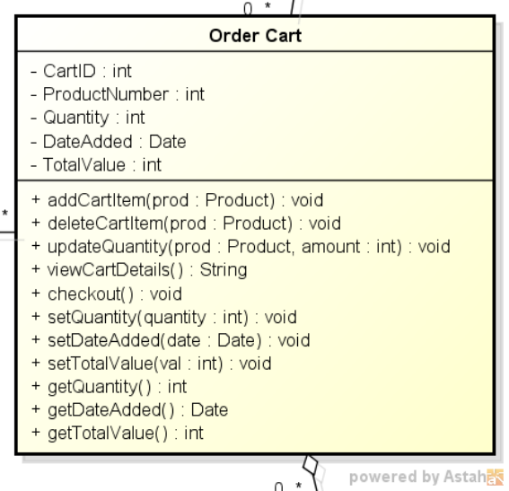

Figure 24: OrderCart Class

Class Name: OrderCart
Fields:
1. Name: ProductNumber
Type: int
Description: The number of the product that is added to the cart.
2. Name: Quantity
Type: int
Description: Quantity of the items that are present on the cart.
3. Name: DateAdded
Type: Date
Description: Cart’s creation date.
4. Name: TotalValue
Type: int
Description: Total value of the items that are present on the cart.
Methods:
1. Name: addCartItem
Description: Adds the selected item to the cart.
2. Name: deleteCartItem
Description: Removes the selected item from the cart.
3. Name: updateQuantity
Description: Changes the quantity of the items that are on the cart.
4. Name: viewCartDetails
Description: Returns the items that are on the cart.
5. Name: checkout
Description: Converts the cart to an order of the system.
6. The rest of the methods are classical OOP getter and setter methods that are used to get and set the values of attributes of the class.

5.2.7.1. Activity Diagrams

Activity Diagrams for the Order Cart class has been merged with the Order Class’ diagram as they are closely related to each other.

5.2.8. Order Class
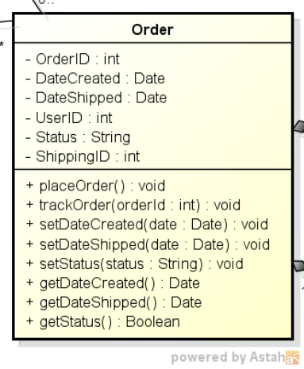

Figure 25: Order Class

Class Name: Order
Fields:
1. Name: DateCreated
Type: Date
Description: Creation date of the order.
2. Name: DateShipped
Type: Date
Description: Shipment date of the order.
3. Name: Status
Type: String
Description: The shipment status of the order.
Methods:
1. Name: placeOrder
Description: Places the order on the system and stores it on database.
2. Name: trackOrder
Description: Returns the tracking information of the order.
4. The rest of the methods are classical OOP getter and setter methods that are used to get and set the values of attributes of the class.

5.2.8.1. Activity Diagrams

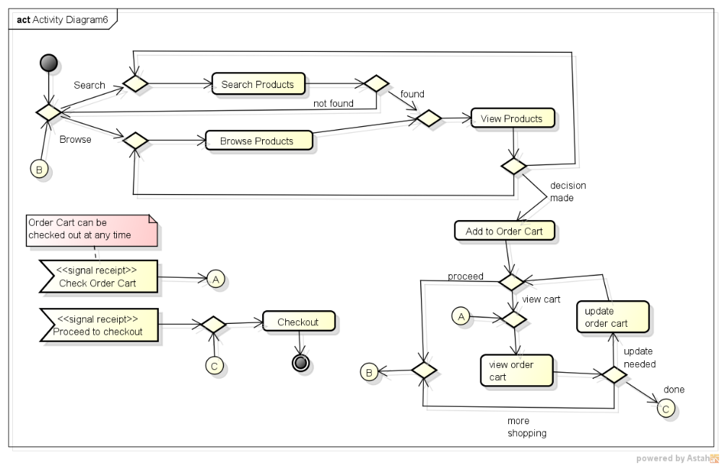
Figure 26: placeOrder Activity Diagram

5.2.9. Product Class
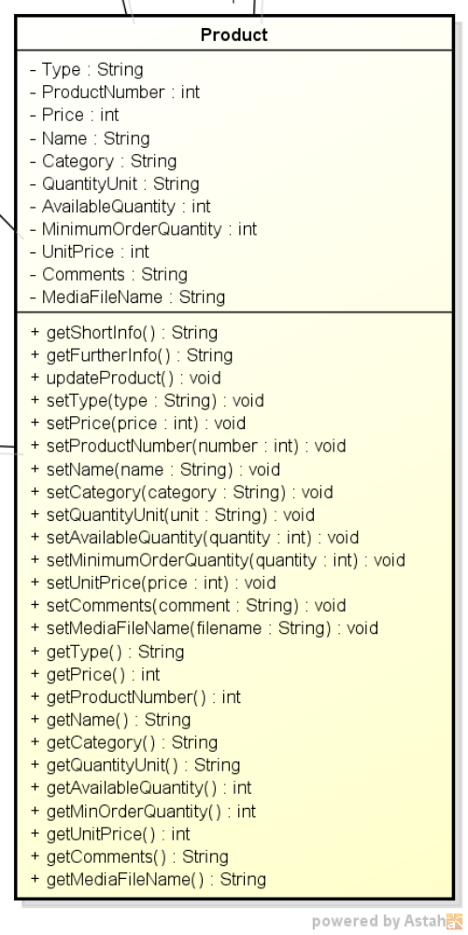

Figure 27: Product Class

Class Name: Product
Fields:
1. Name: Type
Type: String
Description: Type of the product.
2. Name: ProductNumber
Type: int
Description: Unique number that is provided by the user.
3. Name: Price
Type: int
Description: Price of the product per unit.
4. Name: Name
Type: String
Description: Name of the product
5. Name: Category
Type: String
Description: Category of the product.
6. Name: QuantityUnit
Type: String
Description: Unit of the quantity of the product (i.e. kgs.).
7. Name: AvailableQuantity
Type: int
Description: Quantity of the product that is available to sell.
8. Name: MinimumOrderQauntity
Type: int
Description: Minimum quantity of the product to sell.
9. Name: UnitPrice
Type: int
Description: Price per unit.
10. Name: Comments
Type: String
Description: Further comments on the product.
11. Name: MediaFileName
Type: String
Description: Files that may contain some photographs and/or some multimedia files, for example music or film clips in any media format.
Methods:
1. Name: getShortInfo
Description: Returns some brief information about the product.
2. Name: getFurtherInfo
Description: Returns detailed information about the product.
3. Name: updateProduct
Description: Changes the information provided by the user.
4. The rest of the methods are classical OOP getter and setter methods that are used to get and set the values of attributes of the class.

5.2.10. ShippingInfo Class
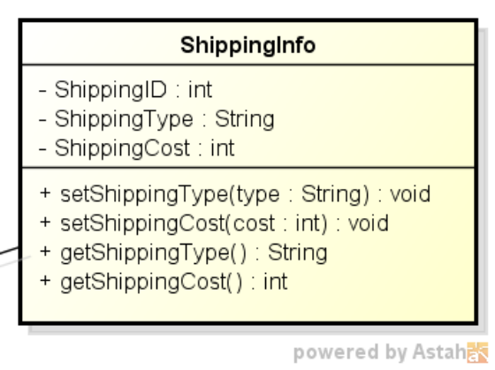

Figure 28: ShippingInfo Class

Class Name: ShippingInfo
Fields:
1. Name: ShippingType
Type: String
Description: Type of shipment (air cargo, standard, fast track).
2. Name: ShippingCost
Type: int
Description: The cost of shipment.
Methods:
1. All of the methods are classical OOP getter and setter methods that are used to get and set the values of attributes of the class.

5.2.11. OrderDetail Class
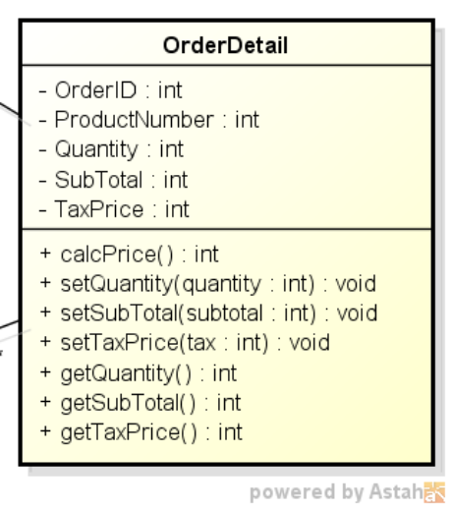

Figure 29: OrderDetail Class

Class Name: OrderDetail
Fields:
1. Name: Quantity
Type: int
Description: Quantity of the items that are present on the order.
2. Name: SubTotal
Type: int
Description: Total price of the order excluding tax.
3. Name: TaxPrice
Type: int
Description: The price of the tax for the items on the order.
Methods:
1. Name: calcPrice
Description: Calculates the grand total of the items that are on the order including tax.
2. The rest of the methods are classical OOP getter and setter methods that are used to get and set the values of attributes of the class.

5.3. Common Infrastructure Modules/Classes

5.3.1. Logger Class
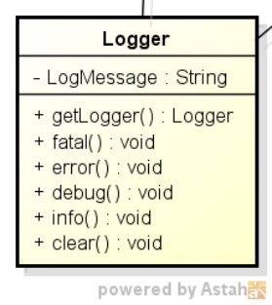

Figure 30: Logger Class

Class Name: Logger
Fields:
1. Name: LogMessage
Type: String
Description: Message to be written on the specified log file.
Methods:
1. Name: getLogger
Description: Returns the logger class instance.
2. Name: fatal
Description: Writes the log message on fatal system errors.
3. Name: error
Description: Writes the log message on system errors.
4. Name: debug
Description: Writes the log message on debug purposes.
5. Name: info
Description: Writes the log message on information purposes.
6. Name: clear
Description: Clears the log file.

6. Testing Design

The testing process covers verification and validation of correct operation and boundary conditions of each
requirement given in Section 5.

During the development, continuous integration will be handled to avoid any errors and integration failures.
This way, any developed code will be tested automatically as soon as they are committed to the code repository.
By the help of extra plug-ins, we will also be having the static code analysis checks to keep the code clean in a daily basis.

Quality assurance specifically deals with the management of quality. In this term “assurance” means that under
the condition that the processes are followed, the quality management can be assured regarding product quality.
Furthermore, quality assurance strives to encourage quality attitudes and discipline among the developers and the
management. Quality assurance encompasses software configuration management, quality control and software testing.

Software testing can be used to verify the implementation of functional requirements and hence is a popular strategy of
risk management. To some extent software testing can also be used to find errors, however, testing cannot prove the
absence of errors in software as testing is only as good as its test cases. Furthermore, by the time that testing occurs, it is
too late to build quality into the product.

According to the IEEE the test plan is part of the test documentation. It prescribes the scope, approach,
resources and schedule of testing activities. Thus it specifies which items and features are to be tested and how, who is
responsible for testing and what associated risks are.

Besides the test plan, the test documentation contains specifications of actual tests and reports of their
application. In GEW application we plan to have the test specifications evolve along with the software. The same holds for the tests of unit testing, which constitute a formalization of test specifications that can be executed by machines. Test reporting will be kept as non-bureaucratic and transparent as possible, rather focusing on immediate feedback so that bugs can be tracked down faster and more easily. For example, automatically generated reports of failed integration
tests instantly inform developers via email. Finally, we want to stress that for creating high quality software it is not
enough to follow a high quality process (including testing), but also to utilize modern and sophisticated technologies,
and to employ motivated, capable and well-trained personnel. We commit ourselves to reacting appropriately to such
challenges.

7. References

- SWE-530-P5-GEW-RSD-2013-05-08-Rev-2.0
- Gurkas-SWE-530-P4-Kuka-DPSD-2013-05-01-Rev-1.0
- Gurkas-SWE-530-P4-Kuka-UMLStandards-2013-04-01-Rev-1.0
- IEEE 1471, http://en.wikipedia.org/wiki/IEEE_1471

