SWE 530 Software Design Process, Spring 2013
Instructor: M. Ufuk Çağlayan

Project 3
CWA: Conference Web Application
Requirements Specifications Document

10.04.2013
Revision 2.0

By: Mustafa Göksu GÜRKAŞ
Student Id: 2011719225

Revision History

Revision | Date | Explanation
1.0 | 27.03.2013 | Initial requirements
2.0 | 10.04.2013 | Initial requirements are transformed into their UML equivalents as the customer requested.

Table of Contents

Revision History 2
Table of Contents 3
1. Introduction 4
2. Requirements 4
2.1. Requirement 1. Main User Interface and Functions 4
2.1.1. Conference Registation and Administrative Functions 4
2.1.2. Overall Functionality 4
2.2. Requirement 2. Function 1: Enter Registration Information 5
2.2.1 Use Case Name: Enter Registration Information 5
2.3. Requirement 3. Function 2: Update Registration Information 6
2.3.1 Use Case Name: Update Registration Information 6
2.4. Requirement 4. Function 3: List Names and Organizations of All Conference Participants 7
2.4.1 Use Case Name: List Conference Participants 7
2.5. Requirement 5. Function 4: Display, update, delete all information about a specific conference participant (administrative function) 7
2.5.1 Use Case Name: Manage Participant Information 7
2.6. Requirement 6. Function 5: List all registration information about all conference participants (administrative function) 8
2.6.1 Use Case Name: List All Participants’ Information 8
2.7. Requirement 7. Function 6. Send email to all conference participants (administrative function) 9
2.7.1 Use Case Name: Send Email to Participants 9
2.8. Requirement 8. Development Environement 9
2.9. Requirement 9. Security 9
2.10. Requirement 10. Conference Administrators and Logging 10
3. Appendices 11
3.1. Class Diagram for Conference Web Application 11
3.2. Miscellaneous 12
3.2.1. Table Formats 12

1. Introduction

The purpose of the software project is to develop a web application in an object oriented programming language such as C++ or Java, in LINUX and MySQL environment, to do mainly the following.

- Participants of a conference should be able to register for the conference and update their registration information,
- Conference administrators should be able to retrieve information about individual conference participants, update participant information, enter additional participant information and display/list conference participant information in various forms.

The web application functions and user interface details are given in the following sections of this document.

2. Requirements

2.1. Requirement 1. Main User Interface and Functions

2.1.1. Conference Registation and Administrative Functions

The application shall be able perform the following operations (partitioned according to their actors) throughout its execution plan. Note that, all functions below are links to related web pages.

I am a participant of the conference and;
- I want to register for the conference,
- I want to display my registration information,
- I want to update my registration information.

I am an administrator of the conference system and;
- I want to list the names and organization information of all conference participants,
- I want to display all information about a specific conference participant,
- I want to update the information of a specific conference participant,
- I want to delete a specific conference participant,
- I want to send email to all conference participants.

2.1.2. Overall Functionality

The use case diagram below depicts the overall functionalities and the actors of the application.

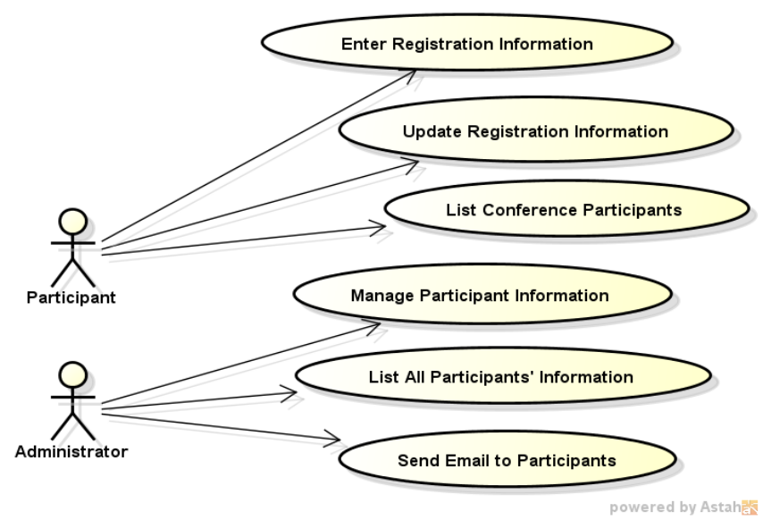

Figure 1: Use Case Diagram of CWA

2.2. Requirement 2. Function 1: Enter Registration Information

2.2.1 Use Case Name: Enter Registration Information
Actors:
- Participant
Triggers:
The participant indicates that he wants to register for the conference through Conference Web Application.
Pre-conditions:
None.
Post-conditions:
A new participant is added in Conference Web Application Database.
Normal Flow:
- Participant indicates that he wants to register for the conference.
- Participant clicks on the “Register for the Conference” button.
- System displays the form that includes the information fields to be filled by the participant some of which are mandatory fields and are marked with a “*” sign next to them.
- System warns the participant about his obligation to fill the mandatory fields to complete his registration.
- Participant enters his lastname to the field “Lastname”, which is a mandatory field.
- Participant inputs his name to the field “Name”, which is a mandatory field.
- Participant enters his email address to the field “Email”, which is a mandatory field.
- Participant specifies his password on the field “Password”, which is a mandatory field.
- Participant inputs his organization’s name to the field “Organization”, which is a mandatory field.
- Participant enters his job function to the field “Job Function”.
- Participant specifies his office phone number on the field “Office Phone”.
- Participant enters his GSM phone number to the field “GSM Phone”.
- Participant enters his address information to the field “Address Line 1”.
- Participant chooses his country of address from a list of all countries.
- Participant enters his payment due date to the field “Payment Due”.
- Participant inputs his status of payment to the field “Payment Status”.
- Participant enters some comments (if there is any) to the field “Comments”.
- Participant submits the form to the system by clicking on the “SUBMIT” button.
- System controls whether the given information is appropriate or not.
- System generates a web link and random character string to be used in confirmation process.
- System sends an email to the participant’s mail address which includes a proper message about his confirmation and activation of conference registration by clicking the web link generated by the system.
- System displays the “RETURN to MAIN MENU” button to enable the participant to return to the main menu.
- Participant clicks on the button.
- System displays the main menu to the participant.
- Participant clicks on the confirmation link that the system sent him through his email.
- System controls whether the participant confirmed his registration within 24 hours.
- System stores the participant information on the CWA database as a participant where the date and time of registration in the format yyyymmdd-hhmm must also be recorded in the database.
- System displays an information page to the participant on which includes the participant number and the name of the conference.
- Participant clicks on the “RETURN to MAIN MENU” button.
- System displays the main menu to the participant.

Alternate Flows:
18A1. Participant discovers that he wants to clear the information that he has put on the form, and clicks on “CANCEL” button.
- Participant clicks on the “CANCEL” button.
- System clears all the information that is put on the form.
- The use case returns to step 3 of normal flow and continues.
20A1. System discovers that the email address that the participant has provided exists on the database, and warns the participant.
- System indicates that there is another participant data that uses the same email address that the participant has provided.
- System displays a warning to the participant about the existence of the same email address and warns the participant to enter a new one.
- Paticipant enters another email address to the “Email” field.
- The use case returns to step 19 of normal flow and continues.
27A1. System discovers that the paticipant has not confirmed his registration within 24 hours, and warns the participant.
- System indicates that the confirmation of registration has been performed 24 hours or more later than the submission.
- System discards the information that has been provided by the participant.
- System warns the participant to start the registration process from scratch.
- The use case returns to step 3 of normal flow and continues.

2.3. Requirement 3. Function 2: Update Registration Information

2.3.1 Use Case Name: Update Registration Information
Actors:
- Participant
Triggers:
The participant indicates that he wants to update his registration information he has provided before.
Pre-conditions:
The participant has been registered to Conference Web Application.
Post-conditions:
The participant’s information is changed on Conference Web Application database.
Normal Flow:
- Participant indicates that he wants to update his registration information on CWA.
- System displays a form to the participant in order to be able to authenticate the participant.
- Participant enters his email address, that is recorded before on the CWA database during registration, to the “Email” field.
- Participant enters his password, that is determined before on the CWA database during registration, to the “Password” field.
- Participant submits the form to the system by clicking on the “SHOW MY REGISTRATION INFO” button.
- System controls whether provided credentials are valid according to the database records or not.
- System displays all of the participant’s information on a tabular form, including the participant’s registration number and the time of registration, which are editable for the participant except for “Payment Due”, “Payment Status” and “Registration Date”.
- Participant changes the fields as he likes. (i.e. he may change the “Password” field in order to change his password.)
- Participant submits the form to the system by clicking on “UPDATE” button.
- System asks for a confirmation of the participant to proceed update operation.
- Participant confirms the update operation.
- System updates the participant’s information as provided on the database.
- System displays a proper message to the participant for a successful completion of his information update.

Alternate Flows:
5A1. Paticipant indicates that he forgot his password and needs a recall of the system, and clicks on “I FORGOT MY PASSWORD” button.
- Paticipant clicks on “I FORGOT MY PASSWORD” button.
- System sends an email, which includes his system password, to the participant’s email address that was recorded on the database during his registration.
- The use case returns to step 2 of normal flow and continues.
5A2. Participant indicates that he wants to give up update operation, and clicks on “CANCEL” button,
- Participant clicks on “CANCEL” button.
- System displays the main menu to the participant.
- The use case ends.
6A1. System discovers that provided credentials do not exist on the database, and warns the participant.
- System indicates that the email-password pair doesn’t exist on the CWA database.
- System displays a warning to the participant about the incorrect information entry and suggests participant to try submission again.
- The use case returns to step 2 of normal flow and continues.
9A1. Participant indicates that he wants to give up update operation after changing the fields on update screen, and clicks on “CANCEL” button.
- Participant clicks on “CANCEL” button.
- System displays the main menu to the participant.
- The use case ends.

2.4. Requirement 4. Function 3: List Names and Organizations of All Conference Participants

2.4.1 Use Case Name: List Conference Participants
Actors:
- Participant
Triggers:
The participant indicates that he wants to list the participants of the conference.
Pre-conditions:
None.
Post-conditions:
None.
Normal Flow:
- Participant indicates that he wants to see the list of all participants of the conference.
- Participant clikcs on “DISPLAY” button.
- System displays a heading and the total number of participants for the conference.
- System displays the sequentially numbered list of all conference participants in database one screenful at a time, with their lastname, name and organization information, sorted by lastname.
- System displays a button called “PREVIOUS”, that can be used by the participant to browse to the previous page of participant list.
- System displays a button called “NEXT”, that can be used by the participant to browse to the next page of participant list.

Alternate Flows:
2A1. Participant indicates that he wants to export the list of all participants of the conference, and clicks on “EXPORT MS Word DOC FILE” button.
- Participant clicks on “EXPORT MS Word DOC FILE” button.
- System lists all the participants of the conference to a word document, with a heading for the conference and a table with proper column headings and one table row per participant.
- Participant saves the Word document on his local disk.
- System directs the participant to the main menu.
- The use case ends.

2.5. Requirement 5. Function 4: Display, update, delete all information about a specific conference participant (administrative function)

2.5.1 Use Case Name: Manage Participant Information
Actors:
- Administrator
Triggers:
The administrator indicates that he wants to manage (display/update/delete) the information of a specific participant.
Pre-conditions:
None.
Post-conditions:
If an update/delete occurs, participant data will be changed.
Normal Flow:
- Administrator indicates that he wants to manage a participant’s information on CWA.
- System displays a form to the administrator in order to be able to authenticate the administrator and decide which participant to get.
- Administrator enters the participant’s email address to the “Email” field or enters the participant’s registration number to the “Registration ID” field.
- Administrator enters his password to the “Password” field.
- Administrator submits the form to the system by clicking on the “SHOW REGISTRATION INFO” button.
- System controls whether provided email address/registration id exist and the administrator’s password is valid on the database or not.
- System displays all of the participant’s information on a tabular form, including the participant’s registration number and the time of registration, which are editable for the administrator.
- Administrator changes the fields as he likes. (i.e. he may change the “Email” field of a participant in order to change his email record on the system.)
- Administrator submits the form to the system by clicking on “UPDATE” button.
- System asks for a confirmation of the administrator to proceed update operation.
- Administrator confirms the update operation.
- System updates the participant’s information as provided on the database.
- System logs the update activity of administrator to a log file in a proper format.
- System sends an informative e-mail to the “Master Conference Administrator” (See Requirement 10) explaining the actions taken on participant’s registration data.
- System displays a proper message to the administrator for a successful completion of information update.

Alternate Flows:
5A1. Administrator indicates that he wants to give up management operation, and clicks on “CANCEL” button,
- Administrator clicks on “CANCEL” button.
- System displays the main menu to the administrator.
- The use case ends.
6A1. System discovers that provided credentials do not exist on the database, and warns the administrator.
- System indicates that the email/registration id-password pair doesn’t exist on the CWA database.
- System displays a warning to the administrator about the incorrect information entry and suggests administrator to try submission again.
- The use case returns to step 2 of normal flow and continues.
9A1. Administrator indicates that he wants to delete the participant from CWA, and clicks on “DELETE” button.
- Administrator clicks on “DELETE” button.
- System asks for a confirmation of the administrator to proceed delete operation.
- Administrator confirms the delete operation.
- System deletes the record of the selected participant from CWA database.
- System logs the delete activity of administrator to a log file in a proper format.
- System sends an informative e-mail to the “Master Conference Administrator” (See Requirement 10) explaining the actions taken on participant’s registration data.
- System displays a proper message to the administrator for a successful completion of deletion.
- The use case ends.
9A2. Administrator indicates that he wants to give up update/delete operation of a participant, and clicks on “CANCEL” button.
- Administrator clicks on “CANCEL” button.
- System displays the main menu to the administrator.
- The use case ends.

2.6. Requirement 6. Function 5: List all registration information about all conference participants (administrative function)

2.6.1 Use Case Name: List All Participants’ Information
Actors:
- Administrator
Triggers:
The administrator indicates that he wants to list all information of all participants.
Pre-conditions:
None.
Post-conditions:
None.
Normal Flow:
- System displays a form to the administrator in order to be able to authenticate the administrator.
- Administrator enters his password to the “Password” field.
- Administrator clicks on “LIST” button.
- System displays a sequentially numbered list sorted by lastname of all conference participants in database.
- Administrator clicks on “DISPLAY” button.
- System displays all conference participants one screenful at a time with each display screen containing a heading for the conference, the total number of records for that conference and buttons to display previous and next screens and return to main menu.

Alternate Flows:
5A1. Administrator indicates that he wants to export the list of all participants of the conference, and clicks on “EXPORT MS Word DOC FILE” button.
- Administrator clicks on “EXPORT MS Word DOC FILE” button.
- System lists all the participants of the conference to a word document, with a heading for the conference and a table with proper column headings and one table row per participant.
- Administrator saves the Word document on his local disk.
- System directs the administrator to the main menu.
- The use case ends.
5A2. Administrator indicates that he wants to export the list of all participants of the conference, and clicks on “EXPORT MS Word XLS FILE” button.
- Administrator clicks on “EXPORT MS Word XLS FILE” button.
- System lists all the participants of the conference to an excel document, with a heading for the conference and a table with proper column headings and one table row per participant.
- Administrator saves the Excel document on his local disk.
- System directs the administrator to the main menu.
- The use case ends.

2.7. Requirement 7. Function 6. Send email to all conference participants (administrative function)

2.7.1 Use Case Name: Send Email to Participants
Actors:
- Administrator
Triggers:
The administrator indicates that he wants to send an email to all participants.
Pre-conditions:
None.
Post-conditions:
None.
Normal Flow:
- System displays a form to the administrator in order to be able to authenticate the administrator.
- Administrator enters his password to the “Password” field.
- System controls whether the password of the administrator is valid or not.
- System displays the email composition screen, that is composed of “Subject”, “Email Message” and “Attachment” fields, to the administrator.
- Administrator enters the subject of the email to the “Subject” field,
- Administrator inputs the message body of his email to the “Email Message” field.
- Administrator clicks on the “Any File to Attach” field if he wants to attach a file to that email.
- System provides a browsing function to the administrator to let him select the file from his local disk.
- Administrator browses his local disk and selects the file to be sent by email.
- Administrator clicks on the “SEND EMAIL” button.
- System sends the email one by one to all conference participants that are present on the database.

Alternate Flows:
4A1. System discovers that provided password doesn’t exist on the database, and warns the administrator.
- System indicates that the password doesn’t exist on the CWA database.
- System displays a warning to the administrator about the incorrect information entry and suggests him to try submission again.
- The use case returns to step 1 of normal flow and continues.
10A1. Administrator indicates that he wants to clear the contents of the email, and clicks on “CLEAR” button.
- Administrator clicks on “CLEAR” button.
- System deletes all the information that are entered from the email form.
- The use case returns to step 4 of normal flow and continues.
10A2. Administrator indicates that he wants to return back to the main menu without sending the email, and clicks on “BACK TO MAIN MENU” button.
- Administrator clicks on “BACK TO MAIN MENU” button.
- System displays the main menu to the administrator.
- The use case ends.

2.8. Requirement 8. Development Environement

The software will be developed in an object oriented programming language such as C++ or Java. The development and operation environment is any computer system with LINUX OS and MySQL DBMS.

2.9. Requirement 9. Security

All client-server operations over Internet will be through SSL to provide security.

2.10. Requirement 10. Conference Administrators and Logging

When the server side of the conference web application is installed first time and/or started with a new and empty database, it must allow the entry of a conference name, conference web address and up to 10 administrator names, email addresses and passwords. The first administrator in the list of all conference administrators is the master conference administrator. Conference identification is by the conference web address.

Actions of all conference administrators regarding participant deletion, participant name, lastname, email, payment due and payment status updates must be logged to a file and info about such actions must be emailed to the first administrator in the list of all conference administrators, the master conference administrator.

3. Appendices

3.1. Class Diagram for Conference Web Application

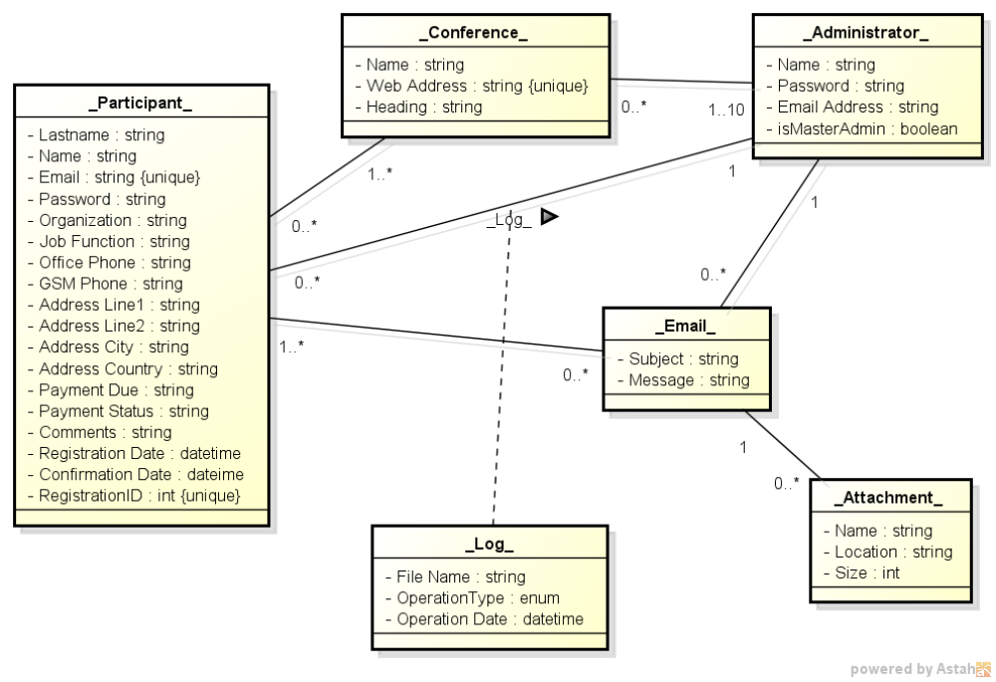

Figure 2: Class Diagram of CWA

3.2. Miscellaneous

3.2.1. Table Formats

The tabular form that shall hold the participants’ information that is mentioned in Requirement 4 of this document is depicted below.

GENERAL INFORMATION OF THE PARTICIPANTS FOR
XXXXX CONFERENCE
Sequence Number | Lastname | Name | Organization
1 | … | .. | …
2 | … | … | …
3 | Caglayan | M. Ufuk | Bogazici University
4 | … | … | …

Figure 3: Tabular Form (Requirement 4)

The tabular form that shall hold the participants’ information that is mentioned in Requirement 6 of this document is depicted below.

INFORMATION OF THE PARTICIPANTS FOR
XXXXX CONFERENCE
Sequnce Num. | Registration ID | Lastname | Name | Email | Organization | Job Function | Office Phone | GSM | Address Line 1 | Address Line 2 | Address City | Address Country | Payment Due | Payment Statyus | Comments
98
99 | 123 | Caglayan | M. Ufuk | caglayan@boun.edu.tr | Bogazici University | Prof. | … | … | … | … | … | … | … | … | …
100

Figure 4: Tabular Form (Requirement 6)

