Ground Penetrating Radar

Team 24

Progress Report

March 6 2016

ECEN 404 – Senior Design Project

Texas A&M University, College Station, TX

Daniel Miller

Michael Turner

Tyler Castro

Coy Coburn

# Abstract

The goal of this project is to create a ground penetrating radar system to serve as a non-destructive method for mapping plant root systems. The system consists of a transmitting and receiving antenna and circuitry for both the transmitter and receiver. The transmitting circuit generates a linear frequency-modulated continuous wave from 2.4- 2.475GHz. The wave is pulsed to avoid interference between the transmitting and receiving antenna. The transmitting antenna passes the generated signal into the ground while the receiving antenna collects the reflected signal. The signal will reflect off materials with different dielectric constants like that of roots and pipes. The received signal will then be sent through an LNA for amplification to balance any loss of gain. The signal is also fed into a frequency mixer to correct any occured frequency shift. Finally, the IF signal is converted into digital data that will be recorded for image processing.

# Table of Contents

**Abstract**

**Table of Contents**

**1 Project Overview**

1.1 Proposed System

1.2 Project Deliverables

1.2.1 Project Specifications

1.2.2 Significant Direction Changes

1.3 Project Timeline and Task Ownership

**2 Subsystem Antennas**

2.1 Significant Changes in Direction

2.2 Subsystem Specifications

2.3 Subsystem Status

2.4 Subsystem Technical Details

2.5 Subsystem Testing

2.5.1 Validation of Antenna Specifications

**3 Subsystem Receiver Circuit**

3.1 Significant Changes in Direction

3.2 Subsystem Specifications

3.3 Subsystem Status

3.4 Subsystem Technical Details

3.5 Subsystem Testing

3.5.1 Schottky Diode

3.5.2 PIN Diode Driver

**4 Subsystem Signal Generation**

4.1 Significant Changes in Direction

4.2 Subsystem Specifications

4.3 Subsystem Status

4.4 Subsystem Technical Details

4.5 Subsystem Testing

4.5.1 VCO output

**5 Subsystem Receiver Signal Converter**

5.1 Significant Changes in Direction

5.2 Subsystem Specifications

5.3 Subsystem Status

5.4 Subsystem Technical Details

5.5 Subsystem Testing

5.5.1 Mixer induced frequency shift

**6 Conclusions**

**References**

**Appendix A Project Budget**

**Appendix B Subsystem Schematic**

Function Generator Schematic

Receiver Circuit Diagram

**List of Figures**

**Figure 1.1: System block diagram.**

**Figure 1.2: Gantt Chart**

**Figure 2.1: Figure 2.1: Vivaldi Antenna Diagram, with microstrip feedline**

**Figure 3.1: Schottky test circuit diagram**

**Figure 3.2: PIN diode driver test circuit diagram**

**Figure 5.1. Typical output phase noise plot for the AD9834**

**List of Tables**

**Table 1.1 Specification Compliance Matrix**

**Table 1.2 Responsibility Matrix**

**Table 2.1** **Antenna specification Compliance Matrix**

**Table 2.2** **Antenna Design**

**Table 3.1** **Receiver Circuit** **specification Compliance Matrix**

**Table 4.1 Signal Generation specification Compliance Matrix**

**Table 5.1** **Signal Generation specification Compliance Matrix**

**Table A-1 Project Budget**

**Table B-1 BOM for Signal Generation**

**Table B-2 BOM for Receiver Circuit**

# Project Overview

The GPR root mapping systems will locate plant roots underground using radar waves emitted and received by arrays of antennas. Mathematical equations will be applied to the reflected signal so the user can interpret the data. Geophysicists can use this data to examine plant root growth over a period of time.

## Proposed System

The transmitting circuit will generate a continuous wave RF signal with a linearly swept frequency from 2.4025 to 2.4775 GHz. This signal will be fed into the transmitting antenna, which will propagate the wave into the ground. Waves that are reflected off of objects underground will be picked up by the receiver antenna and run into the receiver circuit. The receiver circuit will amplify the signal before passing it to the demodulator, which will convert it to digital point for future signal processing.

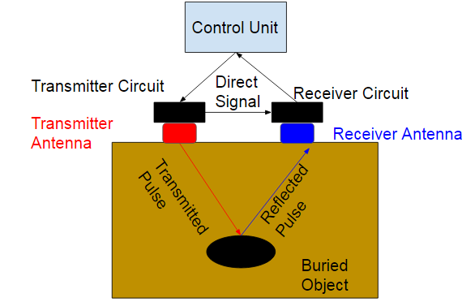

Figure 1.1: System block diagram.

## Project Deliverables

By the end of the semester, we plan to have a working radar system that is able to detect roots 2 inches wide and 4 feet deep in sand.

### Project Specifications

The transmitted signal will reach a ground depth of at least 0.7 m and up to 1.2 m. The spatial resolution will be at most 7.62 cm (3 in). There will be at least one working channel from transmitter to receiver circuitry through vivaldi antennas. These two vivaldi antennas will be specifically designed to transmit through sand with a dielectric constant of 6 at a frequency from 2.4 - 2.475 GHz. Once the received signal has been converted into digital form, the data will be recorded and stored into files that can be sent to systems for image processing.

Table 1.1  
Specification Compliance Matrix

|  |  |  |  |
| --- | --- | --- | --- |
| Specification | Min | Nominal | Max |
| Ground Depth | .7 m | - | 1.2 m |
| Spatial Resolution | - | - | 7.62 cm |
| Operation Frequency | 2.4 GHz | - | 2.75 GHz |

### Significant Direction Changes

The project has recently been altered to operate using a single channel, or only one transmitting and one receiving antenna. Once a single channel has been implemented, we then look towards implementing an array of antennas. This is due to time constraints, and the importance of pure functionality over the less important array feature. Additionally, the frequency range has been heightened considerably, from a center frequency of 915 MHz to a center frequency of 2.44 GHz. This helps our resolution greatly, but hinders our penetration depth into the ground. The penetration depth is to be improved by providing more power to our signals. The change in frequency is also due to our shift away from pulse compression to continuous wave, which will lower the complexity and cost of our system by eliminating the use of SAW filters.

## Project Timeline and Task Ownership

Tyler Castro is responsible for the design and construction of antennas that are able to operate properly in the frequency range required of the system. He will also test the antennas using a network analyzer to determine optimal specifications. Daniel Miller is responsible for signal generation. He calculated the power loss through the media and estimated the amount of power needed at the output of the antenna as well as throughout the transmitting circuit. Michael Turner is responsible for the design and construction of the receiver circuit. The receiver circuit must be able to amplify the signal obtained from the receiver antenna and pass it to the receiver signal converter. Coy Coburn is responsible for the design and construction of the receiver circuit that will mix, demodulate, and convert the received analog signal into digital data.

Table 1.2  
Responsibility Matrix

|  |  |  |
| --- | --- | --- |
| Subsystem | Responsible Engineer | Responsibilities |
|  |  |  |
| Antennas | Tyler Castro | Design and build antennas, and optimize performance |
| Signal Generation | Daniel Miller | Design and build the transmitter circuit for the generated signal. |
|  |  |  |
| Receiver signal converter | Coy Coburn | Design and build the receiver circuit that will mix and demodulate the incoming signal. |
| Receiving Circuit | Michael Turner | Design and build the receiver circuit that will amplify the incoming signal |

Below is the Gantt Chart for the 404 semester.

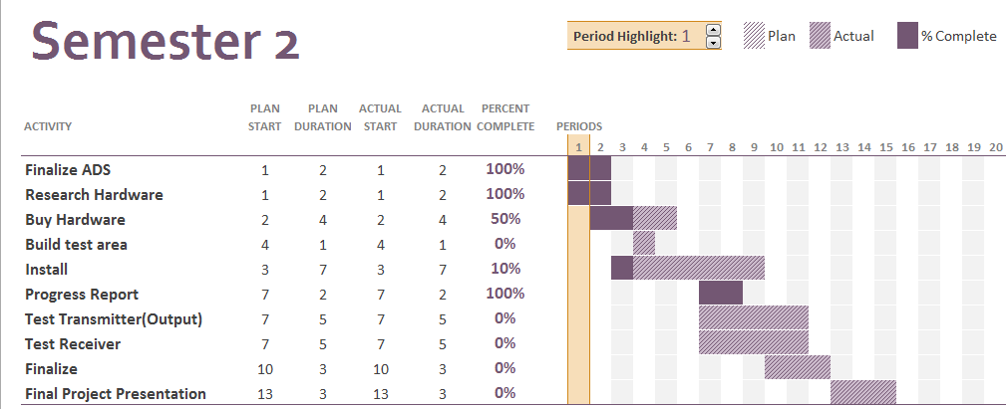

Figure 1.2: Gantt Chart

# Subsystem Antennas

The antennas are responsible for both propagating the signal generated by the transmitting subsystem into the ground, as well as receiving the reflections of the signals that reflect off of objects in the ground. The initial design will have a single transmitting and a single receiving antenna. An array of antennas will be implemented once a single channel is proven to be working. An input signal will be fed into a balun that will prevent current from flowing along the outside of the unbalanced coaxial cable once it reaches the balanced antenna. The output of the balun will be soldered to the sides of a vivaldi antenna, cut from sheet metal and placed in a plastic tube with measurements calculated for a frequency propagation between 2.4 - 2.5 GHz, which will be pointed to the ground. Reflections from objects buried underground will be picked up by another antenna, also connected to a coaxial cable that will serve as the input to the receiving subsystem.

## Significant Changes in Direction

The Antenna Subsystem was created rather recently, as joint efforts were previously being made to create a working transmitting system. The main change in direction is that the antenna is no longer planning to be mounted to a substrate, but rather be suspended in a medium. Our prototype antenna will rest inside a cylindrical plastic tube, having the antenna surrounded by air. Also, initial plans were to have the operating frequency of the antenna be between 900 MHz to 1 GHz, but we have now increased the range of operation to 2.4 - 2.5 GHz. This provides higher resolution and allows for a much smaller antenna design, with the sacrifice being penetration depth. Penetration depth is to be improved with the implementation of an antenna array.

## Subsystem Specifications

In order to transmit and receive the signal properly, the antenna must be constructed according to calculated measurements. Important elements include the length and width of the tapered slot and the diameter of the circular slot stub, located behind the coaxial feed location, as shown in figure - in section 2.4. Width is calculated to be one half of the minimum wavelength of operation, and length is calculated to be the minimum wavelength of operation. The diameter of the slot stub is calculated to be one fourth of the effective wavelength. Another vital specification is the exponential curve of the sides of the tapered slot, which is calculated in section 2.4.

Table 2.1  
Antenna specification Compliance Matrix

|  |  |  |  |
| --- | --- | --- | --- |
| Specification | Min | Nominal | Max |
| Operating Frequency | 2.4025 GHz | N/A | 2.4775 GHz |
| Length of Tapered Slot  Width of Tapered Slot  Diameter of Circular Slot Stub | .125 m  .0625 m  .0306 m | .126 m  .0635 m  .0306 m | N/A  N/A  .0306 m |
|  |  |  |  |

## Subsystem Status

Currently, an antenna surrounded by air has been constructed, except for the slot stub. The coaxial lines have been ordered, and the toroidal core for the balun is also not in-hand yet. Testing can begin the moment components come in and the cable is soldered to the antenna.

## Subsystem Technical Details

A diagram of the vivaldi antenna is shown in (2.1). Note that instead of a microstrip feedline, we are soldering the conductors of a coaxial cable directly to the feed point shown in the diagram. The purpose of using a vivaldi antenna is to provide a smooth transition between the wave being guided through the slotline to the plane wave. This is made possible through the exponential curve of the slotline. The coaxial cable is soldered to where the voltage difference occurs across the slotline gap. As the signal travels across the edges, the increase in the size of the gap causes a gradual change in impedance, until the signal is matched with its surrounding medium, allowing it to propagate out of the metal. The coordinates for the curve are found using (2.1), with (2.2) and (2.3) being supplemental. The coordinate system used has the origin at the center of the coaxial feed point. This mean that, for one side of the antenna and with an initial slotline width of 2 mm, (z1,y1)=(0,1) and (z2,y2)=(126,31.75). The rate of expansion, R, should be adjusted according to how the antenna performs during testing, but as a starting point, has been set to .2 after consulting other vivaldi antenna tests. This sets C1 at .220561 and C2 at -.263939, making the equation used for the curvature of our antenna (2.4).

|  |  |
| --- | --- |
| Figure 2.1: Vivaldi Antenna Diagram, with microstrip feedline |  |
|  | (2.1) |
|  | (2.2) |
|  | (2.3) |
|  | (2.4) |

The balun is a vital aspect of the antenna system, as directly soldering an unbalanced line such as a coaxial cable to a balanced antenna has debilitating effects. Common mode waves, where current is flowing in the same direction on both conductors of the transmission line, is undesirable because it causes the outer surface of the coaxial cable to radiate, causing power to be lost radiating in the wrong direction, which makes the antenna much less effective. For our subsystem, a 1:1 choke balun is to be implemented using a toroidal core. Before feeding into the antenna, the coaxial cable will be wrapped around the toroidal core N amount of times, preventing signals from flowing along the outer surface of the coaxial cable. The necessary amount of loops around the core, N, is expected to be 10, but can be modified if performance is not acceptable.

Vivaldi antennas generally have a gain of roughly 5-10 dBi, and we are expecting a bandwidth of about 75 MHz. The reflection coefficient at the input, S11, is expected to be around .333, and is dependent on how smooth and sharp the exponential curve of the antenna is.

Table 2.2  
Antenna Design

|  |  |  |
| --- | --- | --- |
| Parameter | Specification | Simulation results |
| Gain | 5-10 dBi | - |
| Bandwidth | 75 MHz | - |
| Reflection Coefficient | .333 | - |

## Subsystem Testing

### Validation of Antenna Specifications

The purpose of this test is to use a network analyzer to fully test the functionality of the constructed vivaldi antennas in order to verify that the specifications allow the antenna to operate at an acceptable level for the system as a whole. The major passing condition is whether the antenna is deemed able to properly emit a signal powerful enough to overcome attenuation through the ground. Specifications can be actively altered during testing until results are acceptable.

#### Test Setup

The input coaxial line will be fed into a network analyzer for testing. The vivaldi antenna must be facing free space with no obscurities around it. The primary results to be analyzed from the network analyzer include the reflection, the VSWR, the smith chart, and the radiation.

#### Data

Currently, the test has not yet been completed due to lack of physical components. Testing is to be run as soon as the subsystem is complete.

#### Test Conclusion

Currently, the test has not yet been completed due to lack of physical components. Testing is to be run as soon as the subsystem is complete.

# Subsystem Receiver Circuit

The receiving circuit will take the signal obtained by the receiver antenna and amplify the signal before passing it on the the demodulator. Circuit itself will consist of a PIN diode and driver circuit, a schottky diode clamp, and an LNA (Low Noise Amplifier). The circuit diagram for the subsystem is in Appendix B.

## Significant Changes in Direction

The original design of the circuit consisted of a TVG (Time Varying Gain) followed by a LNA. The TVG was removed due to the risk of it producing noise that could lead to the loss of detected objects. A PIN diode and a schottky diode clamp were added to help prevent high powered signals, that could be generated from the air to ground reflection, from damaging the LNA. A driver was added to control the switching of the PIN diode. These changes help simplify the design and construction of the receiver circuit as well as help improve its ability to handle the signal obtained by the receiver antennas.

## Subsystem Specifications

In order to prepare the signal for converting, the receiver circuit must be able to amplify the signal for the demodulator while limiting the incoming signal to protect the LNA. Important elements include the LNA, the schottky diodes and the PIN Diode Driver. The specifications of the important elements are listed in Table 3.1.

Table 3.1  
 Receiver Circuit specification Compliance Matrix

|  |  |  |  |
| --- | --- | --- | --- |
| Specification | Min | Nominal | Max |
| LNA Gain | 15.5 dB | 17.9 dB | 18.9 dB |
| LNA Noise Figure | 0.4 dB | 0.5 dB | 0.9 dB |
| Schottky Diode Forward Voltage | 250 mV | 340 mV | 700 mV |
| PIN Diode Driver Switching Speed | 10 ns | 50 ns | 100 ns |
|  |  |  |  |

## Subsystem Status

Currently the receiver has been designed and simulations using ADS (Advanced Design Software). The LNAs and the LNA eval board have arrived. The Schottky diodes and SMA cords have been ordered. The PIN diode driver needs work to improve its switching speed.

## Subsystem Technical Details

The LNA is the main component of the receiver circuit as it is required to amplify the signal for the signal converter. The LNA needs a very low noise figure and must be able the handle the required frequency range of 2.4GHz. The TAV-541+ was chosen because it meets the requirements with a frequency range of 0.450 GHz to 6 GHz, a noise figure of 0.7 dB at 2.4 Ghz, and has a gain of 18 dB at 2.4 Ghz.

The schottky diodes are added to protect the LNA from high powered signals. The activation range of the schottky diode was determined to be between 1 dBm and 17 dBm. Using the equation 3.1, it was calculated that the schottky must have a forward voltage greater than 0.250 V but lower 1.5V. The 1PS70SB84 was chosen because it meets the requirements with a forward voltage of 0.340 V.

|  |  |
| --- | --- |
|  | (3.1) |

The PIN diodes and driver were added to protect the LNA from initial air to ground reflection. The PIN diode driver must be able produce the proper forward voltage and reverse current to drive the PIN Diode. The driver must also be able to switch between forward bias and reverse bias rapidly.

## Subsystem Testing

Two test will be performed for the receiver circuit. The first will test if the schottky diodes can limit high powered signals that can damage the LNA. The second will test if the PIN diode driver can successfully generate the proper forward voltage and reverse current.

### Schottky Diodes

The purpose of this test it to determine if the Schottky diodes can protect the LNA from high powered signals. The Schottky needs to turn on when the input is between 0.250 V and 1.5 V to sufficiently prevent high powered signals from passing to the LNA. The test will pass if the Schottky diodes can activated within that range.

#### Test Setup

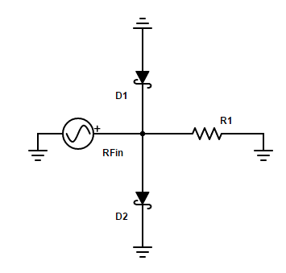

Figure 3.1 Schottky test circuit diagram

The test will be conducted in lab using the function generator, the oscilloscope, the schottky diodes (D1 and D2), and a 50Ω resistor (R1). The circuit will be set up as shown in Figure 3.1. The function generator (RFin) will generate a sine wave with a frequency of 2.4 GHz with a starting amplitude of 100 mV. A probe from the oscilloscope will be connected after the schottky diodes and measure the signal over the 50Ω resistor (R1). The amplitude of function generator will be increased until 2 V.

#### Data

No data has been recorded for this test setup as of now. This will change once the necessary hardware has been bought and accounted for.

#### Test Conclusion

No data has been recorded for this test setup as of now. This will change once the necessary hardware has been bought and accounted for.

### PIN Diode Driver

The purpose of this test it to determine if the PIN Diode driver can produce the proper forward voltage and reverse current. The test will pass if the PIN Diode driver can properly produce the correct forward voltage and reverse current.

#### Test Setup

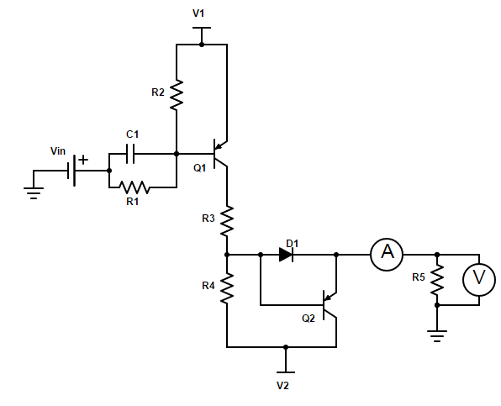

Figure 3.2 PIN diode driver test circuit diagram

The test will be conducted in lab using 3 DC power supply, a voltmeter, an ammeter, the PIN diode driver, and a 50Ω resistor (R5). The circuit will be set up as shown in Figure 3.2. The first DC power supply will be connected to V1 and set to 5V. The second DC power supply will be connected to V2 and set to 40V. The third DC power supply will be connected to Vin and set to 0V. A voltmeter will be connected in parallel to the 50Ω resistor (R5) to measure the forward voltage. Vin will be set to 5V. The ammeter will be connected in series with the 50Ω resistor (R5) to measure the reverse current.

#### Data

No data has been recorded for this test setup as of now. This will change once the necessary hardware has been bought and accounted for.

#### Test Conclusion

No data has been recorded for this test setup as of now. This will change once the necessary hardware has been bought and accounted for.

# Subsystem Signal Generation

Signal generation focuses on generating a linear frequency-modulated continuous wave. The signal will operate in the 2.4-2.475GHz ISM band. A triangular wave generated from a monolithic function generator will be passed to a voltage-controlled oscillator (VCO) that will modulate the signal frequency based directly on the voltage applied. The triangular wave’s frequency and duty cycle can be modulated by resistors placed across selected terminals on the function generator. The waveform then passes through a series of power amplifiers before being propagated into the ground by the transmitting antenna.

## Significant Changes in Direction

A recent significant change in direction is the shift from pulse-compression to continuous wave. This change was made to simplify the circuit and to save overall costs by avoiding SAW filters. The omittance of pulse-compression comes at cost though; range of resolution is slightly impaired and more power is needed to generate this signal. To counteract this impairment, the frequency was increased from the 915 MHz ISM band to the 2.4 GHz ISM band. The increase in frequency also means higher attenuation losses and therefore more power needed at the transmitting antenna. Overall these changes were made to simple the circuit but at the cost of more power.

## Subsystem Specifications

In order to generate the correct signal, the components in table 4.1 were carefully selected to meet the desired frequency range. The next criteria for selecting the components were based on performance. An important performance parameter displayed in table 4.1 is input and output voltages as well as gain through the elements. Based on antenna sensitivity and power loss through the material a minimum of 50 mW is required at the output. The following components were selected to achieve this requirement.

Table 4.1

Signal Generation specification Compliance Matrix

|  |  |  |  |
| --- | --- | --- | --- |
| Specification | Min | Nominal | Max |
| XR-2206 (Function Generator)(Output) | N/A | 160 mV/kΩ | N/A |
| ZX95-2536C+ (VCO)(frequency)  VCO (input)  VCO(power) | 2.315 GHz  .5 V  N/A | N/A  N/A  6dBm | 2.536 GHz  5V  N/A |
|  |  |  |  |
| ZX60-272LN+ (PA) | N/A | 14 dB | N/A |
|  |  |  |  |

## Subsystem Status

The function generator and VCO are currently in the mail. Once the components arrive they will be tested and finalized following the test plan detailed in section 4.5 Subsystem testing. A power amplifier is still being considered because of the relatively high costs when operating at such high frequencies but the component detailed in table 4.1 should prove a likely candidate for the final selection.

## Subsystem Technical Details

The objective of this analysis turns out to be finding the minimum require pulse duration to achieve the required range of resolution. The minimum required pulse duration can be calculated from (4.1) where dm is the required range of resolution of 3 inches. According to (4.1) the minimum required pulse would be 1.24 ns. The monolithic function generator was selected for its frequency of over 1 MHz which satisfies the pulse duration required above.

|  |  |
| --- | --- |
|  | (4.1) |
|  | (4.2) |
|  | (4.3) |

This minimum pulse is considered a percentage or duty cycle of the period (T). Working backwards from (4.3) to (4.2) with R1 = 100kΩ as a requirement, one will find that R2=10kΩ and C=.01μF with f= 1MHz. Following the circuit displayed in appendix B, the function generator circuit, R1 is connected across pin 7 and ground and R2 is connected across pin 8 and ground. The capacitor is then connected across pins 5 and 6. These components will produce a triangle wave with a pulse of 1.24 ns.

The voltage controlled oscillator (VCO) was selected because its optimum frequency range between 2.315 GHz to 2.536 GHz. Voltage is directly proportional to the output frequency this means as voltage increases, so will the output frequency. According to the data sheet in order to operate within our desired ISM band and bandwidth a voltage range of 2.2-2.7 voltages will be applied. The VCO offers two soldering points so the function generator can easily be attached to the input and a coaxial output so it can be easily be connected the power amplifiers in the next stage.

The power amplifier was selected to meet the required minimum of 50 mW. The calculation is based on antenna sensitivity(Si), tangential sensitivity(TS), power loss through the media(A), signal reflection of ground and roots(GR), line loss (LS) and power generator by the VCO(VCO). Equation (4.4) shows the power calculation needed at the antenna.

According to this equation the power amplifier needs to be greater than 11dB. By cascading several of the power amplifiers selected in table 4.1 a large power output can be achieved.

## Subsystem Testing

### VCO Output

The purpose of this test is to observe and verify the change in frequency versus time in the signal generated by the VCO. The major pass fail condition for this test is whether the frequency change spans the proper bandwidth or not, as well as if the signal period is the proper duration.

#### Test Setup

The output of the VCO should be connected directly to the oscilloscope using a coaxial cable and set up with the proper power level. The oscilloscope should be set up to view the resulting waveform as a function of time, and used to view the frequency according to time.

#### Data

Currently this test is unable to be performed due to lack of the proper materials. Once the parts are physically in hand, testing will begin.

#### Test Conclusion

Currently this test is unable to be performed due to lack of the proper materials. Once the parts are physically in hand, testing will begin.

# Subsystem Receiver Signal Converter

The purpose of the receiver signal converter subsystem is to take the Rx signal and convert its wave into digital points to be used for image processing. Once the received signal has been amplified by the LNA circuit, it will then be sent through a frequency mixer to manipulate the frequency back to the frequency that was originally transmitted. A DDS will be used as the LO feed for correct matching. Once mixed, the resulting IF signal is fed to a demodulator and ADC to sample and convert the analog signal into digital values that will be recorded and saved for image processing uses.

## Significant Changes in Direction

Multiple changes have been made during the production of this subsystem. Originally, a BeagleBone Black was chosen for AD conversion, however the sampling rate of a regular unit is 200 KHz, which is too low for the necessary sampling frequency needed for this circuit. Earlier requirements included processing the digital data into an image displayed on screen for the user, however the new requirement is to only record and store the digital data into easily imported files for other machines and systems to use. Finally, the phased array portion of the project was replaced with only one channel. This resulted in the circuit’s need of only one mixer instead of a mixer for each channel and power combiner. The coaxial phase shifters were also removed from the subsystem due to this change.

## Subsystem Specifications

The hardware needed for this subsystem must be able to work in the necessary frequency range, which is based on the bandwidth of 2.4025 – 2.4775 GHz. With this bandwidth spec, a sampling rate of 150 MHz is also needed for correct sampling based on the Nyquist theorem. With the requirement of a spatial resolution of 7.62 cm, a frequency resolution of 2.4 MHz was calculated as the requirement. Based on the prior sampling rate, about 63 samples will be taken during each rise in the triangular wave.

Table 5.1

Signal Generation specification Compliance Matrix

|  |  |  |  |
| --- | --- | --- | --- |
| Specification | Min | Nominal | Max |
| Direct Digital Synthesizer | 2.4025 GHz | N/A | 2.4775 GHz |
| Mixer  Analog to Digital Converter  Demodulator | 2.0 GHz  150 MHz  2.0 GHz | 2.4 – 2.475 GHz  150 MHz  2.4 – 2.475 GHz | 2.75 GHz  N/A  2.75 GHz |
|  |  |  |  |

## Subsystem Status

Hardware is currently being researched and listed in a pricing document that will be sent to the sponsor in the Geophysics department. From there, a matching will be done and the team will be given an approved budget. Given the specific and needed specs for the conversion hardware, this subsystem will be the most expensive of the project.

## Subsystem Technical Details

The DDS was included into the receiver signal converter subsystem for the intended purpose to act a local oscillator for the mixer circuit. Initial plans were to install a power splitter from the transmitter circuit and send it to the mixer, but concerns on testing and possible desynchronization of the two systems led to the decision to include the DDS. The key performance specs of the DDS is the phase noise, jitter, and spurious-free dynamic range.

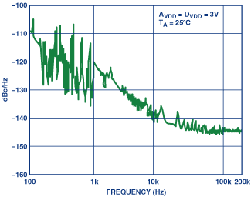

**Figure 5.1. Typical output phase noise plot for the AD9834. Output frequency is 2 MHz and M clock is 50 MHz.**

The mixer is fundamental in correcting any frequency change occurs in the received signal. The mixer needs to be able to work in the bandwidth range expected. The LO power into a diode mixer should be 10 dB greater than the highest input signal level anticipated. However, high-IP3 mixers can work with a LO power 3dB less than the RF power. The 1-dB compression point is used for choosing the mixer’s LO power.

The demodulator needs to meet certain specs regarding the frequency range, sampling rate, and power dissipation. The sampling rate is taken from the bandwidth of the transmitted signal. The frequency range is found through the minimum and maximum frequencies that the signal will reach. The power dissipation will need to be kept to as little as possible to avoid having to change power amplification due to the increased attenuation.

The analog-to-digital converter must meet certain specifications that have been found through calculations.

|  |  |
| --- | --- |
|  | 5.2 |
|  | 5.3 |
|  | 5.4 |
|  | 5.5 |
|  | 5.6 |
|  | 5.7 |

These calculations can be utilized to find the necessary sampling rate and samples that will be needed for accurate conversion of the given signal. Based on a maximum depth of 1.2 m and the signal speed through sand found to be 1.22 * 108 m/s, the time of flight is 9.8 ns. With a bandwidth of 75 MHz and increasing the time to 40 ns as a buffer, the slope is found to be 1.9 * 1015 Hz/s. Based on the Nyquist sampling theorem, the sampling rate must be at least equal to twice the bandwidth, which results in being 150 MHz. Frequency resolution is then found from the spatial resolution of 7.62 cm, Csand, and the slope of frequency rising over time. Taking into consideration of the relation between the frequency resolution and sampling rate, the number of samples can be found. The lowest possible number of samples will be 62.5, with the ceiling resulting in 63 samples per rise. The key with the ADC is finding a unit that has the necessary sampling rate, since higher sampling frequencies also means higher cost.

## Subsystem Testing

Two test will be performed. The first will test the mixer and the DDS capabilities. The second will test the demodulator and ADC.

### Mixer induced frequency shift

This test will be testing for the accuracy of the resulting IF signal once the Rx has been mixed with the LO signal generated by the DDS.

#### Test Setup

The needed hardware is the DDS, the mixer circuit, wave function generator, and a network analyzer. Using frequency-offset mode, the output from the mixer will be sent directly into the reference input of the analyzer. Once specifying the measurement setup on the settings panel, the proper RF frequency span is calculated to create the needed IF frequency. Some analyzers will also sweep the source backwards to find the wanted IF span. The DDS will be utilized of the LO, which will also check its capabilities with the mixer circuit.

#### Data

No data has been recorded for this test setup as of now. This will change once the necessary hardware has been bought and accounted for.

#### Test Conclusion

No data has been recorded for this test setup as of now. This will change once the necessary hardware has been bought and accounted for.

### Demodulation and analog-to-digital conversion

The purpose of this test is to test the reliability of the demodulator and ADC. This will be done by measuring the code transitions.

#### Test Setup

The test will need the demodulator, ADC, analog voltage source, LED display, and a DVM. The analog source is fed through the demodulator and to the ADC circuit. The input source is varied across the possible values until the LEDs continue switching between two codes. The input voltage is recorded. Possible problems include the ADC not possessing a good PTP input-referred noise.

#### Data

No data has been recorded for this test setup as of now. This will change once the necessary hardware has been bought and accounted for.

#### Test Conclusion

No data has been recorded for this test setup as of now. This will change once the necessary hardware has been bought and accounted for.

# Conclusions

The signal generating subsystem consists of a function generator, VCO and several cascading power amplifiers. The function generator produces a triangular waveform that can be modified by changing the selected resistor values depending on the desired pulse duration. The VCO then modulates this triangular by waveform linearly increasing the frequency of a sine wave based on the input voltages. The power amplifiers then amplifies the signal to meet the required minimum 50 mW of power. The power amplifiers are very expensive so selecting a cost efficient amplifier is crucial. Once the function generator and VCO arrive in the mail, testing and finalization as well as incorporation into the transmitting antenna can begin.

The antenna subsystem has properly constructed a prototype antenna designed for wave propagation through air at a frequency between 2.4025 and 2.4775 GHz. The antenna subsystem is currently dependent on the timely construction of the baluns in order to begin testing. Once the baluns are created, the coaxial connections can then be soldered to the vivaldi antennas to begin testing using the network analyzer. Ensuring that the design for the prototype antenna is functioning properly will allow for the altering of the system to fit propagation through ground. A future design idea looking to be implemented is the change of the medium the antenna is sitting in from air to water.

The receiver circuit subsystem is in the process of buying hardware and designing the PIN Diode driver and PCBs for the circuit. Once it is all constructed and tested, it will then be integrated with the receiver antenna and receiver signal conversion to take an incoming Rx signal and test for amplified signal conversion. The main obstacle at the moment is designing a fast switching PIN Diode driver to protect the LNA from the initial air to ground reflection.

The receiver signal conversion subsystem is in the process of buying hardware and finding the necessary funding for these portions. While they were not made, the pieces will still be tested once combined together to actually create the required circuit. Once testing is passed, it will then be integrated with the receiver subsystem to actually take an incoming Rx signal and test for amplified signal conversion. Again, the main obstacle at the moment is finding the funding for the DDS, mixer, demodulator, and ADC with the required specs. Another alternative is to reduce the bandwidth to a smaller gap, which would bring the price of the ADC down. However, the drawback is that the transmitter subsystem would need to be adjusted for the change as well as redo other calculations as well.

The system is currently in the process of gathering all of the required components in order to begin testing. Once the parts are obtained, individual testing can occur, and finally the integration of each subsystem can begin. Further testing will most likely be needed during this process. Our time is constrained, so the team will need to commit extra hours in order to push the project forward at a quicker pace. However, recent progress and reviews with instructors and our sponsor are encouraging, as well as refocused the team's efforts towards our final goal.

# References

[1] Christian Wolff, “Phased Array Antenna ,” [Online]. Available at: http://www.radartutorial.eu/06.antennas/Phased%20Array%20Antenna.en.html. [Accessed: 2015]

[2] Cedric Martel, “Modelling and Design of Antennas for Ground-Penetrating Radar Systems ,” Ph.D. dissertation, Dept. Elect. Eng, Univ. of Surrey, Guildford, United Kingdom, 2002.

[3] “Ground Penetrating RADAR (GPR) (After Basson 2000) Introduction,” GPR theory, 2007. [Online]. Available at: http://www.geo-sense.com/gprmore.htm. [Accessed: Jan-2015].

[4] *Standard Guide for Using the Surface Ground Penetrating Radar Method for Subsurface Investigation*, Active Standard ASTM D6432, 2011

[5] A. P. Annan, "Ground Penetrating Radar Principles, Procedures & Applications," Sensors & software Inc., Mississauga, Ontario, 2003

[6] Bart Scheers, “Ultra-Wideband Ground Penetrating Radar, with Application to the Detection of Anti Personnel Landmines,” Ph.D. dissertation, Dept. Elect. Eng, Catholic Univ. of Louvain, Louvain-la-Neuve, Belgium, 2001.

[7] C. Allen , “Radar Pulse Compression ,” 2004. [Online]. Available at: https://www.ittc.ku.edu/workshops/Summer2004Lectures/Radar_Pulse_Compression.pdf. [Accessed: 2015]

[8] Cedric Martel, “Modelling and Design of Antennas for Ground-Penetrating Radar Systems ,” Ph.D. dissertation, Dept. Elect. Eng, Univ. of Surrey, Guildford, United Kingdom, 2002.

[9] “Ground Penetrating RADAR (GPR) (After Basson 2000) Introduction,” GPR theory, 2007. [Online]. Available at: http://www.geo-sense.com/gprmore.htm. [Accessed: Jan-2015].

[10] Standard Guide for Using the Surface Ground Penetrating Radar Method for Subsurface Investigation, Active Standard ASTM D6432, 2011

[11] A. P. Annan, "Ground Penetrating Radar Principles, Procedures & Applications," Sensors & software Inc., Mississauga, Ontario, 2003

[12] Bart Scheers, “Ultra-Wideband Ground Penetrating Radar, with Application to the Detection of Anti Personnel Landmines,” Ph.D. dissertation, Dept. Elect. Eng, Catholic Univ. of Louvain, Louvain-la-Neuve, Belgium, 2001.

##### 

##### Project Budget

Include a table listing the purchases/expenses for the project thus far, and note any known pending expenses.

Table A-1   
Project Budget

|  |  |  |  |  |
| --- | --- | --- | --- | --- |
| Description | Quantity | Amount | Shipping | Line Total |
| TAV-541+ (LNA) | 20 | 1.390 | - | 27.80 |
| TB-154 (LNA Eval Boards) | 4 | 29.950 |  | 119.80 |
| LNA Shiping Cost | - | - | 21.41 | 21.41 |
| 1PS70SB84 (Schottky diodes) | 20 | 0.358 | - | 7.16 |
| SMA FEMALE PCB MOUNT | 8 | 3.15 | - | 25.20 |
| SMA Cable 24 in | 10 | 10.148 | - | 101.48 |
| XR-2206 (Function Generator) | 2 | 7.95 | 6.63 | 22.53 |
| PA | 1 | 39.95 | - | 39.95 |
| VCO | 1 | 44.95 |  | 44.95 |
| Toroidal Core + Shipping | 1 | 26.51 | 7.99 | 34.50 |
| Sheet Metal | 1 | 5.00 | - | 5.00 |
| LMX2434 | 1 | 4.60 |  | 4.60 |
| LMX2434EVAL | 1 | 249.00 | - | 249.00 |
| MACA-63H+ Mixer | 10 | 12.15 | - | 121.50 |
| Mixer Eval board | 1 | 34.95 | - | 34.95 |
| AD8346ARUZ Demodulator | 1 | 849.39 | - | 849.39 |
| ADC10DV200CISE/NOPB | 1 | 87.55 | - | 87.55 |
|  |  |  | TOTAL | 1796.77 |

##### 

##### Subsystem Schematic

###### Function Generator Schematic

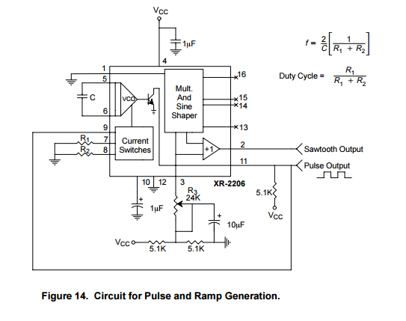

Table B-1  
BOM for Signal Generation

|  |  |  |
| --- | --- | --- |
| Symbol | Value | Description |
| R1 | 100kΩ | RESISTOR, American symbol |
| R2 | 10kΩ | RESISTOR, American symbol |
| C | .01μF | CAPACITOR, American symbol |
|  | 5.1kΩ | RESISTOR, American symbol |
|  | 5.1kΩ | RESISTOR, American symbol |
|  | 5.1kΩ | RESISTOR, American symbol |
|  | 2.4kΩ | POTENTIOMETER, American symbol |
|  | 1μF | CAPACITOR, American symbol |
|  | 1μF | CAPACITOR, American symbol |
|  | 10μF | CAPACITOR, American symbol |

###### Receiver Circuit Diagram

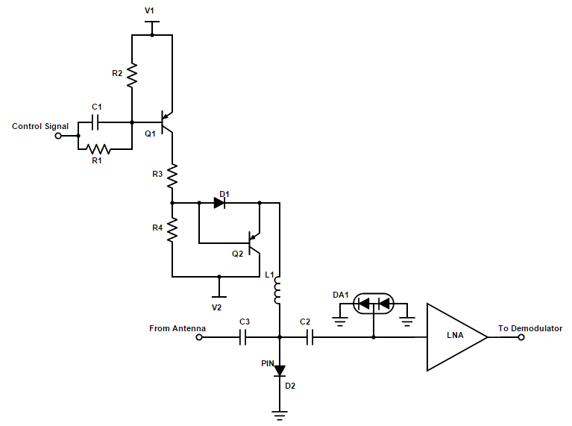

Table B-2  
BOM for Receiver Circuit

|  |  |  |
| --- | --- | --- |
| Symbol | Value | Description |
| R1 | 382Ω | RESISTOR, American symbol |
| R2 | 955Ω | RESISTOR, American symbol |
| R3 | 28Ω | RESISTOR, American symbol |
| R4 | 1kΩ | RESISTOR, American symbol |
| C1 | 100pF | CAPACITOR, American symbol |
| C2 | 1μF | CAPACITOR, American symbol |
| C3 | 1μF | CAPACITOR, American symbol |
| L1 | 0.4nH | INDUCTOR, American symbol |
| D1 | 1N4007 | DIODE |
| D2 |  | PIN DIODE |
| DA1 | 1PS70SB82 | SCHOTTKY DIODE, Series Connection |
| Q1, Q2 |  | PNP Transistor |
| U1 | TAV-541+ | Low Noise Amplifier |