HEALTH AI
European HealthTech Co-Creation & Innovation Platform

Software Design Document (SDD)

Version 2.0 — April 2026

Group: Health Shield
Cem Özal
Emre Kurubaş
Hasabu Can Eltayeb
Sertaç Ataç

Document | Software Design Document
Project | HEALTH AI Platform
Group | Health Shield
Members | Cem Özal, Emre Kurubaş, Hasabu Can Eltayeb, Sertaç Ataç
Version | 2.0
Date | April 1, 2026
Course | SENG 384
Status | Final — Updated

1. Introduction

1.1 Purpose
This Software Design Document (SDD) describes the internal architecture, component design, data structures, and interaction patterns of the HEALTH AI platform. It serves as the technical blueprint for understanding how the system is built, how modules interact, and how data flows through the application.

1.2 Scope
This document covers the complete design of the HEALTH AI platform including its React-based frontend architecture, Firebase Firestore backend integration, real-time communication patterns, component hierarchy, state management through custom hooks, routing strategy, security mechanisms, and deployment configuration. The design reflects the current production build (Version 5) as of April 2026.

2. System Architecture Overview

2.1 Architectural Style
HEALTH AI follows a Client-Side Rendered (CSR) Single Page Application architecture with a serverless backend. Key decisions:
- Component-Based Architecture: All UI elements are reusable React components.
- Hooks-Based State Management: Business logic in custom hooks (useAuth, usePosts, useChat, useNotifications).
- Service Layer Pattern: All Firestore ops abstracted in services/firestore.js.
- Real-Time First: Firestore onSnapshot listeners for instant updates across clients.
- Route-Level Code Organization: Each feature has its own page component.

2.2 Technology Stack
Layer | Technology | Purpose
UI Framework | React 18 | Component-based rendering with virtual DOM
Build Tool | Vite 7.x | Fast HMR dev server and optimized production builds
Routing | React Router v6 | Declarative client-side routing with guards
Animation | Framer Motion 11.x | Physics-based animations and page transitions
3D Effects | react-parallax-tilt | Card hover tilt effects on dashboard
Icons | Lucide React | Tree-shakable SVG icon library
Database | Firebase Firestore v10 | NoSQL real-time document database
Styling | Vanilla CSS + CSS Variables | Theme system with dark/light mode
Hashing | Web Crypto API (Native) | SHA-256 password hashing
Language | JavaScript (JSX, ES2022) | Modern JS with JSX syntax

2.3 Architecture Diagram
PRESENTATION: React Components + Framer Motion + CSS Themes
↕
BUSINESS LOGIC: useAuth, usePosts, useChat, useNotifications
↕
DATA ACCESS: firestore.js — CRUD, Subscriptions, Chat, Presence
↕
INFRASTRUCTURE: Firebase Firestore (Cloud NoSQL)

3. Module Decomposition

3.1 Page Modules
Module | File | Responsibility
LandingPage | pages/LandingPage.jsx | Marketing hero, feature grid, workflow steps, DNA helix background
Login | pages/Login.jsx | Sign In / Register form, .edu validation, SHA-256 hashing
Dashboard | pages/Dashboard.jsx | Announcement feed with search/filter, 3D tilt cards, bookmarks
CreatePost | pages/CreatePost.jsx | 3-step wizard: Core Details → Technical Info → Settings
PostDetail | pages/PostDetail.jsx | Two-column detail: content + sidebar. NDA modal, meetings
MyPosts | pages/MyPosts.jsx | Author post management: stats, filter tabs, status transitions
Profile | pages/Profile.jsx | User card, profile editor, GDPR export/delete
AdminDashboard | pages/AdminDashboard.jsx | 4-tab admin: Overview, Users, Posts, Audit Logs
Chat | pages/Chat.jsx | Two-panel messaging with typing indicators and read receipts

3.2 Component Modules
Component | Responsibility
Navbar | Fixed nav bar with logo, links, theme toggle, notifications, user badge, logout
Notifications | Dropdown notification panel with dismiss actions
ThemeToggle | Dark/Light mode toggle via data-theme attribute
HeroDNA | Canvas-based animated 3D DNA double helix for landing page
PageTransition | Framer Motion wrapper for page route change animations
SkeletonLoader | Animated placeholder cards during data loading
NetworkStatus | Offline warning toast indicator
GlobalErrorBoundary | React Error Boundary catching rendering crashes
AnimatedCounter | Scroll-triggered number animation for statistics

3.3 Custom Hook Modules
Hook | State Managed | Key Operations
useAuth | user, allUsers, loading | login, register, logout, updateUser, deleteUser
usePosts | posts, loading | addPost, updatePost, updatePostStatus, deletePost, expressInterest, proposeMeeting, respondToMeeting
useChat | messages, conversations, activeRecipient, otherIsTyping | send, setTyping, clearHistory, deleteConvo
useNotifications | notifications | addNotification, dismissNotification, dismissAllNotifications

3.4 Service Layer (firestore.js)
- Posts CRUD: getPosts, addPostToFirestore, updatePostInFirestore, deletePostFromFirestore, subscribeToPostsRT
- Users CRUD: getUsers, getUserById, getUserByEmail, addUserToFirestore, updateUserInFirestore, subscribeToUsersRT
- Activity Logs: addActivityLog, subscribeToLogsRT
- Notifications: addNotificationToFirestore, deleteNotificationFromFirestore, subscribeToNotificationsRT
- Chat: getOrCreateConversation, sendMessage, subscribeToConversationsRT, subscribeToMessagesRT, setTypingStatus, markAsRead, deleteConversation
- Presence: updateUserStatus (online/offline), Security: hashPassword (SHA-256)

4. Data Design

4.1 Firestore Collections
Collection | Document ID | Key Fields | RT Listener
users | Custom (doc-1, eng-1) | name, email, passwordHash, role, institution, status, isOnline, savedPosts | subscribeToUsersRT
posts | Custom (post-1) | title, domain, projectStage, explanation, confidentiality, status, interests[], meetings[] | subscribeToPostsRT
conversations | Sorted member IDs joined by _ | members[], memberData{}, lastMessage, updatedAt, unreadCount{}, isTyping{} | subscribeToConversationsRT
conversations/{id}/messages | Auto-generated | senderId, senderName, text, timestamp, read | subscribeToMessagesRT
activityLogs | Custom (log-1) | timestamp, userId, userName, role, actionType, targetEntity, result, details | subscribeToLogsRT
notifications | Custom ID | type, message, postId, fromUser, timestamp, read | subscribeToNotificationsRT

4.2 Real-Time Data Flow
1. Component mounts → Hook initializes → Firestore onSnapshot listener established
2. External change occurs → Firestore pushes snapshot to all listeners
3. Listener callback fires → Hook updates React state via setState
4. React re-renders consuming components → UI reflects change instantly
5. Component unmounts → unsubscribe() called → Listener detached

5. Interface Design

5.1 Design System
The UI uses a premium glassmorphism design with CSS custom properties for theming:
Variable | Dark Value | Purpose
--background | #0f0f1a | Main page background
--surface | rgba(22,22,42,0.6) | Card/panel backgrounds
--primary | #6366f1 | Primary accent (Indigo)
--accent | #a855f7 | Secondary accent (Purple)
--secondary | #10b981 | Success/healthcare green
--error | #ef4444 | Error and danger states
--glass-bg | rgba(22,22,42,0.7) | Glassmorphism panel fill

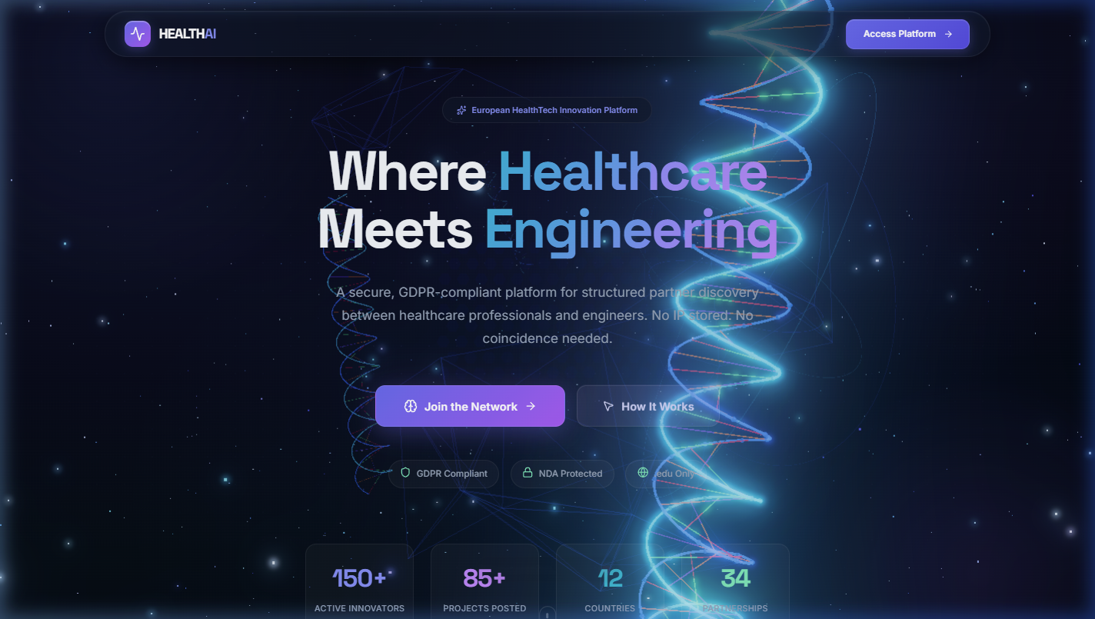
Figure: Landing Page — Glassmorphism design with gradient accents

5.2 Navigation Architecture
Nav Item | Route | Visibility
Feed | /dashboard | All authenticated users
My Posts | /my-posts | All authenticated users
Messages | /chat | All authenticated users
Profile | /profile | All authenticated users
Admin Logs | /admin | Admin role only

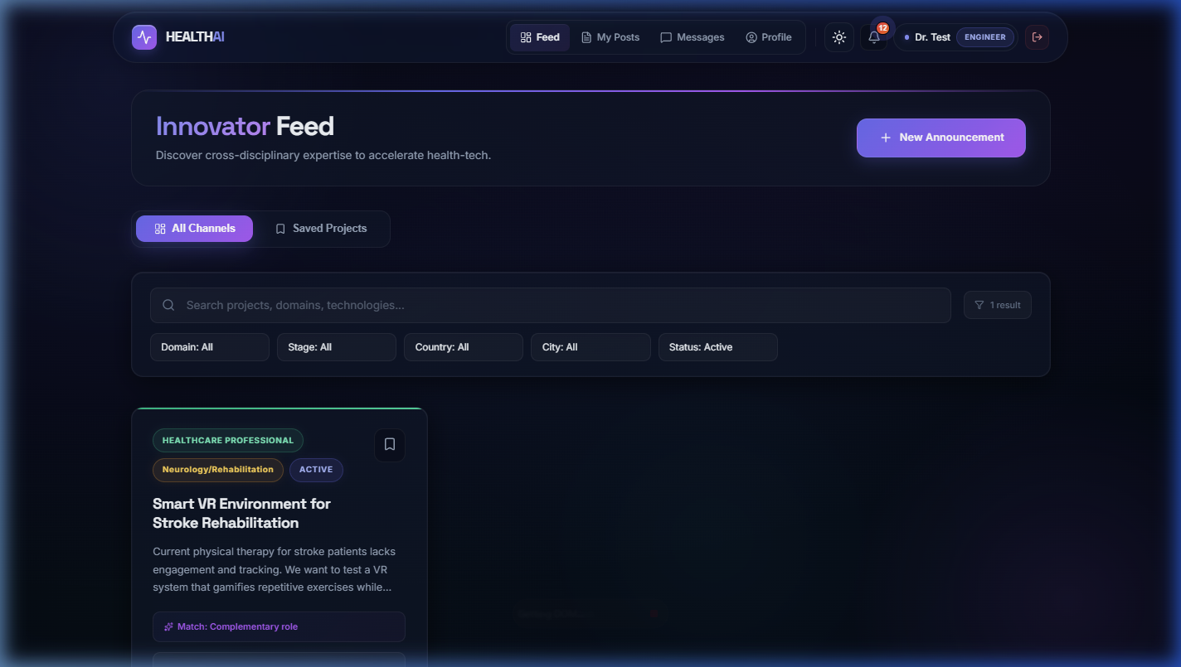
Figure: Dashboard — Navbar with active route indicator

6. Detailed Component Design

6.1 Authentication Module
Sign In: Email (.edu validation) → SHA-256 hash → getUserByEmail() → verify hash → addActivityLog
Register: Email + Password + Name + Role + Institution + Country + City → emailExists() → hashPassword() → addUserToFirestore() → seedCollection()
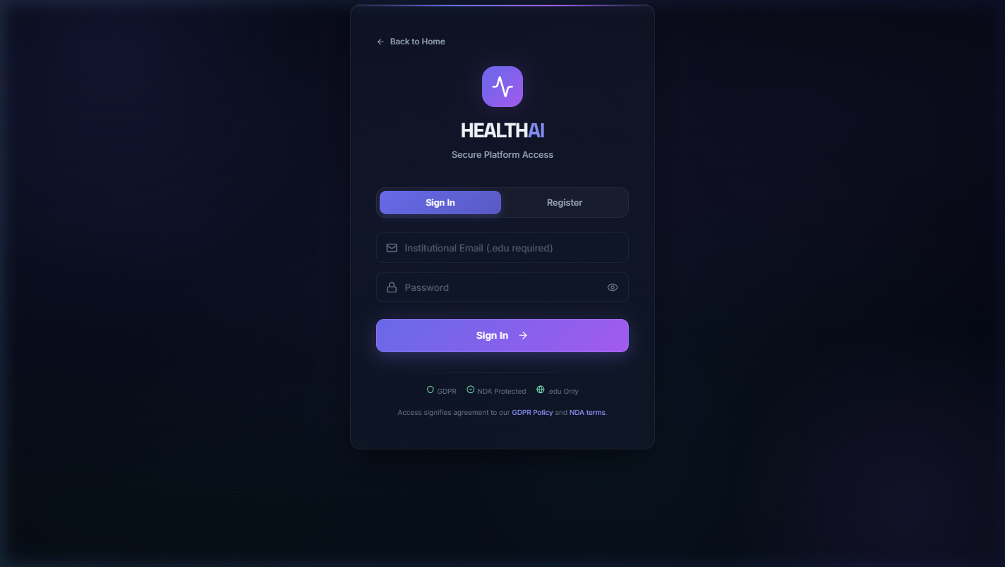
Figure: Login — Sign In with .edu validation

6.2 Announcement Module
Post lifecycle: Draft → (Publish) → Active → (Interest) → Active+Interests → (Propose Meeting) → Meeting Scheduled → (Close) → CLOSED/Partner Found
Step | Fields | Validation
1. Core Details | Title, Domain, Project Stage, Description | All required
2. Technical Info | Technical Blueprint, Required Expertise, Collaboration Type | Expertise + type required
3. Settings | Country, City, Confidentiality, Expiry Days | Location + privacy required

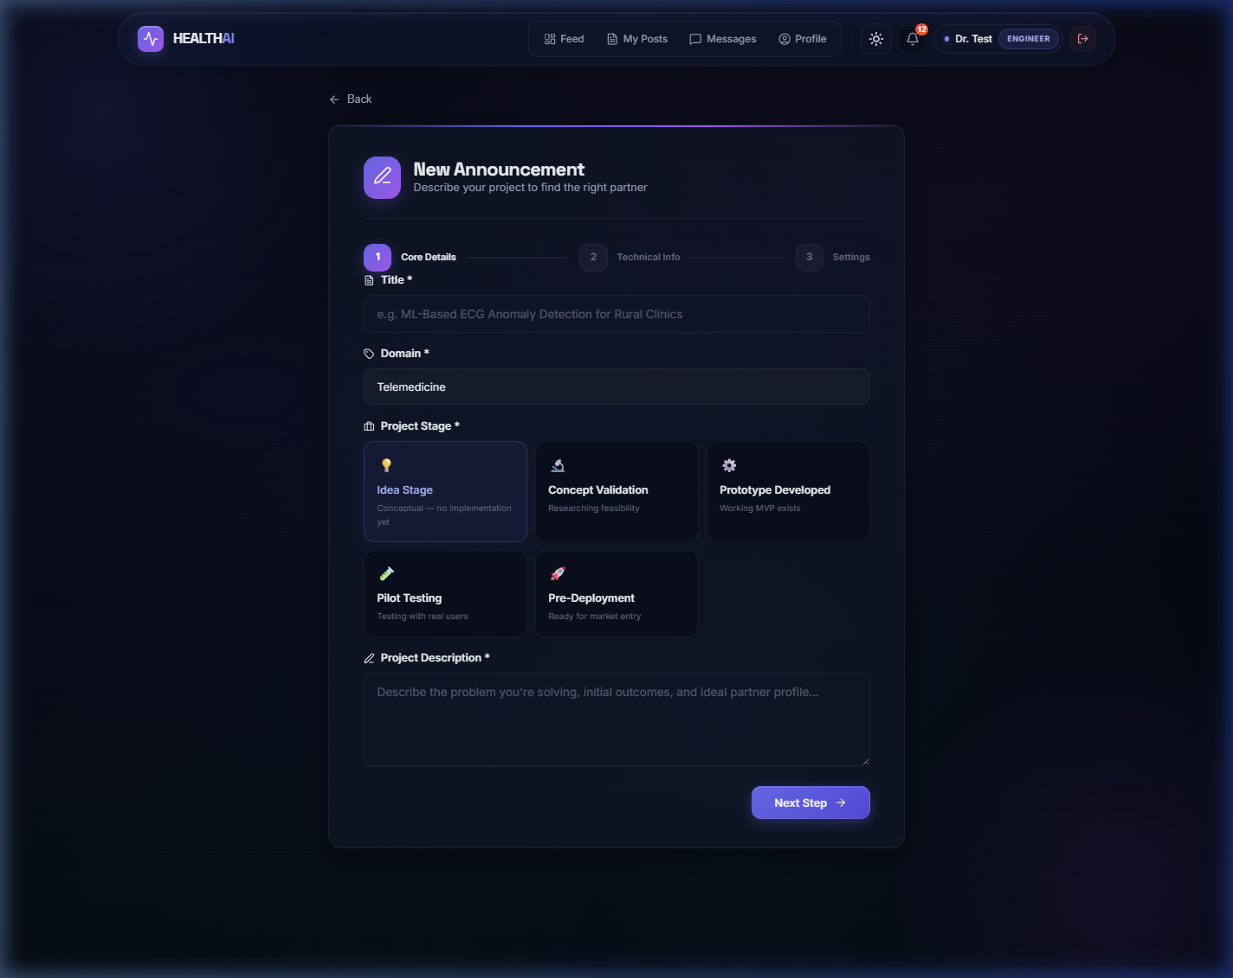
Figure: Create Announcement — Step 1 wizard

6.3 Interest & Meeting Module
Workflow: View Post → Express Interest (NDA modal) → Propose Meeting (time slots) → Author Accept/Decline → Meeting Scheduled → Close (Partner Found)
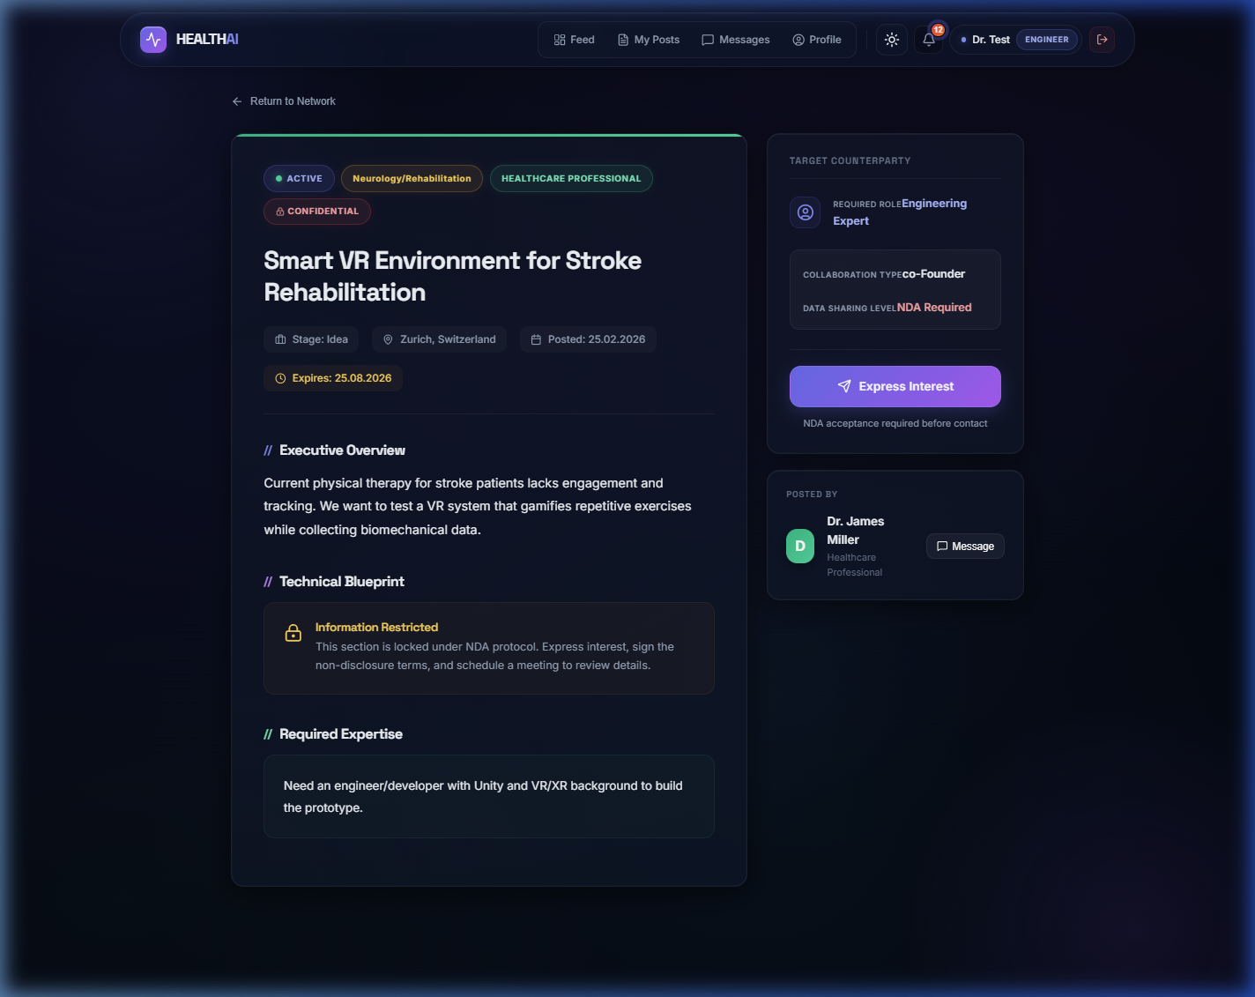
Figure: Post Detail — NDA-gated content with Express Interest

6.4 Chat Module
Three-layer Firestore structure: conversations/ (deterministic IDs) → messages/ (sub-collection, timestamp ordered) → presence (isTyping map field)
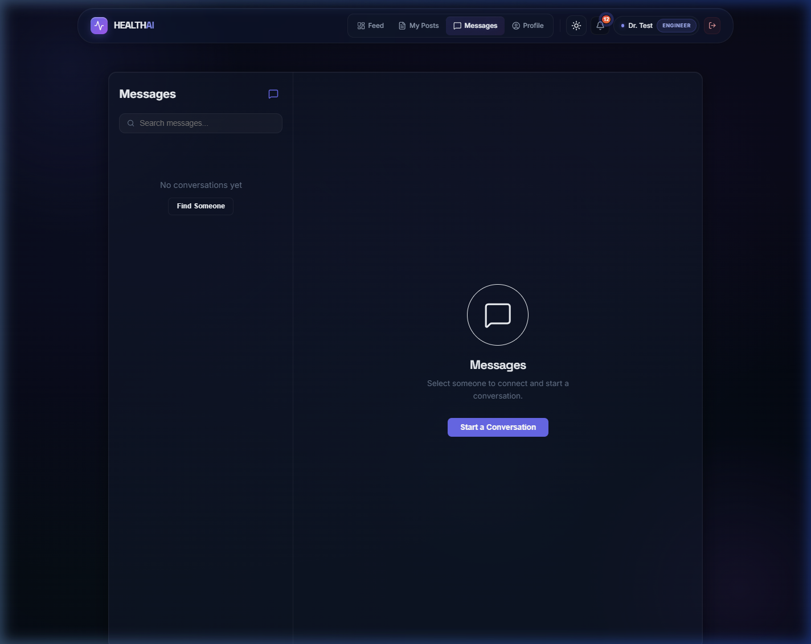
Figure: Messages — Two-panel chat interface

6.5 Admin Module
4-tab interface: Overview (stats) | Users (freeze/unfreeze) | Posts (delete) | Audit Logs (search + filter + CSV export). Access restricted to Admin role.

7. Security Design
Layer | Mechanism | Detail
Password | SHA-256 hashing | Client-side via Web Crypto API, no plaintext stored
Email | .edu enforcement | Personal providers (gmail, yahoo, etc.) blocked
Routes | Guard components | ProtectedRoute + GuestRoute wrappers
IP Protection | NDA workflow | Confidential posts gated behind NDA acceptance
RBAC | Role-based access | Cross-role discovery + admin-only routes
Audit | Activity logging | All login/post/meeting actions logged
GDPR | Data rights | Export (Art. 20), Delete (Art. 17), Access (Art. 15)

8. Error Handling Strategy
Error Type | Mechanism | UX
Render Crash | GlobalErrorBoundary | Recovery UI instead of blank screen
Network Loss | NetworkStatus + navigator.onLine | Offline warning banner
Auth Failure | Try-catch in handlers | Animated error message
Firestore Error | Try-catch + console.error | Graceful degradation
Form Validation | Client-side checks | Contextual error messages

9. Deployment Architecture
Static SPA build: Source → Vite build → dist/ (HTML, CSS, JS bundles) → Static hosting
Runtime: Browser (React SPA) ↔ Firestore SDK (WebSocket) ↔ Firebase Firestore (Google Cloud)
Environment: .env file with VITE_FIREBASE_API_KEY, AUTH_DOMAIN, PROJECT_ID, STORAGE_BUCKET, MESSAGING_SENDER_ID, APP_ID

