HEALTH AI
European HealthTech Co-Creation & Innovation Platform

Software Design Document (SDD)

Version 3.0 — Final Release • April 2026

Group: Health Shield
Cem Özal
Emre Kurubaş
Hasabu Can Eltayeb
Sertaç Ataç

Document | Software Design Document
Project | HEALTH AI Platform
Group | Health Shield
Members | Cem Özal, Emre Kurubaş, Hasabu Can Eltayeb, Sertaç Ataç
Version | 3.1 (Final)
Date | May 1, 2026
Course | SENG 384 — Software Engineering
Standard | IEEE 1016-2009 Software Design Descriptions
Status | Final — UML diagrams and module specifications

Revision History
Version | Date | Author(s) | Description of Changes
1.0 | 2025-12-12 | Health Shield | Initial SDD — module decomposition
2.0 | 2026-04-01 | Health Shield | Refreshed for production build, added screenshots
3.0 | 2026-04-27 | Health Shield | Final — added Use Case, Architecture, Component, Sequence, Class and Deployment diagrams; expanded module specifications, security & deployment sections.

Table of Contents
1. Introduction
1.1 Purpose
1.2 Scope
1.3 Definitions
1.4 References
2. System Architecture Overview
2.1 Architectural Style
2.2 Architecture Diagram
2.3 Technology Stack
2.4 Layer Responsibilities
3. Module Decomposition
3.1 Component Diagram
3.2 Page Modules
3.3 UI Components
3.4 Landing Page Components
3.5 Custom Hooks
3.6 Service Layer
4. Class & Object Design
4.1 Class Diagram
4.2 Hook Contracts
5. Data Design
5.1 Firestore Collections
5.2 Real-Time Subscription Pattern
6. Interface Design
6.1 Design System
6.2 Navigation & Routing
7. Detailed Component Design (Sequence Diagrams)
7.1 Authentication & OTP Flow
7.2 Create Announcement Flow
7.3 Interest, NDA & Meeting Flow
7.4 Real-Time Chat Flow
7.5 Admin Audit Flow
8. Security Design
9. Error Handling Strategy
10. Deployment Architecture
11. Build, Configuration & DevOps
12. Performance & Optimisation
13. Testing Strategy
14. Future Work

1. Introduction

1.1 Purpose
This Software Design Document (SDD) describes the internal architecture, module decomposition, data structures, interaction patterns and deployment design of the HEALTH AI platform. It translates the requirements specified in the SRS (v3.0) into an implementable design and serves as the technical blueprint for the development team and any future maintainer. This document follows the structure recommended by IEEE 1016-2009 Software Design Descriptions.

1.2 Scope
The document covers the complete design of the HEALTH AI platform including its React-based frontend architecture, Firebase Firestore backend integration, real-time communication patterns, component hierarchy, state management through custom hooks, routing strategy, security mechanisms, deployment configuration and DevOps pipeline. The design reflects the production build (Version 3) as of April 2026.

1.3 Definitions
Term | Meaning
CSR-SPA | Client-Side Rendered Single Page Application
Hook | A React function-based primitive for stateful and side-effectful logic
Snapshot | A Firestore real-time event delivered through onSnapshot listeners
Transaction | A Firestore runTransaction call used to atomically read-modify-write multiple documents
Subcollection | A Firestore-native collection nested under a parent document
Liquid-glass | The editorial design system used by HEALTH AI — blurred translucent panels with editorial typography

1.4 References
- HEALTH AI SRS v3.0 (April 2026)
- IEEE 1016-2009 Software Design Descriptions
- React 19 Documentation — https://react.dev
- Firebase Firestore Documentation — https://firebase.google.com/docs/firestore
- Framer Motion 12 — https://www.framer.com/motion
- Vite 7 — https://vitejs.dev

2. System Architecture Overview

2.1 Architectural Style
HEALTH AI is implemented as a Client-Side Rendered (CSR) Single Page Application with a serverless backend (Firebase Firestore). The architecture follows four explicit layers: Presentation, Business Logic, Data Access and Infrastructure. The following design decisions are central to the system:
- Component-Based Architecture: every UI element is a reusable React component.
- Hooks-Based State Management: business logic is encapsulated in custom hooks (useAuth, usePosts, useChat, useNotifications, usePostEngagement, useToast) to keep components rendering-focused.
- Service Layer Pattern: all Firestore operations are abstracted behind services/firestore.js, providing a single seam for the persistence boundary.
- Real-Time First: Firestore onSnapshot listeners drive UI updates instead of polling, enabling sub-second cross-client synchronisation.
- Route-Level Code Organisation: each feature owns its own page component under src/pages, lazy-loaded through React Router v7 + Suspense.
- Editorial Design System: the liquid-glass.css design system provides visual consistency and supports the prefers-reduced-motion query through Framer Motion MotionConfig.

2.2 Architecture Diagram
The diagram below shows the four-layer architecture of HEALTH AI. Each layer depends only on the layer immediately beneath it, which keeps the test surface narrow and the upgrade path for any single technology (e.g., swapping Firestore) localised.
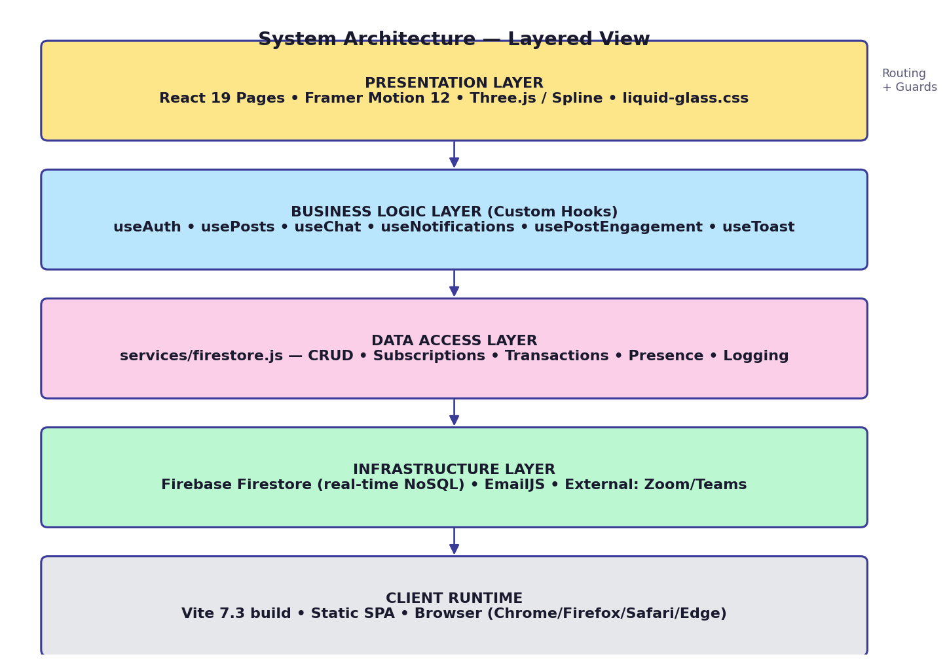
Diagram: Layered Architecture — Presentation, Business Logic, Data Access, Infrastructure

2.3 Technology Stack
Layer | Technology | Purpose
UI Framework | React 19.2 | Component-based rendering with virtual DOM
Build Tool | Vite 7.3 | Fast HMR dev server and optimised production builds
Routing | React Router v7 | Declarative client-side routing with guard wrappers
Animation | Framer Motion 12 | Physics-based animations, scroll-triggered reveals, MotionConfig
3D / WebGL | Three.js 0.183 + React Three Fiber + Drei + Spline | Interactive 3D landing background, particle effects
Video | HLS.js | Adaptive-bitrate looping video backgrounds with crossfade
Icons | Lucide React | Tree-shakable SVG icon library
Database | Firebase Firestore v12 | Real-time NoSQL document database with subcollections
Styling | Vanilla CSS + CSS Variables + liquid-glass.css | Editorial design system with warm amber / cool cyan palette
Hashing | Web Crypto API | SHA-256 password hashing client-side
Email | EmailJS | OTP and meeting notification emails
Utilities | classnames, tailwind-merge | Conditional class composition

2.4 Layer Responsibilities
Layer | Responsibilities | Owns
Presentation | Renders JSX, dispatches user actions, applies design tokens, animations and accessibility attributes | Pages, components, CSS
Business Logic | Orchestrates state, side effects and validation; owns session, post lifecycle, chat semantics, notifications | Custom hooks, context providers
Data Access | Encapsulates Firestore reads/writes, subscriptions, atomic transactions, presence and audit logging | services/firestore.js
Infrastructure | Provides persistence, real-time channel, email transport and external meeting hosts | Firebase Firestore, EmailJS, Zoom/Teams

3. Module Decomposition

3.1 Component Diagram
The diagram below groups every module of the application into clusters: Pages, Custom Hooks, Service Layer, Shell / UI Components, Landing Components, External Services, Routing and Build & Deploy. Arrows indicate the principal "uses" dependencies between clusters.
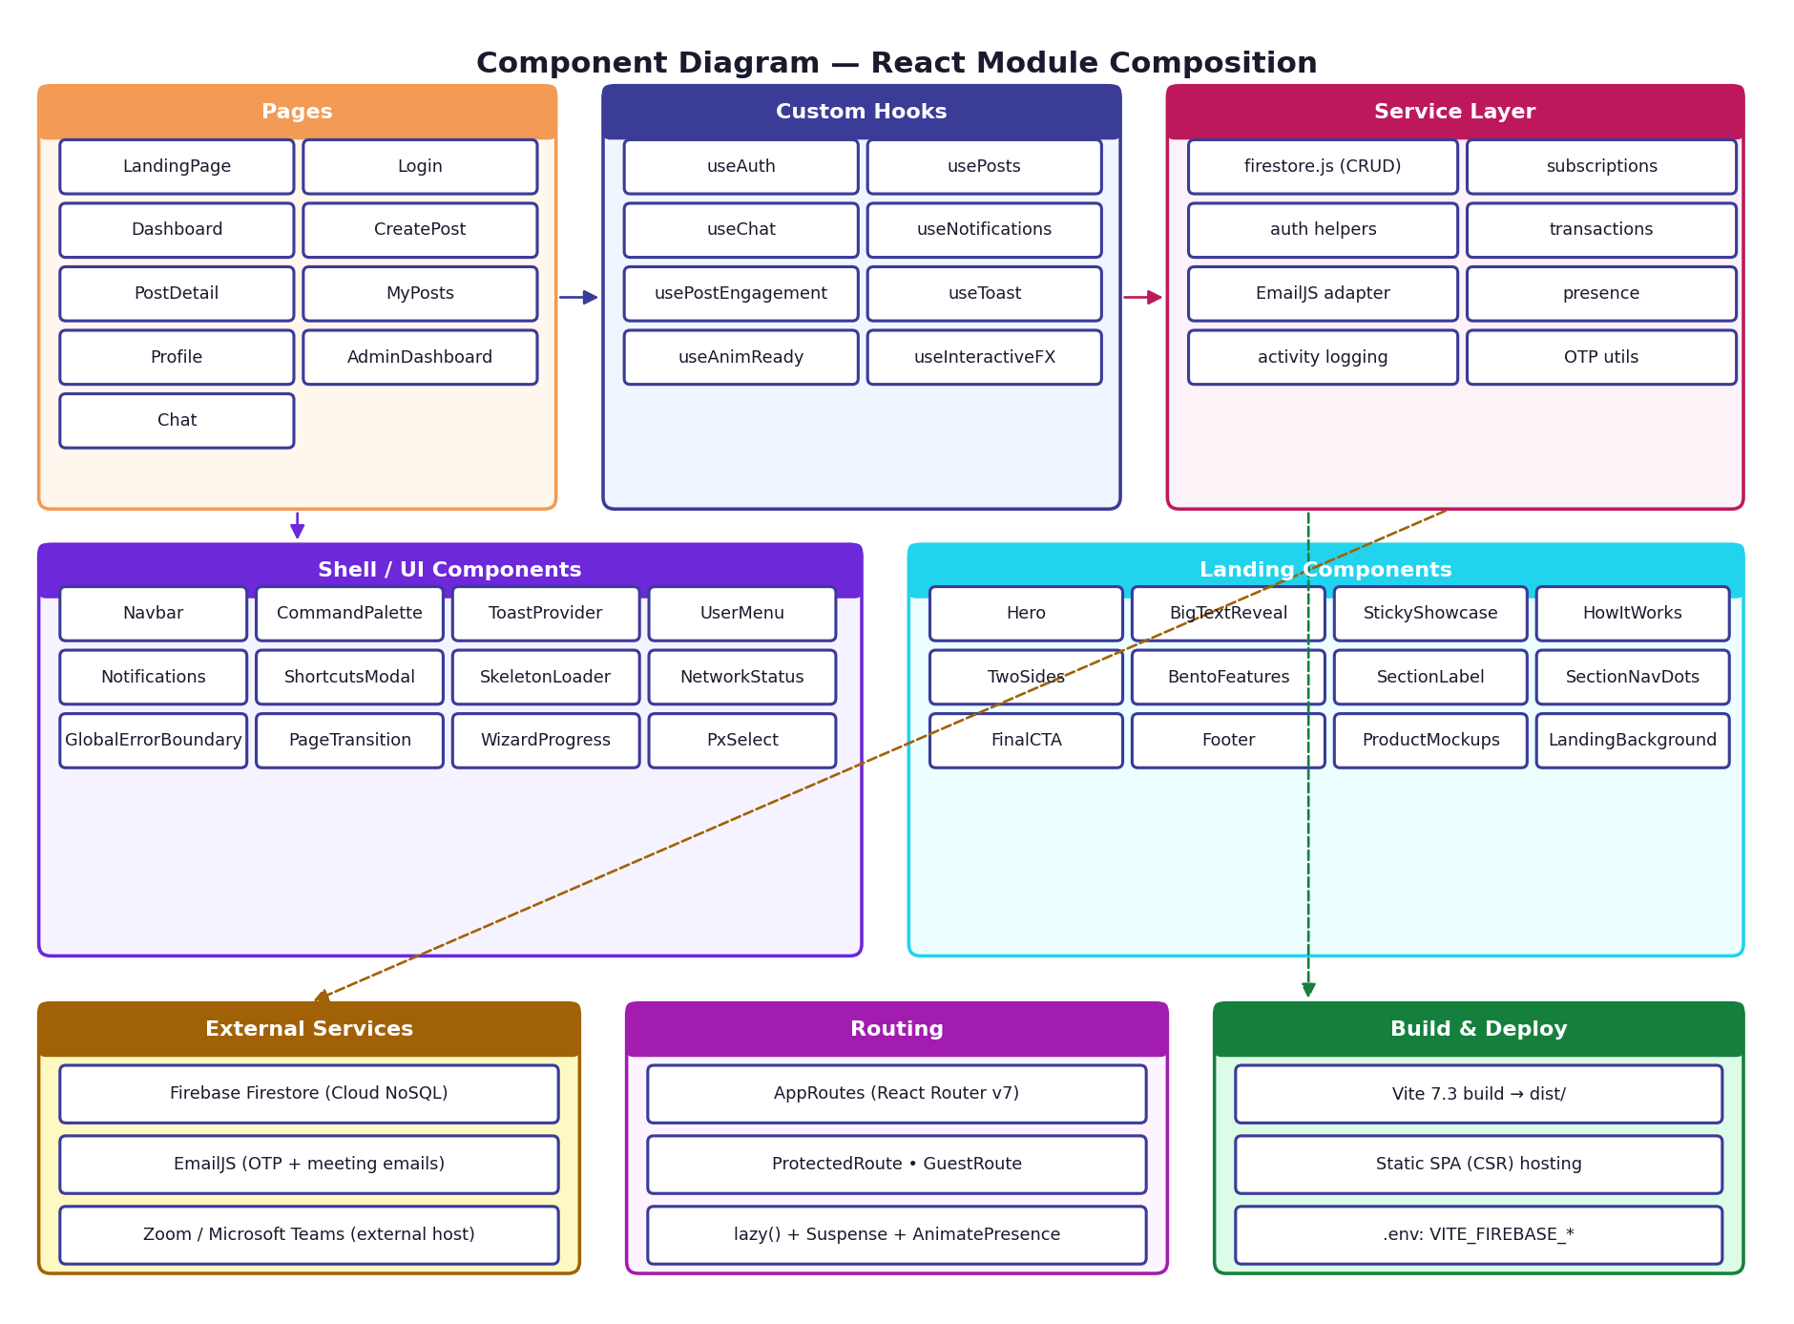
Diagram: Component Diagram — clusters and inter-cluster dependencies

3.2 Page Modules
Module | File | Responsibility
LandingPage | pages/LandingPage.jsx | Cinematic scrollytelling landing — Hero, BigTextReveal, StickyShowcase, HowItWorks, TwoSides, BentoFeatures, FinalCTA, Footer
Login | pages/Login.jsx | Sign In / Register form with .edu validation, SHA-256 hashing and 6-digit OTP via EmailJS
Dashboard | pages/Dashboard.jsx | Announcement feed with search/filter, 3D tilt cards, bookmarks and match indicators
CreatePost | pages/CreatePost.jsx | 3-step wizard: Core Details → Technical Info → Settings with WizardProgress
PostDetail | pages/PostDetail.jsx | Two-column detail (content + sidebar). Hosts NDAModal, MeetingSlotsModal and WorkflowActionPanel
MyPosts | pages/MyPosts.jsx | Author post management — stats, filter tabs, status transitions
Profile | pages/Profile.jsx | User card, profile editor, GDPR export & delete controls
AdminDashboard | pages/AdminDashboard.jsx | 4-tab admin: Overview, Users, Posts, Audit Logs (CSV export)
Chat | pages/Chat.jsx | Two-panel messaging with typing indicators, read receipts, reactions and replies

3.3 UI Components
Component | Responsibility
Navbar | Fixed nav bar with logo, links, notifications bell and user menu
Notifications | Dropdown notification panel with dismiss / dismiss-all actions
UserMenu | Animated dropdown with profile, shortcuts and logout
CommandPalette | Global Cmd/Ctrl+K palette for navigation and search
ShortcutsModal | Keyboard shortcuts reference modal (Shift+?)
ToastProvider | System-wide toast notifications for critical events
LandingBackground | Spline-based 3D background, persistent across routes via display:none toggle
VideoBackground | HLS adaptive-bitrate looping video with crossfade, hidden on landing
PageTransition | Framer Motion wrapper for page route change animations
SkeletonLoader / SkeletonCard | Animated placeholder cards during data loading
NetworkStatus | Offline warning banner indicator
GlobalErrorBoundary | React Error Boundary catching rendering crashes with recovery UI
WizardProgress | Animated step indicator for multi-step forms
PxSelect | Custom styled dropdown select component
AnimatedCounter | Animated number counter for stats / metrics
ScrollToTop | Automatic scroll reset on route change
ReadingProgress | Scroll progress bar for long-form content

3.4 Landing Page Components
Component | Responsibility
Hero | Full-viewport value proposition with gradient text and CTA buttons
BigTextReveal | Per-line clip-path mask text reveal on scroll
StickyShowcase | 3-act cinematic pinned scroll experience (160 vh)
HowItWorks | 4-step workflow with animated SVG connector path
TwoSides | Split-pane persona view: Engineer ↔ Clinician
BentoFeatures | 4 feature cards in bento grid layout
SectionLabel | Editorial hairline separators (01 — PREMISE style)
SectionNavDots | Fixed viewport-aware navigation dots on desktop
FinalCTA | Call-to-action section before footer
Footer | Site footer with links and branding
ProductMockups | SVG mockup illustrations for StickyShowcase

3.5 Custom Hooks
Hook | State Managed | Key Operations
useAuth | user (from localStorage), session timer | login, logout, updateUser, deleteUser, 30-min inactivity timeout
usePosts | posts, postsLoading | addPost, updatePost, updatePostStatus, addInterest, addMeetingRequest, respondToMeeting, auto expiry check
useChat | messages, conversations, activeRecipient, otherIsTyping | send, setTyping, clearHistory, deleteConvo, reactions, replies
useNotifications | notifications, unreadCount | addNotification, dismissNotification, dismissAllNotifications, onNew callback for toasts
usePostEngagement | interests, meetings (subcollections) | Real-time listeners for per-post interests and meetings subcollections
useToast | (context consumer) | success, info, error toast dispatchers
useAnimReady | animReady flag | Prevents animations before first paint
useInteractiveFX | mouse position, hover state | Pointer-following glow / tilt effects for cards

3.6 Service Layer (services/firestore.js)
- Posts CRUD: getPosts, addPostToFirestore, updatePostInFirestore, deletePostFromFirestore, subscribeToPostsRT
- Post Interests subcollection: addInterestToSubcol, subscribeToPostInterests — uses runTransaction for atomic counter increment
- Post Meetings subcollection: addMeetingToSubcol, updateMeetingStatus, subscribeToPostMeetings — uses runTransaction
- Users CRUD: getUsers, getUserById, getUserByEmail, emailExists, addUserToFirestore, updateUserInFirestore, deleteUserFromFirestore, subscribeToUsersRT
- Activity Logs: addActivityLog, getActivityLogs, subscribeToLogsRT
- Notifications: addNotificationToFirestore, deleteNotificationFromFirestore, clearAllNotificationsFromFirestore, subscribeToNotificationsRT
- Chat: getOrCreateConversation, sendMessage, deleteMessage, toggleMessageReaction, subscribeToConversationsRT, subscribeToMessagesRT, setTypingStatus, markAsRead, deleteConversation
- Presence: updateUserStatus (isOnline + lastSeen serverTimestamp)
- Security: hashPassword (SHA-256 via Web Crypto API)
- Seeding: seedCollection — populates empty collections with demo data on first run

4. Class & Object Design

4.1 Class Diagram
Although React encourages functional composition, the diagram below uses class-diagram notation to make the data contracts and dependencies between custom hooks, the firestore.js service and the persisted entities explicit.
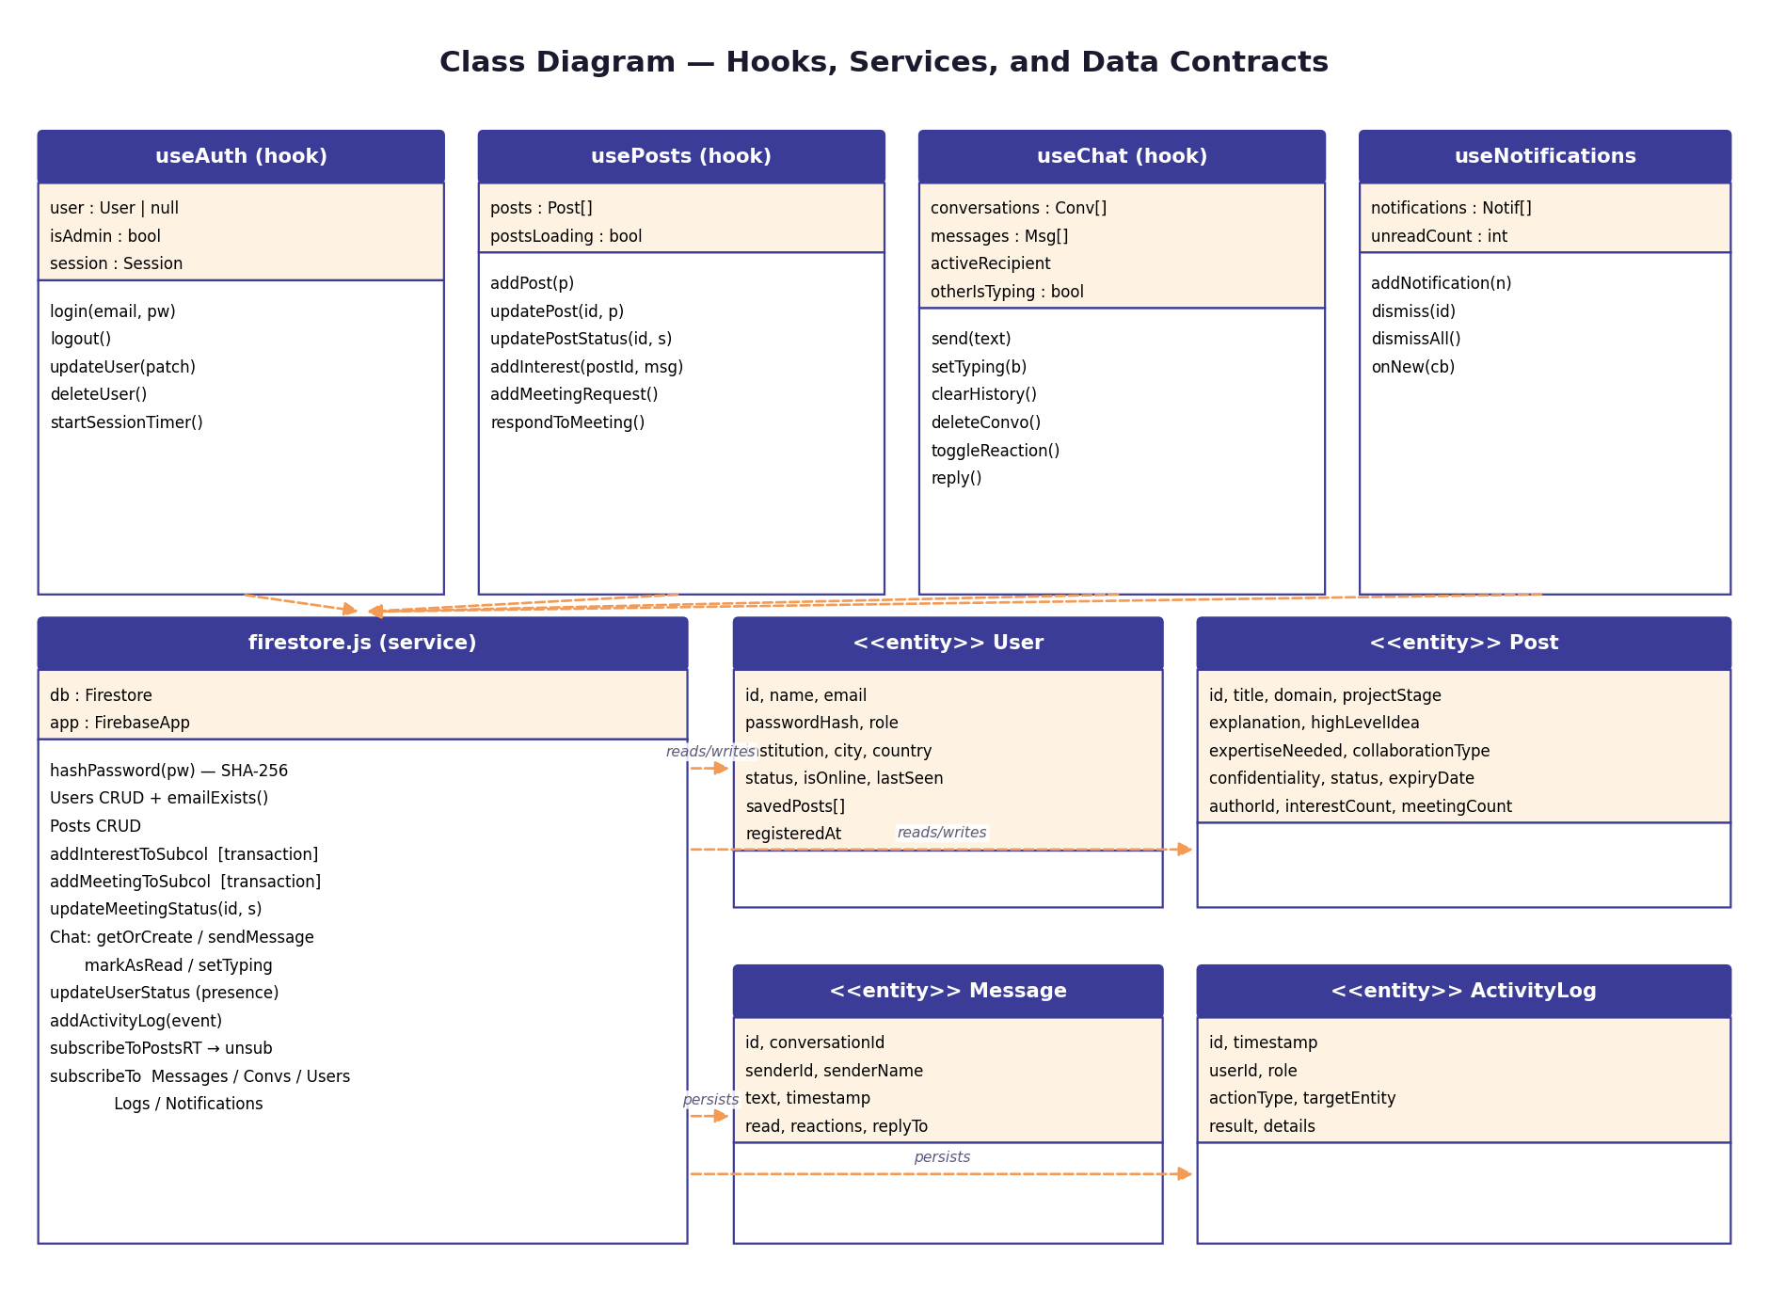
Diagram: Class Diagram — hooks, service layer and persisted entities

4.2 Hook Contracts
Hook | Returned API | Notes
useAuth() | { user, isAdmin, login, logout, updateUser, deleteUser } | Bootstraps from localStorage, starts inactivity timer
usePosts() | { posts, postsLoading, addPost, updatePost, updatePostStatus, addInterest, addMeetingRequest, respondToMeeting } | Subscribes to posts collection in real time
useChat(currentUserId) | { conversations, messages, activeRecipient, otherIsTyping, send, setTyping, clearHistory, deleteConvo, toggleReaction, reply } | Manages conversation list and active conversation
useNotifications(userId, onNew?) | { notifications, unreadCount, addNotification, dismiss, dismissAll } | Subscribes to notifications/{userId} in real time
usePostEngagement(postId) | { interests, meetings } | Subscribes to subcollections with cleanup on unmount
useToast() | { success, info, error, clear } | Context consumer for ToastProvider

5. Data Design

5.1 Firestore Collections
Collection | Document ID | Key Fields | RT Listener
users | Custom (admin-TS) | name, email, passwordHash, role, institution, city, country, status, isOnline, lastSeen, savedPosts | subscribeToUsersRT
posts | Custom (post-TS) | title, domain, projectStage, explanation, confidentiality, status, interestCount, meetingCount, authorId, authorName, authorEmail | subscribeToPostsRT
posts/{id}/interests | Custom (int-UID-TS) | userId, userName, message, ndaAccepted, createdAt (serverTimestamp) | subscribeToPostInterests
posts/{id}/meetings | Custom (meet-UID-TS) | proposedBy, proposedByName, slot, status, createdAt (serverTimestamp) | subscribeToPostMeetings
conversations | Sorted member IDs joined by _ | members[], memberData{}, lastMessage, updatedAt, unreadCount{}, isTyping{} | subscribeToConversationsRT
conversations/{id}/messages | Auto-generated | senderId, senderName, text, timestamp, read, reactions{}, replyTo{} | subscribeToMessagesRT
activityLogs | Custom (log-TS) | timestamp, userId, userName, role, actionType, targetEntity, result, details | subscribeToLogsRT
notifications | Custom ID | type, title, message, postId, fromUser, timestamp, read | subscribeToNotificationsRT

5.2 Real-Time Subscription Pattern
1. Component mounts → hook initialises → Firestore onSnapshot listener established
2. External change occurs → Firestore pushes snapshot to all listeners
3. Listener callback fires → hook updates React state via setState
4. React re-renders consuming components → UI reflects change instantly
5. Component unmounts → unsubscribe() called → listener detached
Atomic counters (interestCount, meetingCount) are updated through runTransaction to remain consistent under concurrent writes. Conversations use deterministic IDs derived from the sorted member IDs to avoid duplicate threads between the same two users.

6. Interface Design

6.1 Design System
The UI uses a premium editorial liquid-glass design system (liquid-glass.css) with a warm amber and cyan accent palette, an SVG noise grain overlay and CSS custom properties for theming.
Variable | Dark Value | Purpose
--background | #0a0a0f | Main page background
--surface | rgba(18,18,28,0.6) | Card and panel backgrounds
--accent-warm | #f5c48a / #f39a54 | Primary warm amber accents
--accent-cool | #67e8f9 / #22d3ee | Secondary cool cyan accents
--text-main | #e8e8ed | Primary text colour
--text-muted | rgba(255,255,255,0.5) | Muted / secondary text
--glass-bg | rgba(255,255,255,0.04) | Liquid-glass panel fill with backdrop-blur
fx-grain-global | 3.5% SVG noise | Anti-banding texture overlay (Stripe / Arc pattern)


Figure: Landing Page — Editorial liquid-glass design with Spline 3D background

6.2 Navigation & Routing
Nav Item | Route | Visibility
Feed | /dashboard | All authenticated users
My Posts | /my-posts | All authenticated users
Messages | /chat | All authenticated users
Profile | /profile | All authenticated users
Admin Logs | /admin | Admin role only

AppRoutes.jsx wraps protected routes in ProtectedRoute (redirects to /login when no user) and public routes in GuestRoute (redirects authenticated users away from /login). Pages are loaded with React.lazy() + Suspense and wrapped in AnimatePresence for transition animations.
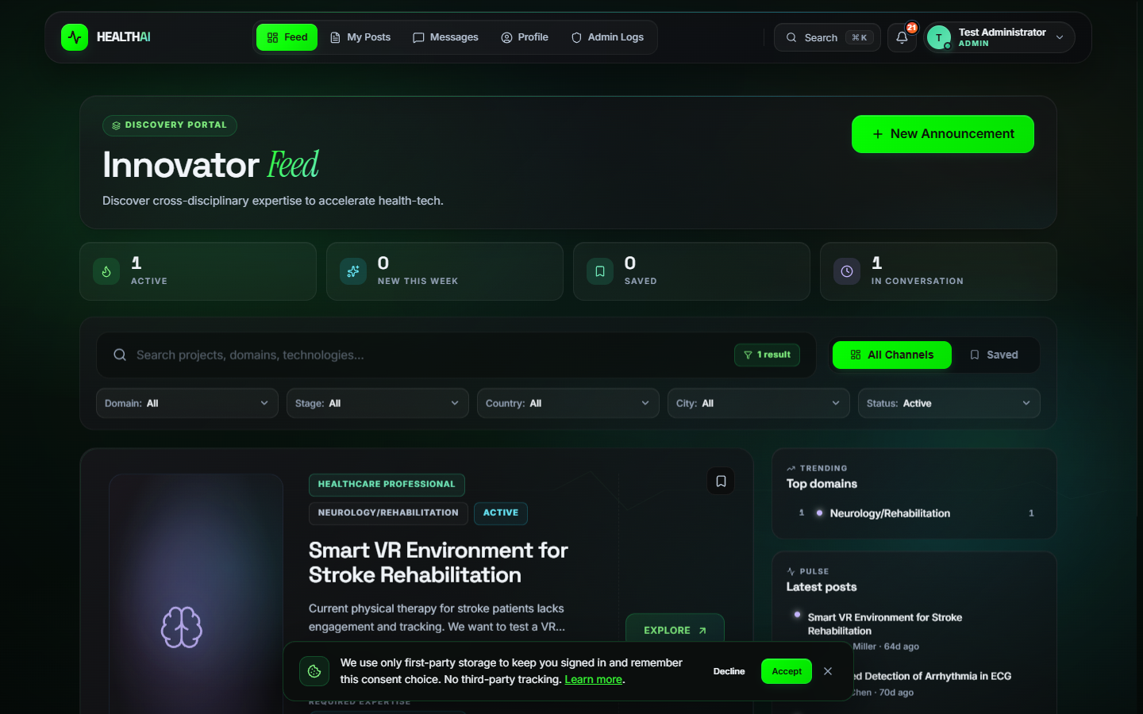
Figure: Dashboard — Navbar with active route indicator

7. Detailed Component Design
This section documents the most important runtime interactions in the application using UML sequence diagrams. Solid arrows represent synchronous calls; dashed green arrows represent asynchronous responses or pushed snapshots.

7.1 Authentication & OTP Flow
On Sign In, Login.jsx calls useAuth.login() which delegates to firestore.js getUserByEmail(); the SHA-256 hash is verified, an activity log is written, and the session is established. On Register, the form submits, an OTP is generated and dispatched through EmailJS, the user enters the code, and only on success is the user document created in Firestore and the user signed in.
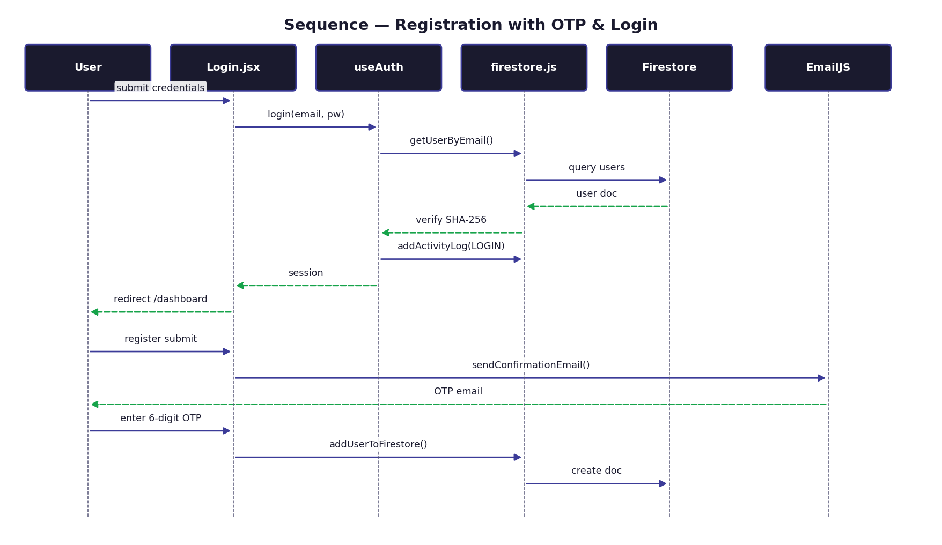
Diagram: Sequence — Registration with OTP and Sign In

7.2 Create Announcement Flow
CreatePost.jsx renders a 3-step wizard backed by WizardProgress. Each Next click advances the step state. On final submit, usePosts.addPost() is invoked which calls firestore.js addPostToFirestore(); the resulting Firestore snapshot is pushed back through subscribeToPostsRT, the dashboard hook updates state, and React re-renders. The user is then redirected to /dashboard.
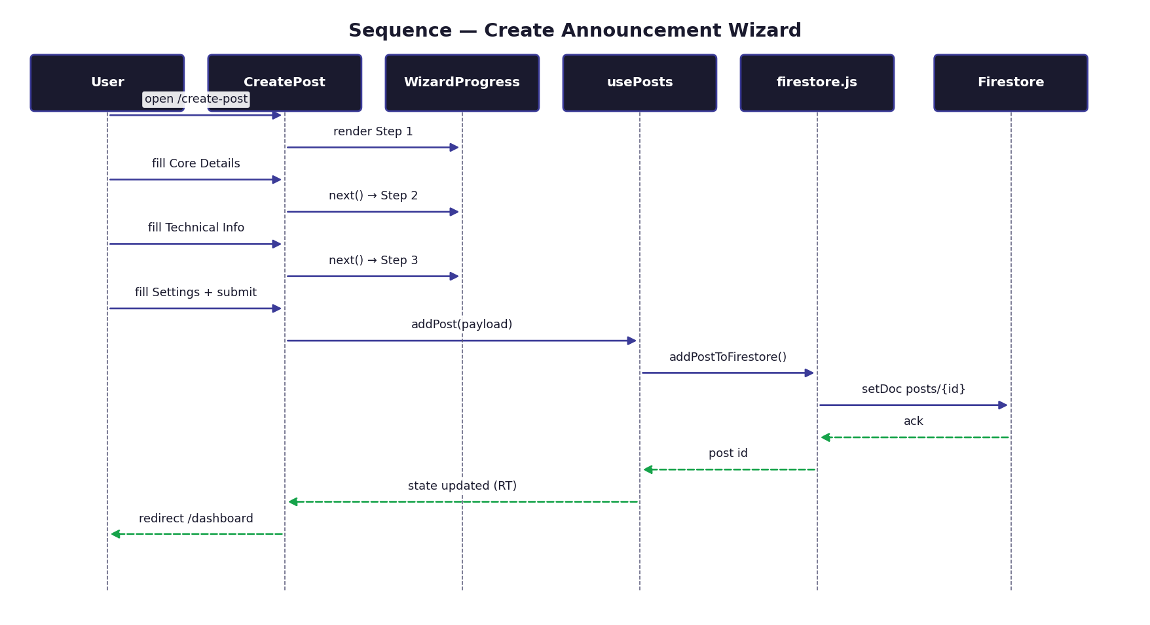
Diagram: Sequence — Create Announcement Wizard end-to-end

7.3 Interest, NDA & Meeting Flow
On Express Interest, PostDetail opens NDAModal. The user checks the NDA box and confirms; usePostEngagement.addInterest() invokes addInterestToSubcol() inside a Firestore transaction that increments interestCount atomically. A notification is dispatched to the post author. Subsequently, the user picks a slot from the auto-generated weekday list; the meeting request is written to posts/{id}/meetings and the author is notified.
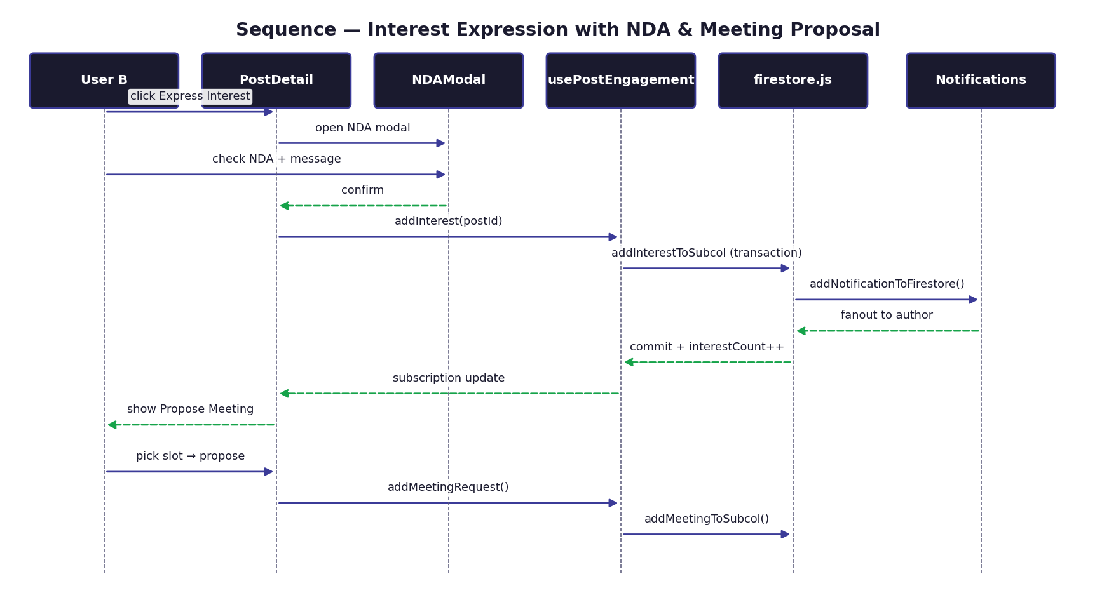
Diagram: Sequence — NDA + Interest + Meeting Proposal

7.4 Real-Time Chat Flow
When a user types, useChat.setTyping(true) updates conversation.isTyping in Firestore; the snapshot reaches the other browser and animates the typing dots. On Send, sendMessage adds a document under conversations/{id}/messages; the snapshot reaches both browsers. When the recipient opens the conversation, markAsRead() updates message.read; the originating browser sees a double-check.
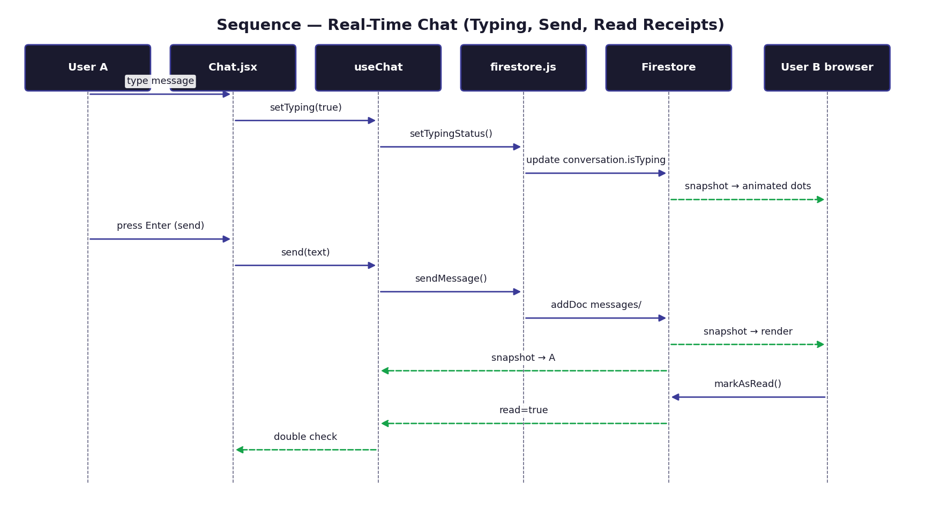
Diagram: Sequence — Real-Time Chat with typing indicator and read receipts

7.5 Admin Audit Flow
AdminDashboard renders four tabs. On Audit Logs, subscribeToLogsRT delivers a real-time view of activityLogs. The admin filters by role, action type or text. Export CSV iterates the filtered list, builds a CSV string and triggers a Blob download in the browser. Freeze / Unfreeze writes to user.status; the next login attempt by a frozen user is rejected.

8. Security Design
Layer | Mechanism | Detail
Password | SHA-256 hashing | Client-side via Web Crypto API; no plaintext stored or transmitted
Email validation | .edu enforcement | Personal providers (gmail, yahoo, outlook, hotmail, icloud, proton, yandex, mail.ru, etc.) blocked
Email verification | 6-digit OTP via EmailJS | 10-minute TTL, 60-second resend cooldown; account inactive until verified
Routes | Guard components | ProtectedRoute redirects unauthenticated users; GuestRoute redirects authenticated users away from /login
IP protection | NDA workflow | Confidential posts gate the technical blueprint behind an explicit NDA acknowledgement modal
RBAC | Role-based access | Cross-role discovery only; admin routes restricted to Admin role
Audit | Activity logging | All login, post, meeting and admin actions persisted to activityLogs with timestamp, user and result
GDPR | Data rights | Article 15 (access via Profile), Article 17 (account delete), Article 20 (JSON export)
Session | Inactivity timeout | 30-minute timeout on user inactivity; cleared from localStorage
Transport | TLS | All network traffic over HTTPS; Firestore SDK uses TLS WebSocket

9. Error Handling Strategy
Error Type | Detection | User Experience
Render crash | GlobalErrorBoundary (componentDidCatch) | Recovery UI with reload button instead of blank screen
Network loss | NetworkStatus + navigator.onLine + window listeners | Offline warning banner; app remains responsive for cached views
Auth failure | Try/catch in handlers + activity log | Animated inline error message; non-leaking error copy
Firestore error | Try/catch around all service calls + console.error | Toast notification with retry hint; graceful degradation of the affected view
Form validation | Client-side validation before submit | Contextual inline error messages adjacent to the offending field
OTP errors | EmailJS response code + TTL check | Inline message explaining expired or invalid code; resend cooldown enforced

10. Deployment Architecture
The HEALTH AI platform is deployed as a static SPA bundle served from a CDN; all backend concerns are handled by Google Firebase. The diagram below shows the runtime nodes and the protocols connecting them.
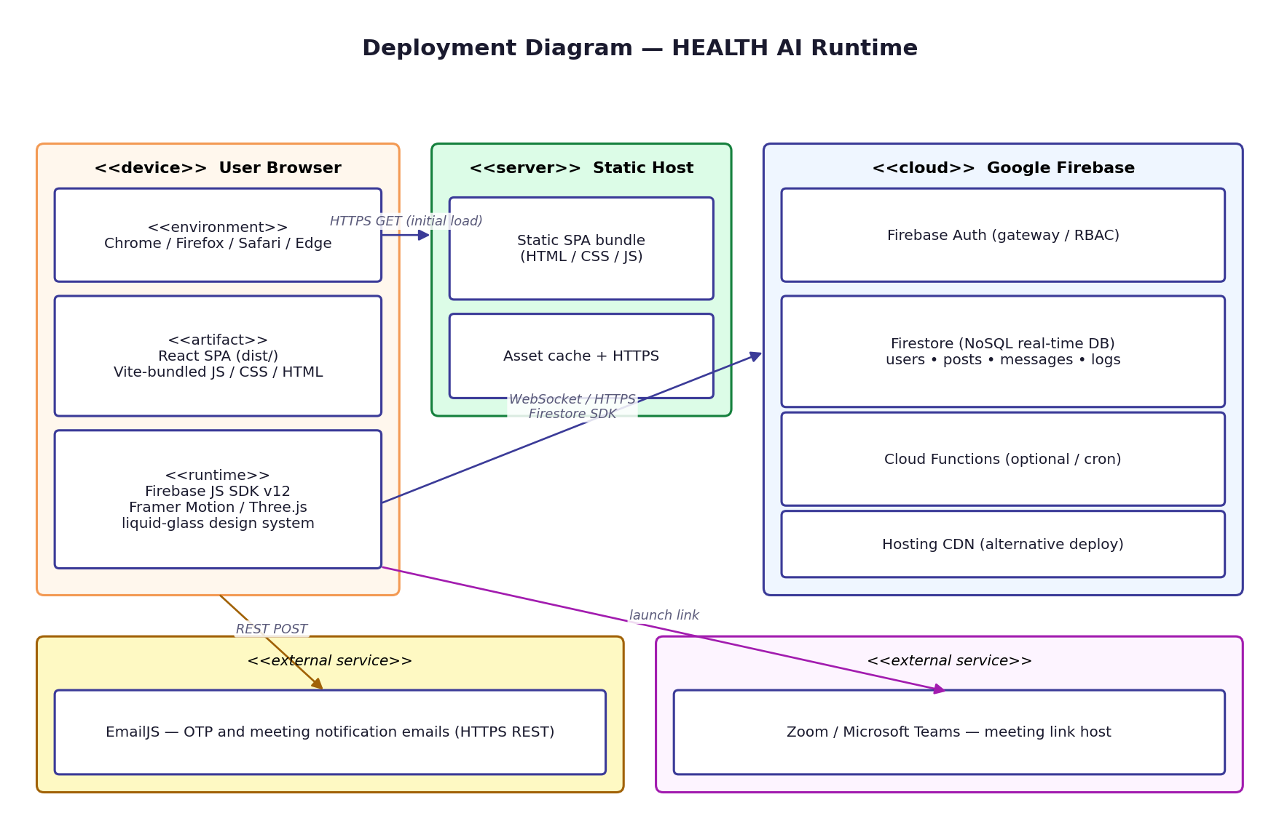
Diagram: Deployment Diagram — Browser, Static Host, Firebase Cloud and external services

Build pipeline: source → Vite production build → dist/ (HTML, CSS, JS bundles) → static host. Runtime: browser ↔ Firestore SDK (WebSocket) ↔ Firebase Firestore (Google Cloud).

11. Build, Configuration & DevOps
Concern | How it is handled
Local dev | `npm run dev` starts Vite at http://localhost:5173 with HMR
Production build | `npm run build` emits a tree-shaken, code-split static bundle to dist/
Preview | `npm run preview` serves the production bundle locally for smoke testing
Configuration | .env (untracked) contains VITE_FIREBASE_API_KEY, VITE_FIREBASE_AUTH_DOMAIN, VITE_FIREBASE_PROJECT_ID, VITE_FIREBASE_STORAGE_BUCKET, VITE_FIREBASE_MESSAGING_SENDER_ID, VITE_FIREBASE_APP_ID; example values in README
Routing fallback | SPA fallback rewrites must point all unknown paths to index.html on the host
Static hosting | Compatible with Firebase Hosting, Vercel or Netlify; no server-side runtime needed
Screenshots | take-screenshots.js (Playwright) refreshes docs/screenshots/ from the running dev server
Documentation generation | docs/generate_srs.py, generate_sdd.py and generate_userguide.py emit the .docx artefacts and embed live screenshots and matplotlib-generated diagrams

12. Performance & Optimisation
- Code splitting through React.lazy() at the page level keeps the initial bundle minimal.
- Vite's production build performs tree shaking and dynamic import chunking automatically.
- Firestore subscriptions reuse a single WebSocket per app instance, multiplexing queries.
- Counters are denormalised on the parent document (interestCount, meetingCount) to avoid expensive aggregate queries.
- Conversations use deterministic IDs derived from sorted member IDs; the SDK can resolve them in a single document read.
- Animations use the GPU-accelerated transform/opacity properties; layout thrash is avoided.
- HLS video backgrounds load only on routes that need them and crossfade with low-CPU transitions.
- The Spline 3D background is mounted once and toggled with display:none on non-landing routes to preserve the WebGL context.
- prefers-reduced-motion is honoured globally through MotionConfig to keep CPU usage low for sensitive users.

13. Testing Strategy
Test Layer | Approach | Coverage Focus
Manual smoke | Two-account walkthrough on Chrome and Firefox | End-to-end happy paths for UC-01..UC-08
Cross-browser | Latest two majors of Chrome, Firefox, Safari, Edge | Layout, animation, WebSocket
Responsive | DevTools at 320, 768, 1024, 1440, 2560 px | Navbar collapse, card grid, modals
Accessibility spot-check | axe-core / Lighthouse | Contrast, semantic landmarks, focus order
Performance spot-check | Lighthouse, devtools throttling | Time-to-Interactive < 2 s on Fast 3G
Security spot-check | OWASP Top 10 review | XSS, injection surface, transport security

14. Future Work
- Migrate authentication to Firebase Auth + custom claims to remove client-side hashing entirely.
- Introduce server-side Firestore Security Rules tied to the auth uid and role claim.
- Add localisation (i18n) — extract UI strings into JSON resource files (English / Turkish to start).
- Implement an institution directory and verified institution badges.
- Provide a moderation queue with reason codes instead of direct deletion.
- Add multi-factor authentication beyond OTP (TOTP / WebAuthn).
- Surface admin analytics (cohort, retention, time-to-first-meeting) through a charting library.
- Generate ICS calendar invites for accepted meetings and integrate with the user's calendar.

