**USER GUIDE DOCUMENT**

**MỤC LỤC**

**1. Main form:** 1

**1.1** **Menu items:** 1

**1.2** **Button** **Choose file**: 1

**1.3** **Textfield path file input:** 3

**1.4** **Combobox templates**: 3

**1.5** **Button Convert File:** 4

**2. System:** 4

**2.1** **System – Set delimiter:** 5

**2.2** **System – Exit:** 5

**3. Log:** 6

**3.1** **Log – Error:** 6

**3.2** **Log – Date:** 7

**4. Path folder:** 7

**4.1** **Path folder - Input:** 8

**4.2** **Path folder – Output:** 9

**4.3** **Path folder – Error:** 10

**4.4** **Path folder – Process:** 11

**4.5** **Path folder – See path:** 12

**5. Config:** 12

**5.1** **Config – Connect to DB:** 13

**5.2** **Config – Default value:** 14

**5.3** **Config – Query:** 18

**6. Header:** 20

**6.1** **Header – New:** 21

**6.2** **Header – List:** 27

**6.3** **Header – Import:** 31

**7. Object:** 32

**7.1** **Object – New:** 32

**7.2** **Object – List:** 33

**7.3** **Object – Import:** 34

**8. Struct:** 34

**8.1** **Struct – New:** 35

**8.2** **Struct – List:** 37

* 1. **Main form:**

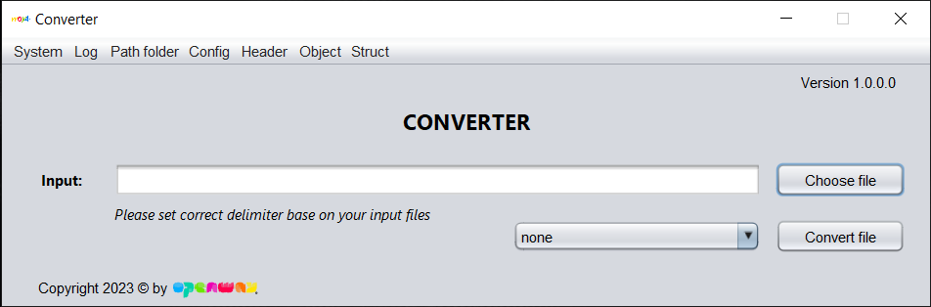

View of main form

1. **Menu items:**

* System, Log, Path folder, Config, Header, Object, Struct.

1. **Button** **Choose file**:

* Open file explorer to choose input file (user can choose multiple file by

***ctrl + left click***). User have 3 options files of type to convert (csv, xlsx, txt).

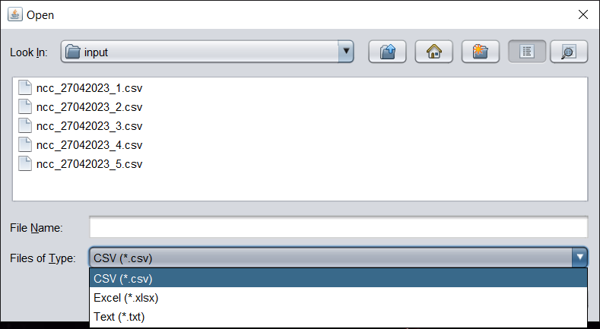

Select path and file name extension.

* Choose multiple file by **ctrl + left click**, then click “Open” to choose (or press Enter).

input file


Choose multiple csv files.

* Dialog notification show files name chosen after user choose complete (click OK or press Enter to exit notification).

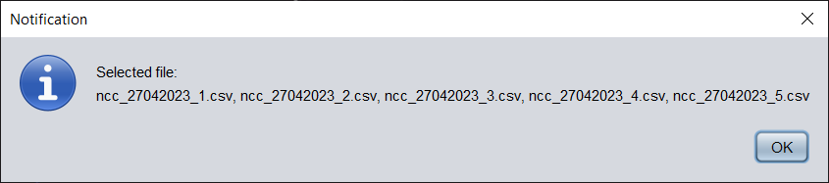

Notification to show file name chosen.

1. **Textfield path file input:**

* Show the name of files chosen (not editable).

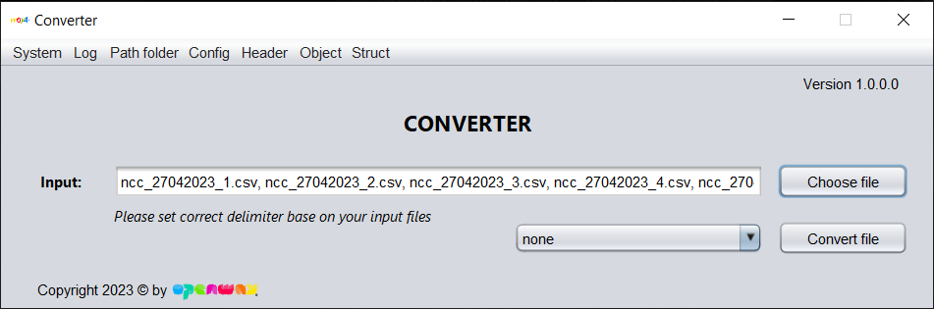

Textfield input show files chosen.

* + 1. **Combobox templates**:
* Show all templates of system (template can be create or import by user).
* After choose file input, you must select the template that matching with all files chosen to convert.

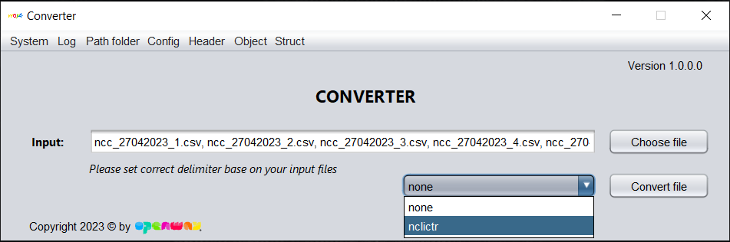

Choose struct.

* + 1. **Button Convert File:**
  1. Convert all files chosen, click button **Convert File**.
  2. After convert, dialog notification will show ***total file convert success / total file input***.
  3. Click button **OK** (or press **Enter**) in dialog notification, then the tool will reset to its original status.

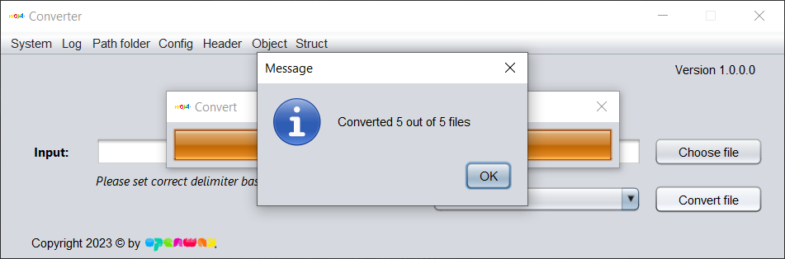

Notification to show convertion status.

* 1. **System:**

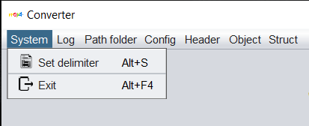

MenuBar – System.

1. If user want to set delimiter base on input files, click **Set delimiter** (or press **Alt + S**). If not set, the tool will auto detect delimiter in your input files.
2. If user want to exit application, click **Exit** (or press **Alt + F4**).
3. **System – Set delimiter:**
4. There are 4 common options to set delimiter, user can also set another delimiter by click **Other**, and then type delimiter into the input text beside and then click button **OK** to complete.
5. **Note:** Delimiter must be a single character.

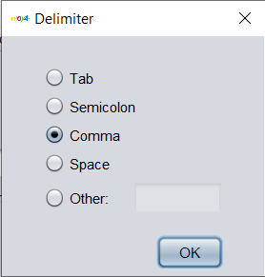 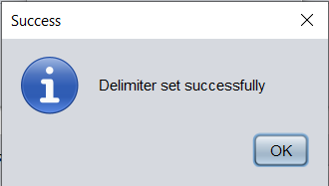

System - Set delimiter.

1. **System – Exit:**

* Click button **Yes** (or press **Enter**) to exit tool. If not, click button **No**.

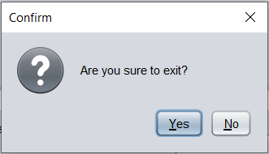

System – Exit.

* 1. **Log:**

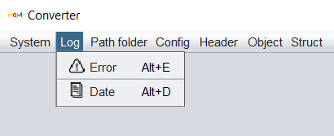

MenuBar – Log.

* 1. If user want to see log error, click **Error** (or press **Alt + E**).
  2. If user want to see log date, click **Date** (or press **Alt + D**).

1. **Log – Error:**
   1. Log error will show the error of the most recent failed conversion.
   2. If user want to copy error to clipboard, click button **Copy to clipboard**.

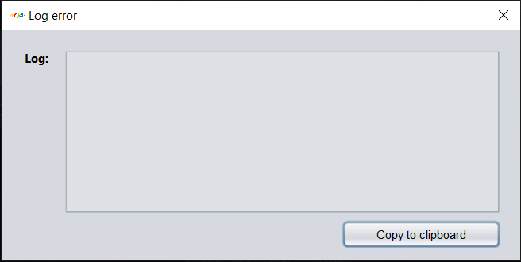

Log error.

1. **Log – Date:**
2. Log date will show all conversion status of this day. It will reset when entering a new day.
3. If user want to copy log date to clipboard, click button **Copy to clipboard**.

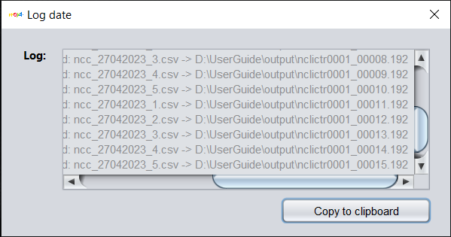

Log date.

* 1. **Path folder:**

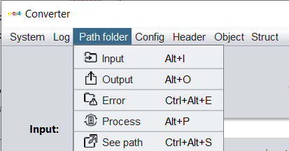

MenuBar - Path folder.

1. If user want to set input folder, click **Input** (or press **Alt + I**).
2. If user want to set output folder, click **Output** (or press **Alt** **+** **O**).
3. If user want to set error folder, click **Error** (or press **Ctrl +** **Alt** **+** **I**).
4. If user want to set process folder, click **Process** (or press **Alt** **+** **P**).
5. If user want to see all path folder, click **See Path** (or press **Ctrl +** **Alt** **+** **S**).
6. **Path folder - Input:**
7. Open dialog, user can choose any folder in user’s file explorer. After choose, user click button **Open** (or press **Enter**) to set input folder.
8. This folder contain input files to convert.

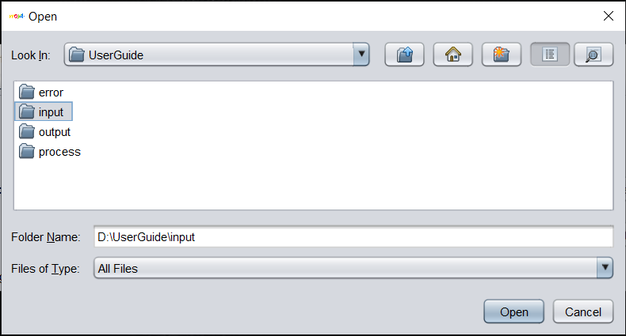

Set input folder.

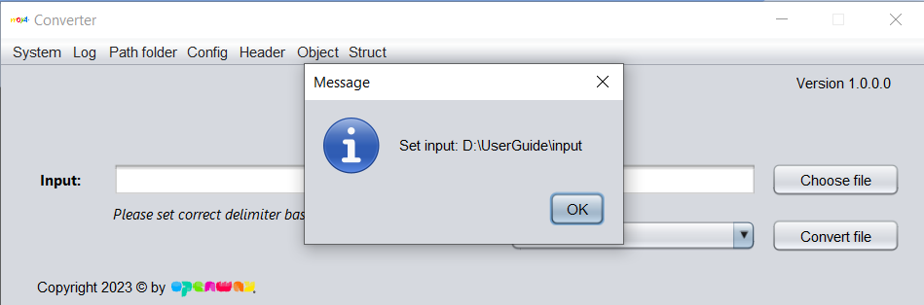

Notification to show path input folder set successfully.

1. **Path folder – Output:**
2. Open dialog, user can choose any folder in user’s file explorer. After choose, user click button **Open** (or press **Enter**) to set output folder.
3. This folder contain output files that converted success.

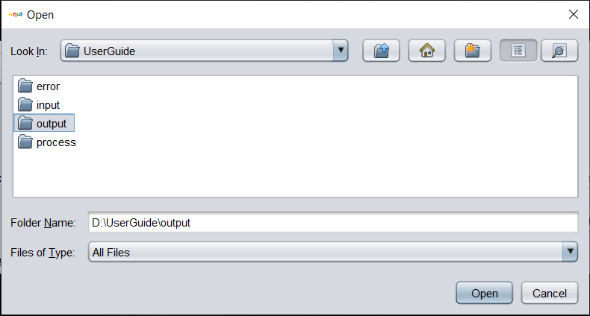

Set output folder.

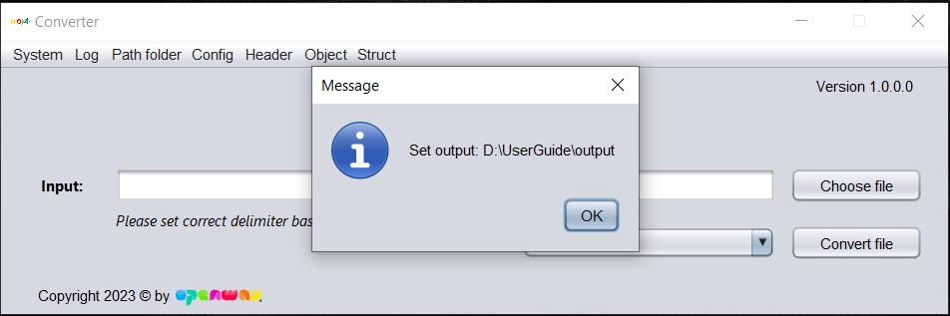

Notification to show path output folder set successfully.

1. **Path folder – Error:**
2. Open dialog, user can choose any folder in user’s file explorer. After choose, user click button **Open** (or press **Enter**) to set error folder.
3. This folder contain input files that converted fail.

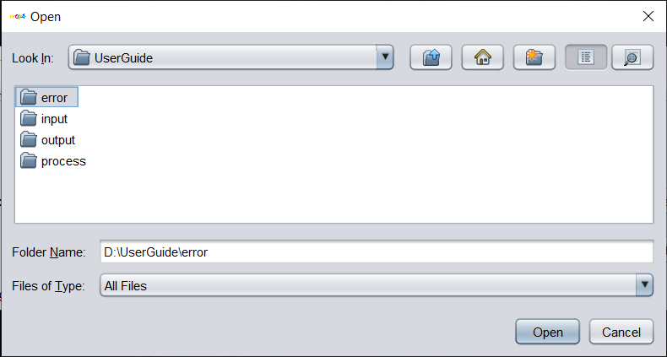

Set error folder.

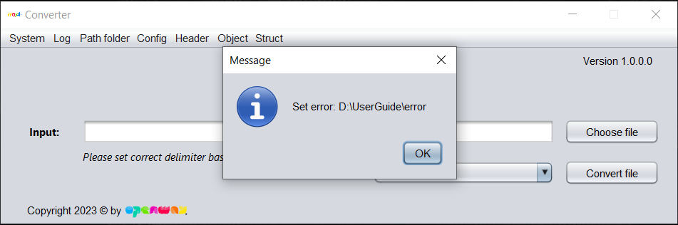

Notification to show path error folder set successfully.

1. **Path folder – Process:**
2. Open dialog, user can choose any folder in user’s file explorer. After choose, user click button **Open** (or press **Enter**) to set process folder.
3. This folder contain input files that converted success.

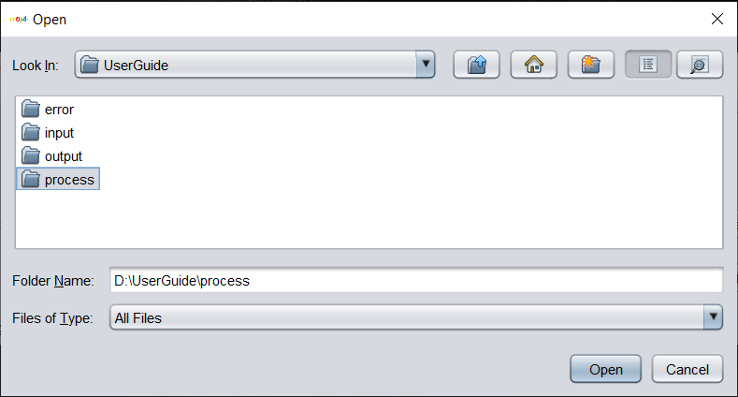

Set process folder.

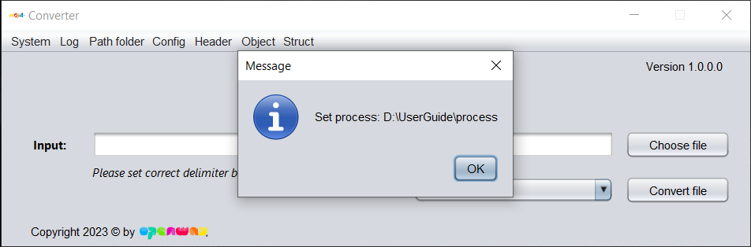

Notification to show path process folder set successfully.

1. **Path folder – See path:**
2. Show all the paths folder that user have set.

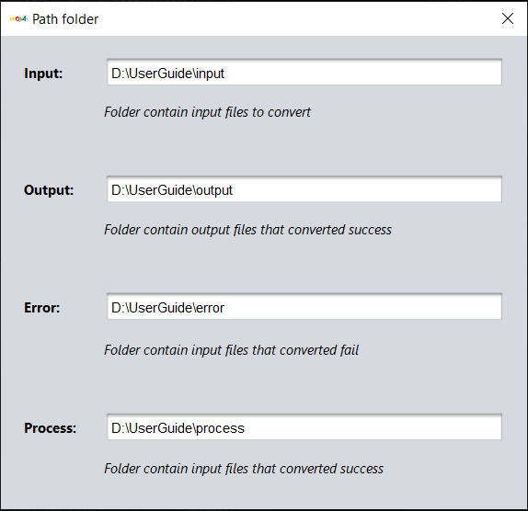

See all the paths folder.

1. **Note:** *when user click button* ***Choose file*** *in main form, dialog will open input folder. If user not set, they have to choose the path manual.*
2. *Default folders output, error, process will auto create in* ***log folder****.*
   1. **Config:**

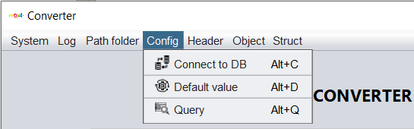

1. Before convert, user have to config to connect database, default value in header of xml output, query to get data from database. If not, user no need to config.
2. Click **Connect to DB** (or press **Alt + C**) to open dialog Connect DB.
3. Click **Default value** (or press **Alt + D**) to open dialog Default value.
4. Click **Query** (or press **Alt + Q**) to open dialog Query.
5. **Config – Connect to DB:**

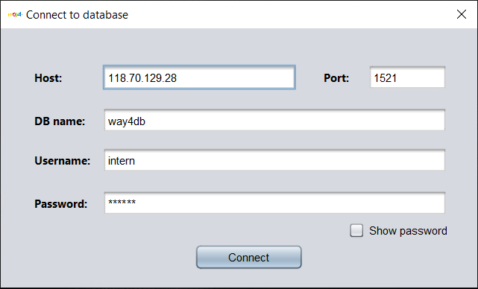

Config to connect database.

* After fill all the information, user click button **Connect** (or press **Enter**) to connect database. If connect success, the tool will encrypt host, port, database name, username, password and then save it in *log/default/database.properties*.

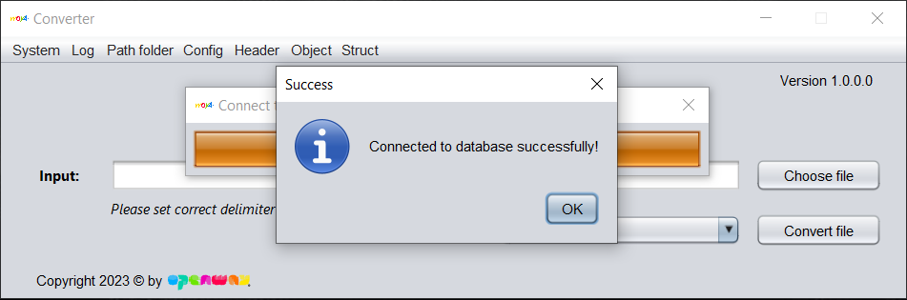

Connect success to database.

1. **Config – Default value:**

* Table show all default values of system. User can **add, update, delete** default values.

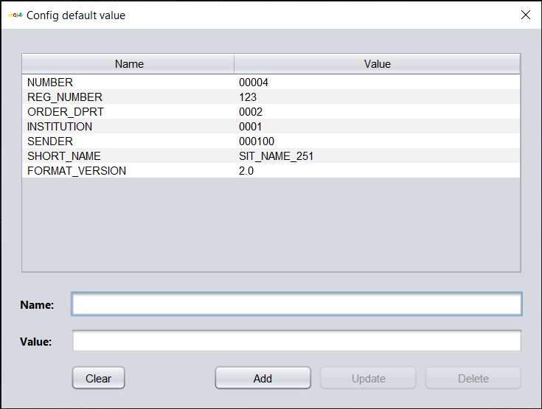

Config default value.

* User must fill the **name** and **value** of default value to add.

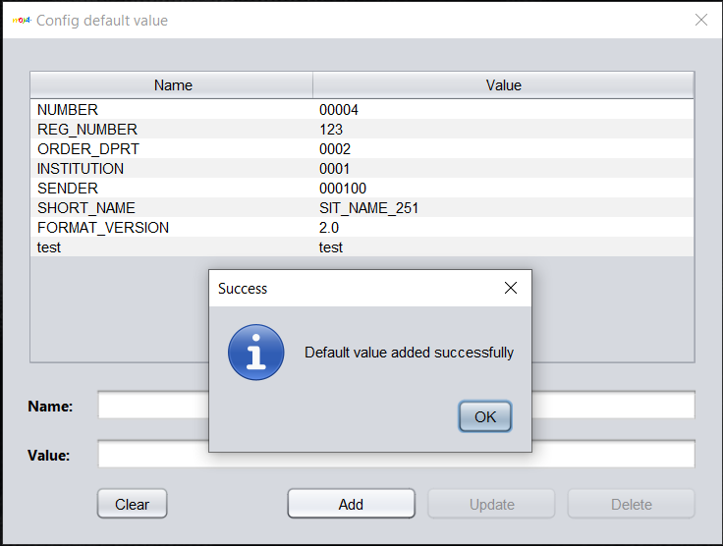

Add new default value.

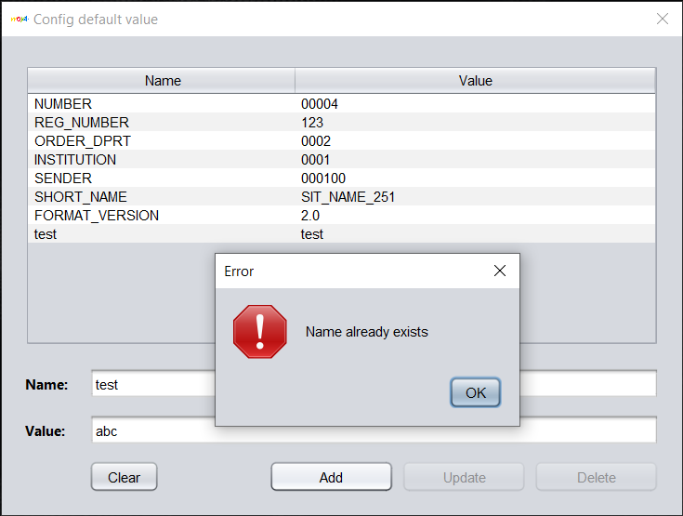

Can't add the name already exists.

* To update:
  + 1. Select a row in table.
    2. Edit the **value** (can’t edit the **name**).
    3. Click button **update.**
    4. Click button **yes** to confirm update.

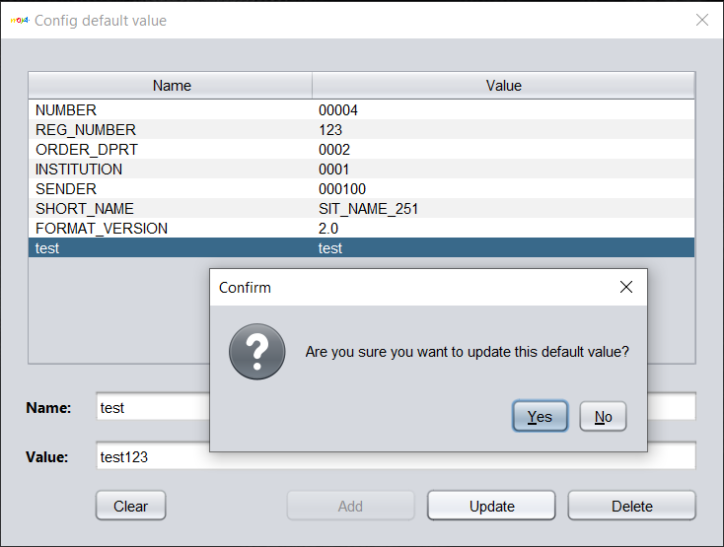

Update default value.

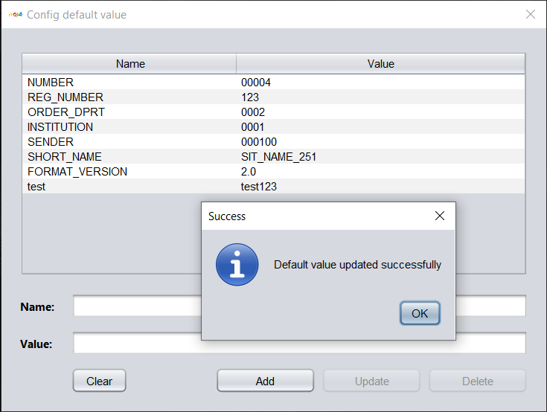

Update success default value.

* To delete:

1. Select a row (or multiple rows by **hold Ctrl + right click**) in table.
2. Click button **delete.**
3. Click button **yes** to confirm delete.

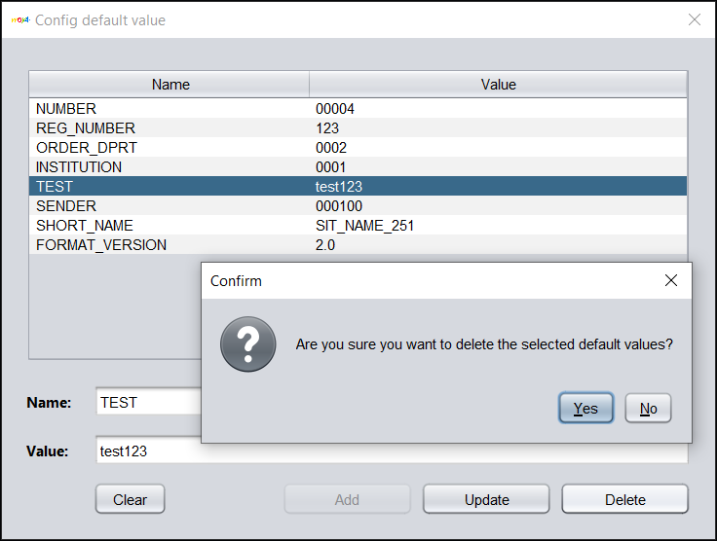

Delete default value.

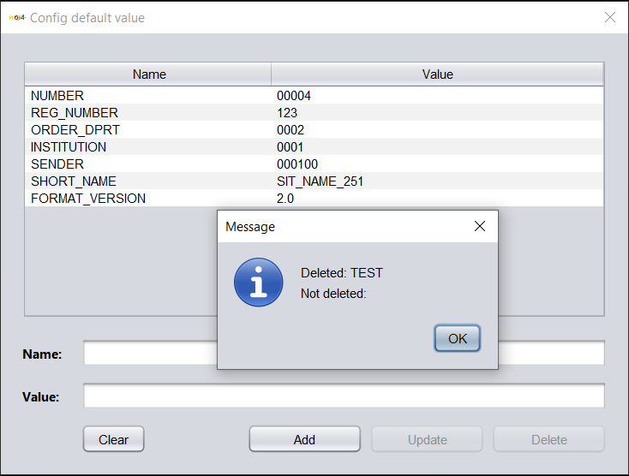

Delete default value success.

* **Button Clear**: Clear selected rows in table, make empty input name and value.

1. **Config – Query:**

* Table show all queries of system. User can *add, update, delete* queries.
* **Add, update, delete** in query is the same with **add, update, delete** in default value.

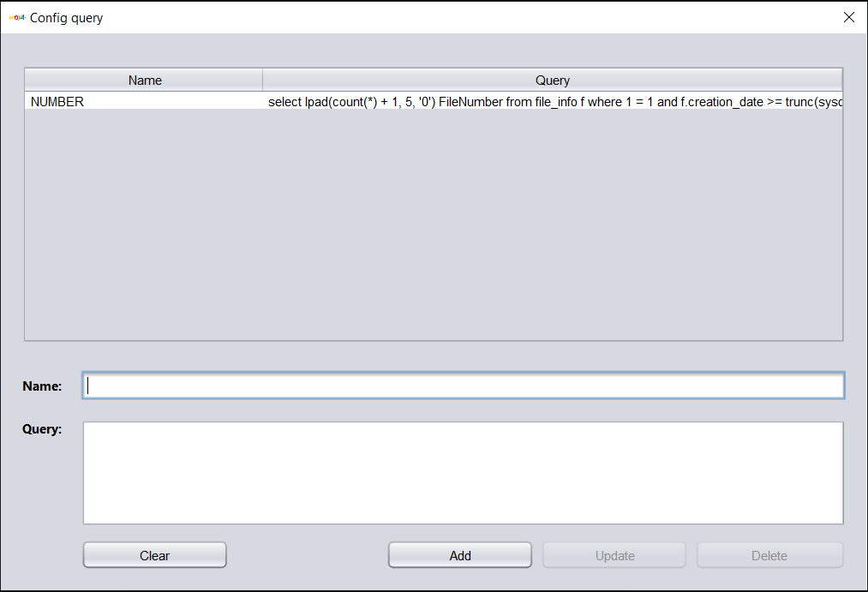

Config query..

* 1. **Header:**

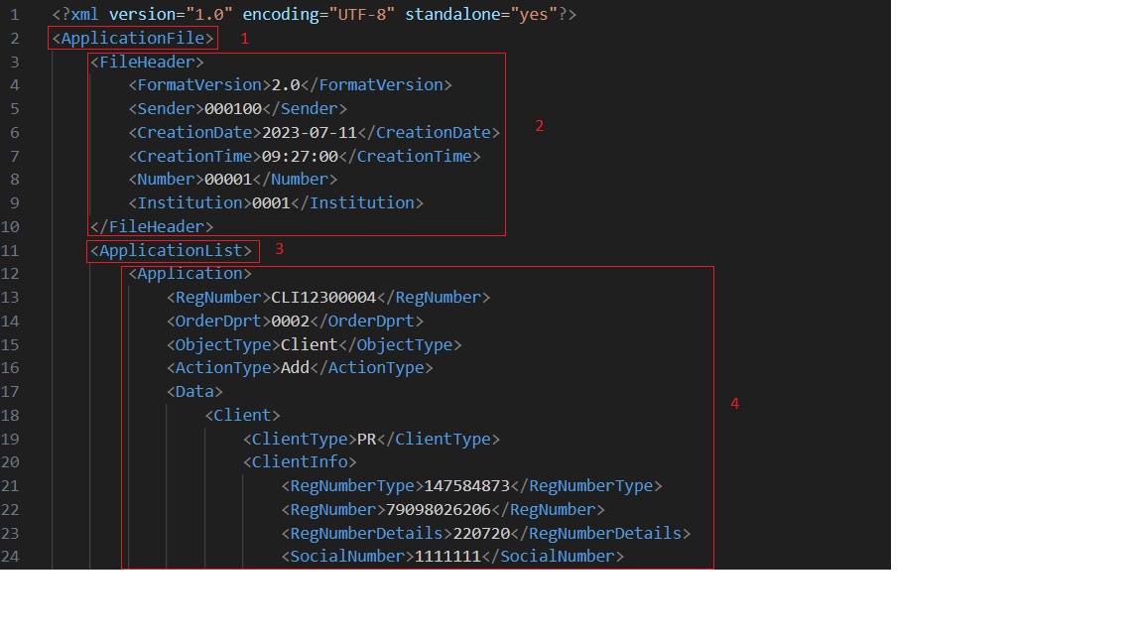

* The tool devide a xml file for **4 parts,** it callas **Struct,** a Struct includes:
  1. **Type file** (tag).
  2. **Header** (xml file).
  3. **Type list** (tag).
  4. **Object** (xml file).
* A struct will be created by user, it mean user have to create **type file**, **header**, **type list** and **object**. A struct will be as template that user can choose when user want to format the xml output files properly.

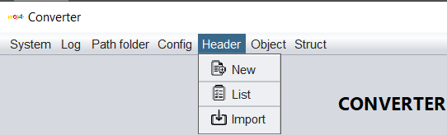

MenuBar – Header.

* + If user want to create a new Header, click **New**.
  + If user want to view all Header, click **List**.
  + If user want to import a Header, click **Import**.

1. **Header – New:**

* Create **node** (it can be a **tag**, **value** or **attributes**).

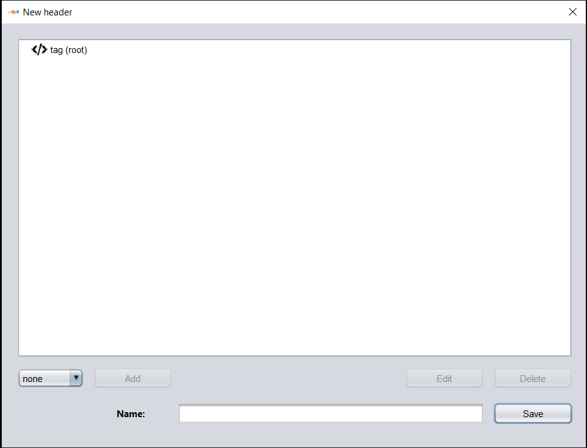

Create Header.

* To add tag:

1. Choose 1 node that you want to add tag by click it.
2. Choose option “tag” in combobox.
3. Click button **Add**.
4. Type your tag name.
5. Click button **OK** (or press **Enter**) to confirm.

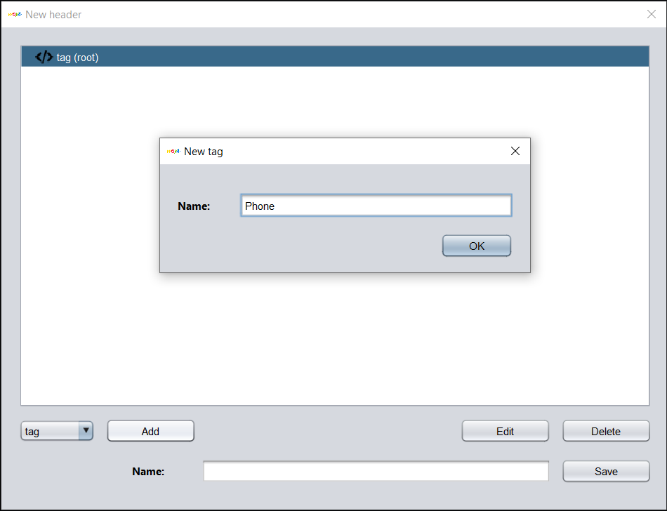

Create tag.

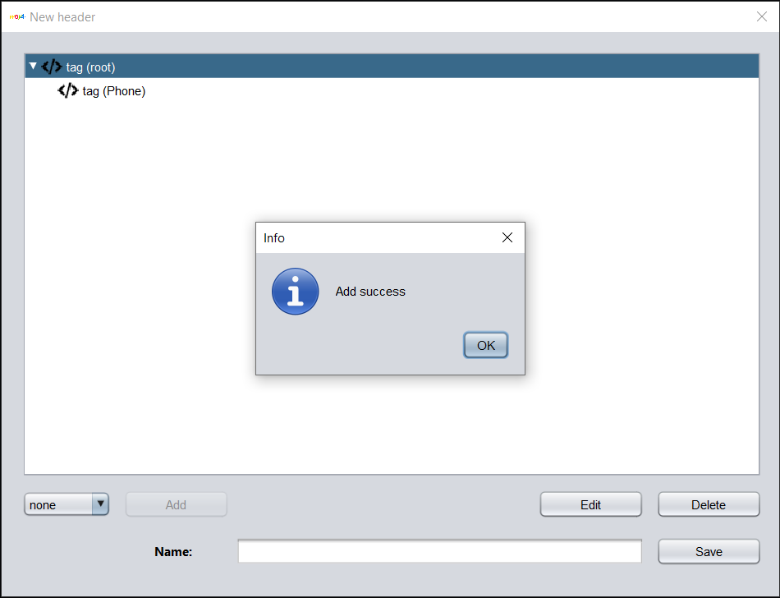

Add tag success.

* To edit tag:

1. Choose 1 node that you want to edit by click it.
2. Click button **Edit**.
3. Type your new tag name.
4. Click button **OK** (or press **Enter**) to confirm.

* To delete tag (or multiple tag):

1. Choose 1 (or multiple) node that you want to delete by click it (**Ctrl + right click** to choose multiple).
2. Click button **Delete**.
3. Click button **OK** (or press **Enter**) to confirm.

* To add attributes for a tag:

1. Choose 1 node.
2. Choose option “attributes” in combobox.
3. Click button **Add**.
4. Choose option for **Use**, **Type**, **Format**.
5. Click button **OK** (or press **Enter**).

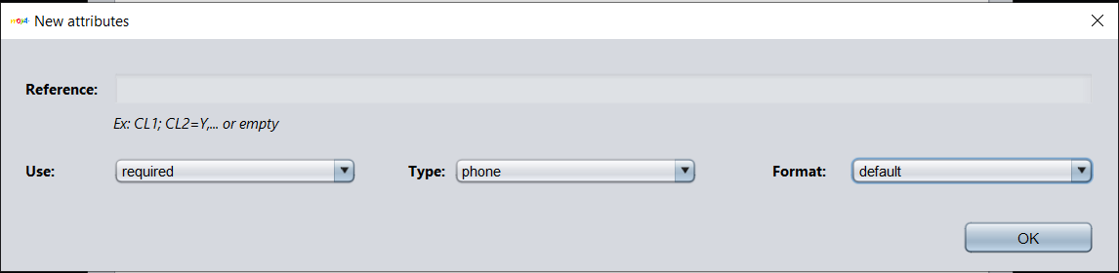

Add attributes.

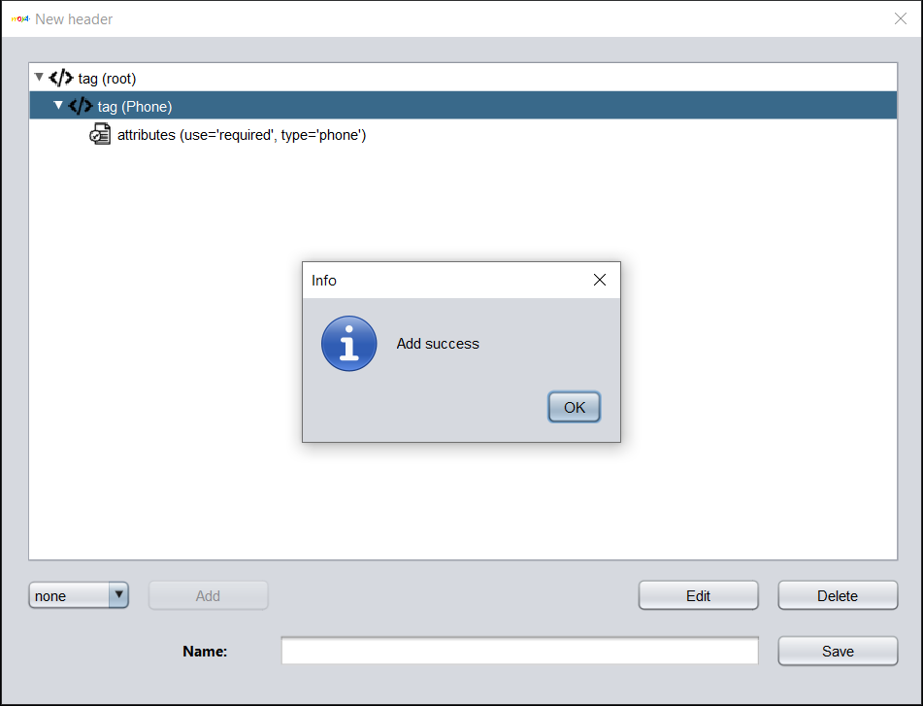

Add attributes success.

* To edit attributes for a tag: (the same with add).
* To delete attributes for a tag: (choose and then delete this node).
* To add value for a tag:

1. Choose 1 node.
2. Choose option “value” in combobox.
3. Click button **Add**.
4. Choose option to get value from where you want, choose option for details that value.
5. Click button **Add** for see preview.
6. Click button **OK** (or press **Enter**) if you accept all the values in preview.

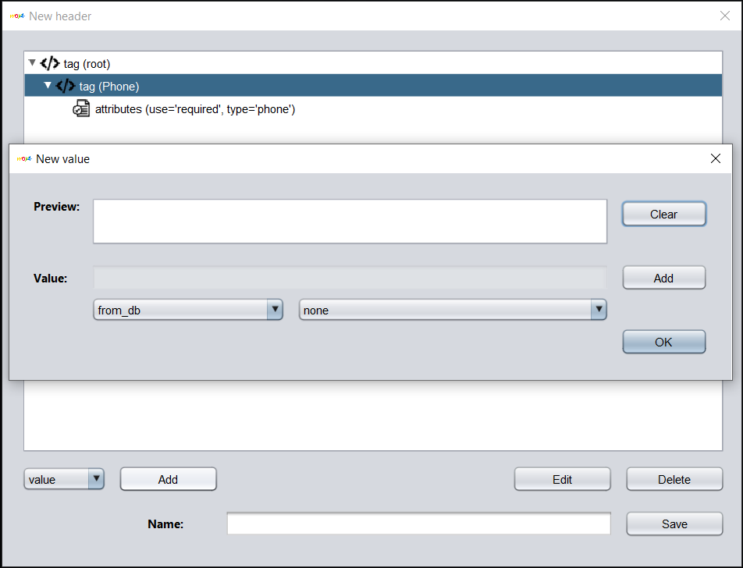

Add value.

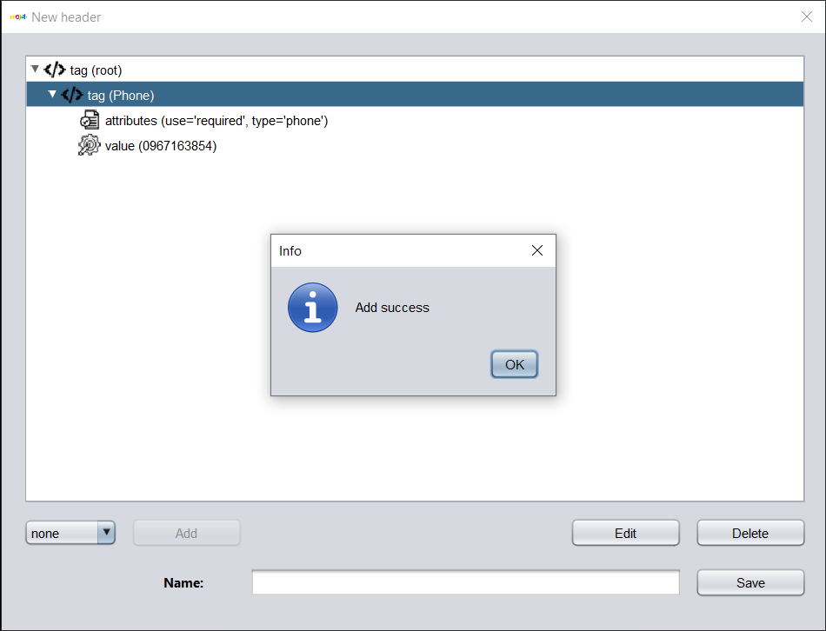

Add value success.

* After create all node for your **Header**. Type your **Header** **name** and then click button **Save** to save this Header.
* *Note: if you exit Dialog New header without saving, a dialog will show notification to you, click* ***Yes*** *to save. If not, click* ***No****.*

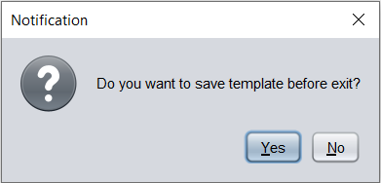

1. **Header – List:**

* Show all Header in table. User can **edit, delete, duplicate** Header.

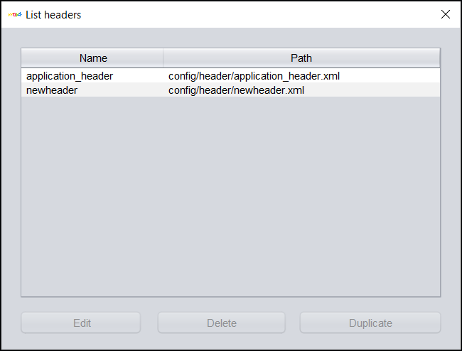

List Header.

* To edit Header:

1. Choose 1 Header.
2. Click button **Edit** (or double click this row in table).
3. Edit your Header.
4. Click button **Save**.

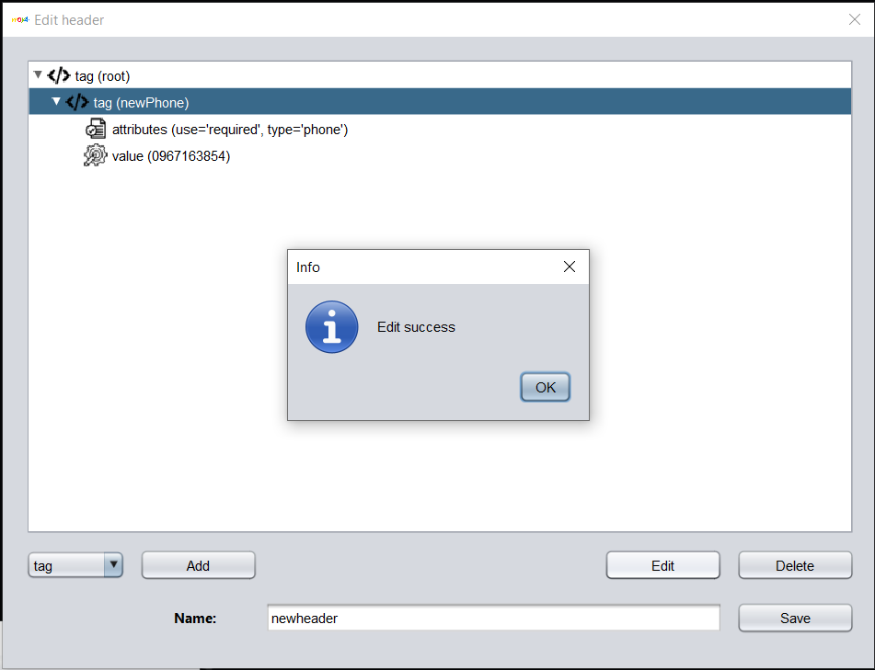

Edit a tag in Header.

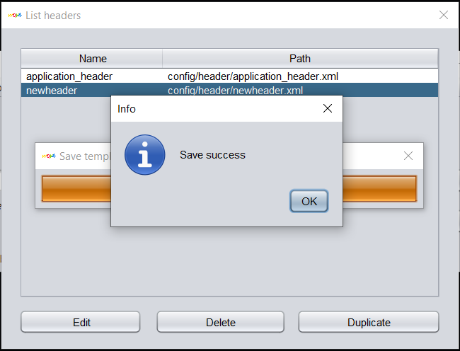

Edit success Header.

* To delete Header:

1. Choose 1 row (or multiple row by Ctrl + right click).
2. Click button **Delete**.
3. Click button **OK** (or press **Enter**) to confirm.

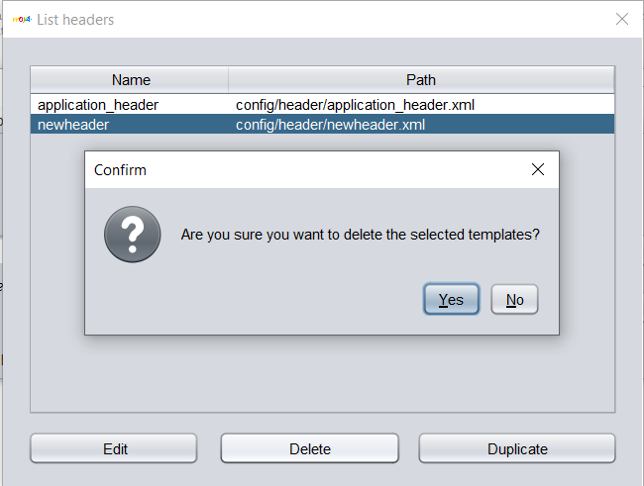

Delete Header.

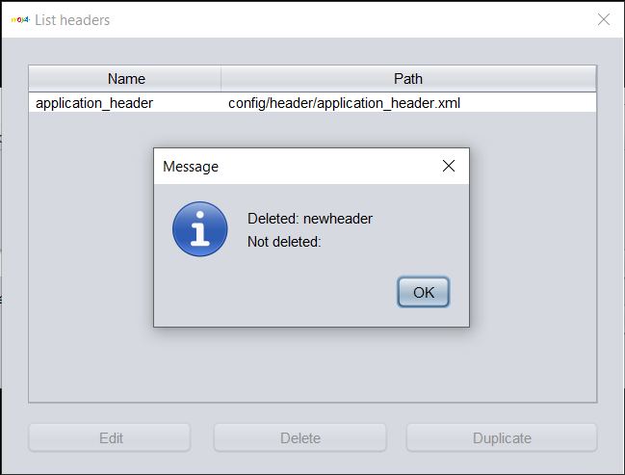

Delete Header success.

* To duplicate Header:

1. Choose 1 row.
2. Click button **Duplicate**.
3. Type a new for your new Header.
4. Click button **OK** (or press **Enter**).

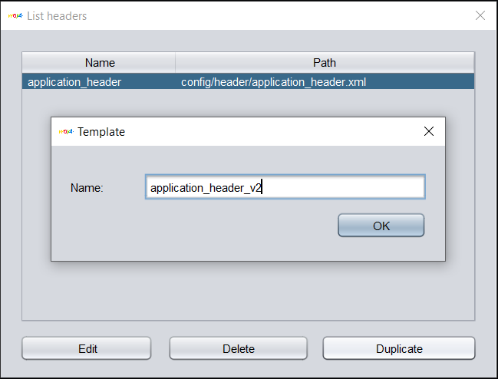

Duplicate a Header.

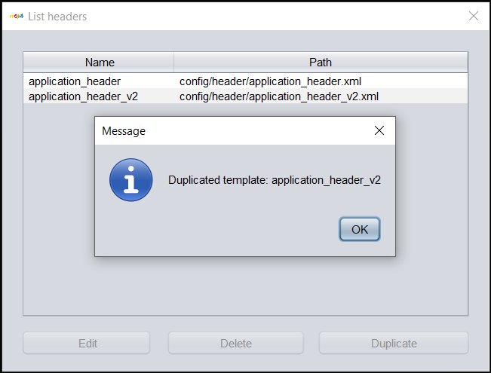

Duplicate a Header success.

1. **Header – Import:**

* If user have a xml Header, so no need to create, just need to import.
  1. Click **Import**.
  2. Choose file Header xml.
  3. Click button **Open** (or press **Enter**).
  4. Click button **OK** (or press **Enter**).

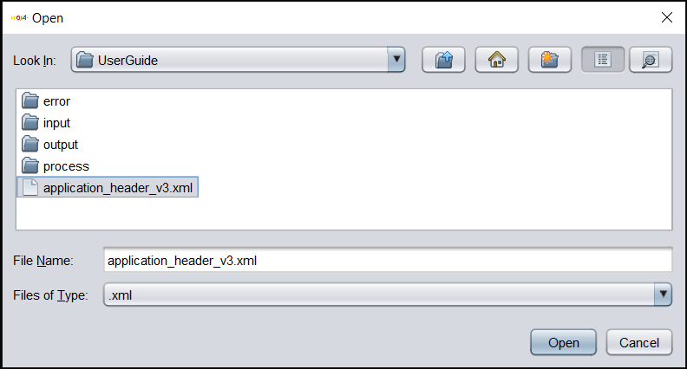

Import Header.

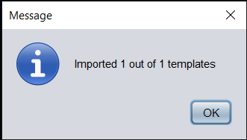

Import Header success.

* 1. **Object:**

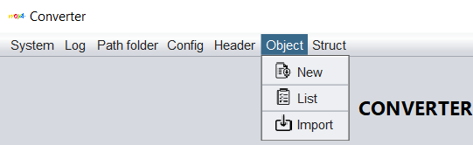

MenuBar – Object.

* + If user want to create a new Object, click **New**.
  + If user want to view all Object, click **List**.
  + If user want to import an Object, click **Import**.

1. **Object – New:**

* To create an new Object: (the same with create a new Header.)

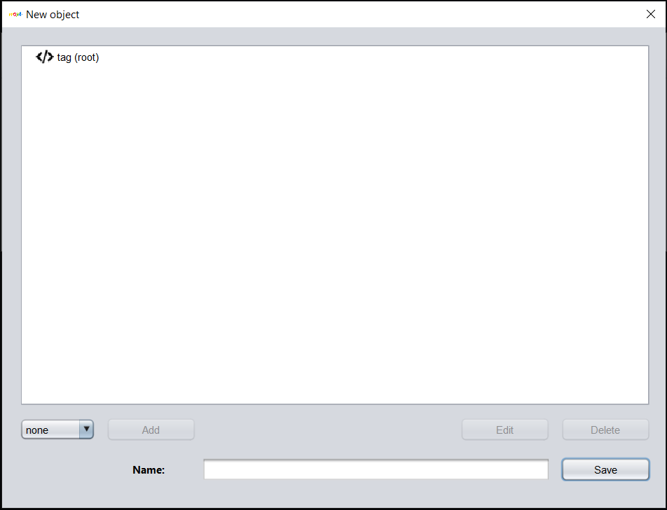

Create Object.

1. **Object – List:**

* Show all Object in table. User can **edit, delete, duplicate** Object (the same with Header).

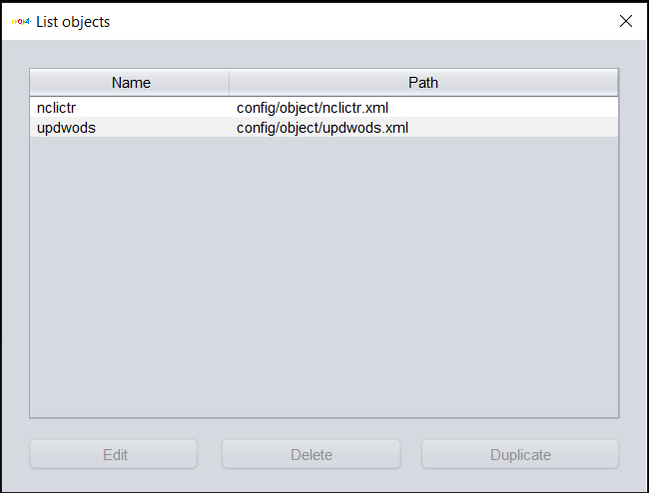

List Object.

1. **Object – Import:**

* If user have a xml Object, so no need to create, just need to import (the same with Header).

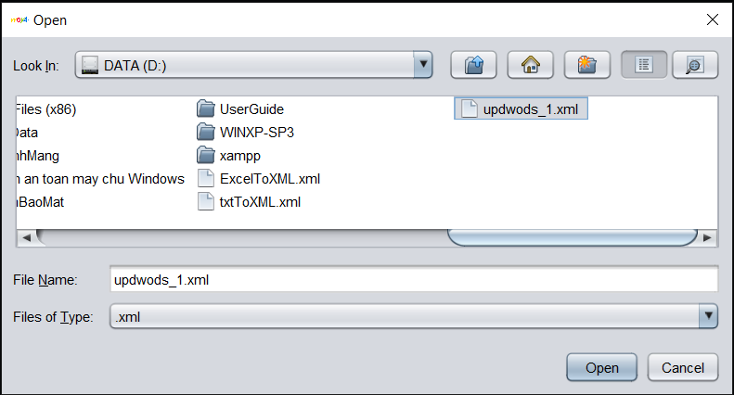

Import Object.

* 1. **Struct:**

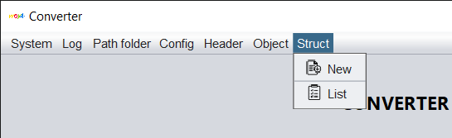

MenuBar – Struct.

* + If user want to create a new **Struct**, click **New**.
  + If user want to view all **Struct**, click **List**.

1. **Struct – New:**

* To create a new **Struct**:

1. Fill **type file**.
2. Choose **Header** in combobox.
3. Fill **type list**.
4. Choose **Object** in combobox.
5. Set **file name output** by click button **Set**.
6. Fill **Struct name**.
7. Click button **Save**.

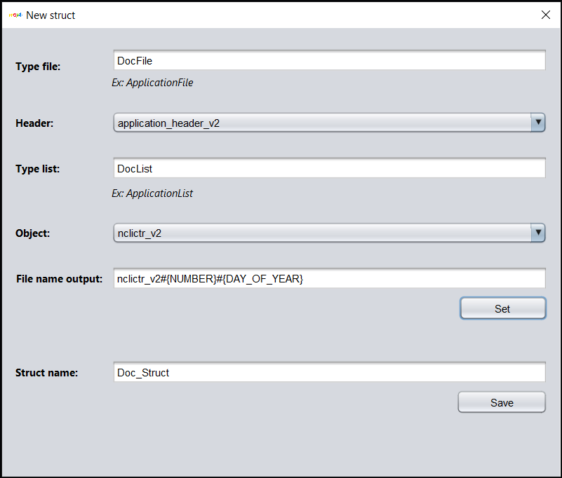

Create new Struct.

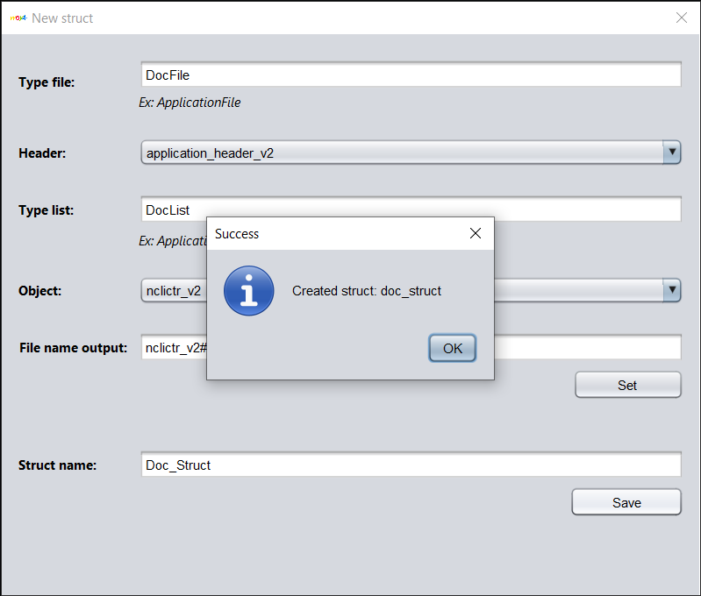

Create success Struct.

* To set **file name output**:

1. Choose option combobox or type to create value.
2. Click button **Add** to see preview (if you want to delete preview, click button **Clear**).
3. Click button **OK** to get all value in preview to set file name output.

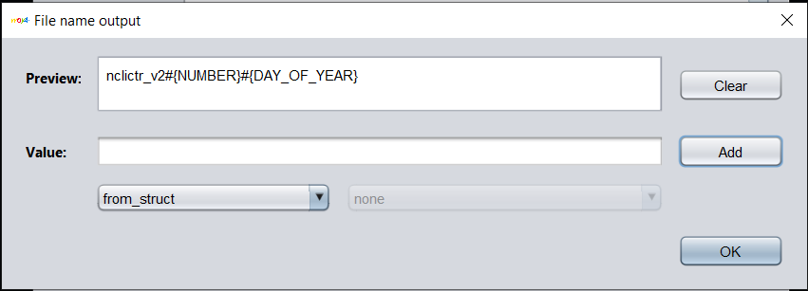

Set file name output.

1. **Struct – List:**

* Show all **Struct** in table. User can **edit, delete, duplicate** **Struct** (the same with **Header** and **Object**).

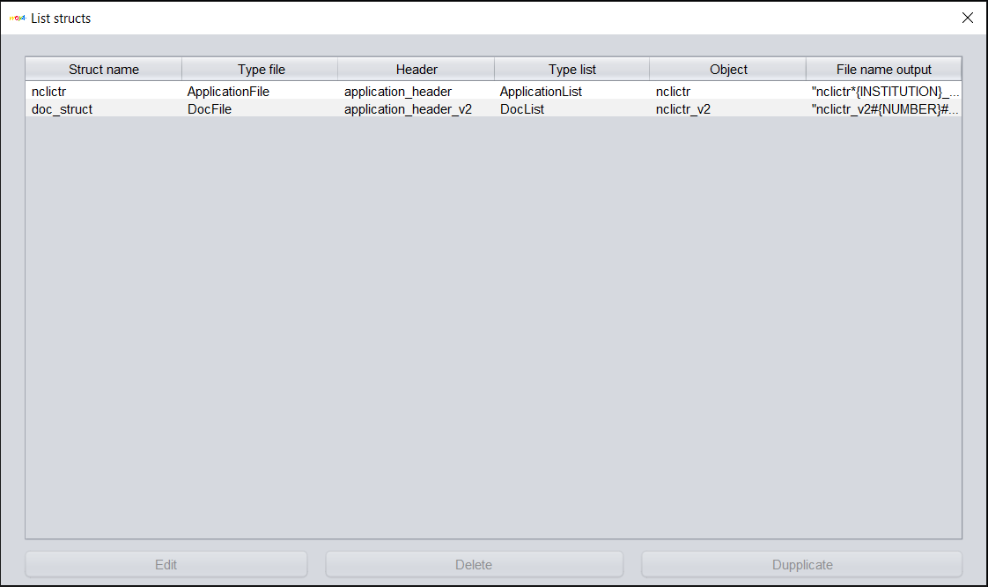

List Struct.

* After add Struct, combobox template in main form will **show all Templates (Structs)** in system.

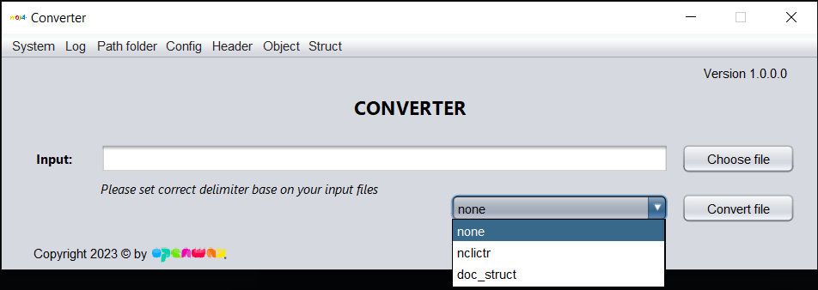

Show all Template (Struct) in main form.