# Introduction

### Purpose

This design document describes how the requirements for the Study Space application will be achieved. It will go into detail regarding software architecture,

### Scope

This document is constructed with the purpose of guiding the software developers in designing the product.

### Definitions

List definitions here.

### References

IEEE Standard for Software Project Management Plans. Will need to cite it.

### Overview

This document is written adhering to the guidelines outlined by the IEEE Recommended Practice for Software Design Descriptions.

# Decomposition Description

### Module Decomposition

### Concurrent Process Decomposition

### Data Decomposition

**Concurrent Process Decomposition**

This section shows the decomposition in multiple forms:

Home Screen:

Contains two buttons(one for Host, other for Guest)

Login: Host

A login page requesting an ID and a Password. Followed by a login button

Guest

A page that has the

Host: Host Beacon

An interface for the host to create a Beacon. Requesting course code, time for study, location of study, what the study area includes, and a brief description of what the group wants to study for.

Guest: Join Beacon

An interface showing a map with available study areas, and requesting information to narrow the searches of beacons

# 

# 3.Interface Description

### 3.1Module Interface

#### 3.1.1 HomeView

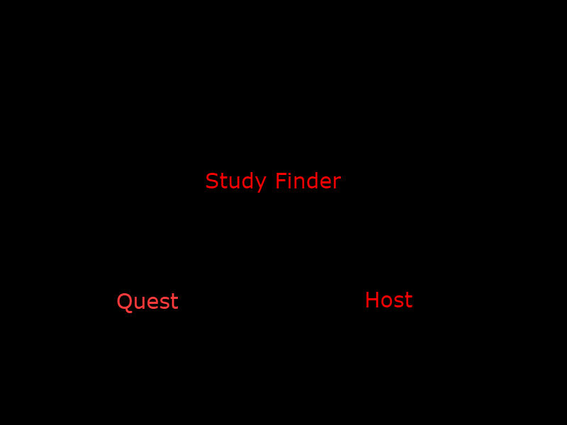

Field Type Description

Host-Button Links user to the RegisteredUserLoginView

Guest-Button Links user to the QuestView

#### 3.1.2 RegisteredUserLoginView

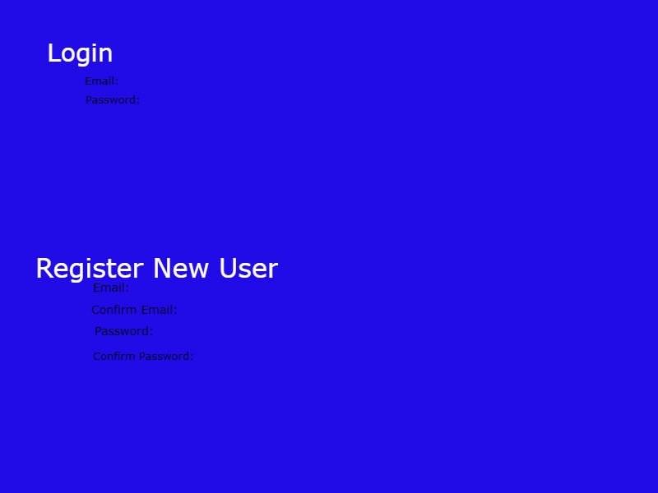

Login Field Type Description

Email: Confirm if the email is registered

Password: Confirm if the password is valid

Register New User Field Type Description

Email: user inputs their desired email

Confirm Email confirms the emai

Password: user input desired password

Confirm Password: confirm password

#### 3.1.3 BeaconCreationWindow

|  |  |  |
| --- | --- | --- |
| Field | Type | Description |
| beacon-school | Input text | School that the course being studied is listed under |
| beacon-courseID | Input text | Course that the beacon group is studying |
| beacon-timeframe | Input select | Time of when the beacon is going to start and end |
| beacon-location | Input text | Location of where the beacon is going to be taking place |
| host beacon-button | Input button | Registered user attempts to create beacon. Redirects back to BeaconCreateWindow if it fails |

# 3.1.4

# 

# Detailed Design

### Module Detailed Design

### Data Detailed Design

### Documentation