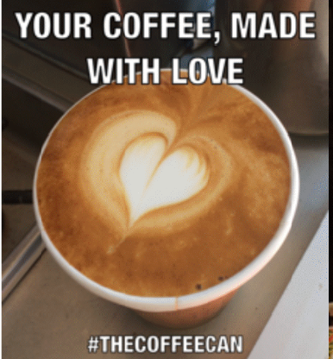

Mr Can had a burning ambition to start a coffee van. In May 2014 The Coffee Can was born with love for coffee. After searching extensively for a van to purchase we decided to have a van custom made. This was custom made by Bella Manufacturing on the Sunshine Coast to our specifications. Now four year on we have the van operating nearly seven days a week.

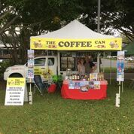 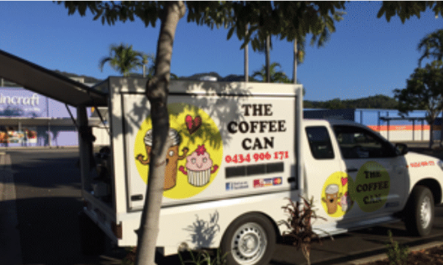

We came to the choice of either buying another van or creating a bricks and mortar option to our portfolio. This led to us purchasing the Corner Store on Michaelangelo, Redlynch in September in 2017 and convert it to a cafe, the Coffee Can Café has been a complete success. Our reputation has further increased for great customer service and serving great coffee every time. We have also included a coffee cart, The Coffee Can Cart, to further enhance our business by providing a service for indoors events and catering such as Corporate Events and other indoor events bookings.

Sharon and Chris are the owners and our staff are: Favourite Coffee: extra hot.

Name: Sharon (the boss lady) and owner. Favourite Food: All of it.

Skinny flat white.

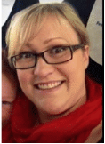

Name: Deearn(Manager)

Favourite Coffee: Caramel Latte.

Favourite Food: Banana Bread.

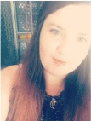

Name: Fal(Boss lady’s unicorn).

Favourite Coffee: Iced Latte(strong).

Favourite Food: Everything I am not allowed to have.

Things I am good at: Dropping shots, spinning milk and running my mouth.

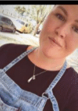

Our coffee is great because our Coffee Beans are roasted locally at The White Whale Coffee Roasters in Cairns. The blend is excellent and consistent all year round and is enhanced by the use of the local creamy milk produced by Mungalli Milk in all coffees. We serve double shot standard and triple shot in our large coffees. The Barista Blend we use is super smooth with hints of hazelnut and milk chocolate with a long sweet finish.

* See The Coffee Can because document for more information about our ingredients and products.
* See wedding leaflet for details of our coffee cart service.

The Coffee Can has serviced events with up to 10,000 people in attendance, nothing is too big or small if we have the availability. We can also host your work meetings, Expo’s, Birthdays and other special occasions at our Redlynch Café.

The type of events that we have served with coffee and drinks are:

Festivals, Race Meets, Birthdays, Wedding receptions, Charity Events, Sporting Events, Work Meetings, Fetes, School Carnivals, Concerts, Markets, Workplace coffee and Conferences

The other type of events we served with catering and drinks are:

Expo’s, TV Crews, Club Meets, Birthdays and Funerals.