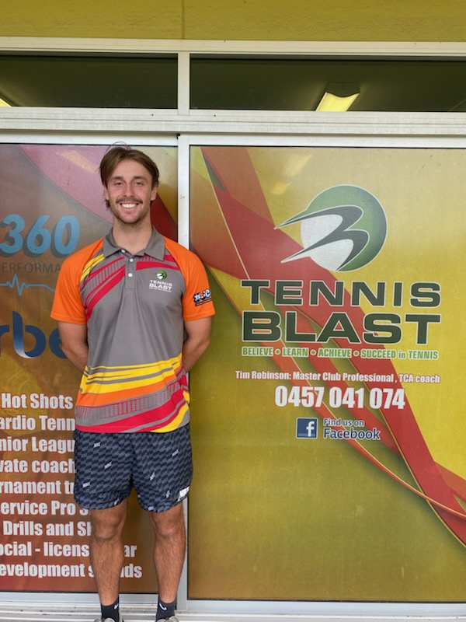
DOB 20/04/2001
Former NCAA collegiate tennis player with over 12 years of coaching experience working with players of all levels, from beginners to advanced competitors. Having coached across the Gold Coast, Brisbane, and the United States, I bring diverse international experience to every session. My coaching philosophy centres on discipline, problem solving, and strong fundamentals.

My qualifications include bachelors degree in health and physical health education, certifications in Strength & Conditioning and coaching.

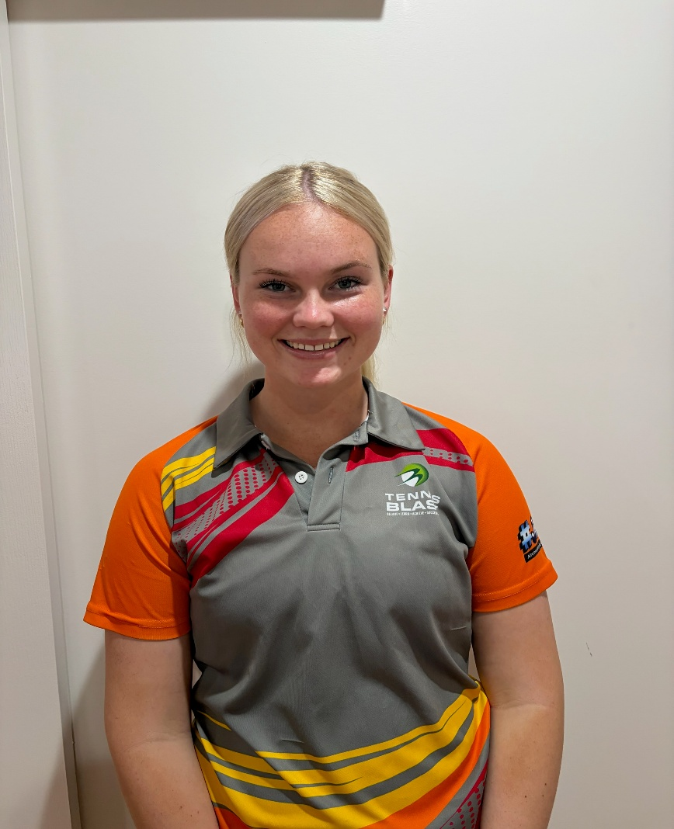

Alani Burton,
DOB ???
Trainee Qualified Coach, I have started my coaching journey at the club I grew up playing at as a 5-year-old. I help deliver red ball, orange and green ball group classes and help with Holiday camps through school holidays.
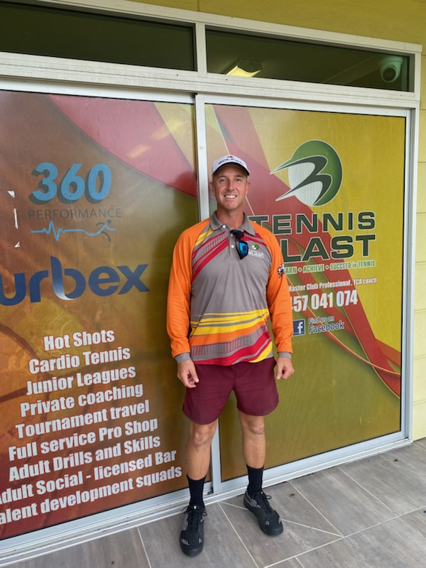
Brad Taylor (Coach B-Rad)
DOB 11/10/1979
Junior Development Level 1 Coach, Advantage Coach Qualified with 8 years’ experience as a coach running a private coaching business and 3 years with Tennis Blast.
Cert IV Recreation sports coaching, Cert IV Work Health and Safety, Strength and Conditioning Level 1.
I lead squad classes and private sessions for junior players aiming to improve their competitive tennis skills. I share my knowledge to help others develop both athletically and personally, while also working to enhance my own performance.

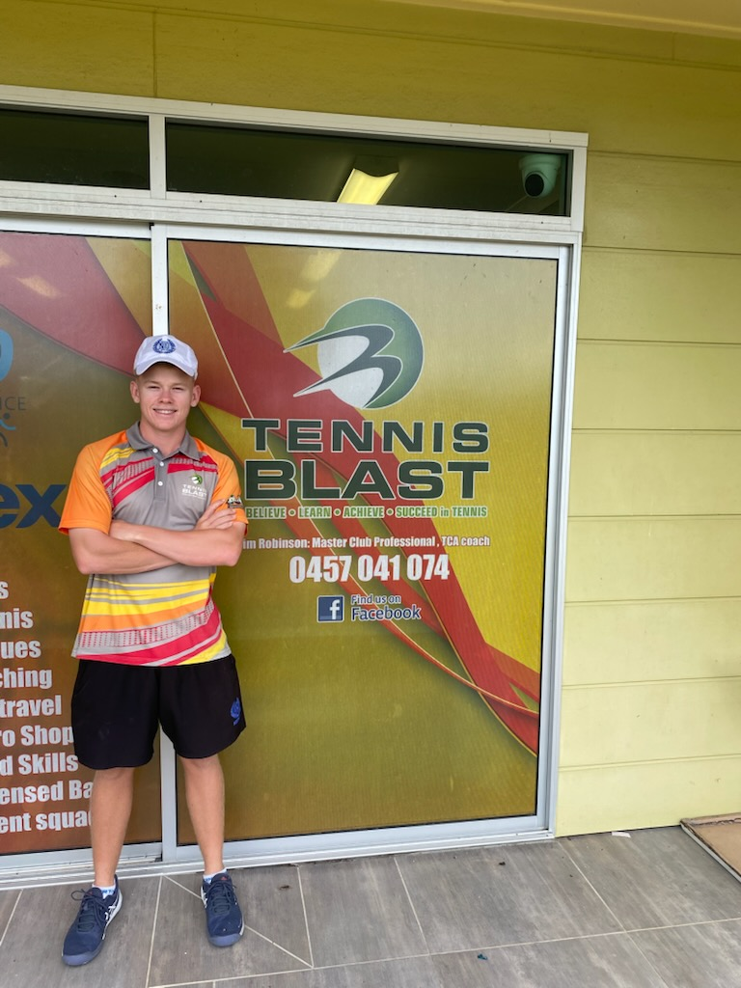

Patrick Brennan Paddy)
DOB: 03/10/2006, started tennis as a beginner in 2011 at age 5. Joined the club (Tennis Blast) as a staff member at age 14, passionate about maintaining a positive attitude and ensuring high standards of training. I lead Hot Shot group lessons, adult Skills and drills and adult fixtures, and Privates lessons.

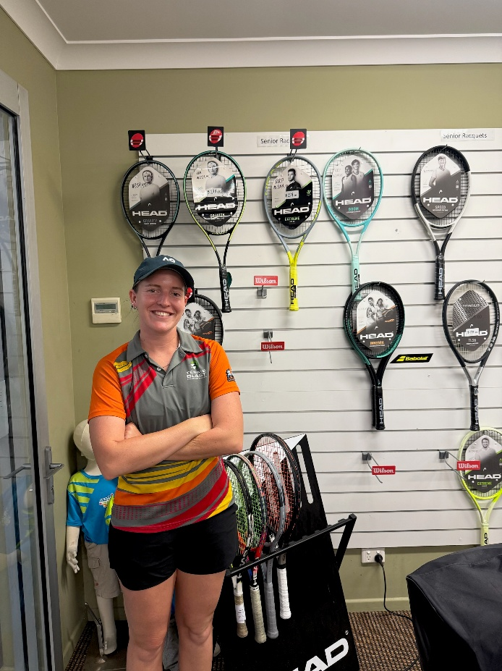

Sophie Stephenson
DOB 28/07/2000
Qualified Level 1 Coach
Started at Kalynda in 2018 as a junior coach and have now been coaching for 10 years. I love supporting kids to develop confidence in tennis and enjoy the sport, helping them grow both as players and individuals. Creating a positive and encouraging environment is important to me.

